**109年資通安全稽核作業**

**資安弱點檢測報告**

**Vulnerability Assessment Report**

**中華民國 109 年 10 月 23 日**

* SMB檢測項目：
  + SMB系統漏洞檢：
    1. CVE 2020-1206
    2. CVE 2020-0796
    3. MS 08-067
    4. MS 17-010
  + 高風險帳號
    - 風險帳號清單：

1. administrator
2. Administrator
3. user1
4. admin
5. alex
6. pos
7. demo
8. db2admin
9. Admin
10. sql
11. Root
12. Admin
13. Test
14. Guest
15. Info
16. Adm
17. Mysql
18. User
19. Administrator
20. Oracle
    * + 風險密碼清單：
21. 12345
22. 123456
23. 123456789
24. test1
25. password
26. 12345678
27. zinch
28. g_czechout
29. asdf
30. qwerty
31. dubsmash
32. test
33. 1234567890
34. 1234567
35. Aa123456
36. iloveyou
37. 1234
38. abc123
39. 11111111
40. 123123
41. 1qaz@WSX
42. 2wsx#ED
43. 3edc$RFV
44. 4rfv%TGB
45. x
46. Zz
47. St@rt123
48. 1
49. bl4ck4ndwhite
50. admin
51. alex
52. administrator
53. .......
54. Username
55. Username123
56. 123456
57. Password
58. 1234
59. 12345
60. Passwd
61. 123
62. Test
63. 1
    * 風險資料夾資訊

#### SMB低安全性帳號概況

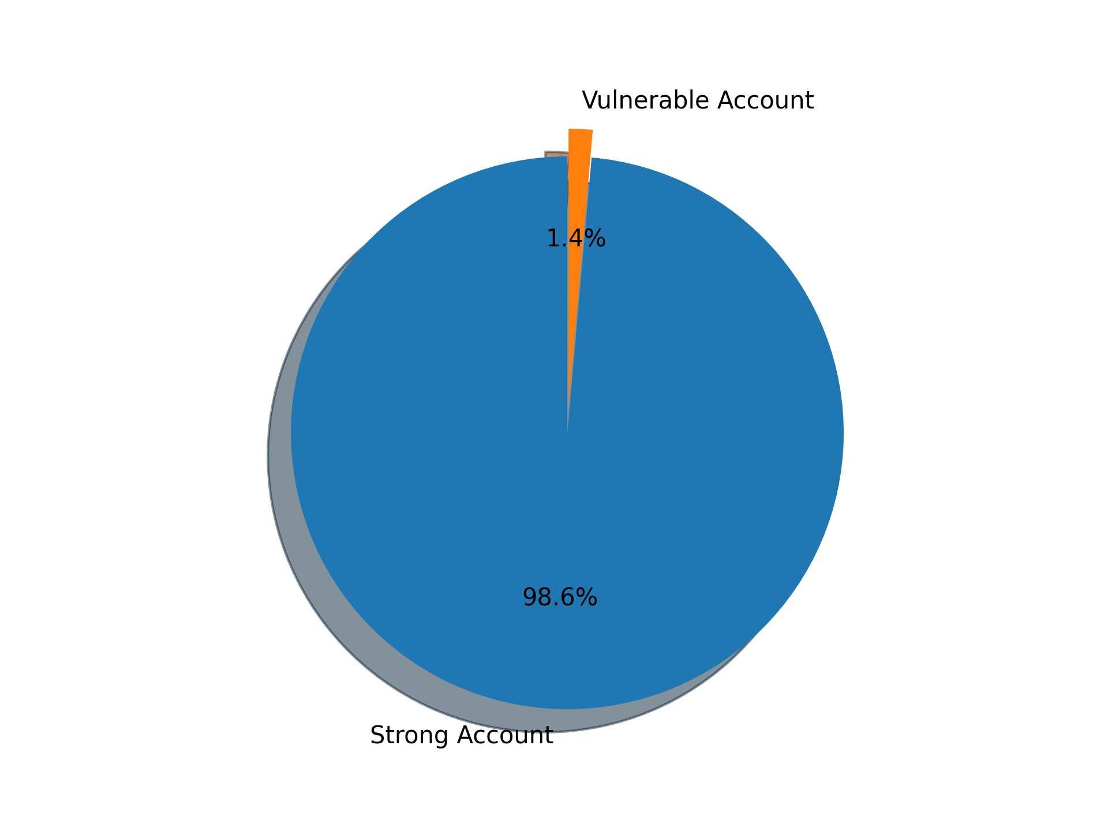

#### SMB系統漏洞檢測概況

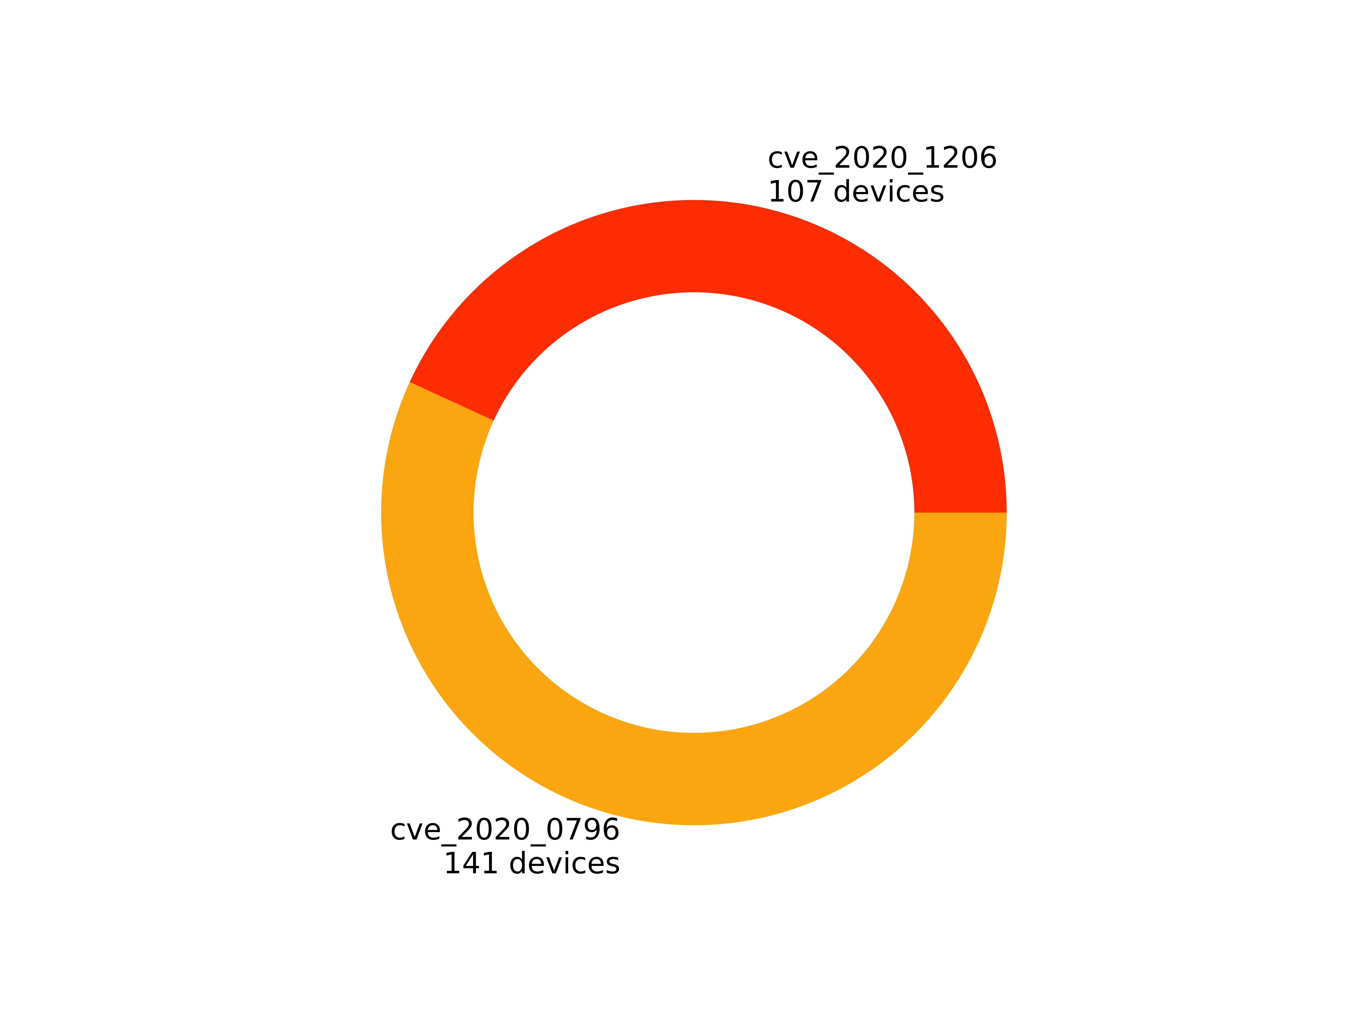

#### SMB資料共享風險概況

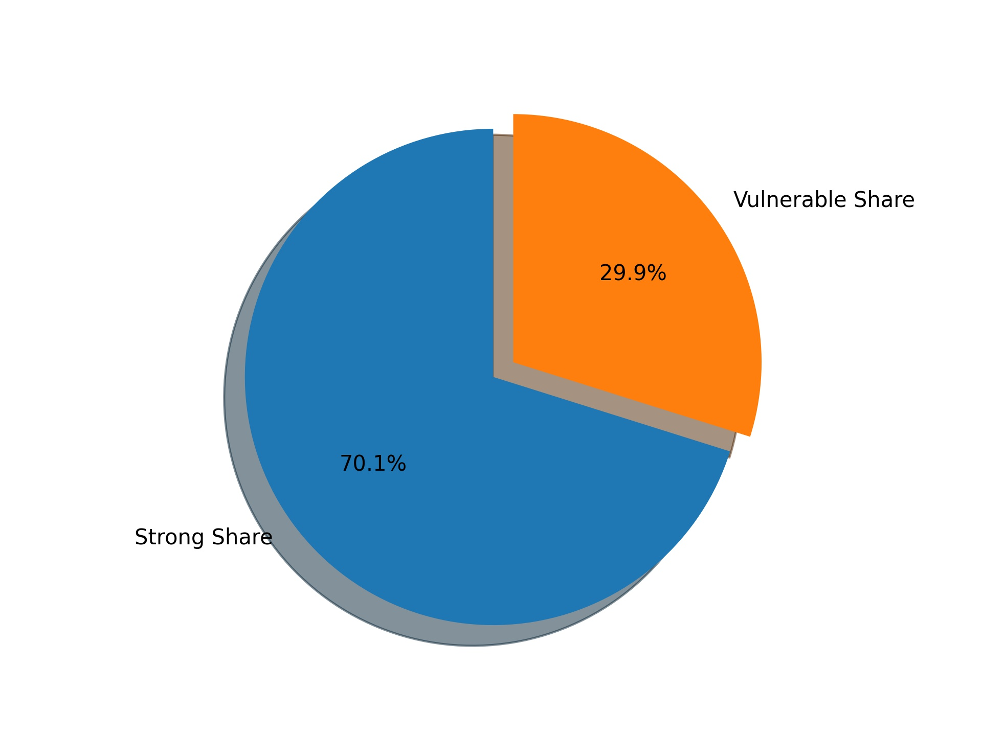

詳細資訊

#### SMB低安全性帳號詳細資訊

|  |  |  |
| --- | --- | --- |
| * 風險IP | 風險帳號 | 風險密碼 |
| 192.168.28.113 | administrator | 1qaz@WSX |
| 詳細資訊 | | |
| 4MOSAn_GCB_Doctor  Common Files  desktop.ini  Internet Explorer  Microsoft Analysis Services  Microsoft Help Viewer  Microsoft Office  Microsoft SDKs  Microsoft SQL Server  Microsoft Visual Studio 10.0  Microsoft Visual Studio 14.0  Microsoft.NET  MSBuild  Reference Assemblies  Trend Micro  Uninstall Information  Windows Kits  Windows Mail  Windows NT  WindowsPowerShell  Xensor | | |

|  |  |  |
| --- | --- | --- |
| * 風險IP | 風險帳號 | 風險密碼 |
| 192.168.28.206 | administrator | 1qaz@WSX |
| 詳細資訊 | | |
| Common Files  desktop.ini  DSMDrivers  InstallJammer Registry  Internet Explorer  Microsoft SQL Server  Microsoft.NET  MSBuild  Reference Assemblies  StorageManager  Symantec  Uninstall Information  VMware  Windows Mail  Windows NT  Zero G Registry | | |

#### SMB系統漏洞檢測詳細資訊

|  |  |
| --- | --- |
| 弱點名稱 | cve_2020_1206 |
| 弱點敘述 | 該漏洞產生的原因是SMB的解壓縮函數Srv2DecompressData在處理發送給目標SMBv3服務器以偽造的息請求時，所產生問題，攻擊者可以讀取未初始化的kernel內存，還可以對壓縮函數進行修改。 |
| 建議措施 | 用管理員身份執行命令提示字元，必輸入以下命令，Set-ItemProperty -Path "HKLM:\SYSTEM\CurrentControlSet\Services\LanmanServer\Parameters" DisableCompression -Type DWORD -Value 1 -Force,此外無需重啟電腦 |
| 風險IP  資訊 | 192.168.28.86  192.168.28.208  192.168.28.209  192.168.28.94  192.168.28.79  192.168.28.132  192.168.28.93  192.168.28.23  192.168.28.82  192.168.28.174  192.168.28.131  192.168.28.100  192.168.28.10  192.168.28.116  192.168.28.6  192.168.28.140  192.168.28.11  192.168.28.57  192.168.28.72  192.168.28.221  192.168.28.125  192.168.28.84  192.168.28.155  192.168.28.26  192.168.28.12  192.168.28.85  192.168.28.156  192.168.28.66  192.168.28.127  192.168.28.151  192.168.28.123  192.168.28.175  192.168.28.104  192.168.28.129  192.168.28.152  192.168.28.143  192.168.28.118  192.168.28.73  192.168.28.39  192.168.28.98  192.168.28.207  192.168.28.239  192.168.28.113  192.168.28.69  192.168.28.178  192.168.28.179  192.168.28.210  192.168.28.22  192.168.28.220  192.168.28.30  192.168.28.111  192.168.28.107  192.168.28.95  192.168.28.59  192.168.28.7  192.168.28.189  192.168.28.121  192.168.28.24  192.168.28.62  192.168.28.126  192.168.28.89  192.168.28.112  192.168.28.110  192.168.28.63  192.168.28.21  192.168.28.87  192.168.28.76  192.168.28.108  192.168.28.15  192.168.28.56  192.168.28.70  192.168.28.32  192.168.28.206  192.168.28.171  192.168.28.101  192.168.28.222  192.168.28.191  192.168.28.36  192.168.28.190  192.168.28.78  192.168.28.90  192.168.28.153  192.168.28.64  192.168.28.18  192.168.28.54  192.168.28.192  192.168.28.81  192.168.28.99  192.168.28.105  192.168.28.106  192.168.28.77  192.168.28.35  192.168.28.9  192.168.28.96  192.168.28.37  192.168.28.4  192.168.28.80  192.168.28.34  192.168.28.97  192.168.28.3  192.168.28.102  192.168.28.130  192.168.28.117  192.168.28.145  192.168.28.74  192.168.28.154  192.168.28.17 |

|  |  |
| --- | --- |
| 弱點名稱 | cve_2020_0796 |
| 弱點敘述 | 該漏洞遠讓遠端攻擊者可對目標系統之SMBv3服務發送特製請求或架設惡意的SMBv3伺服器誘騙受害者進行連線，導致遠端執行任意程式碼 |
| 建議措施 | 目前微軟官方已針對此弱點釋出更新程式，請至下列連結進行更新：https://portal.msrc.microsoft.com/en-US/security-guidance/advisory/CVE-2020-0796 |
| 風險IP  資訊 | 192.168.28.86  192.168.28.208  192.168.28.209  192.168.28.94  192.168.28.79  192.168.28.132  192.168.28.238  192.168.28.93  192.168.28.23  192.168.28.173  192.168.28.82  192.168.28.174  192.168.28.131  192.168.28.100  192.168.28.61  192.168.28.10  192.168.28.116  192.168.28.6  192.168.28.140  192.168.28.11  192.168.28.247  192.168.28.5  192.168.28.57  192.168.28.72  192.168.28.251  192.168.28.221  192.168.28.125  192.168.28.84  192.168.28.109  192.168.28.155  192.168.28.26  192.168.28.12  192.168.28.167  192.168.28.85  192.168.28.67  192.168.28.38  192.168.28.156  192.168.28.66  192.168.28.127  192.168.28.245  192.168.28.151  192.168.28.123  192.168.28.114  192.168.28.175  192.168.28.104  192.168.28.252  192.168.28.129  192.168.28.152  192.168.28.143  192.168.28.118  192.168.28.73  192.168.28.218  192.168.28.39  192.168.28.98  192.168.28.207  192.168.28.239  192.168.28.113  192.168.28.69  192.168.28.178  192.168.28.179  192.168.28.210  192.168.28.22  192.168.28.248  192.168.28.220  192.168.28.30  192.168.28.134  192.168.28.111  192.168.28.52  192.168.28.107  192.168.28.164  192.168.28.92  192.168.28.95  192.168.28.235  192.168.28.103  192.168.28.59  192.168.28.14  192.168.28.7  192.168.28.161  192.168.28.189  192.168.28.121  192.168.28.24  192.168.28.168  192.168.28.8  192.168.28.62  192.168.28.126  192.168.28.89  192.168.28.75  192.168.28.112  192.168.28.234  192.168.28.133  192.168.28.110  192.168.28.63  192.168.28.21  192.168.28.87  192.168.28.76  192.168.28.108  192.168.28.13  192.168.28.15  192.168.28.56  192.168.28.53  192.168.28.70  192.168.28.32  192.168.28.206  192.168.28.171  192.168.28.101  192.168.28.240  192.168.28.222  192.168.28.191  192.168.28.36  192.168.28.190  192.168.28.78  192.168.28.90  192.168.28.153  192.168.28.1  192.168.28.64  192.168.28.18  192.168.28.54  192.168.28.192  192.168.28.81  192.168.28.99  192.168.28.105  192.168.28.106  192.168.28.77  192.168.28.35  192.168.28.9  192.168.28.225  192.168.28.96  192.168.28.37  192.168.28.4  192.168.28.80  192.168.28.34  192.168.28.97  192.168.28.3  192.168.28.102  192.168.28.130  192.168.28.117  192.168.28.145  192.168.28.74  192.168.28.154  192.168.28.33  192.168.28.17 |

#### 資料共享風險詳細資訊

|  |  |
| --- | --- |
| IP位置 | 192.168.28.86 |
| 資料夾資訊 | \\192.168.28.86\ADMIN$  Anonymous access  none  Current user access  none  \\192.168.28.86\C$  Anonymous access  none  Current user access  none  \\192.168.28.86\D$  Anonymous access  none  Current user access  none  \\192.168.28.86\IPC$  Anonymous access  none  Current user access  READ/WRITE |

|  |  |
| --- | --- |
| IP位置 | 192.168.28.208 |
| 資料夾資訊 | \\192.168.28.208\ADMIN$  Anonymous access  none  Current user access  none  \\192.168.28.208\C$  Anonymous access  none  Current user access  none  \\192.168.28.208\IPC$  Anonymous access  none  Current user access  READ/WRITE  \\192.168.28.208\Share_Folder  Anonymous access  none  Current user access  READ |

|  |  |
| --- | --- |
| IP位置 | 192.168.28.209 |
| 資料夾資訊 | \\192.168.28.209\ADMIN$  Anonymous access  none  Current user access  none  \\192.168.28.209\C$  Anonymous access  none  Current user access  none  \\192.168.28.209\IPC$  Anonymous access  none  Current user access  READ/WRITE |

|  |  |
| --- | --- |
| IP位置 | 192.168.28.94 |
| 資料夾資訊 | \\192.168.28.94\ADMIN$  Anonymous access  none  Current user access  none  \\192.168.28.94\C$  Anonymous access  none  Current user access  none  \\192.168.28.94\D$  Anonymous access  none  Current user access  none  \\192.168.28.94\F$  Anonymous access  none  Current user access  none  \\192.168.28.94\IPC$  Anonymous access  none  Current user access  READ/WRITE |

|  |  |
| --- | --- |
| IP位置 | 192.168.28.132 |
| 資料夾資訊 | \\192.168.28.132\ADMIN$  Anonymous access  none  Current user access  none  \\192.168.28.132\C$  Anonymous access  none  Current user access  none  \\192.168.28.132\IPC$  Anonymous access  none  Current user access  READ/WRITE |

|  |  |
| --- | --- |
| IP位置 | 192.168.28.93 |
| 資料夾資訊 | \\192.168.28.93\ADMIN$  Anonymous access  none  Current user access  none  \\192.168.28.93\C$  Anonymous access  none  Current user access  none  \\192.168.28.93\IPC$  Anonymous access  none  Current user access  READ/WRITE |

|  |  |
| --- | --- |
| IP位置 | 192.168.28.82 |
| 資料夾資訊 | \\192.168.28.82\ADMIN$  Anonymous access  none  Current user access  none  \\192.168.28.82\C$  Anonymous access  none  Current user access  none  \\192.168.28.82\D$  Anonymous access  none  Current user access  none  \\192.168.28.82\IPC$  Anonymous access  READ  Current user access  READ/WRITE |

|  |  |
| --- | --- |
| IP位置 | 192.168.28.174 |
| 資料夾資訊 | \\192.168.28.174\ADMIN$  Anonymous access  none  Current user access  none  \\192.168.28.174\C$  Anonymous access  none  Current user access  none  \\192.168.28.174\E$  Anonymous access  none  Current user access  none  \\192.168.28.174\IPC$  Anonymous access  none  Current user access  READ/WRITE |

|  |  |
| --- | --- |
| IP位置 | 192.168.28.131 |
| 資料夾資訊 | \\192.168.28.131\ADMIN$  Anonymous access  none  Current user access  none  \\192.168.28.131\C$  Anonymous access  none  Current user access  none  \\192.168.28.131\IPC$  Anonymous access  none  Current user access  READ/WRITE  \\192.168.28.131\Users  Anonymous access  none  Current user access  READ |

|  |  |
| --- | --- |
| IP位置 | 192.168.28.100 |
| 資料夾資訊 | \\192.168.28.100\ADMIN$  Anonymous access  none  Current user access  none  \\192.168.28.100\C$  Anonymous access  none  Current user access  none  \\192.168.28.100\D$  Anonymous access  none  Current user access  none  \\192.168.28.100\IPC$  Anonymous access  none  Current user access  READ/WRITE  \\192.168.28.100\backup  Anonymous access  none  Current user access  READ/WRITE |

|  |  |
| --- | --- |
| IP位置 | 192.168.28.140 |
| 資料夾資訊 | \\192.168.28.140\ADMIN$  Anonymous access  none  Current user access  none  \\192.168.28.140\C$  Anonymous access  none  Current user access  none  \\192.168.28.140\D$  Anonymous access  none  Current user access  none  \\192.168.28.140\IPC$  Anonymous access  none  Current user access  READ/WRITE  \\192.168.28.140\PersonalImageLibrary  Anonymous access  none  Current user access  READ  \\192.168.28.140\PersonalPStampLibrary  Anonymous access  none  Current user access  READ  \\192.168.28.140\PersonalTStampLibrary  Anonymous access  none  Current user access  READ  \\192.168.28.140\Report  Anonymous access  none  Current user access  READ  \\192.168.28.140\ReportFormat  Anonymous access  none  Current user access  READ  \\192.168.28.140\ReportTemplate  Anonymous access  none  Current user access  READ  \\192.168.28.140\Share  Anonymous access  none  Current user access  READ  \\192.168.28.140\SharedImageLibrary  Anonymous access  none  Current user access  READ  \\192.168.28.140\eweb  Anonymous access  none  Current user access  READ |

|  |  |
| --- | --- |
| IP位置 | 192.168.28.57 |
| 資料夾資訊 | \\192.168.28.57\ADMIN$  Anonymous access  none  Current user access  none  \\192.168.28.57\C$  Anonymous access  none  Current user access  none  \\192.168.28.57\D$  Anonymous access  none  Current user access  none  \\192.168.28.57\IPC$  Anonymous access  READ  Current user access  READ/WRITE  \\192.168.28.57\declare$  Anonymous access  none  Current user access  READ  \\192.168.28.57\hv-backup$  Anonymous access  none  Current user access  READ |

|  |  |
| --- | --- |
| IP位置 | 192.168.28.221 |
| 資料夾資訊 | \\192.168.28.221\ADMIN$  Anonymous access  none  Current user access  none  \\192.168.28.221\C$  Anonymous access  none  Current user access  none  \\192.168.28.221\D$  Anonymous access  none  Current user access  none  \\192.168.28.221\IPC$  Anonymous access  READ  Current user access  READ/WRITE  \\192.168.28.221\hmisa  Anonymous access  none  Current user access  READ  \\192.168.28.221\send  Anonymous access  none  Current user access  READ/WRITE |

|  |  |
| --- | --- |
| IP位置 | 192.168.28.66 |
| 資料夾資訊 | \\192.168.28.66\ADMIN$  Anonymous access  none  Current user access  none  \\192.168.28.66\C$  Anonymous access  none  Current user access  none  \\192.168.28.66\E$  Anonymous access  none  Current user access  none  \\192.168.28.66\IPC$  Anonymous access  READ  Current user access  READ/WRITE  \\192.168.28.66\Users  Anonymous access  none  Current user access  READ  \\192.168.28.66\tools  Anonymous access  none  Current user access  READ |

|  |  |
| --- | --- |
| IP位置 | 192.168.28.245 |
| 資料夾資訊 | \\192.168.28.245\ADMIN$  Anonymous access  none  Current user access  none  \\192.168.28.245\C$  Anonymous access  none  Current user access  none  \\192.168.28.245\D$  Anonymous access  none  Current user access  none  \\192.168.28.245\E$  Anonymous access  none  Current user access  none  \\192.168.28.245\IPC$  Anonymous access  READ  Current user access  READ/WRITE |

|  |  |
| --- | --- |
| IP位置 | 192.168.28.123 |
| 資料夾資訊 | \\192.168.28.123\ADMIN$  Anonymous access  none  Current user access  none  \\192.168.28.123\C$  Anonymous access  none  Current user access  none  \\192.168.28.123\D$  Anonymous access  none  Current user access  none  \\192.168.28.123\IPC$  Anonymous access  none  Current user access  READ/WRITE |

|  |  |
| --- | --- |
| IP位置 | 192.168.28.175 |
| 資料夾資訊 | \\192.168.28.175\ADMIN$  Anonymous access  none  Current user access  none  \\192.168.28.175\C$  Anonymous access  none  Current user access  none  \\192.168.28.175\D$  Anonymous access  none  Current user access  none  \\192.168.28.175\IPC$  Anonymous access  none  Current user access  READ/WRITE  \\192.168.28.175\address  Anonymous access  none  Current user access  READ |

|  |  |
| --- | --- |
| IP位置 | 192.168.28.104 |
| 資料夾資訊 | \\192.168.28.104\ClusterStorage$  Anonymous access  none  Current user access  none  \\192.168.28.104\F$  Anonymous access  none  Current user access  READ  \\192.168.28.104\IPC$  Anonymous access  none  Current user access  READ/WRITE |

|  |  |
| --- | --- |
| IP位置 | 192.168.28.129 |
| 資料夾資訊 | \\192.168.28.129\ADMIN$  Anonymous access  none  Current user access  none  \\192.168.28.129\C$  Anonymous access  none  Current user access  none  \\192.168.28.129\D$  Anonymous access  none  Current user access  none  \\192.168.28.129\IPC$  Anonymous access  READ  Current user access  READ/WRITE |

|  |  |
| --- | --- |
| IP位置 | 192.168.28.73 |
| 資料夾資訊 | \\192.168.28.73\ADMIN$  Anonymous access  none  Current user access  none  \\192.168.28.73\C$  Anonymous access  none  Current user access  none  \\192.168.28.73\D$  Anonymous access  none  Current user access  none  \\192.168.28.73\IPC$  Anonymous access  none  Current user access  READ/WRITE |

|  |  |
| --- | --- |
| IP位置 | 192.168.28.39 |
| 資料夾資訊 | \\192.168.28.39\ADMIN$  Anonymous access  none  Current user access  none  \\192.168.28.39\C$  Anonymous access  none  Current user access  none  \\192.168.28.39\D$  Anonymous access  none  Current user access  none  \\192.168.28.39\IPC$  Anonymous access  READ  Current user access  READ/WRITE |

|  |  |
| --- | --- |
| IP位置 | 192.168.28.98 |
| 資料夾資訊 | \\192.168.28.98\ADMIN$  Anonymous access  none  Current user access  none  \\192.168.28.98\C$  Anonymous access  none  Current user access  none  \\192.168.28.98\D$  Anonymous access  none  Current user access  none  \\192.168.28.98\IPC$  Anonymous access  none  Current user access  READ/WRITE |

|  |  |
| --- | --- |
| IP位置 | 192.168.28.207 |
| 資料夾資訊 | \\192.168.28.207\ClusterStorage$  Anonymous access  none  Current user access  none  \\192.168.28.207\IPC$  Anonymous access  none  Current user access  READ/WRITE |

|  |  |
| --- | --- |
| IP位置 | 192.168.28.239 |
| 資料夾資訊 | \\192.168.28.239\ADMIN$  Anonymous access  none  Current user access  none  \\192.168.28.239\C$  Anonymous access  none  Current user access  none  \\192.168.28.239\D$  Anonymous access  none  Current user access  none  \\192.168.28.239\IPC$  Anonymous access  none  Current user access  READ/WRITE |

|  |  |
| --- | --- |
| IP位置 | 192.168.28.113 |
| 資料夾資訊 | \\192.168.28.113\ADMIN$  Anonymous access  none  Current user access  none  \\192.168.28.113\C$  Anonymous access  none  Current user access  none  \\192.168.28.113\D$  Anonymous access  none  Current user access  none  \\192.168.28.113\IPC$  Anonymous access  none  Current user access  READ/WRITE  \\192.168.28.113\TY_DICOMDIR_7Z  Anonymous access  none  Current user access  READ |

|  |  |
| --- | --- |
| IP位置 | 192.168.28.178 |
| 資料夾資訊 | \\192.168.28.178\ADMIN$  Anonymous access  none  Current user access  none  \\192.168.28.178\Backup  Anonymous access  none  Current user access  READ  \\192.168.28.178\C$  Anonymous access  none  Current user access  none  \\192.168.28.178\D$  Anonymous access  none  Current user access  none  \\192.168.28.178\HV-backup$  Anonymous access  none  Current user access  READ  \\192.168.28.178\IPC$  Anonymous access  READ  Current user access  READ/WRITE  \\192.168.28.178\backup2  Anonymous access  none  Current user access  READ |

|  |  |
| --- | --- |
| IP位置 | 192.168.28.179 |
| 資料夾資訊 | \\192.168.28.179\ADMIN$  Anonymous access  none  Current user access  none  \\192.168.28.179\C$  Anonymous access  none  Current user access  none  \\192.168.28.179\D$  Anonymous access  none  Current user access  none  \\192.168.28.179\IPC$  Anonymous access  READ  Current user access  READ/WRITE  \\192.168.28.179\print$  Anonymous access  none  Current user access  READ |

|  |  |
| --- | --- |
| IP位置 | 192.168.28.210 |
| 資料夾資訊 | \\192.168.28.210\ADMIN$  Anonymous access  none  Current user access  none  \\192.168.28.210\C$  Anonymous access  none  Current user access  none  \\192.168.28.210\D$  Anonymous access  none  Current user access  none  \\192.168.28.210\E$  Anonymous access  none  Current user access  none  \\192.168.28.210\IPC$  Anonymous access  none  Current user access  READ/WRITE  \\192.168.28.210\cook  Anonymous access  none  Current user access  READ |

|  |  |
| --- | --- |
| IP位置 | 192.168.28.220 |
| 資料夾資訊 | \\192.168.28.220\ADMIN$  Anonymous access  none  Current user access  none  \\192.168.28.220\C$  Anonymous access  none  Current user access  none  \\192.168.28.220\D$  Anonymous access  none  Current user access  none  \\192.168.28.220\IPC$  Anonymous access  none  Current user access  READ/WRITE  \\192.168.28.220\vision95  Anonymous access  none  Current user access  READ |

|  |  |
| --- | --- |
| IP位置 | 192.168.28.30 |
| 資料夾資訊 | \\192.168.28.30\ADMIN$  Anonymous access  none  Current user access  none  \\192.168.28.30\C$  Anonymous access  none  Current user access  none  \\192.168.28.30\D$  Anonymous access  none  Current user access  none  \\192.168.28.30\HV-BACKUP$  Anonymous access  none  Current user access  READ  \\192.168.28.30\IPC$  Anonymous access  READ  Current user access  READ/WRITE  \\192.168.28.30\WB$  Anonymous access  none  Current user access  READ  \\192.168.28.30\filet-t1  Anonymous access  none  Current user access  READ |

|  |  |
| --- | --- |
| IP位置 | 192.168.28.134 |
| 資料夾資訊 | \\192.168.28.134\ADMIN$  Anonymous access  none  Current user access  none  \\192.168.28.134\C$  Anonymous access  none  Current user access  none  \\192.168.28.134\D$  Anonymous access  none  Current user access  none  \\192.168.28.134\IPC$  Anonymous access  READ  Current user access  READ/WRITE  \\192.168.28.134\print$  Anonymous access  none  Current user access  READ |

|  |  |
| --- | --- |
| IP位置 | 192.168.28.111 |
| 資料夾資訊 | \\192.168.28.111\ADMIN$  Anonymous access  none  Current user access  none  \\192.168.28.111\C$  Anonymous access  none  Current user access  none  \\192.168.28.111\D$  Anonymous access  none  Current user access  none  \\192.168.28.111\IPC$  Anonymous access  none  Current user access  READ/WRITE |

|  |  |
| --- | --- |
| IP位置 | 192.168.28.107 |
| 資料夾資訊 | \\192.168.28.107\ADMIN$  Anonymous access  none  Current user access  none  \\192.168.28.107\C$  Anonymous access  none  Current user access  none  \\192.168.28.107\CertEnroll  Anonymous access  none  Current user access  READ  \\192.168.28.107\D$  Anonymous access  none  Current user access  none  \\192.168.28.107\IPC$  Anonymous access  none  Current user access  READ/WRITE |

|  |  |
| --- | --- |
| IP位置 | 192.168.28.95 |
| 資料夾資訊 | \\192.168.28.95\ADMIN$  Anonymous access  none  Current user access  none  \\192.168.28.95\C$  Anonymous access  none  Current user access  none  \\192.168.28.95\D$  Anonymous access  none  Current user access  none  \\192.168.28.95\IPC$  Anonymous access  READ  Current user access  READ/WRITE |

|  |  |
| --- | --- |
| IP位置 | 192.168.28.103 |
| 資料夾資訊 | \\192.168.28.103\ADMIN$  Anonymous access  none  Current user access  none  \\192.168.28.103\C$  Anonymous access  none  Current user access  none  \\192.168.28.103\F$  Anonymous access  none  Current user access  none  \\192.168.28.103\IPC$  Anonymous access  READ  Current user access  READ/WRITE  \\192.168.28.103\shard  Anonymous access  none  Current user access  READ |

|  |  |
| --- | --- |
| IP位置 | 192.168.28.189 |
| 資料夾資訊 | \\192.168.28.189\ADMIN$  Anonymous access  none  Current user access  none  \\192.168.28.189\C$  Anonymous access  none  Current user access  none  \\192.168.28.189\D$  Anonymous access  none  Current user access  none  \\192.168.28.189\E$  Anonymous access  none  Current user access  none  \\192.168.28.189\IPC$  Anonymous access  none  Current user access  READ/WRITE |

|  |  |
| --- | --- |
| IP位置 | 192.168.28.121 |
| 資料夾資訊 | \\192.168.28.121\ADMIN$  Anonymous access  none  Current user access  none  \\192.168.28.121\C$  Anonymous access  none  Current user access  none  \\192.168.28.121\D$  Anonymous access  none  Current user access  none  \\192.168.28.121\E$  Anonymous access  none  Current user access  none  \\192.168.28.121\IPC$  Anonymous access  none  Current user access  READ/WRITE  \\192.168.28.121\IPS  Anonymous access  none  Current user access  READ |

|  |  |
| --- | --- |
| IP位置 | 192.168.28.126 |
| 資料夾資訊 | \\192.168.28.126\ADMIN$  Anonymous access  none  Current user access  none  \\192.168.28.126\C$  Anonymous access  none  Current user access  none  \\192.168.28.126\D$  Anonymous access  none  Current user access  none  \\192.168.28.126\IPC$  Anonymous access  READ  Current user access  READ/WRITE |

|  |  |
| --- | --- |
| IP位置 | 192.168.28.89 |
| 資料夾資訊 | \\192.168.28.89\ADMIN$  Anonymous access  none  Current user access  none  \\192.168.28.89\C$  Anonymous access  none  Current user access  none  \\192.168.28.89\D$  Anonymous access  none  Current user access  none  \\192.168.28.89\IPC$  Anonymous access  none  Current user access  READ/WRITE  \\192.168.28.89\hmisa  Anonymous access  none  Current user access  READ/WRITE |

|  |  |
| --- | --- |
| IP位置 | 192.168.28.75 |
| 資料夾資訊 | \\192.168.28.75\ADMIN$  Anonymous access  none  Current user access  none  \\192.168.28.75\C$  Anonymous access  none  Current user access  none  \\192.168.28.75\IPC$  Anonymous access  READ  Current user access  READ/WRITE  \\192.168.28.75\NR8  Anonymous access  none  Current user access  READ  \\192.168.28.75\tmp  Anonymous access  none  Current user access  READ |

|  |  |
| --- | --- |
| IP位置 | 192.168.28.133 |
| 資料夾資訊 | \\192.168.28.133\ADMIN$  Anonymous access  none  Current user access  none  \\192.168.28.133\C$  Anonymous access  none  Current user access  none  \\192.168.28.133\D$  Anonymous access  none  Current user access  none  \\192.168.28.133\IPC$  Anonymous access  READ  Current user access  READ/WRITE  \\192.168.28.133\ssis  Anonymous access  none  Current user access  READ |

|  |  |
| --- | --- |
| IP位置 | 192.168.28.110 |
| 資料夾資訊 | \\192.168.28.110\ADMIN$  Anonymous access  none  Current user access  none  \\192.168.28.110\B$  Anonymous access  none  Current user access  none  \\192.168.28.110\C$  Anonymous access  none  Current user access  none  \\192.168.28.110\D$  Anonymous access  none  Current user access  none  \\192.168.28.110\IPC$  Anonymous access  none  Current user access  READ/WRITE |

|  |  |
| --- | --- |
| IP位置 | 192.168.28.87 |
| 資料夾資訊 | \\192.168.28.87\ADMIN$  Anonymous access  none  Current user access  none  \\192.168.28.87\ARCserve$  Anonymous access  none  Current user access  READ  \\192.168.28.87\C$  Anonymous access  none  Current user access  none  \\192.168.28.87\E$  Anonymous access  none  Current user access  none  \\192.168.28.87\F$  Anonymous access  none  Current user access  none  \\192.168.28.87\G$  Anonymous access  none  Current user access  none  \\192.168.28.87\IPC$  Anonymous access  READ  Current user access  READ/WRITE  \\192.168.28.87\ca_apm$  Anonymous access  none  Current user access  READ |

|  |  |
| --- | --- |
| IP位置 | 192.168.28.76 |
| 資料夾資訊 | \\192.168.28.76\ADMIN$  Anonymous access  none  Current user access  none  \\192.168.28.76\C$  Anonymous access  none  Current user access  none  \\192.168.28.76\D$  Anonymous access  none  Current user access  none  \\192.168.28.76\IPC$  Anonymous access  READ  Current user access  READ/WRITE  \\192.168.28.76\print$  Anonymous access  none  Current user access  READ |

|  |  |
| --- | --- |
| IP位置 | 192.168.28.108 |
| 資料夾資訊 | \\192.168.28.108\ADMIN$  Anonymous access  none  Current user access  none  \\192.168.28.108\C$  Anonymous access  none  Current user access  none  \\192.168.28.108\D$  Anonymous access  none  Current user access  none  \\192.168.28.108\IPC$  Anonymous access  none  Current user access  READ/WRITE |

|  |  |
| --- | --- |
| IP位置 | 192.168.28.70 |
| 資料夾資訊 | \\192.168.28.70\ADMIN$  Anonymous access  none  Current user access  none  \\192.168.28.70\C$  Anonymous access  none  Current user access  none  \\192.168.28.70\IPC$  Anonymous access  READ  Current user access  READ/WRITE |

|  |  |
| --- | --- |
| IP位置 | 192.168.28.101 |
| 資料夾資訊 | \\192.168.28.101\ADMIN$  Anonymous access  none  Current user access  none  \\192.168.28.101\C$  Anonymous access  none  Current user access  none  \\192.168.28.101\D$  Anonymous access  none  Current user access  none  \\192.168.28.101\IPC$  Anonymous access  none  Current user access  READ/WRITE |

|  |  |
| --- | --- |
| IP位置 | 192.168.28.191 |
| 資料夾資訊 | \\192.168.28.191\ADMIN$  Anonymous access  none  Current user access  none  \\192.168.28.191\API  Anonymous access  none  Current user access  READ  \\192.168.28.191\C$  Anonymous access  none  Current user access  none  \\192.168.28.191\D$  Anonymous access  none  Current user access  none  \\192.168.28.191\IPC$  Anonymous access  none  Current user access  READ/WRITE  \\192.168.28.191\zpt.dir  Anonymous access  none  Current user access  READ |

|  |  |
| --- | --- |
| IP位置 | 192.168.28.190 |
| 資料夾資訊 | \\192.168.28.190\ADMIN$  Anonymous access  none  Current user access  none  \\192.168.28.190\C$  Anonymous access  none  Current user access  none  \\192.168.28.190\D$  Anonymous access  none  Current user access  none  \\192.168.28.190\FileDir  Anonymous access  none  Current user access  READ/WRITE  \\192.168.28.190\IPC$  Anonymous access  none  Current user access  READ/WRITE  \\192.168.28.190\LayoutView  Anonymous access  none  Current user access  READ/WRITE |

|  |  |
| --- | --- |
| IP位置 | 192.168.28.78 |
| 資料夾資訊 | \\192.168.28.78\ADMIN$  Anonymous access  none  Current user access  none  \\192.168.28.78\C$  Anonymous access  none  Current user access  none  \\192.168.28.78\D$  Anonymous access  none  Current user access  none  \\192.168.28.78\IPC$  Anonymous access  none  Current user access  READ/WRITE |

|  |  |
| --- | --- |
| IP位置 | 192.168.28.64 |
| 資料夾資訊 | \\192.168.28.64\2fc471fa-a2e8-41aa-8335-f8f4be4edce2-135266304$  Anonymous access  none  Current user access  READ  \\192.168.28.64\ADMIN$  Anonymous access  none  Current user access  none  \\192.168.28.64\C$  Anonymous access  none  Current user access  none  \\192.168.28.64\E$  Anonymous access  none  Current user access  none  \\192.168.28.64\F$  Anonymous access  none  Current user access  none  \\192.168.28.64\IPC$  Anonymous access  READ  Current user access  READ/WRITE  \\192.168.28.64\Q$  Anonymous access  none  Current user access  none |

|  |  |
| --- | --- |
| IP位置 | 192.168.28.54 |
| 資料夾資訊 | \\192.168.28.54\ADMIN$  Anonymous access  none  Current user access  none  \\192.168.28.54\C$  Anonymous access  none  Current user access  none  \\192.168.28.54\D$  Anonymous access  none  Current user access  none  \\192.168.28.54\E$  Anonymous access  none  Current user access  none  \\192.168.28.54\IPC$  Anonymous access  none  Current user access  READ/WRITE |

|  |  |
| --- | --- |
| IP位置 | 192.168.28.192 |
| 資料夾資訊 | \\192.168.28.192\ADMIN$  Anonymous access  none  Current user access  none  \\192.168.28.192\API  Anonymous access  none  Current user access  READ  \\192.168.28.192\C$  Anonymous access  none  Current user access  none  \\192.168.28.192\D$  Anonymous access  none  Current user access  none  \\192.168.28.192\IPC$  Anonymous access  none  Current user access  READ/WRITE  \\192.168.28.192\zpt.dir  Anonymous access  none  Current user access  READ |

|  |  |
| --- | --- |
| IP位置 | 192.168.28.99 |
| 資料夾資訊 | \\192.168.28.99\ADMIN$  Anonymous access  none  Current user access  none  \\192.168.28.99\C$  Anonymous access  none  Current user access  none  \\192.168.28.99\D$  Anonymous access  none  Current user access  none  \\192.168.28.99\IPC$  Anonymous access  none  Current user access  READ/WRITE |

|  |  |
| --- | --- |
| IP位置 | 192.168.28.105 |
| 資料夾資訊 | \\192.168.28.105\ADMIN$  Anonymous access  none  Current user access  none  \\192.168.28.105\C$  Anonymous access  none  Current user access  none  \\192.168.28.105\D$  Anonymous access  none  Current user access  none  \\192.168.28.105\IPC$  Anonymous access  none  Current user access  READ/WRITE |

|  |  |
| --- | --- |
| IP位置 | 192.168.28.106 |
| 資料夾資訊 | \\192.168.28.106\ADMIN$  Anonymous access  none  Current user access  none  \\192.168.28.106\C$  Anonymous access  none  Current user access  none  \\192.168.28.106\D$  Anonymous access  none  Current user access  none  \\192.168.28.106\IPC$  Anonymous access  none  Current user access  READ/WRITE |

|  |  |
| --- | --- |
| IP位置 | 192.168.28.77 |
| 資料夾資訊 | \\192.168.28.77\ADMIN$  Anonymous access  none  Current user access  none  \\192.168.28.77\C$  Anonymous access  none  Current user access  none  \\192.168.28.77\D$  Anonymous access  none  Current user access  none  \\192.168.28.77\IPC$  Anonymous access  none  Current user access  READ/WRITE |

|  |  |
| --- | --- |
| IP位置 | 192.168.28.96 |
| 資料夾資訊 | \\192.168.28.96\ADMIN$  Anonymous access  none  Current user access  none  \\192.168.28.96\C$  Anonymous access  none  Current user access  none  \\192.168.28.96\E$  Anonymous access  none  Current user access  none  \\192.168.28.96\F$  Anonymous access  none  Current user access  none  \\192.168.28.96\IPC$  Anonymous access  none  Current user access  READ/WRITE  \\192.168.28.96\update  Anonymous access  none  Current user access  READ |

|  |  |
| --- | --- |
| IP位置 | 192.168.28.97 |
| 資料夾資訊 | \\192.168.28.97\ADMIN$  Anonymous access  none  Current user access  none  \\192.168.28.97\C$  Anonymous access  none  Current user access  none  \\192.168.28.97\D$  Anonymous access  none  Current user access  none  \\192.168.28.97\IPC$  Anonymous access  none  Current user access  READ/WRITE  \\192.168.28.97\print$  Anonymous access  none  Current user access  READ |

|  |  |
| --- | --- |
| IP位置 | 192.168.28.102 |
| 資料夾資訊 | \\192.168.28.102\A$  Anonymous access  none  Current user access  none  \\192.168.28.102\ADMIN$  Anonymous access  none  Current user access  none  \\192.168.28.102\Backup  Anonymous access  none  Current user access  READ  \\192.168.28.102\C$  Anonymous access  none  Current user access  none  \\192.168.28.102\D$  Anonymous access  none  Current user access  none  \\192.168.28.102\IPC$  Anonymous access  none  Current user access  READ/WRITE  \\192.168.28.102\TamisCancer  Anonymous access  none  Current user access  READ  \\192.168.28.102\hisimages  Anonymous access  none  Current user access  READ |