**Creating a Rich Frontend**

FSD: Lab Guide - Phase 4



This section will guide you to:

* Use practice labs to execute all demos included in this course

This lab has two subsections, namely:

1. Starting practice labs on LMS
2. Using different IDEs and software required for Phase 4

**Step 1:** Starting practice labs on LMS

* Login to Simplilearn LMS
* Navigate to the respective course and click on it

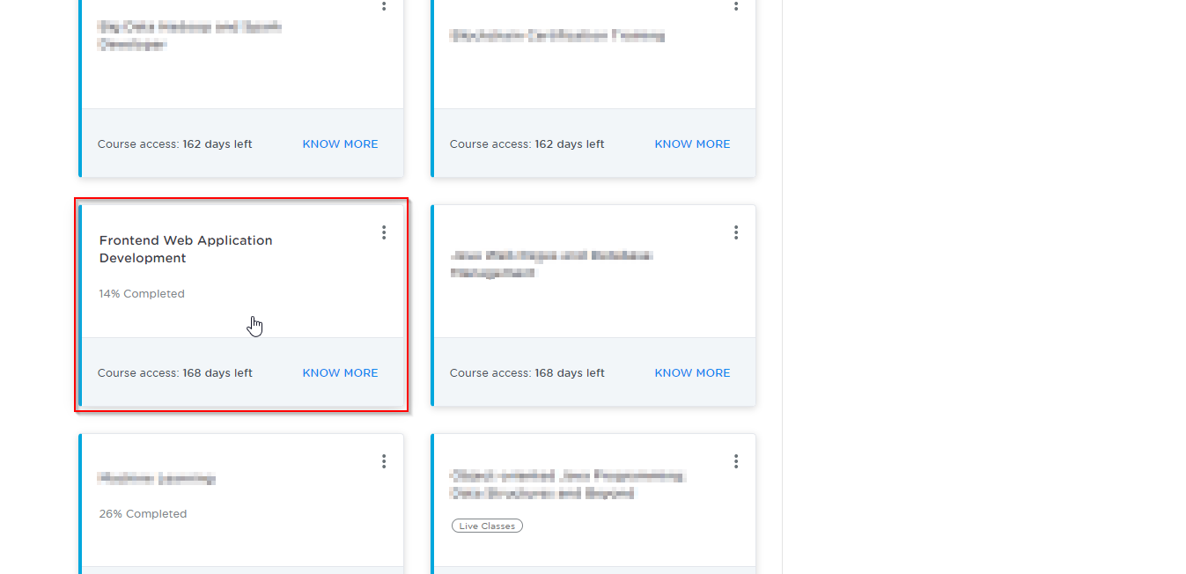

* On the left, you will find the course ToC page
* To its left, you will find the **PRACTICE LABS** tab
* Click on it

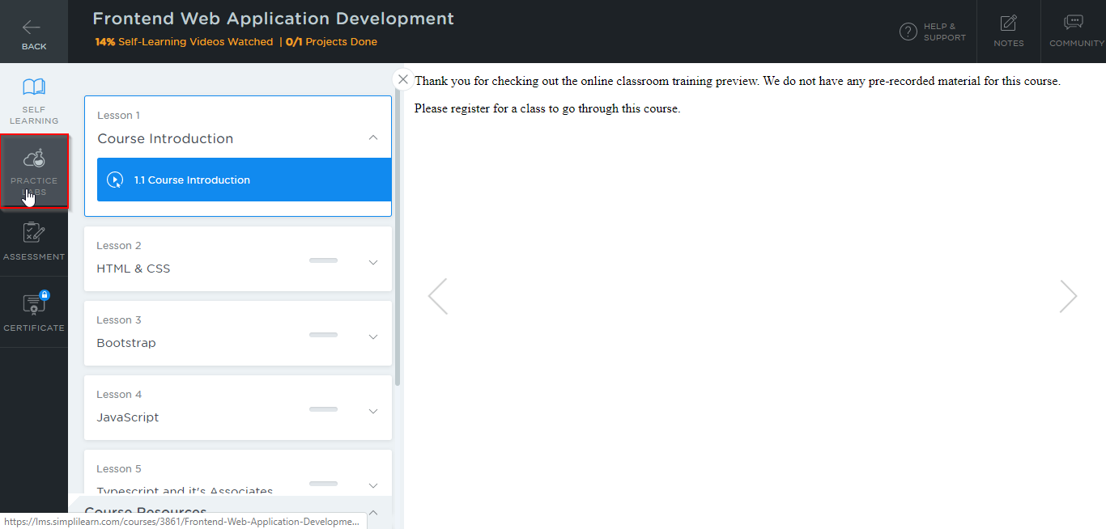

* As a new window opens, read the instructions and click on **LAUNCH LAB**
* This will launch the practice labs for this course

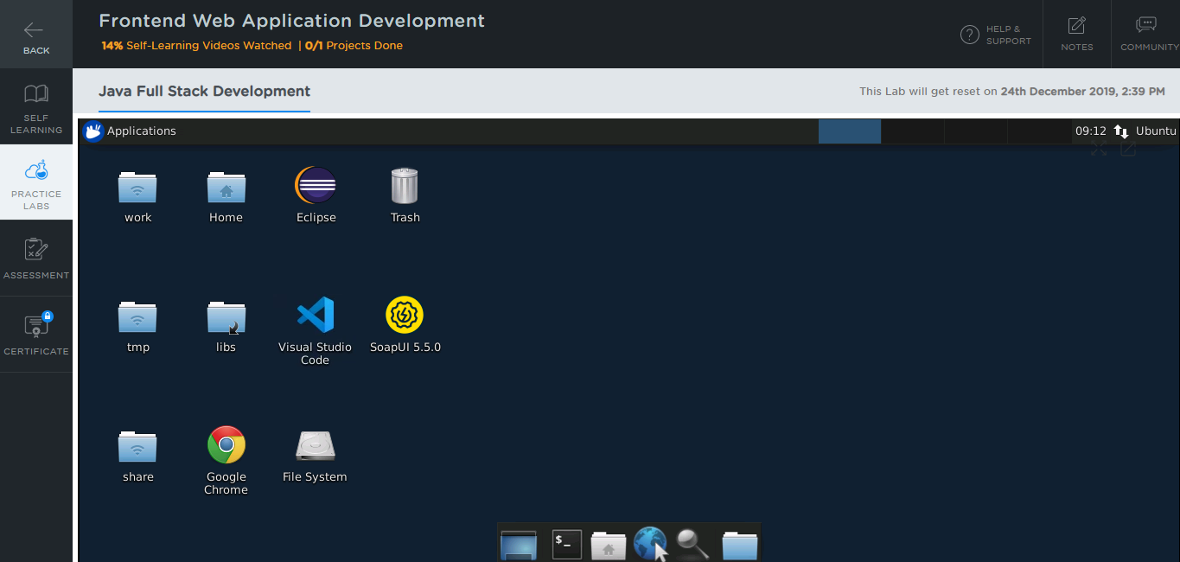

**Step 2:** Using different IDEs and software required for Phase 4

All the required IDEs and software can be accessed from the labs

**Visual Studio Code:**

* Visual Studio Code is already installed in your practice labs
* You can launch it by clicking on the **visual studio code** icon on your desktop

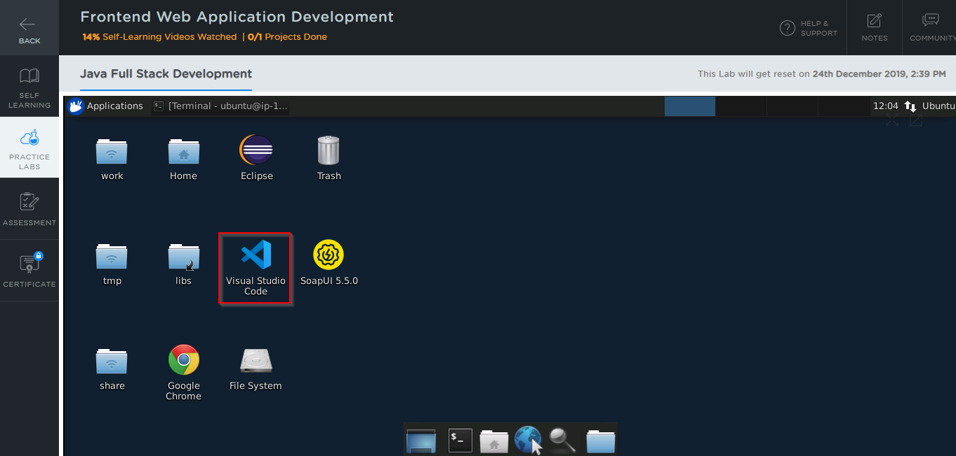

**Node JS:**

* Node JS 12.18.2 version is installed in your practice labs
* To verify the installation:
  + Open the command-line interface
  + Type the command:

*node -v*

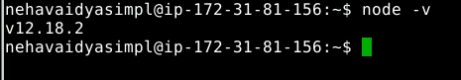

The command mentioned above displays the Node JS version installed in your practice lab

* If Node JS is not installed in your practice lab, you can install it using the commands:

*sudo apt-get update*

*sudo apt-get install nodejs*

**Jasmine:**

* Jasmine has been installed in your practice lab using *npm*
* To verify the installation:
  + Open the command-line interface
  + Type the command:

*jasmine version*

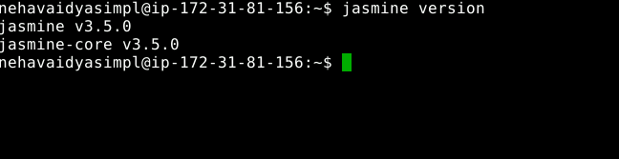

* If Jasmine is not installed in your practice lab, you can install it using the command:

*npm install -g jasmine*

**Angular:**

* Angular has been installed in your practice labs using *npm*
* To verify the installation:
  + Open the command-line interface
  + Type the command:

*ng --version*

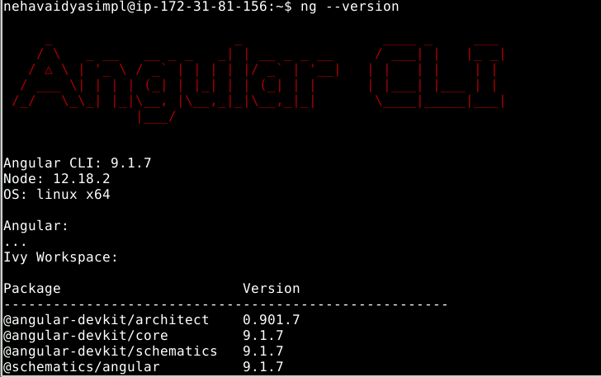

* In case Angular is not installed in your practice lab, you can install it using the command:

*npm install -g @angular/cli*

**MongoDB:**

* To verify the installation:
  + Open the command-line interface
  + Type the command:

*mongod --version*

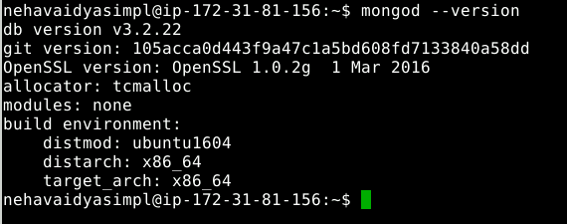

* In case MongoDB is not installed in your practice lab, you can install it using the commands:

*sudo apt-get update*

*sudo apt-get install -y mongodb-org*