**Testing a Full Stack Application**

FSD: Lab Guide - Phase 5



This section will guide you to:

* Use practice labs to execute all demos included in this course

This lab has two subsections, namely:

1. Starting practice labs on LMS
2. Using different IDEs and software required for Phase 5

**Step 1:** Starting practice labs on LMS

* Login to Simplilearn LMS
* Navigate to the respective course and click on it

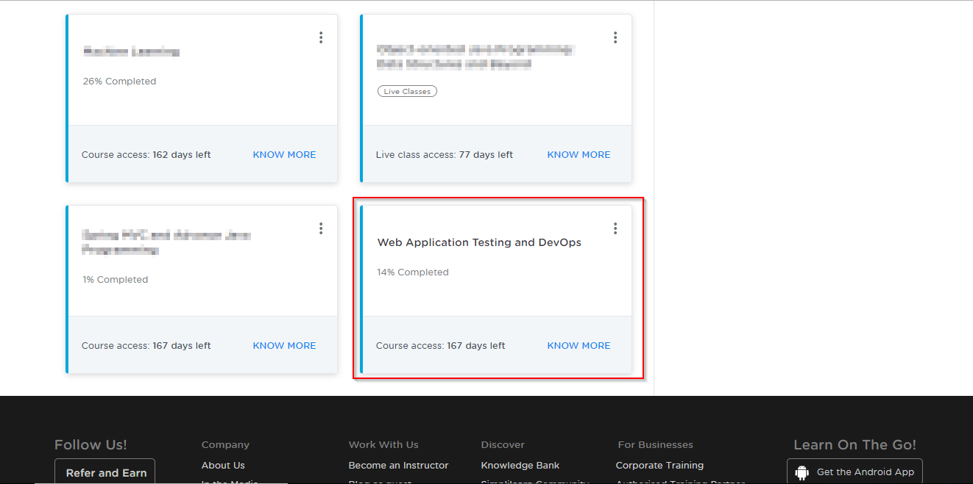

* On the left, you will find the course ToC page
* To its left, you will find the **PRACTICE LABS** tab
* Click on it

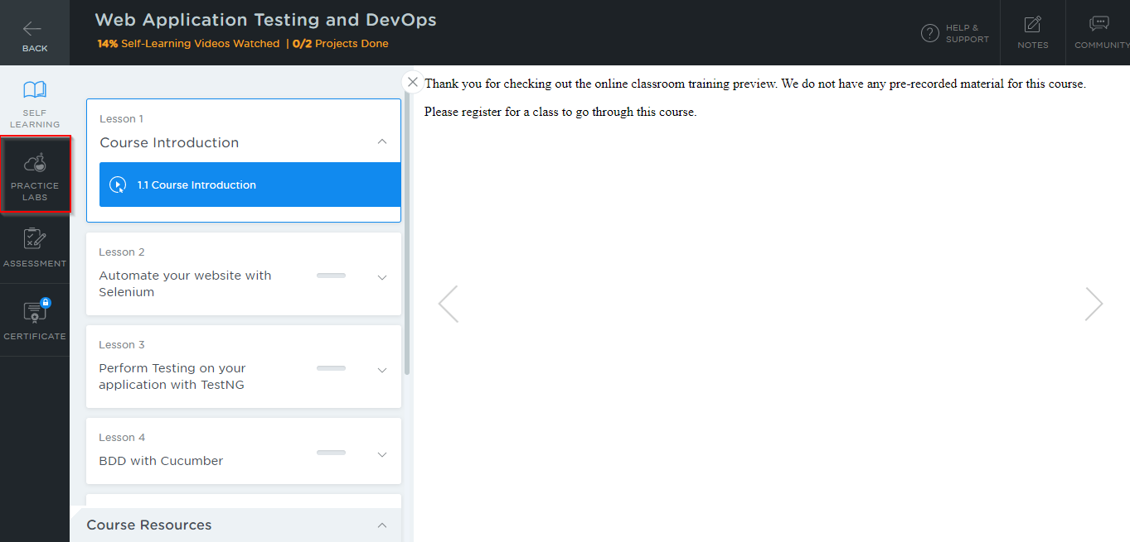

* As a new window opens, read the instructions and click on **LAUNCH LAB**
* This will launch the practice labs for this course

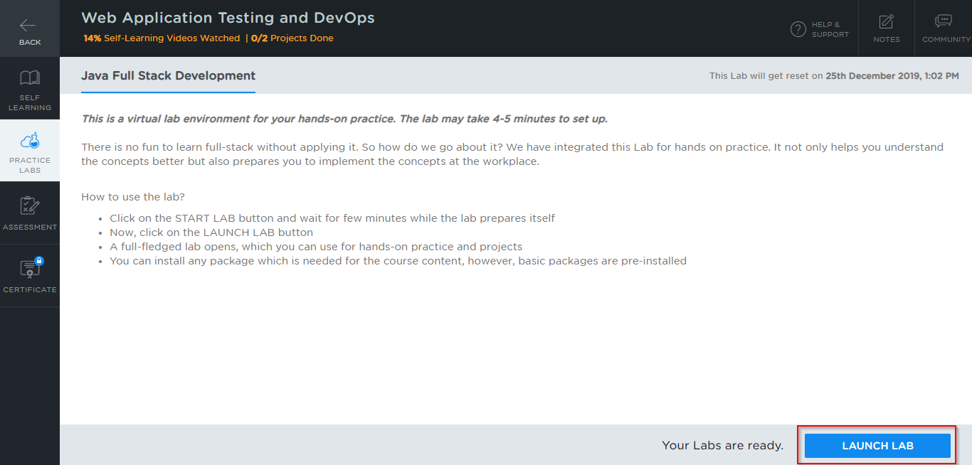

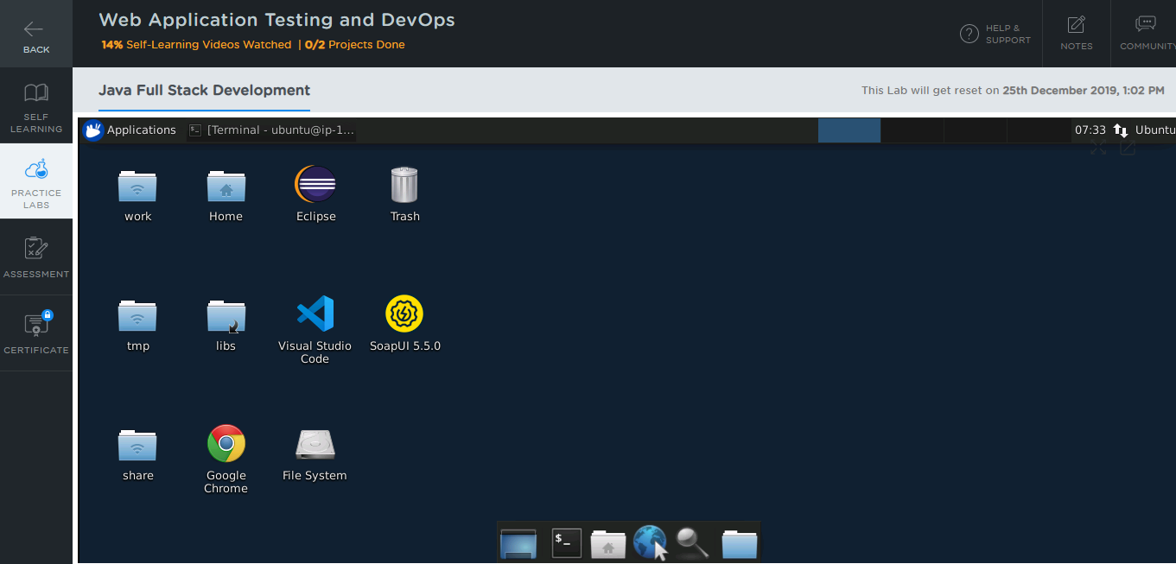

**Step 2:** Using different IDEs and software required for Phase 5

All the required IDEs and software can be accessed from the labs

**Selenium:**

* You will find Selenium in the directory *home/ubuntu/libs* which is shown in the screenshot below:

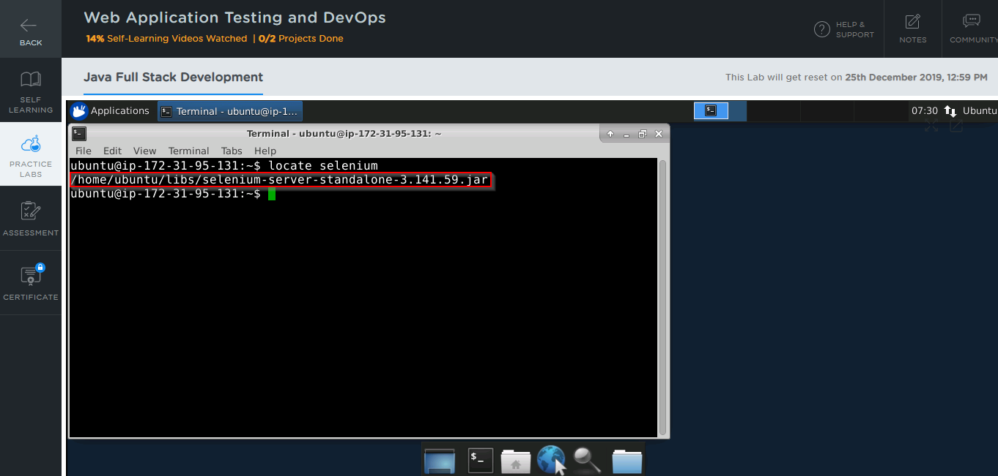

* In case Selenium is not installed in your practice lab, you can install it using the command:

*sudo npm install selenium-standalone@latest -g*

**TestNG:**

* TestNG is installed as an Eclipse plugin in your practice lab
* To verify the installation:

1. Open the Eclipse environment from your desktop
2. Click the **Help** tab and select **Install New Software**

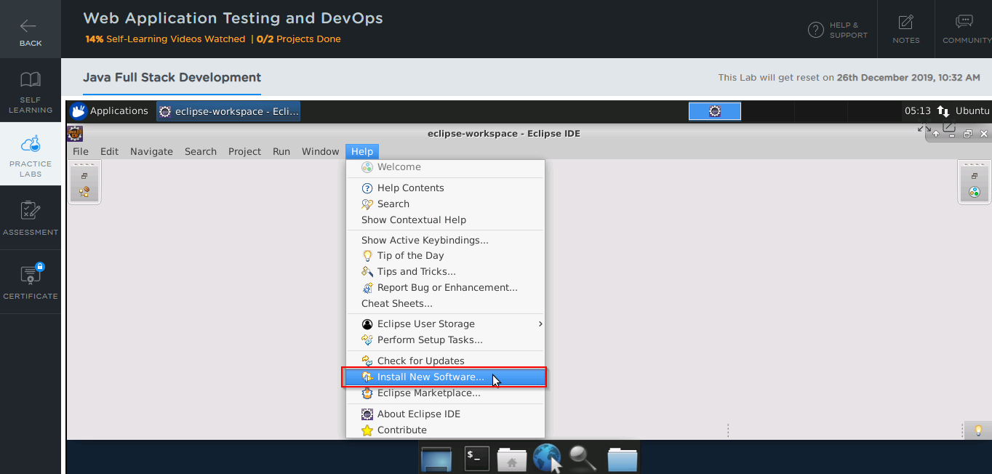

1. In the next window, click on **Already Installed**

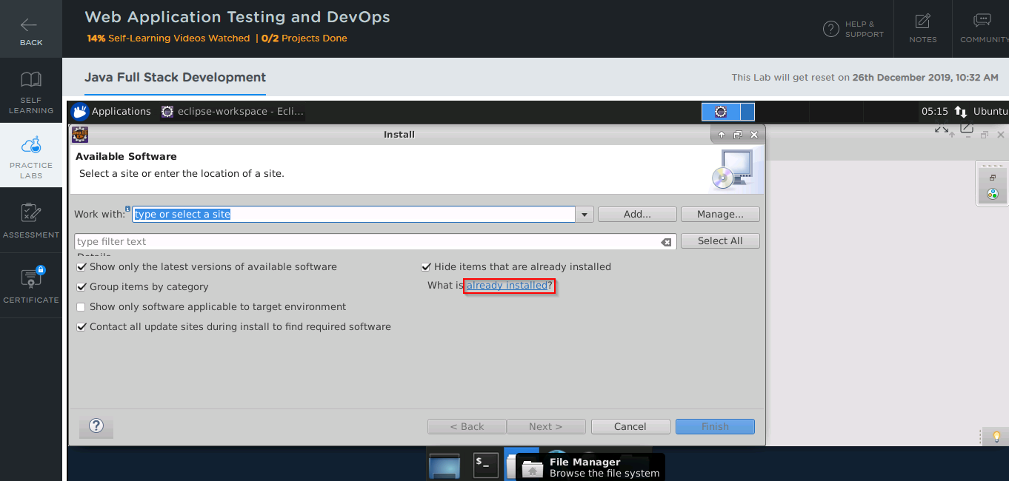

1. In the **filter text** field, type **TestNG**

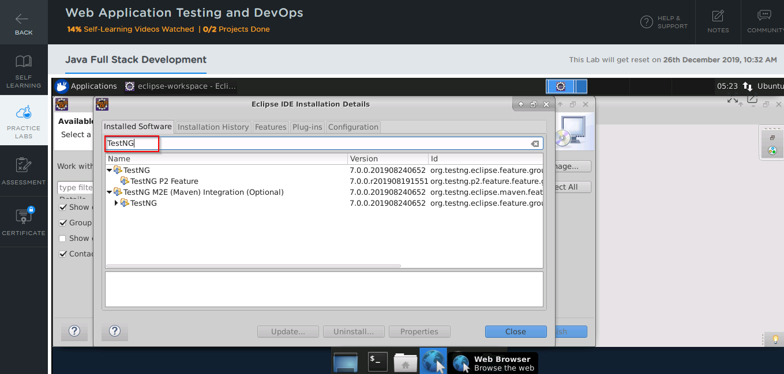

* In case TestNG is not installed in your practice lab, you can install it following these steps:

1. Open the Eclipse environment from your desktop, navigate to the **Help** tab, and click on **Eclipse Marketplace**

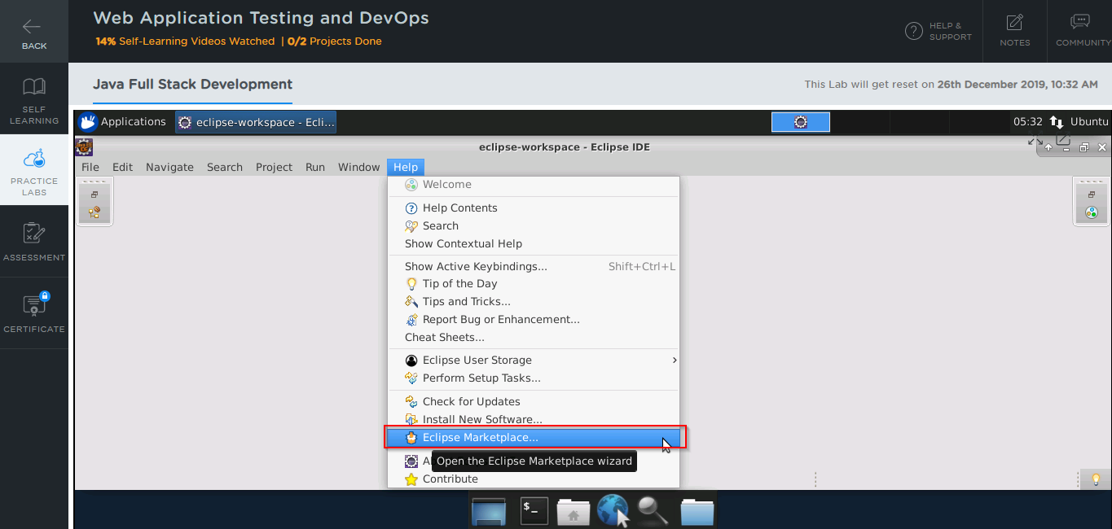

1. Type **TestNG** in the **Find** field and click on **Go**

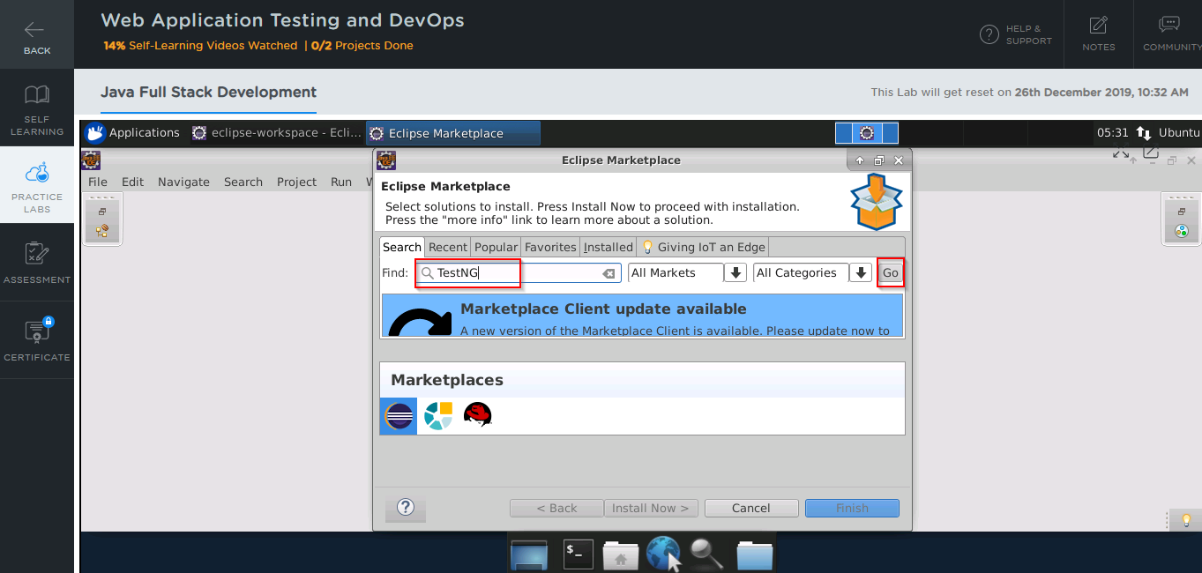

1. In the next window, you will see the TestNG tool
2. Click on the **Install** button to start the installation

**Jenkins:**

* Jenkins is already installed in your practice lab
* You will find it in the directory */usr/share*
* Use the following commands to navigate to the above-mentioned directory

*cd /usr/share*

*ls*

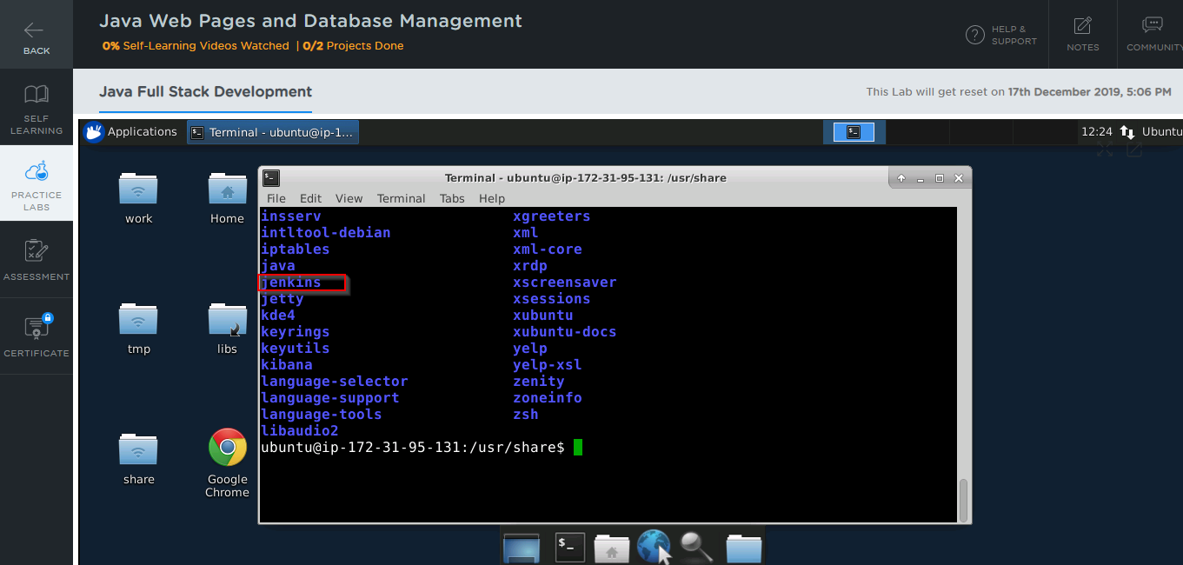

* In case Jenkins is not installed in your practice lab, you can install it using the commands:

*sudo apt update*

*sudo apt install jenkins*

**Cucumber:**

* Cucumber is installed as an Eclipse plugin in your practice lab
* To verify the installation:

1. Open the Eclipse environment from your desktop
2. Click the **Help** tab and select **Install New Software**



1. In the next window, click on **Already Installed**



1. In the **filter text** field, type **Cucumber**

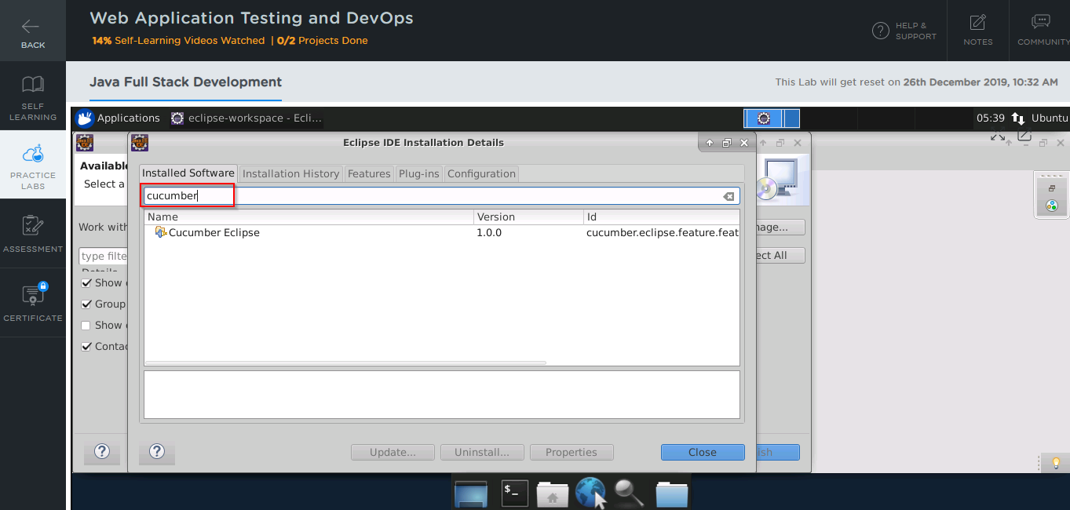

* In case Cucumber is not installed in your practice lab, you can install it following these steps:

1. Open the Eclipse environment from your desktop, navigate to the **Help** tab, and click on **Eclipse Marketplace**



1. Type **Cucumber** in the **Find** field and click on **Go**
2. In the next window, you will see the Cucumber tool
3. Click on the **Install** button it to start the installation

**Docker:**

* Docker version 18.09.7 is already installed in your practice lab
* To verify the installation:

1. Open the command-line interface
2. Type the command:

*docker --version*

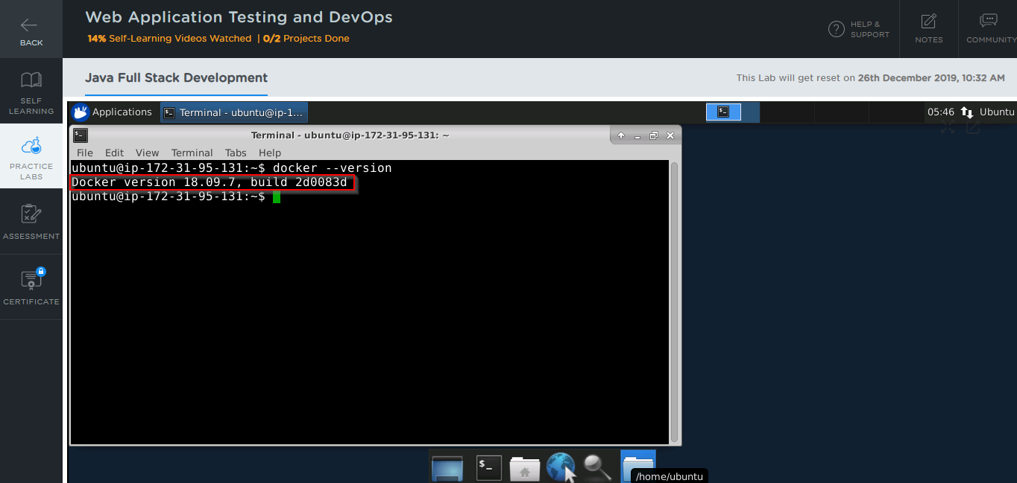

* In case Docker is not installed in your practice lab, you can install it following these steps:

1. Set up the Docker repository using the following commands:

*sudo apt-get update*

*sudo apt-get install apt-transport-https ca-certificates curl software-properties-common*

*curl -fsSL https://download.docker.com/linux/ubuntu/gpg | sudo apt-key add -*

*sudo add-apt-repository "deb [arch=amd64] https://download.docker.com/linux/ubuntu $(lsb_release -cs) stable"*

1. Install Docker using the command:

*sudo apt-get install docker-ce*

**Kubernetes:**

* Kubernetes is already installed in your practice lab
* To verify the installation:

1. Open the command-line interface
2. Type the command:

*Kubeadm version*

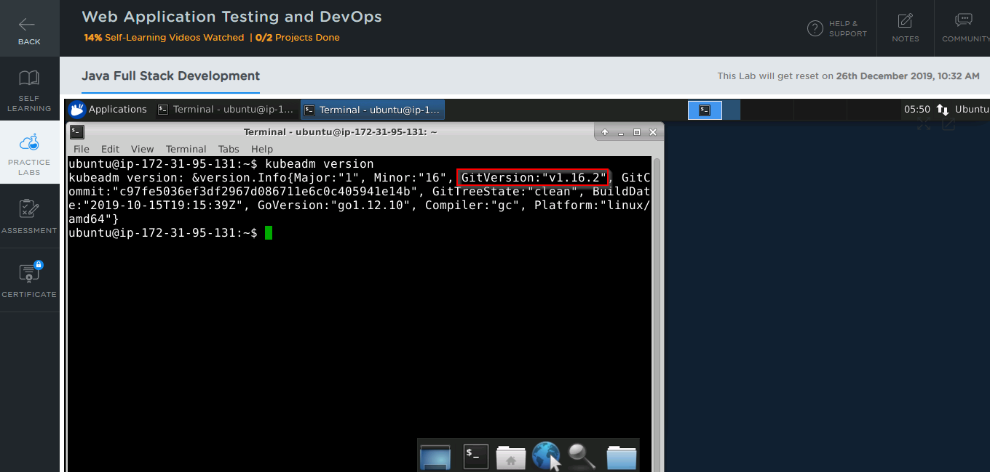

* In case Kubernetes is not installed in your practice lab, you can install it following these steps:

1. Set up the repository using the following commands:

*curl -s https://packages.cloud.google.com/apt/doc/apt-key.gpg | apt-key add -*

*echo 'deb http://apt.kubernetes.io/ kubernetes-xenial main' | sudo tee*

*/etc/apt/sources.list.d/kubernetes.list*

1. Install Kubernetes using the command:

*sudo apt-get install kubelet kubeadm kubectl -y*