ASSIGNMENT N° 2  **| Calatayud, Alex Gabriel**

**A. GENERAL EXERCISES**

**1. Write each verb with the correct -*s*, -*es*, or -*ies* ending.**

|  |  |
| --- | --- |
| 1. study ***studies***  2. fish ***fishes***  3. pass ***passes***  4. worry ***worries***  5. explore ***explores***  6. bite ***bites***  7. buy ***buys*** | 8. help ***helps*** 9. miss ***misses*** 10. fly ***flies***  11. fix ***fixes***  12. watch ***watches***  13. like ***likes***  14. pay ***pays*** |

**2. Underline the correct form of the verb to complete each sentence**.  
1. A video game developer write / writes code for games.  
2. Frank study / studies English at university  
3. A system maintenance officer **keep /keeps** the systems going.  
4. Video game designers design / designs games for different formats, for example, game consoles.  
5. A game development team usually **have / has** a lead designer.

7. Lead designers coordinate / coordinates the work of the other designers in the team.   
6. We code / codes in C++.  
7. Our office close / closes at 7:00 p.m.  
8. She take / takes classes at the business school.  
10. I start / starts work at 8:00 a.m. every morning.

**3. Make these sentences negative.**

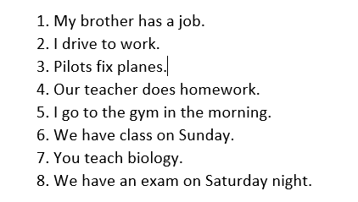

1. My brother doesn't have a job.

2. I don't drive to work.

3. Pilots don't fix planes.

4. Our teacher doesn't do homework.

5. I don't go to the gym in the morning.

6. We don't have class on Sunday.

7. You don't teach biology.

8. We don't have an exam on Saturday night.

**3. Complete each sentence with the correct form of the verb in parentheses.**  
1. A game programmer develops (develop) video games software.  
2. Computer programmers write (write) software.  
3. Photographers take (take) photos.  
4. 3D artists produce (produce) 3D models and animation.  
5. An art director manages (manage) the art team.  
6. Sound engineers are (be) responsible for sound effects.   
7. A level designer creates (create) levels, missions or challenges for video games.   
8. A writer writes (write) books.

**b. READING COMPREHENSION AND GRAMMAR**

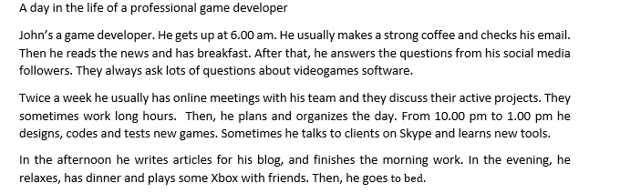

1. 1. Read the list of verbs in the chart. Who does each action? Check (✓) the correct column.

|  |  |  |  |
| --- | --- | --- | --- |
| Verbs | John | His social media followers | John and his team |
| Makes | ü |  |  |
| reads | ü |  |  |
| Answers | ü |  |  |
| ask |  | ü |  |
| has |  |  | ü |
| discuss |  |  | ü |
| work |  |  | ü |
| designs, codes and tests | ü |  |  |

2. Read again and complete the table;

|  |  |  |
| --- | --- | --- |
| Things John does in the morning | Things John does in the afternoon | Things John does in the evening |
| **Gets up at 6.00 am** | Writes articles for his blog. | Relaxes has dinner and plays some Xbox friends. |
| Makes a strong coffee and hecks his email. | Finishes the morning work. | Go to bed. |
| Reads the news and has breakfast. |  |  |
| Answers Questions. |  |  |
| Designs, codes and tests new games.  Sometimes he talks to clients  On Skype and learns new tools. |  |  |

1. Are these sentences about John true or false? Correct the false sentences.
2. John gets up early. **True**
3. He never drinks coffee. **False**
4. His social media followers rarely ask him questions. **False**
5. John has online meetings with his team twice a week. **True**
6. He sometimes talks to clients on Zoom. **False**
7. Make 2 yes/no and 2WH questions about John.

**Yes/No Questions:**

1. Does John enjoy playing Xbox with friends in the evening?
2. Is John responsible for designing, coding, and testing new games?

**WH Questions:**

1. What does John do in the morning before checking his email?
2. When does John have online meetings with his team?