**Python Program to** **Display the multiplication Table**

**Purpose of program:**

This program can help people to:

1. Directly show the multiplication table with specific numbers, make the calculation more efficiency.
2. The process of simplifying repeated calculation of multiply with the same number. Use this program in some teaching scene.

**Target users:**

The students can use this program to reduce the work in calculation*.* Moreover, this program can help teachers in teaching. They have this program, it will double their working efficiency. Some parents can use this to teach their children in home without paper, and also can help their children to get familiar to operate some function of the computer.

**How will they use the program?**

When user run this program, it will ask user to input the table number(integer) to multiply, the low bound and the high bound. When user input wrong type of variable such as "@" and "abc", they’ll get an error message: "Please Enter Appropriate Values". After typing the number and clicked "Make Table" button, computer will output the result and a message to users " Is your multiplication correct? ". Hence, if users click the "Yes" button, computer will output a message randomly from "Correct!", "Good One!", "Well done!". In opposite, if users click the “No” button, computer will output a message to users "Do it again.", "Sorry.", "Wrong."

**Which is the programming language?**

This program using python 3.2 to create. IDLE 3.5 to edit. Python is easy to learn for even a novice developer. Its code is easy to read and you can do a lot of things just by looking at it. Also, you can execute a lot of complex functionalities with ease, thanks to the standard library.

**Variables Table:**

|  |  |  |  |
| --- | --- | --- | --- |
| **Name** | **Type** | **Scope** | **Description** |
| num | Integer | multiply_table | Get number from users’ input |
| low_bound | Integer | multiply_table | Get low bound from users’ input |
| high_bound | Integer | multiply_table | Get high bound from users’ input |
| mt_result | Integer | multiply_table | Create a table result |
| i | Integer | multiply_table | Use "i" to loop and multiply |
| rtable | Integer | righttable | Random number chose from the list 0, 1, 2 |
| wtable | Integer | wrongtable | Random number chose from the list 0, 1, 2 |

**Class Table**

|  |  |  |  |
| --- | --- | --- | --- |
| **Class Name** | **Type** | **Scope** | **Description** |
| Application (Frame) | class | global | Application Class for the complete program |

**List Table**

|  |  |  |
| --- | --- | --- |
| **Type** | **Scope** | **Description** |
| rtablelist | righttable | Storing three list values in rtablelist and displays when users get right result |
| wtablelist | wrongtable | Storing three list values in wtablelist and displays when users get wrong result |

**Testing Table**

|  |  |  |  |
| --- | --- | --- | --- |
| **Input** | **Expected Result** | **Actual Result** | **Test Result** |
| num = 3  low_bound = 1  high_bound = 4 | Make Table:  3×1=3  3×2=6  3×3=9  3×4=12 | 3×1=3  3×2=6  3×3=9  3×4=12 | Passed |
| num = 5  low_bound = 2  high_bound = 5 | Make Table:  5×2=10  5×3=15  5×4=20  5×5=25 | 5×2=10  5×3=15  5×4=20  5×5=25 | Passed |
| num = 7  low_bound = 3  high_bound = 6 | Make Table:  7×3=21  7×4=28  7×5=35  7×6=42 | 7×3=21  7×4=28  7×5=35  7×6=42 | Passed |

**Subroutine Table**

|  |  |
| --- | --- |
| **Subroutine Name** | **Description** |
| multiply_table | Creates a display multiplication table subroutine |
| righttable | Creates a subroutine that displays comments when users get the right answer |
| wrongtable | Creates a subroutine that displays comments when users get the wrong answer |

**Program Sketch**

**Multiplication Table**

**Quit**

**Make Table**

**Input the High bound (Integer):**

**Input the Low bound (Integer):**

**Input the table number (Integer):**

**Program Code Screenshot – Explanation:**

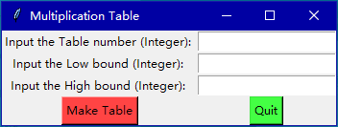

This is main GUI for the program. The progress of the program goes like the following.

1. First, user input all the number.

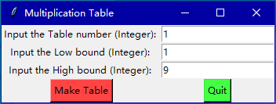

1. Click “Make Table”, then the program will calculate the result of the multiplication and display down below.

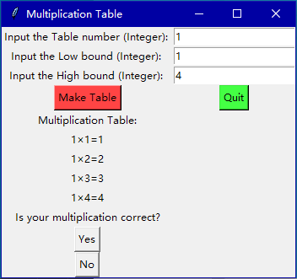

1. Programs among will give you a question "Is your multiplication correct?" If you click button "Yes", it will show the sentences randomly like below ("Correct!", "Good One!", "Well done!").

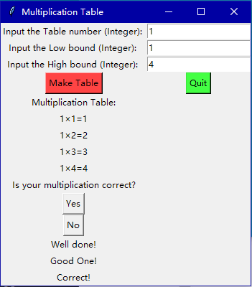

If users click button "No", it will show the sentences randomly like below ("Sorry.", "Do it again.", "Wrong.").

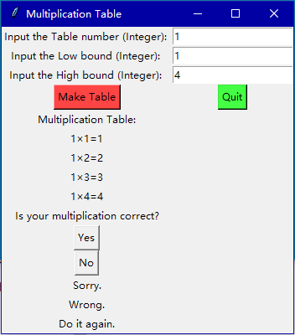

1. When users want to finish the program, they can click the button “Quit” to stop it

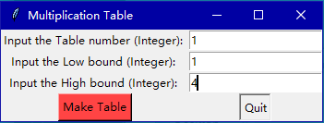

**Program Code – Screenshot:**

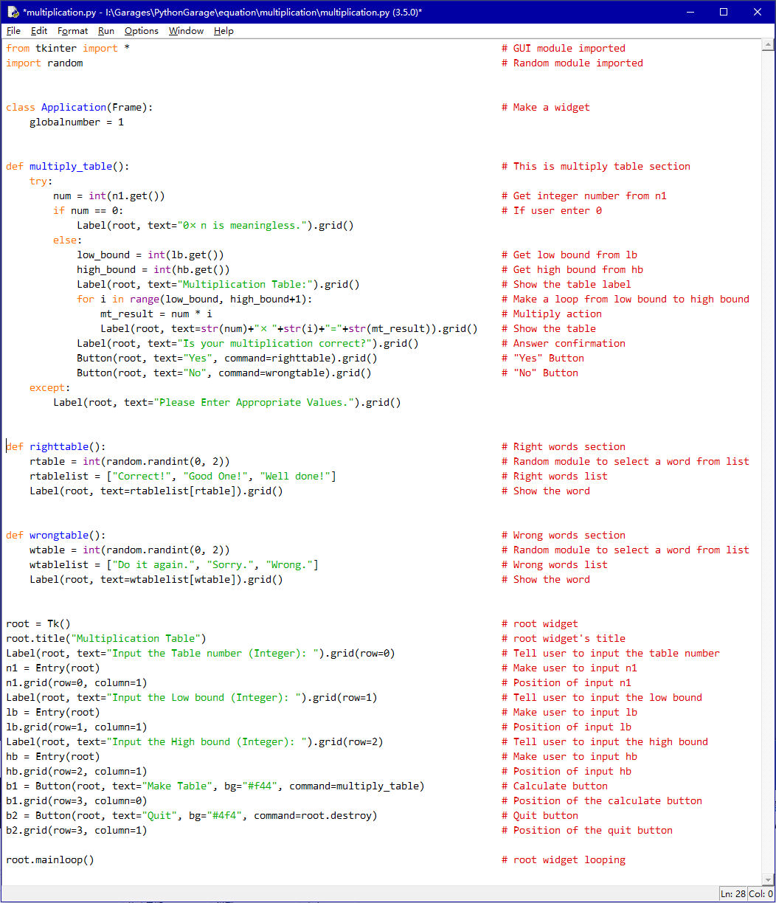

**Program Code:**

from tkinter import * # GUI module imported

import random # Random module imported

class Application(Frame): # Make a widget

globalnumber = 1

def multiply_table(): # This is multiply table section

try:

num = int(n1.get()) # Get integer number from n1

if num == 0: # If user enter 0

Label(root, text="0×n is meaningless.").grid()

else:

low_bound = int(lb.get()) # Get low bound from lb

high_bound = int(hb.get()) # Get high bound from hb

Label(root, text="Multiplication Table:").grid() # Show the table label

for i in range(low_bound, high_bound+1): # Make a loop from low bound to high bound

mt_result = num * i # Multiply action

Label(root, text=str(num)+"×"+str(i)+"="+str(mt_result)).grid() # Show the table

Label(root, text="Is your multiplication correct?").grid() # Answer confirmation

Button(root, text="Yes", command=righttable).grid() # "Yes" Button

Button(root, text="No", command=wrongtable).grid() # "No" Button

except:

Label(root, text="Please Enter Appropriate Values.").grid()

def righttable(): # Right words section

rtable = int(random.randint(0, 2)) # Random module to select a word from list

rtablelist = ["Correct!", "Good One!", "Well done!"] # Right words list

Label(root, text=rtablelist[rtable]).grid() # Show the word

def wrongtable(): # Wrong words section

wtable = int(random.randint(0, 2)) # Random module to select a word from list

wtablelist = ["Do it again.", "Sorry.", "Wrong."] # Wrong words list

Label(root, text=wtablelist[wtable]).grid() # Show the word

root = Tk() # root widget

root.title("Multiplication Table") # root widget's title

Label(root, text="Input the Table number (Integer): ").grid(row=0) # Tell user to input the table number

n1 = Entry(root) # Make user to input n1

n1.grid(row=0, column=1) # Position of input n1

Label(root, text="Input the Low bound (Integer): ").grid(row=1) # Tell user to input the low bound

lb = Entry(root) # Make user to input lb

lb.grid(row=1, column=1) # Position of input lb

Label(root, text="Input the High bound (Integer): ").grid(row=2) # Tell user to input the high bound

hb = Entry(root) # Make user to input hb

hb.grid(row=2, column=1) # Position of input hb

b1 = Button(root, text="Make Table", bg="#f44", command=multiply_table) # Calculate button

b1.grid(row=3, column=0) # Position of the calculate button

b2 = Button(root, text="Quit", bg="#4f4", command=root.destroy) # Quit button

b2.grid(row=3, column=1) # Position of the quit button

root.mainloop() # root widget looping

**Flow Chart:**

Start

Subroutine: Main

Import GUI

Class Application

wrongtable

righttable

multiply_table

Functions

Main

Label: table number, low bound, high bound

Start loop

multiply_table

Integer n1, Integer lb,

Integer hb

Meaningless

No

If num == 0

Yes

mt_result = num * i

Return

Button: “Yes”

Button: “No”

Display:” Is your multiplication correct?”

Display: mt_result

Quit

End

Create: wtablelist

Import random function

wrongtable

righttable

Import random function

Create: rtablelist

Display: rtablelist[rtable]

Display: wtablelist[wtable]

Return

Return