Direct Partners
Data Analytics

Project Handbook

Candidate Name | Alex Vasile
Assessor Name
Start Date | 06/07/2026
End Date

Stage | Complete? | Uploaded Date.
- Planning
- Management |  | Not required.
- Analysis
- Presentation
- Evaluation

Welcome to your final project for the Diploma in Digital Technology: Data Analytics (SCQF Level 8).

This handbook is your primary project document. It is designed to be a single, complete guide that supports you through your project and provides the evidence required to demonstrate achievement of the qualification.

You should treat this handbook as:
- Your project planning and delivery record
- Your assessment evidence
- A professional portfolio demonstrating how you apply data analytics skills in a real organisational context

You will complete this document as you progress through your project and upload it, along with any supporting materials, at the points agreed with your assessor.

This final project is a holistic assessment. Rather than assessing units in isolation, the project brings together the knowledge, skills, and behaviours developed across the award.

Each project stage aligns to specific mandatory units within the qualification. By completing all stages of the project and providing appropriate evidence, you will demonstrate achievement of all required units. This project is designed so that your work across the five stages collectively meets the qualification requirements.

How to Use This Handbook

Each stage of the handbook follows a consistent structure:
- Purpose of the stage – what this stage is intended to demonstrate
- Guiding questions – prompts to help you structure your work
- Mandatory evidence – what you must include for assessment
- Reflection – your evaluation of challenges, decisions, and learning

Stages 1, 4 and 5 contain mandatory questions. These must be completed and evidenced. Other questions are supportive prompts to help you think critically about your work and strengthen your submission. If a question is not relevant to your specific project, you should briefly explain why.

Throughout the handbook, you are expected to include supporting evidence, such as:
- Screenshots (e.g. tools, workflows, dashboards, code, project boards)
- Diagrams (e.g. data models, pipelines)
- Links to repositories, dashboards, or reports
- Brief extracts from working documents (where appropriate)

Your evidence should demonstrate:
- What you did
- Why you made key decisions
- How you worked professionally and securely with data

This handbook is not just about the final output. Your process, decision-making, and reflection are equally important. If you are unsure about any aspect of your project or this handbook, contact your assessor as early as possible. You are encouraged to use:
- Regular check-ins
- Sprint reviews and retrospectives
- Feedback from mentors or colleagues

This will help ensure your project remains on track and aligned with the qualification expectations.

Stage 1: Planning

The purpose of Stage 1 is to ensure that your project is well defined, feasible, and compliant before you begin your analysis.

In this stage you will:
- Identify a clear business or organisational problem
- Define the question(s) your project will address
- Identify and assess data sources
- Consider governance, ethics, and data protection
- Plan the tools, structure, and outputs of your project

This stage ensures that your project is appropriately scoped and aligned with organisational and legal requirements before moving into delivery.

Evidence from this stage primarily contributes to the following mandatory units:
- Planning Data Analysis
- Locating and Accessing Data Sources
- Managing Data Assets

Your responses and evidence in this stage will be used to demonstrate that you can plan a data analysis project responsibly, securely, and in line with organisational expectations.

What You Must Submit for This Stage

To complete Stage 1, you must include:
- A clear description of the business problem and its impact
- Defined project questions or objectives
- Evidence of data source identification and access permissions
- Consideration of risks, governance, and data protection
- A proposed data structure or model
- A description of tools and technologies you plan to use
- Reflection on challenges and learning during the planning process

Supporting evidence (screenshots, diagrams, links) must be embedded where relevant.

Part 1 – Question and Answer with Supporting Evidence

Answer the following questions and include supporting evidence where appropriate.

- What is the business or organisational problem you will be addressing in this project, and how will your project relate to the digital economy or digital transformation within your organisation or sector?
  - State the clear problem you are trying to address.
  - Explain what digital transformation means in your organisational context and why this project represents digital improvement rather than a purely operational change.

(a) Clear problem statement
HMRC's compliance directorate works to identify and recover tax that would otherwise be lost to the Exchequer. A key challenge in this work is understanding which industry sectors carry the greatest compliance risk, where the gap between tax theoretically owed and tax collected is largest relative to the size of that sector's economic activity. Currently, the data needed to answer this question exists across multiple separate published statistical releases: compliance yield figures broken down by customer segment, Corporation Tax liabilities by industry sector, and Companies House registration data showing the population and health of businesses by sector. These datasets are never combined into a single integrated view, which means analysts and compliance managers cannot easily ask cross-cutting questions such as: "Which sectors generate the most yield per investigation?", "Are certain sectors over- or under-represented in compliance activity relative to their economic footprint?", or "How has sector-level compliance risk shifted over the last decade?" This project addresses that gap by building a relational database which brings these datasets together for the first time in a structured, easy to query form and produces a dashboard that presents the findings visually.

(b) Digital transformation context
HMRC published its Transformation Roadmap in July 2025, setting out its ambition to become a digital-first organisation by 2030, with at least 90% of customer interactions taking place digitally and a strategic commitment to closing the tax gap using improved data and analytics capabilities. One of the Roadmap's stated priorities is the use of better data, including third-party and open data, to target compliance resource more effectively. This project directly supports that strategic direction. Rather than manually cross-referencing spreadsheets from separate GOV.UK publications, this project aggregates open data into a clean relational model, enabling repeatable SQL-driven analysis and a live dashboard. This is a digital improvement rather than an operational one because it creates a reusable data asset and analytical workflow that did not previously exist. Any analyst could update the database with the following year's data releases and regenerate the dashboard without starting from scratch, embedding data-driven insight into the compliance planning process rather than treating it as a one-off exercise.

- Which existing business/organisational process does this project relate to? How did you identify the need to address this problem?
  - Describe the current “as-is” process and where the data/digital technology fits into that process.
  - If this arose from your own role, how did you confirm with colleagues or stakeholders that it was a wider issue?
  - Include evidence such as emails, notes, screenshots, or meeting summaries.
(a) Current "as-is" process
Currently, analysts wishing to understand sector-level compliance risk must manually download individual Excel/ODS spreadsheet releases from GOV.UK, the Measuring Tax Gaps publication, the Corporation Tax Statistics publication, and the compliance yield technical notes published alongside HMRC's Annual Report. These files use different column structures, different sector classification schemes, and different reference years. Joining them to produce a cross-cutting view requires manual reformatting in Excel, with no reproducible audit trail. There is no shared database, no single source of truth, and no visual dashboard through which compliance managers can explore sector-level trends.
(b) Stakeholder confirmation
It did not arise from my own role because we tend to make internal reports only in my role. Whereas we have reporting analysts within CCG that create the open data I shall be using.
(c) Haven’t had a discussion with the reporting analysts as we are not on the same team. I’ve only had confirmation from my manager who will stand as my reference.

- What change would be required for your organisation to adopt the outcomes of this project?
  - Consider who would need to change how they work, what systems might be affects and any barriers to adoption.

For the outcomes of this project to be adopted, the following changes would be needed: Compliance planning teams would need to move from relying on individual published spreadsheets to using the integrated database as their primary reference for sector-level risk data. This would require the database to be hosted somewhere accessible, for example on a shared drive, or migrated into an internal system. The dashboard output would need to be either hosted on an internal server or distributed as a packaged HTML file. Barriers to adoption include HMRC's strict information security controls around approved software and data storage and the fact that open data is often structured inconsistently between annual releases requiring manual mapping updates.

- Where will you source the data required for this project?
  - Have you conducted a risk assessment of your planned data gathering?
  - Provide evidence.

The project will use the following five open datasets, all published under the Open Government Licence (OGL v3.0), which permits free reuse for any purpose including analysis and publication:

Source 1 - HMRC Measuring Tax Gaps 2025: https://www.gov.uk/government/statistics/measuring-tax-gaps
Content: Annual tax gap estimates broken down by tax type (VAT, Income Tax, Corporation Tax etc.), customer segment (individuals, small businesses, large businesses, criminals), and behaviour type (evasion, avoidance, error, non-payment). Time series from 2005-06 to 2023-24.
Source 2 - HMRC Compliance Yield Technical Note (2023-24): https://www.gov.uk/government/publications/hmrc-annual-report-and-accounts-2023-to-2024-technical-notes
Content: Compliance yield broken down by HMRC directorate (Large Business, Wealthy & Mid-Sized Business, Individuals & Small Business, Fraud Investigation Service) and by head of duty (Corporation Tax, VAT, PAYE, etc.). Published annually alongside HMRC's Annual Report.
Source 3 - HMRC Corporation Tax Statistics 2025: https://www.gov.uk/government/statistics/corporation-tax-statistics-2025
Content: Corporation Tax receipts and liabilities broken down by industry sector, company size, and financial year. Provides the economic footprint of each sector against which compliance yield can be benchmarked.
Source 4 - HMRC Tax by Different Customer Groups (technical note): https://www.gov.uk/government/publications/hmrc-annual-report-and-accounts-2023-to-2024-technical-notes
Content: Compliance yield and tax contributions broken down by HMRC's customer segments (large business, wealthy individuals, mid-sized business, small business, individuals/employees). Directly relevant to the project's customer segment analysis.
Source 5 - Companies House Free Company Data (bulk CSV): https://download.companieshouse.gov.uk/en_output.html
Content: Monthly snapshot of all live UK companies including company status, SIC code (industry classification), incorporation date, and dissolution date. Enables calculation of active company populations and dissolution rates by sector.

Risk Assessment:
Risk | Likelihood | Impact | Mitigation
Sector classification inconsistency across datasets (HMRC uses SIC divisions, Companies House uses individual SIC codes) | High | Medium | Create a sector mapping lookup table in DBeaver to standardise all sources to a common classification.
Annual data releases change format between years | Medium | Medium | Document column mappings explicitly in the data dictionary; re-check on each update.
Companies House bulk file is large (~700MB unzipped) and may be unwieldy | Medium | Low | Import only required columns (Company Status, SIC Code, Incorporation Date, Dissolution Date) during the ETL stage.
Tax gap data at customer-segment level is not always further broken down by sector | High | Medium | Use Corporation Tax sector data as the proxy for sector-level economic footprint; note this limitation in Stage 3.

- Do you have authorisation to access all required data?
  - If not, how will this be resolved?

Yes. All five datasets are published on GOV.UK under the Open Government Licence v3.0. This licence grants a worldwide, royalty-free, perpetual licence to use, adapt, and republish the information for any purpose, including commercial use, provided HMRC is acknowledged as the source.

- Have you modelled the desired structure of your data?
  - Provide a diagram or structured description.

I will attach the data dictionary file on Trello but here is an incomplete snapshot of it:

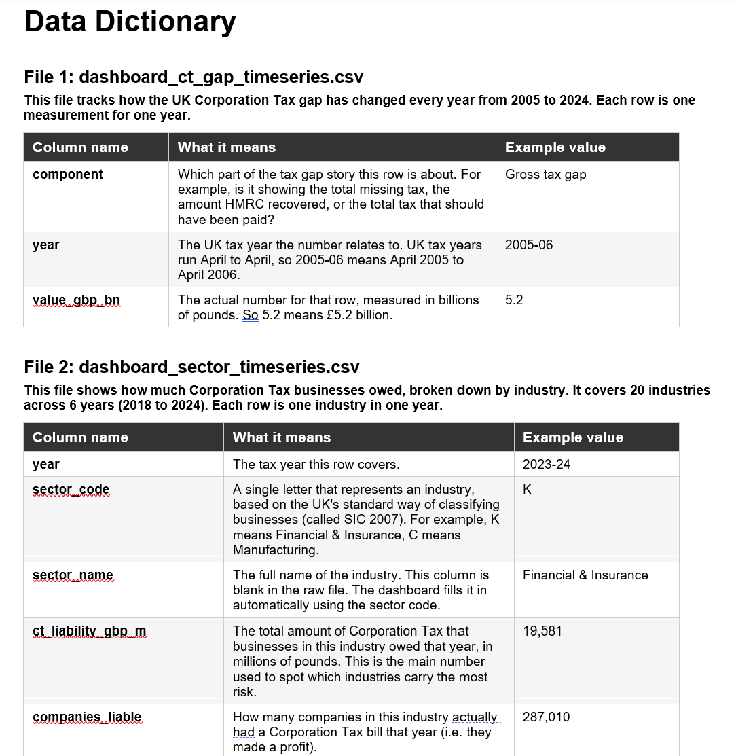

- What organisational policies must you follow when working with this data?
  - Include links where possible or explain the policy requirements.

As a HMRC employee, the following policies apply:

HMRC Acceptable Use Policy - governs use of IT systems and data handling. Even though this project uses publicly available data, work conducted on HMRC devices must comply with AUP restrictions on software installation and data storage locations.

Civil Service Code - requires honesty, integrity, objectivity, and impartiality. Any analytical conclusions drawn from this project must be presented honestly, with limitations acknowledged, and not used to support predetermined conclusions.

UK GDPR and the Data Protection Act 2018 - while all data used is anonymised aggregate statistics with no personal data, awareness of data protection obligations is required as a background principle. See Question 8 for the DPIA assessment.

Government Security Classifications - all data in this project is OFFICIAL (open published data). No SECRET or TOP SECRET data is involved. Storage and processing must be on appropriately classified systems.

Open Government Licence v3.0 - requires that HMRC is acknowledged as the data source in any published output. The dashboard will include appropriate attribution to all five data sources.

- How will you ensure the security of your data throughout the project?
  - Have you conducted a Data Protection Impact Assessment (DPIA) where required?
  - Are there any additional restrictions on how the data can be used (e.g. GDPR or contractual limitations)?

Security measures: The project database (managed in DBeaver) will be stored securely on my device. The final dashboard will be run locally and shared as a static export where required.
DPIA assessment: A formal DPIA is not required for this project because according to UK GDPR Article 35 and ICO guidance, a DPIA is required where processing is "likely to result in a high risk to the rights and freedoms of individuals." This project uses only published aggregate statistical data. There is no personal data, no individual-level data, no special category data, and no data subject whose rights could be affected. All five datasets are already in the public domain. No DPIA trigger applies.
Additional restrictions: The OGL requires source attribution but imposes no restrictions on analysis, adaptation, or republication of findings. There are no contractual limitations. The data contains no commercially sensitive third-party information.

- Beyond data protection, what legislation, regulations or organisational policies are relevant to the safe and responsible use of digital technology in this project?
  - This may include: IT acceptable use policies, health and safety considerations and/or sector-specific regulations.

Computer Misuse Act 1990 - all data is accessed via official public download pages. No scraping, unauthorised API access, or system intrusion is involved.
Statistics and Registration Service Act 2007 - several datasets used (e.g. Measuring Tax Gaps, Corporation Tax Statistics) are designated National Statistics or Official Statistics under this Act. Their use for research and analysis is entirely appropriate and consistent with their publication intent.

- What will be the final output of your project (e.g. dashboard, report, automated process)?
  - Why is this format appropriate for your audience?

The final output will be an interactive web dashboard built in Python using the Dash library, exported as an HTML file for distribution.
This format is appropriate for the intended audience, compliance managers and analysts because it presents complex multi-year, multi-dataset findings in a visual and interactive form without requiring the audience to have any SQL or coding skills. It is the method HMRC themselves use to showcase their ‘open to the public’ reports.
The format also demonstrates the full technical pipeline required by the qualification: data sourcing, cleaning, database design, SQL querying, and Python visualisation.

- What tools and technologies will you use during the project?
  - This may include programming languages, libraries, databases, project management tools, or visualisation platforms.
  - You may list tools you later decide not to use; this should be reflected on in Stage 5.

Dbeaver: A database management tool used to connect to, query, and manage databases through a graphical interface.
Python 3.x: A widely used programming language that supports data analysis, automation, and software development.
pandas: A Python library used for cleaning, manipulating, and analysing structured data.
PostgreSQL: An open-source relational database management system used to store and manage large datasets.
Plotly: A data visualisation library used to create interactive charts, graphs, and dashboards.
Trello: A project management tool that helps organise tasks, deadlines, and project progress using boards and cards.
VS Code (Visual Studio Code): A source code editor that provides tools for writing, debugging, and managing code efficiently.
HTML: The standard markup language used to create and structure content on web pages.
Jupyter Notebooks: An interactive development environment that allows users to write code, display outputs, create visualisations, and document their work in a single file.

Part 2 – Reflection

Reflect on your experience of the planning stage by addressing the following:

- What challenges did you face when identifying or refining your project topic?

The main challenge was scoping the project appropriately. Initial ideas were either too broad (analysing the entire tax gap across all dimensions) or too narrow (a single year's compliance yield figures). Settling on sector-level compliance risk as the core question provided a specific, answerable focus that could realistically be addressed with open data within the project timeline.

- Did you encounter any difficulties accessing internal or external data?

No access barriers were encountered. All datasets are freely available on GOV.UK without registration. The main practical challenge is that HMRC's annual publications use slightly different sector classification schemes across different releases and different years, which will require careful mapping work during the data cleaning stage.

- What are the key risks and opportunities associated with this project?
  - For each briefly describe the likelihood and potential impact, and how you plan to manage or monitor them.

Risk/Opportunity | Likelihood | Impact | Management
Sector classification inconsistency making joins unreliable | High | Medium | Build and document a sector mapping table as the first task in Stage 3
Compliance yield data not broken down to sector level in all years | High | Medium | Use customer segment as primary dimension; supplement with CT sector data
Project scope creep (adding additional datasets or questions) | Medium | Medium | Fix scope at three fact tables and one core analytical question; note extensions for Stage 5
Opportunity: findings could inform real compliance targeting conversations | Low | High | Present dashboard to line manager as part of Stage 4 presentation

- Did you need to modify your original plan to ensure compliance with organisational or legal requirements?

No modifications were required. The exclusive use of OGL-licensed open data means there are no data protection, access permission, or information governance barriers to the project proceeding as planned.

- Did you identify any additional training or skill development needs in order to complete the project?

I require learning how to better use and plan around project management tools such as JIRA.

Your reflection should focus on decision-making and learning, not just what went well.

Once you have completed this stage:

- Review your answers and ensure supporting evidence is included

- Upload your updated handbook and any supplementary materials to your Trello board

- Confirm completion of Stage 1 with your assessor

Stage 1 will provide evidence for the following performance points:
- J6V8 48: 1, 2, 3, 5, 6, 7, 8, 9
- J6V6 47: 1, 6
- J6V4 47: 1, 2, 6
- J6VF 47: 1
- J6VC 48: 1, 2, 3, 4, 5, 6, 7
- J6TS 48: 1

Stage 1 will provide evidence for the following knowledge points:
- J6VC 48: 1, 2, 3, 4, 5, 6, 7, 8, 9, 10, 11, 12, 13
- J6V8 48: 2, 5, 7

Stage 2: Project Principles and Management

The purpose of Stage 2 is to demonstrate that you can plan, manage, and monitor a data analytics project in a structured and professional way.

In this stage you will:
- Apply a recognised project management methodology
- Plan and manage work through sprints
- Capture and act on feedback
- Communicate progress clearly to stakeholders
- Demonstrate professional behaviours such as organisation, reflection, and accountability

This stage focuses on how you work, not just what you produce.

Evidence from this stage primarily contributes to the following mandatory units:
- Applying Methods and Principles in Project Management
- Developing Meta-Skills and Personal Professionalism

Your evidence should demonstrate effective planning, communication, reflection, and use of appropriate project management tools.

For this qualification, you are required to use the Scrum methodology.

You are expected to demonstrate:
- Iterative planning through sprints
- Regular review and reflection through retrospectives
- Ongoing prioritisation of work

You may adapt Scrum to suit your organisational context, but the core principles must be evident in your project management approach.

What is Scrum?
Jira (example project management tool)

Answer the following questions and include supporting evidence.

- Have you set up a tool to track your project progress?
  - Provide a link and screenshots showing its structure.

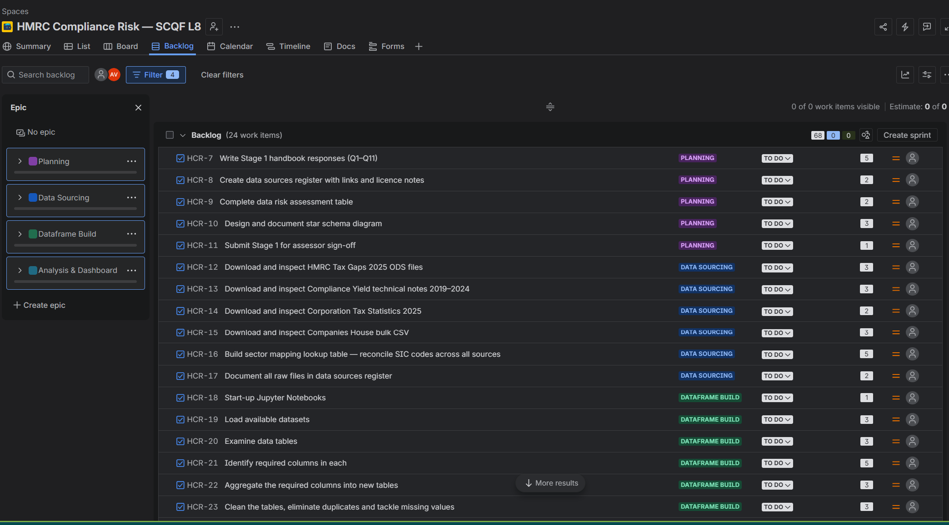

https://alexamara72.atlassian.net/jira/software/projects/HCR/boards/34/backlog?atlOrigin=eyJpIjoiMjI2YTVhM2Q2NGZjNDNhZTk5NzQ0NjI3YzEzOWU0MjMiLCJwIjoiaiJ9

- Have you agreed a target delivery date with your assessor, manager, and/or mentor?

Yes, the last day of June(30th) has been agreed as the delivery date with Catriona and my manager.

- How long will your sprints be, and why is this appropriate for your project?

A sprint is a fixed amount of time (e.g. 1-2 weeks) that you use to work towards a goal, with plan-setting beforehand and a reflection afterwards. You may want to divide your project into multiple sprints.
My sprints will be 1 week (5 working days) each, giving me 3 full sprints before the 30 June deadline (e.g., Sprint 1: 10–14 June, Sprint 2: 17–21 June, Sprint 3: 24–28 June, with 29–30 June for final polish and submission).
A 1-week sprint forces rapid, focused delivery – essential when time is short.
The project has clear separable chunks: (1) source & clean data, (2) build database & write SQL queries, (3) create dashboard & export HTML. One week per chunk is realistic if I work efficiently.
Shorter sprints mean faster feedback loops where I can catch problems within days, not weeks.
It still follows Scrum principles: planning, review, retrospective every 7 days.
A 2-week sprint would allow only one full cycle before deadline, which defeats iterative feedback.

- Who will attend your sprint planning meetings and retrospectives? These do not need to be the same people.
  - A sprint planning meeting is where you define which tasks you will work on during the sprint.
  - A retrospective is a debrief at the end, where you reflect on how things went and which tasks will need to be completed in the next sprint.

For spring planning meetings, it would be myself and my assessor.
For my retrospectives, myself and my manager.

- How will you ensure feedback from colleagues, mentors, or assessors is captured during the project?

I would do a Sprint review at end of each week (Friday), demo what I have and record feedback in a Feedback Log.

- How will you record and share notes from sprint retrospectives?

Most likely via JIRA, by journalling and sharing this with the assessor.

- Is there anyone else who needs to be kept informed of your progress?
  - How will you document and communicate updates to them?

No one outside of my assessor and manager. They will be informed via JIRA and Trello notes.

- How often will you check in with Direct Partners?
  - How will you ensure these meetings are used effectively?

I will try and check in every Friday, at the end of each sprint and give an update.
I will also ask for feedback as I go.

- Reflect on your experience of managing the project so far:

  - What aspects of Scrum worked well for your project?
  - Did you need to adapt the methodology to suit your context? Why?
  - How did you manage competing priorities or changes in scope?
  - How effective was your communication with stakeholders?
  - What professional skills have you developed or strengthened during this stage?

a) I think the sprints worked well alongside the tasks but I kind of avoided stories as I find SCRUM can be quite complex for non-lengthy projects, especially where there’s only one person working on it.
b) Yes, I adapted it by focusing only on sprints and tasks.
c) When one of my raw datasets proved unusable, I had to cut down on my scope and try to answer my questions solely from the datasets I could use.
d) Due to my manager being off or busy in these last 2 weeks, I ended up only setting up the project idea with them but that’s it.
e) I think I further developed my data cleaning skills and my ability to use JIRA.

Before moving on to Stage 3, ensure that:

- Your project management tool is up to date

- Sprint planning and retrospectives are clearly evidenced

- Reflections are complete

The questions will provide evidence for the following performance points:
- J6V8 48: 4, 11
- J6TR 48: 6

Stage 3: Analysis

The purpose of Stage 3 is to demonstrate that you can prepare, analyse, and interrogate data effectively in order to answer the project questions identified in Stage 1.

In this stage you will:
- Prepare raw data for analysis
- Assess and address data quality issues
- Apply appropriate analytical techniques
- Document your analytical process clearly and transparently

This stage focuses on how you work with data, not just the final insights or visuals.

Evidence from this stage primarily contributes to the following mandatory units:
- Transforming Data for Analysis
- Analysing Data

Your work in this stage should demonstrate that you can:
- Apply structured data preparation techniques
- Select and justify appropriate analytical methods
- Critically assess the quality and limitations of your data
- Document analytical decisions in a professional manner

Top data analysis tools
Common data quality issues

Consider the following questions to help…

Project Focus
- What are you investigating in this project?
- How will your analysis help answer the question(s) identified in Stage 1?

Data Preparation
- How was your data gathered?
  - If this is not fully known, what steps have you taken to assess its reliability?
- What data preparation steps were required before analysis (e.g. cleaning, filtering, joining, transforming)?
- Have you identified any data quality issues?
  - What were they and how did you address them?
- What steps were necessary to combine multiple datasets, if applicable?
- Have you created data dictionaries or documentation for your datasets?

Analysis
- What types of charts, plots, or summaries did you create during analysis?
- Did you need to prepare or restructure your data to create these outputs?
- What statistical tests or analytical methods (if any) did you apply?
  - Why were these appropriate for your data and question?
- Did you build any predictive or analytical models?
  - If so, summarise the techniques used and your rationale.

You should maintain a clear record of your analytical process. This is not the same as your final report or dashboard.

Your documentation should include evidence of:
- Data gathering
- Data preparation
- Any data synthesis or transformation
- Decisions about which analyses or visualisations to include
- A record of analyses or approaches that were started but later abandoned, and why

Reflect on your experience of the analysis stage:
- What challenges did you encounter when preparing or analysing the data?
- Were there any limitations in the data that affected your analysis?
- How did you ensure your analysis was robust and appropriate?
- What decisions had the biggest impact on your findings?
- What would you do differently if you were to repeat this analysis?

Before moving on to Stage 3, ensure that:

- Your project management tool is up to date

- Analyses are clearly documented

- Reflections are complete

The questions will provide evidence for the following performance points:
- J6V6 47: 5, 7
- J6V4 47: 3, 4, 5, 7, 8, 9, 10, 11
- J6VE 48: 1, 2, 3, 4, 5. 6, 7, 8, 9
- J6TR 48: 1, 2, 3, 4, 5, 7, 8

Stage 4: Presentation and Communication of Findings

The purpose of Stage 4 is to demonstrate that you can communicate data-driven insights clearly and effectively to a defined audience.

In this stage you will:
- Present the findings of your analysis in an appropriate format
- Use effective data visualisation techniques
- Tailor your communication to the needs of stakeholders
- Provide clear conclusions and recommendations based on evidence

This stage focuses on how well you communicate insights, not just the technical analysis behind them.

Your work should demonstrate that you can:
- Select appropriate visualisations for different types of data
- Present information clearly and accurately
- Explain insights and implications to a non-technical audience where appropriate
- Link analysis directly to business or organisational decisions

Choosing the right data visualisation
Five tips for making your data understandable

To complete Stage 4, you must include:

- A final project output, such as:
  - A report
  - A dashboard
  - A presentation
  - Another agreed format appropriate to your audience
- Evidence of how your visualisation and presentation decisions were made

- Clear conclusions and recommendations

- Evidence of how the presentation was, or will be, shared with stakeholders

Your final output must be linked or embedded within this handbook.

Part 1 – Question and Answer with Supporting Evidence

Answer the following questions and include supporting evidence.

Project Overview
- If your project were to be implemented fully, what digital or technology-enabled solution are you proposing?
  - Describe the proposed solution, how it would be used in practice and how it improves the current process.

A Python-based interactive dashboard built with Dash and Plotly that combines four separate HMRC datasets into a single visual interface. In practice, a compliance manager opens it in their browser, selects a year or sector, and instantly sees which industries carry the highest CT liability and how the tax gap has shifted over time

- How does your project align with wider organisational objectives or strategy?
  - If this alignment is unclear explain why and what would be needed to strengthen it.
HMRC's compliance directorate aims to reduce the tax gap and target resources where risk is highest. This dashboard directly supports that by surfacing sector-level compliance risk in one place, enabling more evidence-based decisions about where to focus investigations.

- What are the expected benefits of this solution, and what costs or resource implications should be considered?
  - Benefits may include efficiency, accuracy, service quality, or decision-making improvements.
  - Costs may include time, training, tools or system changes.

Benefits: faster identification of high-risk sectors; reduced manual data-wrangling by analysts; a consistent view across datasets that didn't previously exist together; supports more targeted compliance activity.
Costs: Python and Dash must be installed on the user's machine; basic Python literacy is needed to run and update it; the CSVs need to be refreshed manually when HMRC publishes new data.

- How could the success of this solution be measured?
Reduction in time taken to produce sector risk comparisons; adoption by compliance managers as a reference tool; whether sector prioritisation decisions reference the dashboard findings; and longer term, whether targeted sectors show improvement in yield-to-gap ratios.

Presentation Requirements
- What are the visualisation requirements of your project? For example, do you need to:
- Show distributions of data
- Show relationships between variables
- Highlight trends over time
- Compare groups or categories
- Predict future patterns

The project needed to: highlight trends over time (CT gap line chart), compare groups and categories (sector bar chart, segment comparison), and show relationships between variables (liability per company vs sector size). All five types listed applied to some degree.

- What format has your final output taken (e.g. report, dashboard, presentation)?
An interactive web dashboard, run locally via Python and viewed in a browser

- Why is this format appropriate for your intended audience?

Dashboards are widely used in HMRC and across the Civil Service to showcase insights to stakeholders. It creates a pipeline that can keep things dynamic even if the data changes.

Visualisation Design
- Which tools have you used to create your visualisations?

Python (pandas for data loading and cleaning, Plotly Express for charting, Dash for the web interface). VS Code as the development environment. Data sourced from HMRC published statistics in CSV format.

- What types of charts or visuals have you included, and why are they appropriate?

Horizontal bar chart (sector risk tab): best for comparing many named categories — easier to read sector names than on a vertical chart.
Line chart (CT gap over time): standard for time-series trends; shows direction and rate of change clearly.
Line chart (segment gap history): allows multiple groups to be compared across the same time axis.
Bar chart (segment snapshot): compares groups on a single metric at a point in time — clear and familiar to a non-technical audience.

- How have you ensured your visualisations are:

  - Clear
  - Accurate
  - Accessible to your audience

Clear: plain-English labels on all axes and dropdowns; a collapsible glossary explains every technical term (tax gap, compliance yield, etc.) on the page itself.
Accurate: data is loaded directly from the source CSVs with no manual transformation; column names are preserved and displayed with units (£bn, £m, £k).
Accessible: colour scales are single-hue (Blues, Teal) rather than red-green, avoiding issues for colour-blind users; font is Arial throughout; chart heights are fixed to avoid crowding.

- Did you create any visualisations that were not included in the final output?
  - If so, explain why they were excluded.

An earlier version included a scatter plot comparing median earnings to the tax gap, carried over from a previous iteration of the project. It was removed because it answered a different question from the final problem statement and would have confused the audience about the dashboard's purpose.

Workflow and Automation
- Have you identified any opportunities to automate part of your workflow? For example, updating outputs when data changes or responding to user input.
  - If so, describe what you implemented and why.

Yes. The dashboard is fully reactive. All four charts update automatically when the user changes a dropdown or checklist, without reloading the page. This is handled by Dash's callback system.

Final Presentation

- How did you present or share your work with your manager, mentor, assessor, or other stakeholders?

The dashboard was run locally and demonstrated live to colleagues, walking through each tab in sequence, starting with the sector risk view (the core research question), then the CT gap trend, then the segment breakdown.

- How does your presentation answer the business or organisational questions identified in Stage 1?
What recommendations have you made based on your findings?

Which sectors carry the greatest risk? Tab 1 ranks all 20 SIC sectors by CT liability and liability per company.
Which sectors generate the most yield per investigation? Partially addressed through the compliance yield and spend-per-£1 metrics in the segment snapshot.
Are sectors over/under-represented in compliance activity? The yield-%-of-gap metric highlights where recovery is low relative to the size of the gap.
How has risk shifted over the last decade? The sector trend line chart and CT gap time series both address this directly.

- How confident are you in these recommendations, given the data and analysis carried out?

Moderate. The analysis is based on published HMRC statistics which are reliable sources, but CT liability is a proxy for compliance risk, not a direct measure of non-compliance. Sectors with high liability may simply be large and profitable rather than non-compliant. Stronger conclusions would require combining this with actual investigation outcome data, which was not available for this project.

Part 2 – Reflection

- Reflect on your experience of presenting your findings.
  - What aspects of your communication were most effective?
  - What feedback did you receive from stakeholders?
  - Were there any challenges in explaining technical findings to a non-technical audience?
  - What would you improve if you were to present this work again?

- When presenting it to my manager, I believe the strongest aspect of my communication was setting the scene in terms of explaining away the business question and showcasing the dashboard.
- My manager thought the dashboard would be useful, however pointed to the fact that there are other multi-level processes in place for this that are far less efficient but guidance compliant. They also raised concerns about accessibility due to the colour scheme I chose.
- No, but that is because the stakeholders in my team were actually pretty tech literate.
- I would honestly pay more attention to the accessibility ahead of time but when it comes to the presentation itself, I believe I would structure it better. I would definitely add a section at the end with a results overview.

Your reflection should demonstrate awareness of audience, clarity, and impact.

Before moving on to the final stage, ensure that:
- Your final output is complete and accessible

- Supporting evidence is embedded in this handbook

- Reflections are complete

- Feedback from presentation attendees has been captured where possible

The questions will provide evidence for the following performance points:
- J6VF 47: 2, 3, 4, 5, 6, 7, 8, 9, 10

Stage 5: Reflection and Evaluation

The purpose of Stage 5 is to demonstrate that you can critically evaluate your project as a whole, reflecting on both the outcomes achieved and the way the project was delivered.

In this stage you will:
- Evaluate whether the project met its original objectives
- Reflect on the effectiveness of your analysis and recommendations
- Consider the impact of your work on the organisation
- Demonstrate professional self-reflection and learning

This stage brings together technical, professional, and organisational considerations.

Evidence from this stage primarily contributes to the following mandatory units:
- Developing Meta-Skills and Personal Professionalism
- Supporting Digital Business Transformation

Your evaluation should show that you can:
- Reflect critically on your own practice
- Assess the value and impact of data-driven work
- Identify lessons learned and areas for development
- Consider how analytics supports wider organisational goals

To complete Stage 5, you must include:
- A holistic evaluation of the project
- Evidence of a final retrospective
- Reflection on impact, effectiveness, and limitations
- Feedback from relevant stakeholders where available
- Clear identification of lessons learned and next steps

Part 1 – Question and Answer with Supporting Evidence

Answer the following questions and include supporting evidence where appropriate.

Measuring Success
- How did you define success for this project?

Success meant producing a working dashboard that combined all four datasets, answered the four research questions visually, and could be understood by a non-technical compliance manager without explanation beyond the built-in glossary.

- To what extent did your project meet the objectives identified in Stage 1?

The core objectives were met: the dashboard loads all four CSVs, presents sector risk, time trends, and segment comparisons in plain English, and runs without errors. The objective of combining datasets that "have never been combined into a single integrated view" was achieved in the dashboard layer, though not via a formal relational database as originally scoped.

- What evidence do you have that your project delivered value?

The dashboard produces in seconds a cross-dataset comparison that would otherwise require manually opening and aligning multiple HMRC statistical releases.

Impact and Outcomes
- What actions (if any) has the organisation taken as a result of your project?

At this stage the dashboard has been demonstrated internally. No formal adoption decision has been made.

- How have your recommendations been received or used?

They have been received positively by my manager.

- What impact do you expect your work to have in the short or longer term?

To be honest, this would have to be presented further to the parts of our directorate that focus their work on that data before we can see an actual implementation.

Part 2 – Reflection

You should conduct a final retrospective after presenting your project. For example, this might be a structured call with the Direct Tech team.

Address the following:
- When did you hold your final retrospective?
- Who was involved?
- What went well during the project overall?
- What ethical, professional, or behavioural considerations arose during this project?
- What challenges did you face across the project lifecycle?
- If changes were required to scope, timeline, or resources during this project, how should these be managed in a professional organisational context?
- How effectively did your project management approach support delivery?
- What would you do differently if you were to repeat this project?

Include notes, screenshots, or summaries from the retrospective as evidence.

I had my final retrospective on Friday the 26th of June with Ziska McManus.

What went well?
Forming an idea and sourcing the datasets went smoothly and fast. I’d say it was the least problematic part of the process.

What ethical, professional, or behavioural considerations arose?
None. All data used is publicly published by HMRC, so there were no data privacy or confidentiality concerns. I just had to make sure I didn’t use comparisons that were misleading.

Part 3 – Reflection on Learning and Development
How should changes to scope, timeline, or resources be managed professionally?
Any change to scope, timeline, or resources should be flagged to relevant stakeholders as early as possible. In a professional context this means documenting what changed, why, and what the impact is.

How effectively did the project management approach support delivery?
The iterative approach worked well. However, in a real life scenario where projects would be larger and team members would be involved, JIRA and SCRUM would prove to be far more useful than in this case where the initial sprint was completed before JIRA was even set up and I would invest time in keeping a detailed changelog for my stakeholders.

What would you do differently?
Four things.
First, I would validate the data files and file paths at the very start before writing any code.
Second, I would define the research questions more precisely before building anything.
Third, I would keep a detailed changelog.
Fourth, I would write a cleaning plan checklist and make a mock-up of the dashboard before rushing into those processes.

Reflect on your personal and professional development during the project:
- What new skills or knowledge have you developed?
- How has this project improved your confidence or capability as a data analyst?
- What technical or professional areas do you want to develop further?
- How will you apply what you have learned in future work?

This reflection should demonstrate self-awareness, honesty, and growth.

- I think I developed further knowledge into dashboard design, HTML and JIRA.
- I think it has showed me that if I plan well enough for a specific project, I can get a really good start and architecture for it. On top of that, I’ve become far more confident in my troubleshooting abilities as I’ve constantly run into errors. I’m more relaxed thinking that no matter what, I’ll be able to get a project sorted.
- I think I want to develop my skills further when it comes to HTML based dashboards, statistics but also learn machine learning as I think it would specialize me further.
- I will plan my data cleaning in Jupyter Notebooks going further rather than completing it in Excel or Google Sheets as I have until now.

Before final submission, ensure that:
- All five stages of the handbook are complete
- Supporting evidence is embedded throughout
- Reflections are thoughtful and complete
- Your assessor has confirmed readiness for final review

Once complete, upload the final version of this handbook and any supplementary materials to Trello as instructed.

Stage 5 will provide evidence for the following performance points:

J6V0 48 (Developing Meta-Skills and Personal Professionalism):
1, 2, 3, 4, 5, 6, 7, 8

J6VC 48 (Supporting Digital Business Transformation):
8, 9, 10, 11

J6TS 48 (Applying Methods and Principles in Project Management):
5

Stage 5 will provide evidence for the following knowledge points:

J6V0 48 (Developing Meta-Skills and Personal Professionalism):
1, 2, 3, 4, 5, 6

J6VC 48 (Supporting Digital Business Transformation):
6, 7, 8

