**The Installation of GLScene in Embarcadero RAD Studio**

1. Download the latest version of GLScene from Gitgub at page <https://github.com/GLScene/GLScene/releases> or from SourceForge at page <http://sourceforge.net/projects/glscene/files/> . You may fork or clone the current source codes from <https://github.com/GLScene/GLScene.git>  [to you](https://svn.code.sf.net/p/glscene/code/trunk)r disk, e.g. D:\GLScene.
2. Use TortoiseGit/TortoiseSVN clients, Github Desktop or RAD Studio’s embedded subversion control system in menu File|Open From Version Control… to check out and update the codes.
3. Run _setupDLL.cmd from directory ..\GLScene\external as administrator before compiling and installing packages in IDE to copy third party dynamic libraries into C:\Windows\System32 or C:\Windows\SysWOW64 directories to support 3D sounds (BASS, FMOD, OpenAL), game API (SDL2), nVidia CG shaders and physics (ODE, Newton).
4. Setup Delphi Library Paths in Options|Language dialog. Open Delphi Options Library page and add paths to sources files.

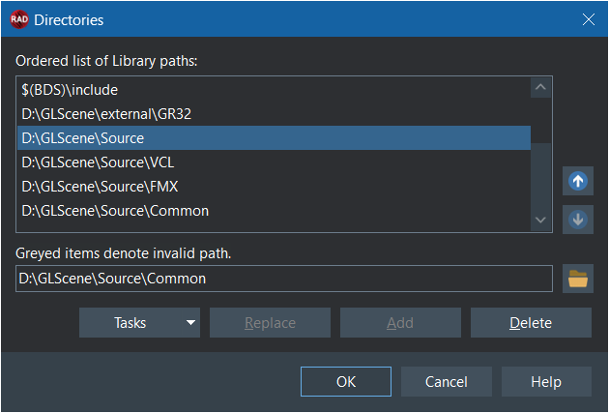

1. Setup C++ Options for C++Builder to include autogenerated hpp files. Open Cpp Options dialog in Paths and Directories menu and add paths in “System include path” to headers for Win32 and Win64 platforms. The same for modern compiler.

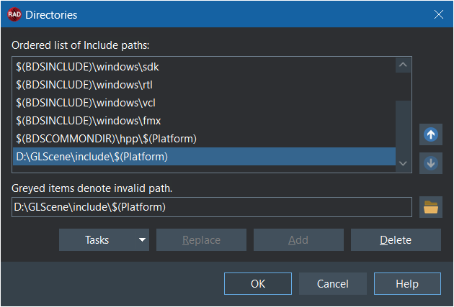



1. Setup C++ Options for libraries. Add paths in “Ordered list of Library paths” to lib/bpi files for all platforms.

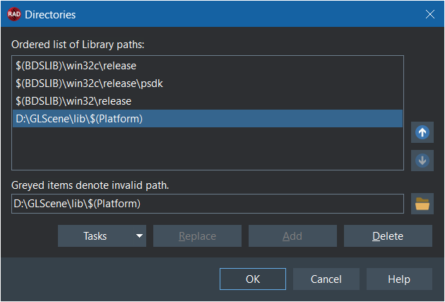

1. Open the GLScene.groupproj in your directory ..\GLScene\Packages\ using menu item File|Open Project…(Ctrl+F11). The next list of projects with *.bpl extensions there will be in Project Manager window :

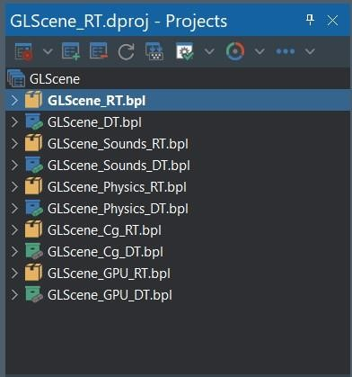

1. Compile GLScene’s packages for Win32/Win64 using “Compile All From Here” and install components by choosing every DT (DesignTime)

package in GLScene.groupproj to RAD Studio component palette. Then you should get an information for GLScene_DT.bpl as shown below

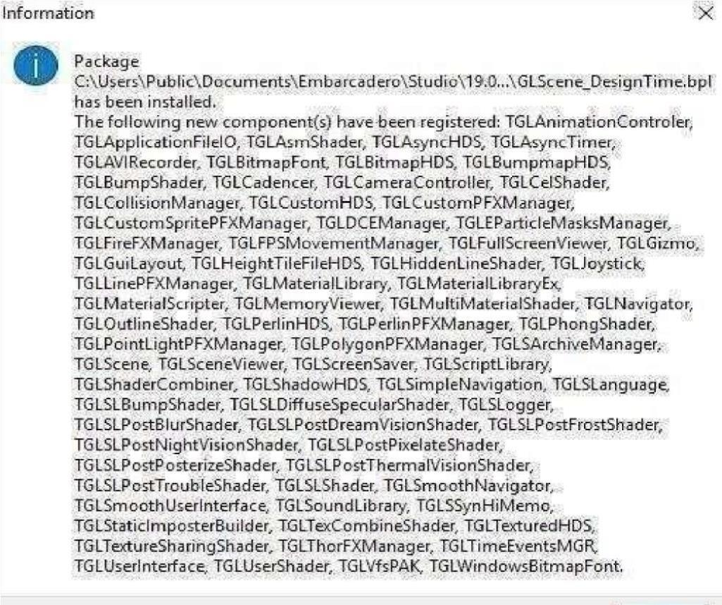

1. Setup the same options for cross-platform compilations in IDE, open the GLXcene.groupproj and install GLXcene components for FireMonkey.
2. Run Examples for Delphi & C++Builder in ..GLScene\Examples directory to learn demos and advdemos projects.

