**SAINT PETERSBURG NATIONAL RESEARCH UNIVERSITY**

**OF INFORMATION TECHNOLOGIES, MECHANICS AND OPTICS**

**(ITMO UNIVERSITY)**

|  |  |
| --- | --- |
| Faculty | Information Technologies and Programming |
| Department | High Performance Computing |
| Field of education | Applied Mathematics and Informatics |

**R E P O R T**

**about final project for**

**Introduction to Computational Science course**

**The task title:** Forest fire model with wind and different types of trees

**Student ____** Maliutin A.A ______ ____ M4119C **___**

(Surname, initials) Group

**Student** _ Khodorchenko M.A. __ ___ M4117C **____**

(Surname, initials) Group

**Student _____** Sokhin T. R. ______ ____ M4119C **___**

(Surname, initials) Group

**Student __**Vychuzhanin P.V. _____ ____ M4117C **___**

(Surname, initials) Group

**Date ____________________**

**Saint-Petersburg**

**2018**

TABLE OF CONTENT

INTRODUCTION 3

1 Model description 5

1.1 Cell 5

1.2 Grid 6

2 Implementation 7

3 Experiments 8

3.1 Verification 8

3.1.1 Density 8

3.1.2 Wind 8

3.1.3 Defense barrier 9

3.2 Critical density 10

3.3 Comparison with a real fire 10

3.4 Time of fire 11

CONCLUSION 13

CONTRIBUTION OF TEAM MEMBERS 14

REFERENCES 15

INTRODUCTION

Forest fires are one of the demanding issues that humanity faces with all over the world. This problem affects the overall environmental state by increasing the amount of carbon dioxide emitted into the air and endangering the forest wildlife. In spite of the positive effects that take place, like ecosystem renewal, fires are a huge hazard for households and thus for human lives. The geographical locations of fires vary from seasons and from the amount of people living in the particular area due to the fact that the main reason of forest fires is human factor.

During the 2017 in the US (*Facts + Statistics: Wildfires*, 2017) 66,131 were recorded with about 9.8 million acres burned. Most of the wildfires happen in California, the state, which has the largest fraction of forests among all the US states. The overall trend reveals the increasing intensity of fires and area destroyed in the last 10 years’ period. In Russia the situation is similar with the prevailing amount of bon (Kukavskaya *et al.*, 2016).

One of the reasons of such changes may be connected with the forests becoming more dense nowadays (*Nearly a record breaking year for acres burned in the U.S.*, 2017) and the weather becoming more dry and warm. All that demand the development of systems to gain the understanding of fire behavior (speed and direction of fire front) in order to develop the strategies of firefighting.

Different approaches (Papadopoulos and Pavlidou, 2011) can be considered when modeling forest fires but the most simple in realization and yet very effective is based on cellular automata (Karafyllidis and Thanailakis, 1997). It represents a way to define the complex dynamics of the system such as fire propagation by changing the states of the cells in the grid using the cells in local proximity. Most relative works describe the usage of Moore neighborhood (8 cells) as providing the closer to reality results in comparison to Von Neumann neighborhood (4 cells).

Huge variety of modifications to the basic cellular automata model (Karafyllidis and Thanailakis, 1997) were introduced until now. The most common one is presenting the discrete set of cell states (Zheng *et al.*, 2017) that came instead of the presenting state as the fraction of cell area burned. Wind strength and direction is considered to have a large impact on the fire spreading and can be included to the model as weights coefficients. Regarding the structural components of the forests types of trees can be introduced with their differences in burning (Xuehua *et al.*, 2016) that are caused by differences in wood types and that ability to retain moisture.

More complexity can be added by including embers behavior that is difficult to incorporate into models due to their random nature (Mahmoud and Chulahwat, 2017). The number of system parameters can be extended though there are no evident connection between parameters incensement and model quality which leads to the possibility to obtain better results with less sophisticated model.

The integration with GIS systems (Yassemi, Dragićević and Schmidt, 2008; Gaudreau, Perez and Drapeau, 2016) is possible yet challenging question that is not fully solved. One of the main difficulties that most of the researches met

The aim of this research was to develop the efficient model in terms of computational time on the large grid and output results based on the state-of-the-art cellular automata approaches and on the idea of heat emission and consumption in particular. In addition, fire prevention methods like borders were included in order to evaluate their influence on fire spread. The model was validated on real data from satellite images and revealed the consistency with natural processes.

# Model description

## Cell

Our main goal was to determine the parameters that are the most significant (have huge influence) for the forest fire modeling. We decided to make the model more deterministic to reduce the spread of output values (amount of burned trees and duration of the fire).

Each cell is defined by the set of following parameters:

1. coordinates on the grid (x, y position);
2. state:
   1. soil - standard surface that is not able to burn;
   2. ignited – when in this state, trees become burning after the defined time period;
   3. burning – when in this state, trees contain a certain amount of heat, which they emit to the environment;
   4. embers – this state indicates that the tree is burned to embers which die after some passage of time;
   5. dead (burned) - the last stage of fire, similar to soil. Included for further computations;
   6. tree – basic forest tree.

Various cell states differ by the colors.

In order to bring the model closer to the real forest, the following characteristics were introduced for each tree:

1. size – discrete set of sizes:
   1. tiny;
   2. normal;
   3. big;
2. type – each type of tree has its own heat capacity that is necessary for ignition and that allocates heat to the external environment:
   1. deciduous – this type of tree has medium heat volume value;
   2. conifer – this type of tree is easily ignited and gives a huge amount of heat after that;
   3. dry tree – this type of tree is similar to conifer, but it is less heat capacity;
   4. hardwood – this type of tree is heavily ignited and gives the greatest amount of heat comparing to other types.

## Grid

The grid is a general description of the forest parameters, which, from our point of view, has a major impact on the nature of the fire.

1. Size of the forest – indicates the number of cells in the grid;
2. density of trees;
3. distribution of tree types:
   1. deciduous;
   2. conifer;
   3. hardwood;
   4. dry tree;
4. wind direction and power - determines the fire spread direction;
5. starting position of fire.

To assess the possibility of fire prevention, we introduced a barrier installation on the path of fire. We present it as the strip which is cleaned from any combustible objects (see in Figure 1).

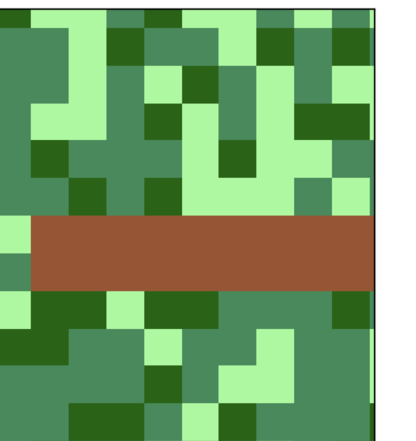

Figure 1 – Defense barrier

# Implementation

The provided implementation is based on the python programming language. The following libraries are used:

1. json;
2. tqdm – progress bar;
3. scipy, multiprocessing - to use multithreading, which allows you to significantly increase the calculation speed;
4. seaborn – for the beautiful visualization of algorithm results.

The core of used approach is

Our implementation based on dictionary approach to decrease calculation time of the next state. We specified four types of objects: trees themselves (TREES), burning state (FIRE), which includes igniting, burning and embers, trees that can catch fire (BORDER), dead trees (DEAD).

Each step consists of the following actions:

1. find the trees that stand next to the burning to form BORDER dictionary;
2. check the trees from the BORDER dictionary - is there enough heat for igniting;
3. check the trees from FIRE dictionary whether they are already burned or not;

We use Moors neighborhood to calculate heat volume. The algorithm steps are listed below:

1. get neighborhoods in fire - 8 cells in the general case;
2. check attitude - if the burning tree is lower, then the heat volume increases;
3. check wind influence - if the wind accompanies - multiply, otherwise divide To determine the effect of wind, it is set as a mask for the amount of heat received from neighbor burning trees;
4. make summation.

In addition, each cell that contains tree from FIRE dictionary makes its own step to check current state: igniting, burning or embers.

# Experiments

## Verification

### Density

Fire with forest density 1.0 is shown in Figure 2. The initial test demonstrates the complete burnout of the forest, which was expected. This is a primary indicator that the model is created right with respect to natural fire behavior.

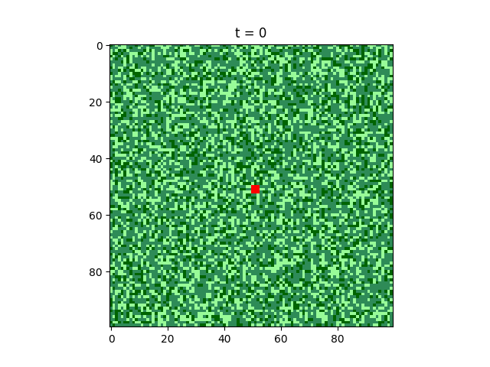 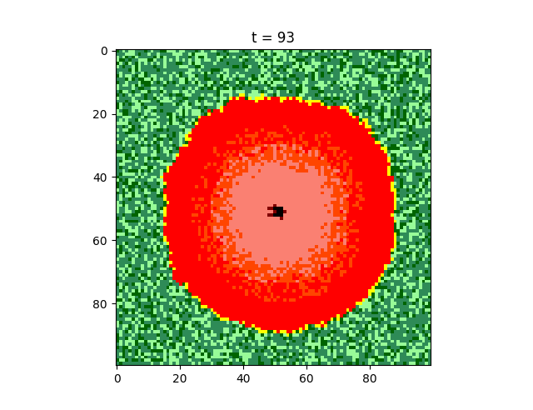 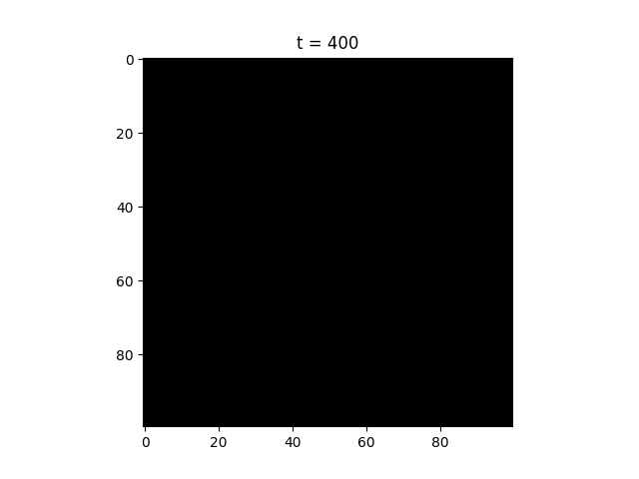

Figure 2 – Density 1.0

### Wind

The wind should affect the direction of the spread of the fire. The result which is presented in Figure 3 fully meets the expectations. The wind is a very factor of crucial importance. In the shortest possible time, it can completely change the picture of the fire. The installation of a protective barrier on path of the wind direction can stop the spread of fire with less labor.

s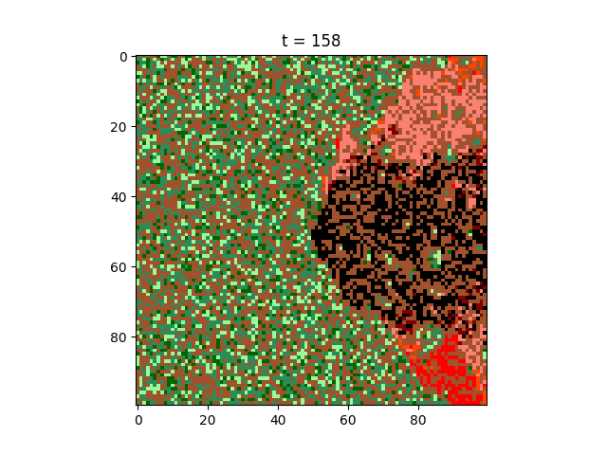

Figure 3 – Wind

### Defense barrier

In our approach, the barrier from fire should slow the spread of fire in the defined direction (see Fig. 4).

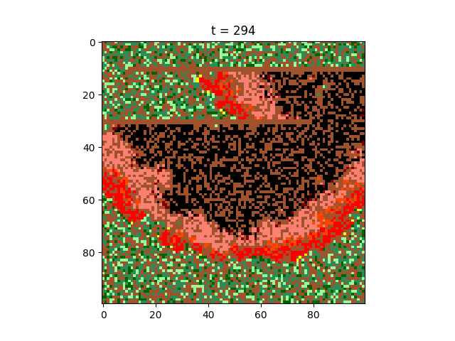 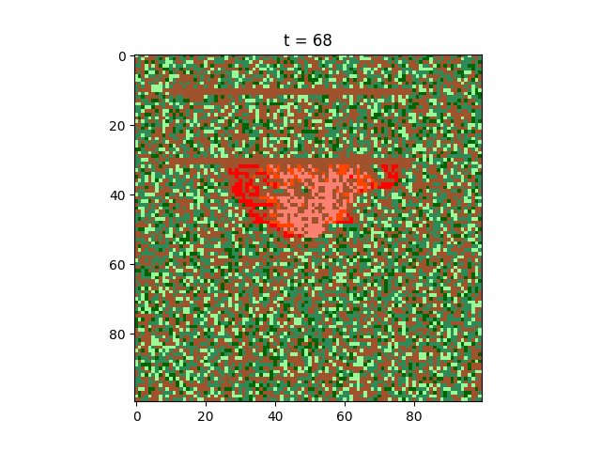

Figure 4 – Defense

Even with modern firefighting equipment, often not possible to contain fire with sufficient efficiency. This model can help to predict where to create a barrier and how long it should be. Thus it can be used to model real life conditions due to the fact that for each geographical location Rose of Wind can be taken into consideration and such knowledge of prevailing wind direction may be brought in the simulation.

## Critical density

One of the main parameters that we are particularly interested in is the critical density. This parameter allows us to make assumptions about the effects of forest fire before experiments or real occurrence.

The results are shown in Figure 5.

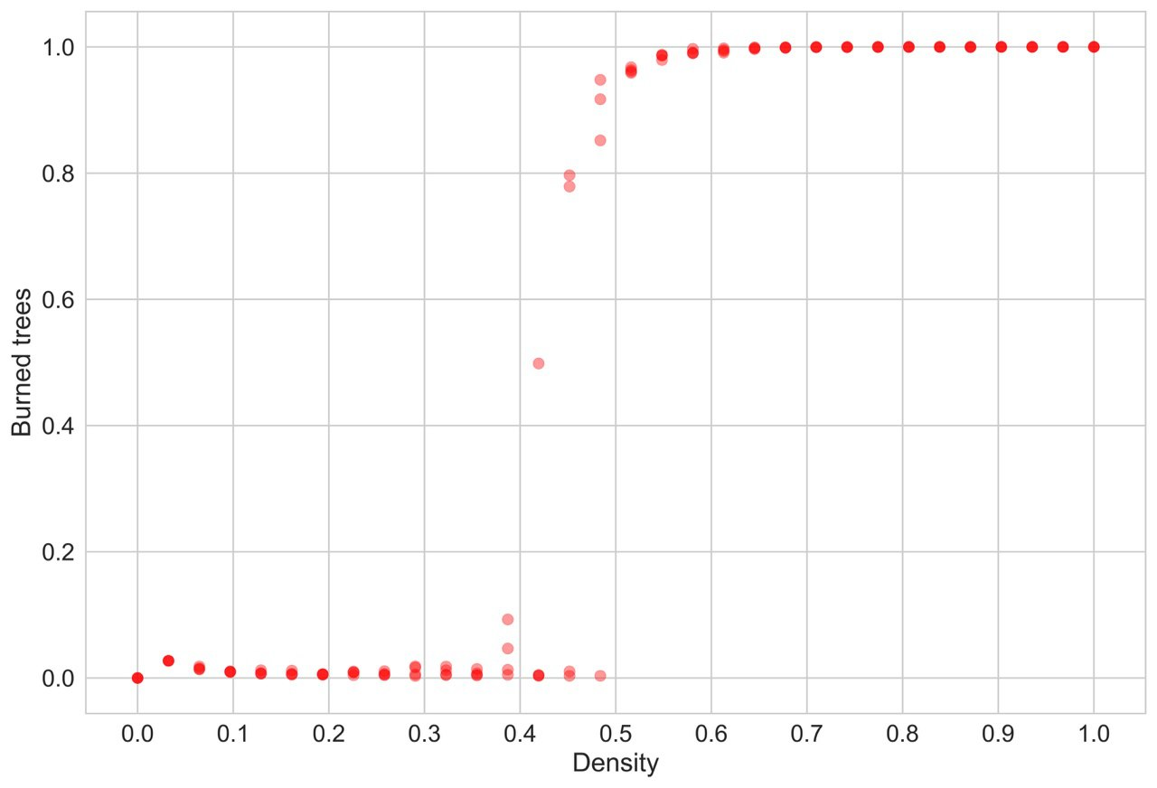

Figure 5 – Critical density

Some oscillations at low density values can be observed due to the fact that trees can stand very close to each other in a small area. However, a sharp increase in the amount of burnt forest is clearly seen at a density of 0.50-0.55, at the same time, bifurcation points are noticeable.

It’s noteworthy that the critical density value is the same for different types of trees.

## Comparison with a real fire

When thinking about model quality estimation, we should at least approximately assess whether our model is consistent with real fires. There were no specific values for which evaluation could be carried out, so validation was performed by extracting the general "pattern" of the fire from the real-life images.

We used satellite images of the forest before and after the fire which helped us to calibrate the parameters in order to obtain a similar fire pattern (see Fig. 6).

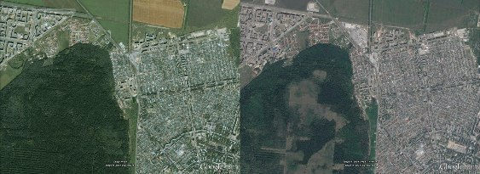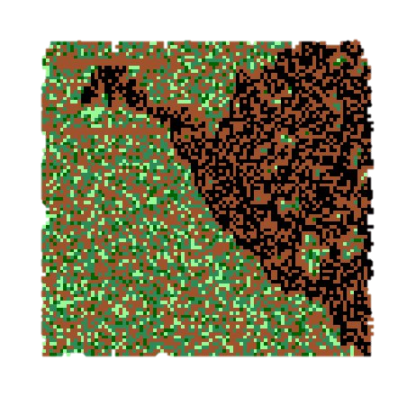

Figure 6 – Real vs Model

## Time of fire

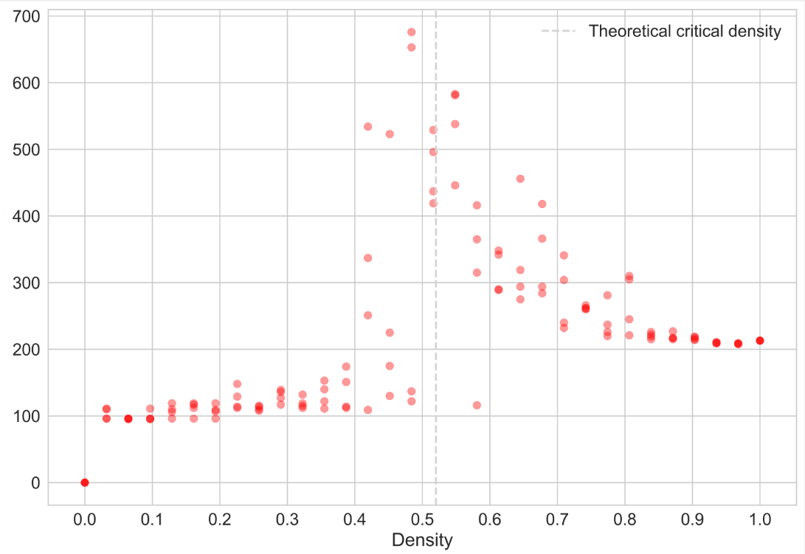

Figure 7 – Time of fire

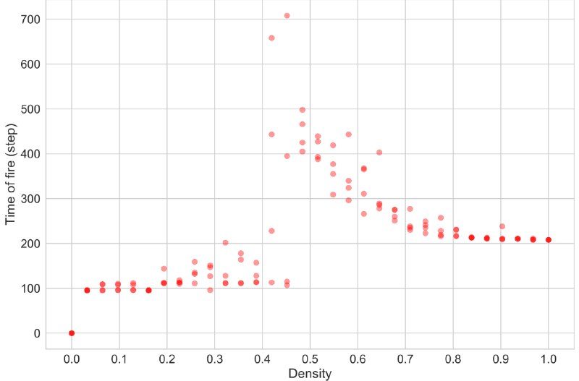

Figure 8 - Time of fire for conifer trees

Also, in proximity to the critical density we observe the changes in the distribution of the duration of fire that is shown in Figure 7-9. Moreover, the type of forest has a significant impact on the duration of forest fire, what is similar in real life. This data can be useful in the course of extinguishing, to make assumptions about how much time there is to contain the fire.

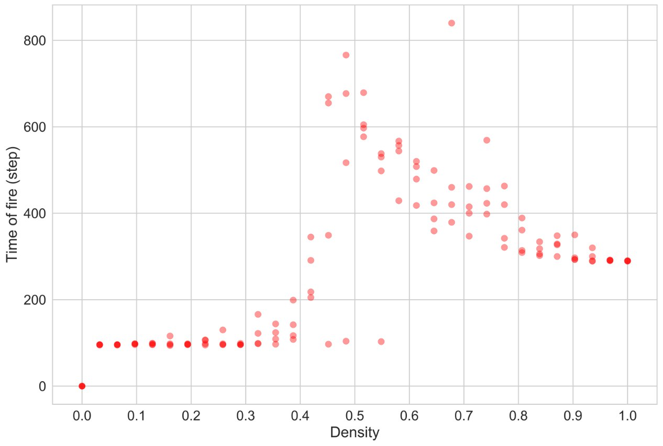

Figure 9 – Time of fire for deciduous trees

CONCLUSION

The developed model of forest fire is a simplification with respect to real characteristics, but nevertheless it is capable of demonstrating the behavior of forest fire in mixed forest conditions of different density with sufficiently high level of accuracy. The effects of wind and altitude as the most influential factors were also taken into consideration.

The conducted experiments allow us to draw conclusions about the prospects of the developed model and about the possibility of its further improvement: bringing to a non-discrete form, adding more numbers of weather parameters, improving the way the forest is placed.

CONTRIBUTION OF TEAM MEMBERS

*Mary*

* Related works analysis – 100%
* Final report – 50%

**TOTAL: 24.6%**

*Alexey*

* Model Implementation – 90.1%
* Scripts for collecting different measurements of model – 100%
* Graph plotting methods – 50%
* Slides for presentation – 49.9%
* Data computation for final Report – 75%

**TOTAL: 40.4%**

*Timur*

* Slides for presentation – 50.1%
* Final report – 50%
* Graph plotting methods – 50%
* Data computation for final Report – 25%

**TOTAL: 25%**

*Pavel*

* Model Implementation – 9.9%

**TOTAL: 10%**

REFERENCES

1. *Facts + Statistics: Wildfires* (2017). Available at: https://www.iii.org/fact-statistic/facts-statistics-wildfires.
2. Gaudreau, J., Perez, L. and Drapeau, P. (2016) ‘BorealFireSim: A GIS-based cellular automata model of wildfires for the boreal forest of Quebec in a climate change paradigm’, *Ecological Informatics*. doi: 10.1016/j.ecoinf.2015.12.006.
3. Karafyllidis, I. and Thanailakis, A. (1997) ‘A model for predicting forest fire spreading using cellular automata’, *Ecological Modelling*. doi: 10.1016/S0304-3800(96)01942-4.
4. Kukavskaya, E. A. *et al.* (2016) ‘The impact of increasing fire frequency on forest transformations in southern Siberia’, *Forest Ecology and Management*. doi: 10.1016/j.foreco.2016.10.015.
5. Mahmoud, H. and Chulahwat, A. (2017) ‘A Probabilistic Cellular Automata Framework for Assessing the Impact of WUI Fires on Communities’, in *Procedia Engineering*. doi: 10.1016/j.proeng.2017.07.153.
6. *Nearly a record breaking year for acres burned in the U.S.* (2017). Available at: http://wildfiretoday.com/tag/statistics/.
7. Papadopoulos, G. D. and Pavlidou, F. N. (2011) ‘A comparative review on wildfire simulators’, *IEEE Systems Journal*. doi: 10.1109/JSYST.2011.2125230.
8. Xuehua, W. *et al.* (no date) ‘A Cellular Automata Model for Forest Fire Spreading Simulation’.
9. Yassemi, S., Dragićević, S. and Schmidt, M. (2008) ‘Design and implementation of an integrated GIS-based cellular automata model to characterize forest fire behaviour’, *Ecological Modelling*. doi: 10.1016/j.ecolmodel.2007.07.020.
10. Zheng, Z. *et al.* (2017) ‘Forest fire spread simulating model using cellular automaton with extreme learning machine’, *Ecological Modelling*. doi: 10.1016/j.ecolmodel.2016.12.022.