Introduction
Virtual screening in the pharmaceutical industry is an essential part of molecular modellings contribution to lead discovery and, to a lesser extent, lead optimization. This has led to considerable research into what method or approach works best, typically by means of ‘retrospective’ evaluations, i.e. attempting to predict future, i.e. prospective behaviour by appraising techniques on known systems. Despite this there is no agreed upon theory as to how to conduct a retrospective evaluation. As a consequence, it is very difficult for an outsider to assess if methods are getting better, have stayed the same, or even worsened over time. In a practical enterprise, such as drug discovery, the proposed benefits of virtual screening, i.e. avoiding the cost and time of a real screen, have to be weighed against one simple question: does it actually work? Without proper metrics of success, i.e. ones that go beyond the anecdotal, molecular modelling is not guaranteed a vibrant future[1].

What is Virtual Screening?
Virtual screening (VS) is a computational technique used in drug discovery to search libraries of small molecules in order to identify those structures which are most likely to bind to a drug target, typically a protein receptor or enzyme [4][5]. Более формально можно так же сказать что Virtual screening (VS) is the term applied to a type of problem which is conceptually the computational equivalent of (experimental) high-throughput screening, wherein a large number of samples are quickly assayed to discriminate active samples from inactive samples [3].
Evaluating the performance of VS methods is a necessary practice that both the method developers and the end-users perform. For the developers, it is done to parametrize and validate the methods, for the end users, it is a way to select which method performs best in a given situation.
The key requirement for success in VS is that it must rank actives very early in the larger set of compounds, since only a very small proportion of the compounds ranked will actually be tested experimentally. For instance, sample repositories of pharmaceutical companies commonly contain more than 1 million compounds. Identifying a set of a few thousand compounds to screen experimentally requires that the VS method perform well within the first 0.1% of the scored compounds! Even if the VS method is excellent at retrieving all actives for any target within the first half of the data set, it is useless if the early performance is bad [3].

Traditional Measures
This has led to considerable research into what method or approach works best, typically by means of ‘retrospective’ evaluations, i.e. attempting to predict future, i.e. prospective, behaviour by appraising techniques on known systems. Despite this there is no agreed upon theory as to how to conduct a retrospective evaluation. As a consequence, it is very difficult for an outsider to assess if methods are getting better, have stayed the same, or even worsened over time. Здесь мы рассмотрим базовые методы, которые часто можно встретить в различных источниках.

Area under Receiver operation characteristic curve
The ROC metric is widely used across many disciplines. The popularity of ROC over other metrics lies in the fact that it is non-parametric: no assumption is made about the shape of the distribution. Also, its graphical representation gives a good feeling about the performance of the ranking [3].

Receiver Operating Characteristic Curve
In statistics, a receiver operating characteristic (ROC), or ROC curve, is a graphical plot that illustrates the performance of a binary classifier system as its discrimination threshold is varied. The discrete formula [3] for a set of ranked elements is given below:

- is the cumulative count of inactives at rank position k
- is a number of actives distributed in list of compounds
- is a number of compounds
На рисунке 1 можно видеть графическое представление ROC. Так же можно получить представление о позитивных и негативных тенденциях.
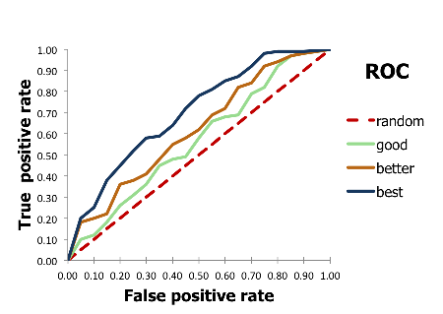
Можно заметить что здесь фигурирют такие понятия как True Positive Rate and False Positive Rate. Formulas to calculate this rates are given below:
Figure 1: ROC-Curve, just an example

- – Tue positive values
- – Tue negative values
- – False positive values
- – False negative values
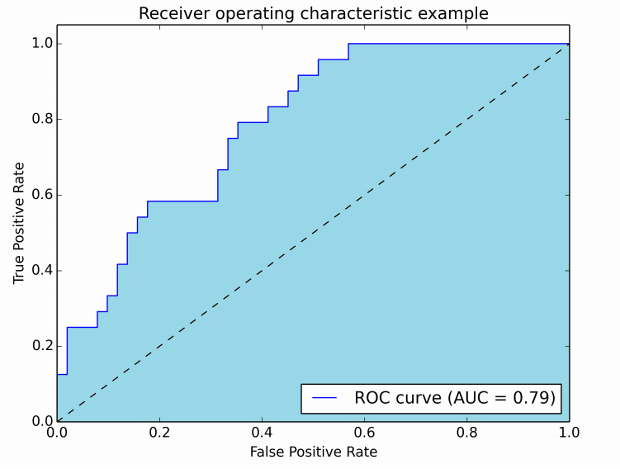
Собственно имея готовую ROC-Curve достаточно просто рассчитать площадь под этой кривой. На рисунке 2 изображен пример AUROC.
Figure 2: Area under ROC-Curve, just an example

Area under the Accumulation Curve and Enrichment Factor
Эти 2 метода так же можно отнести к классическим, так как они довольно часто встречаются в литературе. В рамках текущей статьи они не рассматриваются, по этому я так же не буду на них детально останавливаться, но не упомянуть их все – же мне показалось непозволительным.

Why is AUC not enough?
Указанные классические методы хорошо работают только на ретроспективных исселодованиях и it is surprising that almost none of these metrics address the “early recognition” problem specific to VS[1].
Figure 3 illustrates the supposed limitations of the AUC as a measure of performance. The graph shows two ROC curves, each with an AUC of exactly 0.5. Overall this means that an active is as equally likely to out-rank an inactive than the other way around. However, clearly in the case of the solid line a certain fraction of actives is being scored significantly higher than most inactives, while another fraction is being scored worse, i.e. it is only the average behaviour that appears even-handed. Similarly, the dashed curve illustrates the case where the actives are all scored better then a certain fraction of the inactives but worse than another fraction. The solid and dashed curves are instances of bimodal score distributions for the actives and inactives respectively. Since the goal of a virtual screen is to save us the trouble of actually screening all the compounds it is entirely reasonable to prefer good ‘early’ behaviour.
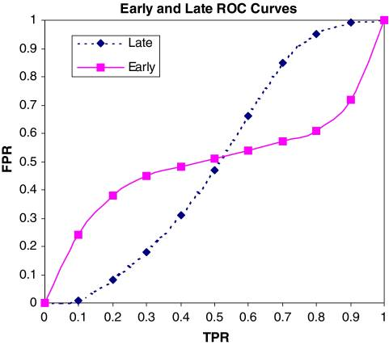Figure 3: Example ROC plots for “early” and “late” methods

Alternatives
It is against this backdrop that metrics such as RIE [2] and BedROC [3] were developed. In both cases the essential idea is to give early rankings of actives more weight than late rankings.

Robust Initial Enhancement (RIE)
Robust Initial Enhancement. RIE, developed by Sheridan et al.[2], is a metric using a continuously decreasing exponential weight as a function of rank. The original discrete formula is given below:

- is a rank of the i-th active
- is a number of elements
- is a number of actives
- is an exponential factor
- angle brackets means averaging
- subscript means that it is over a uniform distribution.
The curve in Figure 4 indicates the maximum value of the RIE metric if a perfect ordering is obtained from a ranking method [3].
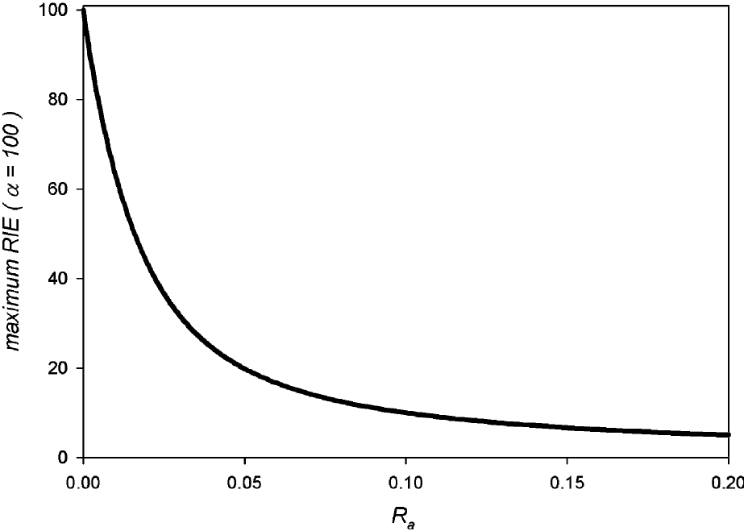Figure 4: RIE maximum as a function
of the ratio of actives Ra with a=100.

Boltzmann-Enhanced Discrimination of ROC (BEDROC)
Boltzmann-Enhanced Discrimination of ROC (BEDROC), developed by Truchon et al.[3]. The original discrete formula is given below:

В отличие от RIE, диапазон значений BedROC находится в интервале от 0.0 to 1.0, что достаточно удобно для сравнения результатов различных исследований. However, как и в случае RIE there would still remains the issue of the arbitrariness of the exponential factor . There is nothing intrinsically wrong with the freedom to select a threshold that is of interest to the particular research group. Some companies might have the facility to physically screen ten percent of their database, another only one percent. However, as a characteristic of a method, or a class of methods, it is a disadvantage. A proponent of a method has a free parameter with which to make their method look favorable or even just less unfavorable.

Common properties of RIE and BedROC
In RIE/BedROC actives are given a weight depending on their position in the list using an exponential function running from 1.0 for the top ranked compound to a number typically close to zero for the lowest ranked. The exponential factor, beta, determines how fast this exponential dies away from the top rank and controls how much the RIE/BedROC parameter focuses on the top of the list. The larger beta the greater the early focus. In RIE the sum of active weights is normalized by the RIE of a random distribution of actives. In BedROC normalization is by the maximum dynamic range, i.e. the score with all the actives ranked at the top minus the score with all the actives ranked at the bottom. In addition, by first subtracting the score of the worst-case scenario, BedROC has the elegant property of running from 0.0 to 1.0. The rational behind using these approaches is to give precedence to actives ranking early but not to fall into the trap of choosing a single enrichment value, i.e. be more robust to perturbations in the rank ordering.

Are they better as AUC?
So does BedROC or RIE qualify as a good metric for virtual screening? RIE suffers from having an ill-defined numerical interpretation (i.e. how good is an RIE of 5.34?). BedROC attempts to overcome this by scaling between 0.0 and 1.0, but does this qualify as being understandable? There is no absolute, interpretable meaning to a BedROC (or RIE) number, only a relative meaning when ranking methods.
Suppose the structure of virtual screening does favours early enrichment. Can we at least say metrics such as RIE and BedROC are superior to AUC? If the early behaviour shown in Fig. 3 were indeed repeated from system to system then clearly this would be the case [1].

In Fig. 5 we show data from Warren et al. for twenty docking procedures averaged over all eight targets in the study. Examination of these curves reveals nothing that resembles the biphasic nature anticipated from Fig. 3. Individual curves might occasionally suggest biphasic behaviour but there is little evidence for this in target-averaged ROC curves.
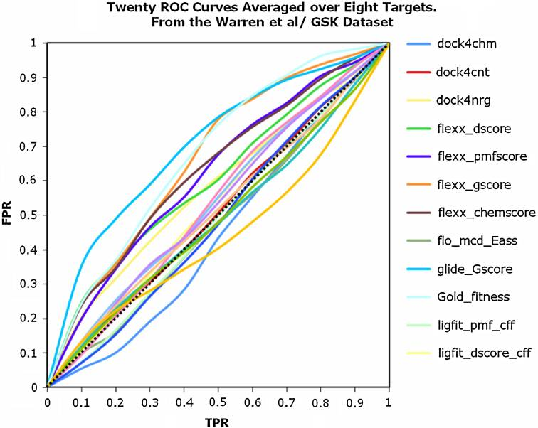Figure 5: Averaged ROC curves for twenty methods in the Warren study for which scores for all eight targets where available. Programs and scoring functions listed to the right of the graph

The curves in Fig. 6 are smoother because the averaging across forty targets in DUD is more extensive than the eight from GSK and show even less evidence of biphasic behavior. There are two possibilities for these observations. Either the individual curves are not biphasic or the averaging dilutes this characteristic. It is possible to imagine a technique that would rank one type of actives well, perhaps hydrophobic moieties, but ranks others badly, e.g. hydrophilic ones, but that the proportions of each set differ target to target such that the total behavior appears monophasic. To see if this might be the case we examined two hundred and seventy virtual screens from the Warren study, looking for a divergence between BedROC, with exponential parameter 5.0, and AUC, i.e. an abnormally low AUC and a high BedROC, although possibly the reverse. The results are shown in Fig. 7.
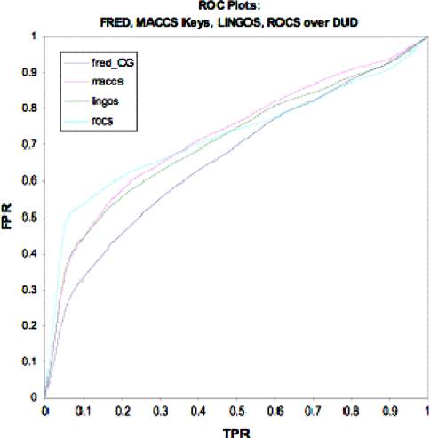Figure 6: Average ROC curves for FRED, ROCS, MACCS keys
and LINGOS over DUD, with DUD-self decoys.
FRED was run with the ChemGauss3 scoring function
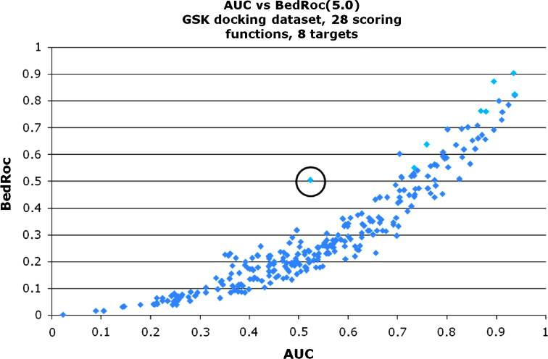
Clearly there is a strong correlation between BedROC and AUC. Similar correlations were also seen when higher exponential factors were employed and suggest no evidence for biphasic behaviour. A better AUC naturally leads to a better BedROC value and does so with surprisingly little variation. It might still be possible that one of the methods has average biphasic behaviour, for instance if all the BedROC/AUC points for a method trended higher.
Figure 7: BedROC scores with anexponential
factor of 5.0 versusthe AUC for
270 virtual screensfrom the Warren study
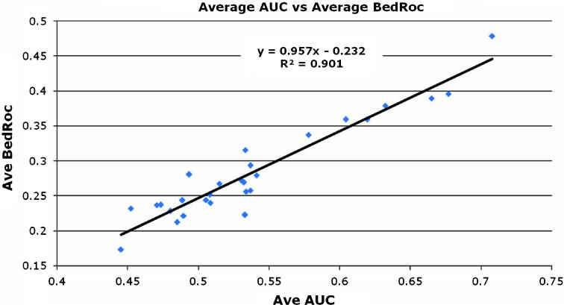
Figure 8 shows this is not the case. Here, the average AUC per method is compared to the average BedROC value for that method. In addition, the correlation is stronger the better the BedROC value, so that methods that have a good AUC will also have a (strongly correlated) good BedROC score.
Figure 8: Figure 9. The average AUC for each method run against all eight targets in the Warren study versus the averaged BedROC score for each such method.

Cost structure of Virtual Screening
There is no fundamental meaning to BedROC or RIE. Neither gets to the real heart of why the solid curve in Fig. 3 represents a better method than the dashed curve. In what follows we will argue that this can be stated with respect to a set of assigned costs, assumed but never stated.
The assignment of a cost structure to the components of a screen is common in the field of medical diagnostics. Here the costs can be estimated with some reliability. A true positive represents the successful diagnosis of a condition that will save money when treated. A false positive means further, costly, tests will need to be performed. A false negative might cost a lot if a more severe condition develops. Finally, a true negative can be set to the cost of the test or a small saving if compared to a more expensive test. If these values are assigned to each “truth table” component (TP, FP, TN, FN), a ROC curve can be transformed into a cost curve. A small caveat is that the ROC curve deals with true and false positive rates and so to transform to real costs the expected number of actives and inactives is required, or at least the ratio of the two.
Suppose we apply a cost structure to Fig. 3 as follows:
TP | 8,0
FN | -2,0
FP | -0,16
TN | 0,02

Let us assume, then:

This is a simple linear scaling of the graphs in Fig. 3, as shown in Fig. 10.
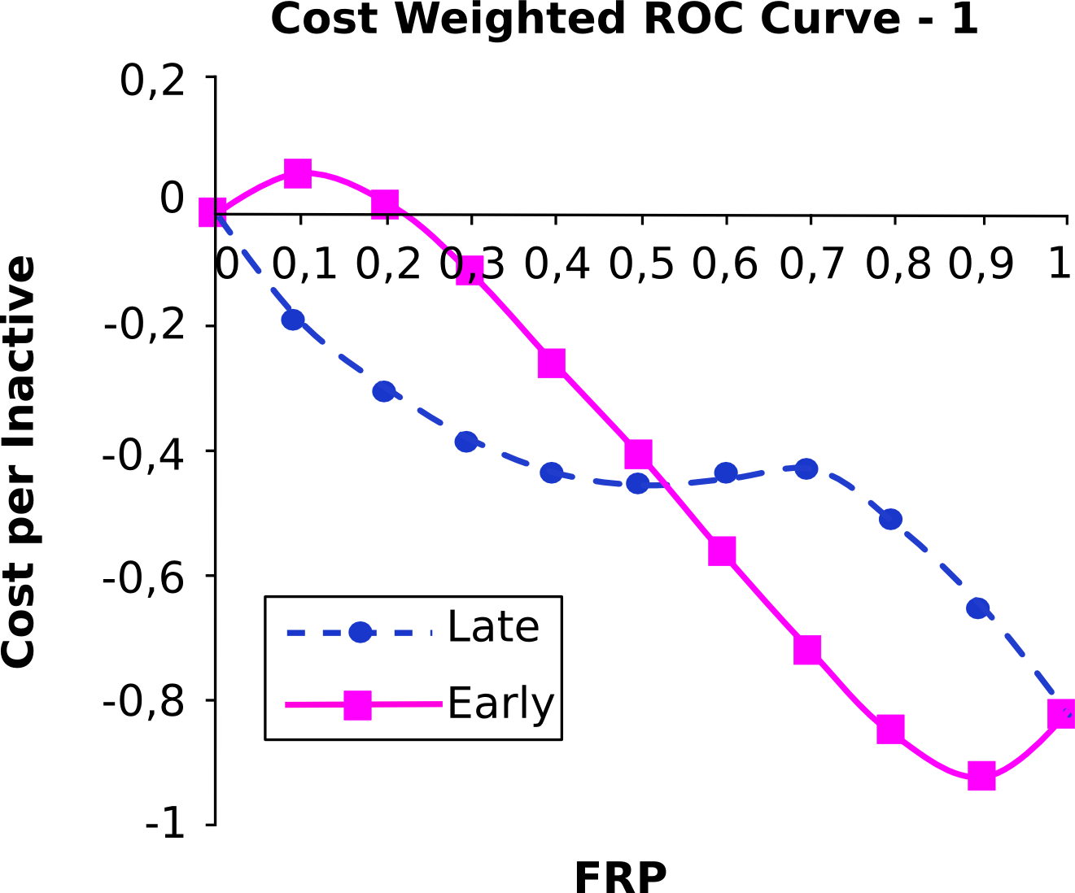
As expected, the best approach is to take the method with early performance over the later performance. Notice that the late performing method is never cost effective and even the early method is only cost effective for a narrow range of rankings.
Figure 10: Cost weighted versions of the curves in Figure 3
as per the first description in the text.
Now consider a slightly difference weighting:

TP | 8,0
FN | -2,0
FP | -0,04
TN | 0,03

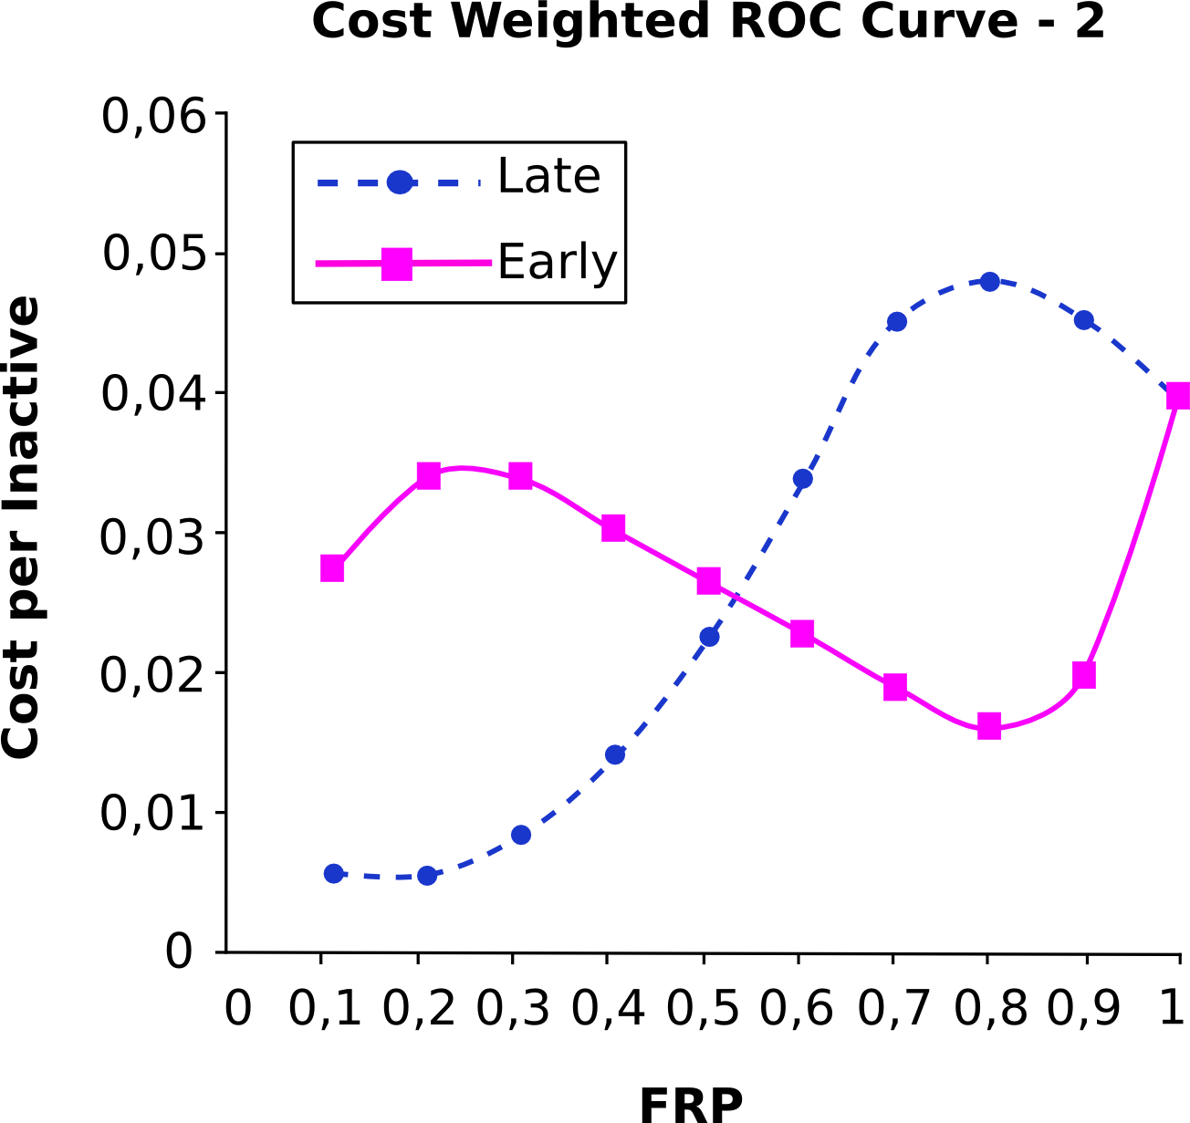
Figure 11: Cost weighted versions of the curves in Fig. 3
as per the second description in the text
Figure 11 illustrates the effect of these new weightings. By reducing the cost of a false positive by 75%, i.e. to around the savings of a true negative, both methods are always cost effective. Furthermore, although the early method has a clear maximum at around 20% of the database.

Assumptions
These examples are obviously only illustrative, but the point they make is real. Early enrichment is important only because of an assumed cost structure. Clearly much more complicated models could be constructed, possibly with real data, as with medical tests. However, to the author’s knowledge this has never been published, presented or even discussed within the industry. It is an assumption that early enrichment is better. Likewise, it is also an assumption that virtual screening itself is a productive exercise compared to physical screening.

Conclusions
In the current report we have examined the evaluation techniques applied to virtual screening, including new approaches such as RIE and BedROC, так же была предложена использования как метрики структуры стоимости Virtual Screening. Despite the great importance of a virtual screening in a drug development process, still there are no well-established and generally accepted approaches for method evaluation in this field, which is always the case for a young and developing industry. Also an attempt was made to link an evaluation of a method effectiveness to a real cost structure when developing a new drug. This approach demonstrates all benefits of using virtual screening, it translates abstract numerical metrics into a real cost structure that allows not only researchers that conduct the screening to evaluate the method effectiveness , but also allows people who are not engaged in this field to do so.

References
- Nicholls A (2008) What do we know and when do we know it?
J Comput Aided Mol Des 22:239–255
- Sheridan RP, Singh SB, Fluder EM, Kearsley SK (2001) Protocols for bridging the peptide to nonpeptide gap in topological similarity searches. J Chem Inf Comput Sci 41(5):1395–1406
- Truchon J-F, Bayly CI (2007) Evaluating virtual screening methods: good and bad metrics for the ‘‘early recognition’’ problem.
J Chem Inf Model 47(2):488–508
- Rester, U (July 2008). "From virtuality to reality - Virtual screening in lead discovery and lead optimization: A medicinal chemistry perspective".
Curr Opin Drug Discov Devel 11 (4): 559–68
- Rollinger JM, Stuppner H, Langer T (2008). "Virtual screening for the discovery of bioactive natural products".
Prog Drug Res. Progress in Drug Research 65 (211): 213–49
- Huang N, Shoichet BK, Irwin JJ (2006) Benchmarking sets for molecular docking.
J Med Chem 49(23):6789–6807
- Warren GL, Andrews CW, Capelli AM, Clarke B, LaLonde J, Lambert MH, Lindvall M, Nevins N, Semus SF, Senger S, Tedesco G, Wall ID, Woolven JM, Peishoff CE, Head MS (2006) A critical assessment of docking programs and scoring functions.
J Med Chem 49(20):5912–5931

DUD dataset [6] of Irwin et al. Here, for each target thirty-six decoys are found for each active by matching physical properties, forming a mimetic set referred to as DUD-self. The combined set, i.e. across all targets is drug-like and is referred to as DUD-all.
GlaxoSmithKline plc (GSK) is a British multinational pharmaceutical, biologics, vaccines and consumer healthcare company which has its headquarters in Brentford, London.

