The Fiscal Consequences of AI Automation
A multi-actor accounting model of United States federal and state revenue under labor-displacing artificial intelligence — data, equations, and findings across seven literature-anchored scenarios.
Abstract. We build a bottom-up accounting model of what AI-driven labor displacement does to the United States fiscal system. The model prices displacement one occupation-by-state cell at a time — exact tax-schedule re-evaluation, means-tested transfer cliffs integrated over within-cell wage distributions, two unemployment-insurance phases — then wraps those per-worker fiscal deltas in a dynamic multi-actor system: firms dispose of the saved wage bill into profit, prices, and survivor raises; a compute-capital pool absorbs automation spending at capital tax rates; the federal ledger runs deficits while all fifty-one state and local systems must balance each year; and a second-round demand channel converts standing income withdrawal into induced layoffs. Every period of every run satisfies eight conservation identities, and the full system reduces bit-for-bit to a hand-checkable static kernel when the behavioral levers are switched off. We run the model through seven scenarios anchored to the empirical and theoretical literature — from Acemoglu's deliberately modest bounds to a five-year artificial general intelligence transition — each with Monte Carlo uncertainty bands, and through four composable policy overlays (two robot taxes at literature-optimal rates, a universal basic income, and compute-pool tax parity). Three findings organize the results: the tax base migrates from labor to capital faster than output falls; revenue falls faster than employment; and the states, which cannot print or borrow, act as an asymmetric amplifier — hiking rates until caps bind, then cutting spending, which feeds back into demand. Literature-optimal robot taxes recover only a small share of the fiscal gap in every scenario. All numbers in this document are generated by a seeded, reproducible pipeline; the build stamp appears in the footer.

1. Introduction and summary of findings
The question this model answers is narrower and more concrete than "what will AI do to the economy": if AI automates some share of the work Americans currently do, what happens to the public finances that depend on that work being done by taxed humans? The United States raises roughly $4,983 billion of federal revenue and $3,515 billion of state and local revenue against a $15.0 trillion compensation base. Eighty-four percent of federal receipts come from individual income and payroll taxes — taxes on people being employed. When a job is automated, the wage disappears from that base, but the value the job produced does not disappear: it re-emerges as corporate profit, lower prices, or capital income, each taxed at a different — usually lower, and sometimes zero — effective rate. The fiscal question is therefore an accounting question about base migration, and this model is built as an accounting machine first: every dollar of displaced compensation is tracked to a destination, every destination has a tax treatment, and the books are forced to balance by construction.
Three theses organize everything that follows.
- The tax base migrates from labor to capital. The saved wage bill flows to retained profit
(taxed at effective corporate rates near 17–18 percent), to price reductions (taxed at roughly 2 percent through state consumption taxes, and not at all federally), and to compute capital (taxed at an effective rate near 5 percent post-TCJA). Every one of those destinations yields the government less than the 25–40 percent combined marginal wedge on the wages they replace.
- Revenue falls faster than employment. Displacement is not uniform: AI exposure concentrates
in above-median-wage occupations, so the workers displaced first carry more than their per-capita share of income tax. Progressive rate schedules do the rest.
- The states are the asymmetric amplifier. The federal government meets lost revenue with
deficits. The states cannot: they must close their gaps each year by raising rates on a shrinking base or cutting spending, and both responses withdraw demand from the same economy that is shedding jobs, feeding back into further displacement.

1.1 What the model is
The model is a two-layer system. The static kernel computes, for each of roughly 33,000 occupation-by-state cells, the exact fiscal delta of removing one worker: federal and state income tax from hand-rolled bracket schedules, payroll tax with the OASDI cap, means-tested transfers (Medicaid, SNAP, EITC, CTC, ACA, SSI, TANF) from an offline PolicyEngine bake integrated over the within-cell wage distribution, a consumption-tax channel, and a corporate offset. The dynamic layer turns those deltas into a multi-actor simulation: a seven-state worker stock-flow machine, a firm disposition router, a compute-capital pool, survivor wage dynamics, a price and productivity macro block, the federal debt ledger, a fifty-one-state balanced-budget closure, and a lagged demand feedback. Section 4 walks the within-period sequence; Appendix A carries the full equation reference.
Two design disciplines distinguish the exercise. First, conservation: eight identities (worker headcounts partition the baseline; the disposition of the saved bill sums exactly; the federal deficit reconciles to its labeled components; state gaps close to numerical residual zero; and so on) are asserted on every period of every run, including every Monte Carlo draw sampled for this report. Second, reduction: with every behavioral lever switched off, the dynamic system reproduces the static kernel bit-for-bit — an anchor that pins the elaborate machinery to a hand-checkable base case. Section 5 states the identities precisely.

1.2 What the model is not
It is not a general-equilibrium forecast. There is no monetary policy block, no endogenous interest rate, no behavioral response of automation investment to taxation, and no representation of within-job augmentation (a worker made more productive but not displaced). Prices deflate reported real aggregates but are never injected into nominal tax computations. Section 10 lists every known simplification with its direction of bias; the external-validation exercises in Section 9 quantify how far these omissions move the results relative to models that make the opposite choices.

1.3 The scenario space and the headline result
Rather than defend one forecast, the model ships seven scenario presets, each anchored lever-by-lever to a specific literature (Section 6): Acemoglu's deliberately modest bounds; an augmentation-leaning reading of the Brynjolfsson micro-evidence; the Windfall Trust's medium displacement scenario (our closest external comparator); a "China-shock grind" that pairs a moderate shock with the slow, scarring labor-market adjustment Autor, Dorn, and Hanson actually measured; Korinek and Suh's twenty-year and five-year AGI transitions; and the AI Futures Project's fast takeoff. Government policy composes separately as overlays — two robot taxes at literature-optimal rates, a universal basic income with recapture, and compute-pool tax parity — so that each scenario answers "what does the world do to the budget" and each overlay answers "what does policy recover."
Table 1 — Cross-scenario comparison: final-year outcomes with Monte Carlo P10–P90 bands (N=1000, seed 0). Net fiscal impact is the signed change in the federal balance (negative = worse); the band applies to the final-year federal deficit change.
Preset | Horizon | Employment | Net fiscal (final yr) | Deficit %GDP | Debt Δ | State gap | Final deficit P10–P90
① Acemoglu — Modest AI | 10y | −3% | +12 | 4.4% | 33 | 7 | -18 … -3
② Brynjolfsson — Augmentation | 10y | −6% | +72 | 3.9% | -214 | 6 | -91 … -53
③ Windfall Trust — Medium | 10y | −21% | -208 | 4.7% | 1,830 | 88 | 137 … 285
④ China-Shock Grind | 15y | −19% | -624 | 5.1% | 5,059 | 123 | 384 … 803
⑤ Korinek-Suh — AGI in 20 years | 20y | −99% | -1,882 | 2.6% | 35,961 | 533 | 1,599 … 2,142
⑥ Korinek-Suh — AGI in 5 years | 10y | −100% | -2,567 | 4.6% | 23,245 | 628 | 2,257 … 2,889
⑦ AI 2027 — Fast takeoff | 8y | −99% | -2,204 | 5.0% | 12,549 | 606 | 1,852 … 2,328

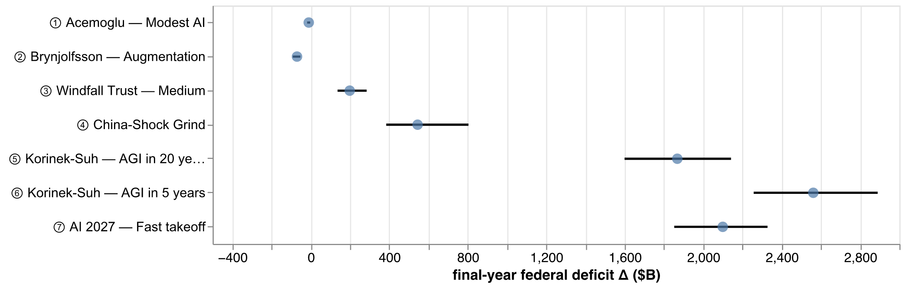
Figure 1 — Final-year federal deficit change by scenario: P10–P90 range (rule) and median (dot) across 1000 Monte Carlo draws per scenario.
The range is the finding. A world that stays inside Acemoglu's bounds is fiscally almost invisible — the deficit change turns negative (a small improvement) by the end of the decade as capital-side recoveries outgrow modest labor losses. A world in which the Korinek–Suh five-year transition happens is a fiscal regime change: employment falls 100 percent, the federal deficit widens by $2,567 billion in the final year alone, and cumulative new federal debt reaches $23,245 billion inside ten years. Between those poles, the scenarios differ not mainly in how much work is automated but in what the labor market and the firms do with it — reabsorption rates, wage scarring, and the disposition of the saved wage bill move the fiscal outcome as much as the displacement share does. The Monte Carlo tornados in Section 7 make that attribution precise, and the policy analysis in Section 8 shows that the taxes the optimal-taxation literature actually recommends recover only a small fraction of the gap in every scenario where the gap is large.

1.4 How to read this document
Sections 2–5 are the model: data, kernel, dynamics, and the correctness discipline. Section 6 is calibration. Sections 7–9 are results: the seven scenarios, the policy overlays, and validation against external models (RAND, Windfall Trust, Acemoglu). Section 10 is the honest-limitations table. Every model-derived number in the text, including those in this introduction, is resolved at build time from a manifest generated by a seeded pipeline (Appendix D); numbers cannot drift from the model without breaking the build.

2. Data
The model is anchored to the 2024 United States economy as measured by the statistical agencies, with every input file carrying control totals that the loader asserts on every run — a load that does not reconcile to the published aggregates fails before a single scenario is computed.

2.1 Sources
Input | Source and vintage | Role
Employment × industry matrix | BLS OEWS 2024, interior aligned to BEA 2024 industry totals | 833 occupations × 71 industries; employment and compensation
State wage distributions | BLS OEWS May 2025 | 51 jurisdictions × 822 occupations; mean wages and p10–p90 percentiles
AI exposure | Yale Budget Lab PCA | standardized cognitive-exposure score per occupation
Robot exposure | Webb (2020) robot-patent measure | physical-automation feasibility per occupation
Capital income by sector | BEA 2024 NIPA | value added, capital share, corporate profits, effective corporate rates
Government fiscal accounts | BEA 2024 national accounts | receipts by stream (federal and state-local), 17 transfer programs, base-linkage effective rates
Consumption tax base | state PCE and taxable-base analysis | effective consumption tax rate per state
Household archetypes | ACS PUMS 2024 (WGTP-weighted) | filing-status mix and household income by occupation × state; children distribution
Tax schedules | 2025 federal / 2026 state brackets; FICA parameters | the hand-rolled tax engine
Benefit lookup | PolicyEngine-US, baked offline | means-tested benefits as a function of (state, filing, children, income)

2.2 Control totals
The loader asserts, among others: total employment 163.2 million; total compensation $15,049 billion; value added (GDP proxy) $29,298 billion; federal receipts $4,982.8 billion; state and local receipts $3,515.0 billion; Medicaid outlays $938.2 billion; corporate profits before tax $3,722 billion. The baseline federal deficit is anchored at $1,833 billion. These are the denominators for every percentage in this report.

2.3 Validation gates
Four checks connect the constructed inputs to independent references.
- Tax cross-check. The hand-rolled bracket engine is compared to PolicyEngine-US on a grid of
incomes, states, and filing statuses: income tax agrees within 2.5 percent (a 2024/2025 bracket vintage gap), payroll tax exactly (excluding state disability insurance, which the model does not levy).
- The kink test. Fiscal deltas computed at the within-cell mean wage understate the
integrated delta by a factor of 2.7–7.8 in cells whose wage distribution straddles a means-tested eligibility threshold. This is the empirical justification for Section 3's within-cell integration: the EITC hump, the SNAP phase-out, and the Medicaid cliff are exactly where displacement lands, and evaluating at the mean silently steps over them.
- Aggregate transfer reconciliation. Population-weighting the baked benefit entitlements
reproduces the working-family program aggregates (EITC plus refundable CTC: $228.8 billion actual) and deliberately undershoots the aged/disabled-dominated programs (Medicaid, SSI), which the working-household bake does not represent. The reconciliation validates marginal mechanics, not program levels; Section 10 carries the caveat.
- The t = 0 base-rate gate. Before any displacement, the dynamic model must reproduce the
published base-linkage effective rates — individual income receipts at 19.5 percent of the wage base, with payroll and corporate rates matched to their published rows — tying the simulated economy's starting point to the national accounts.

2.4 From files to per-worker deltas
The construction pipeline joins occupation × state wage distributions to household archetypes (filing status, household income, number of children from ACS PUMS), evaluates the five kernel channels of Section 3 on a frozen quadrature grid over each cell's lognormal wage distribution, and caches the result: one vector of per-worker fiscal deltas per (occupation, state) cell, by channel and by benefit program. The dynamic layer never re-derives these; it prices worker stocks against frozen per-worker deltas and recomputes only what the levers actually move (survivor wages, re-employment wages, and the government ledgers). That split is what makes a 33,000-cell model run a full scenario in a quarter of a second.

3. The static kernel: pricing one displaced worker
The kernel answers a single question exactly: if this worker, in this occupation and this state, loses this wage, what happens to every level of government? Five additive channels, each an independently inspectable ledger line.
Δfiscal(cell) = Δincome_tax + Δpayroll + Δtransfers + Δconsumption_tax + Δcorporate_offset
Income tax is computed by exact re-evaluation of the bracket schedules — federal 2025 and state 2026, stratified by filing status — at household income with and without the worker's wage: T(HH) − T(HH − w). No elasticities, no average rates; the marginal dollars come off the top brackets first, which is precisely why revenue falls faster than employment when displacement skews high-wage.
Payroll applies the FICA schedule to the worker's own wage with the OASDI cap and the additional Medicare rate — exact, not linearized, because the cap makes the schedule kinked in exactly the wage range where AI exposure peaks.
Transfers are the reason the kernel integrates rather than averages. Means-tested programs are step functions and humps: Medicaid eligibility is a cliff, SNAP phases out, the EITC rises then falls. The kernel evaluates the baked PolicyEngine entitlement schedules at household income including unemployment insurance during the UI window and at zero worker earnings after exhaustion — two distinct fiscal phases, because the Medicaid/SNAP step-up mostly arrives at UI exhaustion, not at displacement. And it evaluates them as an expectation over the within-cell lognormal wage distribution fitted to the OEWS percentiles, not at the cell mean: the kink test (Section 2.3) shows the at-mean shortcut understates transfer deltas by up to a factor of eight in threshold-straddling cells.
Consumption tax applies each state's effective consumption tax rate to the change in taxable consumption implied by the change in disposable income, with a marginal propensity to consume of 0.95 and a stickiness parameter for the transition.
The corporate offset is the first appearance of the base-migration thesis: the compensation a firm stops paying does not vanish — absent other dispositions it becomes operating surplus, taxed at the sector's effective corporate rate. The kernel books this at the most generous plausible rate (full conversion of saved compensation to taxable surplus) as a deliberate steelman: even with the most optimistic corporate recapture, the wedge between labor and capital taxation leaves the government short.
The per-worker deltas from these five channels — 33,000 cells, seven benefit programs, two UI phases — are precomputed once and cached. Everything dynamic in the next section is stock-flow arithmetic on top of them.

4. The dynamic multi-actor model
The dynamic layer runs the economy forward one year at a time. Workers move through seven states; firms route the saved wage bill; the compute pool accumulates; survivor wages update under an explicit budget constraint; the federal government borrows; the states balance; and the demand consequences of all of it come back one period later as induced layoffs. This section walks one period in execution order. Appendix A carries the complete equation reference; here we state the load-bearing mechanics.

4.1 Workers: seven states and a diffusion ceiling
Each occupation × state cell tracks seven mutually exclusive stocks — employed, on unemployment insurance, exhausted (post-UI), reabsorbed (re-employed at a lower wage), exited (out of the labor force onto SSDI), induced (laid off by second-round demand), and retired (natural attrition of the long-term unemployed, fiscally delta-neutral because the baseline counterfactual retires too). Their sum equals baseline employment in every cell in every period — conservation identity C1.
Automation displacement follows a cumulative diffusion ceiling, not a compounding rate:
g_cell(t) = 1 − (1 − cog·cf) · (1 − rob·pf · min(1, t/robotics_lag))
target(t) = clip(g_cell(t) · adoption(t), 0, 1) · emp0
flow(t) = clip(target(t) − auto_disp, 0, employed)
adoption(t) is the cumulative share of feasible work automated by year t — a ceiling against baseline employment, so "60 percent by year ten" means exactly that, not 60 percent per year compounding on a shrinking base. The two feasibility channels — cognitive (Yale exposure × cognitive feasibility) and physical (Webb robot exposure × robotics feasibility) — combine multiplicatively, and the physical channel ramps in linearly over robotics_lag years: physical automation waits for AI-built industrial capacity.
Displaced workers draw UI for the statutory window, then exhaust; the exhausted are reabsorbed at reabsorption_rate per year into re-employment at max(origin_wage·(1−haircut), service_floor) — the permanent scar the displacement literature measures — or exit the labor force at lfp_exit_rate onto SSDI at $18,000 per year.

4.2 Firms: the disposition router
The firm side is keyed to the cumulative automated stock, not to worker states — a job stays automated when its former holder finds other work. Each period the automated stock's compensation defines the saved bill, and an explicit partition routes it:
saved_bill = Σ_automated comp_per_worker
automation_spend = auto_cost · saved_bill → the compute-capital pool
net_saving = saved_bill − automation_spend (≥ 0 by construction)
net_saving = retained_profit + price_reduction + survivor_gains (shares sum to 1)
Retained profit is taxed at sector effective corporate rates. Price reductions accrue to consumers — taxed only through the ~2 percent state consumption channel, the quantitatively dominant leak in the base-migration story. Survivor gains fund wage raises for the still-employed (below). The compute pool is taxed at compute_effective_rate (5 percent in the AGI presets, per the effective post-TCJA rate on equipment and software capital), with an optional offshore leakage share that is zero in every shipped scenario.

4.3 Survivors: the funded wage index
Workers who keep their jobs may capture part of the surplus. The mechanical component is funded: the routed survivor_gains flow must first pay the maintenance cost of the standing raise before any increment, and unfundable raises snap back —
maintenance = ℓ · wage_bill · (W − 1) ℓ = compensation loading ≈ 1.4
available = survivor_gains − maintenance
W ← W + min(available, room)/(ℓ·wage_bill) room = ℓ·wage_bill·(ceiling − W)
with the overflow above the raise ceiling routed to profit or prices by the spillover lever. A market component responds to labor-market slack with elasticity survivor_elasticity (negative: substitution pushes wages down; positive: complementarity pulls them up), evaluated on lagged slack so the system never solves a within-period fixed point. Survivor raises are re-taxed through the exact bracket schedules — the one channel where displacement creates labor-side revenue.

4.4 Government: one borrower, fifty-one balancers
The federal ledger nets every labeled flow — income and payroll losses, transfer and UI outlays, UI benefit taxation, the corporate offset, survivor wage taxes, compute-pool tax, robot tax, UBI gross and recapture, SSDI — into a deficit that accumulates into debt at the federal interest rate. The reconciliation of that deficit to its components is asserted every period (C6).
The states cannot borrow. Each period, each state's revenue loss net of its recoveries defines a gap that must close: rate increases on the remaining labor-income base up to a feasibility cap, then forced spending cuts for whatever the cap leaves. The closure is solved per state (one Newton step on the post-recomputation base, residual asserted ≈ 0, identity C7), and its real economy consequences — spending cuts at a government-spending multiplier, rate hikes at the household MPC — are not free: they enter the demand channel below, in the state where they happen.

4.5 Demand: a level-targeting controller
Second-round demand is modeled as a stock, not a ratchet. The standing net income withdrawal — take-home pay lost by every non-employed stock, minus UI and transfers actually received, minus UBI net of recapture, minus survivor raises — defines a target level of induced layoffs through an Okun-style multiplier; the induced stock adjusts toward that target with a one-period lag, and releases workers back when the withdrawal shrinks (a UBI visibly re-employs induced workers). The loop gain is provably below one at every shipped configuration, so the feedback converges geometrically instead of spiraling — and the model asserts this at construction rather than trusting it.

4.6 Prices and productivity
Automation deflates prices through the price-reduction disposition (pass-through configurable) and raises real output through an output-weighted productivity dividend (full automation of the compensation bill raises GDP by productivity_passthrough). Both are reporting-layer effects by design: the price level deflates real and percent-of-GDP columns but is never injected into nominal tax computations — a discipline (the "A2 rule") that prevents double-counting deflation through bracket schedules that are nominally indexed in reality. The consequences of this choice for external comparability are quantified in Section 9.

5. Correctness discipline
A model whose output is an accounting claim should be held to accounting standards. Two mechanisms do that here: conservation identities asserted at runtime, and an exact reduction anchor.

5.1 The conservation battery
Eight identities hold on every period of every run — including every Monte Carlo draw sampled for this report, and including the presentation layer (the fiscal summary tables in Section 7 assert their own reconciliation before rendering):
- C1 (headcount). The seven worker stocks sum to baseline employment in every occupation ×
state cell, every period. No worker is created, destroyed, or double-counted.
- C2 (disposition partition). `automation_spend + retained_profit + price_reduction +
survivor_gains = saved_bill`, per sector, per period — every saved dollar has exactly one destination.
- C3 (compute pool). Pool tax equals the domestic inflow times the effective rate; leakage is
metered, not lost.
- C4 (deflation). Real aggregates equal nominal divided by the price level — the price channel
cannot double-apply.
- C5c (funded raises). Survivor wage cost plus overflows exactly equals the routed survivor
gains, in every branch of the funding logic — raises cannot be paid out of nothing.
- C6 (federal reconciliation). The federal deficit equals the signed sum of its thirteen
labeled components. Any new fiscal flow that is not added to the reconciliation breaks the build, which is the point: the ledger cannot silently drop a leg.
- C6-state / C7 (state composition and closure). Each state's revenue change is composed from
its labeled parts before the balanced-budget solve, and the solve closes the gap to numerical residual zero.
- C8 (reduction). With every behavioral lever at its off value, the full multi-actor system
reproduces the static kernel's dynamic wrapper bit-for-bit — not approximately: the test is exact float equality across output columns, and it is differential (v2 against v1 run on the same inputs), so shared re-bases cannot mask a divergence.

5.2 Why C8 matters
Every behavioral mechanism in Section 4 is gated by a lever whose off value removes it exactly. That means the elaborate system is pinned, at a reachable point of its configuration space, to a small model that can be checked by hand against the national accounts (the t = 0 base-rate gate of Section 2.3). Complexity added above that anchor must justify itself lever by lever, and a regression anywhere in the machinery — including refactors that merely change floating-point operation order — is caught as a bit-level diff. The Monte Carlo machinery is held to the same standard: the fast path that re-binds lever values onto a prebuilt model is verified to reproduce fresh construction exactly, so 1,000-draw uncertainty bands are 1,000 real model runs, not an approximation of them.

5.3 Test surface
The repository carries 245 regression tests: the conservation battery across lever sweeps, numeric anchors for each kernel channel, the displacement-literature behavioral pins (attrition lowers the deficit; a job stays automated after its worker is reabsorbed; a stationary shock produces a stationary induced-layoff stock), sampler domain properties for the Monte Carlo, UI-grid representability and provenance completeness for every scenario preset, and the C8 sweep. The artifact pipeline that generated every number in this document is seeded and re-runs deterministically; its build stamp is in the footer of every page.

6. Calibration: scenarios and policy overlays
The model has roughly thirty continuous levers. Rather than defend one setting, we anchor them to the literature — every anchor fetch-verified against the source text, with verbatim quotes and URLs preserved in the repository's evidence base — and package coherent configurations as presets. Three unit conversions recur and are worth stating once, because getting them wrong changes answers by an order of magnitude.
- Exposure is not feasibility is not adoption. Task-exposure measures (Eloundou et al.'s
"GPTs are GPTs") are time-savings potentials, agnostic between augmentation and substitution. We treat them as upper bounds on feasibility and let adoption — a cumulative ceiling with its own timeline — carry realized automation.
- Ad-valorem robot taxes are levied on robot spending, not on saved wages. The
optimal-taxation literature's "1–3.7 percent robot tax" (Costinot–Werning) applies to the price of automation inputs. On this model's saved-compensation base the equivalent rate is that number times `auto_cost` — roughly 0.3–1 percent, not 3 percent. Presets that skip this conversion overstate optimal robot-tax revenue by 10–25×.
- Present-value earnings losses bundle spells with scars. Davis–von Wachter's 1.4–2.8 years
of pre-displacement earnings include unemployment time the model prices separately through UI and reabsorption; only the long-run annual loss (10–20 percent, ten-plus years out) maps to the permanent re-employment haircut.

6.1 The seven scenarios
Each preset is a full lever configuration with per-lever provenance (the application surfaces the anchor sentence for every value; the evidence document carries the quotes). In brief:
- Acemoglu — Modest AI. His ten-year upper bounds at face value: 19.9 percent of the wage
bill exposed, 23 percent of exposed tasks profitably automatable within the decade, a 0.15 productivity pass-through implied by his TFP arithmetic, no wage response, and a normal labor market (Farber-central haircut 0.13, reabsorption 0.5/year).
- Brynjolfsson — Augmentation. AI complements more than it substitutes: adoption starts near
the realized pace measured in early payroll data (~2 percent cumulative), survivors capture a fifth of the surplus with positive wage complementarity, scarring is mild, and productivity pass-through is strong (the GenAI-at-Work gains).
- Windfall Trust — Medium. Their medium displacement scenario translated onto our levers: 60
percent of jobs exposed, half of exposed work automated over the decade, re-employment at 70 percent of prior wage, their high-value-capture disposition, and capital taxed at their 26.7 percent ETR. The direct external comparator (Section 9).
- China-Shock Grind. A moderate shock met by the labor market Autor, Dorn, and Hanson
actually measured: reabsorption at 0.075/year (decade-scale adjustment), labor-force exit the dominant margin, JLS-severity scarring, and full demand amplification, over fifteen years. The mechanism preset: displacement is moderate but nothing heals.
- Korinek–Suh — AGI in 20 years. Full automation over twenty years, wages collapsing before
the end, capital keeping the gains, states forced onto spending cuts.
- Korinek–Suh — AGI in 5 years. The aggressive transition as its own stress case: a kinked
adoption path reaching full automation at year five, viewed over a ten-year fiscal window.
- AI 2027 — Fast takeoff. The AI Futures Project's scenario shape: cognition maxes almost
immediately, robots ramp over three years through crash build-out, heavy compute investment, an eight-year horizon.
The as-shipped lever table for all seven appears in Appendix B.

6.2 The four policy overlays
Policy composes on top of any scenario and overrides the corresponding levers:
- Robot tax, Costinot–Werning optimal — 2.7 percent ad-valorem on robot spending (their
sufficient-statistic central value), converted through auto_cost.
- Robot tax, Guerreiro–Rebelo–Teles transitional — their 5.1 percent decade-one Mirrleesian
rate; their steady state is zero, and the overlay flags that holding decade-one constant overstates the tax beyond year ten.
- UBI — $12,000 per worker per year with 30 percent recapture (income-tax clawback per
Korinek–Lockwood's 0.25–0.375 range).
- Compute-pool parity — the compute-capital pool taxed like domestic capital (26.7 percent,
the Windfall capital ETR) instead of the 5 percent post-TCJA effective rate.
Scenarios ship with the robot tax at zero deliberately. The separation keeps the question clean: Section 7 reports what each world does to the budget; Section 8 reports what policy recovers.

7. Findings: seven worlds
Each subsection reports one scenario: the story its levers tell, its fiscal summary (revenue lines are signed changes, negative = lost revenue; the keystone row Net fiscal impact equals the signed change in the federal balance and reconciles exactly to the deficit by identity C6), the Monte Carlo fan around the federal deficit path (1000 draws, ±2σ-truncated relative perturbations of spread 0.15, seed 0), and the tornado attributing final-year deficit variance to individual assumptions. Dollar figures are nominal changes against the 2024 baseline; the fiscal summary "Total" column sums flow rows over the scenario horizon.

7.1 Acemoglu — Modest AI
If AI stays inside Acemoglu's ten-year bounds, the fiscal system barely notices. Employment falls 3.0 percent by year ten; the federal balance moves by +11.5 billion dollars in the final year — the sign is worth pausing on: after a decade of modest displacement met by a healthy labor market (half of the exhausted re-employed every year at a 13 percent haircut), the capital-side recoveries — corporate offset, compute-pool tax, survivor wage taxes — have grown past the shrinking labor losses, and the deficit change turns favorable. Cumulative new debt over the decade is 33 billion dollars — a rounding error against the $1,833 billion baseline deficit. The Monte Carlo band is correspondingly tight: the final-year deficit change spans -18 to -3 billion dollars between the 10th and 90th percentiles. The strongest single driver of that residual variance is reabsorption_rate (ρ = -0.64).
Table 2 — Acemoglu — Modest AI: fiscal summary ($B, condensed years; full table in Appendix C).
Line | Year 0 | Year 1 | Year 3 | Year 5 | Year 9 | Total
Income tax | -3.9 | -7.1 | -11.0 | -14.0 | -19.2 | -128.0
Payroll (FICA) | -3.8 | -6.9 | -10.4 | -12.9 | -17.0 | -117.7
Corporate recovery | 4.1 | 9.2 | 19.7 | 30.9 | 54.6 | 286.7
Compute-pool tax | 0.2 | 0.4 | 0.8 | 1.3 | 2.2 | 11.7
Survivor wage taxes | 0.4 | 0.9 | 2.0 | 3.2 | 5.6 | 29.5
Overflow corporate tax | 0.0 | 0.0 | 0.0 | 0.0 | 0.0 | 0.0
Automation (robot) tax | 0.0 | 0.0 | 0.0 | 0.0 | 0.0 | 0.0
UBI recapture | 0.0 | 0.0 | 0.0 | 0.0 | 0.0 | 0.0
Tax on UI benefits | 0.3 | 0.4 | 0.4 | 0.5 | 0.4 | 4.3
Δ Federal revenue | -2.7 | -3.2 | 1.5 | 8.8 | 26.6 | 86.4
Means-tested transfers | 1.6 | 3.0 | 4.6 | 5.6 | 7.0 | 50.2
Unemployment insurance | 3.2 | 3.8 | 4.2 | 4.5 | 4.4 | 43.0
SSDI | 0.0 | 0.2 | 0.9 | 1.7 | 3.7 | 16.4
UBI (gross) | 0.0 | 0.0 | 0.0 | 0.0 | 0.0 | 0.0
Δ Federal outlays | 4.7 | 7.0 | 9.6 | 11.8 | 15.1 | 109.5
Net fiscal impact (federal) | -7.4 | -10.2 | -8.1 | -3.0 | 11.5 | -23.2
Federal revenue (absolute) | 4,980.1 | 4,979.6 | 4,984.3 | 4,991.6 | 5,009.4 | 5,009.4
Federal deficit (absolute) | 1,840.4 | 1,843.2 | 1,841.1 | 1,836.0 | 1,821.5 | 1,821.5
Federal debt (Δ cumulative) | 7.4 | 17.9 | 37.1 | 48.2 | 32.9 | 32.9
Deficit (% of GDP) | 6.3 | 6.0 | 5.6 | 5.1 | 4.4 | 4.4
State income tax | -1.0 | -1.7 | -2.7 | -3.3 | -4.5 | -30.5
State consumption tax | -0.3 | -0.6 | -0.9 | -1.2 | -1.5 | -10.5
Survivor wage taxes (state) | 0.1 | 0.1 | 0.3 | 0.4 | 0.7 | 3.7
State transfers (outlay) | 0.4 | 0.9 | 1.3 | 1.5 | 1.9 | 13.7
Net fiscal impact (state) | -1.7 | -3.1 | -4.6 | -5.6 | -7.2 | -51.0

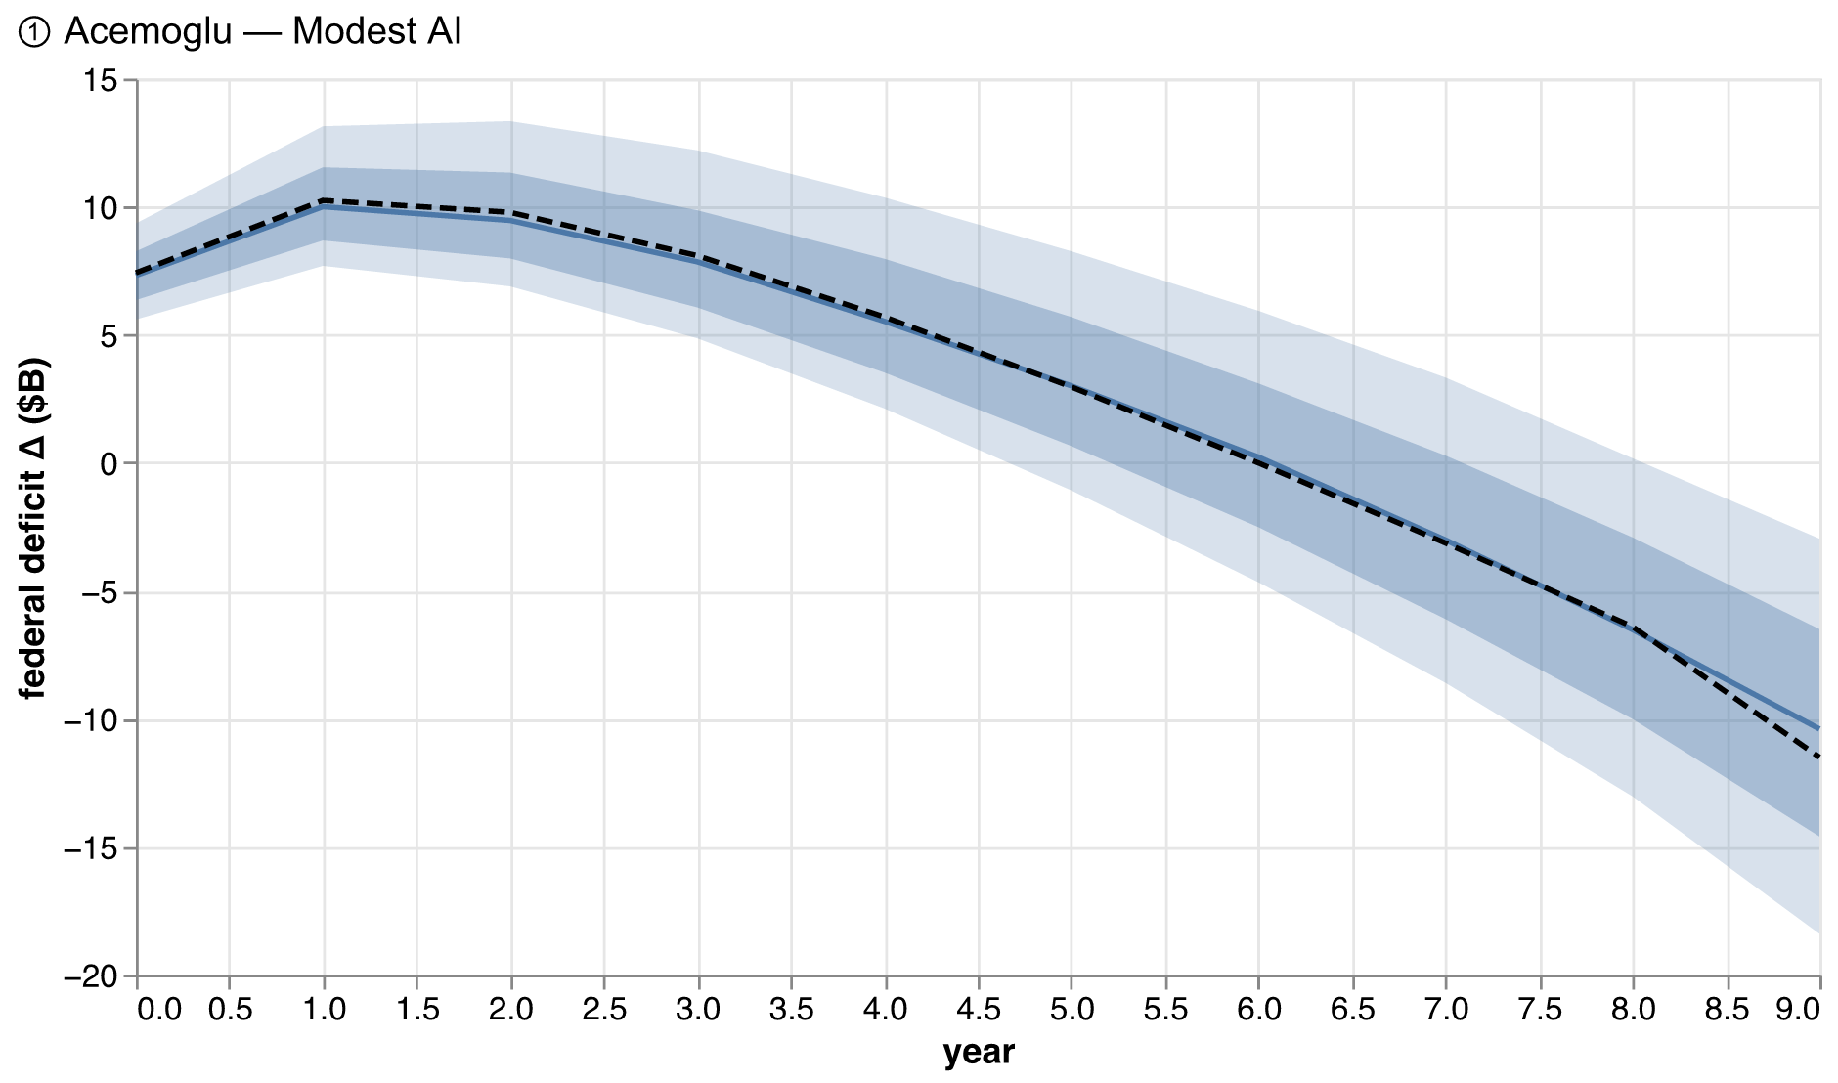
Figure 2 — Acemoglu — Modest AI: federal deficit change, Monte Carlo fan (P10–P90 and P25–P75 bands, median, dashed base run).
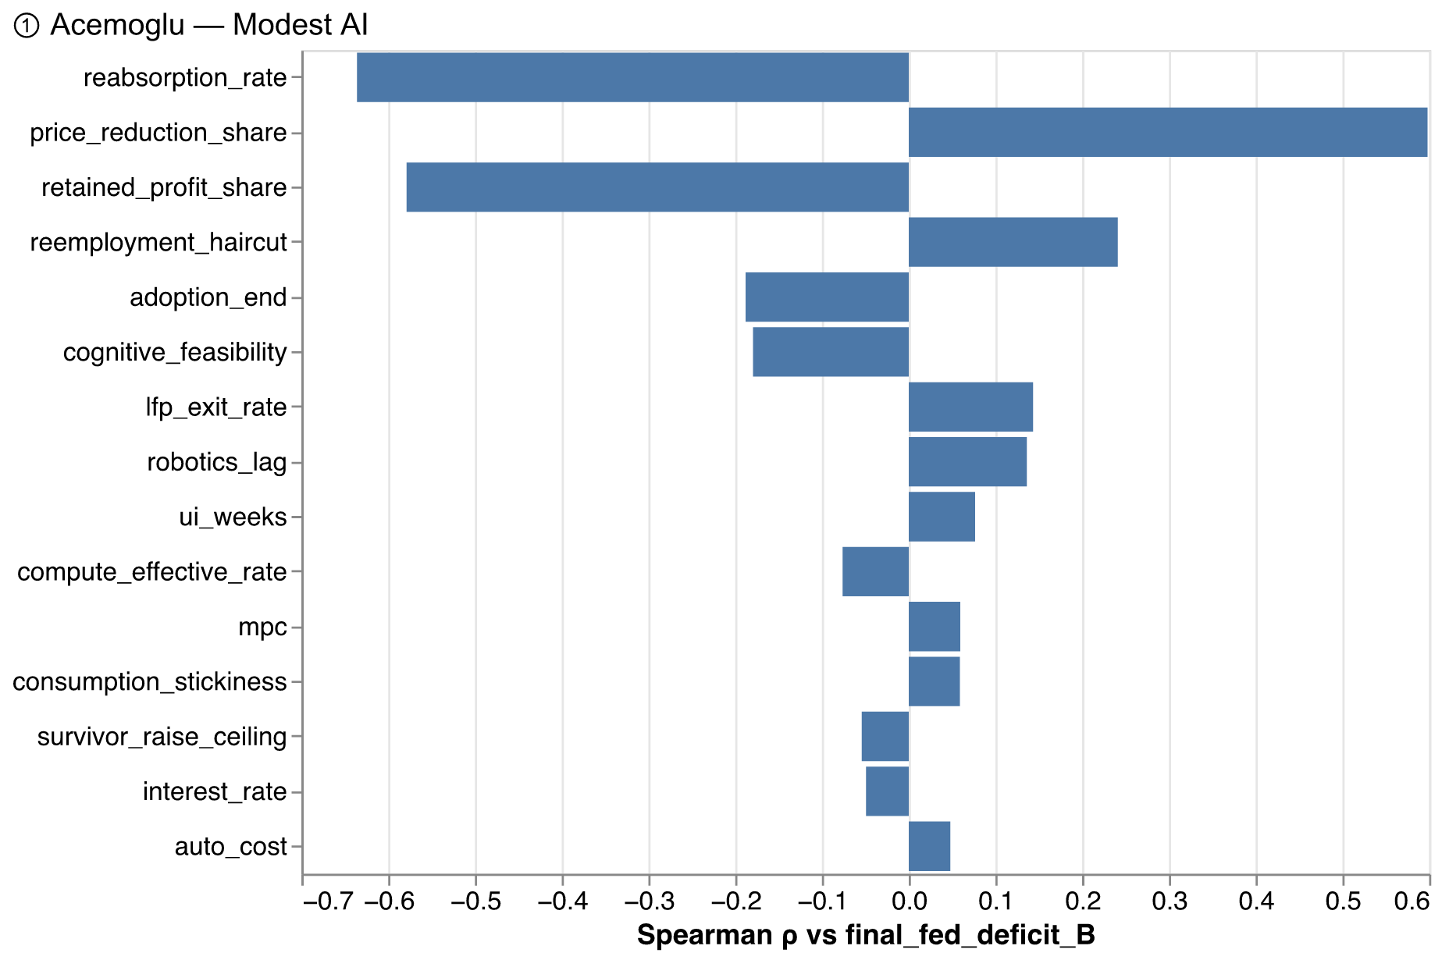
Figure 3 — Acemoglu — Modest AI: Spearman rank correlation of each perturbed lever with the final-year deficit change.

7.2 Brynjolfsson — Augmentation
The augmentation world is the optimist's case with the optimism located in the labor market rather than in the technology being small. Adoption reaches 30 percent of a moderately exposed economy, but survivors share a fifth of the surplus, complementarity lifts wages, scarring is mild (10 percent), and reabsorption runs at 0.6 per year. Employment falls 6.0 percent; the final-year federal balance change is +72.2 billion dollars, and the cumulative debt change is -214 billion — a net paydown: this is the one scenario in which AI improves the federal fiscal position over its whole horizon. The survivor-wage channel does real fiscal work here: raises re-taxed at full marginal rates partially rebuild the labor base that displacement erodes — the one mechanism by which the labor share of revenue defends itself.
Table 3 — Brynjolfsson — Augmentation: fiscal summary ($B, condensed).
Line | Year 0 | Year 1 | Year 3 | Year 5 | Year 9 | Total
Income tax | -5.9 | -12.5 | -19.2 | -24.2 | -29.9 | -212.2
Payroll (FICA) | -5.7 | -12.1 | -18.2 | -22.5 | -26.5 | -195.8
Corporate recovery | 5.4 | 14.2 | 33.4 | 54.7 | 95.9 | 499.0
Compute-pool tax | 0.5 | 1.3 | 3.1 | 5.1 | 9.0 | 46.7
Survivor wage taxes | 2.4 | 7.6 | 18.1 | 28.3 | 46.9 | 253.8
Overflow corporate tax | 0.0 | 0.0 | 0.0 | 0.0 | 0.0 | 0.0
Automation (robot) tax | 0.0 | 0.0 | 0.0 | 0.0 | 0.0 | 0.0
UBI recapture | 0.0 | 0.0 | 0.0 | 0.0 | 0.0 | 0.0
Tax on UI benefits | 0.5 | 0.8 | 0.9 | 1.0 | 0.9 | 8.8
Δ Federal revenue | -2.8 | -0.7 | 18.1 | 42.4 | 96.3 | 400.2
Means-tested transfers | 2.4 | 5.2 | 7.9 | 9.7 | 10.6 | 82.6
Unemployment insurance | 4.7 | 7.8 | 9.0 | 10.1 | 9.1 | 87.7
SSDI | 0.0 | 0.2 | 1.0 | 2.1 | 4.4 | 19.5
UBI (gross) | 0.0 | 0.0 | 0.0 | 0.0 | 0.0 | 0.0
Δ Federal outlays | 7.1 | 13.3 | 17.9 | 21.9 | 24.1 | 189.8
Net fiscal impact (federal) | -9.9 | -14.0 | 0.2 | 20.5 | 72.2 | 210.4
Federal revenue (absolute) | 4,980.0 | 4,982.1 | 5,000.9 | 5,025.2 | 5,079.1 | 5,079.1
Federal deficit (absolute) | 1,842.9 | 1,847.0 | 1,832.8 | 1,812.5 | 1,760.8 | 1,760.8
Federal debt (Δ cumulative) | 9.9 | 24.2 | 34.0 | 5.3 | -213.6 | -213.6
Deficit (% of GDP) | 6.3 | 6.0 | 5.4 | 4.9 | 3.9 | 3.9
State income tax | -1.4 | -3.0 | -4.6 | -5.8 | -7.0 | -50.7
State consumption tax | -0.5 | -1.0 | -1.6 | -2.0 | -2.4 | -17.1
Survivor wage taxes (state) | 0.3 | 1.0 | 2.3 | 3.6 | 5.9 | 32.1
State transfers (outlay) | 0.7 | 1.5 | 2.2 | 2.6 | 2.8 | 22.4
Net fiscal impact (state) | -2.3 | -4.6 | -6.1 | -6.8 | -6.2 | -58.1

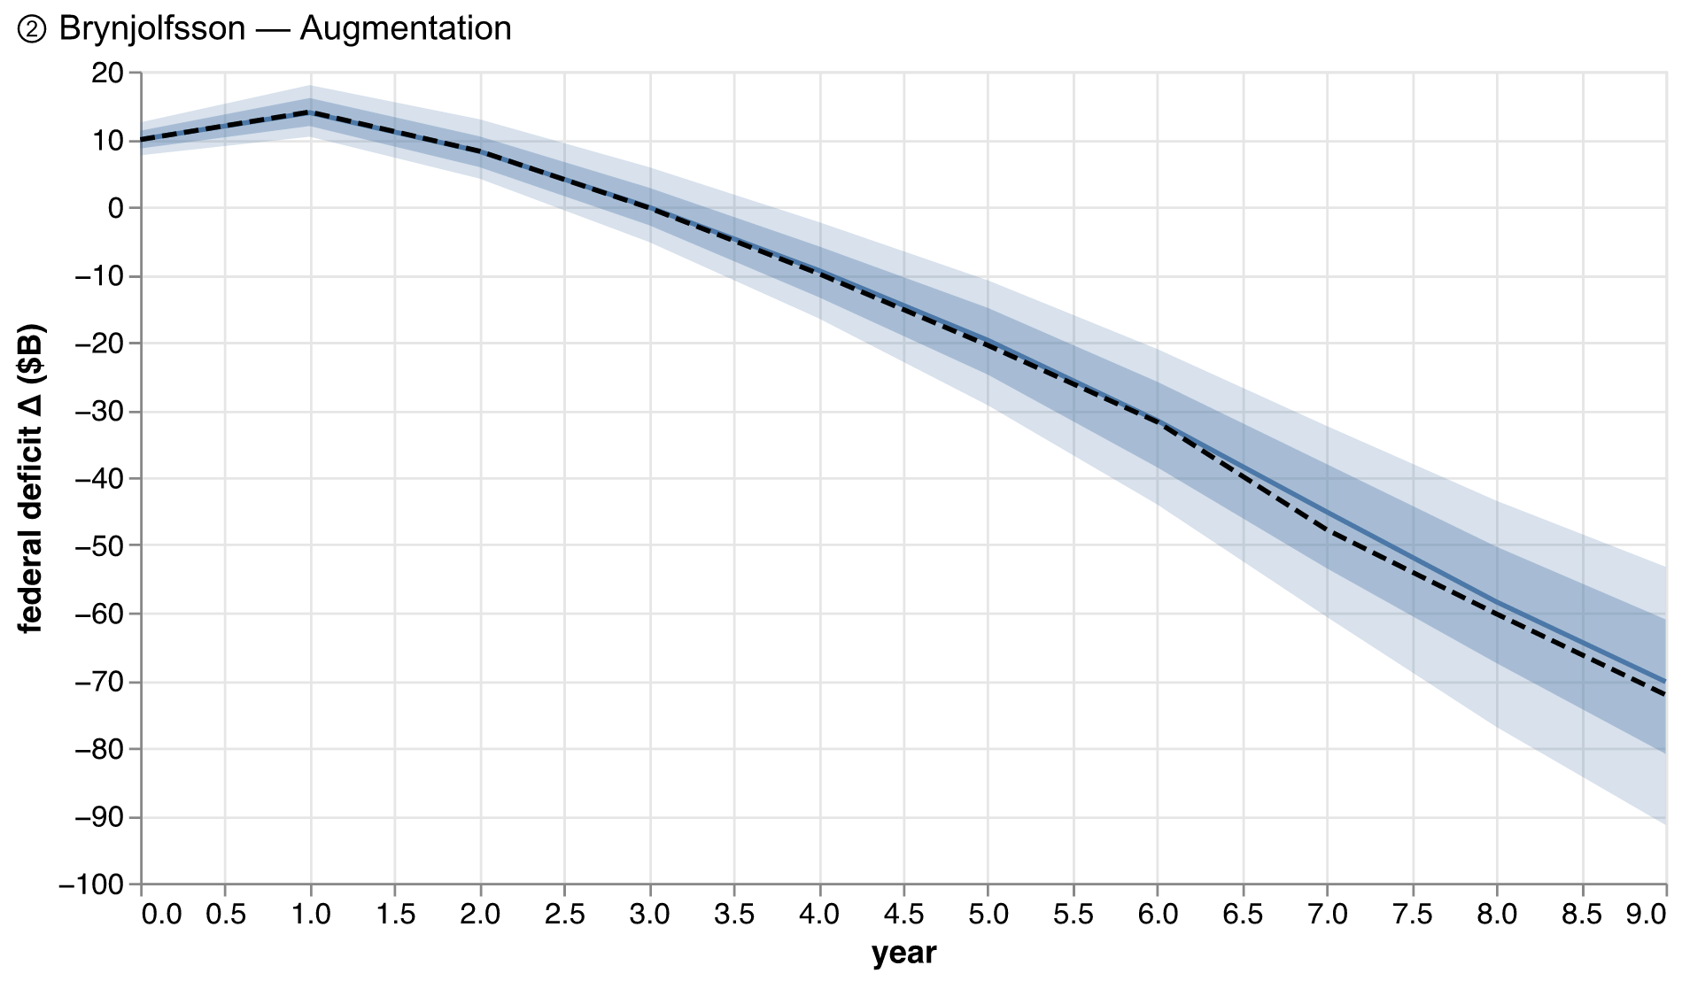
Figure 4 — Brynjolfsson — Augmentation: federal deficit fan.
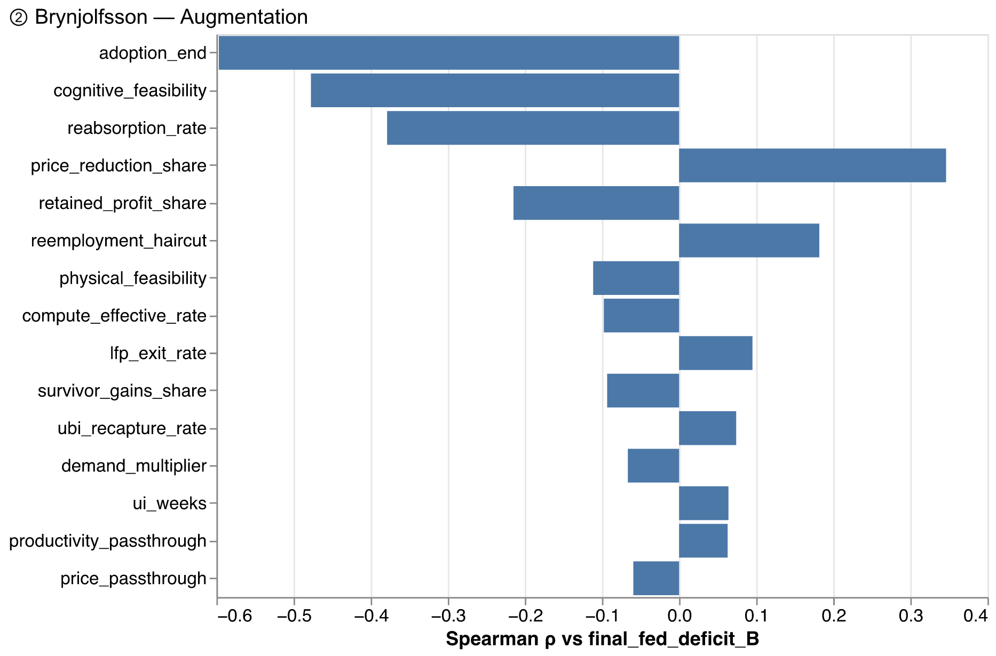
Figure 5 — Brynjolfsson — Augmentation: deficit tornado.

7.3 Windfall Trust — Medium
The comparator scenario. Sixty percent of jobs exposed, half of exposed work automated in a decade, re-employment at 70 percent of prior wage, high value capture split evenly between firms and consumers, capital taxed at their 26.7 percent ETR. Employment falls 21 percent; the final-year federal balance deteriorates by 208 billion dollars and cumulative debt reaches 1,830 billion. The ten-year total-revenue change of -1.35 percent of the combined federal-plus-state baseline is the number compared against the Windfall Trust's own −2.8 percent target in Section 9. Note the composition: the state consumption-tax line barely moves even as consumer prices fall — the taxable-to-consumer-surplus channel is quantitatively real and almost entirely untaxed.
Table 4 — Windfall Trust — Medium: fiscal summary ($B, condensed).
Line | Year 0 | Year 1 | Year 3 | Year 5 | Year 9 | Total
Income tax | -26.9 | -52.5 | -98.0 | -140.5 | -200.7 | -1,226.6
Payroll (FICA) | -26.3 | -50.8 | -92.8 | -130.8 | -178.7 | -1,129.1
Corporate recovery | 22.5 | 46.6 | 99.4 | 158.5 | 264.2 | 1,425.9
Compute-pool tax | 6.3 | 13.0 | 27.7 | 44.0 | 73.3 | 395.9
Survivor wage taxes | 0.0 | -7.8 | -19.8 | -27.5 | -31.6 | -218.3
Overflow corporate tax | 0.0 | 0.0 | 0.0 | 0.0 | 0.0 | 0.0
Automation (robot) tax | 0.0 | 0.0 | 0.0 | 0.0 | 0.0 | 0.0
UBI recapture | 0.0 | 0.0 | 0.0 | 0.0 | 0.0 | 0.0
Tax on UI benefits | 2.2 | 2.4 | 2.8 | 3.2 | 2.7 | 26.6
Δ Federal revenue | -22.2 | -49.2 | -80.7 | -93.1 | -70.8 | -725.6
Means-tested transfers | 10.9 | 22.8 | 42.3 | 59.1 | 75.8 | 498.9
Unemployment insurance | 21.7 | 23.7 | 27.6 | 31.6 | 26.6 | 266.2
SSDI | 0.0 | 1.2 | 6.6 | 14.7 | 34.8 | 145.2
UBI (gross) | 0.0 | 0.0 | 0.0 | 0.0 | 0.0 | 0.0
Δ Federal outlays | 32.6 | 47.7 | 76.5 | 105.4 | 137.2 | 910.2
Net fiscal impact (federal) | -54.8 | -96.9 | -157.2 | -198.6 | -208.0 | -1,635.8
Federal revenue (absolute) | 4,960.6 | 4,933.6 | 4,902.1 | 4,889.7 | 4,912.0 | 4,912.0
Federal deficit (absolute) | 1,887.8 | 1,929.9 | 1,990.2 | 2,031.6 | 2,041.0 | 2,041.0
Federal debt (Δ cumulative) | 54.8 | 153.3 | 454.2 | 865.2 | 1,829.6 | 1,829.6
Deficit (% of GDP) | 6.4 | 6.3 | 6.0 | 5.6 | 4.7 | 4.7
State income tax | -6.6 | -12.8 | -23.7 | -33.8 | -47.4 | -293.6
State consumption tax | -2.1 | -4.4 | -8.4 | -12.0 | -16.6 | -103.1
Survivor wage taxes (state) | 0.0 | -1.0 | -2.5 | -3.5 | -4.0 | -27.6
State transfers (outlay) | 3.1 | 6.5 | 11.8 | 16.1 | 19.6 | 134.5
Net fiscal impact (state) | -11.7 | -24.7 | -46.4 | -65.4 | -87.6 | -558.8

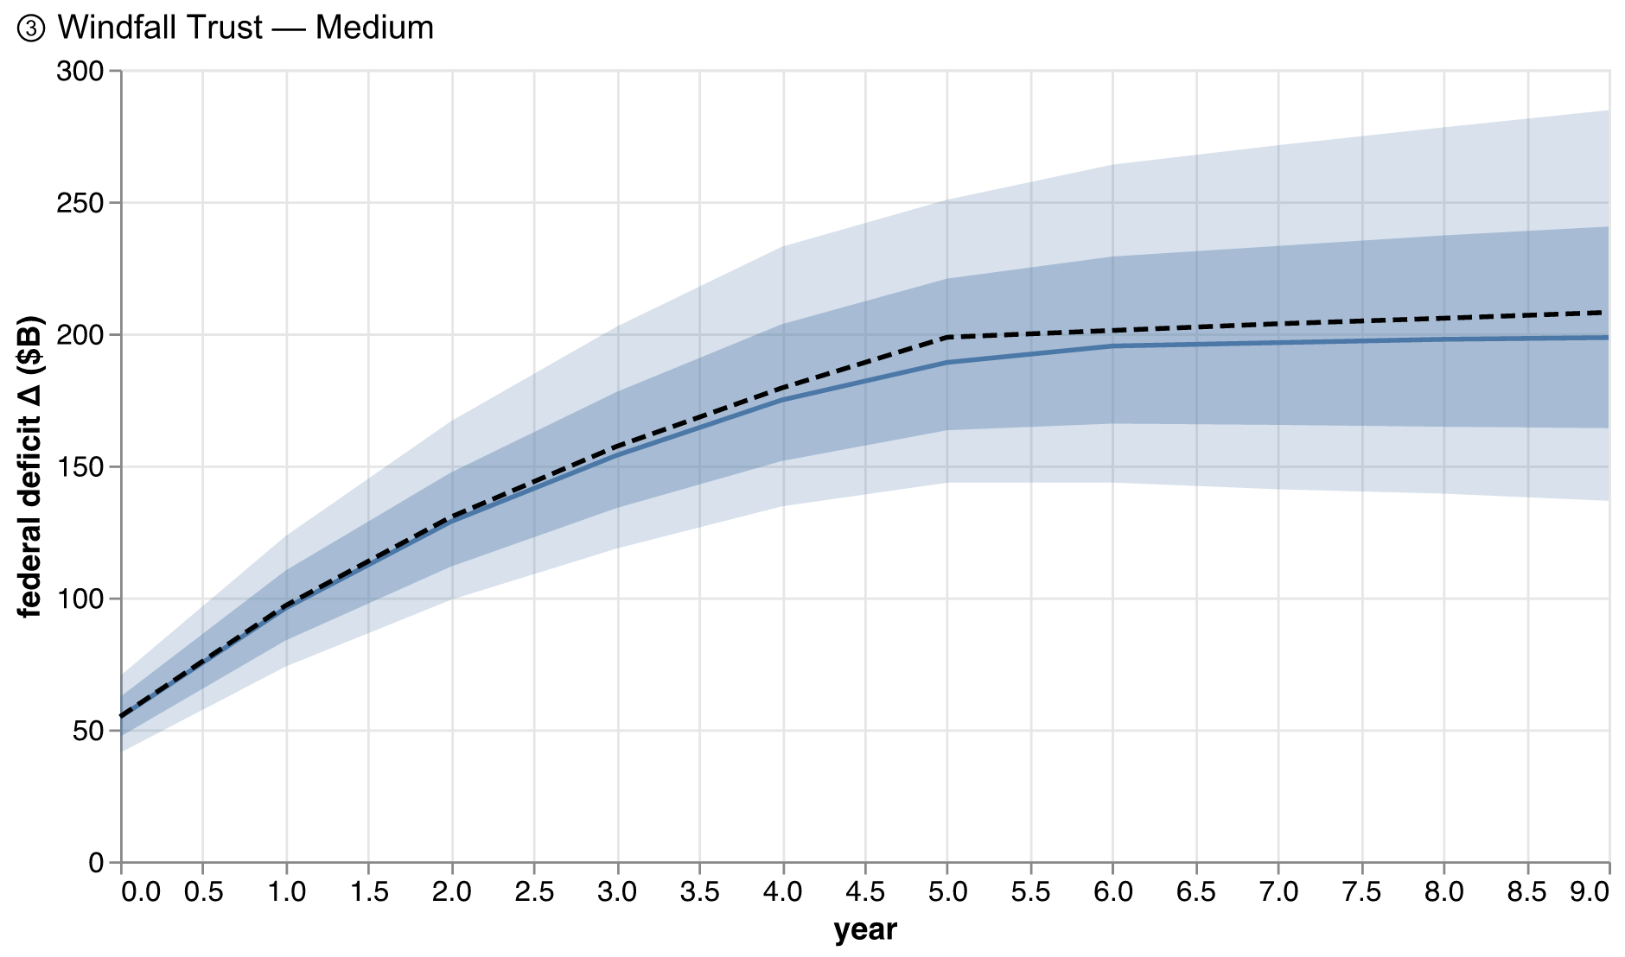
Figure 6 — Windfall Trust — Medium: federal deficit fan.
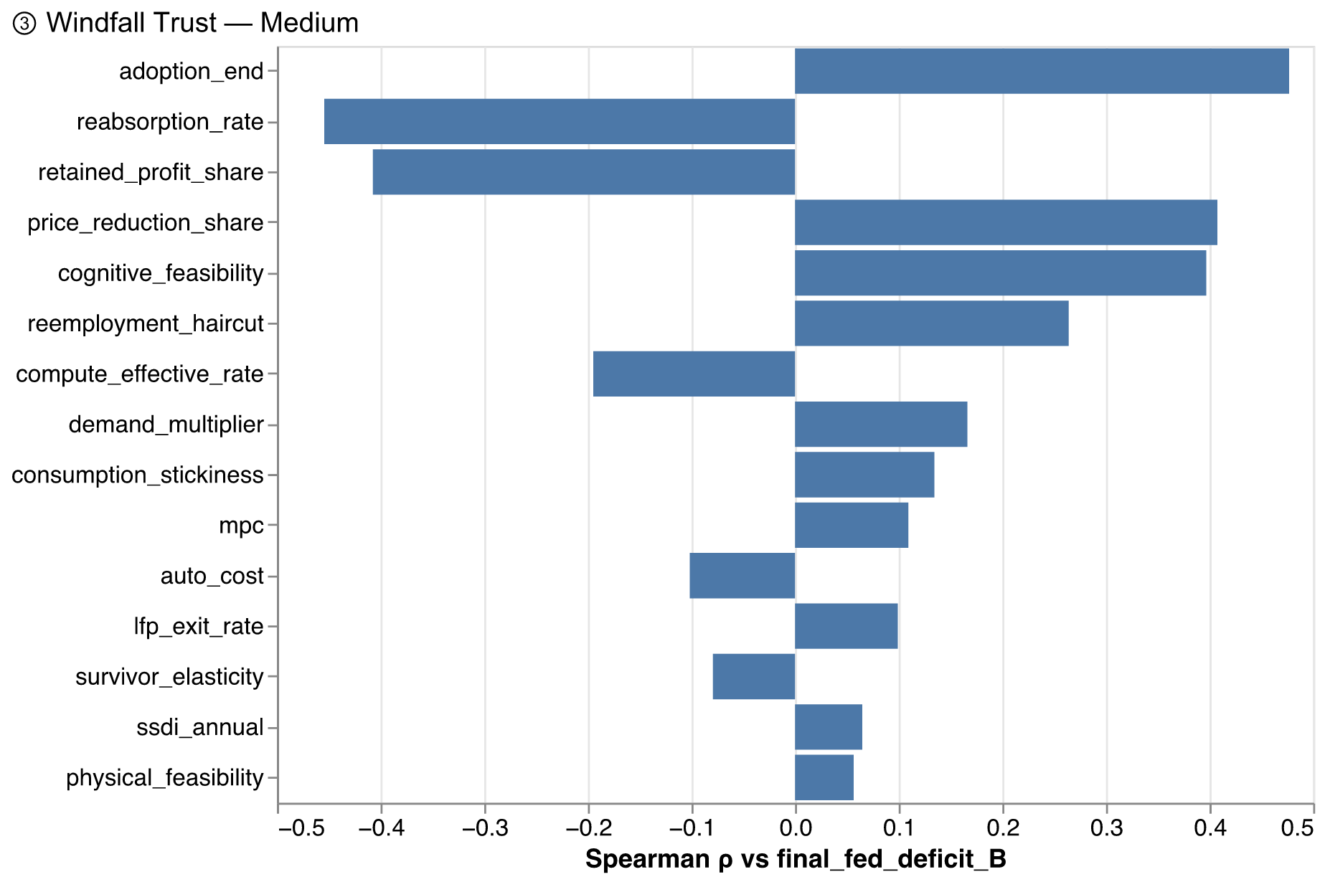
Figure 7 — Windfall Trust — Medium: deficit tornado.

7.4 China-Shock Grind
The displacement here is smaller than Windfall-Medium's — 40 percent of a moderately exposed economy over fifteen years — but the labor market is the one Autor, Dorn, and Hanson measured: reabsorption at 0.075 per year, labor-force exit the dominant adjustment margin, a 25 percent permanent wage scar, and demand amplification at the no-monetary-offset end of the evidence. Nothing heals, so everything accumulates: employment is down 19 percent at year fifteen, the final-year deficit change is 624 billion dollars, induced layoffs stand at 6.5 million, and cumulative debt reaches 5,059 billion — the grind converts a moderate technology shock into a large fiscal one purely through adjustment failure. This is the scenario that most cleanly isolates the model's second and third theses: revenue falls much faster than output, and the state closure (123 billion dollars of gap to close in the final year) feeds austerity back into demand.
Table 5 — China-Shock Grind: fiscal summary ($B, condensed).
Line | Year 0 | Year 1 | Year 3 | Year 5 | Year 14 | Total
Income tax | -14.7 | -26.3 | -55.7 | -87.6 | -231.9 | -1,778.0
Payroll (FICA) | -14.3 | -25.9 | -55.2 | -86.7 | -226.6 | -1,747.2
Corporate recovery | 17.2 | 28.2 | 54.8 | 82.2 | 187.9 | 1,561.7
Compute-pool tax | 1.3 | 2.1 | 4.0 | 6.0 | 13.7 | 114.3
Survivor wage taxes | 3.0 | -3.8 | -15.5 | -30.7 | -76.3 | -590.3
Overflow corporate tax | 0.0 | 0.0 | 0.0 | 0.0 | 0.0 | 0.0
Automation (robot) tax | 0.0 | 0.0 | 0.0 | 0.0 | 0.0 | 0.0
UBI recapture | 0.0 | 0.0 | 0.0 | 0.0 | 0.0 | 0.0
Tax on UI benefits | 1.2 | 0.8 | 1.1 | 0.9 | 0.9 | 13.9
Δ Federal revenue | -6.3 | -24.9 | -66.6 | -115.9 | -332.3 | -2,425.6
Means-tested transfers | 6.0 | 12.5 | 28.2 | 45.5 | 118.3 | 909.5
Unemployment insurance | 11.8 | 8.0 | 10.8 | 8.7 | 8.7 | 139.2
SSDI | 0.0 | 2.2 | 12.0 | 29.8 | 165.1 | 960.3
UBI (gross) | 0.0 | 0.0 | 0.0 | 0.0 | 0.0 | 0.0
Δ Federal outlays | 17.8 | 22.7 | 51.0 | 84.0 | 292.1 | 2,008.9
Net fiscal impact (federal) | -24.1 | -47.6 | -117.5 | -199.9 | -624.3 | -4,434.5
Federal revenue (absolute) | 4,976.5 | 4,957.9 | 4,916.2 | 4,866.9 | 4,650.5 | 4,650.5
Federal deficit (absolute) | 1,857.1 | 1,880.6 | 1,950.5 | 2,032.9 | 2,457.3 | 2,457.3
Federal debt (Δ cumulative) | 24.1 | 72.5 | 277.2 | 658.9 | 5,059.2 | 5,059.2
Deficit (% of GDP) | 6.3 | 6.2 | 6.0 | 5.8 | 5.1 | 5.1
State income tax | -3.6 | -6.5 | -13.9 | -21.8 | -57.7 | -442.8
State consumption tax | -1.2 | -2.3 | -5.1 | -8.2 | -21.8 | -166.4
Survivor wage taxes (state) | 0.4 | -0.5 | -2.0 | -3.9 | -9.6 | -74.5
State transfers (outlay) | 1.7 | 3.6 | 8.2 | 13.2 | 34.2 | 263.3
Net fiscal impact (state) | -6.0 | -12.9 | -29.2 | -47.2 | -123.3 | -947.0

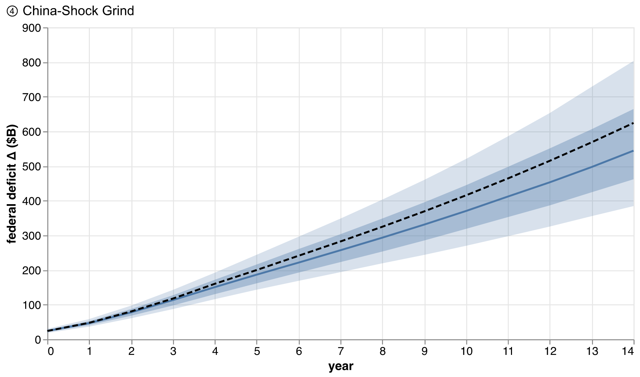
Figure 8 — China-Shock Grind: federal deficit fan.
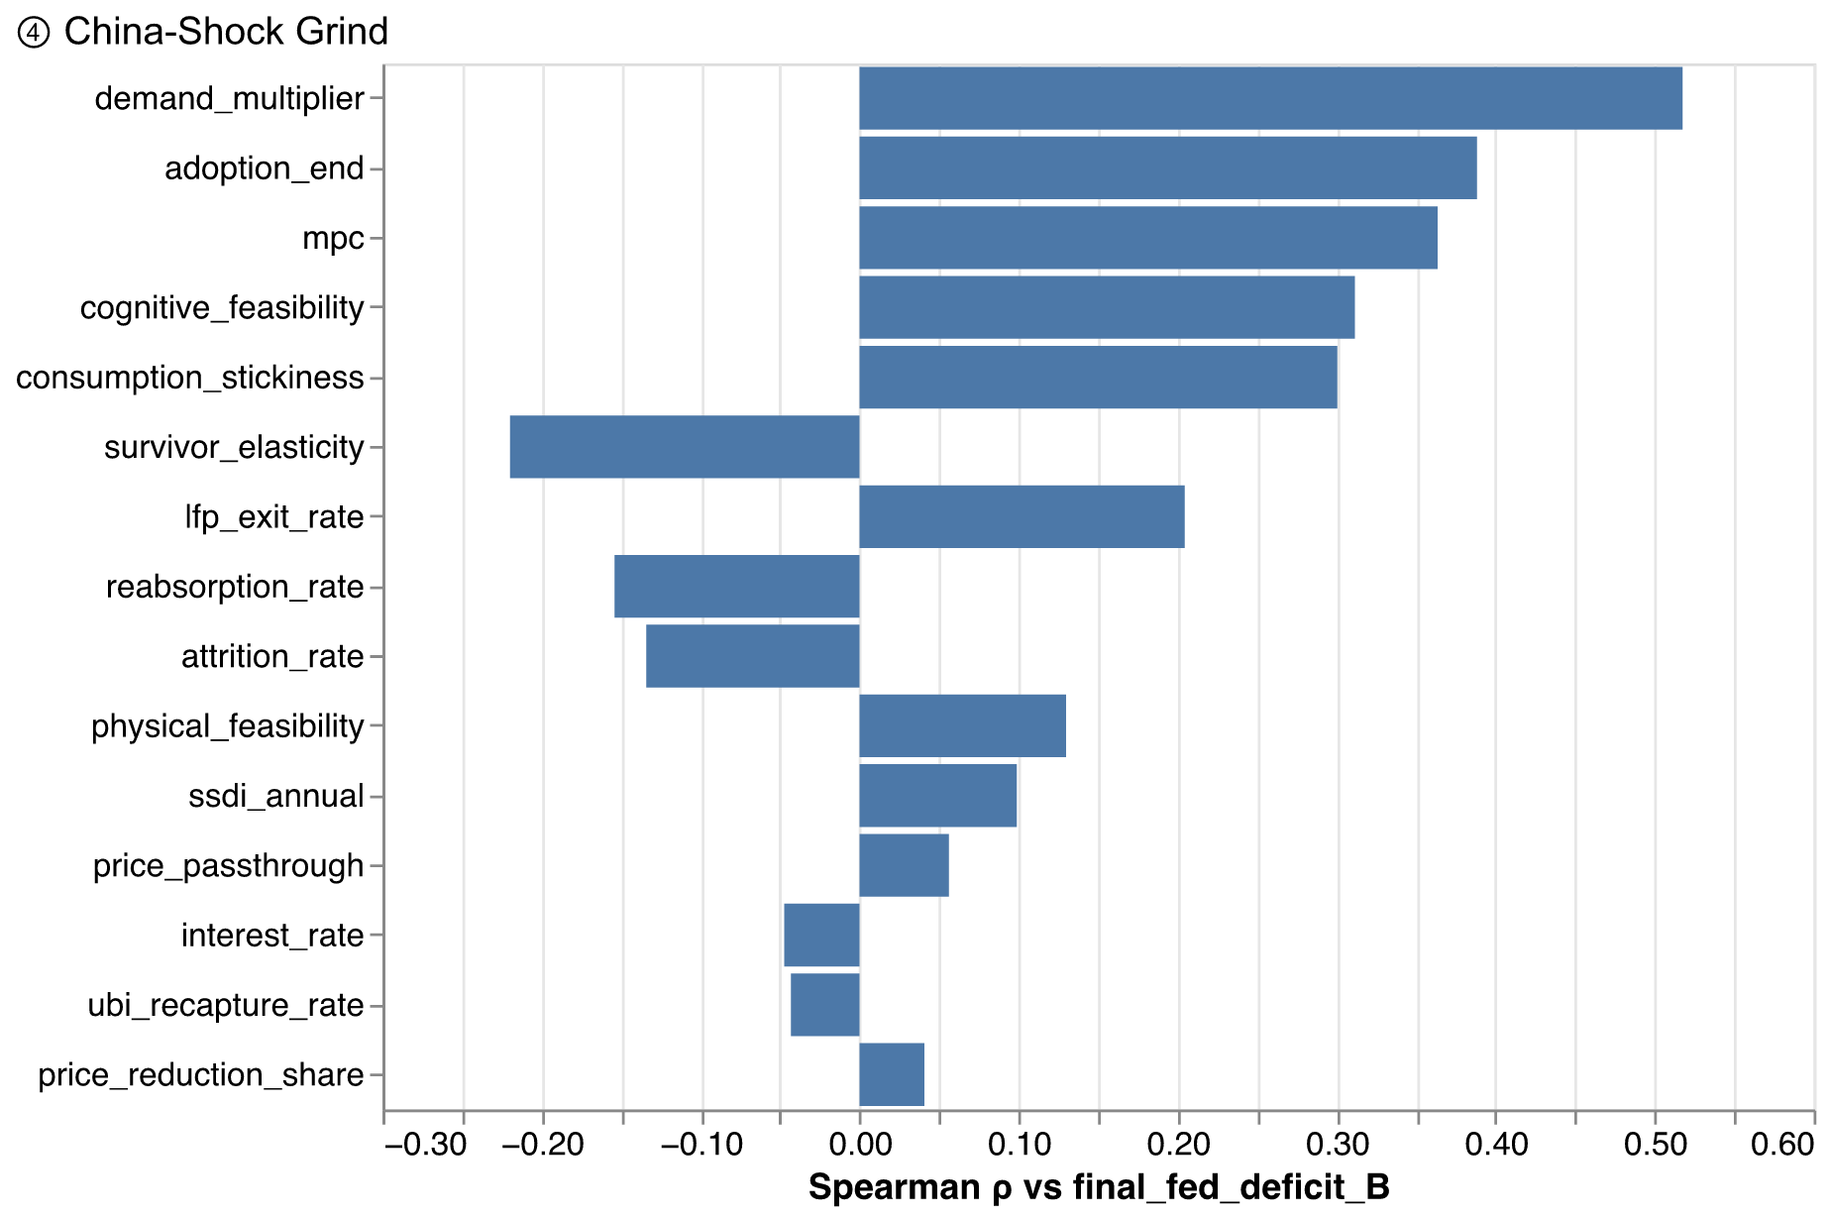
Figure 9 — China-Shock Grind: deficit tornado.

7.5 Korinek–Suh — AGI in 20 years
Full automation, slowly. Over twenty years the adoption ceiling climbs to one, wages collapse ahead of it (elasticity at the slider floor, a 40 percent re-employment haircut, reabsorption near zero), and capital keeps 80 percent of the net saving. By the final year employment is down 99 percent, the deficit change is 1,882 billion dollars per year, and cumulative new debt is 35,961 billion. The productivity dividend is enormous — real output ends 64 percent above baseline — which is precisely the point: the fiscal crisis and the abundance are simultaneous, because the tax system is plumbed to wages and the abundance arrives as profit, price declines, and capital income. The states close a gap of 533 billion dollars in the final year alone — half of it, by this scenario's Korinek–Lockwood-motivated configuration, through direct spending cuts whose demand consequences feed straight back into the induced-layoff channel.
Table 6 — Korinek–Suh — AGI in 20 years: fiscal summary ($B, condensed).
Line | Year 0 | Year 1 | Year 3 | Year 5 | Year 19 | Total
Income tax | -48.9 | -107.4 | -250.5 | -406.8 | -1,127.1 | -14,186.8
Payroll (FICA) | -47.8 | -105.3 | -246.8 | -401.6 | -1,086.5 | -13,886.5
Corporate recovery | 61.9 | 128.0 | 273.3 | 435.7 | 1,571.6 | 16,799.2
Compute-pool tax | 3.2 | 6.6 | 14.0 | 22.2 | 79.8 | 851.7
Survivor wage taxes | 4.8 | -36.1 | -133.4 | -218.6 | 9.0 | -2,518.5
Overflow corporate tax | 0.0 | 0.0 | 0.0 | 0.0 | 39.5 | 97.1
Automation (robot) tax | 0.0 | 0.0 | 0.0 | 0.0 | 0.0 | 0.0
UBI recapture | 0.0 | 0.0 | 0.0 | 0.0 | 0.0 | 0.0
Tax on UI benefits | 3.9 | 4.3 | 5.1 | 5.8 | 6.5 | 110.3
Δ Federal revenue | -22.9 | -109.8 | -338.4 | -563.2 | -507.3 | -12,733.4
Means-tested transfers | 19.9 | 49.2 | 123.5 | 206.0 | 552.4 | 7,199.5
Unemployment insurance | 39.4 | 43.2 | 50.8 | 58.4 | 64.7 | 1,103.0
SSDI | 0.0 | 3.7 | 24.9 | 67.2 | 757.3 | 5,909.4
UBI (gross) | 0.0 | 0.0 | 0.0 | 0.0 | 0.0 | 0.0
Δ Federal outlays | 59.3 | 96.1 | 199.2 | 331.6 | 1,374.3 | 14,211.8
Net fiscal impact (federal) | -82.2 | -205.9 | -537.6 | -894.8 | -1,881.6 | -26,945.3
Federal revenue (absolute) | 4,959.9 | 4,873.0 | 4,644.4 | 4,419.6 | 4,475.5 | 4,475.5
Federal deficit (absolute) | 1,915.2 | 2,038.9 | 2,370.6 | 2,727.8 | 3,714.6 | 3,714.6
Federal debt (Δ cumulative) | 82.2 | 291.4 | 1,231.2 | 2,971.6 | 35,960.6 | 35,960.6
Deficit (% of GDP) | 6.4 | 6.3 | 6.1 | 5.9 | 2.6 | 2.6
State income tax | -11.9 | -26.3 | -61.9 | -100.9 | -275.4 | -3,505.2
State consumption tax | -3.8 | -9.3 | -22.9 | -37.7 | -103.8 | -1,322.4
Survivor wage taxes (state) | 0.6 | -4.6 | -16.9 | -27.6 | 1.2 | -317.0
State transfers (outlay) | 5.6 | 14.2 | 35.8 | 59.7 | 154.8 | 2,056.9
Net fiscal impact (state) | -20.7 | -54.4 | -137.5 | -226.0 | -532.8 | -7,201.5

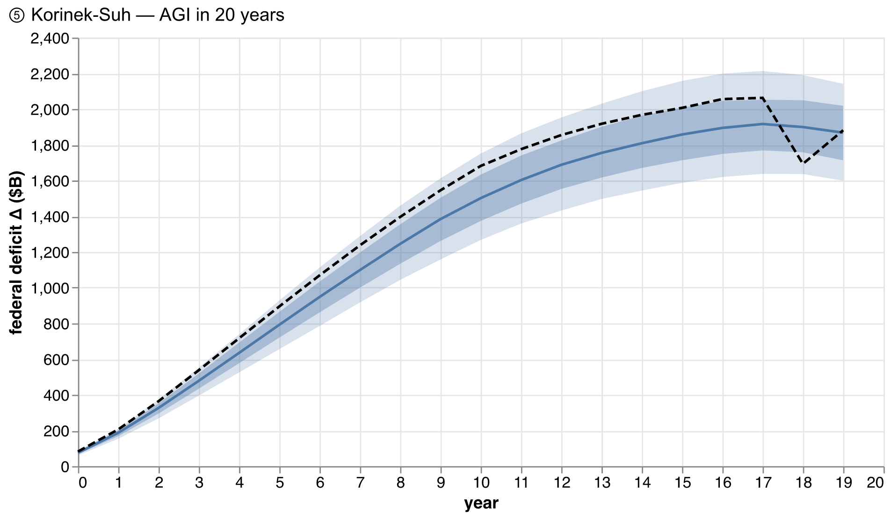
Figure 10 — AGI in 20 years: federal deficit fan.
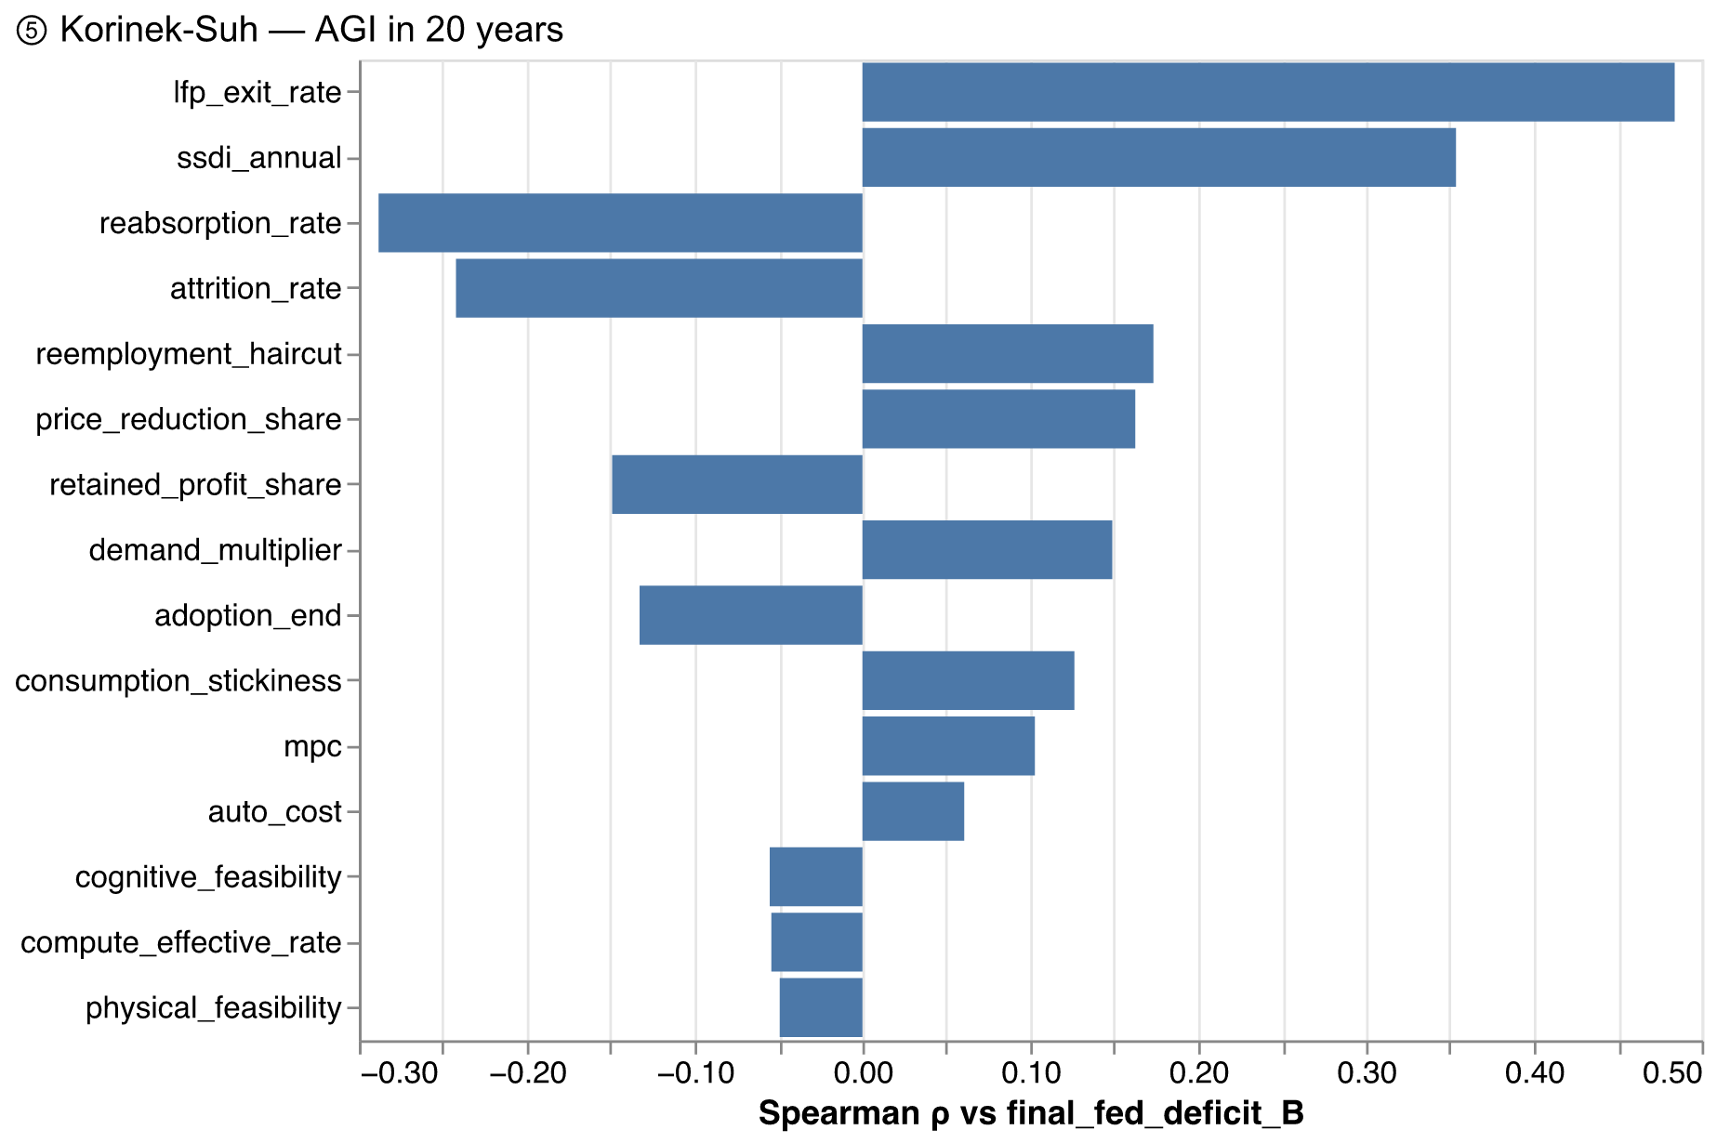
Figure 11 — AGI in 20 years: deficit tornado.

7.6 Korinek–Suh — AGI in 5 years
The stress case: the same destination reached at year five (a kinked adoption path — linear to full automation at year five, flat thereafter — viewed over a ten-year fiscal window), with crash robotics build-out, mass labor-force exit, and crisis-regime demand amplification. Employment effectively ceases to be the tax base: down 100 percent, with the final-year deficit change at 2,567 billion dollars and cumulative debt of 23,245 billion — against a GDP that is simultaneously 67 percent larger in real terms. No plausible parameter perturbation changes the qualitative picture: the P10–P90 band on the final-year deficit change runs from 2,257 to 2,889 billion dollars — the best decile of this world is fiscally worse than the worst decile of every scenario outside the AGI-and-takeoff class.
Table 7 — Korinek–Suh — AGI in 5 years: fiscal summary ($B, condensed).
Line | Year 0 | Year 1 | Year 3 | Year 5 | Year 9 | Total
Income tax | -195.6 | -450.0 | -1,118.9 | -1,364.8 | -1,281.0 | -10,336.0
Payroll (FICA) | -191.1 | -447.5 | -1,120.1 | -1,355.9 | -1,255.7 | -10,244.7
Corporate recovery | 232.9 | 492.1 | 1,067.1 | 1,404.1 | 1,556.4 | 11,469.7
Compute-pool tax | 16.9 | 35.5 | 76.5 | 101.2 | 111.6 | 823.8
Survivor wage taxes | 18.0 | -102.9 | -156.7 | 9.1 | 0.9 | -414.5
Overflow corporate tax | 0.0 | 0.0 | 0.0 | 13.0 | 47.3 | 104.0
Automation (robot) tax | 0.0 | 0.0 | 0.0 | 0.0 | 0.0 | 0.0
UBI recapture | 0.0 | 0.0 | 0.0 | 0.0 | 0.0 | 0.0
Tax on UI benefits | 15.8 | 19.5 | 18.7 | 7.0 | 0.0 | 115.8
Δ Federal revenue | -103.1 | -453.2 | -1,233.3 | -1,186.3 | -820.4 | -8,481.8
Means-tested transfers | 79.5 | 216.2 | 591.1 | 722.7 | 664.2 | 5,375.7
Unemployment insurance | 157.7 | 194.6 | 187.0 | 70.3 | 0.2 | 1,158.3
SSDI | 0.0 | 29.4 | 227.3 | 588.9 | 1,082.6 | 5,042.3
UBI (gross) | 0.0 | 0.0 | 0.0 | 0.0 | 0.0 | 0.0
Δ Federal outlays | 237.2 | 440.2 | 1,005.4 | 1,381.8 | 1,747.0 | 11,576.4
Net fiscal impact (federal) | -340.3 | -893.5 | -2,238.7 | -2,568.1 | -2,567.4 | -20,058.2
Federal revenue (absolute) | 4,879.7 | 4,529.6 | 3,749.5 | 3,796.5 | 4,162.4 | 4,162.4
Federal deficit (absolute) | 2,173.3 | 2,726.5 | 4,071.7 | 4,401.1 | 4,400.4 | 4,400.4
Federal debt (Δ cumulative) | 340.3 | 1,247.4 | 5,302.9 | 11,071.5 | 23,244.9 | 23,244.9
Deficit (% of GDP) | 6.8 | 7.2 | 7.7 | 6.5 | 4.6 | 4.6
State income tax | -47.7 | -111.7 | -280.0 | -337.2 | -315.6 | -2,563.4
State consumption tax | -15.3 | -39.5 | -105.0 | -130.3 | -121.7 | -970.7
Survivor wage taxes (state) | 2.3 | -13.0 | -19.5 | 1.2 | 0.1 | -52.2
State transfers (outlay) | 22.3 | 62.1 | 171.6 | 209.6 | 190.4 | 1,550.2
Net fiscal impact (state) | -83.0 | -226.3 | -576.2 | -675.8 | -627.5 | -5,136.5

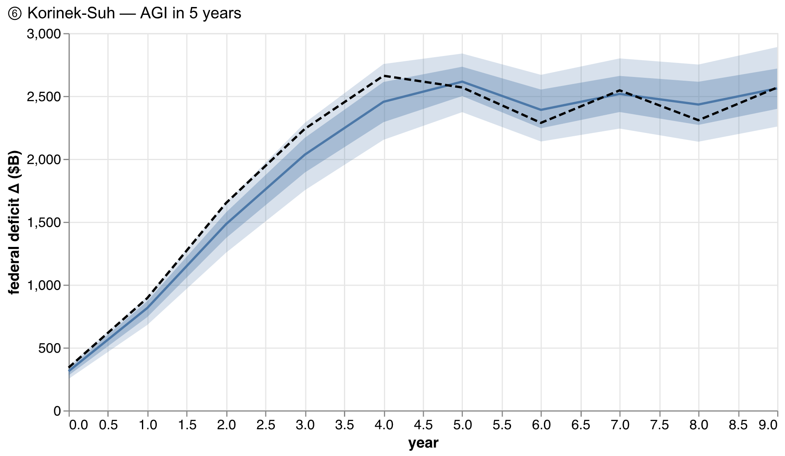
Figure 12 — AGI in 5 years: federal deficit fan.
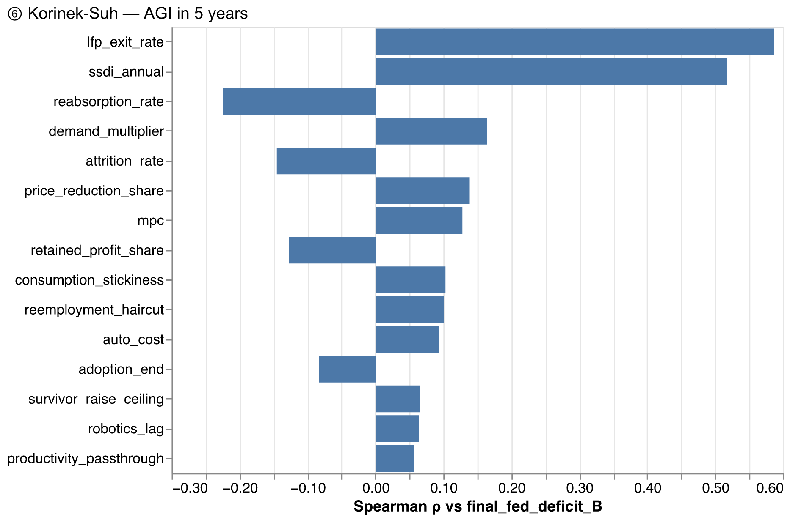
Figure 13 — AGI in 5 years: deficit tornado.

7.7 AI 2027 — Fast takeoff
The AI Futures shape: cognitive feasibility maxes almost immediately, robots ramp over three years of crash build-out, and nearly a third of the saved bill flows to compute investment. Over its eight-year window employment falls 99 percent and cumulative debt reaches 12,549 billion dollars. The heavy auto_cost matters fiscally: a large automation-input bill shrinks the net saving available for profit (and therefore the corporate offset) while the compute pool it feeds is taxed at 5 percent — the fast-takeoff world is one where an unusually large share of the migrated base lands at the lowest-taxed destination, which is what makes the compute-parity overlay bind hardest here (Section 8).
Table 8 — AI 2027 — Fast takeoff: fiscal summary ($B, condensed).
Line | Year 0 | Year 1 | Year 3 | Year 5 | Year 7 | Total
Income tax | -97.8 | -256.9 | -691.3 | -1,060.8 | -1,265.1 | -5,928.6
Payroll (FICA) | -95.6 | -253.3 | -687.8 | -1,044.0 | -1,231.8 | -5,830.0
Corporate recovery | 89.2 | 225.0 | 568.5 | 869.5 | 1,120.3 | 4,996.3
Compute-pool tax | 12.7 | 31.9 | 80.0 | 122.3 | 157.9 | 703.6
Survivor wage taxes | 15.8 | -42.9 | -166.2 | -72.1 | 7.3 | -476.9
Overflow corporate tax | 0.0 | 0.0 | 0.0 | 0.0 | 69.7 | 71.8
Automation (robot) tax | 0.0 | 0.0 | 0.0 | 0.0 | 0.0 | 0.0
UBI recapture | 0.0 | 0.0 | 0.0 | 0.0 | 0.0 | 0.0
Tax on UI benefits | 7.9 | 12.7 | 18.6 | 14.5 | 10.0 | 108.6
Δ Federal revenue | -67.9 | -283.4 | -878.2 | -1,170.5 | -1,131.6 | -6,355.2
Means-tested transfers | 39.8 | 117.8 | 350.7 | 539.4 | 634.0 | 2,970.1
Unemployment insurance | 78.8 | 127.4 | 186.1 | 145.4 | 100.4 | 1,085.6
SSDI | 0.0 | 7.3 | 63.1 | 182.5 | 338.0 | 992.4
UBI (gross) | 0.0 | 0.0 | 0.0 | 0.0 | 0.0 | 0.0
Δ Federal outlays | 118.6 | 252.6 | 599.9 | 867.3 | 1,072.4 | 5,048.0
Net fiscal impact (federal) | -186.5 | -536.0 | -1,478.2 | -2,037.8 | -2,204.0 | -11,403.2
Federal revenue (absolute) | 4,914.9 | 4,699.4 | 4,104.6 | 3,812.3 | 3,851.2 | 3,851.2
Federal deficit (absolute) | 2,019.5 | 2,369.0 | 3,311.2 | 3,870.8 | 4,037.0 | 4,037.0
Federal debt (Δ cumulative) | 186.5 | 729.9 | 3,298.7 | 7,488.3 | 12,548.9 | 12,548.9
Deficit (% of GDP) | 6.6 | 6.7 | 6.9 | 6.1 | 5.0 | 5.0
State income tax | -23.9 | -63.3 | -172.3 | -263.1 | -310.4 | -1,466.7
State consumption tax | -7.7 | -22.0 | -63.0 | -98.2 | -117.3 | -543.1
Survivor wage taxes (state) | 2.0 | -5.4 | -21.0 | -9.0 | 1.0 | -60.2
State transfers (outlay) | 11.1 | 33.6 | 100.6 | 154.3 | 179.4 | 847.5
Net fiscal impact (state) | -40.7 | -124.3 | -356.9 | -524.6 | -606.1 | -2,917.6

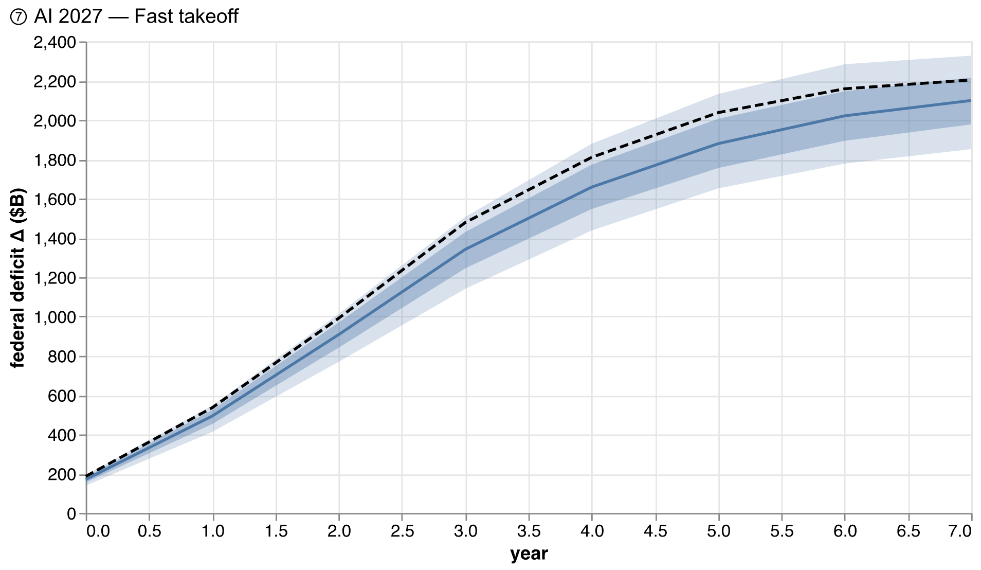
Figure 14 — AI 2027 — Fast takeoff: federal deficit fan.
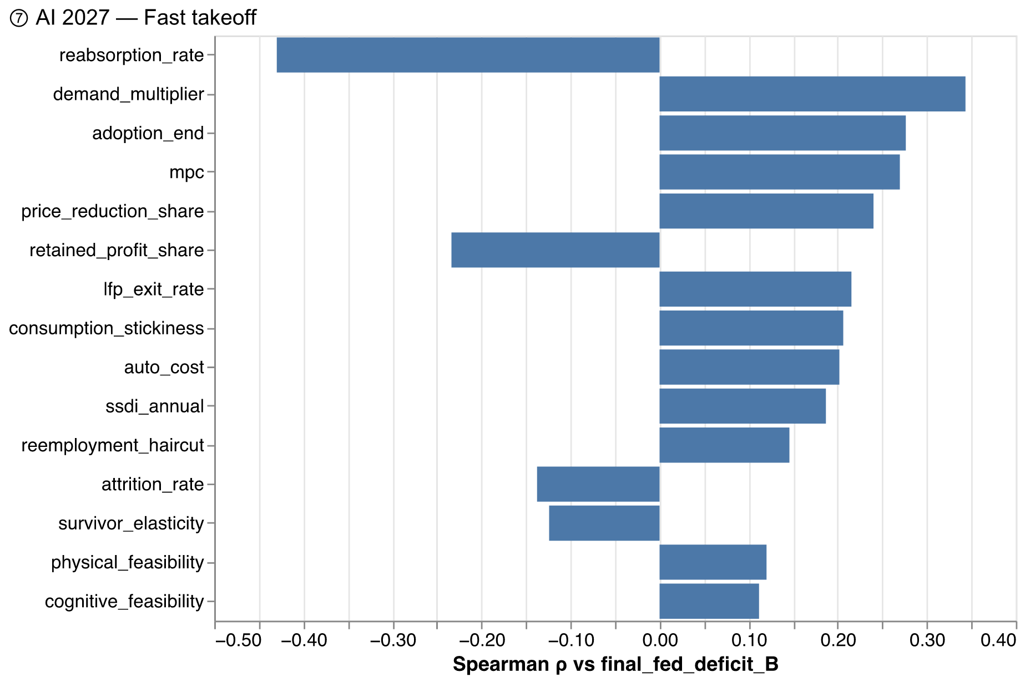
Figure 15 — AI 2027 — Fast takeoff: deficit tornado.

7.8 The three theses, across worlds
Base migration. In every scenario with substantial displacement, the channel decomposition (the four-channel view for the Windfall comparator appears in Appendix C) shows the same anatomy: labor taxes lost at combined marginal rates, partially recovered through capital-side channels at roughly half those rates or less, with the consumer-surplus channel — price declines — recovered at roughly two cents on the dollar through state consumption taxes.
Revenue vs. employment. Because exposure skews above-median-wage and the schedules are progressive, the percentage revenue loss exceeds the percentage employment loss early in every scenario; the wedge narrows only where survivor raises rebuild the base (the augmentation world) and widens where scarring is deep (the grind).
The state amplifier. The federal government's deficit is a shock absorber; the states' balance requirement is a shock transmitter. Across scenarios, state gaps scale with displacement, the rate-hike caps bind in the severe worlds, and every dollar of forced spending cuts re-enters the demand channel as first-round-multiplier withdrawal — visible in the induced-layoff stocks and in the difference between scenarios with and without state stress in their configuration.

8. Policy overlays: what government recovers
Each overlay is applied on top of each scenario and re-run; the recovery is the year-by-year difference in the federal deficit. The table reports the cumulative recovery over each scenario's horizon, with the share of the scenario's cumulative fiscal gap in parentheses where the gap is large enough for the ratio to be meaningful.
Table 9 — Cumulative federal deficit recovery by scenario × overlay, $B (share of the scenario's cumulative gap in parentheses; omitted where the cumulative gap is below $100B). The UBI column is negative: it is a net cost, shown here for the same accounting frame.
Preset | Robot tax (CW optimal) | Robot tax (GRT trans.) | UBI $12k + 30% recapture | Compute parity 0.27
① Acemoglu — Modest AI | +2 | +5 | -12,921 | +20
② Brynjolfsson — Augmentation | +10 | +19 | -12,929 | +79
③ Windfall Trust — Medium | +31 (2%) | +59 (4%) | -12,615 (-771%) | +0 (0%)
④ China-Shock Grind | +24 (0%) | +46 (1%) | -16,890 (-381%) | +194 (4%)
⑤ Korinek-Suh — AGI in 20 years | +360 (1%) | +680 (2%) | -21,148 (-78%) | +3,748 (14%)
⑥ Korinek-Suh — AGI in 5 years | +348 (2%) | +658 (3%) | -11,620 (-58%) | +3,625 (18%)
⑦ AI 2027 — Fast takeoff | +297 (3%) | +562 (5%) | -8,877 (-78%) | +3,096 (27%)

Three results.
Literature-optimal robot taxes are small money. This is the section's headline and it follows from an accounting identity, not a modeling choice: the optimal-taxation literature's rates are ad-valorem on robot spending (Costinot–Werning's sufficient statistic tops out at 3.7 percent; Thuemmel's published estimate is near zero; Guerreiro–Rebelo–Teles is transitional and zero in steady state), and converting to the saved-wage base multiplies them by auto_cost. At Costinot–Werning's central 2.7 percent the effective rate on saved compensation is 0.3–0.8 percent across scenarios — recovering single-digit percentages of the fiscal gap everywhere the gap is large. A robot tax big enough to replace the lost labor wedge would need to be an order of magnitude above anything in the optimal-taxation literature, which that literature rules out precisely because such a tax would suppress the automation that funds the productivity gains — a behavioral response this model does not even represent (Section 10), meaning these recovery numbers are upper bounds.
UBI is a fiscal decision, not a fiscal offset. At $12,000 per worker with 30 percent recapture, the UBI's cumulative net cost over the Windfall-Medium decade is 12,932 billion dollars — dwarfing the fiscal damage of every scenario except the AGI transitions, in which it is comparable to the damage. Its demand-side effect is real (the level-targeting controller visibly releases induced workers when the UBI lands) but second-order against its gross cost. In the AGI worlds the interesting number is different: the required flat tax rate on the eroded base to fund it exceeds 100 percent — UBI in those worlds is only fundable from the capital side, which is Korinek and Lockwood's point.
Compute parity is the sleeper. Taxing the compute-capital pool at the domestic-capital ETR (26.7 percent) instead of the post-TCJA 5 percent recovers the most where automation investment is heaviest — the fast-takeoff world, where nearly a third of the saved bill flows through the pool. It is also the overlay with the cleanest incidence story: it taxes the new capital stock that displacement creates, rather than the act of automation itself.

Figure 16 — Reprise: the scenario space the overlays operate in. No overlay moves a scenario across the bands separating the modest, grinding, and AGI worlds.

9. Validation against external models
No other public model computes exactly this object, but three come close enough to triangulate. The comparisons below are run inside the artifact pipeline — the external targets are hard-coded from the source documents; the model numbers are computed fresh each build. We deliberately do not tune any preset to hit an external number.

9.1 Windfall Trust (Ieong, Saputra, Maniar, and Cheng 2026)
Their simulator computes ten-year total tax revenue changes for an average OECD country under three displacement scenarios and two value-capture regimes. We replicate their grid on our machinery: the scenario axis maps to adoption ceilings of 0.20/0.50/0.80 with scarring of 20/30/40 percent; their high-capture allocation (45 percent firms / 45 percent consumers / 10 percent residual) is the Windfall-Medium preset's disposition, and their low-capture allocation (15/15/70) maps exactly by routing 70 percent of the saved bill to automation inputs that leak untaxed. Our metric matches theirs: cumulative ten-year total (federal plus pre-closure state) revenue change as a share of baseline.
Table 10 — Windfall Trust replication grid: this model vs. their published targets (10-year total revenue change, % of baseline).
Scenario | Value capture | This model | Windfall Trust
Low | High | -0.46% | +0.2%
Low | Low | -0.73% | -1.8%
Medium | High | -1.35% | -2.8%
Medium | Low | -1.96% | -7.7%
High | High | -2.42% | -7.3%
High | Low | -3.36% | -15.3%

The comparison validates structure, not magnitude: our grid reproduces their sign everywhere and their double monotonicity — worse with more displacement, worse with less value capture — but at roughly half their magnitudes. The wedge has a known anatomy: their tax base is an average OECD country (46 percent labor, with a VAT that taxes the consumption their consumer-surplus channel feeds), while ours is the actual US federal-plus-state system — more labor-skewed on the loss side, but with corporate, compute, and survivor-wage recoveries their static accounting does not model, and with only a ~2 percent consumption wedge for prices to escape through. A model of the US that agreed with a model of the average OECD country would be wrong.

9.2 RAND (Price and Suresh 2025)
Their at-cost scenario runs a +10 percentage-point unemployment shock for five years through FRB/US with AI pricing at cost, and finds federal revenue roughly 25 percent lower by 2035, almost entirely via a 26 percent lower nominal GDP. We replicate the shock: a one-shot displacement calibrated to exactly 10 percent of the workforce (flat adoption ceiling, solved to 0.222), reabsorption at 0.2 per year (their five-year full return — our unemployment proxy starts at 10.0 percent and falls to 3.7 percent by year five), with all net saving routed to price reductions at full pass-through.
Our federal revenue at year ten is -3.1 percent below baseline in the model's own accounting, and -7.8 percent below after scaling revenue unit-elastically by our modeled price level (0.951 at year ten) — against their −25 percent. The gap is a mechanism difference, stated plainly: RAND's number is overwhelmingly a deflation result inside a nominal macro model with an active Federal Reserve, while this model deliberately never feeds price-level changes into nominal tax computations (the A2 rule, Section 4.6) because real-world bracket schedules are indexed and the double-count risk runs the other way. What the comparison does confirm: when we let prices carry revenue the way theirs do (the adjusted number), the two models' displacement-plus-pricing stories are the same order of magnitude, and the remaining difference is our recovery channels — corporate offset and reabsorption — which their five-year-recovery scenario also builds in on the employment side but not the revenue side.

9.3 Acemoglu (2024) and Korinek–Suh (2024)
Two cheap but non-trivial checks. The Acemoglu preset's real-output gain at year ten is 0.44 percent — inside his ~1.1 percent upper bound (which includes capital-deepening effects our productivity dividend does not claim). And the non-AGI presets run on a baseline growth rate consistent with Korinek and Suh's business-as-usual 2 percent real growth. Neither is a strong test; both would have caught a gross mis-calibration.

9.4 What validation cannot do here
All three external models are themselves models. Agreement in sign and ordering across independent architectures — static accounting (Windfall), a DSGE with monetary policy (RAND), and this bottom-up cell-level machine — is evidence that the base-migration mechanism is robust to modeling choices. The magnitudes disagree for identified, mechanical reasons, and we have chosen to display the disagreement rather than tune it away.

10. Simplifications and biases
Following the practice we admired in the Windfall Trust's paper, every known simplification is listed with its direction of bias on the headline (the federal fiscal gap). "Overstates" means the true gap is likely smaller than modeled; "understates" means larger.
Simplification | Direction of bias on the fiscal gap
No behavioral response of automation to the robot tax (Korea evidence: a 2pp tax-credit cut reduced robot installations 28%) | overlay recoveries are upper bounds; scenario paths unaffected at shipped tax = 0
No monetary-policy block (no Fed response to the demand shock) | overstates in crisis scenarios (dm calibrated to partially compensate)
Within-job augmentation not represented (a worker made more productive but retained) | overstates where augmentation dominates (the Brynjolfsson preset carries it only via survivor shares)
Corporate channel books full conversion of saved compensation to taxable surplus | **understates** (a deliberate steelman of the recovery)
Pass-through (proprietor) capital tax routed federal-only | overstates the federal share, understates the state share
UI parameters national (45% replacement, 26 weeks, $20k cap), not per-state DOL schedules | direction ambiguous, small
Transfer federal/state splits flat (e.g. Medicaid 65/35) vs. actual FMAP 50–77% by state | shifts fed/state composition, not the total
Benefits are entitlement values, not take-up-adjusted spending | overstates transfer outlays (especially ACA PTC)
Benefits looked up by total household income, not earned income | understates EITC deltas
Robot exposure anchored to the current patent stock (dexterity/care/performance occupations near zero even at full feasibility) | **understates** AGI scenarios' physical channel
Price level never enters nominal tax computations (A2 rule) | understates relative to deflation-driven models (quantified in §9.2)
Cross-sectional local evidence (China shock, fiscal multipliers) applied nationally | overstates if national general-equilibrium offsets are large
Fixed baseline economy (no counterfactual growth in the wage base beyond a denominator trend) | understates losses at long horizons in level terms
AGI presets run a wage-economy accounting frame through a post-wage transition | the frame itself strains; treat ⑤⑥ as transition stories, not steady states
Monte Carlo perturbs levers locally and independently (no correlated shocks, no Latin-hypercube global exploration) | bands are local credibility intervals, not full uncertainty

Two of these deserve emphasis because they cut against the model's thesis: the corporate steelman and the robotics floor both make the modeled fiscal gap smaller than the mechanism implies. The headline findings survive their correction in the wrong-for-the-thesis direction.

11. Conclusion and further work
The United States taxes work. This model prices what happens when machines do some of it instead, and the answer is robust across seven differently-anchored futures: the money the economy keeps making stops flowing through the fiscal system's main intake. In the modest worlds the effect is absorbable — even self-correcting, once capital-side recoveries compound. In the grinding and AGI worlds the deficit widens by hundreds to thousands of billions per year while real output booms, the states hit their rate caps and transmit austerity back into demand, and the taxes the optimal-taxation literature recommends recover cents on the dollar. The policy problem, on this accounting, is not how to tax robots; it is how to re-plumb a wage-based revenue system for an economy whose value increasingly arrives as profit, price declines, and capital income.
Further work, in rough order of value: a take-up adjustment and earned-income axis for the transfer bake (closing the known level-vs-mechanics gap); per-state UI and FMAP schedules; a behavioral adoption response to automation taxation (the Korea elasticity); an augmentation channel distinct from displacement; O*NET-anchored physical-task ceilings to replace the patent-stock robotics floor; Latin-hypercube global sensitivity screening on top of the local Monte Carlo; and a skill-similarity reabsorption matrix to replace the service-floor approximation. The scaffolding for each — lever seams, conservation gates, and the reduction anchor — is already in place.

Appendix A — Equation reference
The complete reference, including the per-lever effect table and the Monte Carlo whitelist, lives in the repository (docs/EQUATIONS.md); this appendix carries the load-bearing core in execution order. Notation: per-cell quantities are (occupation × state) vectors; Σ sums over cells unless subscripted.

A.1 Displacement (per period t)
g_cell(t) = 1 − (1 − cog_exposure · cognitive_feasibility)
· (1 − robot_exposure · physical_feasibility · min(1, t / robotics_lag))
target(t) = clip(g_cell(t) · adoption(t), 0, 1) · emp0 # cumulative ceiling vs baseline
flow(t) = clip(target(t) − auto_disp, 0, employed) # never un-automates, never overdraws
auto_disp += flow(t) # the firm side keys off this stock

A.2 Worker transitions
employed → on_ui → exhausted → { reabsorbed at reabsorption_rate
exited(SSDI) at lfp_exit_rate
retired at attrition_rate } (induced joins the pool)
w_d = max(origin_wage · (1 − haircut), service_floor) # re-employment wage, permanent scar
C1: employed + on_ui + exhausted + reabsorbed + exited + induced + retired = emp0 (per cell)

A.3 Disposition of the saved bill
saved_bill = Σ_auto_disp comp_per_worker
automation_spend = auto_cost · saved_bill → compute pool
net_saving = saved_bill − automation_spend (≥ 0, C-gate)
net_saving = retained_profit + price_reduction + survivor_gains (simplex, C2)
corp_offset = auto_disp · corp_per_worker · [retained_share·(1−auto_cost) − robot_tax_rate]
compute_pool_tax = compute_effective_rate · (1 − offshore_share) · automation_spend
automation_tax = automation_tax_rate · saved_bill # paid from retained profit

A.4 Survivor wages (funded W*)
ℓ = Σ emp_post · comp_pw / Σ emp_post · wage # compensation loading ≈ 1.4
maintenance = ℓ · wage_bill · (W_mech − 1)
available = survivor_gains − maintenance
if available ≥ 0: room = ℓ·wage_bill·(ceiling − W_mech)
W_mech += min(available, room)/(ℓ·wage_bill); overflow = available − room⁺
else: W_mech = 1 + max(0, survivor_gains)/(ℓ·wage_bill) # snap
C5c: ℓ·wage_bill·(W_mech_new − 1) + overflow_to_profit + overflow_to_price = survivor_gains
W = W_mech + elasticity · slack(t−1) · market_frac # market component, lagged slack

A.5 Macro
Y(t) = 1 + productivity_passthrough · saved_bill / COMP_TOTAL # output-weighted dividend
P(t) = P(t−1) · (1 − price_passthrough · price_reduction_flow / consumption_base)
real X = nominal X / P(t) # reporting only (A2 rule); C4

A.6 Government
fed_deficit = inc_fed_loss + payroll_loss + transfer_fed + ui_outlay − ui_tax − corp_offset
− survivor_gain_fed − compute_pool_tax − overflow_corp_tax + ubi_outlay
− ubi_recapture − automation_tax + ssdi_outlay (C6, asserted)
fed_debt(t) = fed_debt(t−1) · (1 + r) + fed_deficit(t)
state gap_s = losses_s − recoveries_s ; closed by Δrate ≤ cap · base_s, remainder forced cuts
contraction_s = cuts_s · MPC_gov + hikes_s · MPC_hh (C7 ≈ 0)

A.7 Demand (level-targeting controller)
withdrawal = Σ_stocks stock · net_income_pw − wage_bill·(W−1) − ubi_net # standing LEVEL
target_induced = k · [max(0, withdrawal) · emp_share + contraction_s · state_share]
k = demand_multiplier · mpc · stickiness / va_per_worker
induced(t+1) → target_induced # signed flow; releases on recovery
loop gain ρ = k · d̄ ≈ 0.22 · demand_multiplier < 1 # asserted at construction

Appendix B — The seven scenarios, as shipped
Values not shown inherit the shipped defaults. All presets run the service-floor reabsorption engine; the AGI-5y adoption path is kinked (full automation at year 5, flat thereafter). Two values are grid-snapped from their sources (Windfall lfp 0.033→0.03, capital ETR 0.267→0.27); provenance for every value is carried in fiscal_model/presets.py and docs/PRESET_EVIDENCE.md.
Lever | ①Acemoglu | ②Brynjolfsson | ③Windfall | ④China-Shock | ⑤AGI-20y | ⑥AGI-5y | ⑦AI-2027
cognitive / physical feasibility | .20/.05 | .30/.10 | .55/.20 | .30/.20 | 1.0/1.0 | 1.0/1.0 | 1.0/.90
robotics_lag (years) | 8 | 6 | 5 | 4 | 10 | 2 | 3
adoption start→end | .02→.23 | .02→.30 | .05→.50 | .05→.40 | .05→1.0 | .20→1.0 | .10→1.0
horizon (years) | 10 | 10 | 10 | 15 | 20 | 10 | 8
reabsorption / haircut | .50/.13 | .60/.10 | .30/.30 | .075/.25 | .05/.40 | .05/.40 | .10/.40
lfp_exit / attrition | .03/.025 | .02/.025 | .03/.025 | .10/.04 | .05/.025 | .10/.025 | .05/.025
retained/price/survivor | .60/.35/.05 | .55/.25/.20 | .50/.50/.00 | .70/.20/.10 | .80/.15/.05 | .80/.15/.05 | .70/.20/.10
auto_cost / compute ETR | .05/.10 | .10/.10 | .10/.27 | .10/.10 | .15/.05 | .20/.05 | .30/.05
survivor elasticity | 0.0 | +.10 | −.15 | −.30 | −.50 | −.50 | −.50
productivity / price passthrough | .15/.30 | .50/.30 | .30/.50 | .20/.30 | .90/.50 | .90/.50 | .90/.50
demand multiplier | .30 | .30 | .50 | 1.50 | 1.00 | 1.50 | 1.20
baseline growth / interest | .04/.03 | .045/.03 | .04/.03 | .035/.03 | .06/.04 | .08/.04 | .08/.04
state cut share / hike cap | — | — | — | — | .5/.5 | .5/.5 | —
automation_tax_rate | 0 | 0 | 0 | 0 | 0 | 0 | 0

Appendix C — Full fiscal summaries (all years)
The condensed tables in Section 7 omit intermediate years and memo rows; these are complete. The channel-view decomposition (labour→capital / resident→non-resident / consumer surplus / spending) is shown for the Windfall comparator.
Table 11 — Acemoglu — Modest AI, full fiscal summary ($B).
Line | Year 0 | Year 1 | Year 2 | Year 3 | Year 4 | Year 5 | Year 6 | Year 7 | Year 8 | Year 9 | Total
Income tax | -3.9 | -7.1 | -9.3 | -11.0 | -12.6 | -14.0 | -15.5 | -16.9 | -18.4 | -19.2 | -128.0
Payroll (FICA) | -3.8 | -6.9 | -8.9 | -10.4 | -11.7 | -12.9 | -14.1 | -15.4 | -16.6 | -17.0 | -117.7
Corporate recovery | 4.1 | 9.2 | 14.3 | 19.7 | 25.2 | 30.9 | 36.8 | 42.8 | 49.1 | 54.6 | 286.7
Compute-pool tax | 0.2 | 0.4 | 0.6 | 0.8 | 1.0 | 1.3 | 1.5 | 1.7 | 2.0 | 2.2 | 11.7
Survivor wage taxes | 0.4 | 0.9 | 1.5 | 2.0 | 2.6 | 3.2 | 3.8 | 4.4 | 5.0 | 5.6 | 29.5
Overflow corporate tax | 0.0 | 0.0 | 0.0 | 0.0 | 0.0 | 0.0 | 0.0 | 0.0 | 0.0 | 0.0 | 0.0
Automation (robot) tax | 0.0 | 0.0 | 0.0 | 0.0 | 0.0 | 0.0 | 0.0 | 0.0 | 0.0 | 0.0 | 0.0
UBI recapture | 0.0 | 0.0 | 0.0 | 0.0 | 0.0 | 0.0 | 0.0 | 0.0 | 0.0 | 0.0 | 0.0
Tax on UI benefits | 0.3 | 0.4 | 0.4 | 0.4 | 0.4 | 0.5 | 0.5 | 0.5 | 0.5 | 0.4 | 4.3
Δ Federal revenue | -2.7 | -3.2 | -1.4 | 1.5 | 5.0 | 8.8 | 12.9 | 17.2 | 21.6 | 26.6 | 86.4
Means-tested transfers | 1.6 | 3.0 | 3.9 | 4.6 | 5.1 | 5.6 | 6.0 | 6.5 | 7.0 | 7.0 | 50.2
Unemployment insurance | 3.2 | 3.8 | 4.0 | 4.2 | 4.3 | 4.5 | 4.7 | 4.9 | 5.0 | 4.4 | 43.0
SSDI | 0.0 | 0.2 | 0.5 | 0.9 | 1.3 | 1.7 | 2.2 | 2.7 | 3.2 | 3.7 | 16.4
UBI (gross) | 0.0 | 0.0 | 0.0 | 0.0 | 0.0 | 0.0 | 0.0 | 0.0 | 0.0 | 0.0 | 0.0
Δ Federal outlays | 4.7 | 7.0 | 8.4 | 9.6 | 10.7 | 11.8 | 12.9 | 14.0 | 15.2 | 15.1 | 109.5
Net fiscal impact (federal) | -7.4 | -10.2 | -9.8 | -8.1 | -5.7 | -3.0 | 0.0 | 3.1 | 6.4 | 11.5 | -23.2
Federal revenue (absolute) | 4,980.1 | 4,979.6 | 4,981.4 | 4,984.3 | 4,987.8 | 4,991.6 | 4,995.7 | 5,000.0 | 5,004.4 | 5,009.4 | 5,009.4
Federal deficit (absolute) | 1,840.4 | 1,843.2 | 1,842.8 | 1,841.1 | 1,838.7 | 1,836.0 | 1,833.0 | 1,829.9 | 1,826.6 | 1,821.5 | 1,821.5
Federal debt (Δ cumulative) | 7.4 | 17.9 | 28.2 | 37.1 | 44.0 | 48.2 | 49.7 | 48.0 | 43.1 | 32.9 | 32.9
Deficit (% of GDP) | 6.3 | 6.0 | 5.8 | 5.6 | 5.4 | 5.1 | 4.9 | 4.7 | 4.5 | 4.4 | 4.4
State income tax | -1.0 | -1.7 | -2.2 | -2.7 | -3.0 | -3.3 | -3.7 | -4.0 | -4.4 | -4.5 | -30.5
State consumption tax | -0.3 | -0.6 | -0.8 | -0.9 | -1.0 | -1.2 | -1.3 | -1.4 | -1.5 | -1.5 | -10.5
Survivor wage taxes (state) | 0.1 | 0.1 | 0.2 | 0.3 | 0.3 | 0.4 | 0.5 | 0.6 | 0.6 | 0.7 | 3.7
State transfers (outlay) | 0.4 | 0.9 | 1.1 | 1.3 | 1.4 | 1.5 | 1.6 | 1.7 | 1.9 | 1.9 | 13.7
Net fiscal impact (state) | -1.7 | -3.1 | -3.9 | -4.6 | -5.1 | -5.6 | -6.1 | -6.6 | -7.1 | -7.2 | -51.0
Gap states must close | 1.7 | 3.1 | 3.9 | 4.6 | 5.1 | 5.6 | 6.1 | 6.6 | 7.1 | 7.2 | 51.0
…closed via rate hikes | 1.7 | 3.1 | 3.9 | 4.6 | 5.1 | 5.6 | 6.1 | 6.6 | 7.1 | 7.2 | 51.0
…closed via spending cuts | 0.0 | 0.0 | 0.0 | 0.0 | 0.0 | 0.0 | 0.0 | 0.0 | 0.0 | 0.0 | 0.0

Table 12 — Brynjolfsson — Augmentation, full fiscal summary ($B).
Line | Year 0 | Year 1 | Year 2 | Year 3 | Year 4 | Year 5 | Year 6 | Year 7 | Year 8 | Year 9 | Total
Income tax | -5.9 | -12.5 | -16.4 | -19.2 | -21.7 | -24.2 | -26.6 | -27.2 | -28.5 | -29.9 | -212.2
Payroll (FICA) | -5.7 | -12.1 | -15.7 | -18.2 | -20.4 | -22.5 | -24.6 | -24.7 | -25.4 | -26.5 | -195.8
Corporate recovery | 5.4 | 14.2 | 23.6 | 33.4 | 43.8 | 54.7 | 66.1 | 76.0 | 85.9 | 95.9 | 499.0
Compute-pool tax | 0.5 | 1.3 | 2.2 | 3.1 | 4.1 | 5.1 | 6.2 | 7.1 | 8.0 | 9.0 | 46.7
Survivor wage taxes | 2.4 | 7.6 | 13.0 | 18.1 | 23.1 | 28.3 | 33.6 | 38.3 | 42.5 | 46.9 | 253.8
Overflow corporate tax | 0.0 | 0.0 | 0.0 | 0.0 | 0.0 | 0.0 | 0.0 | 0.0 | 0.0 | 0.0 | 0.0
Automation (robot) tax | 0.0 | 0.0 | 0.0 | 0.0 | 0.0 | 0.0 | 0.0 | 0.0 | 0.0 | 0.0 | 0.0
UBI recapture | 0.0 | 0.0 | 0.0 | 0.0 | 0.0 | 0.0 | 0.0 | 0.0 | 0.0 | 0.0 | 0.0
Tax on UI benefits | 0.5 | 0.8 | 0.8 | 0.9 | 1.0 | 1.0 | 1.1 | 0.9 | 0.9 | 0.9 | 8.8
Δ Federal revenue | -2.8 | -0.7 | 7.6 | 18.1 | 29.8 | 42.4 | 55.7 | 70.4 | 83.5 | 96.3 | 400.2
Means-tested transfers | 2.4 | 5.2 | 6.9 | 7.9 | 8.8 | 9.7 | 10.5 | 10.3 | 10.4 | 10.6 | 82.6
Unemployment insurance | 4.7 | 7.8 | 8.4 | 9.0 | 9.6 | 10.1 | 10.7 | 9.1 | 9.1 | 9.1 | 87.7
SSDI | 0.0 | 0.2 | 0.5 | 1.0 | 1.5 | 2.1 | 2.7 | 3.3 | 3.8 | 4.4 | 19.5
UBI (gross) | 0.0 | 0.0 | 0.0 | 0.0 | 0.0 | 0.0 | 0.0 | 0.0 | 0.0 | 0.0 | 0.0
Δ Federal outlays | 7.1 | 13.3 | 15.8 | 17.9 | 19.9 | 21.9 | 23.9 | 22.7 | 23.3 | 24.1 | 189.8
Net fiscal impact (federal) | -9.9 | -14.0 | -8.2 | 0.2 | 9.9 | 20.5 | 31.8 | 47.8 | 60.2 | 72.2 | 210.4
Federal revenue (absolute) | 4,980.0 | 4,982.1 | 4,990.4 | 5,000.9 | 5,012.6 | 5,025.2 | 5,038.5 | 5,053.2 | 5,066.3 | 5,079.1 | 5,079.1
Federal deficit (absolute) | 1,842.9 | 1,847.0 | 1,841.2 | 1,832.8 | 1,823.1 | 1,812.5 | 1,801.2 | 1,785.2 | 1,772.8 | 1,760.8 | 1,760.8
Federal debt (Δ cumulative) | 9.9 | 24.2 | 33.1 | 34.0 | 25.1 | 5.3 | -26.3 | -74.9 | -137.3 | -213.6 | -213.6
Deficit (% of GDP) | 6.3 | 6.0 | 5.7 | 5.4 | 5.2 | 4.9 | 4.6 | 4.4 | 4.2 | 3.9 | 3.9
State income tax | -1.4 | -3.0 | -4.0 | -4.6 | -5.2 | -5.8 | -6.4 | -6.5 | -6.7 | -7.0 | -50.7
State consumption tax | -0.5 | -1.0 | -1.3 | -1.6 | -1.8 | -2.0 | -2.2 | -2.2 | -2.3 | -2.4 | -17.1
Survivor wage taxes (state) | 0.3 | 1.0 | 1.6 | 2.3 | 2.9 | 3.6 | 4.2 | 4.8 | 5.4 | 5.9 | 32.1
State transfers (outlay) | 0.7 | 1.5 | 1.9 | 2.2 | 2.4 | 2.6 | 2.8 | 2.7 | 2.7 | 2.8 | 22.4
Net fiscal impact (state) | -2.3 | -4.6 | -5.6 | -6.1 | -6.5 | -6.8 | -7.1 | -6.6 | -6.3 | -6.2 | -58.1
Gap states must close | 2.3 | 4.6 | 5.6 | 6.1 | 6.5 | 6.8 | 7.1 | 6.6 | 6.3 | 6.2 | 58.1
…closed via rate hikes | 2.3 | 4.6 | 5.6 | 6.1 | 6.5 | 6.8 | 7.1 | 6.6 | 6.3 | 6.2 | 58.1
…closed via spending cuts | 0.0 | 0.0 | 0.0 | 0.0 | 0.0 | 0.0 | 0.0 | 0.0 | 0.0 | 0.0 | 0.0

Table 13 — Windfall Trust — Medium, full fiscal summary ($B).
Line | Year 0 | Year 1 | Year 2 | Year 3 | Year 4 | Year 5 | Year 6 | Year 7 | Year 8 | Year 9 | Total
Income tax | -26.9 | -52.5 | -76.0 | -98.0 | -119.3 | -140.5 | -156.0 | -170.9 | -185.8 | -200.7 | -1,226.6
Payroll (FICA) | -26.3 | -50.8 | -72.7 | -92.8 | -112.0 | -130.8 | -143.2 | -155.1 | -166.9 | -178.7 | -1,129.1
Corporate recovery | 22.5 | 46.6 | 72.2 | 99.4 | 128.2 | 158.5 | 185.0 | 211.4 | 237.8 | 264.2 | 1,425.9
Compute-pool tax | 6.3 | 13.0 | 20.1 | 27.7 | 35.6 | 44.0 | 51.3 | 58.7 | 66.0 | 73.3 | 395.9
Survivor wage taxes | 0.0 | -7.8 | -14.5 | -19.8 | -24.0 | -27.5 | -30.6 | -31.1 | -31.4 | -31.6 | -218.3
Overflow corporate tax | 0.0 | 0.0 | 0.0 | 0.0 | 0.0 | 0.0 | 0.0 | 0.0 | 0.0 | 0.0 | 0.0
Automation (robot) tax | 0.0 | 0.0 | 0.0 | 0.0 | 0.0 | 0.0 | 0.0 | 0.0 | 0.0 | 0.0 | 0.0
UBI recapture | 0.0 | 0.0 | 0.0 | 0.0 | 0.0 | 0.0 | 0.0 | 0.0 | 0.0 | 0.0 | 0.0
Tax on UI benefits | 2.2 | 2.4 | 2.6 | 2.8 | 3.0 | 3.2 | 2.7 | 2.7 | 2.7 | 2.7 | 26.6
Δ Federal revenue | -22.2 | -49.2 | -68.2 | -80.7 | -88.5 | -93.1 | -90.9 | -84.4 | -77.6 | -70.8 | -725.6
Means-tested transfers | 10.9 | 22.8 | 33.1 | 42.3 | 50.9 | 59.1 | 64.0 | 68.0 | 71.9 | 75.8 | 498.9
Unemployment insurance | 21.7 | 23.7 | 25.6 | 27.6 | 29.6 | 31.6 | 26.6 | 26.6 | 26.6 | 26.6 | 266.2
SSDI | 0.0 | 1.2 | 3.5 | 6.6 | 10.4 | 14.7 | 19.6 | 24.6 | 29.7 | 34.8 | 145.2
UBI (gross) | 0.0 | 0.0 | 0.0 | 0.0 | 0.0 | 0.0 | 0.0 | 0.0 | 0.0 | 0.0 | 0.0
Δ Federal outlays | 32.6 | 47.7 | 62.2 | 76.5 | 90.8 | 105.4 | 110.3 | 119.3 | 128.2 | 137.2 | 910.2
Net fiscal impact (federal) | -54.8 | -96.9 | -130.5 | -157.2 | -179.3 | -198.6 | -201.2 | -203.7 | -205.8 | -208.0 | -1,635.8
Federal revenue (absolute) | 4,960.6 | 4,933.6 | 4,914.6 | 4,902.1 | 4,894.3 | 4,889.7 | 4,891.9 | 4,898.4 | 4,905.2 | 4,912.0 | 4,912.0
Federal deficit (absolute) | 1,887.8 | 1,929.9 | 1,963.5 | 1,990.2 | 2,012.3 | 2,031.6 | 2,034.2 | 2,036.7 | 2,038.8 | 2,041.0 | 2,041.0
Federal debt (Δ cumulative) | 54.8 | 153.3 | 288.4 | 454.2 | 647.2 | 865.2 | 1,092.3 | 1,328.7 | 1,574.4 | 1,829.6 | 1,829.6
Deficit (% of GDP) | 6.4 | 6.3 | 6.1 | 6.0 | 5.8 | 5.6 | 5.4 | 5.1 | 4.9 | 4.7 | 4.7
State income tax | -6.6 | -12.8 | -18.4 | -23.7 | -28.8 | -33.8 | -37.3 | -40.7 | -44.0 | -47.4 | -293.6
State consumption tax | -2.1 | -4.4 | -6.5 | -8.4 | -10.2 | -12.0 | -13.2 | -14.3 | -15.4 | -16.6 | -103.1
Survivor wage taxes (state) | 0.0 | -1.0 | -1.8 | -2.5 | -3.0 | -3.5 | -3.9 | -3.9 | -4.0 | -4.0 | -27.6
State transfers (outlay) | 3.1 | 6.5 | 9.3 | 11.8 | 14.0 | 16.1 | 17.2 | 18.0 | 18.8 | 19.6 | 134.5
Net fiscal impact (state) | -11.7 | -24.7 | -36.1 | -46.4 | -56.0 | -65.4 | -71.6 | -77.0 | -82.3 | -87.6 | -558.8
Gap states must close | 11.7 | 24.7 | 36.1 | 46.4 | 56.0 | 65.4 | 71.6 | 77.0 | 82.3 | 87.6 | 558.8
…closed via rate hikes | 11.7 | 24.7 | 36.1 | 46.4 | 56.0 | 65.4 | 71.6 | 77.0 | 82.3 | 87.6 | 558.8
…closed via spending cuts | 0.0 | 0.0 | 0.0 | 0.0 | 0.0 | 0.0 | 0.0 | 0.0 | 0.0 | 0.0 | 0.0

Table 14 — Windfall Trust — Medium, four-channel decomposition ($B): labour→capital, resident→non-resident, taxable→consumer-surplus, government spending.
Line | Year 0 | Year 1 | Year 2 | Year 3 | Year 4 | Year 5 | Year 6 | Year 7 | Year 8 | Year 9 | Total
Labour taxes lost (displaced) | -59.7 | -116.1 | -167.1 | -214.4 | -260.1 | -305.1 | -336.5 | -366.7 | -396.7 | -426.8 | -2,649.3
Labour taxes gained (survivors) | 0.0 | -8.8 | -16.4 | -22.3 | -27.1 | -31.0 | -34.4 | -35.0 | -35.4 | -35.6 | -245.9
Capital-side recoveries | 28.8 | 59.6 | 92.4 | 127.1 | 163.8 | 202.5 | 236.3 | 270.0 | 303.8 | 337.5 | 1,821.9
Channel 1 net | -30.9 | -65.3 | -91.1 | -109.7 | -123.3 | -133.6 | -134.7 | -131.7 | -128.2 | -124.8 | -1,073.4
Offshore leakage (untaxed, memo) | 0.0 | 0.0 | 0.0 | 0.0 | 0.0 | 0.0 | 0.0 | 0.0 | 0.0 | 0.0 | 0.0
Consumer price gains (untaxed, memo) | 104.8 | 216.5 | 335.2 | 460.9 | 593.6 | 733.2 | 855.4 | 977.6 | 1,099.8 | 1,222.0 | 6,598.9
Consumption tax change | -2.1 | -4.4 | -6.5 | -8.4 | -10.2 | -12.0 | -13.2 | -14.3 | -15.4 | -16.6 | -103.1
Net new spending (transfers+UI+SSDI+UBI) | 33.5 | 51.8 | 69.0 | 85.5 | 101.9 | 118.4 | 124.9 | 134.6 | 144.3 | 154.2 | 1,018.1
Net fiscal impact (federal + state) | -66.5 | -121.6 | -166.6 | -203.5 | -235.4 | -263.9 | -272.8 | -280.7 | -288.0 | -295.6 | -2,194.6

Table 15 — China-Shock Grind, full fiscal summary ($B).
Line | Year 0 | Year 1 | Year 2 | Year 3 | Year 4 | Year 5 | Year 6 | Year 7 | Year 8 | Year 9 | Year 10 | Year 11 | Year 12 | Year 13 | Year 14 | Total
Income tax | -14.7 | -26.3 | -40.5 | -55.7 | -72.9 | -87.6 | -102.3 | -116.8 | -131.6 | -146.8 | -162.6 | -178.9 | -195.9 | -213.6 | -231.9 | -1,778.0
Payroll (FICA) | -14.3 | -25.9 | -40.0 | -55.2 | -72.4 | -86.7 | -101.1 | -115.2 | -129.5 | -144.3 | -159.6 | -175.4 | -191.9 | -208.9 | -226.6 | -1,747.2
Corporate recovery | 17.2 | 28.2 | 40.7 | 54.8 | 70.5 | 82.2 | 93.9 | 105.7 | 117.4 | 129.2 | 140.9 | 152.7 | 164.4 | 176.1 | 187.9 | 1,561.7
Compute-pool tax | 1.3 | 2.1 | 3.0 | 4.0 | 5.2 | 6.0 | 6.9 | 7.7 | 8.6 | 9.4 | 10.3 | 11.2 | 12.0 | 12.9 | 13.7 | 114.3
Survivor wage taxes | 3.0 | -3.8 | -8.9 | -15.5 | -22.2 | -30.7 | -36.6 | -42.2 | -47.3 | -52.3 | -57.2 | -62.0 | -66.8 | -71.6 | -76.3 | -590.3
Overflow corporate tax | 0.0 | 0.0 | 0.0 | 0.0 | 0.0 | 0.0 | 0.0 | 0.0 | 0.0 | 0.0 | 0.0 | 0.0 | 0.0 | 0.0 | 0.0 | 0.0
Automation (robot) tax | 0.0 | 0.0 | 0.0 | 0.0 | 0.0 | 0.0 | 0.0 | 0.0 | 0.0 | 0.0 | 0.0 | 0.0 | 0.0 | 0.0 | 0.0 | 0.0
UBI recapture | 0.0 | 0.0 | 0.0 | 0.0 | 0.0 | 0.0 | 0.0 | 0.0 | 0.0 | 0.0 | 0.0 | 0.0 | 0.0 | 0.0 | 0.0 | 0.0
Tax on UI benefits | 1.2 | 0.8 | 0.9 | 1.1 | 1.2 | 0.9 | 0.9 | 0.9 | 0.9 | 0.9 | 0.9 | 0.9 | 0.9 | 0.9 | 0.9 | 13.9
Δ Federal revenue | -6.3 | -24.9 | -44.8 | -66.6 | -90.7 | -115.9 | -138.3 | -159.8 | -181.5 | -203.9 | -227.3 | -251.7 | -277.3 | -304.2 | -332.3 | -2,425.6
Means-tested transfers | 6.0 | 12.5 | 20.0 | 28.2 | 37.5 | 45.5 | 53.0 | 60.4 | 67.9 | 75.5 | 83.5 | 91.7 | 100.3 | 109.1 | 118.3 | 909.5
Unemployment insurance | 11.8 | 8.0 | 9.4 | 10.8 | 12.2 | 8.7 | 8.7 | 8.7 | 8.7 | 8.7 | 8.7 | 8.7 | 8.7 | 8.7 | 8.7 | 139.2
SSDI | 0.0 | 2.2 | 6.1 | 12.0 | 19.8 | 29.8 | 41.0 | 53.4 | 66.7 | 80.9 | 96.0 | 112.0 | 128.8 | 146.5 | 165.1 | 960.3
UBI (gross) | 0.0 | 0.0 | 0.0 | 0.0 | 0.0 | 0.0 | 0.0 | 0.0 | 0.0 | 0.0 | 0.0 | 0.0 | 0.0 | 0.0 | 0.0 | 0.0
Δ Federal outlays | 17.8 | 22.7 | 35.5 | 51.0 | 69.5 | 84.0 | 102.7 | 122.4 | 143.3 | 165.2 | 188.2 | 212.4 | 237.8 | 264.3 | 292.1 | 2,008.9
Net fiscal impact (federal) | -24.1 | -47.6 | -80.3 | -117.5 | -160.2 | -199.9 | -241.1 | -282.3 | -324.8 | -369.1 | -415.5 | -464.1 | -515.1 | -568.5 | -624.3 | -4,434.5
Federal revenue (absolute) | 4,976.5 | 4,957.9 | 4,938.0 | 4,916.2 | 4,892.1 | 4,866.9 | 4,844.5 | 4,823.0 | 4,801.3 | 4,778.9 | 4,755.5 | 4,731.1 | 4,705.5 | 4,678.6 | 4,650.5 | 4,650.5
Federal deficit (absolute) | 1,857.1 | 1,880.6 | 1,913.3 | 1,950.5 | 1,993.2 | 2,032.9 | 2,074.1 | 2,115.3 | 2,157.8 | 2,202.1 | 2,248.5 | 2,297.1 | 2,348.1 | 2,401.5 | 2,457.3 | 2,457.3
Federal debt (Δ cumulative) | 24.1 | 72.5 | 155.0 | 277.2 | 445.6 | 658.9 | 919.8 | 1,229.6 | 1,591.3 | 2,008.1 | 2,483.9 | 3,022.5 | 3,628.3 | 4,305.7 | 5,059.2 | 5,059.2
Deficit (% of GDP) | 6.3 | 6.2 | 6.1 | 6.0 | 5.9 | 5.8 | 5.7 | 5.6 | 5.5 | 5.5 | 5.4 | 5.3 | 5.2 | 5.2 | 5.1 | 5.1
State income tax | -3.6 | -6.5 | -10.0 | -13.9 | -18.2 | -21.8 | -25.5 | -29.1 | -32.8 | -36.6 | -40.5 | -44.6 | -48.8 | -53.2 | -57.7 | -442.8
State consumption tax | -1.2 | -2.3 | -3.7 | -5.1 | -6.8 | -8.2 | -9.6 | -11.0 | -12.4 | -13.8 | -15.3 | -16.8 | -18.4 | -20.0 | -21.8 | -166.4
Survivor wage taxes (state) | 0.4 | -0.5 | -1.1 | -2.0 | -2.8 | -3.9 | -4.6 | -5.3 | -6.0 | -6.6 | -7.2 | -7.8 | -8.4 | -9.0 | -9.6 | -74.5
State transfers (outlay) | 1.7 | 3.6 | 5.8 | 8.2 | 10.9 | 13.2 | 15.4 | 17.5 | 19.7 | 21.9 | 24.2 | 26.5 | 29.0 | 31.5 | 34.2 | 263.3
Net fiscal impact (state) | -6.0 | -12.9 | -20.7 | -29.2 | -38.6 | -47.2 | -55.2 | -62.9 | -70.8 | -78.9 | -87.2 | -95.7 | -104.6 | -113.8 | -123.3 | -947.0
Gap states must close | 6.0 | 12.9 | 20.7 | 29.2 | 38.6 | 47.2 | 55.2 | 62.9 | 70.8 | 78.9 | 87.2 | 95.7 | 104.6 | 113.8 | 123.3 | 947.0
…closed via rate hikes | 6.0 | 12.9 | 20.7 | 29.2 | 38.6 | 47.2 | 55.2 | 62.9 | 70.8 | 78.9 | 87.2 | 95.7 | 104.6 | 113.8 | 123.3 | 947.0
…closed via spending cuts | 0.0 | 0.0 | 0.0 | 0.0 | 0.0 | 0.0 | 0.0 | 0.0 | 0.0 | 0.0 | 0.0 | 0.0 | 0.0 | 0.0 | 0.0 | 0.0

Table 16 — Korinek–Suh AGI-20y, full fiscal summary ($B).
Line | Year 0 | Year 1 | Year 2 | Year 3 | Year 4 | Year 5 | Year 6 | Year 7 | Year 8 | Year 9 | Year 10 | Year 11 | Year 12 | Year 13 | Year 14 | Year 15 | Year 16 | Year 17 | Year 18 | Year 19 | Total
Income tax | -48.9 | -107.4 | -176.9 | -250.5 | -327.6 | -406.8 | -487.8 | -570.2 | -653.9 | -738.7 | -824.6 | -893.7 | -956.8 | -1,016.5 | -1,073.6 | -1,129.2 | -1,179.6 | -1,192.2 | -1,024.7 | -1,127.1 | -14,186.8
Payroll (FICA) | -47.8 | -105.3 | -174.0 | -246.8 | -323.1 | -401.6 | -481.7 | -563.3 | -646.1 | -729.9 | -814.7 | -880.4 | -940.5 | -996.8 | -1,050.6 | -1,102.7 | -1,149.7 | -1,158.4 | -986.5 | -1,086.5 | -13,886.5
Corporate recovery | 61.9 | 128.0 | 198.5 | 273.3 | 352.3 | 435.7 | 523.4 | 615.4 | 711.6 | 812.2 | 917.1 | 1,000.4 | 1,083.8 | 1,167.2 | 1,250.6 | 1,333.9 | 1,413.7 | 1,466.6 | 1,481.9 | 1,571.6 | 16,799.2
Compute-pool tax | 3.2 | 6.6 | 10.2 | 14.0 | 18.0 | 22.2 | 26.6 | 31.3 | 36.1 | 41.2 | 46.4 | 50.6 | 54.9 | 59.1 | 63.3 | 67.5 | 71.6 | 74.3 | 75.0 | 79.8 | 851.7
Survivor wage taxes | 4.8 | -36.1 | -82.5 | -133.4 | -179.5 | -218.6 | -248.2 | -267.0 | -273.5 | -266.6 | -245.1 | -220.3 | -178.2 | -128.3 | -70.7 | -5.6 | 21.5 | 3.4 | -3.5 | 9.0 | -2,518.5
Overflow corporate tax | 0.0 | 0.0 | 0.0 | 0.0 | 0.0 | 0.0 | 0.0 | 0.0 | 0.0 | 0.0 | 0.0 | 0.0 | 0.0 | 0.0 | 0.0 | 0.0 | 17.0 | 40.7 | 0.0 | 39.5 | 97.1
Automation (robot) tax | 0.0 | 0.0 | 0.0 | 0.0 | 0.0 | 0.0 | 0.0 | 0.0 | 0.0 | 0.0 | 0.0 | 0.0 | 0.0 | 0.0 | 0.0 | 0.0 | 0.0 | 0.0 | 0.0 | 0.0 | 0.0
UBI recapture | 0.0 | 0.0 | 0.0 | 0.0 | 0.0 | 0.0 | 0.0 | 0.0 | 0.0 | 0.0 | 0.0 | 0.0 | 0.0 | 0.0 | 0.0 | 0.0 | 0.0 | 0.0 | 0.0 | 0.0 | 0.0
Tax on UI benefits | 3.9 | 4.3 | 4.7 | 5.1 | 5.5 | 5.8 | 6.2 | 6.6 | 7.0 | 7.4 | 7.7 | 5.8 | 5.8 | 5.8 | 5.8 | 5.8 | 5.6 | 3.8 | 1.0 | 6.5 | 110.3
Δ Federal revenue | -22.9 | -109.8 | -220.0 | -338.4 | -454.4 | -563.2 | -661.5 | -747.3 | -818.8 | -874.5 | -913.1 | -937.4 | -931.0 | -909.6 | -875.2 | -830.3 | -800.0 | -761.8 | -456.8 | -507.3 | -12,733.4
Means-tested transfers | 19.9 | 49.2 | 85.0 | 123.5 | 164.0 | 206.0 | 249.1 | 293.0 | 337.7 | 383.0 | 428.7 | 464.0 | 494.4 | 522.2 | 548.8 | 574.1 | 597.0 | 600.3 | 507.1 | 552.4 | 7,199.5
Unemployment insurance | 39.4 | 43.2 | 47.0 | 50.8 | 54.6 | 58.4 | 62.2 | 66.0 | 69.8 | 73.6 | 77.5 | 58.4 | 58.4 | 58.4 | 58.4 | 58.4 | 55.6 | 37.7 | 10.0 | 64.7 | 1,103.0
SSDI | 0.0 | 3.7 | 11.7 | 24.9 | 43.4 | 67.2 | 96.3 | 130.5 | 169.7 | 213.7 | 262.4 | 315.5 | 370.7 | 427.5 | 485.3 | 544.1 | 603.4 | 662.9 | 719.4 | 757.3 | 5,909.4
UBI (gross) | 0.0 | 0.0 | 0.0 | 0.0 | 0.0 | 0.0 | 0.0 | 0.0 | 0.0 | 0.0 | 0.0 | 0.0 | 0.0 | 0.0 | 0.0 | 0.0 | 0.0 | 0.0 | 0.0 | 0.0 | 0.0
Δ Federal outlays | 59.3 | 96.1 | 143.8 | 199.2 | 262.1 | 331.6 | 407.6 | 489.5 | 577.2 | 670.3 | 768.5 | 837.9 | 923.5 | 1,008.1 | 1,092.5 | 1,176.6 | 1,256.1 | 1,300.9 | 1,236.5 | 1,374.3 | 14,211.8
Net fiscal impact (federal) | -82.2 | -205.9 | -363.8 | -537.6 | -716.5 | -894.8 | -1,069.1 | -1,236.8 | -1,396.0 | -1,544.9 | -1,681.7 | -1,775.3 | -1,854.6 | -1,917.7 | -1,967.8 | -2,006.9 | -2,056.1 | -2,062.7 | -1,693.3 | -1,881.6 | -26,945.3
Federal revenue (absolute) | 4,959.9 | 4,873.0 | 4,762.8 | 4,644.4 | 4,528.4 | 4,419.6 | 4,321.3 | 4,235.5 | 4,164.0 | 4,108.3 | 4,069.7 | 4,045.4 | 4,051.8 | 4,073.2 | 4,107.6 | 4,152.5 | 4,182.8 | 4,221.0 | 4,526.0 | 4,475.5 | 4,475.5
Federal deficit (absolute) | 1,915.2 | 2,038.9 | 2,196.8 | 2,370.6 | 2,549.5 | 2,727.8 | 2,902.1 | 3,069.8 | 3,229.0 | 3,377.9 | 3,514.7 | 3,608.3 | 3,687.6 | 3,750.7 | 3,800.8 | 3,839.9 | 3,889.1 | 3,895.7 | 3,526.3 | 3,714.6 | 3,714.6
Federal debt (Δ cumulative) | 82.2 | 291.4 | 666.9 | 1,231.2 | 1,996.9 | 2,971.6 | 4,159.6 | 5,562.8 | 7,181.3 | 9,013.4 | 11,055.6 | 13,273.2 | 15,658.7 | 18,202.7 | 20,898.6 | 23,741.4 | 26,747.1 | 29,879.7 | 32,768.2 | 35,960.6 | 35,960.6
Deficit (% of GDP) | 6.4 | 6.3 | 6.2 | 6.1 | 6.1 | 5.9 | 5.8 | 5.6 | 5.4 | 5.2 | 4.9 | 4.7 | 4.4 | 4.1 | 3.9 | 3.6 | 3.4 | 3.1 | 2.7 | 2.6 | 2.6
State income tax | -11.9 | -26.3 | -43.6 | -61.9 | -81.1 | -100.9 | -121.1 | -141.7 | -162.6 | -183.8 | -205.2 | -222.0 | -237.4 | -251.8 | -265.5 | -278.8 | -290.4 | -292.4 | -251.0 | -275.4 | -3,505.2
State consumption tax | -3.8 | -9.3 | -15.9 | -22.9 | -30.2 | -37.7 | -45.4 | -53.3 | -61.2 | -69.3 | -77.4 | -84.1 | -89.9 | -95.4 | -100.5 | -105.6 | -110.2 | -111.4 | -95.1 | -103.8 | -1,322.4
Survivor wage taxes (state) | 0.6 | -4.6 | -10.4 | -16.9 | -22.7 | -27.6 | -31.4 | -33.7 | -34.5 | -33.6 | -30.8 | -27.6 | -22.3 | -16.0 | -8.7 | -0.7 | 2.6 | 0.4 | -0.4 | 1.2 | -317.0
State transfers (outlay) | 5.6 | 14.2 | 24.7 | 35.8 | 47.6 | 59.7 | 72.1 | 84.7 | 97.4 | 110.3 | 123.2 | 133.3 | 141.7 | 149.4 | 156.6 | 163.5 | 169.7 | 170.1 | 142.5 | 154.8 | 2,056.9
Net fiscal impact (state) | -20.7 | -54.4 | -94.6 | -137.5 | -181.6 | -226.0 | -270.0 | -313.4 | -355.8 | -396.9 | -436.6 | -467.1 | -491.3 | -512.5 | -531.4 | -548.6 | -567.7 | -573.5 | -489.1 | -532.8 | -7,201.5
Gap states must close | 20.7 | 54.4 | 94.6 | 137.5 | 181.6 | 226.0 | 270.0 | 313.4 | 355.8 | 396.9 | 436.6 | 467.1 | 491.3 | 512.5 | 531.4 | 548.6 | 567.7 | 573.5 | 489.1 | 532.8 | 7,201.5
…closed via rate hikes | 10.4 | 27.2 | 47.3 | 68.8 | 90.8 | 113.0 | 135.0 | 156.7 | 177.9 | 198.5 | 218.3 | 233.5 | 245.7 | 256.2 | 265.7 | 274.3 | 283.8 | 286.7 | 244.6 | 266.4 | 3,600.7
…closed via spending cuts | 10.4 | 27.2 | 47.3 | 68.8 | 90.8 | 113.0 | 135.0 | 156.7 | 177.9 | 198.5 | 218.3 | 233.5 | 245.7 | 256.2 | 265.7 | 274.3 | 283.8 | 286.7 | 244.6 | 266.4 | 3,600.7

Table 17 — Korinek–Suh AGI-5y, full fiscal summary ($B).
Line | Year 0 | Year 1 | Year 2 | Year 3 | Year 4 | Year 5 | Year 6 | Year 7 | Year 8 | Year 9 | Total
Income tax | -195.6 | -450.0 | -801.1 | -1,118.9 | -1,402.2 | -1,364.8 | -1,199.0 | -1,329.9 | -1,193.6 | -1,281.0 | -10,336.0
Payroll (FICA) | -191.1 | -447.5 | -805.2 | -1,120.1 | -1,400.8 | -1,355.9 | -1,185.5 | -1,311.9 | -1,171.0 | -1,255.7 | -10,244.7
Corporate recovery | 232.9 | 492.1 | 816.1 | 1,067.1 | 1,318.2 | 1,404.1 | 1,488.2 | 1,538.5 | 1,556.2 | 1,556.4 | 11,469.7
Compute-pool tax | 16.9 | 35.5 | 58.5 | 76.5 | 94.5 | 101.2 | 106.9 | 110.5 | 111.6 | 111.6 | 823.8
Survivor wage taxes | 18.0 | -102.9 | -174.0 | -156.7 | 29.4 | 9.1 | -57.8 | 4.7 | 14.9 | 0.9 | -414.5
Overflow corporate tax | 0.0 | 0.0 | 0.0 | 0.0 | 3.4 | 13.0 | 0.0 | 40.3 | 0.0 | 47.3 | 104.0
Automation (robot) tax | 0.0 | 0.0 | 0.0 | 0.0 | 0.0 | 0.0 | 0.0 | 0.0 | 0.0 | 0.0 | 0.0
UBI recapture | 0.0 | 0.0 | 0.0 | 0.0 | 0.0 | 0.0 | 0.0 | 0.0 | 0.0 | 0.0 | 0.0
Tax on UI benefits | 15.8 | 19.5 | 25.5 | 18.7 | 18.7 | 7.0 | 6.3 | 3.2 | 1.1 | 0.0 | 115.8
Δ Federal revenue | -103.1 | -453.2 | -880.3 | -1,233.3 | -1,338.8 | -1,186.3 | -840.9 | -944.6 | -680.8 | -820.4 | -8,481.8
Means-tested transfers | 79.5 | 216.2 | 413.3 | 591.1 | 742.1 | 722.7 | 629.4 | 697.3 | 619.9 | 664.2 | 5,375.7
Unemployment insurance | 157.7 | 194.6 | 255.5 | 187.0 | 187.0 | 70.3 | 63.1 | 32.3 | 10.7 | 0.2 | 1,158.3
SSDI | 0.0 | 29.4 | 100.0 | 227.3 | 393.4 | 588.9 | 753.4 | 871.1 | 996.4 | 1,082.6 | 5,042.3
UBI (gross) | 0.0 | 0.0 | 0.0 | 0.0 | 0.0 | 0.0 | 0.0 | 0.0 | 0.0 | 0.0 | 0.0
Δ Federal outlays | 237.2 | 440.2 | 768.8 | 1,005.4 | 1,322.5 | 1,381.8 | 1,445.9 | 1,600.7 | 1,627.0 | 1,747.0 | 11,576.4
Net fiscal impact (federal) | -340.3 | -893.5 | -1,649.1 | -2,238.7 | -2,661.3 | -2,568.1 | -2,286.8 | -2,545.3 | -2,307.8 | -2,567.4 | -20,058.2
Federal revenue (absolute) | 4,879.7 | 4,529.6 | 4,102.5 | 3,749.5 | 3,644.0 | 3,796.5 | 4,141.9 | 4,038.2 | 4,302.0 | 4,162.4 | 4,162.4
Federal deficit (absolute) | 2,173.3 | 2,726.5 | 3,482.1 | 4,071.7 | 4,494.3 | 4,401.1 | 4,119.8 | 4,378.3 | 4,140.8 | 4,400.4 | 4,400.4
Federal debt (Δ cumulative) | 340.3 | 1,247.4 | 2,946.3 | 5,302.9 | 8,176.3 | 11,071.5 | 13,801.1 | 16,898.4 | 19,882.1 | 23,244.9 | 23,244.9
Deficit (% of GDP) | 6.8 | 7.2 | 7.6 | 7.7 | 7.3 | 6.5 | 5.5 | 5.3 | 4.6 | 4.6 | 4.6
State income tax | -47.7 | -111.7 | -200.8 | -280.0 | -349.8 | -337.2 | -297.2 | -328.7 | -294.8 | -315.6 | -2,563.4
State consumption tax | -15.3 | -39.5 | -73.1 | -105.0 | -132.3 | -130.3 | -113.7 | -126.6 | -113.2 | -121.7 | -970.7
Survivor wage taxes (state) | 2.3 | -13.0 | -21.9 | -19.5 | 3.5 | 1.2 | -7.3 | 0.6 | 1.8 | 0.1 | -52.2
State transfers (outlay) | 22.3 | 62.1 | 119.2 | 171.6 | 215.3 | 209.6 | 181.1 | 200.7 | 177.9 | 190.4 | 1,550.2
Net fiscal impact (state) | -83.0 | -226.3 | -415.0 | -576.2 | -693.9 | -675.8 | -599.2 | -655.5 | -584.1 | -627.5 | -5,136.5
Gap states must close | 83.0 | 226.3 | 415.0 | 576.2 | 693.9 | 675.8 | 599.2 | 655.5 | 584.1 | 627.5 | 5,136.5
…closed via rate hikes | 41.5 | 113.1 | 207.5 | 288.1 | 346.0 | 337.9 | 299.6 | 327.7 | 292.1 | 313.7 | 2,567.3
…closed via spending cuts | 41.5 | 113.1 | 207.5 | 288.1 | 347.8 | 337.9 | 299.6 | 327.7 | 292.1 | 313.7 | 2,569.1

Table 18 — AI 2027 — Fast takeoff, full fiscal summary ($B).
Line | Year 0 | Year 1 | Year 2 | Year 3 | Year 4 | Year 5 | Year 6 | Year 7 | Total
Income tax | -97.8 | -256.9 | -459.7 | -691.3 | -887.0 | -1,060.8 | -1,209.9 | -1,265.1 | -5,928.6
Payroll (FICA) | -95.6 | -253.3 | -455.8 | -687.8 | -877.2 | -1,044.0 | -1,184.5 | -1,231.8 | -5,830.0
Corporate recovery | 89.2 | 225.0 | 384.8 | 568.5 | 719.0 | 869.5 | 1,019.8 | 1,120.3 | 4,996.3
Compute-pool tax | 12.7 | 31.9 | 54.3 | 80.0 | 101.1 | 122.3 | 143.4 | 157.9 | 703.6
Survivor wage taxes | 15.8 | -42.9 | -121.5 | -166.2 | -164.5 | -72.1 | 67.1 | 7.3 | -476.9
Overflow corporate tax | 0.0 | 0.0 | 0.0 | 0.0 | 0.0 | 0.0 | 2.1 | 69.7 | 71.8
Automation (robot) tax | 0.0 | 0.0 | 0.0 | 0.0 | 0.0 | 0.0 | 0.0 | 0.0 | 0.0
UBI recapture | 0.0 | 0.0 | 0.0 | 0.0 | 0.0 | 0.0 | 0.0 | 0.0 | 0.0
Tax on UI benefits | 7.9 | 12.7 | 15.7 | 18.6 | 14.5 | 14.5 | 14.5 | 10.0 | 108.6
Δ Federal revenue | -67.9 | -283.4 | -582.2 | -878.2 | -1,094.0 | -1,170.5 | -1,147.4 | -1,131.6 | -6,355.2
Means-tested transfers | 39.8 | 117.8 | 225.2 | 350.7 | 454.0 | 539.4 | 609.2 | 634.0 | 2,970.1
Unemployment insurance | 78.8 | 127.4 | 156.8 | 186.1 | 145.4 | 145.4 | 145.3 | 100.4 | 1,085.6
SSDI | 0.0 | 7.3 | 27.2 | 63.1 | 116.9 | 182.5 | 257.2 | 338.0 | 992.4
UBI (gross) | 0.0 | 0.0 | 0.0 | 0.0 | 0.0 | 0.0 | 0.0 | 0.0 | 0.0
Δ Federal outlays | 118.6 | 252.6 | 409.2 | 599.9 | 716.3 | 867.3 | 1,011.7 | 1,072.4 | 5,048.0
Net fiscal impact (federal) | -186.5 | -536.0 | -991.4 | -1,478.2 | -1,810.3 | -2,037.8 | -2,159.1 | -2,204.0 | -11,403.2
Federal revenue (absolute) | 4,914.9 | 4,699.4 | 4,400.6 | 4,104.6 | 3,888.8 | 3,812.3 | 3,835.4 | 3,851.2 | 3,851.2
Federal deficit (absolute) | 2,019.5 | 2,369.0 | 2,824.4 | 3,311.2 | 3,643.3 | 3,870.8 | 3,992.1 | 4,037.0 | 4,037.0
Federal debt (Δ cumulative) | 186.5 | 729.9 | 1,750.5 | 3,298.7 | 5,240.9 | 7,488.3 | 9,947.0 | 12,548.9 | 12,548.9
Deficit (% of GDP) | 6.6 | 6.7 | 6.8 | 6.9 | 6.6 | 6.1 | 5.5 | 5.0 | 5.0
State income tax | -23.9 | -63.3 | -114.1 | -172.3 | -220.6 | -263.1 | -299.0 | -310.4 | -1,466.7
State consumption tax | -7.7 | -22.0 | -41.1 | -63.0 | -82.1 | -98.2 | -111.8 | -117.3 | -543.1
Survivor wage taxes (state) | 2.0 | -5.4 | -15.4 | -21.0 | -20.7 | -9.0 | 8.2 | 1.0 | -60.2
State transfers (outlay) | 11.1 | 33.6 | 64.6 | 100.6 | 130.4 | 154.3 | 173.4 | 179.4 | 847.5
Net fiscal impact (state) | -40.7 | -124.3 | -235.2 | -356.9 | -453.8 | -524.6 | -576.1 | -606.1 | -2,917.6
Gap states must close | 40.7 | 124.3 | 235.2 | 356.9 | 453.8 | 524.6 | 576.1 | 606.1 | 2,917.6
…closed via rate hikes | 40.7 | 124.3 | 235.2 | 356.9 | 453.8 | 524.6 | 576.1 | 606.1 | 2,917.6
…closed via spending cuts | 0.0 | 0.0 | 0.0 | 0.0 | 0.0 | 0.0 | 0.0 | 0.0 | 0.0

Appendix D — Reproducibility
Every number, table, and figure in this document is generated by a deterministic pipeline in the model repository. To reproduce from a clean checkout:
bash scripts/bootstrap.sh # data artifacts (one-time)
.venv/bin/python -m pytest -q # 245 tests, all green
.venv/bin/python scripts/report_artifacts.py # ~40 min: 7×N=1000 MC + validation
.venv/bin/python scripts/build_report_docx.py # assembles this document
The artifact build is seeded (seed 0, N = 1000 draws per scenario, spread 0.15); re-running it produces a byte-identical manifest.json. The document build resolves every number in the prose from that manifest and fails on any unresolved reference, so the text cannot cite a number the model did not produce. The footer of every page carries the git commit and generation timestamp of the manifest this copy was built from.
Interactive exploration of every scenario, overlay, and lever in this report — including the Monte Carlo — is available in the repository's application (streamlit run app/streamlit_app.py), and a headless runner (scripts/monte_carlo.py --preset <key> --overlay <key>) reproduces any scenario × policy cell from the command line.

References
Scenario and calibration sources (each anchor fetch-verified; verbatim quotes and URLs in docs/research/preset-evidence-raw.json):
- Acemoglu, D. (2024). "The Simple Macroeconomics of AI." NBER WP 32487.
- Autor, D., Dorn, D., and Hanson, G. (2016). "The China Shock: Learning from Labor-Market
Adjustment to Large Changes in Trade." Annual Review of Economics.
- Brynjolfsson, E., Chandar, B., and Chen, R. (2025). "Canaries in the Coal Mine? Six Facts about
the Recent Employment Effects of Artificial Intelligence." Stanford Digital Economy Lab.
- Brynjolfsson, E., Li, D., and Raymond, L. (2025). "Generative AI at Work." Quarterly Journal of
Economics 140(2).
- Brynjolfsson, E., Rock, D., and Syverson, C. (2021). "The Productivity J-Curve." AEJ: Macro.
- Costinot, A., and Werning, I. (2023). "Robots, Trade, and Luddism: A Sufficient Statistic
Approach to Optimal Technology Regulation." Review of Economic Studies.
- Davidson, T. (2023). "What a Compute-Centric Framework Says About Takeoff Speeds." Open
Philanthropy.
- Davis, S., and von Wachter, T. (2011). "Recessions and the Costs of Job Loss." Brookings Papers
on Economic Activity.
- Eloundou, T., Manning, S., Mishkin, P., and Rock, D. (2023). "GPTs are GPTs: An Early Look at
the Labor Market Impact Potential of Large Language Models." arXiv:2303.10130.
- Epoch AI (2025). "GATE: An Integrated Assessment Model for AI Automation." arXiv:2503.04941.
- Farber, H. (2015). "Job Loss in the Great Recession and its Aftermath: U.S. Evidence from the
Displaced Workers Survey." NBER WP 21216.
- Felten, E., Raj, M., and Seamans, R. (2023). "How Will Language Modelers like ChatGPT Affect
Occupations and Industries?" arXiv:2303.01157.
- Guerreiro, J., Rebelo, S., and Teles, P. (2022). "Should Robots Be Taxed?" Review of Economic
Studies 89(1).
- Holtmann, S., Braun, A. S., Cho, J., Koch, R., and Langenmayr, D. (2025). "Investment Effects of
a Quasi-Robot Tax: Evidence from South Korea." arqus Discussion Paper.
- Ieong, T., Saputra, A., Maniar, A., and Cheng, D. (2026). "Mapping Tax Risks From
Labour-Displacing AI." Windfall Trust.
- Jacobson, L., LaLonde, R., and Sullivan, D. (1993). "Earnings Losses of Displaced Workers."
American Economic Review 83(4).
- Korinek, A., and Lockwood, L. (2026). "Public Finance in the Age of AI: A Primer." NBER WP 34873.
- Korinek, A., and Stiglitz, J. (2019). "Artificial Intelligence and Its Implications for Income
Distribution and Unemployment." NBER chapter.
- Korinek, A., and Suh, D. (2024). "Scenarios for the Transition to AGI." NBER WP 32255.
- Kokotajlo, D., Alexander, S., Larsen, T., Lifland, E., et al. (2025). "AI 2027." AI Futures
Project.
- MacAskill, W., and Moorhouse, F. (2025). "Preparing for the Intelligence Explosion." Forethought.
- Price, C., and Suresh, A. (2025). "Federal Revenue When AI Replaces Labor." RAND WRA4443-1.
- Thuemmel, U. (2023). "Optimal Taxation of Robots." Journal of the European Economic Association
21(3).
- Webb, M. (2020). "The Impact of Artificial Intelligence on the Labor Market." SSRN 3482150.
- Chodorow-Reich, G. (2019). "Geographic Cross-Sectional Fiscal Spending Multipliers: What Have We
Learned?" AEJ: Economic Policy.
Data sources: BLS Occupational Employment and Wage Statistics (2024; May 2025 state files); BEA National Income and Product Accounts (2024); Census ACS PUMS (2024); Yale Budget Lab AI exposure index; PolicyEngine-US (offline bake); federal tax schedules (2025) and state schedules (2026).

