**Design Decision**

We choose to use the game engine to developａ2D　running　game, which are highly scalable and interesting. Players can choose different characters to play the game at the beginning, and set up the game score leaderboard.

The character runs from left to right, randomly generating obstacles, monsters, coins and skill balls in the road. The player needs to use the jumping function to avoid obstacles and shoot bullets to kill monsters. In　addition，The more coins you collect, the longer you run, and the more monsters you kill, the higher your score. Players collect skill balls to gain abilities that also　help them score more points.

As the game　running　distance increases, the player's running speed increases．When the player runs for a certain amount of time, the game changes the scene and randomly generates the reward time full of gold coins and the challenge time full of monsters, enhancing the fun of the game. The game includes dynamic　graphics as well as special music to add audio-visual effects.

**Features**

**Start menu**

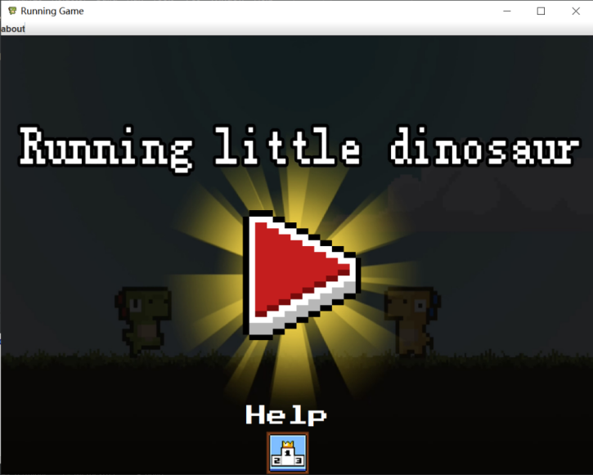

**Ranking view**

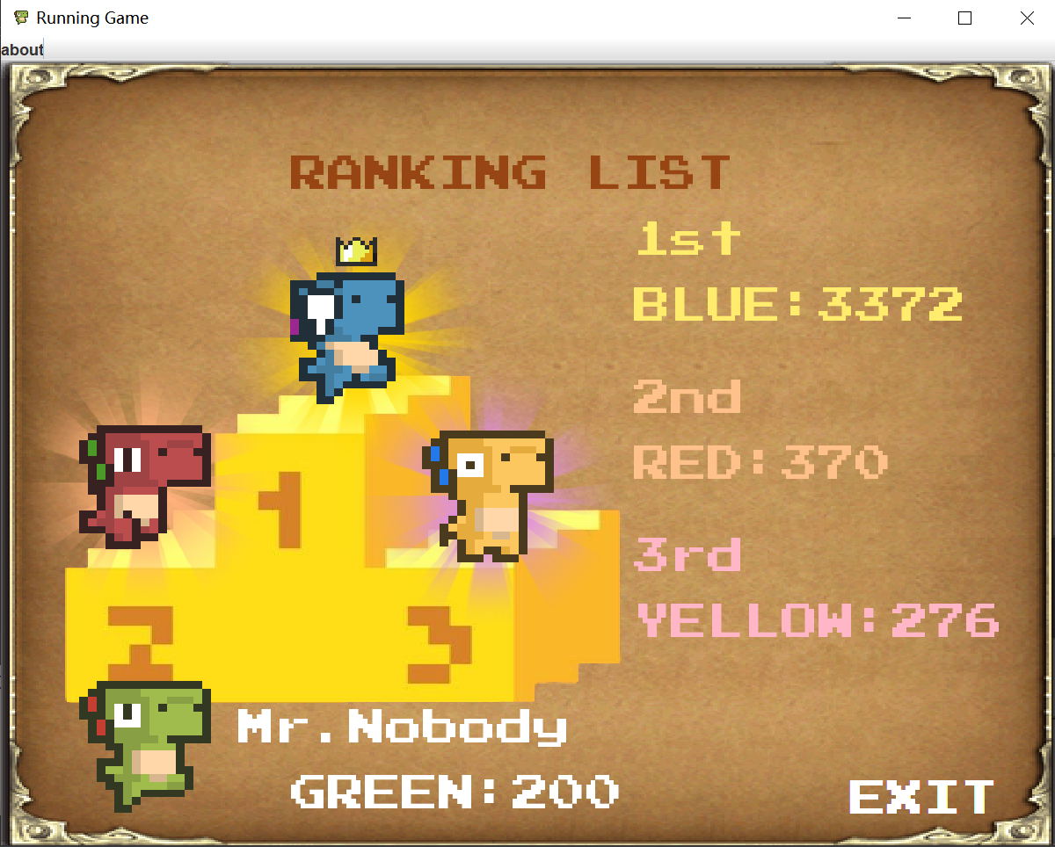

**Select characters**

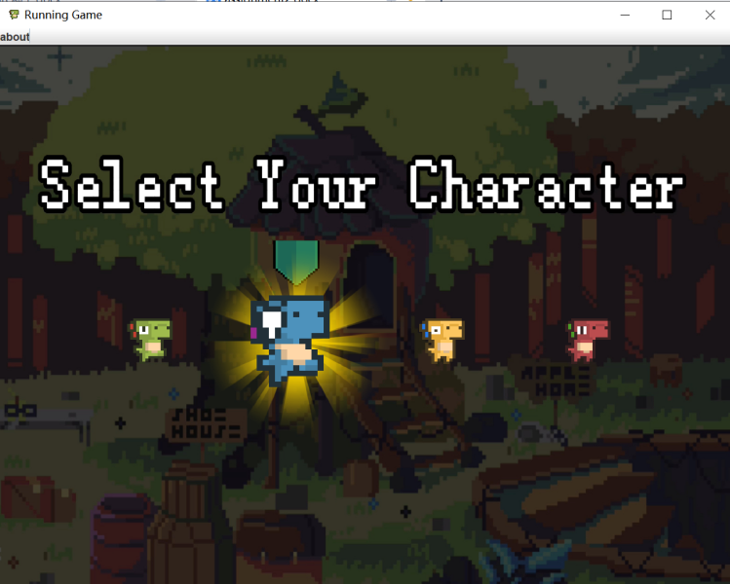

**Status bar -- Information bar: health, score/Skill bar: skill duration, bullet count and cooldown**

-- Character 10 blood

-- Normal time: normal bullet cooldown is 0.5s, super weapon cooldown is 10s, skill cooldown is 8s

-- Monster time: super weapon cooldown is 0.2s

-- Normal ammo capacity is 5 and invincible time is 10



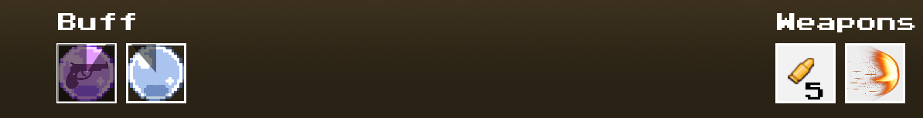

**Regular bullet effect Super weapon effect**

-- Normal time: 3 damage -- 1000 damage

-- Monster time: 5 damage

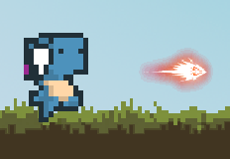 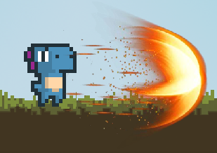

**Skill effects**

**Energy** --Recover 5 blood **Invincibility** - Resist any damage

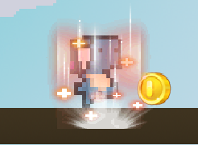 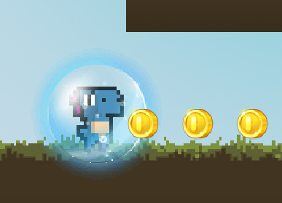

**Stronger damage** --Regular bullet 5 damage **Damage**

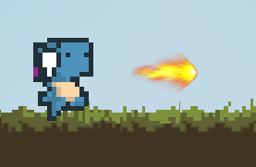 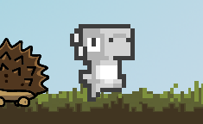

**Coin** --Gain 10 points

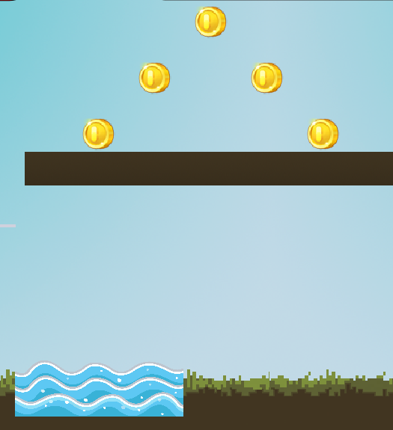 

**Obstacles**

**Water** -- Reduce 1 blood **Thunder** --Reduce 3 blood

 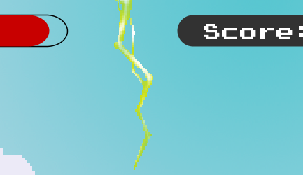

**Enemies** -- Reduce 3 blood/ Gain 10 points

**Enemy1**-- 7 health  **Enemy2**-- 7 health

 

**Enemy3**-- 7 health

 

**Coin Time**

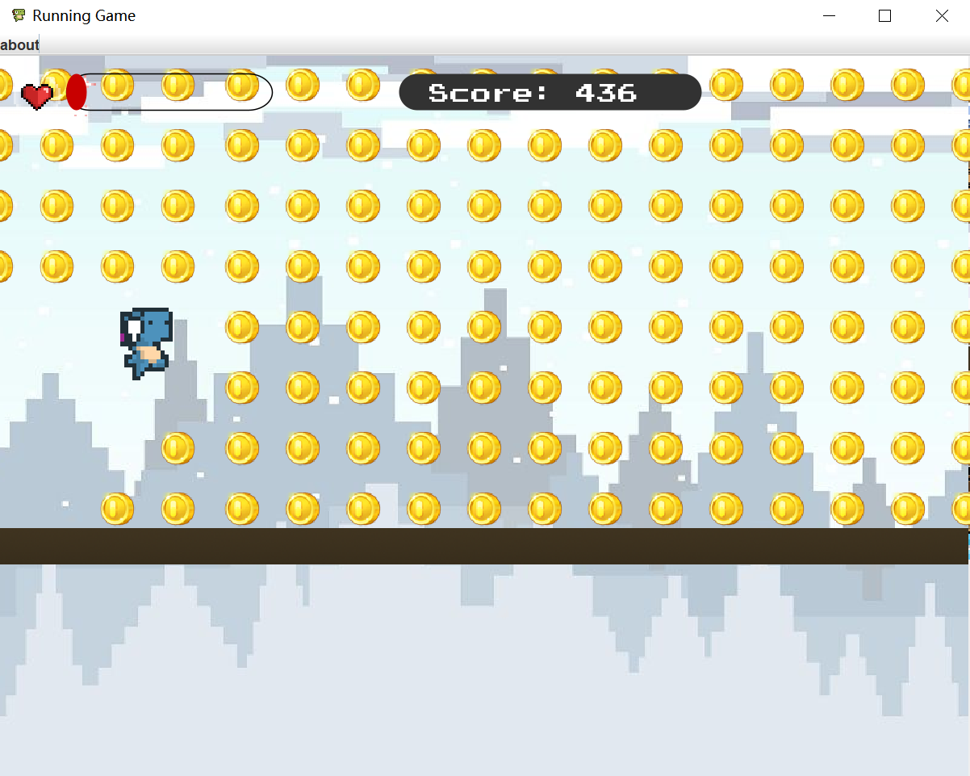

**Monster Time**

-- Superweapon cooldown is 0.2s

-- All enemies have 1 health, only stars have 100 health

-- All enemies cause 2 damage

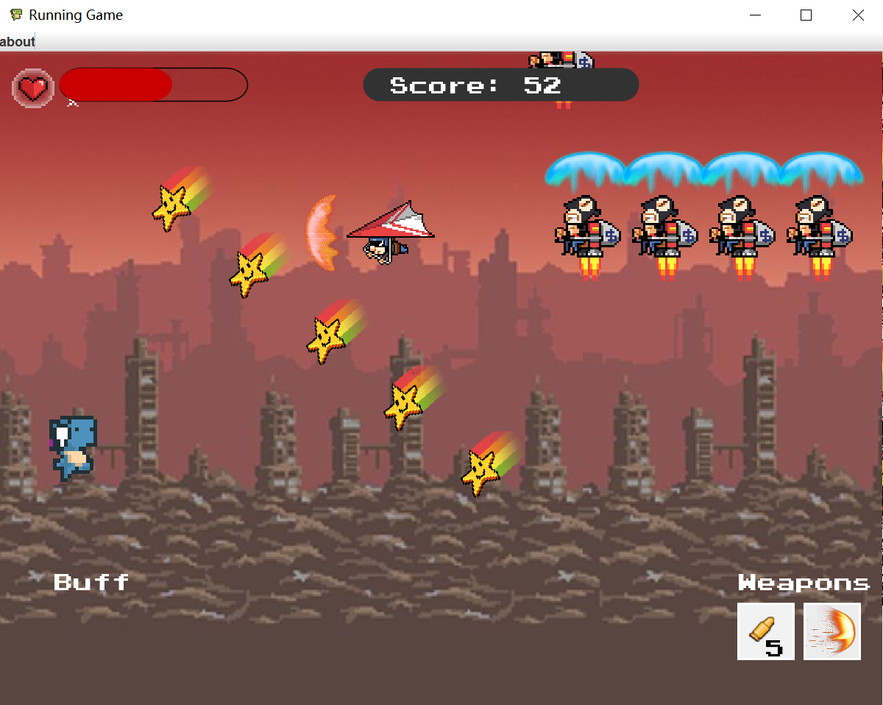

**Switching scenarios**

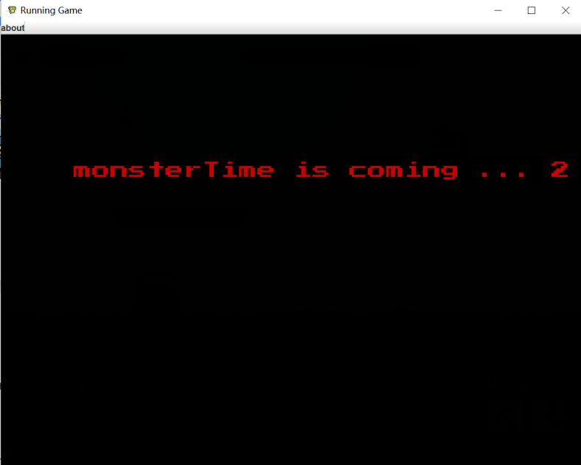

**Game Over**

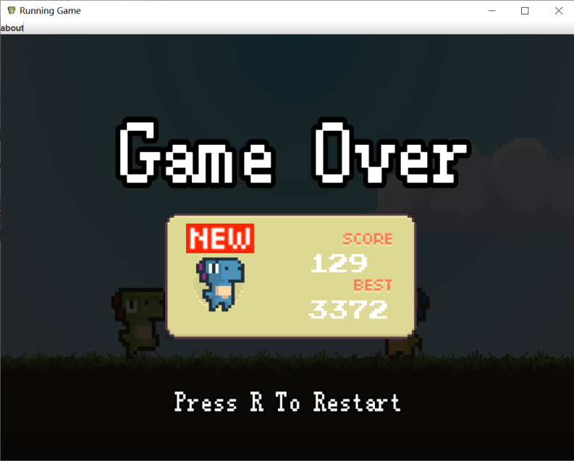

**Contribution**

**20007896 Jiang Yu:** Monster normal state, design the movement and generation of the background and boards in the sky, and deal with the basic collisions between the player and the boards.

**20008017 Mengyao Jia:** Coins/skills/obstacles/coinTime generation and collision with monster, skill effects, status bar, monster/bullet collisions with enemies, document.

**20007864 Zhibo Zhang:** Responsible for the description of monster time, which contains four kinds of monsters, monsters death of the explosion effects refresh way.

**20007895 Alex Wu:** Responsible for UI interface, interaction logic design, material design.