Ministry of Education and Science of the Russian Federation
Peter the Great St. Petersburg Polytechnic University
—–
Institute of Computer Science and Cybersecurity

LABORATORY WORK № 1

«String Class»

on the discipline "Object-Oriented Programming"

Performed by
student group 5151004/10101 Peresunko A. A.,

< sign >

Educator Kubrin G. S.
< sign >

Saint-Petersburg
2023

1. The work goal and task
The main goal of work is to study theory about OOP paradigm and get skills of OOP programming style by implementing own class-analog of standard class std::string in C++.
The main tasks of this laboratory work are:
- implement a class for representing a character string in C++, not using the STL library containers and algorithms;
- extend python interpreter functionality with the implemented class.

2. Theory
Object-Oriented Programming is a programming paradigm that focuses on the creation of objects that have properties and behaviors. It is based on the concept of classes, which are templates for creating objects. OOP allows for encapsulation, inheritance, and polymorphism.
Operator overloading is a feature in C++ that allows operators such as +, -, *, /, etc. to be redefined for user-defined data types. This means that the same operator can be used to perform different operations depending on the data type being used. For example, the + operator can be used to add two integers or concatenate two strings.
Inheritance is a feature in C++ that allows a new class to be created from an existing class. The new class, called the derived class, inherits all the properties and behaviors of the existing class, called the base class. This allows for code reuse and simplifies the development process. The derived class can also add its own properties and behaviors or override the ones inherited from the base class.
Pros of char arrays in C programming language:
- Char arrays are a fundamental data type in C and are used to store strings of characters.
- They are efficient in terms of memory usage and can be easily manipulated using various string functions.
- Char arrays are compatible with many input/output functions in C, making them useful for reading and writing text files.
Cons of char arrays in C programming language:
- Char arrays have a fixed size, which can lead to buffer overflow errors if not properly managed.
- It can be difficult to determine the length of a char array, which can cause issues when working with strings of varying lengths.
- Char arrays do not have any built-in safety features, such as bounds checking, which can make them vulnerable to security vulnerabilities.

3. Results
The main idea of practicing the OOP paradigm by realizing your own class copying functionality from standard C++ class string is to gain a better understanding of object-oriented programming concepts and how they can be applied in practice. By implementing a class that mimics the functionality of the string class, you can learn about topics such as encapsulation, inheritance, polymorphism, and data abstraction. This task also supposed to help student improve coding skills and become more proficient in C++ programming.
My variant of implementation supposed to be an optimal one by correct using memory allocation and usage of overloading and inheritance features of C++.
Table 1. All methods implemented in class – descriptions.
Name | Meaning
Constructor() | default constructor
Constructor(“char string”) | char array constructor
Constructor({‘s’,’t’,’r’,’i’,’n’,‘g’}) | initializer list constructor
Constructor(std::string) | std::string constructor
Constructor(“char string”, count) | init class with count characters of “char string”
Constructor( count, char) | init class with count of characters
Constructor(MyString) | copy constructor
Destructor()
Operator +(Mystring) | concatenate with Mystring
Operator +(“char string”) | concatenate with char array
Operator +(std::string) | concatenate with std::string
Operator +=(“char string”) | assignment concatenate with char array
Operator +=(std::string) | assignment concatenate with std::string
Operator=(“char string”) | char string assignment
Operator=(std::string) | std::string assignment
Operator=(‘char’) | char assignment
Opearator[](int) | index operator
Operator>()  Operator<()  Operator>=()  Operator<=()  Operator!=()  Operator==() | lexicographically comparing
c_str() | return a pointer to null-terminated character array
data() | return a pointer to array data that not required to be null-terminated
length() | same as size
size() | return the number of char elements in string
empty() | true if string is empty
capacity() | return the current amount of allocated memory for array
shrink_to_fit() | reduce the capacity to size
clear() | remove all char element in string
Operator<<(std::basic_ostream), Operator>>(std::basic_istream)
insert(index, count, char) | insert count of char in index position
insert(index, “string”) | insert null-terminated char string at index position
insert(index, “string”, count) | insert count of null-terminated char string at index position
insert(index, std::string) | insert std::string at index position
insert(index, std::string, count) | insert count of std::string at index position
erase(index, count) | erase count of char at index position
append(count, char) | append count of char
append(“string”) | append null-terminated char string
append(“string”, index, count) | append a count of null-terminated char string by index position
append(std::string) | append std:: string
append(std::string, index, count) | append a count of std:: string by index position
replace(index, count, “string”) | replace a count of char at index by “string”
replace(index, count, std::string) | replace a count of char at index by std::string
substr(index) | return a substring starts with index position
substr(index,count) | return a count of substring’s char starts with index position
find(“string”) | if founded return the index of substring
find(“string”, index) | same as find(“string”) but search starts from index position
find(std::string) | if founded return the index of substring
find(std::string, index) | same as find(“string”) but search starts from index position

As the matter of fact, some methods were implemented by reusing of functionality of other methods in list. For example, append method represents the particular case of insert implementation. Therefore, all append-type methods and all operators+= were reusing functionality of insert-type methods.
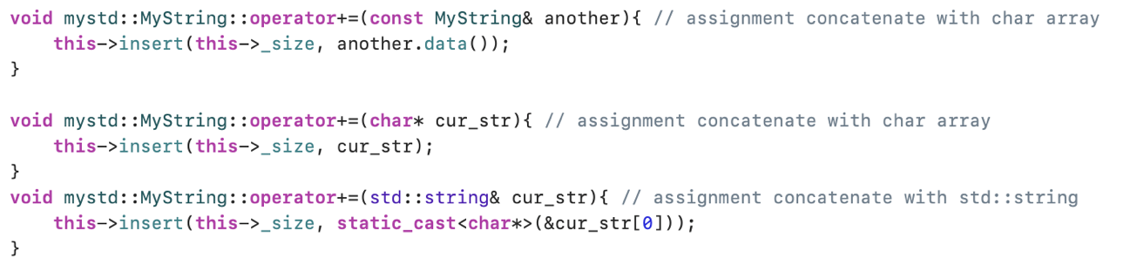
Picture 1. Reusing insert() for operator+= implementation

Some samples of functions and constructors working results are following below:
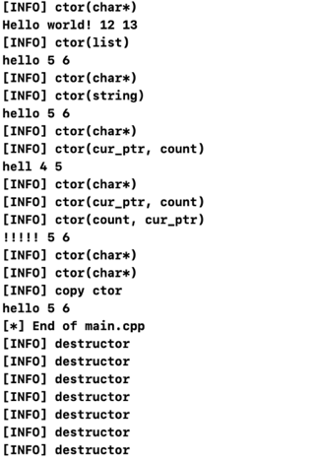
Picture 2. Results of constructors working
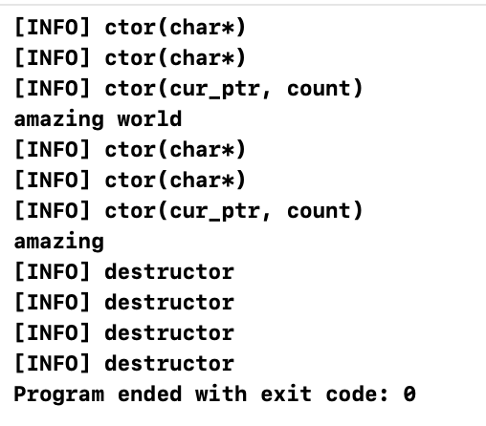
Picture 3. Results of substr functions
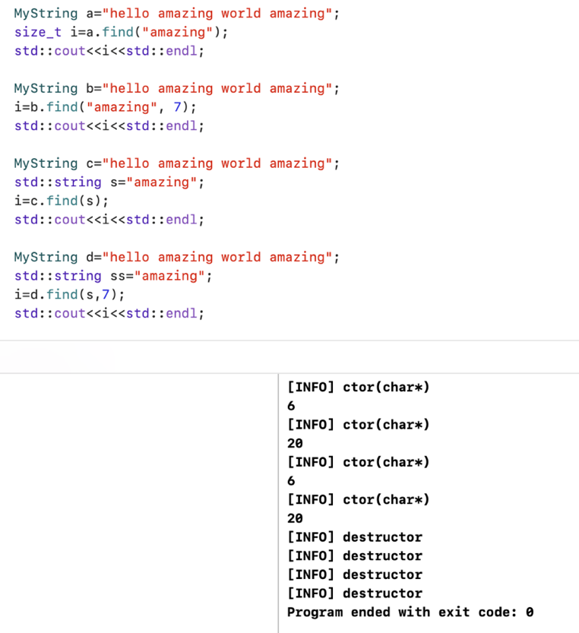
Picture 4. Results of find functions

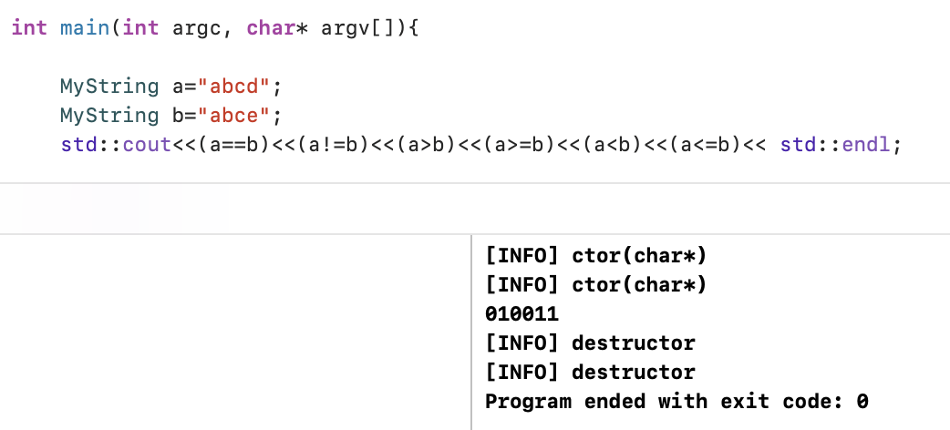
Picture 5. Results of lexicographically comparing

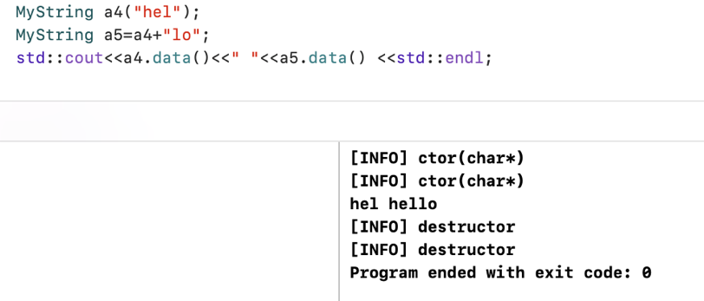
Picture 6. Results of operator=

Appendix A — my_string.hpp file

#ifndef _MY_STRING_
#define _MY_STRING_

#include <iostream>

namespace mystd {
class MyString {
private:
char* _ptr; // string pointer
size_t _size; // len of string
size_t _capacity; // max len of string

public:
MyString(void); // default constructor()
MyString(const char* cur_ptr); // char array constructor
MyString(const std::initializer_list<char>& list); // initializer list constructor
MyString(const std::string& cur_ptr); // std::string constructor
MyString(const char* cur_ptr, const size_t count); // init class with count characters of “char string”
MyString(const size_t count, char cur_char); // init class with count of characters
MyString(MyString& another); // copy constructor
~MyString(); // default destructor

MyString operator+(const MyString& another); // concatenate with Mystring
MyString operator+(const char* cur_string); // concatenate with char array
MyString operator+(std::string& cur_str); // concatenate with std::string
void operator+=(const MyString& another);
void operator+=(char* cur_str); // assignment concatenate with char array
void operator+=(std::string& cur_str); // assignment concatenate with std::string
void operator=(char* cur_str); // char string assignment
void operator=(std::string& сur_str); // std::string assignment
void operator=(char cur_char); // char assignment
char operator[](const size_t index); // index operator

/* lexicographically comparing */
bool operator>(const MyString& another);
bool operator>(char* cur_str);
bool operator<(const MyString& another);
bool operator<(char* cur_str);
bool operator>=(const MyString& another);
bool operator>=(char* cur_str);
bool operator<=(const MyString& another);
bool operator<=(char* cur_str);
bool operator!=(const MyString& another);
bool operator!=(char* cur_str);
bool operator ==(const MyString& another);
bool operator ==(char* cur_str);
char* c_str() const; // return a pointer to null-terminated character array
char* data() const; // return a pointer to array data that not required to be null-terminated
size_t length() const; // same as size
size_t size() const; // return the number of char elements in string
bool empty() const; // true if string is empty
size_t capacity() const; // return the current amount of allocated memory for array
void shrink_to_fit(); // reduce the capacity to size
void clear(); // remove all char element in string
friend std::ostream& operator<<(std::ostream& out, MyString& another);
friend std::istream& operator>>(std::istream& in, MyString& another);

void insert(const size_t index, const size_t count, const char cur_char); // insert count of char in index position
void insert(const size_t index, const char* string); // insert null-terminated char string at index position
void insert(const size_t index, const char* string, const size_t count); // insert count of null-terminated char string at index position
void insert(const size_t index, std::string& cur_ptr); // insert std::string at index position
void insert(const size_t index, std::string& cur_ptr, const size_t count); // insert count of std::string at index position

void erase(const size_t index, const size_t count); // erase count of char at index position

void append(const size_t count, const char cur_char); // append count of char
void append(const char* cur_str); // append null-terminated char string
void append(const char* cur_str, const size_t index, const size_t count); // append a count of null-terminated char string by index position
void append(std::string& cur_str); // append std:: string
void append(std::string& cur_str, const size_t index, const size_t count); // append a count of std:: string by index position

void replace(const size_t index, const size_t count, const char* cur_str); // replace a count of char at index by “string”
void replace(const size_t index, const size_t count, std::string& cur_str); // replace a count of char at index by std::string

MyString substr(const size_t index); // return a substring starts with index position
MyString substr(const size_t index, const size_t count); // return a count of substring’s char starts with index position

size_t find(const char* cur_str); // if founded return the index of substring
size_t find(const char* cur_str, const size_t index); // same as find(“string”) but search starts from index position
size_t find(std::string& cur_str); // if founded return the index of substring
size_t find(std::string& cur_str, const size_t index); // same as find(“string”) but search starts from index position
};
}

#endif

Appendix B — my_string.cpp file
#include "my_string.hpp"
#include <cstring>

using namespace std;

mystd::MyString::MyString() : MyString({'\0'}){ // default constructor()
this->_size = 0;
this->_capacity = 0;
cout << "[INFO] Default ctor" << endl;
}
mystd::MyString::MyString(const char* cur_str) { // char array constructor
this->_size = strlen(cur_str);
this->_ptr = new char[this->_size+1];
strncpy(this->_ptr, cur_str, this->_size);
this->_capacity = length();
cout << "[INFO] ctor(char*)" << endl;
}
mystd::MyString::MyString(const std::initializer_list<char>& list) { // initializer list constructor
this->_size = list.size();
this->_ptr = new char[this->_size+1];
copy(begin(list), end(list), this->_ptr);
this->_capacity = length();
cout << "[INFO] ctor(list)" << endl;
}
mystd::MyString::MyString(const std::string& cur_str) : MyString(cur_str.c_str()){ // std::string constructor
cout << "[INFO] ctor(string)" << endl;
}
mystd::MyString::MyString(const char* cur_ptr, const size_t count) : MyString(cur_ptr){ // init class with count characters of “char string”
this->erase(count, this->_size-count);
this->shrink_to_fit();
cout << "[INFO] ctor(cur_ptr, count)" << endl;
}
mystd::MyString::MyString(const size_t count, char cur_char) : MyString(&cur_char){ // init class with count of characters
this->append(count-1, cur_char);
cout << "[INFO] ctor(count, cur_ptr)" << endl;
}
mystd::MyString::MyString(MyString& another) : MyString(another.data()){ // copy constructor
cout << "[INFO] copy ctor" << endl;
}

mystd::MyString::~MyString(){ // default destructor
cout << "[INFO] destructor" << endl;
if(this->_ptr){delete this->_ptr;}
}

mystd::MyString mystd::MyString::operator+(const MyString& another) { // concatenate with Mystring
char* tmp_str = new char[this->_capacity + another._size];
strcat(tmp_str, this->_ptr);
strcat(tmp_str, another.data());
MyString tmp(tmp_str);
return tmp;
}
mystd::MyString mystd::MyString::operator+(const char* cur_str){ // concatenate with char array
char* tmp_str = new char[this->_capacity + strlen(cur_str)];
strncpy(tmp_str, this->_ptr, this->_size);
strcat(tmp_str, cur_str);
MyString tmp(tmp_str);
return tmp;
}
mystd::MyString mystd::MyString::operator+(std::string& cur_str){ // concatenate with std::string
MyString a(this->_ptr);
MyString tmp = a + &cur_str[0];
return tmp;
}

void mystd::MyString::operator+=(const MyString& another){ // assignment concatenate with char array
this->insert(this->_size, another.data());
}

void mystd::MyString::operator+=(char* cur_str){ // assignment concatenate with char array
this->insert(this->_size, cur_str);
}
void mystd::MyString::operator+=(std::string& cur_str){ // assignment concatenate with std::string
this->insert(this->_size, static_cast<char*>(&cur_str[0]));
}
void mystd::MyString::operator=(char* cur_str){ // char string assignment
delete this->_ptr;
this->_ptr = new char[strlen(cur_str)+1];
this->_size = strlen(cur_str);
strncpy(this->_ptr, cur_str, this->_size);
if(strlen(cur_str) >= this->_capacity){
this->_capacity = length();
}
}
void mystd::MyString::operator=(std::string& cur_str){ // std::string assignment
*this = static_cast<char*>(&cur_str[0]);
}
void mystd::MyString::operator=(char cur_char){ // char assignment
char* tmp = new char[2];
tmp[0] = cur_char;
tmp[1] = '\0';
*this = tmp;
}
char mystd::MyString::operator[](size_t index){ // index operator
if(index <= this->_size){
return this->_ptr[index];}
else{
cout << "[ER] Index out of range" << endl;
return '\0';
}
}

bool mystd::MyString::operator>(const MyString& another){
return *this > another.data();
}
bool mystd::MyString::operator>(char* cur_str){
for(size_t i=0; i<this->_size; i++){
if(this->_ptr[i] > cur_str[i]){
return true;
}
else if(this->_ptr[i] < cur_str[i]){
return false;
}
else{continue;}
}
return false;
}
bool mystd::MyString::operator<(const MyString& another){
return *this < another.data();
}
bool mystd::MyString::operator<(char* cur_str){
return !(*this > cur_str);
}
bool mystd::MyString::operator>=(const MyString& another){
return *this >= another.data();
}
bool mystd::MyString::operator>=(char* cur_str){
if((*this == cur_str)||(*this > cur_str)){
return true;
}
else{return false;}
}
bool mystd::MyString::operator<=(const MyString& another){
return !(*this >= another.data());
}
bool mystd::MyString::operator<=(char* cur_str){
return !(*this >= cur_str);
}
bool mystd::MyString::operator!=(const MyString& another){
return !(*this == another.data());
}
bool mystd::MyString::operator!=(char* cur_str){
return !(*this == cur_str);
}
bool mystd::MyString::operator==(const MyString& another){
return *this == another.data();
}
bool mystd::MyString::operator==(char* cur_str){
for (size_t i=0; i<this->_capacity; i++) {
if(this->_ptr[i] == cur_str[i]){continue;}
else{return false;}
}
return true;
}

char* mystd::MyString::c_str() const { // return a pointer to null-terminated character array
return &(this->_ptr[0]);
}
char* mystd::MyString::data() const { // return a pointer to array data that not required to be null-terminated
return this->_ptr;
}
size_t mystd::MyString::length() const { // same as size
return size();
}
size_t mystd::MyString::size() const { // return the number of char elements in string
size_t i = 0;
while (this->_ptr[i] != '\0') {
i++;
}
return i;
}
bool mystd::MyString::empty() const { // true if string is empty
return this->_size == 0 ? true : false;
}
size_t mystd::MyString::capacity() const { // return the current amount of allocated memory for array
return this->_capacity;
}
void mystd::MyString::shrink_to_fit(){ // reduce the capacity to size
this->_size = strlen(this->_ptr);
this->_capacity = this->_size + 1;
}
void mystd::MyString::clear(){ // remove all char element in string
for(size_t i=0; i<this->_capacity; i++){
this->_ptr[i] = '\0';
}
}
ostream& operator<<(ostream& out, mystd::MyString& another){
out << another.data();
return out;
}
istream& operator>>(istream& in, mystd::MyString& another){
char c = 'a';
while((c != '\n')&&(c != EOF)){
c = in.get();
another.append(1, c);
}
another.append(1, '\0');
return in;
}

void mystd::MyString::insert(size_t index, size_t count, char cur_char){ // insert count of char in index position
if (index <= this->_capacity) {
char* tmp = new char[2];
tmp[0] = cur_char;
tmp[1] = '\0';
for(size_t i=0; i<count; i++){
insert(index, tmp);
}
}
else{ cout << "[ER] Index out of range" << endl; }
}
void mystd::MyString::insert(const size_t index, const char* string){ // insert null-terminated char string at index position
if (index <= this->_capacity) {
size_t len = strlen(string);
char* tmp = new char[this->_capacity+len];
size_t j = 0;
for(size_t i=0; i<(this->_size)+len; i++){
if(i == index){
for(size_t k=0; k<len; k++){
tmp[index+k] = string[k];
}
i = index + len - 1;
}
else{
tmp[i] = this->_ptr[j];
j++;
}
}
this->_ptr = new char[this->_capacity+len];
strncpy(this->_ptr, tmp, this->_capacity+len);
if(this->_capacity < this->_size){
this->_capacity = length();
}
this->_size = strlen(tmp);
}
else{ cout << "[ER] Index out of range" << endl; }
}
void mystd::MyString::insert(const size_t index, const char* string, const size_t count){ // insert count of null-terminated char string at index position
if (index <= this->_capacity) {
for(size_t i = 0; i < count; i++){ this->insert(index, string); }
}
else{ cout << "[ER] Index out of range" << endl; }
}
void mystd::MyString::insert(const size_t index, std::string& cur_ptr){ // insert std::string at index position
if(index <= this->_capacity){
this->insert(index, static_cast<char*>(&cur_ptr[0]));
}
else{ cout << "[ER] Index out of range" << endl; }
}
void mystd::MyString::insert(const size_t index, std::string& cur_ptr, const size_t count){ // insert count of std::string at index position
if(index <= this->_capacity){
this->insert(index,static_cast<char*>(&cur_ptr[0]), count);
}
else{ cout << "[ER] Index out of range" << endl; }
}

void mystd::MyString::erase(size_t index, size_t count){ // erase count of char at index position
char* tmp = new char[this->_capacity];
strncpy(tmp, &(this->_ptr[index+count]), this->_size-index);
for(size_t i=0; i<count; i++){
this->_ptr[index+i] = '\0';
}
strcat(this->_ptr, tmp);
this->_size = strlen(this->_ptr);
}

void mystd::MyString::append(size_t count, char cur_char){ // append count of char
this->insert(this->_size, count, cur_char);
}
void mystd::MyString::append(const char* cur_str){ // append null-terminated char string
this->insert(this->_size, cur_str);
}
void mystd::MyString::append(const char* cur_str, const size_t index, const size_t count){ // append a count of null-terminated char string by index position
if(index <= strlen(cur_str)){
char* tmp = new char[count+1];
strncpy(tmp, &cur_str[index], count);
this->insert(this->_size, tmp);
}
else{
cout << "[ER] Index out of range" << endl;
}
}
void mystd::MyString::append(std::string& cur_str){ // append std:: string
this->insert(this->_size, static_cast<char*>(&cur_str[0]));
}
void mystd::MyString::append(std::string& cur_str, const size_t index, const size_t count){ // append a count of std:: string by index position
this->append(static_cast<char*>(&cur_str[0]), index, count);
}

void mystd::MyString::replace(const size_t index, const size_t count, const char* cur_str){ // replace a count of char at index by “string”
if(index <= this->_capacity){
this->erase(index, count);
this->insert(index, cur_str);
}
else{ cout << "[ER] Index out of range" << endl; }
}
void mystd::MyString::replace(const size_t index, const size_t count, std::string& cur_str){ // replace a count of char at index by std::string
if(index <= this->_capacity){
this->replace(index, count, static_cast<char*>(&cur_str[0]));
}
else{ cout << "[ER] Index out of range" << endl; }
}

mystd::MyString mystd::MyString::substr(size_t index){ // return a substring starts with index position
return this->substr(index, this->_size-index);
}
mystd::MyString mystd::MyString::substr(size_t index, size_t count){ // return a count of substring’s char starts with index position
MyString tmp(this->_ptr+index, count);
return tmp;
}
size_t mystd::MyString::find(const char* cur_str){ // if founded return the index of substring
return this->find(cur_str, 0);
}
size_t mystd::MyString::find(const char* cur_str, const size_t index){ // same as find(“string”) but search starts from index position
if(strlen(cur_str) <= this->_size){
size_t find_letters = 0;
size_t tmp_ind = 0;
size_t j = 0;
for(size_t i=index; i < this->_size; i++){
if(this->_ptr[i] == cur_str[j]){
find_letters++;
j++;
if(find_letters == 1){tmp_ind = i;}
if(find_letters == strlen(cur_str)){return tmp_ind;}
}
else{
find_letters = 0;
j = 0;
}
}
return -1;
}
else{
cout << "[ER] Index out of range" << endl;
return -1;
}
}
size_t mystd::MyString::find(std::string& cur_str){ // if founded return the index of substring
return this->find(&cur_str[0], 0);
}
size_t mystd::MyString::find(std::string& cur_str, size_t index){ // same as find(“string”) but search starts from index position
return this->find(&cur_str[0], index);
}

