**Homework 3**

**Features, Homographies**

**and Panorama Stitching**

Submission Date: 13/12/2022

|  |  |  |
| --- | --- | --- |
| **ID Number** | **Last Name** | **First Name** |
| 324338136 | Yorov | Alexander |
| 316342286 | Kertes | Noga |

# Part 1 – Classic Vs. Deep Learning-based Semantic Segmentation

# Part 2 – Adversarial Images

# Part 3 – Planar Homographies

After we saw how descriptors are implemented and performed, now we will see how to use them for homographies.

In this part you will implement an image stitching algorithm, and will learn how to stitch several images of the same scene into a panorama. First, we’ll concentrate on the case of two images and then extend to several images.

For the following tasks:

- **You are not allowed to use OpenCV/Scipy or any other "ready to use" functions when you are asked to implement a function (you can still use the functions to save and load images).**

- For each step add illustration images to your report.

- You can demonstrate your steps using `incline_L.jpg` and `incline_R.jpg` images, or any other relevant example images (unless specified otherwise).

# Part 4 – Dry Questions

## 

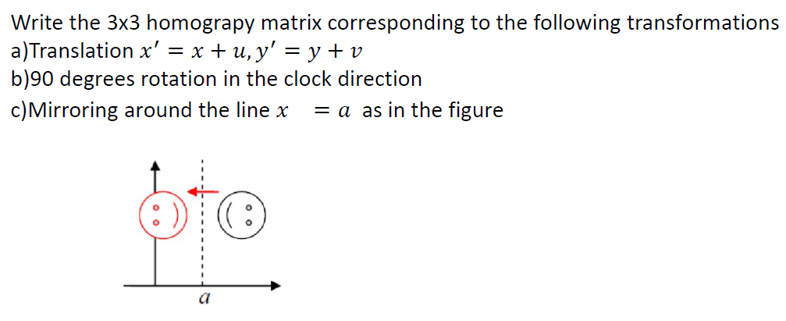

### Translation

Given a translation:

$$x^{'}=x+u \\ y^{'}=y+v$$

We can show it matrix form:

$$\left[\begin{aligned}x^{'} \\ y^{'} \\ 1\end{aligned}\right]=\left[\begin{matrix}1 & 0 & u \\ 0 & 1 & v \\ 0 & 0 & 1\end{matrix}\right]\left[\begin{aligned}x \\ y \\ 1\end{aligned}\right]$$

So the homography matrix is:

$$\left[\begin{matrix}1 & 0 & u \\ 0 & 1 & v \\ 0 & 0 & 1\end{matrix}\right]$$

### Rotation

For a rotation at angle (any angle) we can use a counterclockwise rotation matrix:

$$R=\left[\begin{matrix}\cos\left(θ\right) & -sin\left(θ\right) & 0 \\ \sin\left(θ\right) & \cos\left(θ\right) & 0 \\ 0 & 0 & 1\end{matrix}\right]$$

So, for clockwise rotation:

$$R=\left[\begin{matrix}\cos\left(θ\right) & \sin\left(θ\right) & 0 \\ -\sin\left(θ\right) & \cos\left(θ\right) & 0 \\ 0 & 0 & 1\end{matrix}\right]$$

And, for clockwise rotation at $θ=90°$:

$$R=\left[\begin{matrix}\cos\left(θ\right) & \sin\left(θ\right) & 0 \\ -\sin\left(θ\right) & \cos\left(θ\right) & 0 \\ 0 & 0 & 1\end{matrix}\right]=\left[\begin{matrix}0 & 1 & 0 \\ -1 & 0 & 0 \\ 0 & 0 & 1\end{matrix}\right]$$

### Mirroring

For mirroring (around $x=a$) we use the following homography:

$$\left[\begin{matrix}-1 & 0 & 2a \\ 0 & 1 & 0 \\ 0 & 0 & 1\end{matrix}\right]$$

As we only want to change the $x$ locations, such that:

$$x^{'}=-x+2a$$