Alexander Zayas

Module 5.2

June 20th, 2024

**CURRENT_DATE () Function:**

The CURRENT_DATE() function returns the current date in the format YYYY-MM-DD. It is useful for retrieving the system's current date, which can be used in reports, logs, or any time sensitive data processing.

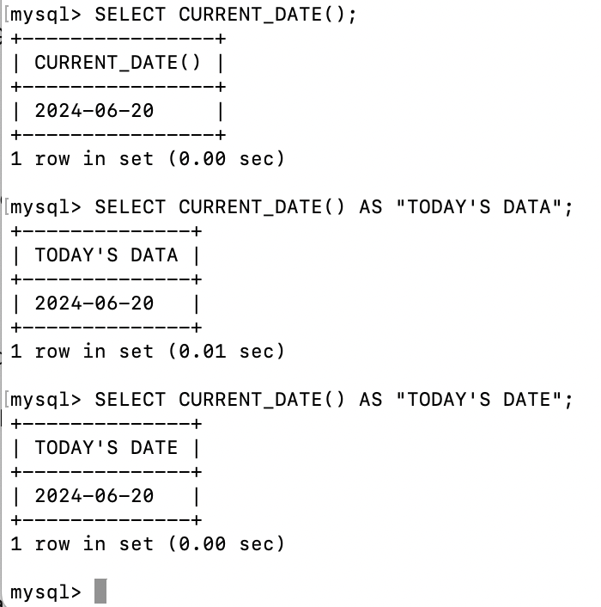

In order for me to be able to use the next two functions, I needed to create my own Sample database and insert sample data. Below is the screenshot of the SQL commands used prior to using the functions themselves.

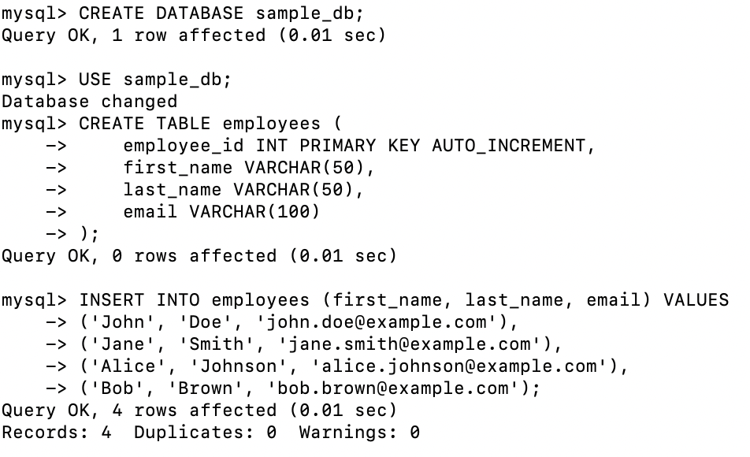

**CONCAT() Function:**

The CONCAT() function is used to concatenate two or more strings into a single string. This is useful for creating full names from first and last names, constructing addresses, or any other scenario where you need to merge text fields.

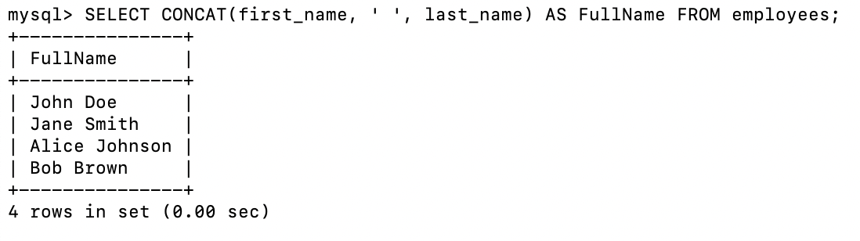

**LENGTH() Function:**

The LENGTH() function returns the length of a string in bytes. This is useful for validating input lengths, checking data quality, or preparing data for processing that requires length constraints.

