Alexander Zayas

Module 1.2

August 11th, 2024

**URL to Github:** <https://github.com/AlexZayas1734/csd-340>

Screen shot of git clone

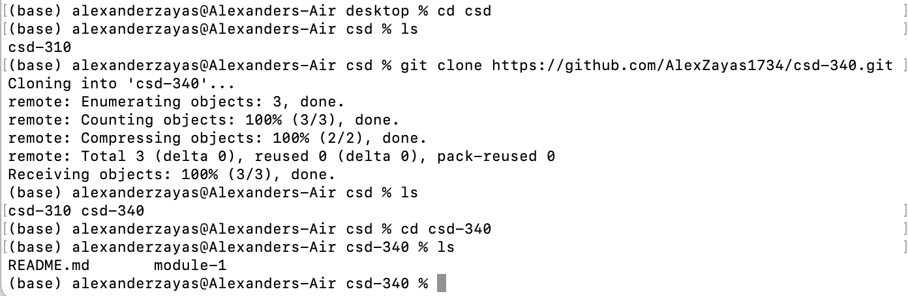Screen shot of Repo landing page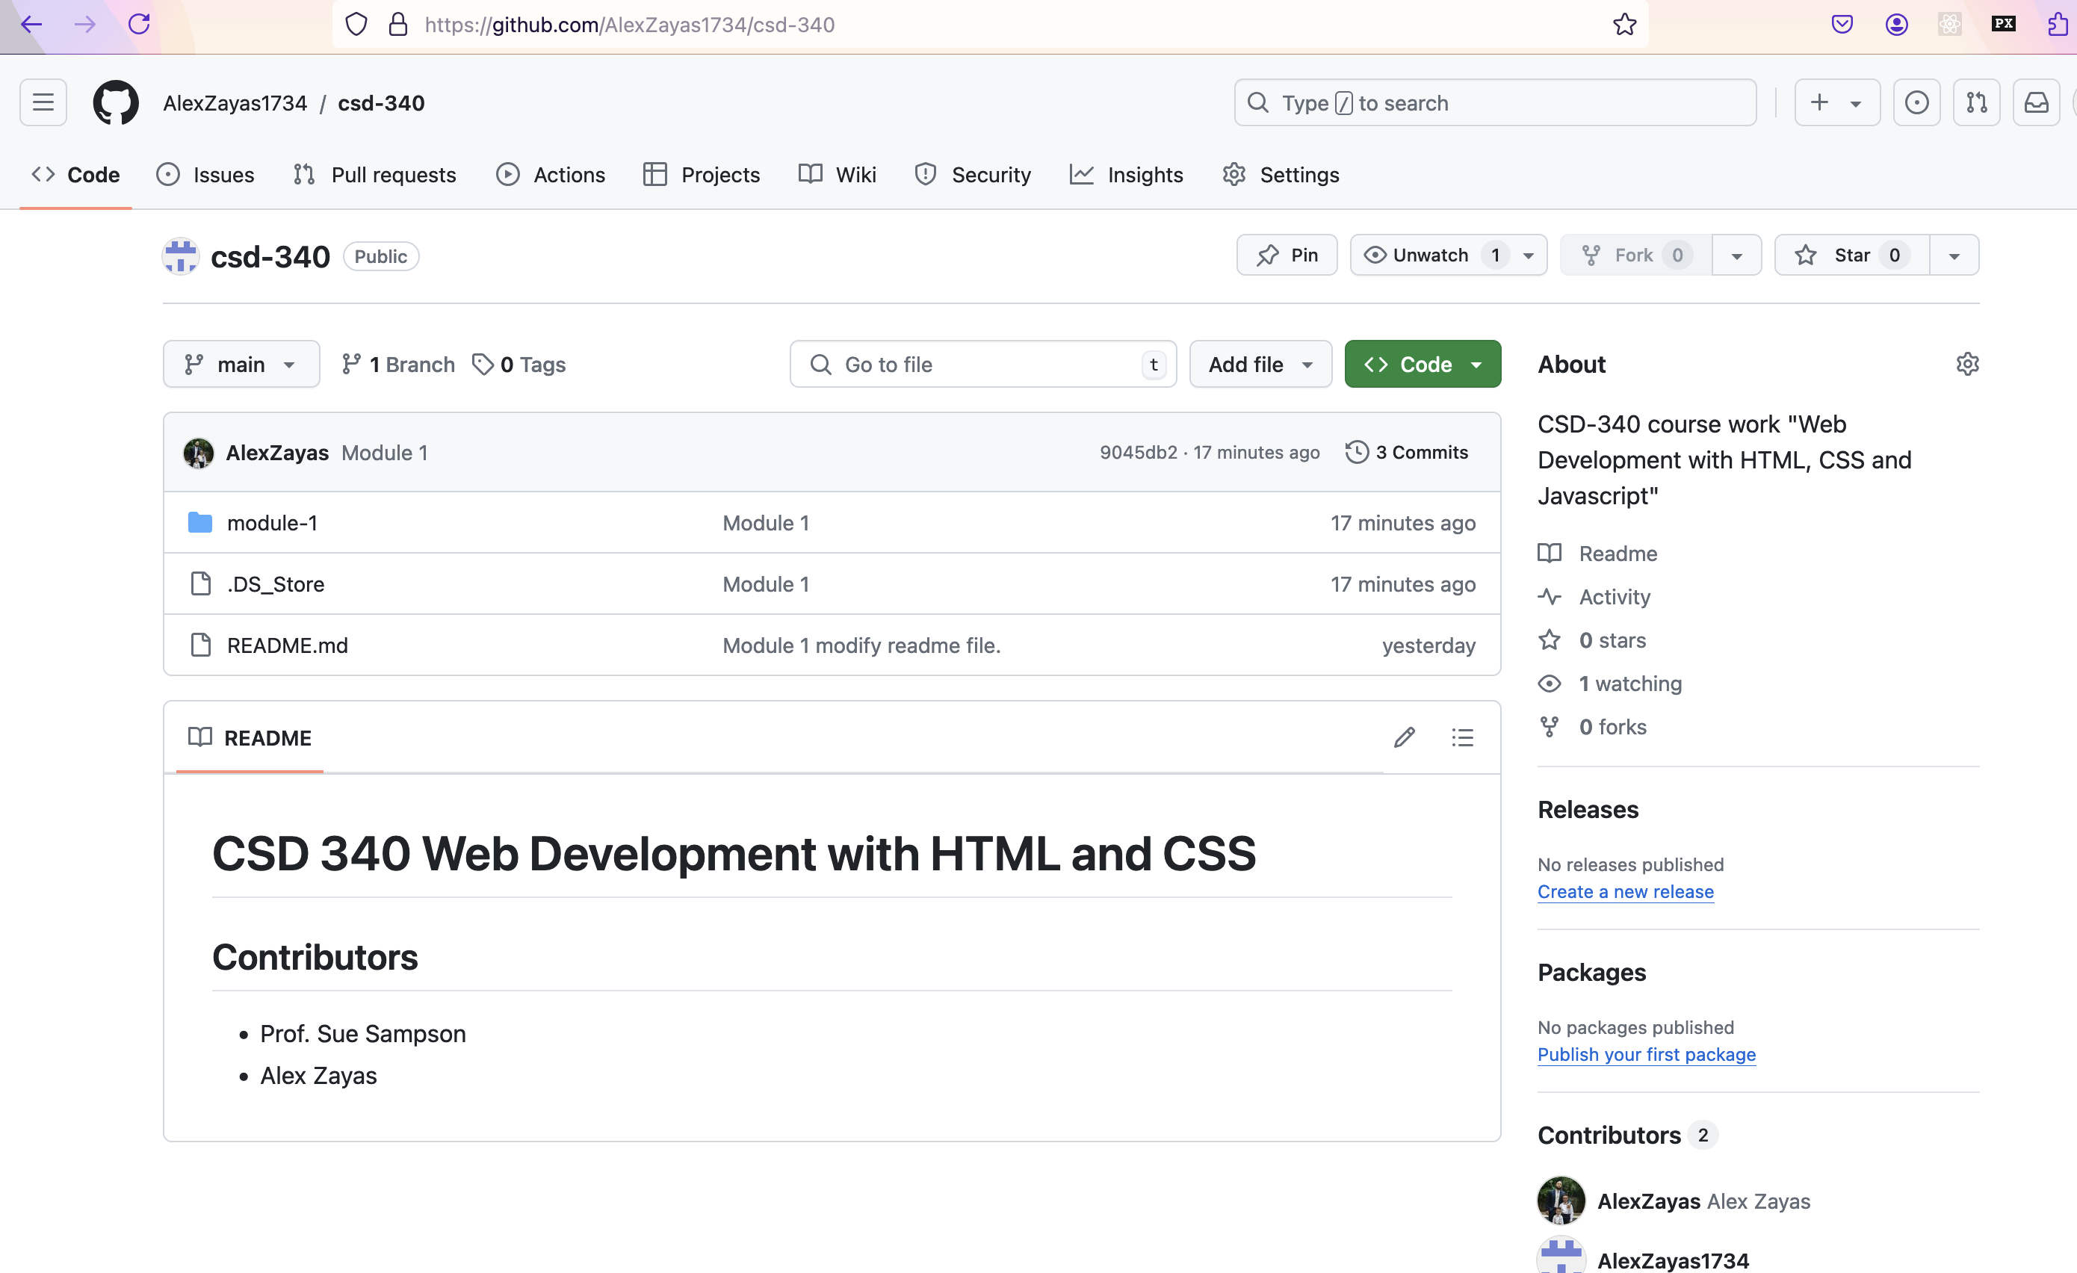

Screenshot of Readme file. 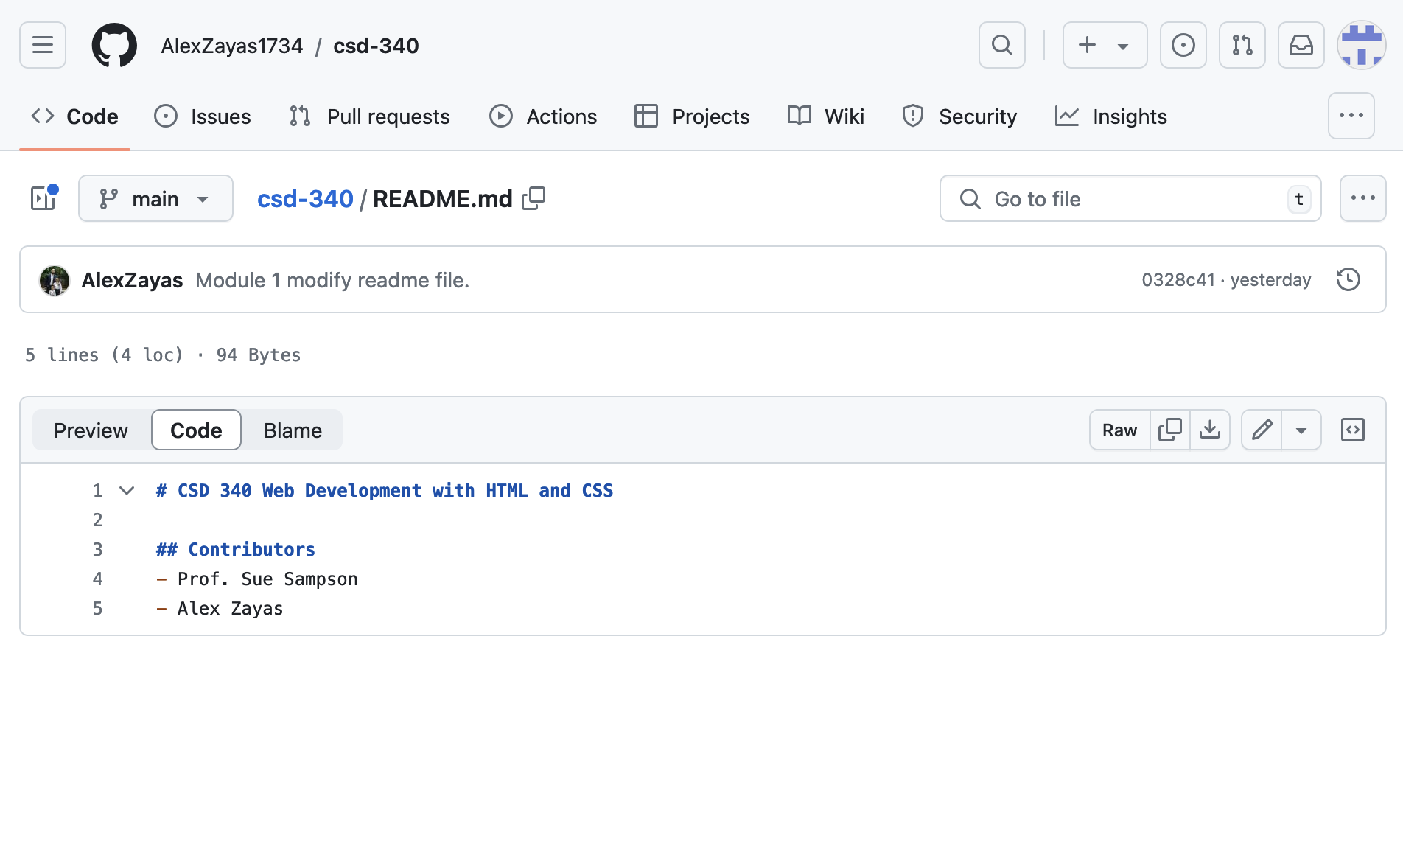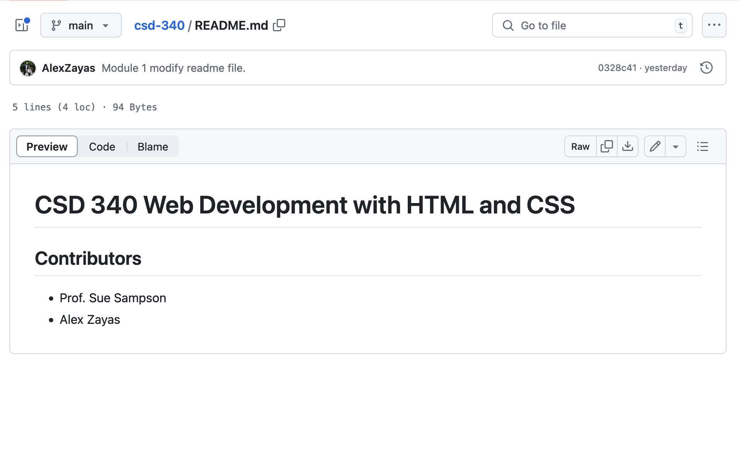

Screenshot of local directory

