Alexander Zayas

Module 1.3

August 11th, 2024

1st check results:

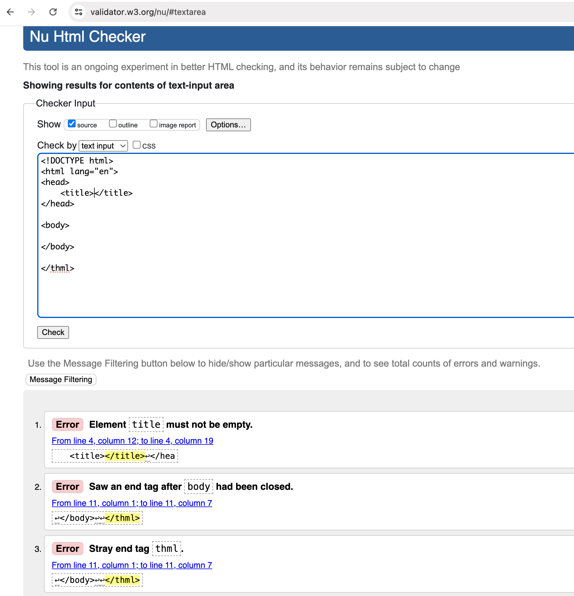

2nd check results:

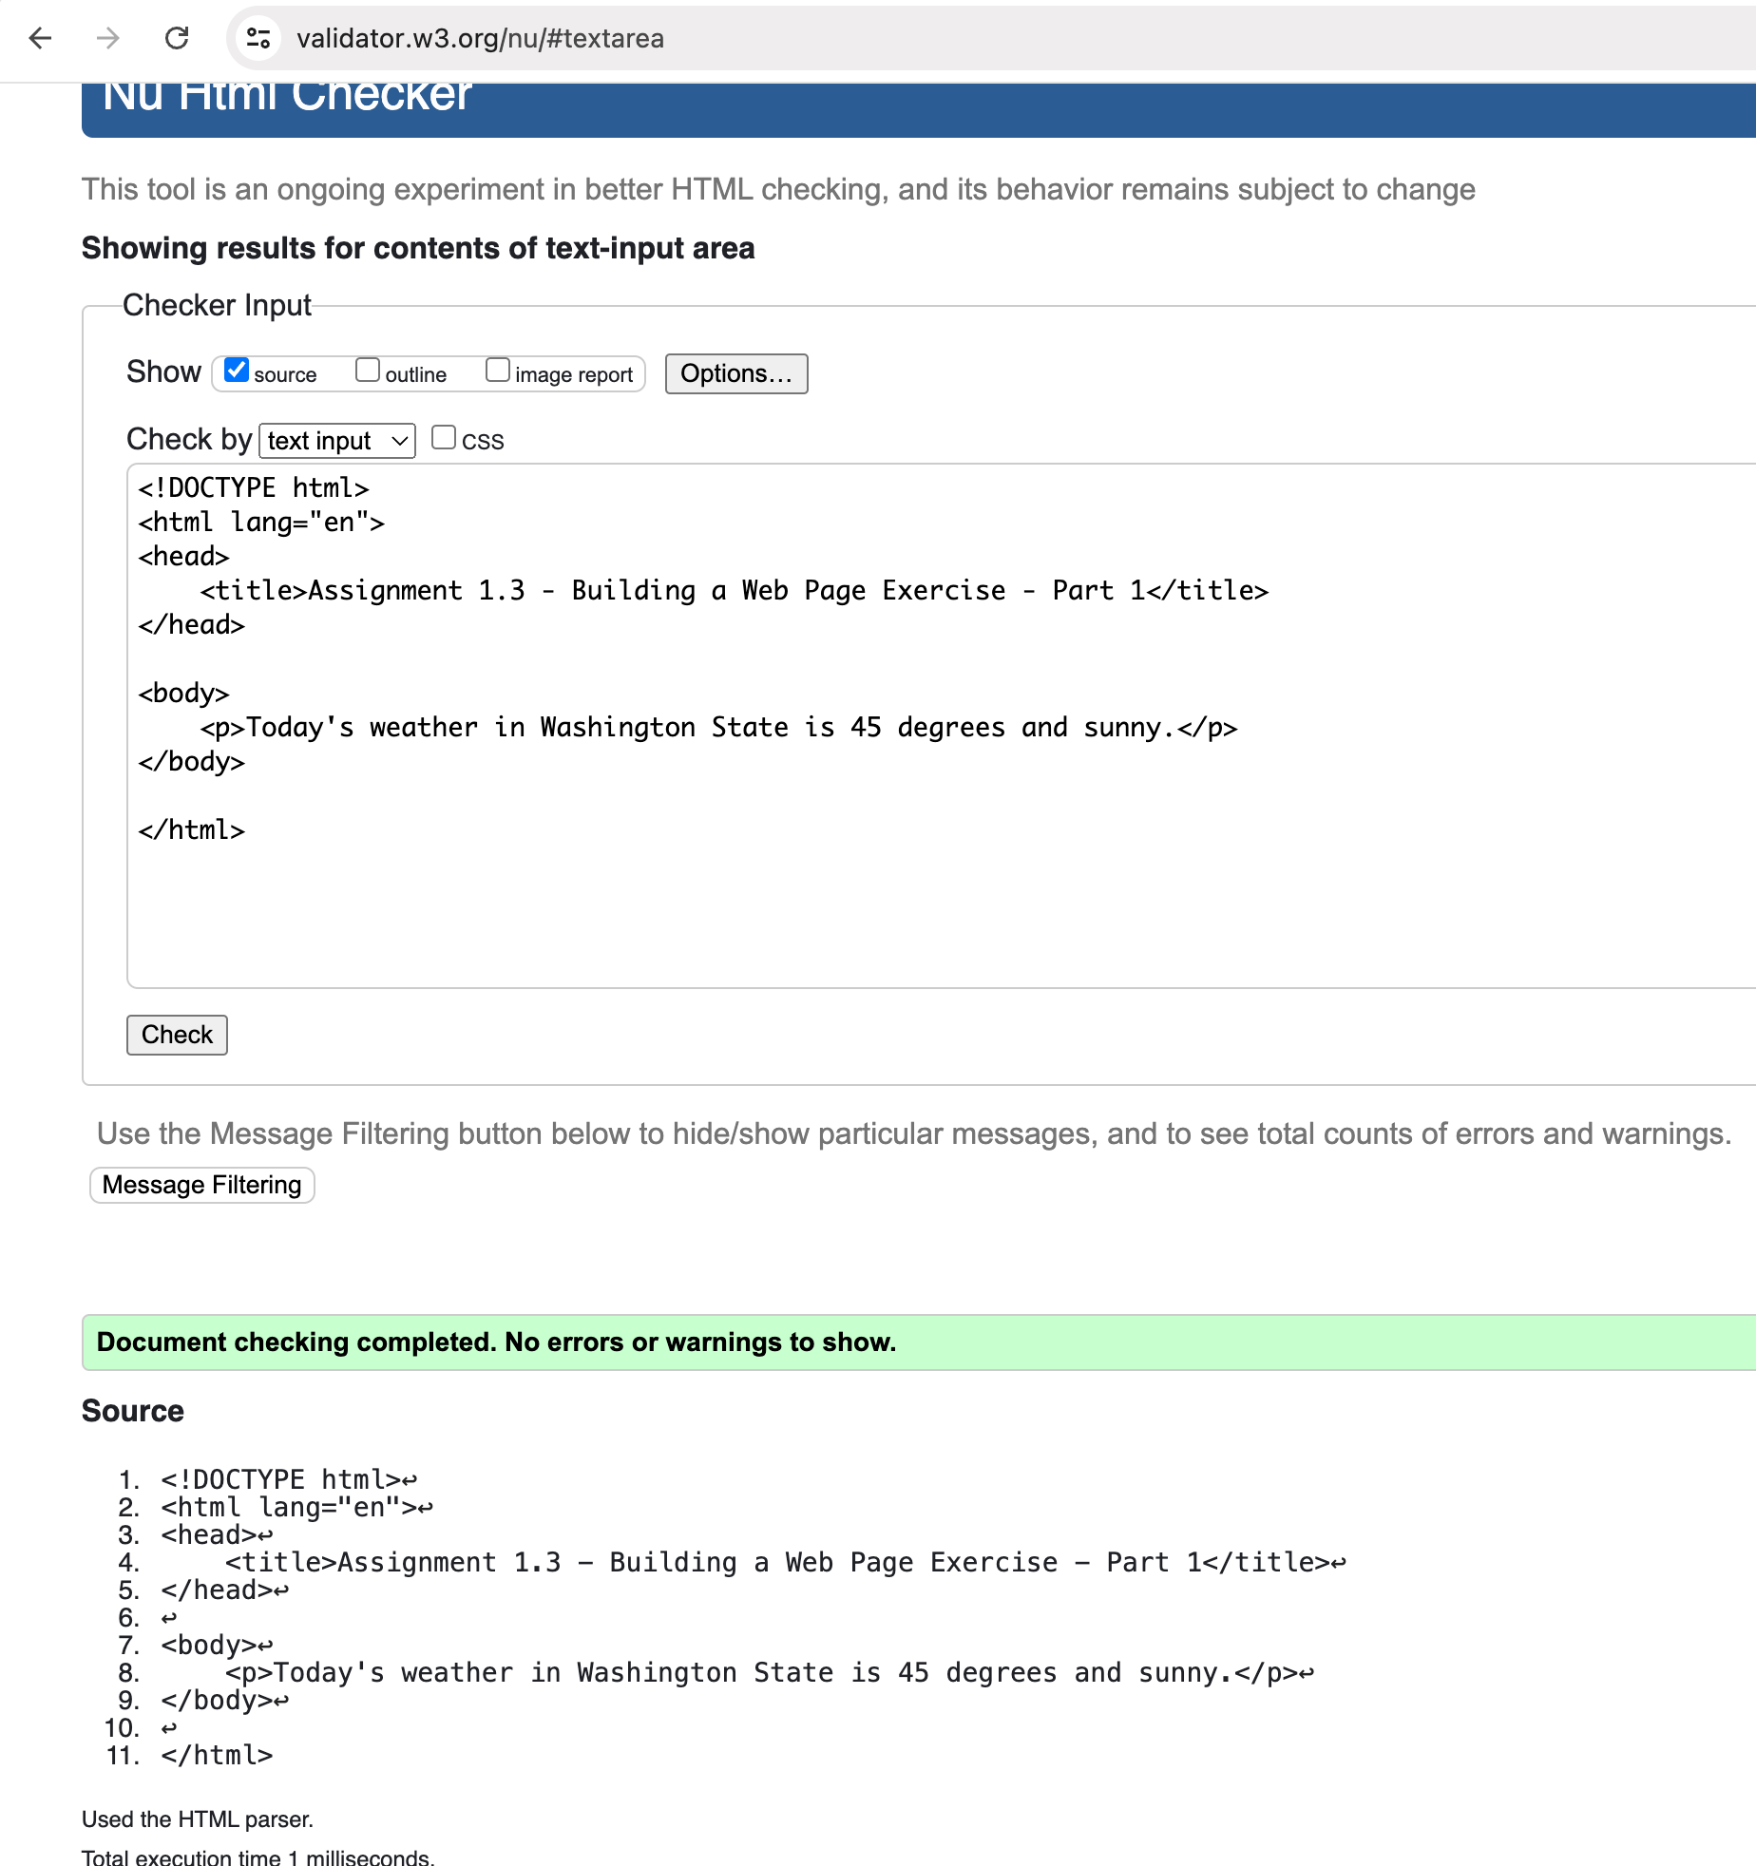

Result with final changes:

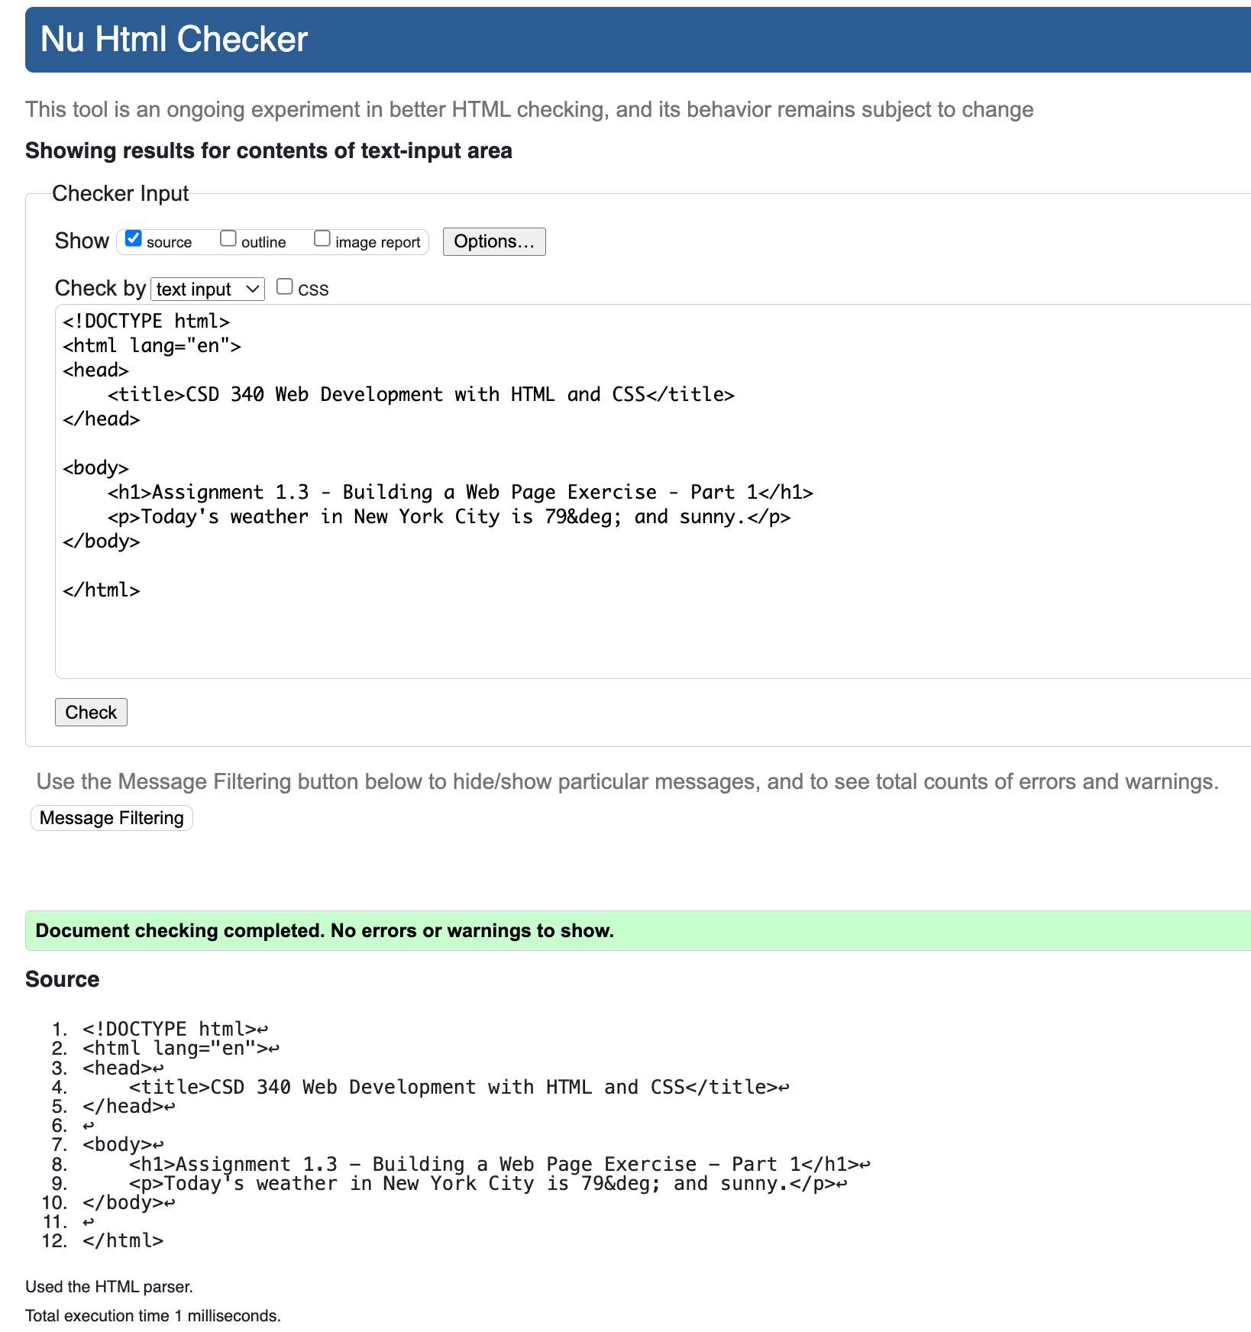

Screenshot of Output on Browser:

