Alexander Zayas

Module 3.2

August 20th, 2024

**GithubLink:** <https://github.com/AlexZayas1734/csd-340>

**Webpage output:**

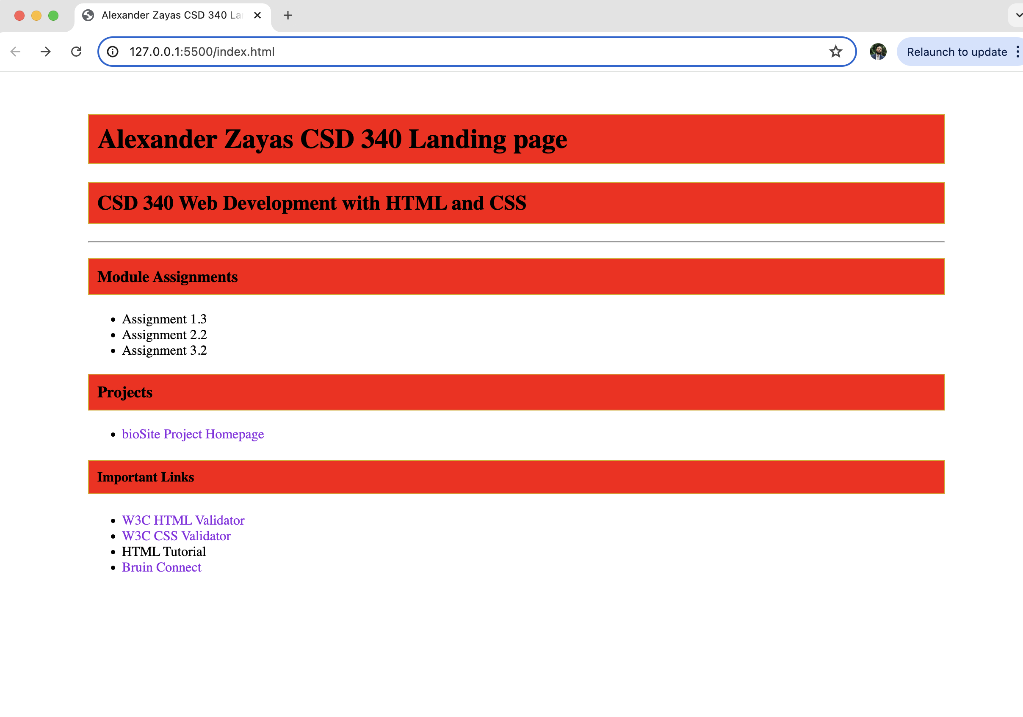

**HTML Validation:**

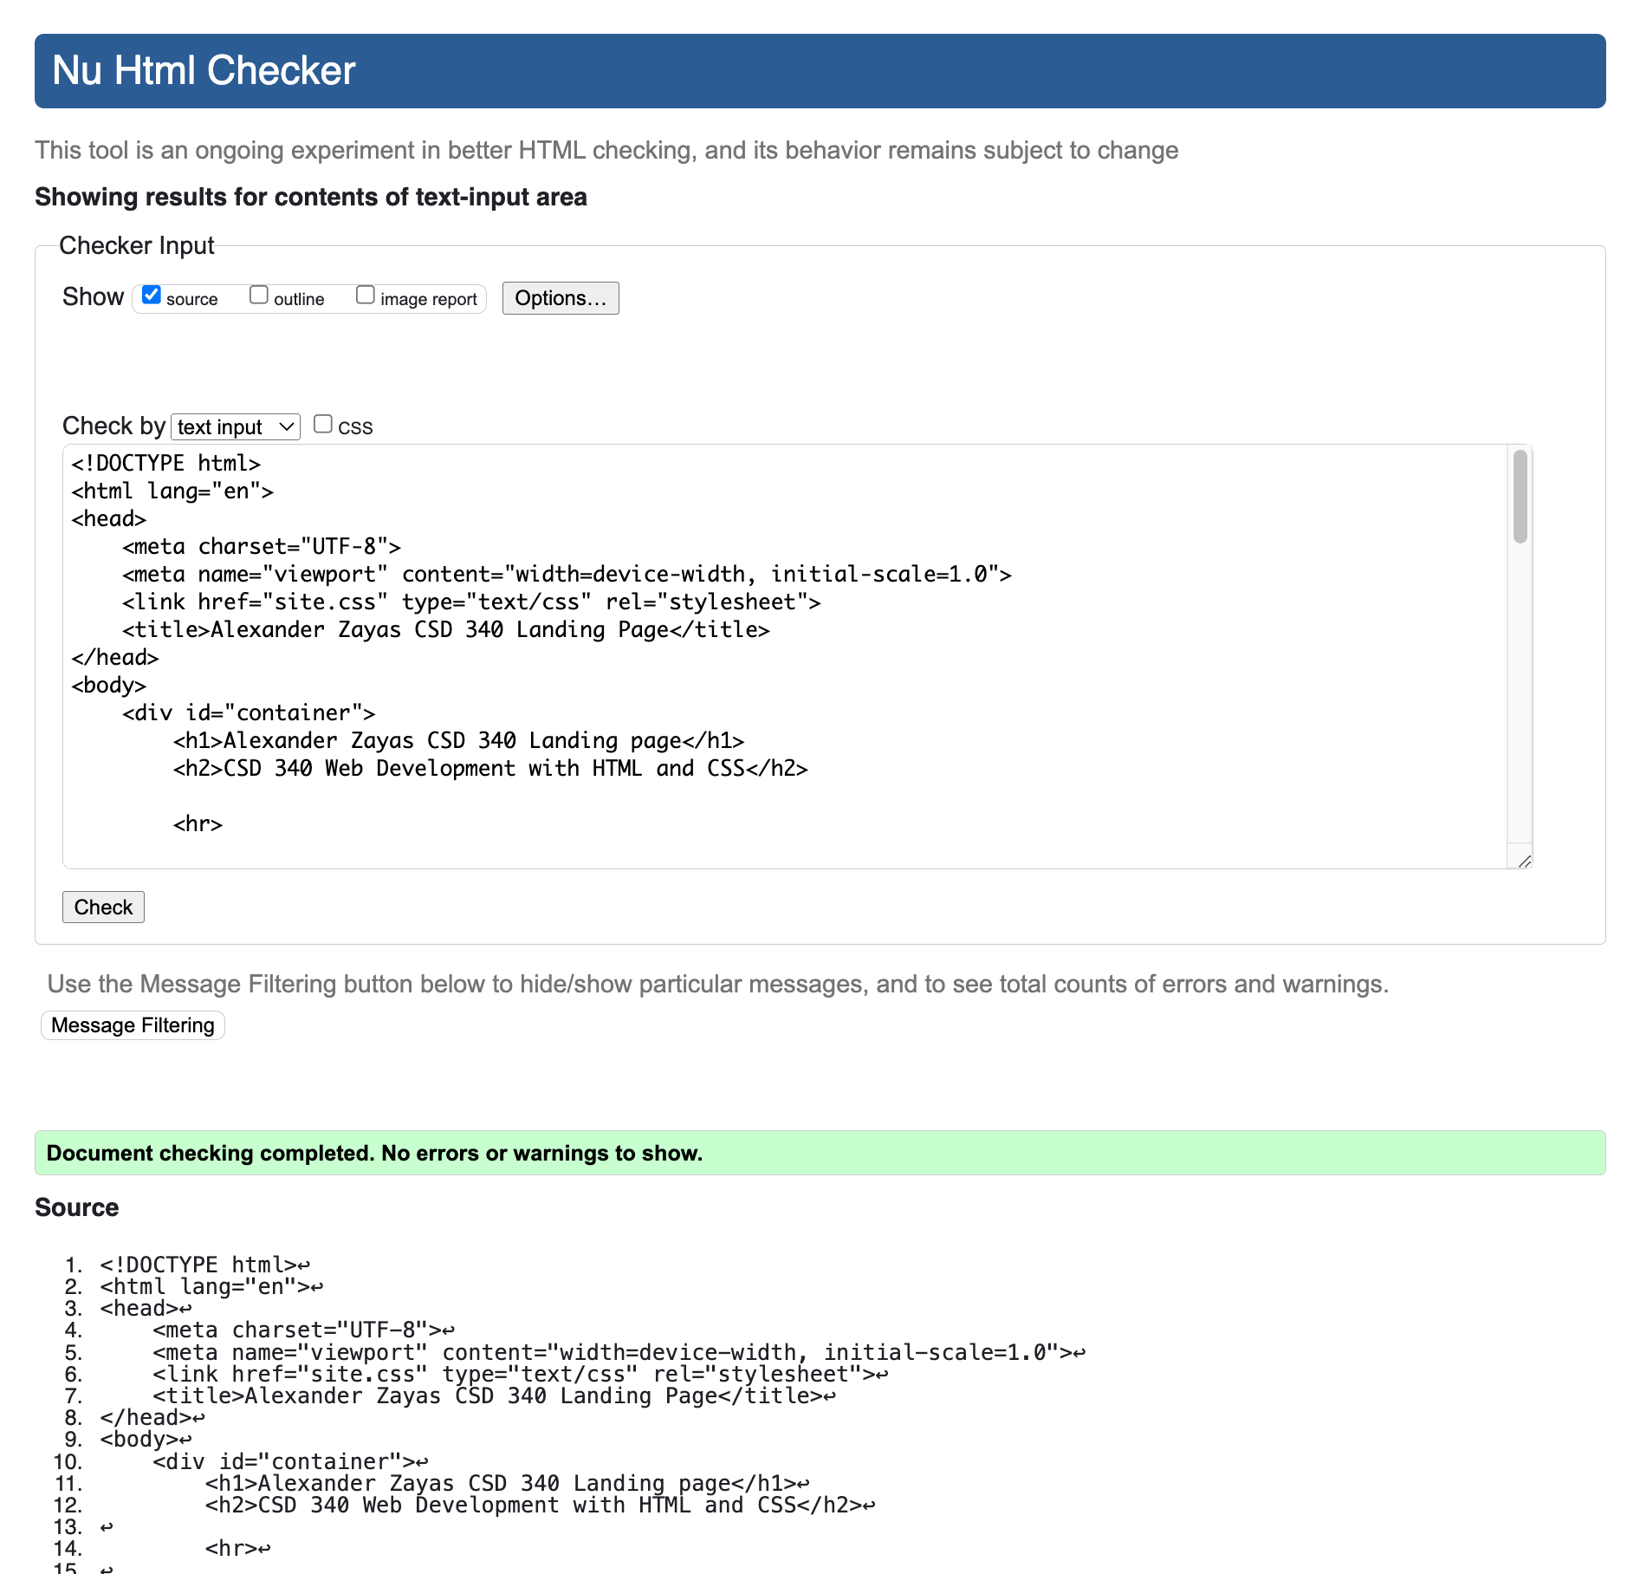

**CSS Validation:**

