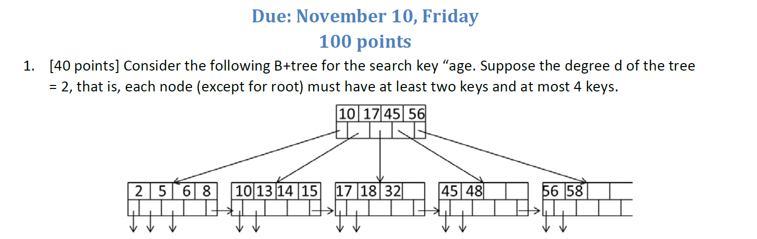



Starting from the Root block, try to find the leaf with value 10 or the smallest value available that larger than 10 (if not 15), use that as the starting point. Then, traverse the leaf from starting point to right most value (until no data left), check if the value is 15, if not, add to result.

Thus, we have to read **5 Blocks**.



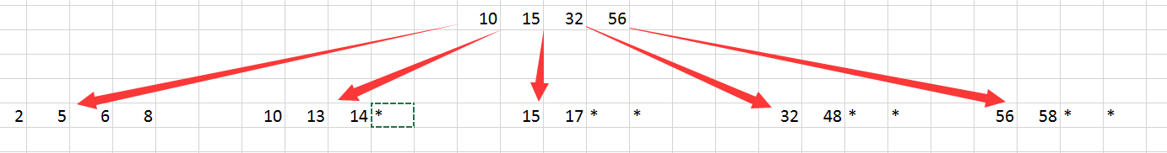



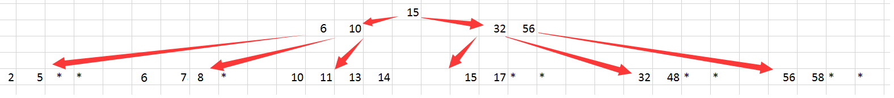

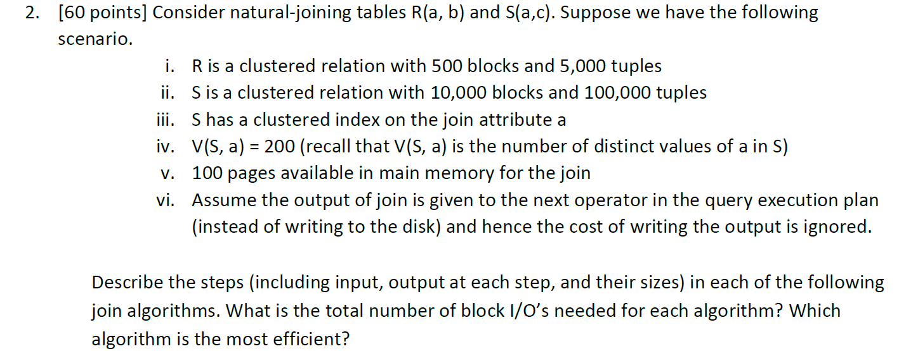

**a. Nested-loop join with R as the outer relation**

**Steps:**

for each (M-2) blocks b_r of R do

For each block b_s of S do

For each tuple r in b_r do

For each tuple s in b_s do

If r and s join then output(r,s)

**Sizes:**

For each step,

input = tuple s and tuple r,

output = (r, s),  1 tuple.

**Cost:**

– Read R once: cost B(R)

– Outer loop runs ceil(B(R)/(M-2)) =6 times, and each time need to read S: costs B(S)*6

– Total cost: B(R) + B(R)*B(S)/(M-2) = 500 + 6*10000 = **60500**

**b. Nested-loop join with S as the outer relation**

**Steps:**

for each (M-2) blocks b_s of S do

For each block b_r of R do

For each tuple s in b_s do

For each tuple r in b_r do

If s and r join then output(s,r)

**Sizes:**

For each step,

input = tuple s and tuple r,

output = (r, s),  1 tuple.

**Cost:**

– Read R once: cost B(S)

– Outer loop runs ceil(B(S)/(M-2)) =103 times, and each time need to read S: costs B(R)*100

– Total cost: B(S) + B(R)*B(S)/(M-2) = 10000+ 103*500 = **61500**

**c. Sort-merge join**

Step 1: Perform a pass 0 on Relation R. This generates __5__ runs each of size ____ blocks.

Cost of this step: _2B(R)___

Step 2: Perform a pass 0 on Relation S. This generates __100__ runs each of size ____ blocks.

Cost of this step: _2B(S)___

**Observe**: Number of runs from Step 1 + Step 2 > Memory Pages (M – 1)

Step 3: Load __7__ runs from S, sort them and write back to disk. (Try to minimize this number instead of blindly writing 99).

Cost of this step: __2M*7___

Observe that # of runs of R + # of runs of S = (M - 1)

Step 4: Join the runs of R and S

Cost of this step: _B(R) + B(S)____

Grand total cost of all the steps: _3*(B(R) + B(S)) + 14M = 3*(10500)+ 1400= **32900**

**d. Simple sort-based join**

Step 1: Perform a pass 0 on Relation R. This generates __5__ runs each of size ____ blocks.

Cost of this step: _2B(R)___

Step 2: Perform a pass 0 on Relation S. This generates __100__ runs each of size ____ blocks.

Cost of this step: _2B(S)___

Sort R runs.

Cost: 2B(R)

Sort S runs.

Since we do not have enough memory, we will merge two runs into one.

Cost: 2B(S) + 2M*2

Step 4: Merge the runs of R and S

Cost of this step: _B(R) + B(S)____

Grand total cost of all the steps: _5*(B(R) + B(S)) + 4M = 5*(10500) + 400= **52900**

**e. Partitioned-hash join**

**Steps:**

Hash S into M – 1 buckets – send all buckets to disk

input: S,

output: M-1 Buckets

Hash R into M – 1 buckets – Send all buckets to disk

input: R,

output: M-1 Buckets

Join every pair of corresponding buckets

input: Block in partition of Si & block in matching partition Ri

output: joined result

**Cost: 3B(R) + 3B(S) = 3*(10000+ 500) = 31500**

**f. Index join (ignore the cost of index lookup)**

**Steps:**

Read R one time,

Iterate over R, for each tuple, fetch corresponding tuple(s) from S

**Cost:**

Since R is clustered, and index is clustered,

Cost = B(R) + T(R)B(S)/V(S,a)= 500 + 5000*10000/200 = **250500**

**Efficiency:**

Overall, compare with all the algorithms, the one has least cost is **Partitioned-hash join**.