Components list:

DS18B20 temperature sensor (received) used as extension

Photoresistor (received) used as analog input

Motor Driver (ULN2003) ?

Stepper Motor (ROB-09320) (received) used as stepper motor

Motor control example diagram:

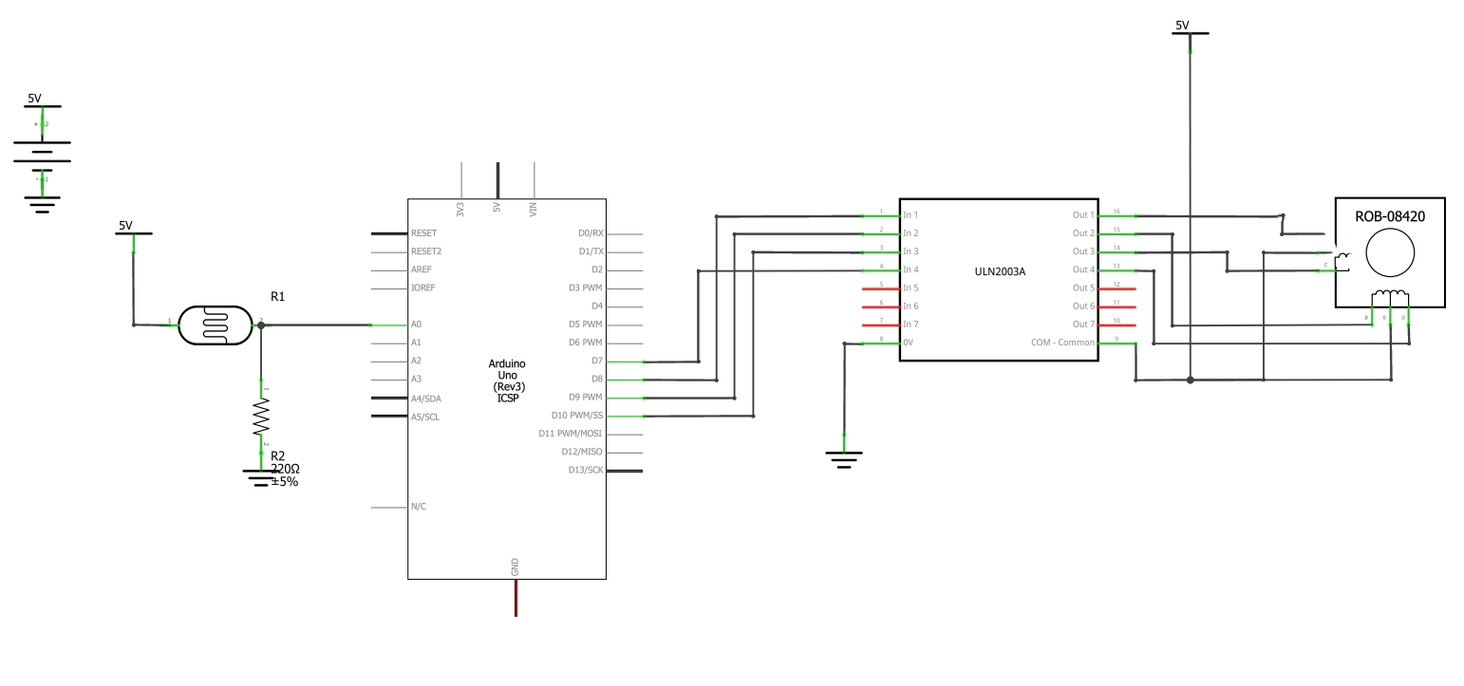

* Buttons:
  + Fully Closed Button: PD2 (Arduino Digital Pin 2) other leg connect to ground
  + Half-Closed Button: PD3 (Arduino Digital Pin 3)
  + Fully Open Button: PD4 (Arduino Digital Pin 4)
  + Light Auto Button: PD5 (Arduino Digital Pin 5)
* Photoresistor:
  + Analog Input: PC0 (Arduino Analog Pin A0) set up a voltage divider.

1. User interface:

Constituted by four buttons: fully-closed, half-open, fully-open, light auto.

1. Photoresistor logic:

If the value input is above 400, then it goes to open. 300-400, half open/close. value < 300, close.

Tasks to accomplish the prototype:

1. Get all the needed components.
2. Initiate the final circuit schematic.
3. Install all the components on our circuit board.
4. Adjust the source code.
5. Test stepper motor performance.
6. Install the smart blinds mechanic structure.
7. Decoration, demonstration, presentation.
8. Finish project final report.