**Deepak sharma**

Roll no-cs22b1024

IIIT-Raichur

karnataka

**Introduction To Computer science**

November 09 2023

**Describe the key components and functions of an operating system.**

# **Operating system**

An operating system is like the boss of a computer. It has many parts that work together to make everything run smoothly.

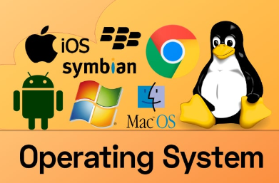

The two main types of operating systems are desktop and mobile. Some popular examples of desktop operating systems include Windows, Linux, and macOS, while common mobile operating systems are Android and iOS.

### Key components

1. **Kernel**:Think of the kernel as the superhero of your computer, making sure everything runs smoothly. Just like a superhero protects a city, the kernel saves the day by managing all the tasks. When you open apps or play games, the kernel is there, ensuring everything works perfectly, just like a superhero keeping the city safe.

**2. User Interface:**The user interface is like the way you talk and play with your video game. It's the screen with all the buttons, pictures, and words that help you control and use the game.

**3. File Management**: it is like a computer's neat and organized filing room. It keeps track of all our documents, photos, and videos, making them easy to find and use.

**4. Memory Management**: This part makes sure the computer's memory is used efficiently. It helps apps and programs run without crashing and overlapping with each other with memory addresses.

**5. Device Drivers**: They're like translators. They help the operating system talk to different devices like printers, keyboards, and screens.

**Functions:**

**1. Running Programs:** The operating system is like the boss of your computer. It's in charge of starting up and running all the software and apps, just like how a teacher starts the class and makes sure everyone is doing their work. For instance, it's the reason you can open games, like Minecraft, or do your homework on programs like Microsoft Word.

**2. Managing Hardware:**The operating system handles your computer's hardware, much like a conductor leading an orchestra. For example, it manages the printer, keyboard, screen, and other devices, ensuring they all work together correctly.

**3. Providing a User Interface**:The user interface is like the way you play with game controllers or buttons on a tablet. For example, on a tablet or a phone, when you tap icons or buttons to open apps or games, that's the user interface letting you control and use the device.

**4. Handling File Systems**: It helps us create, store, and organize files, like documents, pictures, and music.

**5. Ensuring Security**: The operating system keeps our computer safe from viruses and unauthorized access, just like a security guard.