###### Dune map by Ilya front

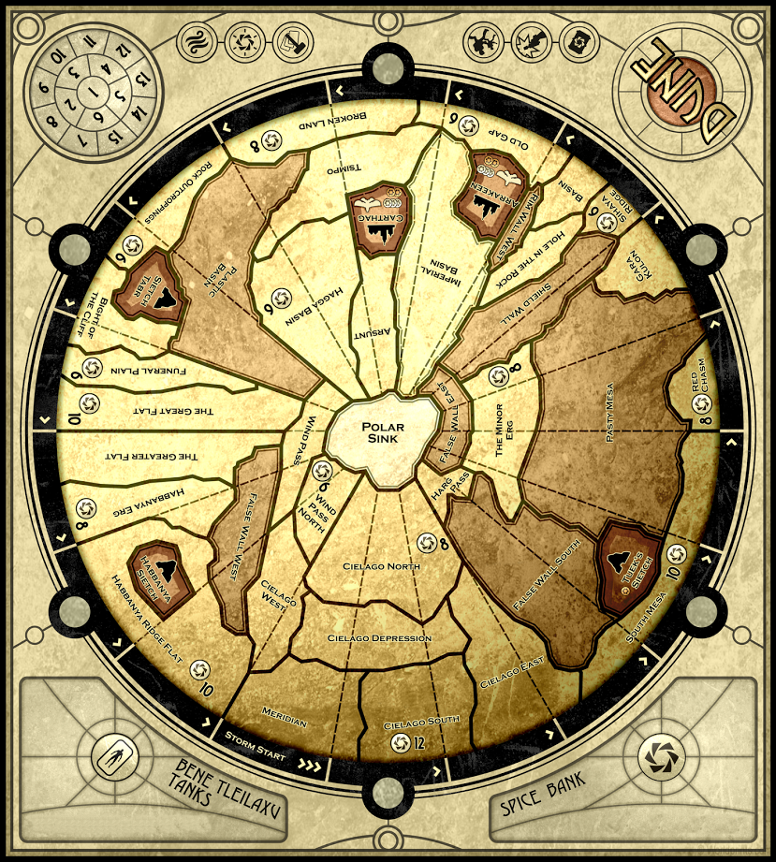

###### Dune map by Ilya back

