Сингулярные покрытия

ИЛИ
1 | x | x | 1
x | 1 | x | 1
x | x | 1 | 1
0 | 0 | 0 | 0

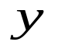
11
a
b
c

ИЛИ-НЕ
1 | x | x | 0
x | 1 | x | 0
x | x | 1 | 0
0 | 0 | 0 | 1

11
a
b
c

И
0 | x | x | 0
x | 0 | x | 0
x | x | 0 | 0
1 | 1 | 1 | 1

&&&
a
b
c

И-НЕ
1 | x | x | 1
x | 1 | x | 1
x | x | 1 | 1
1 | 1 | 1 | 0

&
a
b
c

Простейшие д-кубы
ИЛИ
0 | 0 | d | d
0 | d | 0 | d
d | 0 | 0 | d

ИЛИ-НЕ

0 | 0 | d | d’
0 | d | 0 | d’
d | 0 | 0 | d’

И

1 | 1 | d | d
1 | d | 1 | d
d | 1 | 1 | d

И-НЕ
1 | 1 | d | d’
1 | d | 1 | d’
d | 1 | 1 | d’

Первый пример, 2и-2или
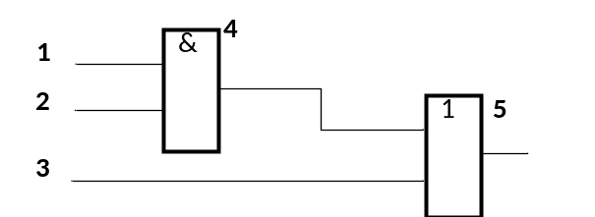

1 | 2 | 3 | 4 | 5
d | 1 | x | d | x | Для И
x | x | 0 | d | d | Для ИЛИ

Объединяем кубы по таблице
 | 0 | 1 | x | d | d’
0 | 0 | ∅ | 0 | ψ | ψ
1 | ∅ | 1 | 1 | ψ | ψ
x | 0 | 1 | x | d | d’
d | ψ | ψ | d | μ | λ
d’ | ψ | ψ | d’ | λ | μ

Пример:
⋂ | d | 1 | x | d | x
⋂ | x | x | 0 | d | d
 | d | 1 | 0 | d | d

Второй пример
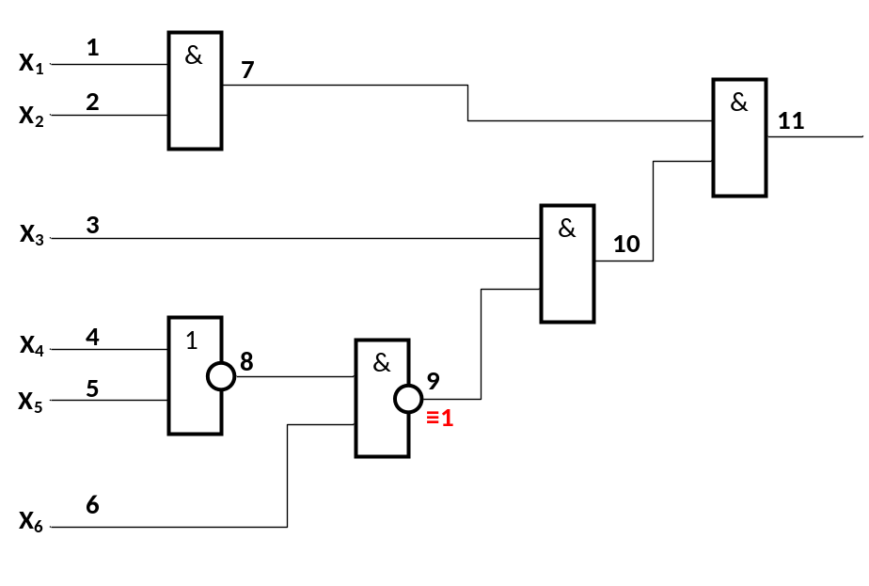

1 | 2 | 3 | 4 | 5 | 6 | 7 | 8 | 9 | 10 | 11
x | x | x | x | x | x | x | x | x | x | x
 |  |  |  |  | 1 |  | 1 | d’
x | x | x | x | x | 1 | x | 1 | d’ | x | x
 |  | d |  |  |  |  |  | 1 | d
x | x | d | x | x | 1 | x | 1 | ψ | d | x
x | x | x | x | x | 1 | x | 1 | d’ | x | x
 |  | 1 |  |  |  |  |  | d’ | d’
x | x | 1 | x | x | 1 | x | 1 | d’ | d’ | x
 |  |  |  |  |  | 0 |  |  | d’ | d’
x | x | 1 | x | x | 1 | 0 | 1 | d’ | d’ | d’
0 | x |  |  |  |  | 0
0 | x | 1 | x | x | 1 | 0 | 1 | d’ | d’ | d’
 |  |  | 0 | 0 |  |  | 1
0 | x | 1 | 0 | 0 | 1 | 0 | 1 | d’ | d’ | d’

Третий пример
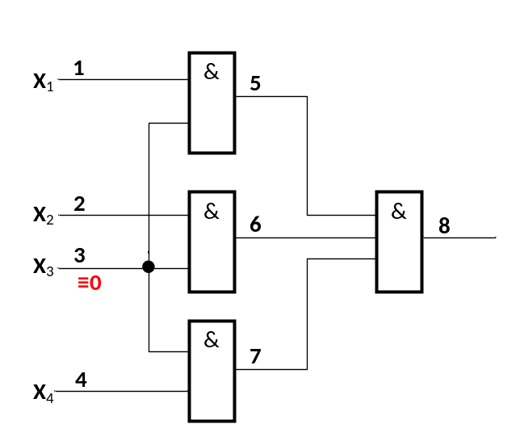
1 | 2 | 3 | 4 | 5 | 6 | 7 | 8
x | x | x | x | x | x | x | x
 |  | d
x | x | d | x | x | x | x | x
1 |  | d |  | d
1 | x | d | x | d | x | x | x
 | 1 | d |  |  | d
1 | 1 | d | x | d | d | x | x
 |  | d | 1 |  |  | d
1 | 1 | d | 1 | d | d | d | x
 |  |  |  | d | d | d | d
1 | 1 | d | 1 | d | d | d | d

Контрпример Шнейдера (???)
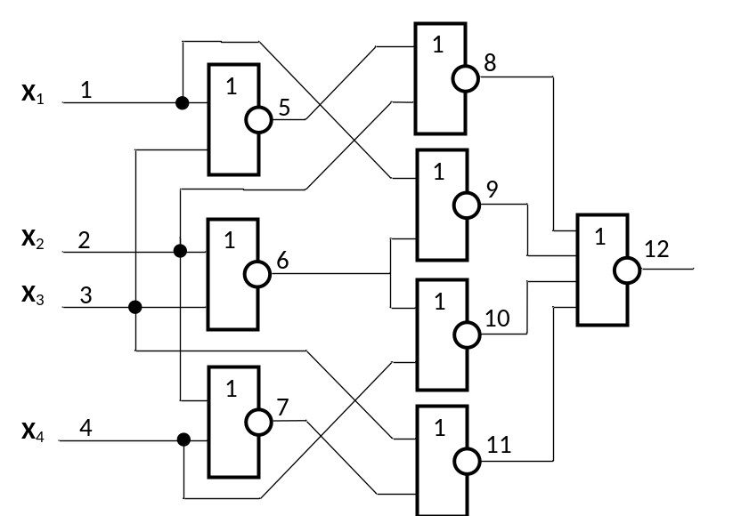
 | 0 | 1 | x | d | d’
0 | 0 | ∅ | 0 | ∅ | ∅
1 | ∅ | 1 | 1 | ∅ | ∅
x | 0 | 1 | x | d | d’
d | ∅ | ∅ | d | d | ↔
d’ | ∅ | ∅ | d’ | ↔ | d’

1 | 2 | 3 | 4 | 5 | 6 | 7 | 8 | 9 | 10 | 11 | 12
x | x | x | x | x | x | x | x | x | x | x | x
 | 0 | 0 |  |  | d
x | 0 | 0 | x | x | d | x | x | x | x | x | x
0 |  |  |  |  | d |  |  | d’
0 | 0 | 0 | x | x | d | x | x | d’ | x | x | x
 |  |  | 0 |  | d |  |  |  | d’
0 | 0 | 0 | 0 | x | d | x | x | d’ | d’ | x | x
 |  |  |  |  |  |  | 0 | d’ | d’ | 0 | d
0 | 0 | 0 | 0 | x | d | x | 0 | d’ | d’ | 0 | d
 | x |  |  | 1 |  |  | 0
0 | 0 | 0 | 0 | 1 | d | x | 0 | d’ | d’ | 0 | d
 |  | x |  |  |  | 1 |  |  |  | 0
0 | 0 | 0 | 0 | 1 | d | 1 | 0 | d’ | d’ | 0 | d

Сигнатурный анализ
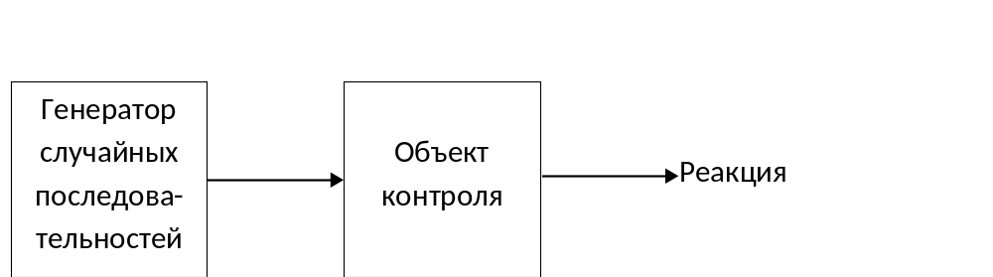

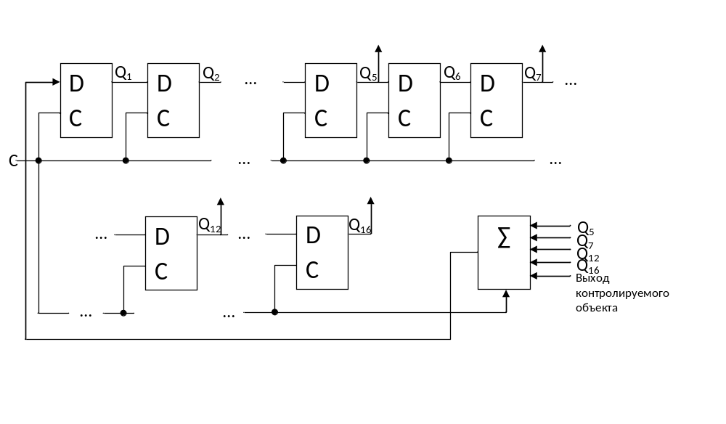

16 | 15 | 14 | 13 | 12 | 11 | 10 | 9 | 8 | 7 | 6 | 5 | 4 | 3 | 2 | 1 | Σ | вход
0 | 0 | 0 | 0 | 0 | 0 | 0 | 0 | 0 | 0 | 0 | 0 | 0 | 0 | 0 | 0 | 1 | 1
 |  |  |  |  |  |  |  |  |  |  |  |  |  |  | 1 | 1 | 1
 |  |  |  |  |  |  |  |  |  |  |  |  |  | 1 | 1 | 1 | 1
 |  |  |  |  |  |  |  |  |  |  |  |  | 1 | 1 | 1 | 1 | 1
 |  |  |  |  |  |  |  |  |  |  |  | 1 | 1 | 1 | 1 | 1 | 1
 |  |  |  |  |  |  |  |  |  |  | 1 | 1 | 1 | 1 | 1 | 0 | 1
 |  |  |  |  |  |  |  |  |  | 1 | 1 | 1 | 1 | 1 | 0 | 1 | 0
 |  |  |  |  |  |  |  |  | 1 | 1 | 1 | 1 | 1 | 0 | 0 | 1 | 0
 |  |  |  |  |  |  |  | 1 | 1 | 1 | 1 | 1 | 0 | 0 | 0 | 0 | 0
...

Самотестирование ОЗУ
