|  |  |  |
| --- | --- | --- |
| **C OLUM N** | **DESC RIPT ION** | **VISIBLE BY DEFAULT** |
| **Request** | The URL of the request. For example,  *home.html*, or *orange-arrow.gif*. | Yes |
| **Scenario** | The name of the scenario. | Yes |
| **Test** | The name of the test. | Yes |
| **Total** | The total number of this web performance test request issued during the load test run. The total includes passed and failed requests, but does not include cached requests, because they are not issued to the web server. | Yes |
| **Passed** | The number of times the request was issued and passed. | No |
| **Failed** | The number of times the request was issued and failed. The entries in this column appear as hyperlinks. You can choose any hyperlink to view a list of the individual errors in the **Load Test Errors** dialog box. For more information, see Analyze load test results. | Yes |
| **Cached** | The total number of times the request was already cached. | No |
| **Requests/Sec** | The rate per second of the request during the load test run. | No |
| **Passed/Sec** | The rate per second of this request during the load test run, for the instances of this request that passed. | No |
| **Failed/Sec** | The rate per second of this request during the load test run, for the instances of this request that failed. | No |
| **First Byte Time** | The average time to receive the first byte of the response, measured from the time the request was sent to the web server. The units are seconds. | No |
| **Response Time** | The average time to receive the entire response to a request, measured from the time the request was sent to the web server. The units are seconds. | Yes |

|  |  |  |
| --- | --- | --- |
| **C OLUM N** | **DESC RIPT ION** | **VISIBLE BY DEFAULT** |
| **Content Length** | The average length of the content of the response to the request. The units are bytes. | Yes |

The Tests table

The **Tests** table displays details for individual tests run during a load test. The table lists tests by test and scenario, because one test can be included in many scenarios.

The following table lists the columns in the **Tests** table.

|  |  |  |
| --- | --- | --- |
| **C OLUM N** | **DESC RIPT ION** | **VISIBLE BY DEFAULT** |
| **Test** | The name of the test. | Yes |
| **Scenario** | The name of the scenario. | Yes |
| **Total** | The total number of times the test was run in the scenario. This includes the number of times the test passed and failed. | Yes |
| **Passed** | The number of times the test was run in the scenario and passed. | Yes |
| **Failed** | The number of times the test was run in the scenario and failed. The entries in this column appear as hyperlinks. You can choose any hyperlink to view a list of the individual errors in the **Load Test Errors** dialog box. For more information, see Analyze load test results. | Yes |
| **Tests/Sec** | The rate per second of the test during the load test run. | Yes |
| **Passed/Sec** | The rate per second of this test during the load test run, for the instances of this test that passed. | No |
| **Failed/Sec** | The rate per second of this test during the load test run, for the instances of this test that failed. | No |
| **Test Time** | The average time to execute the test during the load test run. The units are seconds. | Yes |
| **90% Test Time** | The 90th percentile value for Test Time. | No |
| **95% Test Time** | The 95th percentile value for Test Time. | Yes |

|  |  |  |
| --- | --- | --- |
| **C OLUM N** | **DESC RIPT ION** | **VISIBLE BY DEFAULT** |
| **Requests/Test** | The average number of requests in the test if it is a web performance test. | No |

|  |  |  |
| --- | --- | --- |
| **C OLUM N** | **DESC RIPT ION** | **VISIBLE WIT H OUT T IM ING DETAILS** |
| **Transaction** | The name of the transaction. | Yes |
| **Scenario** | The name of the scenario. | Yes |
| **Test** | The name of the test. | Yes |
| **Total** | The total number of transactions issued during the load test run. | Yes |
| **Transaction Time** | The time to execute the transaction during a load test run. For web performance tests, think time is included in the calculation. The units are seconds. | No |
| **Response Time** | The response time for the web performance test transaction in a load test run. Response Time is different from Transaction Time in that Response Time does not include any think time that occurred during the transaction. The units are seconds. | No |
| **Ave. Transaction Time** | The average transaction time. This time includes think times. For example, if you have three requests and each has a think time, this time will include those think times and the actual time to execute requests. | No |

|  |  |  |
| --- | --- | --- |
| **C OLUM N** | **DESC RIPT ION** | **VISIBLE WIT H OUT T IM ING DETAILS** |
| **Ave. Response Time** | The average response time for a web performance test transaction in a load test run. Response Time is different from Transaction Time in that Response Time does not include any think time that occurred during the transaction. The units are seconds. | No |
| **Min Response Time** | This does not include think times. | No |
| **Max Response Time** | This does not include think times. | No |
| **Median Response Time** | This does not include think times. | No |
| **90% Response Time** | The 90th percentile value for Transaction Time. This does not include think times. **Note:** This is different from Visual Studio Team System 2008 Test Load Agent, which used the **90% Transaction Time** value. | No |
| **95% Response Time** | The 95th percentile value for Transaction Time. This does not include think times. **Note:** This is different from Visual Studio Team System 2008 Test Load Agent, which used the **95% Transaction Time** value. | No |
| **99% Response Time** | The 99th percentile value for Transaction Time. This does not include think times. | No |
| **Std Dev Response Time** | This does not include think times. | No |

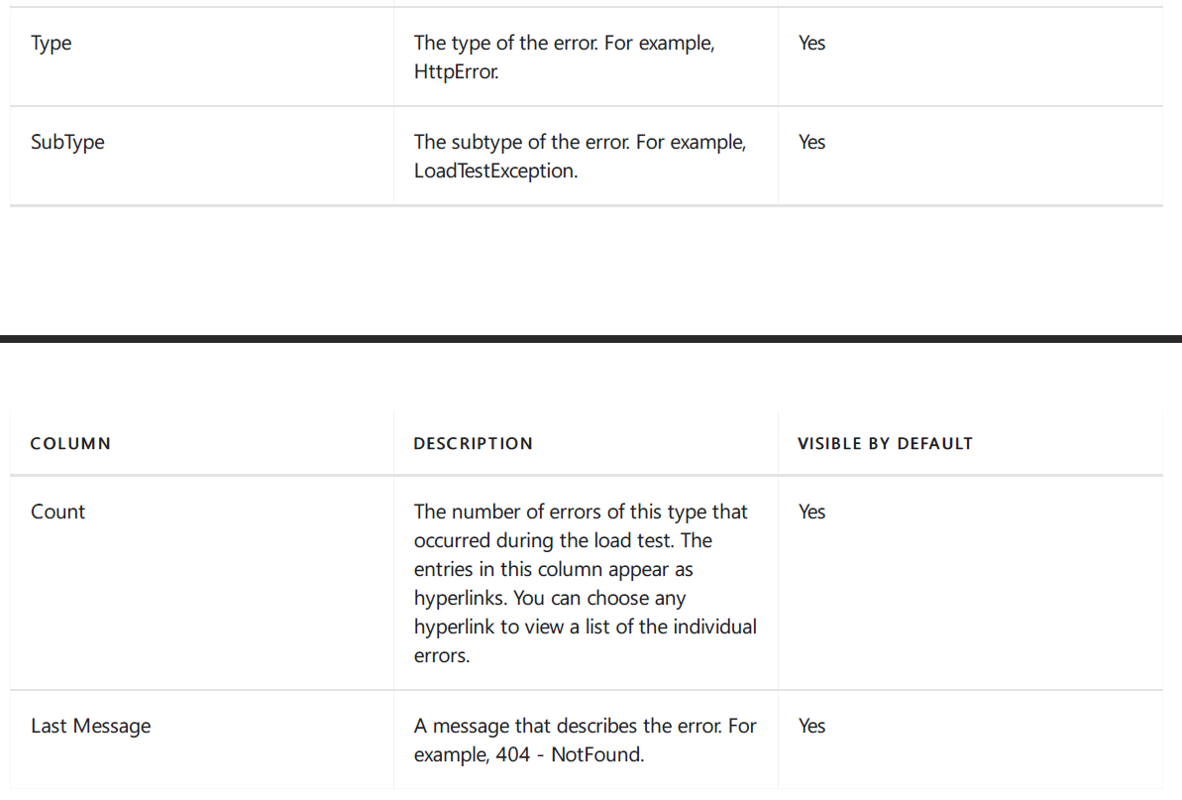

|  |  |
| --- | --- |
| **C OLUM N** | **DESC RIPT ION** |
| **Time** | The time during the load test at which the error occurred. |
| **Agent** | The name of the agent computer on which the error occurred. This is important when you run load tests using test controllers and test agents. For more information, see Install and configure test agents. |
| **Test** | The name of the web performance test in which the error occurred. |
| **Scenario** | The name of the scenario in which the error occurred. |
| **Request** | The URL of the request in which the error occurred. |
| **Type** | The type of the error. For example, HttpError. |
| **SubType** | The subtype of the error. For example, LoadTestException. |
| **Text** | The text of the error message. For example, 404 - NotFound. |
| **Stack** | The entries in this column are either empty, or the word **Stack** is formatted as a hyperlink. You can choose the hyperlink to view a stack trace of the error. |

**C OLUM N**

**DESC RIPT ION**

**Details**

The entries in this column are either empty, or the word

**TestLog** is formatted as a hyperlink. This link can help you isolate errors in the load test. For example, choosing the **TestLog** link on a web performance test request error will

open up the results for the web performance test in the Web Performance Test Results Viewer and highlight the request error.

|  |  |
| --- | --- |
| **C OLUM N H EADING** | **DESC RIPT ION** |
| **Page** | The name of the web page. |
| **Scenario** | The name of the scenario. Important if you have more than one scenario in your web performance test. |
| **Test** | The name of the web performance test. Important if you have more than one web performance test in your load test. |

|  |  |
| --- | --- |
| **C OLUM N H EADING** | **DESC RIPT ION** |
| **Network** | The network type.  By default, this data is not collected. To collect this data, in the **Load Test Editor**, under the **Run Settings** node, select the run setting node to change. In the  **Properties** window, for the **Timing Details Storage** property, select **AllIndividualDetails**. |
| **Total** | The total number of requests that were made for the web page. This is the total for all iterations in the load test. |
| **Ave** | Average page response time.  By default, this data is not collected. To collect this data, in the **Load Test Editor**, under the **Run Settings** node, select the run setting node to change. In the  **Properties** window, for the **Timing Details Storage** property, select **AllIndividualDetails**. |
| **Min** | The minimum page response time.  By default, this data is not collected. To collect this data, in the **Load Test Editor**, under the **Run Settings** node, select the run setting node to change. In the  **Properties** window, for the **Timing Details Storage** property, select **AllIndividualDetails**. |
| **Median** | The median page response time.  By default, this data is not collected. To collect this data, in the **Load Test Editor**, under the **Run Settings** node, select the run setting node to change. In the  **Properties** window, for the **Timing Details Storage** property, select **AllIndividualDetails**. |
| **90%** | The 90th percentile for the response time. This indicates that 90% of the pages responded faster than this number, and 10% of the pages responded more slowly.  By default, this data is not collected. To collect this data, in the **Load Test Editor**, under the **Run Settings** node, select the run setting node to change. In the  **Properties** window, for the **Timing Details Storage** property, select **AllIndividualDetails**. |
| **95%** | The 95th percentile for the response time. This indicates that 95% of the pages responded faster than this number, and 5% of the pages responded more slowly. |

|  |  |
| --- | --- |
| **C OLUM N H EADING** | **DESC RIPT ION** |
| **99%** | The 99th percentile for the response time. This indicates that 99% of the pages responded faster than this number, and 1% of the pages responded more slowly.  By default, this data is not collected. To collect this data, in the **Load Test Editor**, under the **Run Settings** node, select the run setting node to change. In the  **Properties** window, for the **Timing Details Storage** property, select **AllIndividualDetails**. |
| **Max** | The maximum page response time.  By default, this data is not collected. To collect this data, in the **Load Test Editor**, under the **Run Settings** node, select the run setting node to change. In the  **Properties** window, for the **Timing Details Storage** property, select **AllIndividualDetails**. |
| **Std Dev** | By default, the standard deviation data is not collected. To collect this data, in the **Load Test Editor**, under the **Run Settings** node, select the run setting node to change. In the **Properties** window, for the **Timing**  **Details Storage** property, select **AllIndividualDetails**. |
| **Page Time** | The average response time for all requests that were made for the web page. |
| **Goal** | The page time goal. This is a constant value for the page. **Note:** Page Time Goal is displayed only when the goal has been defined for the request in the web performance test. |
| **% Meeting Goal** | The percent of the requests that were made for the web page that met the response time goal. |

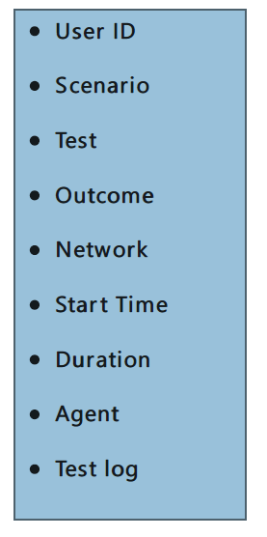

View threshold violations in the table

The threshold violations table displays the first 1,000 violations. The following table contains these columns:

|  |  |  |
| --- | --- | --- |
| **C OLUM N** | **DESC RIPT ION** | **VISIBLE BY DEFAULT** |
| Time | The time during the load test at which the violation occurred. | Yes |
| Computer | The name of the computer under test on which the violation occurred. **Note:** This is important when you run load tests on rigs. | Yes |
| Category | The category of the performance counter on which the violation occurred. | Yes |
| Counter | The name of the performance counter on which the violation occurred. | Yes |
| Instance | The performance counter instance on which the violation occurred. | Yes |
| Message | A message that describes the threshold violation. For example, **The value 5 exceeds the critical**  **threshold value of 0** . | Yes |