The ConnectSix Game Document
Development Tool(s) and Programming Language： Java
- Problem Analysis
Theory of this greddy algorithm^{[1]}
I used a greedy algorithm to solve the problem. The process is divided into the following steps:
1、Identify 15 Types of Board Patterns:
The program categorizes the board into 15 different types of patterns.
2、Score Each Point on the Board:
Traverse the entire board and score each point based on the current situation.
3、Generate a List of Scored Points:
Compile a list of points along with their scores.
4、Iterate Through the List to Evaluate Potential Moves:
For each scored point, evaluate all possible moves and calculate the scores.
Determine the maximum score from this evaluation.
5、Determine the Best Moves:
Identify the two points whose combined score (i.e., first move score + second move score) is the highest.
Return these two points as the optimal moves.
Estimating Time Complexity:
Denoting the board size as n×nn×n, where n=17, n=17.
Scoring Each Point:
Traversing the entire board: O(n2)
Assuming scoring each point involves checking a fixed number of patterns, the complexity per point is O(1).
Generating the List of Scored Points:
Creating the list itself: O(n2)
Evaluating Potential Moves:
For each scored point, evaluating all possible moves: O(n2)
Combining these evaluations: O(n2×n2)=O(n4)O(n2×n2)=O(n4)
Determining the Best Moves:
Iterating through the list and finding the best combination: O(n4)
Combining these steps, the overall time complexity of the algorithm is dominated by the evaluation step, resulting in O(n4).
- The Development Procedure
Find the 15 types of patterns in the board^{[2]}
1、Six-in-a-row and Long Rows (analyse_six):
- Traverse the array to check for sequences of six or more continuous pieces of the same side.
- If exactly six pieces are found, increment the counter for six-in-a-row and mark these pieces.
- If more than six pieces are found, increment the counter for long rows and mark these pieces.
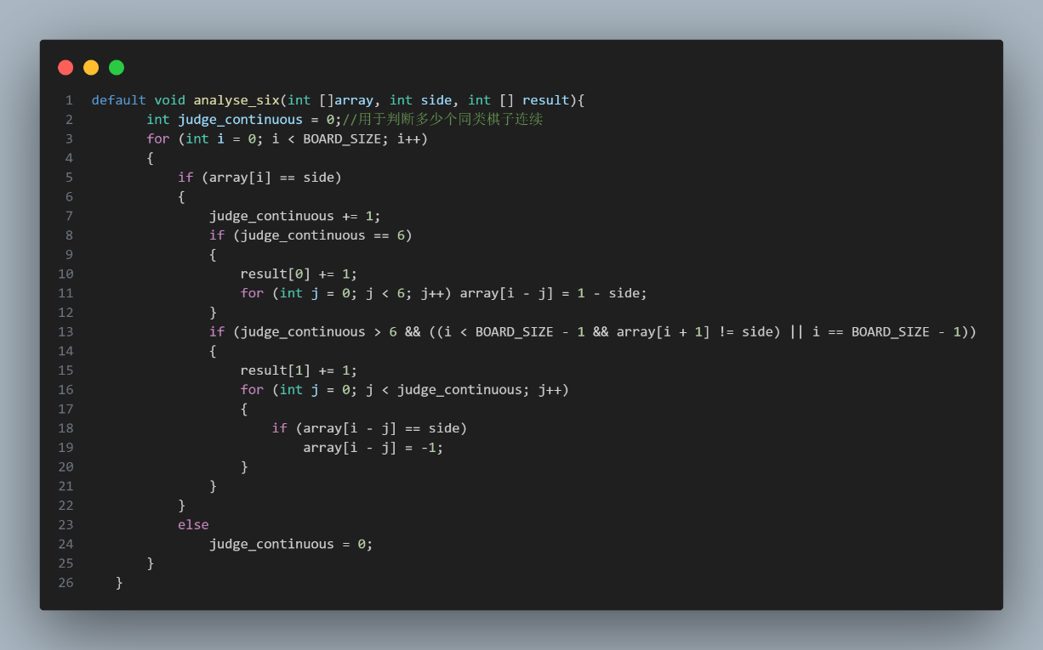
2、Live Five (analyse_five):
- Traverse the array to check for sequences of five continuous pieces of the same side.
- Ensure both ends of this sequence are empty.
- If such a sequence is found, increment the counter for live five and mark these pieces.
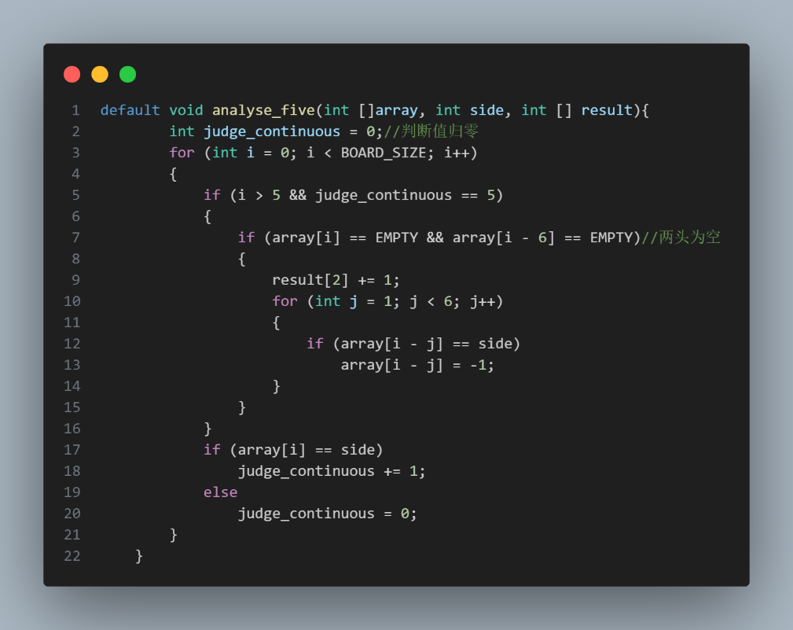
3、Sleep Five (analyse_five_sleep):
- Traverse the array to check for sequences where five continuous pieces of the same side are interrupted by exactly one empty space.
- Ensure that there are no opponent's pieces directly blocking the sequence.
- If such a sequence is found, increment the counter for sleep five and mark these pieces.
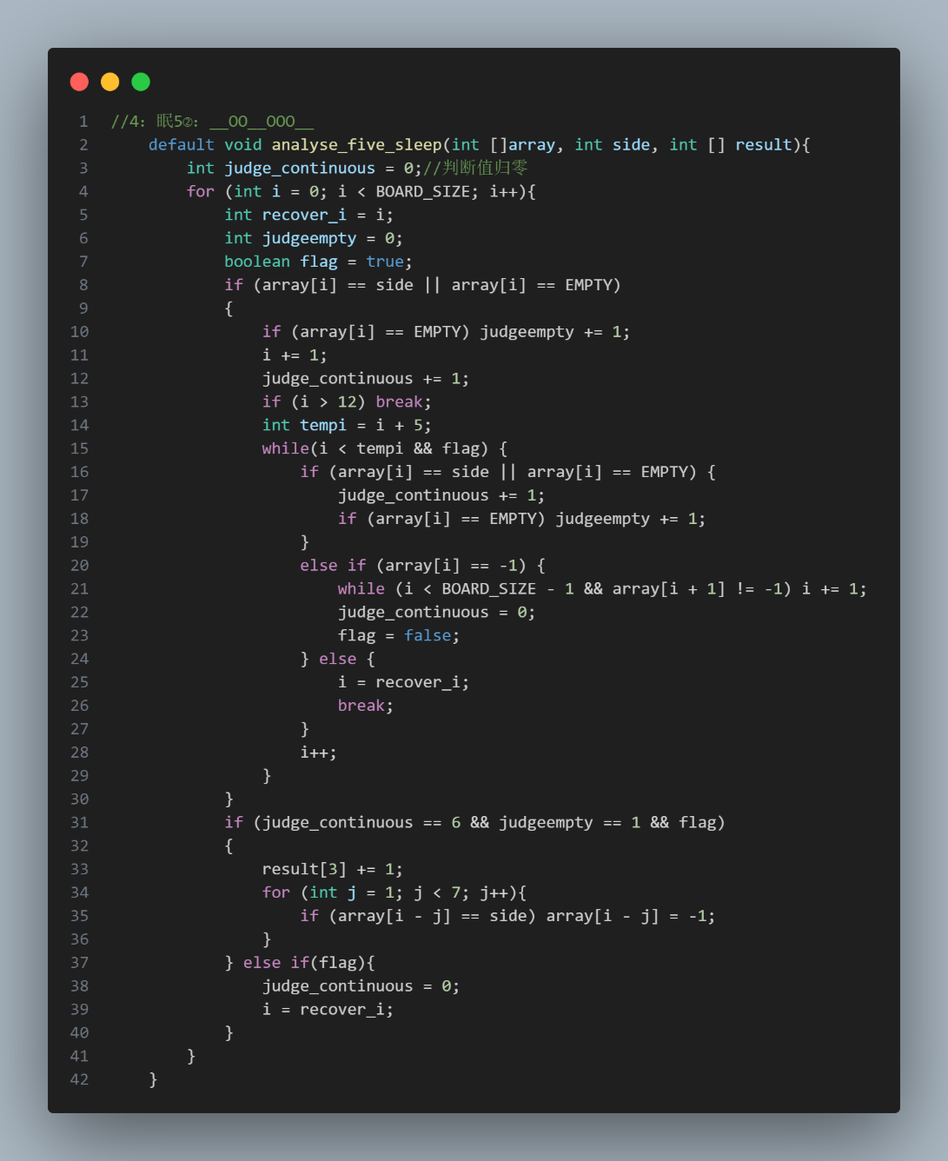
4、Dead Five (analyse_five_dead):
- Traverse the array to check for sequences of five continuous pieces of the same side that are blocked by the opponent's pieces on both ends.
- If such a sequence is found, increment the counter for dead five and mark these pieces.
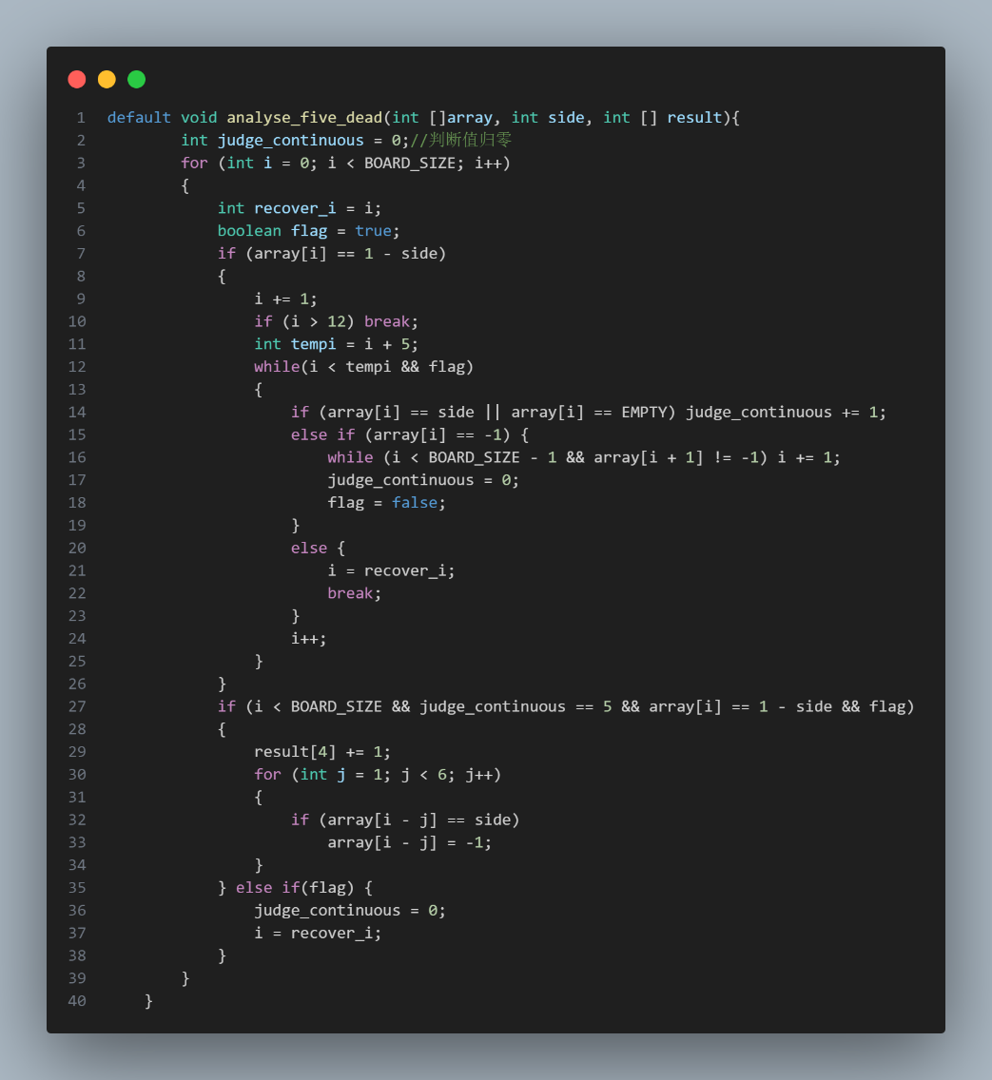
5、Live Four (analyse_four):
- Traverse the array to check for sequences of four continuous pieces of the same side.
- Ensure both ends of this sequence are empty.
- If such a sequence is found, increment the counter for live four and mark these pieces.
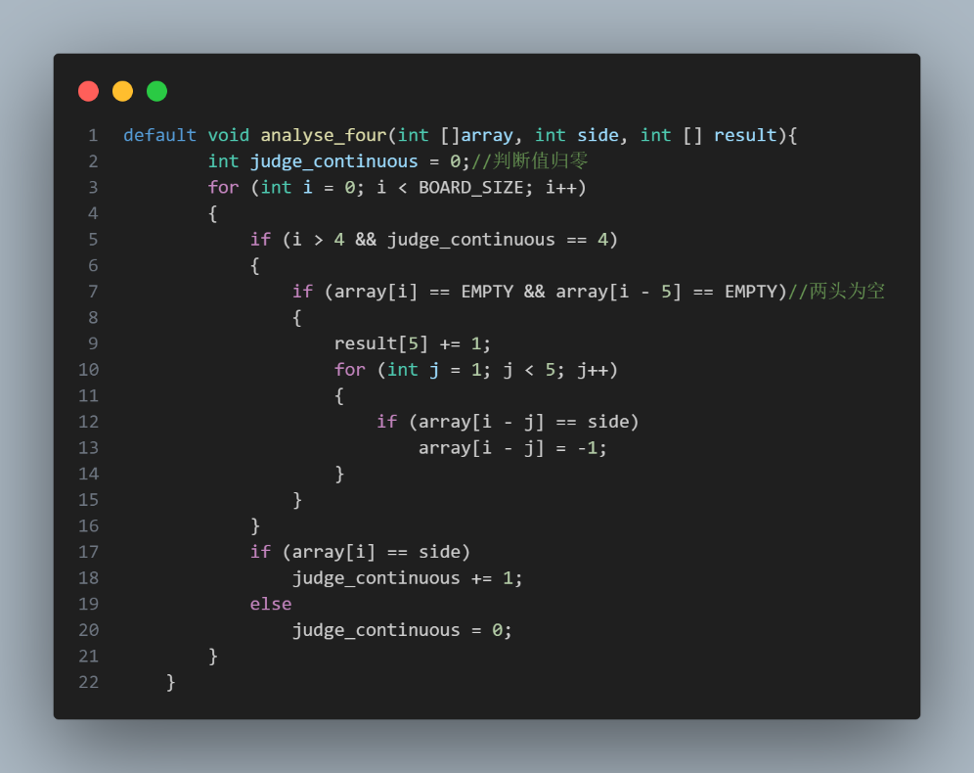
6、Sleep Four (analyse_four_sleep):
- Traverse the array to check for sequences where four continuous pieces of the same side are interrupted by exactly one empty space.
- Ensure that there are no opponent's pieces directly blocking the sequence.
- If such a sequence is found, increment the counter for sleep four and mark these pieces.
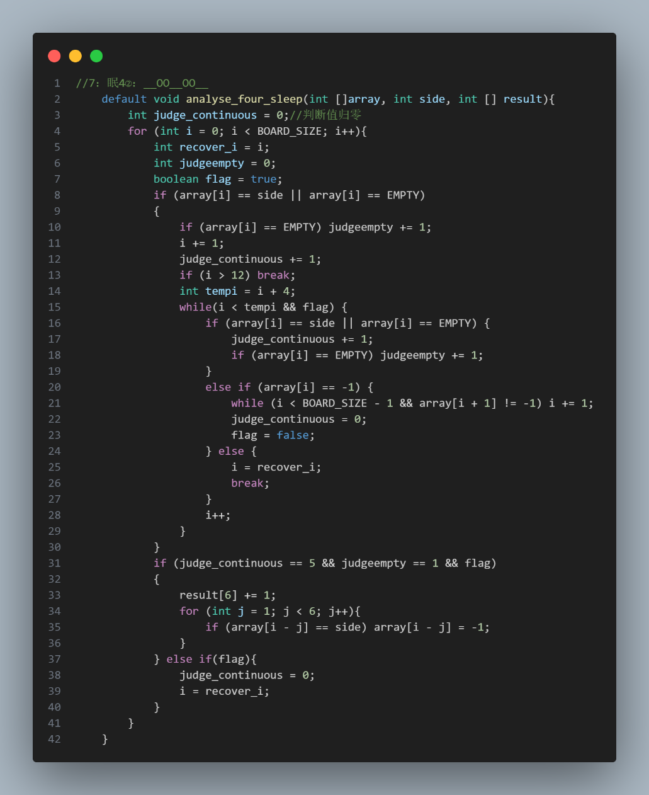
7、Dead Four (analyse_four_dead):
- Traverse the array to check for sequences of four continuous pieces of the same side that are blocked by the opponent's pieces on both ends.
- If such a sequence is found, increment the counter for dead four and mark these pieces.
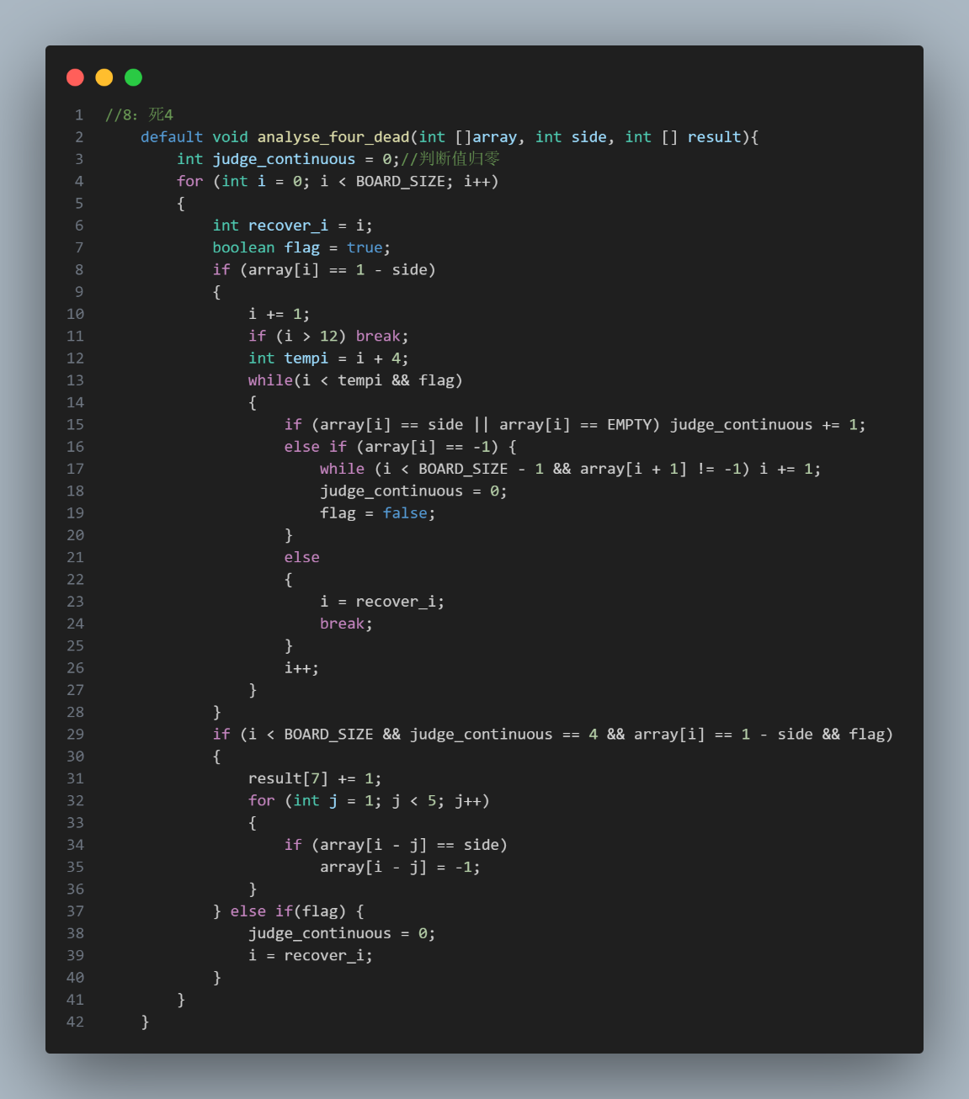
8、Live Three (analyse_three):
- Traverse the array to check for sequences of three continuous pieces of the same side.
- Ensure both ends of this sequence are empty.
- If such a sequence is found, increment the counter for live three and mark these pieces.
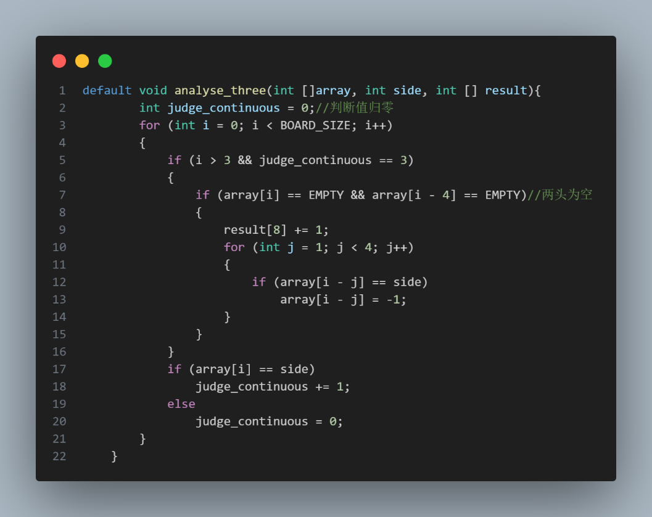
9、Vague Three (analyse_three_vague):
- Traverse the array to check for sequences where three continuous pieces of the same side are interrupted by one or two empty spaces.
- Ensure that the sequence does not form a clear live three or sleep three.
- If such a sequence is found, increment the counter for vague three and mark these pieces.
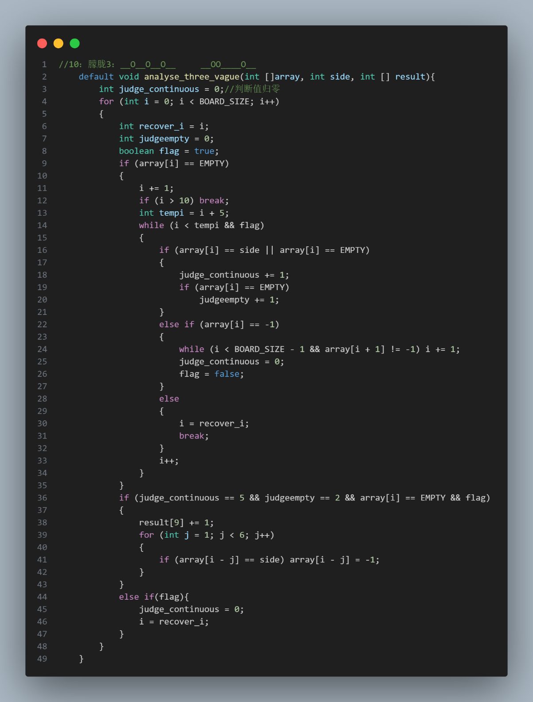
10、Sleep Three (analyse_three_sleep):
- Traverse the array to check for sequences where three continuous pieces of the same side are interrupted by exactly one empty space.
- Ensure that there are no opponent's pieces directly blocking the sequence.
- If such a sequence is found, increment the counter for sleep three and mark these pieces.
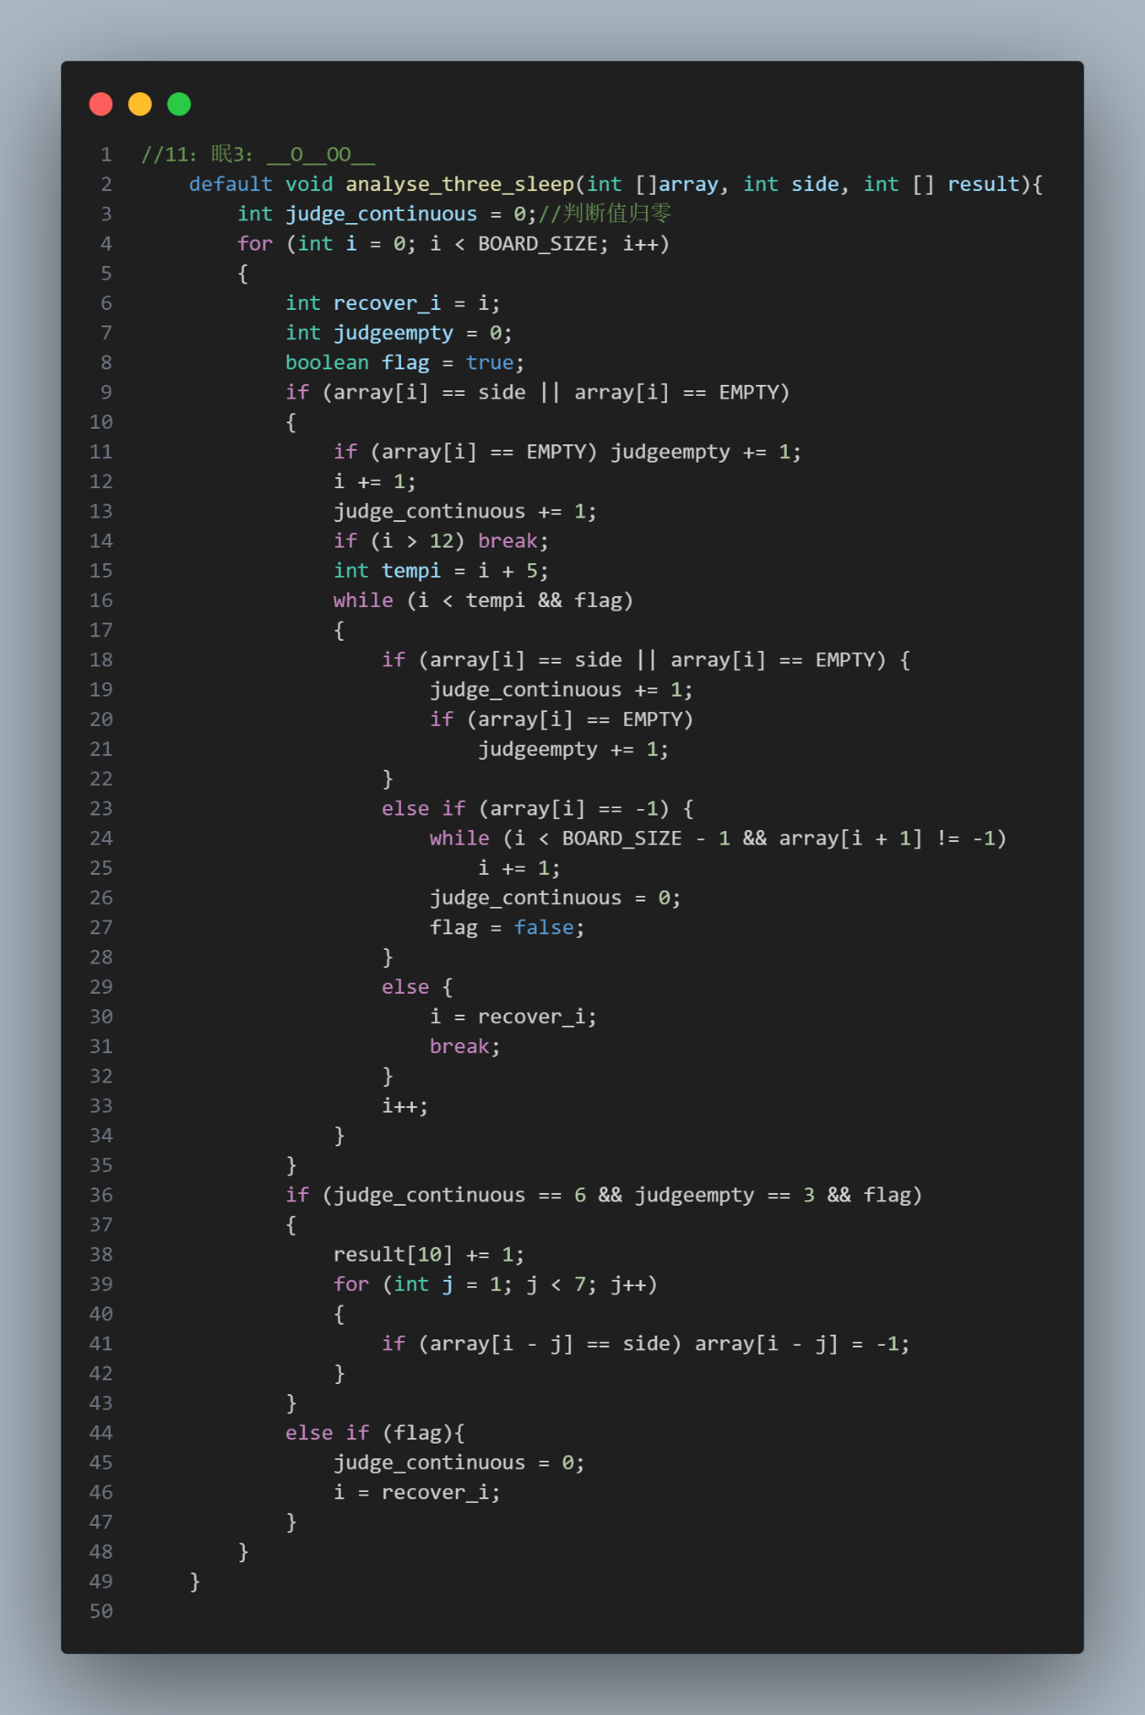
11、Dead Three (analyse_three_dead):
- Traverse the array to check for sequences of three continuous pieces of the same side that are blocked by the opponent's pieces on both ends.
- If such a sequence is found, increment the counter for dead three and mark these pieces.
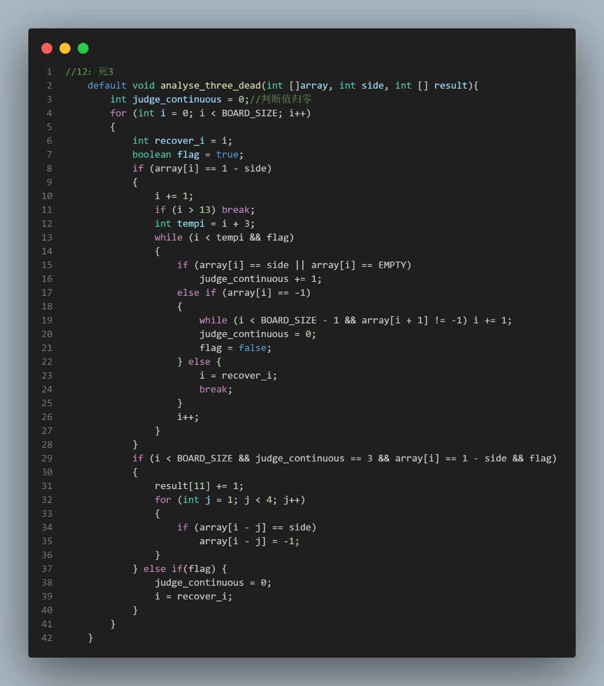
12、Live Two (analyse_two):
- Traverse the array to check for sequences of two continuous pieces of the same side.
- Ensure both ends of this sequence are empty.
- If such a sequence is found, increment the counter for live two and mark these pieces.
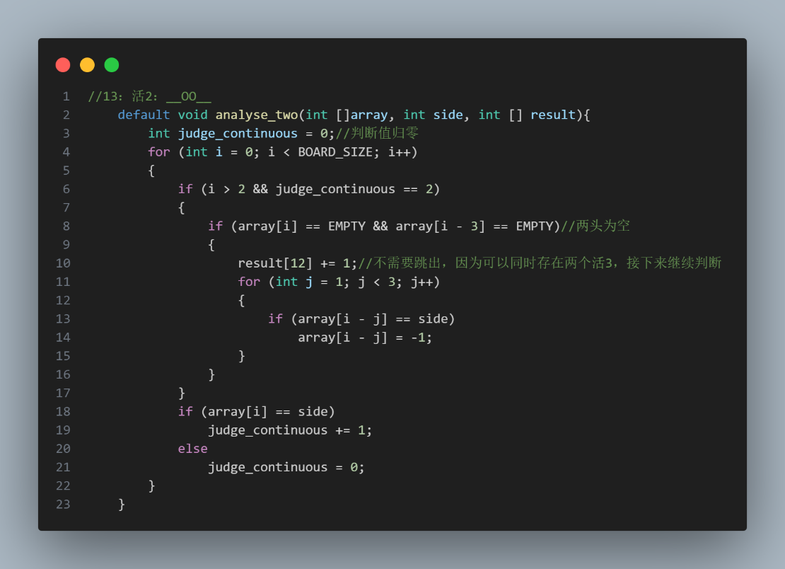
13、Sleep Two (analyse_two_sleep):
- Traverse the array to check for sequences where two continuous pieces of the same side are interrupted by exactly one empty space.
- Ensure that there are no opponent's pieces directly blocking the sequence.
- If such a sequence is found, increment the counter for sleep two and mark these pieces.
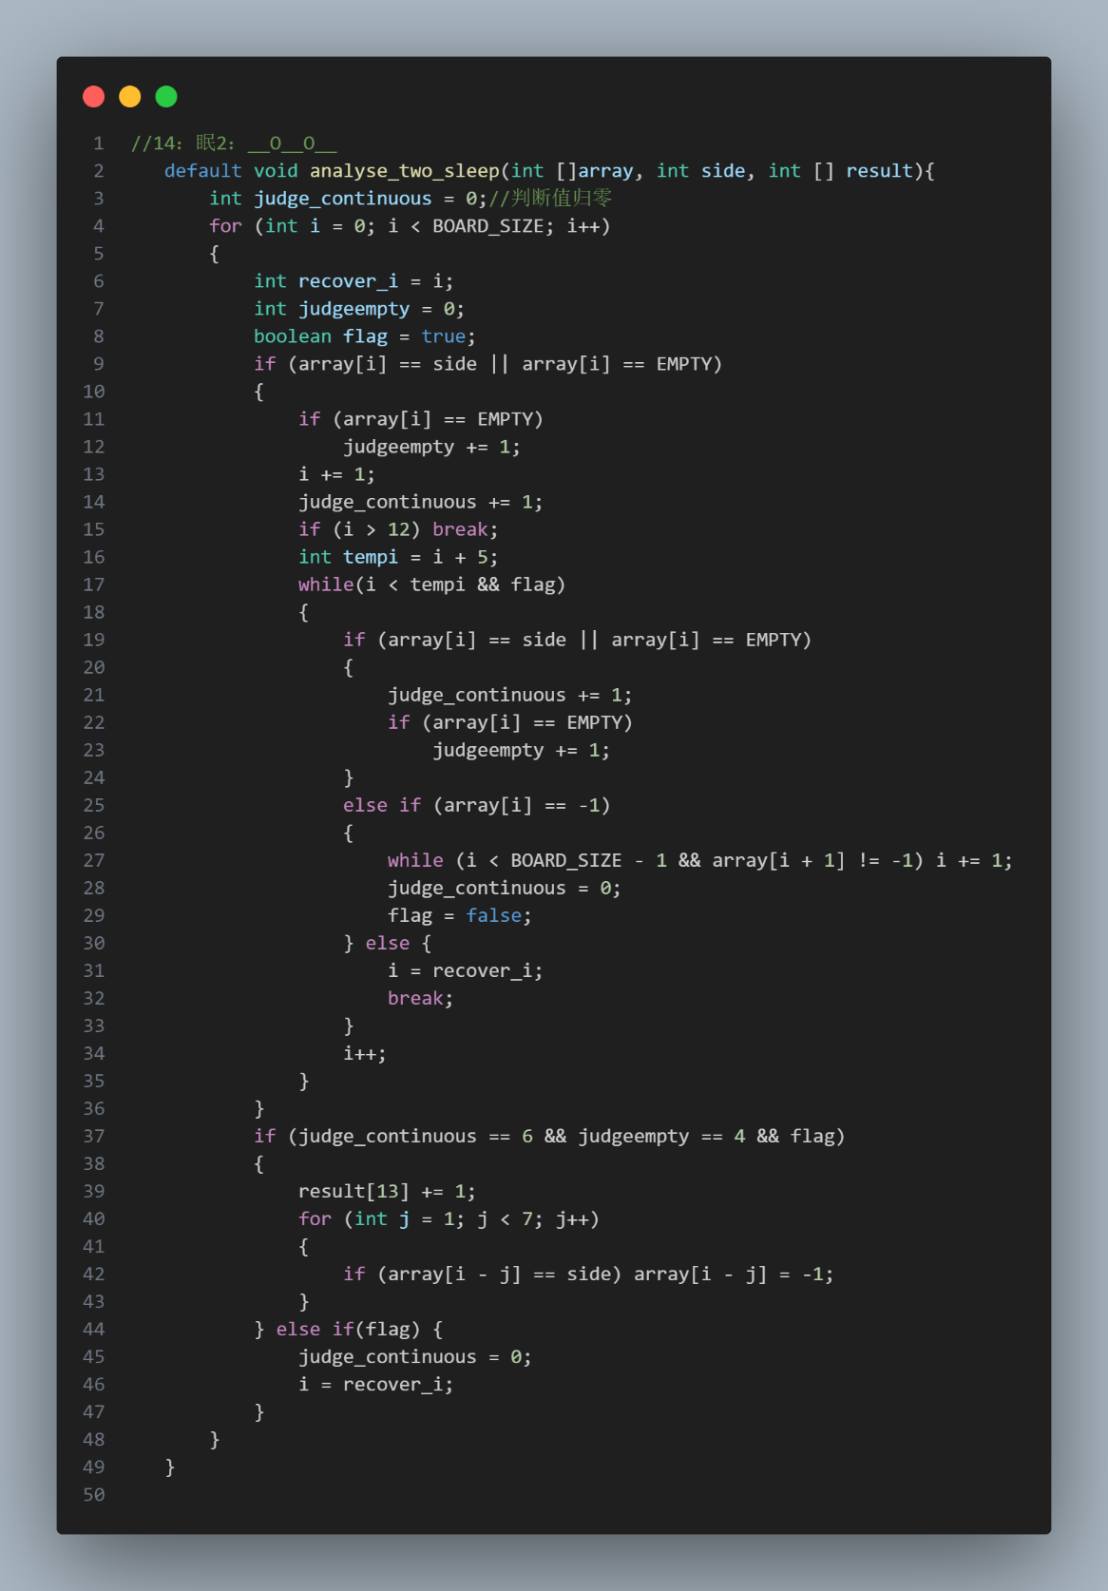
14、Dead Two (analyse_two_dead):
- Traverse the array to check for sequences of two continuous pieces of the same side that are blocked by the opponent's pieces on both ends.
- If such a sequence is found, increment the counter for dead two and mark these pieces.
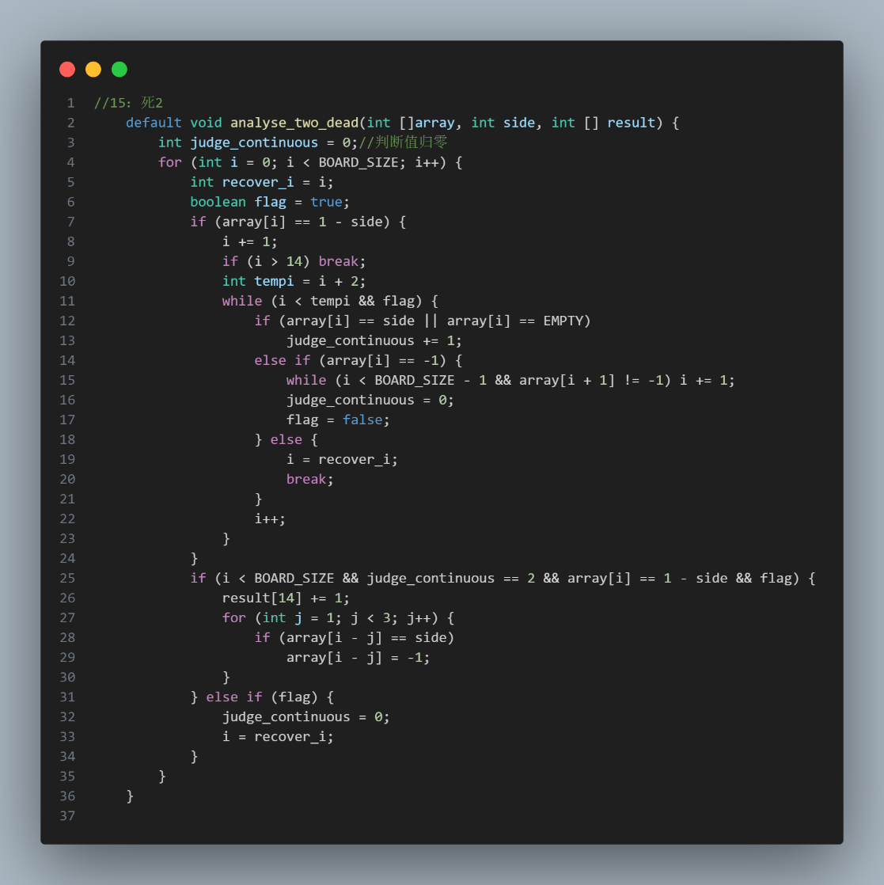
Algorithm's traversal methods for each direction^{[4]}
1、Horizontal Traversal (analyse_horizontal)
- Initialize Array: Create an array to represent the horizontal line at the specified row x.
- Populate Array: Fill the array with the values from the row x of the board.
- Analyze Pattern: Call the analyse_point method with the populated array to analyze and detect patterns for the given side.
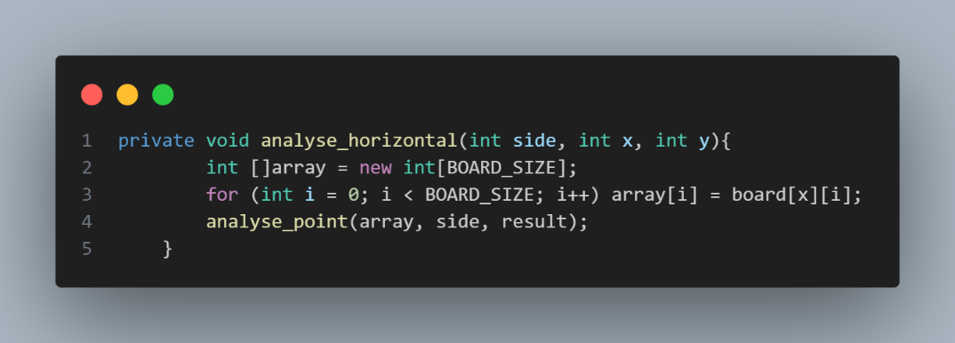
2、Vertical Traversal (analyse_vertical)
- Initialize Array: Create an array to represent the vertical line at the specified column y.
- Populate Array: Fill the array with the values from the column y of the board.
- Analyze Pattern: Call the analyse_point method with the populated array to analyze and detect patterns for the given side.
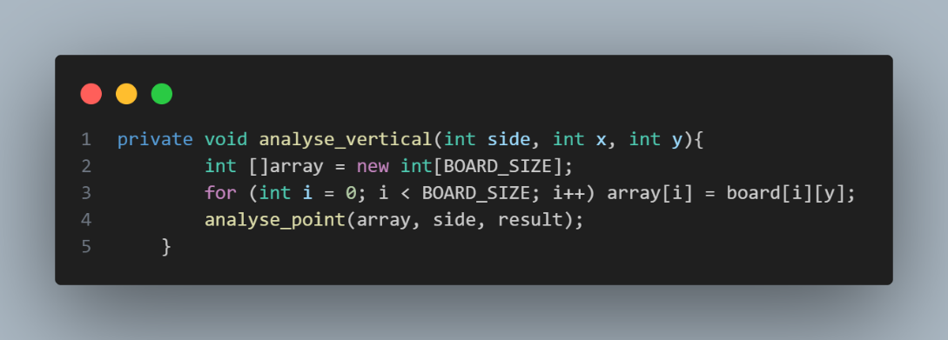
3、Diagonal Traversal (analyse_diagonal)
- Initialize Array: Create an array to represent the diagonal line.
- First Loop:
- Traverse the diagonals where the starting point is on the left border and extends to the bottom border.
- Check if the given coordinates (x, y) fall within the current diagonal being examined.
- If they do, fill the array with the values from the board corresponding to this diagonal and call the analyse_point method.
- Second Loop:
- Traverse the diagonals where the starting point is on the bottom border and extends to the right border.
- Check if the given coordinates (x, y) fall within the current diagonal being examined.
- If they do, fill the array with the values from the board corresponding to this diagonal and call the analyse_point method.
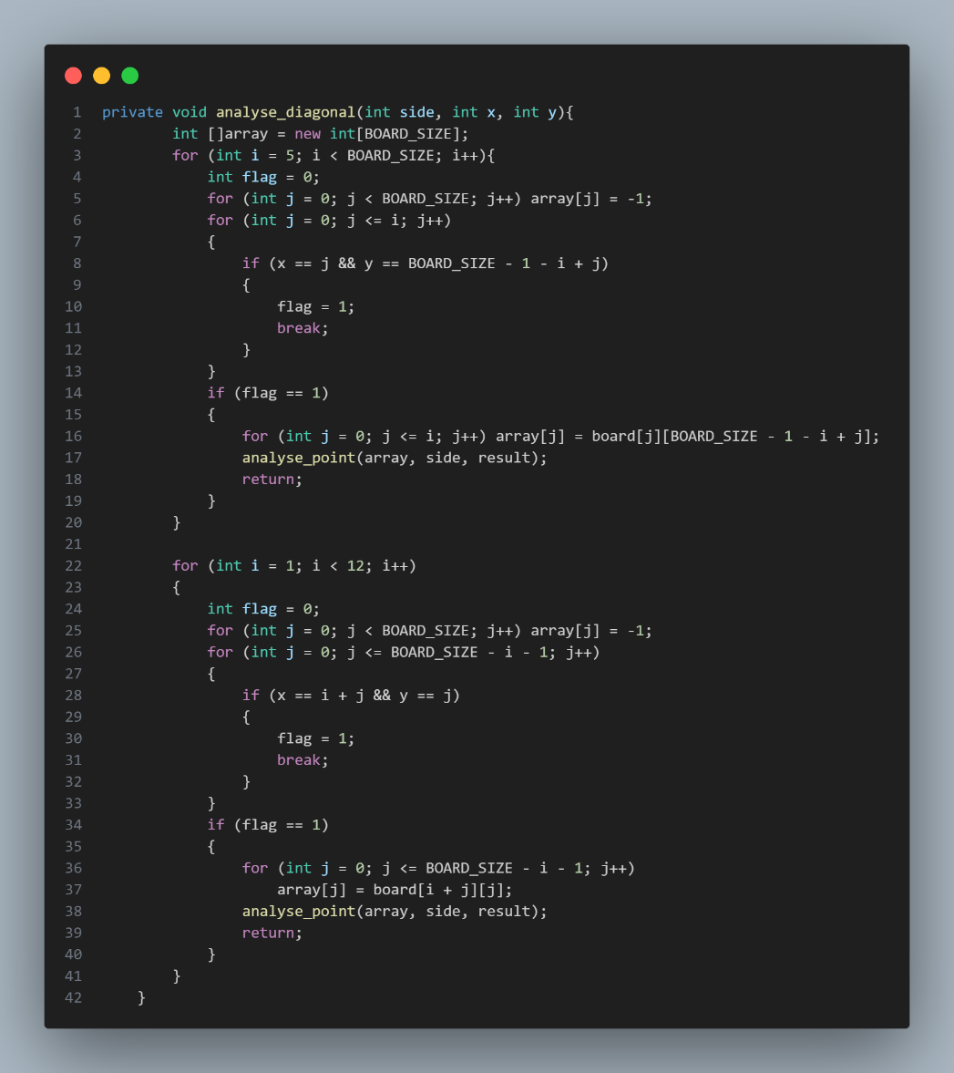
4、Anti-Diagonal Traversal (analyse_antidiagonal)
- Initialize Array: Create an array to represent the anti-diagonal line.
- First Loop:
- Traverse the anti-diagonals where the starting point is on the left border and extends to the top border.
- Check if the given coordinates (x, y) fall within the current anti-diagonal being examined.
- If they do, fill the array with the values from the board corresponding to this anti-diagonal and call the analyse_point method.
- Second Loop:
- Traverse the anti-diagonals where the starting point is on the top border and extends to the right border.
- Check if the given coordinates (x, y) fall within the current anti-diagonal being examined.
- If they do, fill the array with the values from the board corresponding to this anti-diagonal and call the analyse_point method.
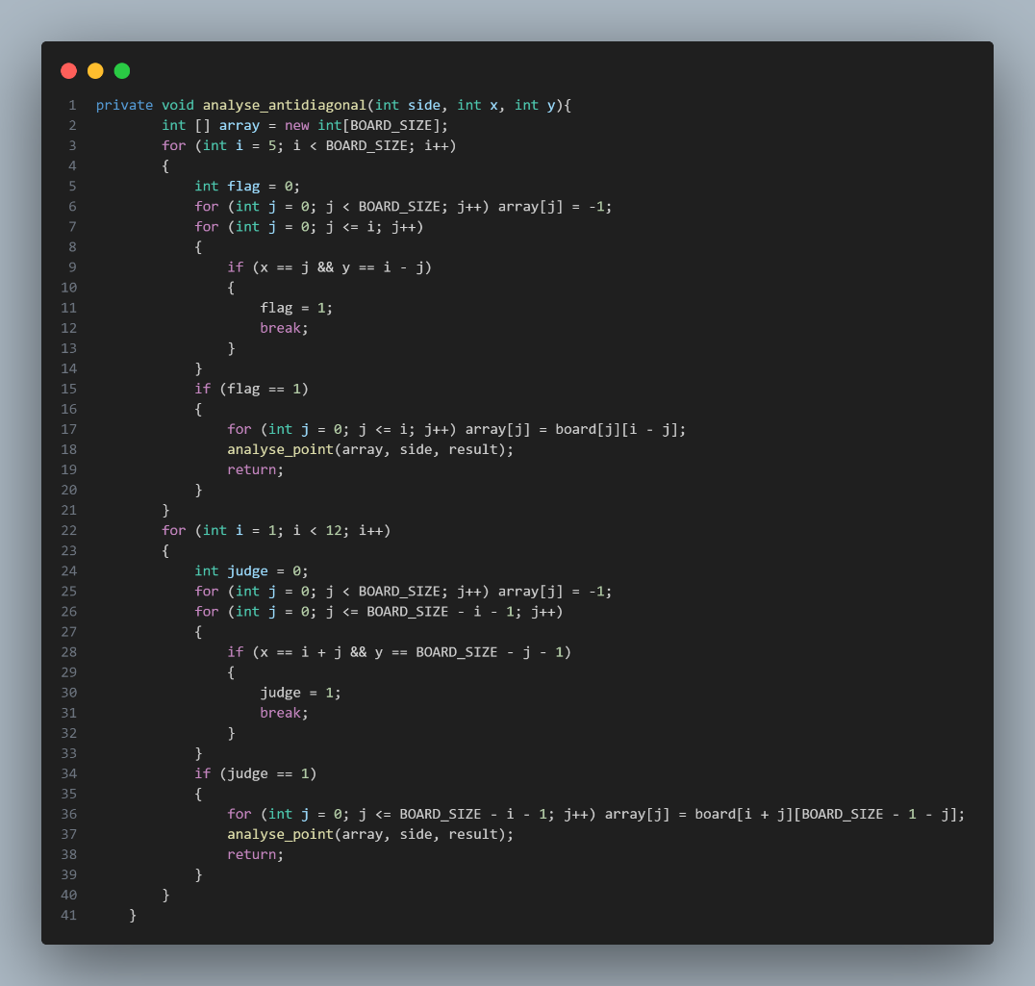
Score each point on the board^{[3]}
- Iterate Through the Board:
- The algorithm loops through each cell (i, j) on the board using nested loops.
- It only considers empty cells (board[i][j] == EMPTY) and checks if they are surrounded by the relevant conditions using the surround function(which means the points is surrounded by any pieces of the specified sides.)
- Analyze Potential Moves:
- Create Auxiliary Board: A copy of the current board (aux_board) is created to simulate potential moves.
- Instantiate Analyzer: An instance of Analyse is created with the auxiliary board.
- Evaluate Enemy Move:
- First Enemy Move:
a) Analyze the board with the enemy placing a piece at (i, j).
b) The function markenemy calculates the score for this enemy move.
2. Second Enemy Move:
a) Place the enemy piece on the auxiliary board at (i, j).
b) Reanalyze the board to get the updated results after this move.
- Calculate the score again using markenemy.
- Place the current player's piece on the auxiliary board at (i, j).
- Reanalyze the board to get the updated results after this move.
- Calculate the score using markself.
- Compute the final score for the point (i, j) using the formula:
- Mark = mark_self_second + mark_enemy_second - mark_enemy_first, which mark_enemy_first means offsets of enemy intervene, mark_self_second means if I move this point what scores can I get and mark_enemy_second means enemy move this point how important of this movement.
- This formula takes into account the second move of both the enemy and self, subtracting the first enemy move to weigh the potential impact of both players.
- Store the Result:
- Create a new Point object with the coordinates (i, j) and the calculated score.
- Add a new Step object containing the point and its score to the results list.
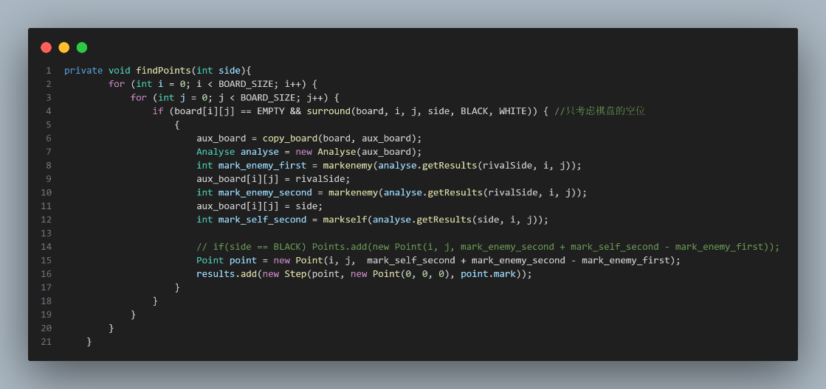
Find the second best point based on the initial scores
- Copy Board State:
- Create a duplicate of the current game board to simulate potential moves without altering the original board.
- Evaluate Each Step in the Results List:
- Loop through each recorded step in the results list.
- Simulate First Move:
- For each step, place the current player's piece at the specified coordinates on the duplicated board.
- Identify Potential Second Moves:
- Create an empty list to store potential second move candidates.
- Loop through each cell in the duplicated board to identify empty positions that are surrounded by pieces.
- For each valid empty position:
- Create another duplicate of the board for further simulations.
- Place the rival's piece at this position and evaluate the board state.
- Calculate the score for the rival's potential first move.
- Place the current player's piece at this position and evaluate the board state again.
- Calculate the score for the rival's potential second move and the current player's move.
- Combine these scores to determine the final score for this potential second move.
- Store this potential second move along with its score in the list.
- Select Best Second Move:
- Sort the list of potential second moves by their scores in descending order.
- Select the move with the highest score as the best second move.
- Update Results:
- For each step in the results list, update the second move with the best-scored second move found.
- If no valid second move is found, set the second move to a default value.
- Determine the Best Overall Step:
- Sort the results list by the overall scores of the steps.
- Identify and record the best step based on the highest overall score.
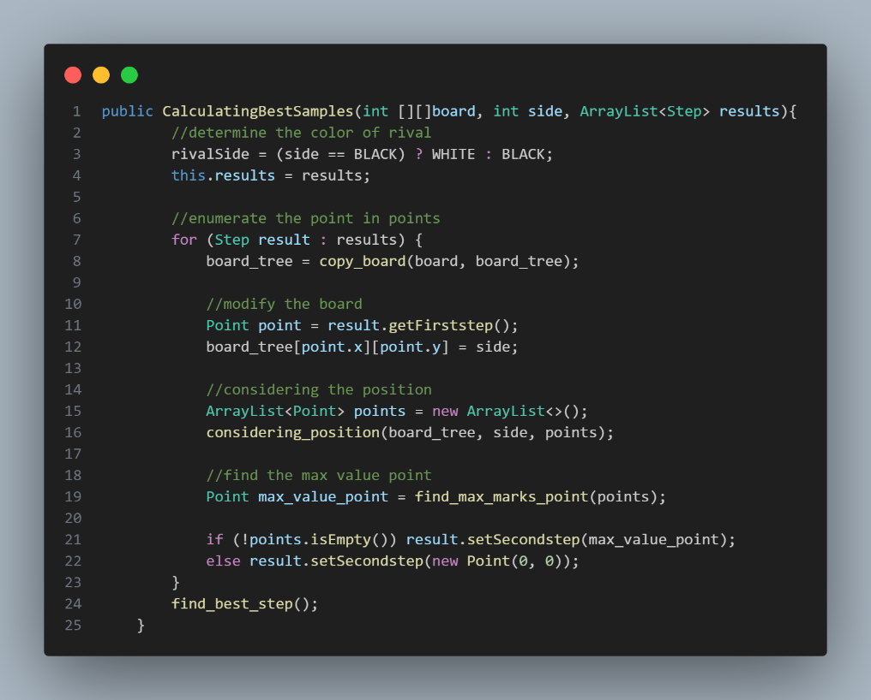
Ensure that the steps generated do not overlap
- Extract Coordinates:
- Retrieve the coordinates of the first step (x1, y1) and the second step (x2, y2) from the Step object.
- Generate Point for the First Step:
- Check Occupancy: Verify if the position (x1, y1) on the board is not empty.
- Find Accessible Point: If (x1, y1) is occupied, call find_accessible_point with the coordinates of the second step (x2, y2) to find a nearby accessible point.
- Update First Step: If an accessible point is found, update the first step's coordinates in the Step object with this new point.
- Mark Board: Mark the board at the updated first step's position with the current player's color.
- Generate Point for the Second Step:
- Check Occupancy: Verify if the position (x2, y2) on the board is not empty.
- Find Accessible Point: If (x2, y2) is occupied, call find_accessible_point with the coordinates of the first step (x1, y1) to find a nearby accessible point.
- Update Second Step: If an accessible point is found, update the second step's coordinates in the Step object with this new point.
- Mark Board: Mark the board at the updated second step's position with the current player's color.
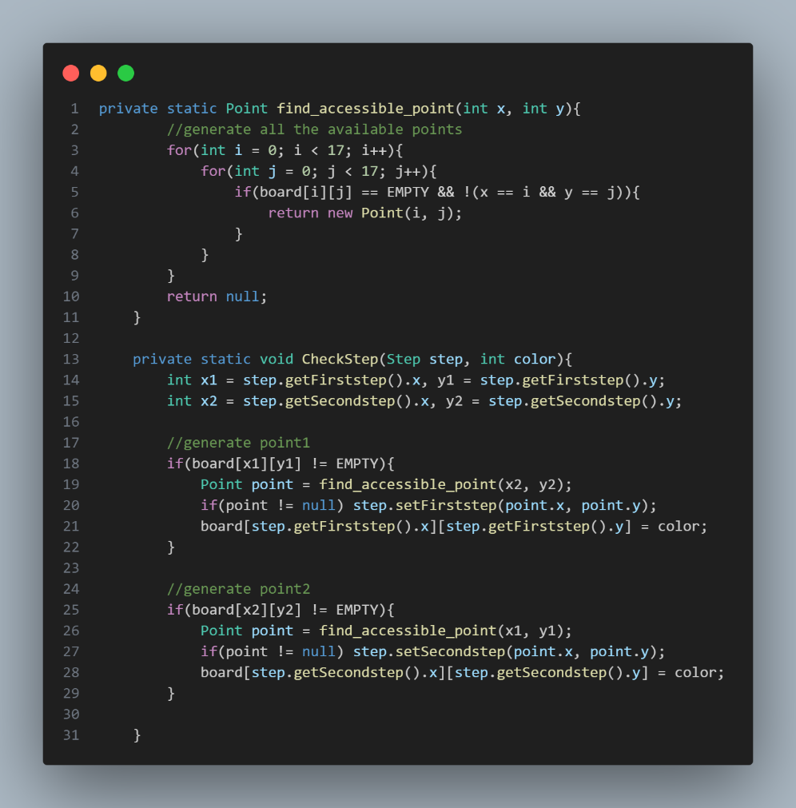
Summary:
During the development of this board game algorithm project, several important insights and challenges were encountered. Here's a summary of the key lessons I learned:
- Complexity of Pattern Detection:
  - Challenge: Implementing precise detection for various patterns (e.g., six-in-a-row, live five, sleep five) was intricate due to the need to differentiate between similar patterns based on surrounding conditions.
  - Insight: Detailed conditional checks and careful boundary management are crucial for accurate pattern detection. Clear, modular functions for each pattern type helped manage this complexity.
- Direction Traversal Efficiency:
- Challenge: Traversing the board in multiple directions (horizontal, vertical, diagonal, anti-diagonal) while ensuring complete and accurate analysis was computationally intensive.
- Insight: Efficient traversal methods and proper handling of board boundaries were essential. Using helper functions to populate arrays for different directions streamlined the process.
- Scoring System and Move Simulation:
- Challenge: Simulating potential moves for both the player and the rival and calculating scores involved significant computational overhead and careful tracking of multiple intermediate results.
- Insight: Creating an auxiliary board for simulations allowed for isolated testing of potential moves. Balancing accuracy and performance required optimizing these simulations to avoid redundant calculations.
- Handling Multiple Potential Moves:
- Challenge: Identifying and scoring multiple potential second moves after an initial move was complex due to the numerous possibilities and the need to evaluate each for strategic impact.
- Insight: Efficient data structures (like sorted lists) and pruning techniques helped manage and prioritize the most promising moves, ensuring timely and effective decision-making.
- Non-overlapping Steps and Board Updates:
- Challenge: Ensuring generated steps did not overlap with existing pieces and finding accessible points when overlaps occurred required robust checks and updates.
- Insight: Implementing a method to check occupancy and find alternative accessible points was vital. Maintaining board state consistency while updating steps was key to avoiding logical errors.
References
[1] https://blog.csdn.net/Achenming1314/article/details/105533308
[2] https://zhuanlan.zhihu.com/p/121127826
[3] https://blog.csdn.net/qq_64534452/article/details/131624326
[4] https://blog.csdn.net/linglaoli/article/details/81701609

