Q1
Based on the ideas presented in Chapter 6, discuss a quick and practical way to conclude that linear regression is not an appropriate model for a given dataset.
Plotting the residuals, which is a plot of actual values across the X-axis and residuals (actual value – prediction) on the Y-axis. This plot should look scattered and linear without curvature. If this plot was curved (its not) then it would suggest there is non-linearity in the data to the output.

Q2
Using your answer from Q1, determine whether linear regression is an appropriate model for the bike rentals problem. Be explicit about uncertainty: if the answer is “partially,” explain why.
Linear regression is “partially” an appropriate model. The plot of the residuals does show a linear relationship with no curvature suggestion linear regression is an appropriate model for the bike rentals problem. However, some individual features have a non-linear relationship like temp and humidity which intuitively makes sense since in lower temperatures one could assume bike rentals would go down. Same for high temperatures. It suggests there is a sweet spot in temperature where people like to rent bikes. Even though some features are non-linear the model still captures the major directional trends.

Q3
Build a linear regression model for the bike rentals problem under the following constraints:
- When one-hot encoding categorical features with L categories, use only L−1 dummy variables, as explained in the chapter.
- Standardize all numerical features before fitting the model, as discussed in the chapter.

Q4
After building the model, identify the intercept value and explain:
- What the intercept represents in this specific model
  - A bike count where its winter, not a holiday, not a working day, and weather is good. Meaning all reference categories
- Under what conditions the intercept is interpretable
  - When the features have been standardized (mean of zero, standard deviation of one)
- Whether the intercept is meaningful given the feature preprocessing choices
  - Without the preprocessing the intercept would have been meaningless because 0 would then mean all values being 0 which is not realistic. Instead now 0 refers to averages of numerical features.

Q5
Calculate the R² value for your model and then discuss:
- What R² tells us in the context of interpretability
  - Tells us how much of total variance of target variable is explained by the model
  - Ranges near 0 explains nothing
  - Ranges to 1 indicate good fit
  - IF values are low model captures on small fraction of what leads to bike rentals
- Whether the value suggests that interpreting individual weights is meaningful
  - Yes because Molnar states that a very low adjusted R^2 value is not meaningful since such a model doesn’t explain much of the variance. The adjust R^2 achieved (0.753) suggests it is meaningful.

Q6
Create weight plots (as shown in Figure 6.1 of the book) for:
- The model before standardizing the features
- The model after standardizing the features
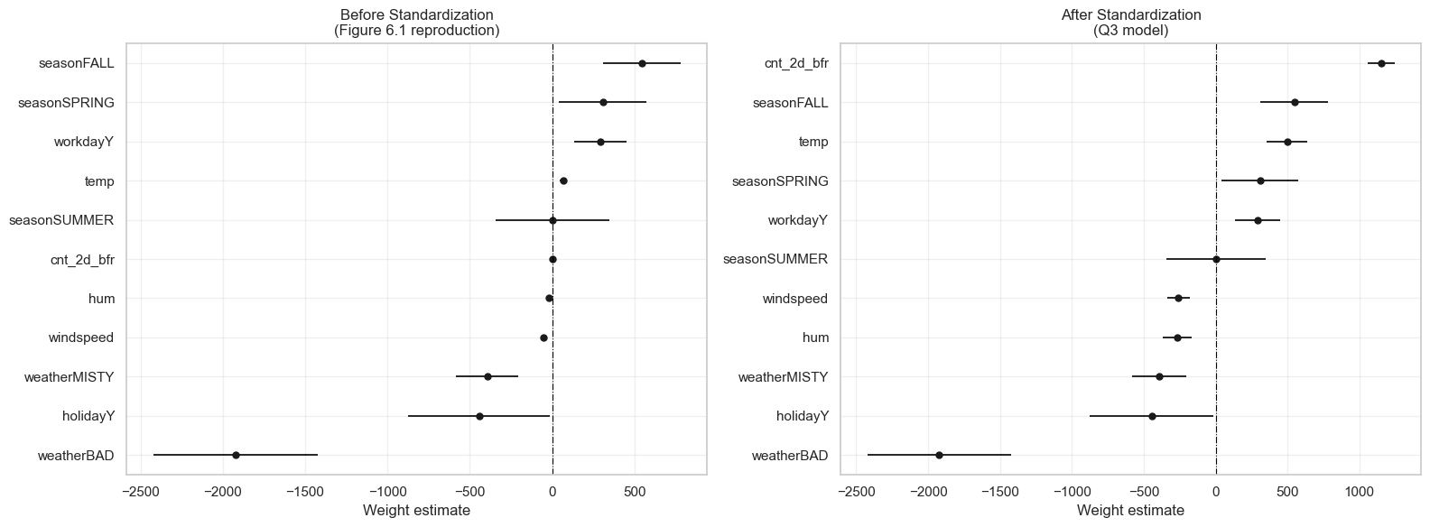
Then discuss which version is more suitable for interpretation, and why.
Standardized is more suitable for interpretation as Molanr states, “You can make the estimated weights more comparable by scaling the features before fitting the model”. This is due to the scales. If it isn’t standardized the units are different, while that allows for direct “for each 1-unit increase in … bike rentals change by X” it does not allow for comparison of which feature matters most given they are on different scales.

Q7
Create effect plots (as shown in Figure 6.2 of the book) for:
- The model before standardizing the features
- The model after standardizing the features
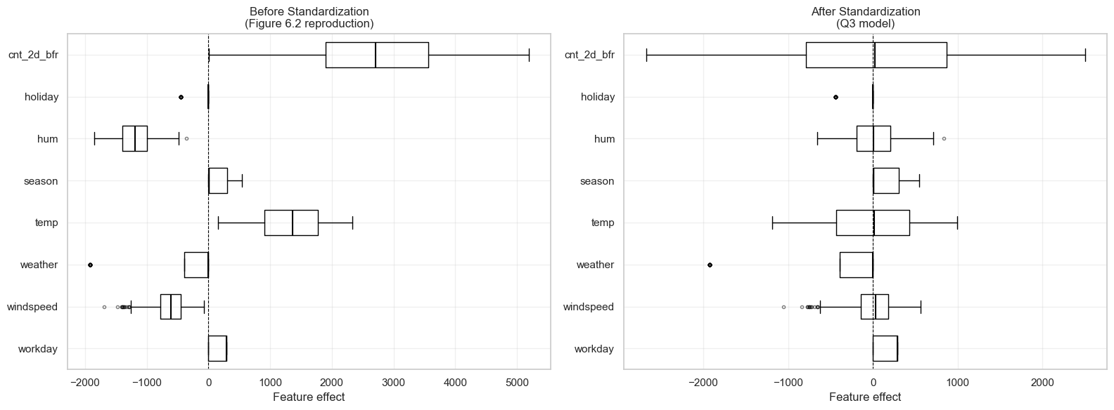
Then discuss which version is more suitable for interpretation, and why.
Here unstandardized is better because you want the real units. Scaling everything around 0 loses the meaning of an increase or decrease in each unit. We can read temperature and know its effect, like it contributes between 500 to 2500 bike rentals in a day, whereas standardized unites lose that meaning.

Q8
Reproduce Figure 6.3 from the book using the same example (instance 6). Your submission must include:
- A faithful reproduction of the figure
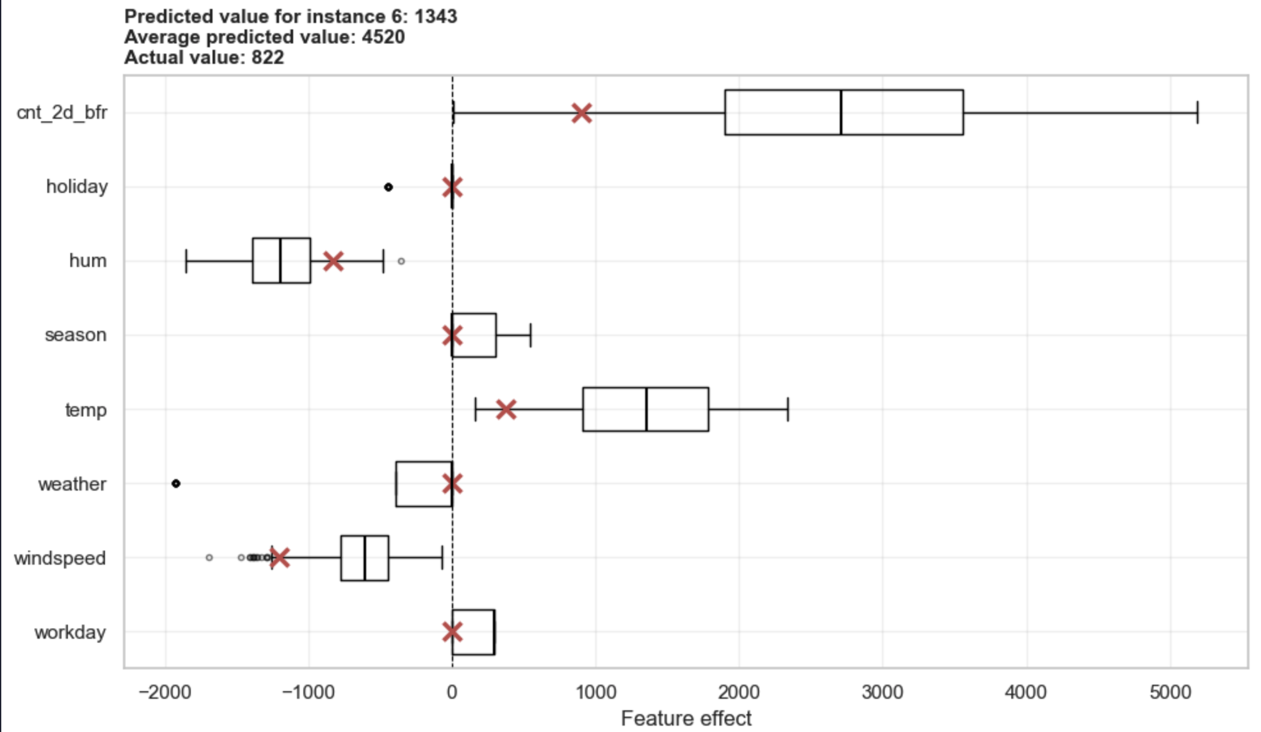
- A brief explanation of how the prediction is decomposed
  - The red X markers show how the model arrived at its prediction for that specific instance (day 6)
  - Values on the left of their box are pushing lower than they typically would and values to the right of the box are pushing high than usual.

