Relating the Theory and Application of LIME
Ch 14. Local Surrogate (LIME)

A) According to the book:
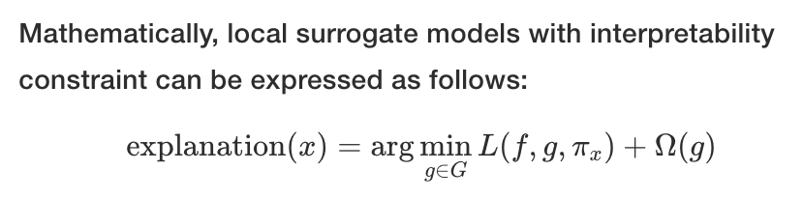
This expression has the following terms:
- explanation(x)
- arg min
- g
- G
- L()
- f,
- x
- π_{x}
- Ω
B) Also, the recipe for training local surrogate models:
- Select your instance of interest for which you want to have an explanation of its black box prediction.
- Perturb your dataset and get the black box predictions for these new points.
- Weight the new samples according to their proximity to the instance of interest.
- Train a weighted, interpretable model on the dataset with the variations.
- Explain the prediction by interpreting the local model.
C) Also, we saw in class how to use LIME. The two code statements below have several functions, arrays, and parameters.

explainer = lime.LimeTabularExplainer(train,
feature_names=fn, class_names=['ND', 'D'],
Discretize_continuous=True)

explain = explainer.explain_instance(train[8], logistic_regression.predict_proba, num_features=6, top_labels=1)

- explainer
- explain
- LimeTabularExplainer()
- explain_instance()
- train
- train[8]
- feature_names
- class_names
- discretize_continuous
- logistic_regression
- logistic_regression.predict_proba
- top_labels
- num_features

