Output

1. Is Pete Mark’s parent?

1. Is Anne Jenny’s parent?

1. Who is Todd’s father?

1. Who is Tom’s sibling?

1. Who is Lilly’s brother?

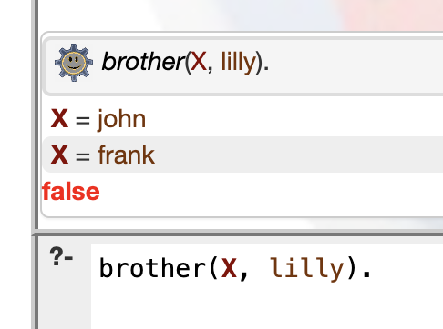

1. Who is Henry grandparent?

1. Who is Alice’s sister?

1. Is Frank Kate’s brother?

1. Who is Matt’s mother?

1. Is Mark Anne’s brother?

Code for Part 1.

male(pete).

male(mark).

male(tom).

male(john).

male(frank).

male(matt).

male(henry).

male(todd).

female(anne).

female(lilly).

female(kate).

female(alice).

female(jenny).

parent(pete, mark).

parent(pete, tom).

parent(pete, anne).

parent(mark, lilly).

parent(mark, john).

parent(mark, frank).

parent(tom, kate).

parent(anne, alice).

parent(anne, matt).

parent(alice, henry).

parent(matt, jenny).

parent(matt, todd).

sibling(X, Y) :- parent(Parent, X), parent(Parent, Y), not(X=Y).

sister(X, Y) :- sibling(X, Y), female(X).

brother(X, Y) :- sibling(X, Y), male(X).

father(X, Y) :- parent(X, Y), male(X).

mother(X, Y) :- parent(X, Y), female(X).

grandparent(X, Y) :- parent(X, Child), parent(Child, Y).

Without tracing list of 8 elements

Code for part 2.

max([], 0).

max([Head | Tail], Max) :- max(Tail, TailMax), Head > TailMax, Max is Head.

max([Head | Tail], Max) :- max(Tail, TailMax), Head =< TailMax, Max is TailMax.