1. Use the Python to declare the following classes [the UML diagram is from

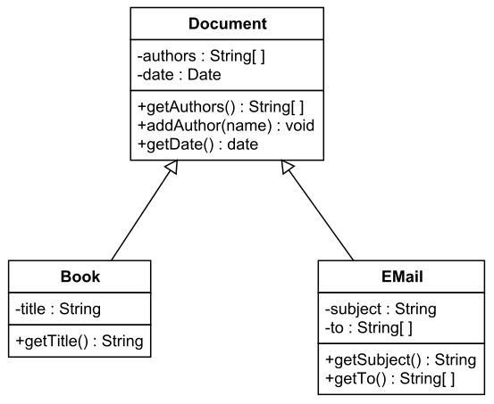

1. Use O(n) to measure the following formular

$10000+\log\left(n\right)+n$

Answer:

$n^{2}+n\log\left(n\right)+5000 n$

Answer:

$2 n^{20}+ 2^{n}$

Answer:

1. If the probability of an event occurring is 0.75, the probability of it not occurring must be [ ].
2. Replace the ‘?’ with the correct information according to above output histogram.

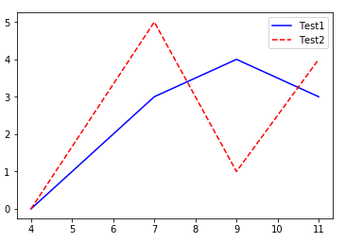

import pylab

xVals = [?, ?, ?, ?]

yVals1 = [?, ?, ?, ?]

yVals2 = [?, ?, ?, ?]

pylab.plot(xVals, yVals1, '?-', label='Test1')

pylab.plot(xVals, yVals2, '?--', label='Test2')

pylab.legend()

1. Describe what the following code is doing?

