Alexander Kahanek – 12/9/2020

**A look into Video Game sales across the globe**

**Abstract**

This report will be looking at the patterns in Video Game sales. This will be done to get insights into the most popular platforms for games, the most popular genres, and to get an idea of the most popular Video Games. These insights could be used by someone looking to break into the Video Game industry, and give insights into which areas of the video game industry would be the beneficial to focus in.

**Introduction**

The research questions will be:

1. Are there differences in the distributions of total sales between groupings of North America, Japan, Europe, Other, and the Global sales? Also, are there any differences in the yearly top platform sales between the groupings?
2. Are there differences in the distribution of sales by genre for the groupings of North America, Japan, Europe, Other, and the Global sales?
3. What are the global top selling Video Games of all time?

These questions will serve to get a good overview of the patterns of Video Game sales across the globe. Such as, are different platforms more popular in Japan versus North America? Or do different areas prefer different genres in Video Games? These would be important questions for anyone attempting to create a Video Game and could provide useful insights.

**Methods**

Python was used for data manipulation; no cleaning was required as there were no null values or errors present in the data. The visualizations were made with Tableau; however, Figure 1 needed to be manually edited with paint as a global legend cannot be created in tableau, with how the graph needed to be made. Data was sourced from: <https://www.kaggle.com/gregorut/videogamesales>.

**Results**

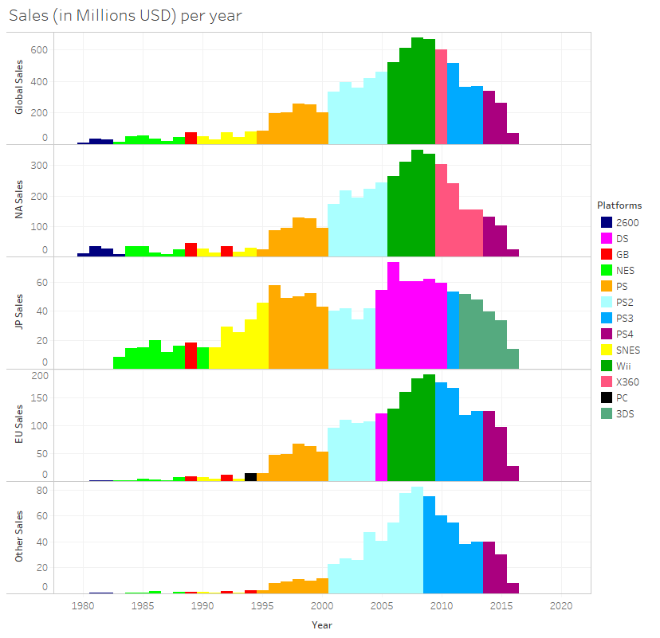

Figure Sales are measured in Millions USD. The platforms represent the top selling platform in the given year.

As seen in Figure 1 the distributions are roughly the same shape, except in Japan where Video Games are proportionally higher between 1982 and 2000 than other countries. It is observed that North American sales are the highest of all the regions, while European sales are the second highest. It also appears that the top selling platforms are roughly the same for all regions before 2004, and start to vary more drastically after that, especially in Japan where handheld consoles seem to be the clear winner. It can also be observed that the European top platforms are most similar to the Global top platforms.

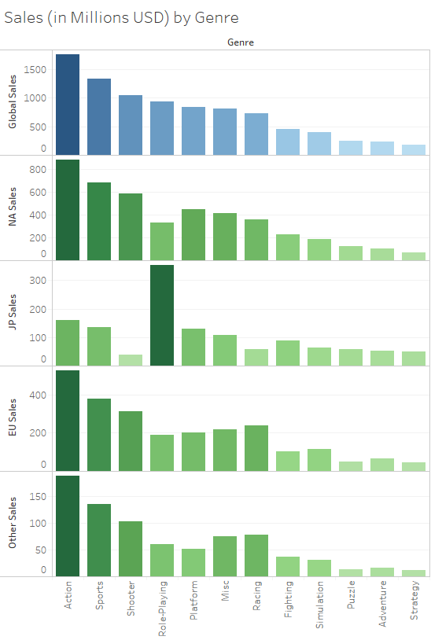

Figure Sales are measured in Millions USD and are the total Global sales throughout all recorded years.

As seen in Figure 2 the top 3 genres are the same throughout the North American, European, and Other regions. The rankings between the European and Other regions are almost identical except for a switch in Role-Playing and Platforming games. However, the North American sales follows the global trend almost identically, which is not surprising as it has the most total sales in total. There are huge differences in the Japan distribution of genres, where it is clear there is a favor towards Role-Playing games in the region.

Figure Sizes of the squares are directly related to the total sales for the individual game.

As seen in Figure 3 Wii Sports is the best selling game of all time, which is a stark contrast to Grand Theft Auto V. It can also be observed that of the top 31 games 7 of them are shooters, which is the leading category in the list. Yet we noticed from Figure 2 that the top two selling Global Genres are Action and Sports, with only 3 Action games and 4 Sports games in the top 31 games. It can also be observed that the only Role-Playing games are Pokémon series, and the only Simulation is Nintendogs, with the only Puzzle game being Tetris. Also, in these top selling games there are no Fighting or Strategy games.

**Discussion**

As noticed in Figure 1 the distribution of sales over the years is roughly the same between the North American, Japan, European, and Other regions. Also, the top selling platforms are roughly the same until 2004, however have been changing past 2004 depending on the region which could be due to more consoles being available. It was observed that Japan prefers handheld gaming though. From Figure 2 it can be observed the top 3 selling Genres are Action, Sports, and Shooters in every region except Japan, where Role-Playing heavily outsold every other genre. From Figure 3 it can be observed Wii Sports is the best selling game of all time; however, Shooting games are more likely to succeed. In general, some very interesting insights were found, and the research questions are sufficiently answered through all 3 figures.