Belgium Campus iTversity
Database Development 181
ActiveLife Fitness Database Project
Phase 1: Database Design
Group V1-B Members:
Alexander Kruger
Michael John Harding
Dustin Hoffmann
Waldo Kilian
Date: 2026/07/28
Lecturer: Desire Sundire

Table of Contents

1. Project Outline 3
1.1 Introduction 3
1.2 Problem Statement 3
1.3 Objectives 3
1.4 Scope 3
2. Entity Relationship Diagram 4
3. Design Justifications 4
Members and Accounts 4
Employees, Positions and Trainers 5
Trainers and Classes 5
Bookings 5
Rooms 5
Classes, Class Types and Equipment 5
Payments 5
Normalisation 5
Assumptions 5
4. Database Features 6
Queries 6
qryAddNewMember 6
qryRemoveOldBookings 6
qryUpdateSalaryExpertTrainers 6
qryStrengthTraining 6
qryIncomePerClass 6
Lookup queries for the forms 6
Reports 6
rptMemberStatement 6
rptMonthlyRevenue 6
rptTrainerLoad 6
Forms 6
frmSplash 6
frmMainMenu 6
frmMembers 6
frmClass 6
frmPaymentEntry 6
5. References 6

1. Project Outline

1.1 Introduction
ActiveLife Fitness is a small, growing community fitness centre offering group classes such as Yoga, Spinning, HIIT, Aerobics, Zumba Dance and Pilates, supported by a team of trainers and administrative staff. With around 150 active members and expanding demand, the centre requires a reliable system to manage member records, staff details, class scheduling, bookings and payments. The aim of this project is to design a Microsoft Access database that will help ActiveLife Fitness manage its daily operations more efficiently (Alexander and Kusleika, 2018).

1.2 Problem Statement

ActiveLife Fitness currently keeps its records using paper forms and Excel spreadsheets. This makes it harder to keep track of members, classes, bookings and payments, and mistakes can easily happen when information is entered more than once. It also takes longer for staff to find information such as who is booked for a class or how much money was received. A Microsoft Access database will help organise all this information in one place and make it easier to manage.

1.3 Objectives
The main objectives of the database are:
- Store and maintain accurate member information, including contact details and membership type.
- Manage employee and trainer records, including positions, specialisations and reporting lines.
- Schedule and organise group classes, including trainers, rooms and equipment.
- Record member bookings for classes and track payment status.
- Process and track member payments, including membership fees and personal training accounts.
- Improve data integrity through normalisation, validation rules and enforced relationships.
- Provide a user-friendly interface (forms, reports and navigation) for staff to interact with the system without requiring technical assistance.

1.4 Scope
The database will be used to manage the main activities of ActiveLife Fitness, including:
- Membership management, including personal training accounts linked to individual members.
- Employee management, covering trainers, receptionists, cashiers and administrative staff, including position and reporting structure.
- Class management, including class types, schedules, room allocation and equipment requirements.
- Booking management, allowing members to be enrolled in one or more classes.
- Payment processing, covering multiple payment methods and linking payments to members and cashiers.

The database will not include accounting, payroll or online booking because these are not part of the project requirements.

2. Entity Relationship Diagram
The ERD below was created using Draw.io. It shows all the tables, their attributes, the primary and foreign keys, and the relationships between them (Bagui and Earp, 2022).
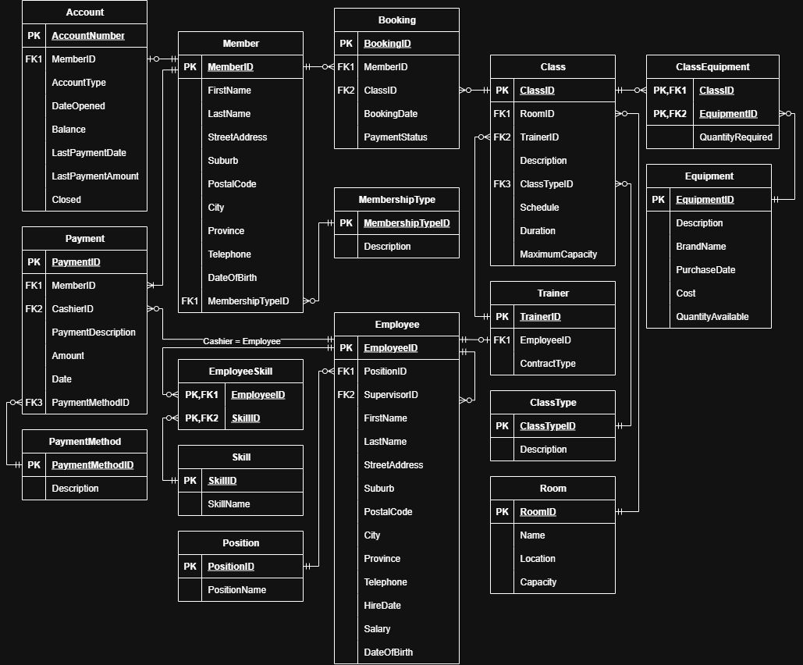
Figure 1: Entity Relationship Diagram for the ActiveLife Fitness database.

3. Design Justifications

This section explains why we designed the database the way we did.

Members and Accounts
We used a one-to-one relationship between Member and Account because each personal training account belongs to only one member (Hernandez, 2020). Members who pay cash or are walk-in clients do not need an account, so not every member will have one.

Employees, Positions and Trainers

We created an Employee table because all employees share information such as their name, address, phone number, salary and date of hire. Trainers were placed in a separate table because only trainers have extra information like their contract type and the classes they teach. We also added a SupervisorID so that one employee can supervise another employee.

Trainers and Classes

We used a one-to-many relationship because one trainer can teach many classes, but each class is taught by only one trainer.

Bookings

We created a Booking table because members can book many classes, and each class can have many members. The Booking table keeps track of which member booked which class, the booking date and the payment status.

Rooms

We created a separate Room table because several classes can use the same room. This prevents us from entering the same room details every time a new class is added.

Classes, Class Types and Equipment

We separated ClassType from Class so that class types such as Yoga, HIIT and Pilates do not have to be entered repeatedly. Equipment was also placed in its own table because different classes can use the same equipment, and one class may need several different pieces of equipment. We used a ClassEquipment table to link classes and equipment together.

Payments

Payments were kept in their own table so that every payment made by a member can be recorded. This also makes it easier to see a member's payment history.

Normalisation
The database was normalised to 3NF to reduce duplicate data and make the information easier to manage (Stephens, 2023). Separate tables were created for things like ClassType, Room, Position and PaymentMethod so that the same information does not need to be entered more than once.

Assumptions
The following assumptions were made where the business rules did not explicitly specify a detail:
- Each class is taught by only one trainer at a time (one-to-many from Trainer to Class).
- A member may book the same class only once per session; repeat bookings for different sessions are treated as separate Booking records.
- Equipment may be shared between multiple classes, and the quantity required is tracked per class via the ClassEquipment entity.
- An employee may supervise other employees, but each employee reports to at most one supervisor.
- Skills/specialisations are stored as a separate lookup entity (Skill) and linked to employees via a many-to-many EmployeeSkill entity, since an employee may have more than one specialisation.

4. Database Features
Besides designing the tables and the relationships between them, we also built several queries, reports and forms inside Microsoft Access. These are the parts of the database that the staff at ActiveLife Fitness will actually see and use every day. This section explains what each one does, why we decided to build it, and how it saves time compared to using paper forms and Excel (McFadyen, 2022).

Queries

Queries are used to quickly find or update information in the database. Instead of searching through paper files or large spreadsheets, staff can run a query and get the information they need in a few seconds.

qryAddNewMember

We created this query so that new member information can be added to the Member table quickly. It saves staff time and reduces the chance of missing important information when adding new members.

qryRemoveOldBookings
This is a delete query that removes bookings that are older than 30 days and are still marked as not paid. We added this query because old, unpaid bookings would otherwise sit in the table forever and make it harder to see which bookings are actually still active. Running this query takes a few seconds, instead of a staff member having to check every booking by hand.

qryUpdateSalaryExpertTrainers
This is an update query that gives a 12% salary increase to full-time trainers who have worked at ActiveLife Fitness for three years or more and who have at least two skills listed against their name. We automated this because checking who qualifies and updating every salary by hand would take a long time and could easily lead to mistakes. The query applies the increase to every trainer who qualifies with a single click.

qryStrengthTraining
This is a select query that lists every member who has booked a Strength Training class, together with the booking date. We built this because trainers wanted an easy way to see who is coming to their classes, without having to look through every booking one by one.

qryIncomePerClass
This is a totals query that adds up all the payments received for each class type, grouped by month and year. We built this so that the owner can quickly see which classes are bringing in the most money, instead of adding up receipts by hand at the end of every month.

Lookup queries for the forms
We also created five smaller queries (FrmqryMemberNames, FrmqryTrainerNames, FrmqryCashierNames, FrmqryClassTypes and FrmqryRooms) that work behind the scenes to fill the drop-down lists on our forms. These queries pull a clean list of names straight from the Member, Trainer, Employee, ClassType and Room tables. We used drop-down lists instead of plain text boxes so that staff pick the correct member, trainer, cashier, class type or room from a list, rather than typing a name and possibly spelling it wrong or choosing someone who does not exist in the system.

Reports

Reports present information from the database in an organised way that is easy to read or print. They help staff find important information quickly without searching through tables.

rptMemberStatement
This report is based on the Payment table and shows a full statement of what a specific member has paid over time. We built this because members sometimes ask what they still owe or what they have already paid, and staff can now print or show this report in seconds instead of paging through old receipts.

rptMonthlyRevenue
This report uses the qryIncomePerClass query to show how much money each class type earned in a given month. We built this so the owner can see at a glance which classes are the most profitable, which helps with decisions such as which classes to run more often.

rptTrainerLoad
This report is based on the Class table and shows how many classes each trainer is currently teaching. We built this so that the person responsible for scheduling can quickly see if one trainer has too many classes while another has too few, without going through the class timetable by hand.

Forms
Forms are the screens that staff actually see and use when they open the database. We designed them so that staff do not need to know how to use tables or write queries themselves (Ulrich and Cook, 2021).

frmSplash
This is a simple welcome screen that appears when the database is opened. Although it is not essential for the database to function, it makes the system look more professional and lets the user know that the database has opened successfully.

frmMainMenu
This is the main menu, with buttons that open the Members form, the Class form, the Payment Entry form and other parts of the system. We built this so that staff can find their way around the database by clicking buttons, instead of having to know the names of the tables, forms or queries.

frmMembers
This form is used to add and update member details. It includes a subform (subfrmAccount) that shows the member's account information at the same time, and a drop-down list for choosing the member's membership type. We built it this way so that staff can see and update everything about one member on a single screen, instead of opening several different tables.

frmClass
This form is used to manage classes, including the room, trainer and class type, using drop-down lists so that staff can simply choose the correct trainer, room and class type from the drop-down lists instead of typing everything themselves. It also includes a subform (subfrmBooking) that shows all the members booked into that class. We built it this way so that a trainer or staff member can see a class and its full booking list in one place.

frmPaymentEntry
This form is used to capture member payments, with a drop-down list to select the payment method. We built this so that payments can be entered quickly and correctly, instead of writing them down on paper and adding them to a spreadsheet afterwards, which is slower and more likely to lead to mistakes.

5. References
Alexander, M. & Kusleika, R. (2018) Access 2019 Bible. Indianapolis, IN: Wiley. Available at: https://www.oreilly.com/library/view/access-2019-bible/9781119514756/ (Accessed: 28 July 2026).
Bagui, S.S. & Earp, R.W. (2022) Database Design Using Entity-Relationship Diagrams. 3rd edn. Boca Raton, FL: Auerbach Publications. Available at: https://www.oreilly.com/library/view/database-design-using/9781000642704/ (Accessed: 28 July 2026).
Hernandez, M.J. (2020) Database Design for Mere Mortals: 25th Anniversary Edition. 4th edn. Boston, MA: Addison-Wesley Professional. Available at: https://www.oreilly.com/library/view/database-design-for/9780136788133/ (Accessed: 28 July 2026).
McFadyen, R. (2022) Relational Databases and Microsoft Access 365. eCampusOntario. Available at: https://ecampusontario.pressbooks.pub/relationaldatabasesandmicrosoftaccess365/ (Accessed: 28 July 2026).
Stephens, R. (2023) Beginning Database Design Solutions: Understanding and Implementing Database Design Concepts for the Cloud and Beyond. 2nd edn. Hoboken, NJ: Wiley. Available at: https://www.oreilly.com/library/view/beginning-database-design/9781394155729/ (Accessed: 28 July 2026).
Ulrich, L.A. & Cook, K. (2021) Access For Dummies. Hoboken, NJ: For Dummies. Available at: https://www.oreilly.com/library/view/access-for-dummies/9781119829089/ (Accessed: 28 July 2026).

