Agricultural ERP
Belgium-campus-itversity
Project – INF181
Alexander Kruger – 605298, Jacinta de sousa - 605264, Nathan Taylor – 605468, Herman Eduan Badenhorst - 605234
2026-10-13
Home Page 2
What is Data and Information Management ? 2
Information Quality 3
Data ethics, Privacy and POPIA compliance 4
Information the system tracks and protects 4
What our system must do 4
How data flows: Old vs New 5
Business and Legal value 5
Limitations 6
AI and DSS 7
The Current Problem 7
What is a Decision Support System? 7
Planting Decisions 8
Logistics Decisions 9
Pricing Decisions 9
Farmer Dashboard 11
Enterprise Systems & Supply Chain Integration 12
The Core Problem 12
Digitizing The Supply Chain Operations 13
Planning & Data-Driven Demand Forecasting 13
Production Tracking & Edge Data Capture 14
Logistics, IoT Sensors, and Value Optimisation 15
Reverse Logistics & Digital Quality Control 16
End To End Digital Traceability 16
Technical Deployment & IS Integration Challenges 17
Adaptability 18
System Adaption 18
Data Privacy Customization 18
Internet Adaptability in South Africa 19
ERP adaptability Across Farming Sectors 20
Workload Distribution 21
Alexander Kruger 21
Jacinta De Sousa 21
Nathan Taylor 21
Herman Eduan Badenhorst 21
AI Disclaimer 22
Usage of Stich Ai 22
Usage of Claude 22
Usage of ChatGPT 22

Home Page

What is Data and Information Management ?
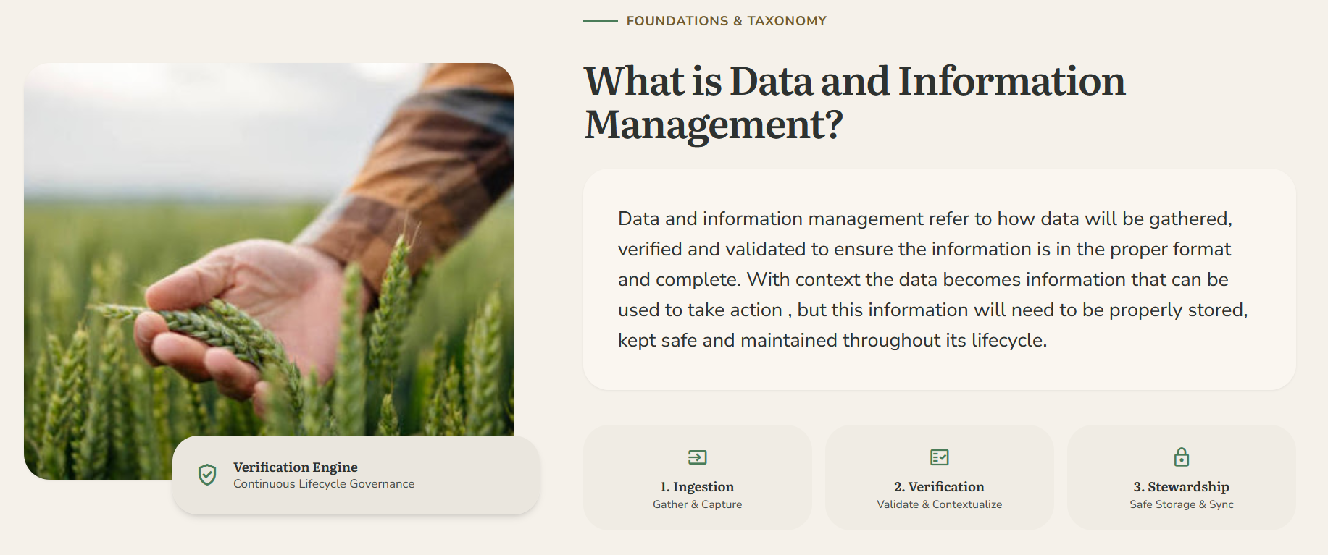
The farmers and employees must be guided to understand what data and information management is before we try to sell them a system that improves their data and information management to improve data quality as well as to make it clear how the as-is system is flawed .
The content also describes how the data will move between the farmers phones , surveys etc , to the database and how the data will be validated and converted into usable dashboards that will act as the decision support system .

Information Quality
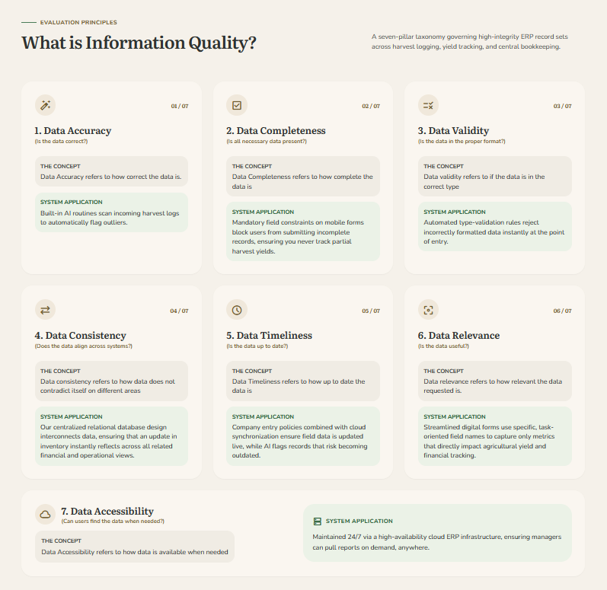
This section contains the different elements of data quality as well as documentation of how each of these qualities are met with the gathering of data as well as the display of data.

Data ethics, Privacy and POPIA compliance

Information the system tracks and protects
An Information System must always first identify the data that needs to be protected. By adding this section, we prove to our clients that we know exactly what sensitive data processes through the new cloud ERP platform, which needs to be protected. This will help to build trust between the clients and us. 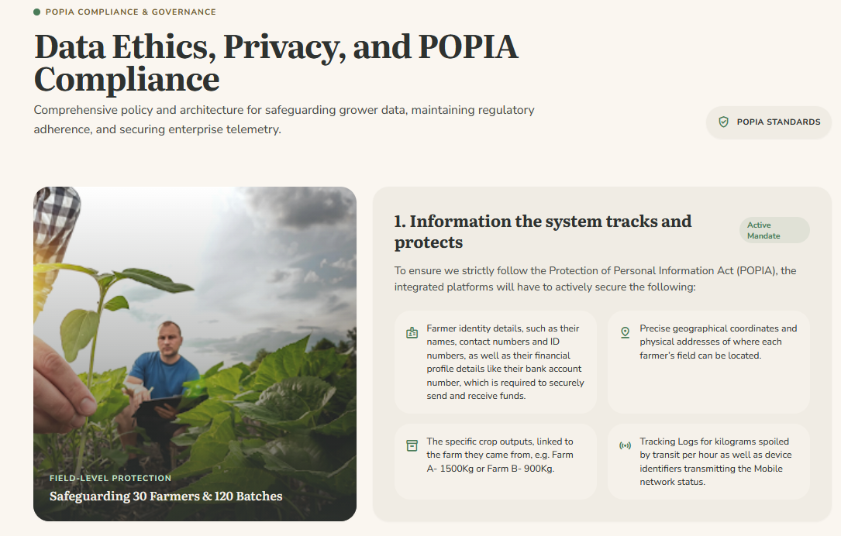

What our system must do
This is the most important part, as this part shows how our system fixes the old problems. We split this section into Data Ethics, Privacy and the POPIA compliance to address all the possible fears a farmer could have with our system. It explains real solutions, like locking data when workers hit poor network status zones. 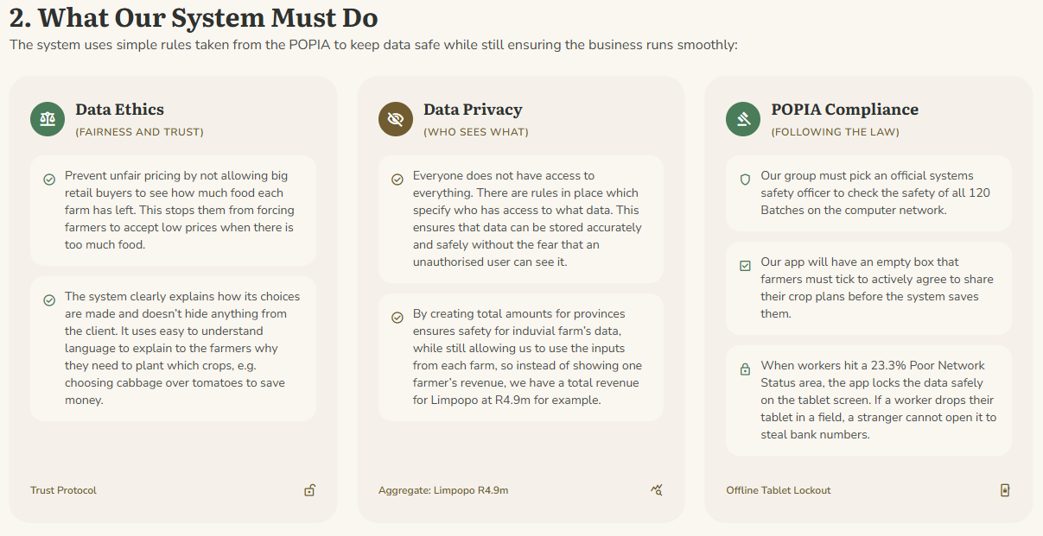

How data flows: Old vs New
It is a lot easier to understand why our program has added certain changes when you can see a direct contrast between how it was and how it is now. We added this section to show to the client exactly how our new system is different from the old, dangerous spreadsheet sharing system.
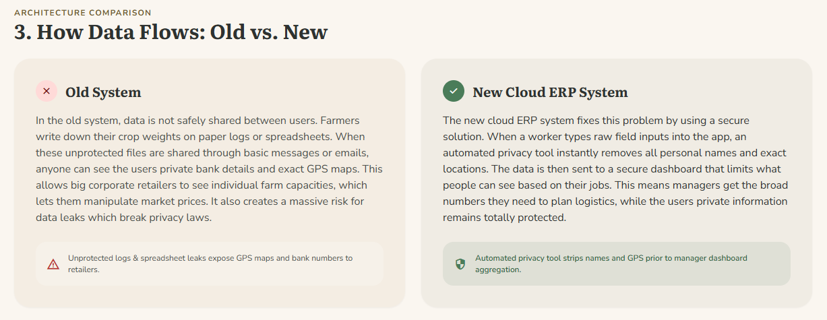

Business and Legal value
We included this section to demonstrate to the client that following the law prevents fines from the government, helps to win big retail contracts, and it tries to build as much trust as possible for the farmer in hopes that they will input honest crop inputs. 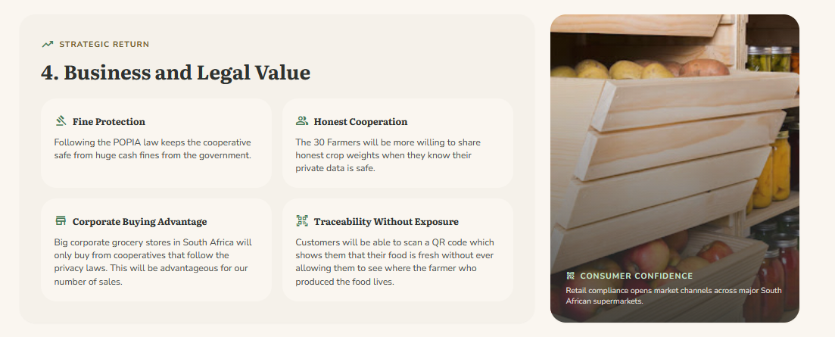

Limitations
A good consultant is always honest about the problems that their technology cannot solve. We included this section to show that our system is realistic and to build that trust with the client. This section is also in place to tell companies that staff training will be necessary to avoid human mistakes.
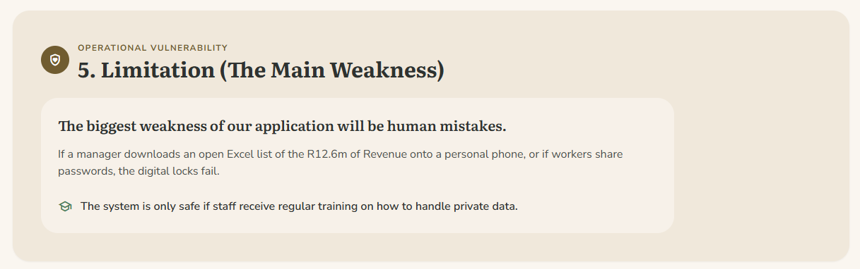

AI and DSS

The Current Problem
I introduced the main challenge faced by the farming cooperative, agri-processing company and retailers. Before discussing AI or Decision Support Systems, users need to understand why these technologies are necessary.
The content explains that poor information flow between farmers, processors and retailers affects decisions about planting, logistics and pricing. It also establishes that AI cannot create useful recommendations without reliable and shared data. 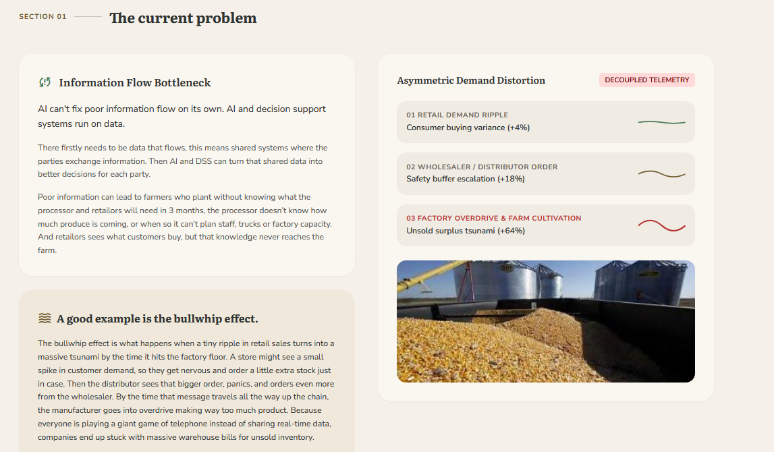

What is a Decision Support System?
I included this because the target audience may have limited technical knowledge. It is important to explain the concept of a Decision Support System before showing how it can be applied within agriculture.
I explained that a DSS collects and analyses data to assist people with decision-making rather than automatically making every decision. This helps users understand the difference between automated decision-making and technology that supports human judgement. 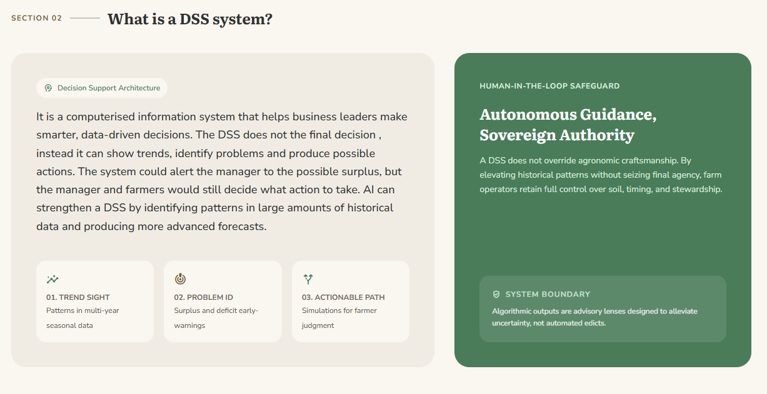

Planting Decisions
Planting is one of the three main decision-making problems identified in the scenario we chose. So there is a dedicated section showing how information systems, analytics and AI can assist farmers.
I explained how information such as historical sales, retailer demand, weather information, previous crop yields and seasonal patterns can be analysed to support planting decisions. This was included to demonstrate how predictive analytics can help farmers decide what to plant, how much to plant and when to plant. This section also shows how better planning may reduce shortages, overproduction and food waste.
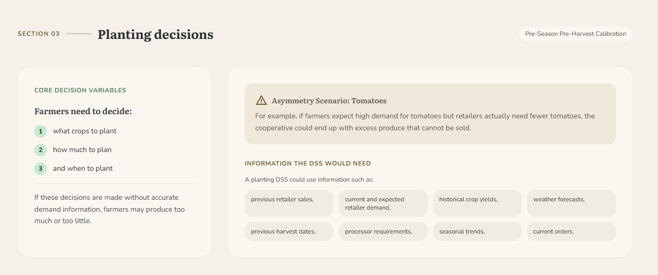

Logistics Decisions
Logistics was selected as a separate heading because the movement of produce between farms, the processing facility and retailers is a major part of the agricultural supply chain. It is also one of the key business problems mentioned in the scenario.
I explained how expected harvest quantities, vehicle availability, farm locations, processing capacity and delivery requirements can be used by a DSS to support transport and scheduling decisions. Route optimisation and collection scheduling were included because they demonstrate practical ways in which decision-support technology could reduce transport costs, delays and spoilage. 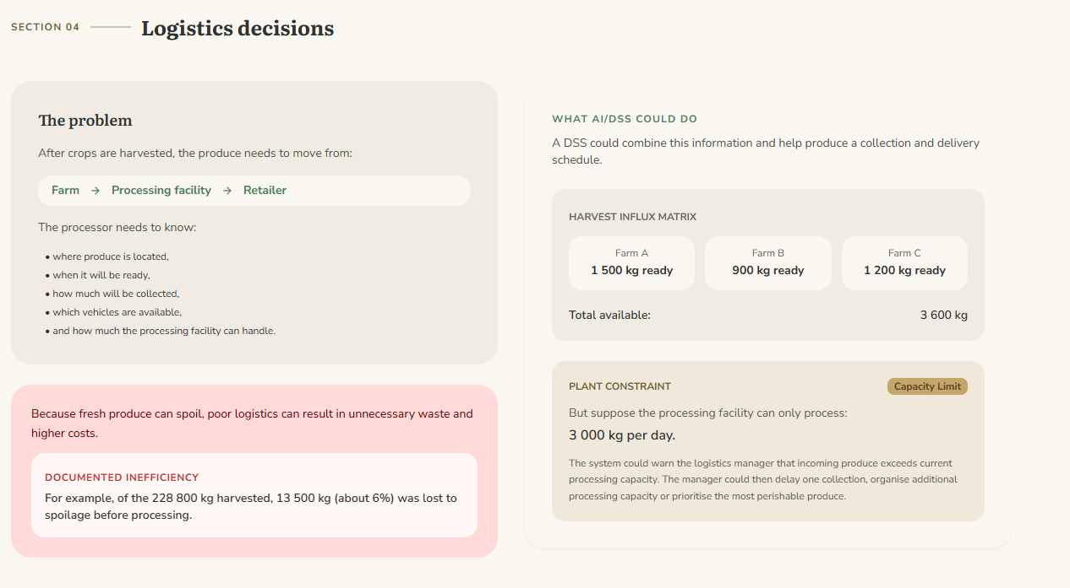

Pricing Decisions
Pricing is the third major decision-making challenge identified in the scenario. Here I explained how information systems can support more informed and transparent pricing decisions.
This includes market prices, demand, supply, production costs, transport costs and seasonal trends because these factors influence agricultural pricing. Price forecasting and market information were included to demonstrate how a DSS can provide useful information to farmers and managers without automatically determining the final selling price.
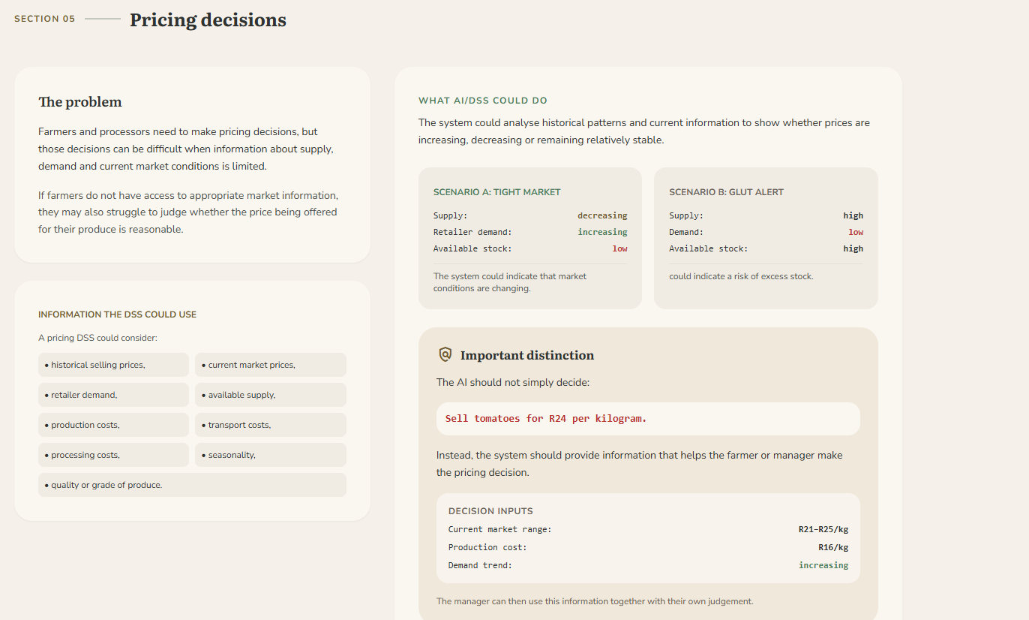
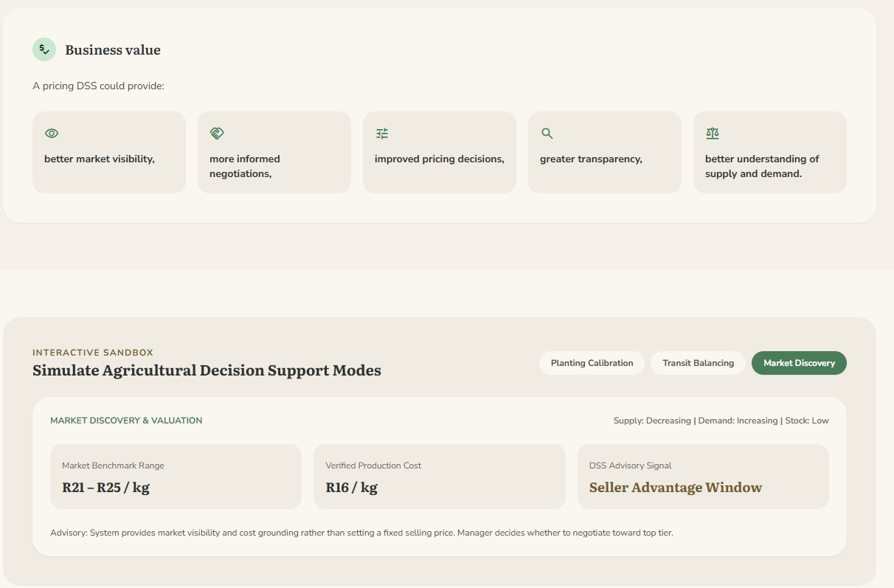

Farmer Dashboard
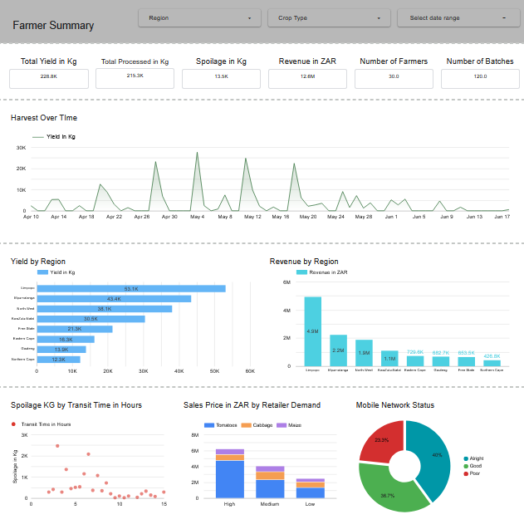
A fully functioning dashboard built to show the client precisely how a decision support system can help visualise a lot of data.

Enterprise Systems & Supply Chain Integration

The Core Problem
In this section, I discuss information silos and their effect on the supply chain. As well as introducing the SCM system and its goals. I believe this section is important because it provides context on the current problem which is needed to continue with the rest of the explanation.
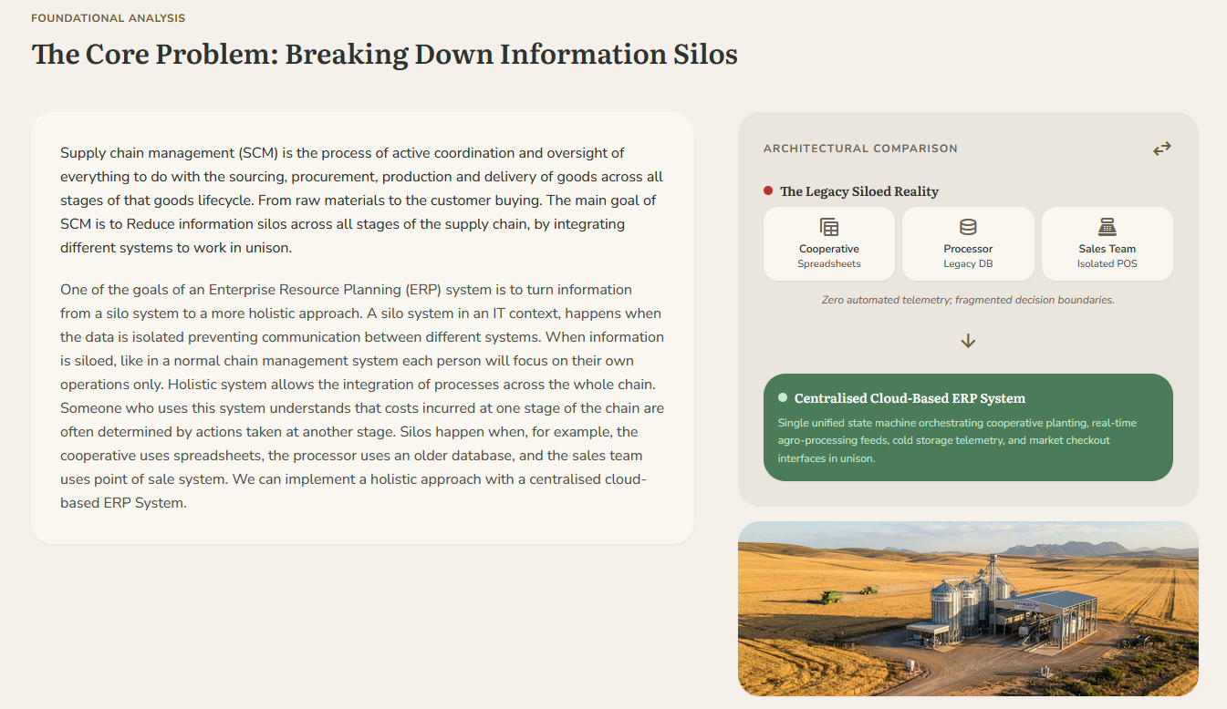

Digitizing The Supply Chain Operations
This short paragraph provides an introduction to the core features of the SCM system.

Planning & Data-Driven Demand Forecasting
Here, I explain the planning core of SCM. I all the topics that planning covers and I justify why it is important to have proper planning. I also go over how we can use our ERP system to predict needs and demand to make informed decisions. This section is important because it explains how we can use our ERP system to work together with SCM.
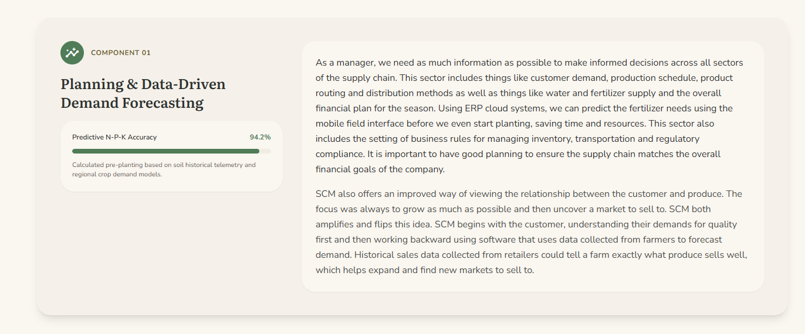Sourcing & Automated Procurement
This section goes over the importance of managing the source of your product, the raw materials and labour required to make the product. I go over the importance of having reliable suppliers. I also explain how we use ERP to automate some processes as well as managing suppliers using the app. Sourcing is an important section of the supply chain
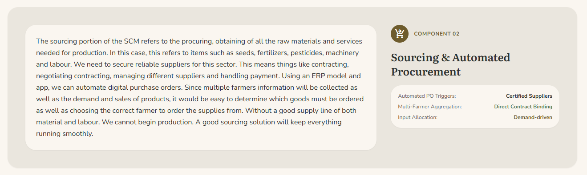

Production Tracking & Edge Data Capture
The production section goes over the process of production of our product. It also explains how we need managed supply networks. I go over how the farmer will use the ERP app to log their production to the cloud.
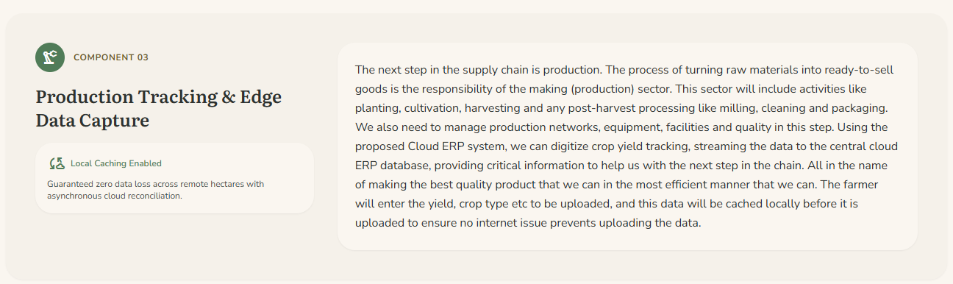

Logistics, IoT Sensors, and Value Optimisation
This section includes important information regarding the logistical importance of the SCM. As well as the system process as a whole. We also go over the uses of the ERP to track logistical operations across the whole network as well as manage fragile storage like a cold storage system. I explain how we can use SCM to view the supply chain as a whole rather than as separate, isolated entities. Which allows us to make better, informed decisions that effect the system as a whole. I then give a modern day example in South Africa of how SCM can help farmers save post-processing loss.
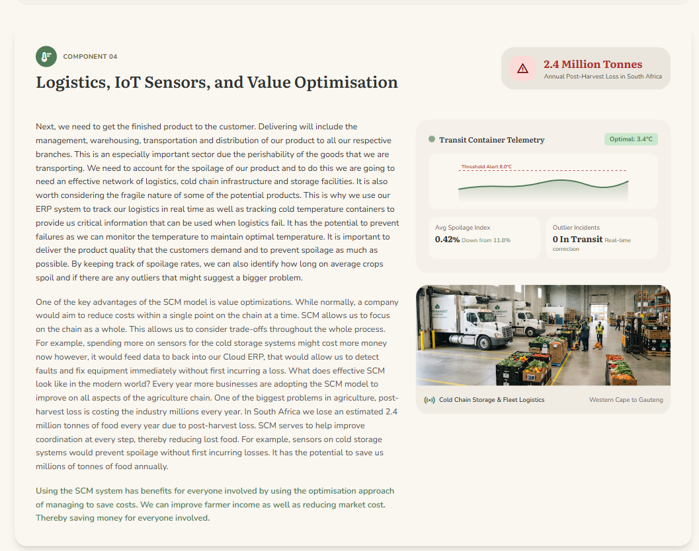

Reverse Logistics & Digital Quality Control
Next, i focus on the returning logistics of goods, why it is important to have a return network in place and how this affects the ERP database. I also touch on some cost saving methods in this sector.
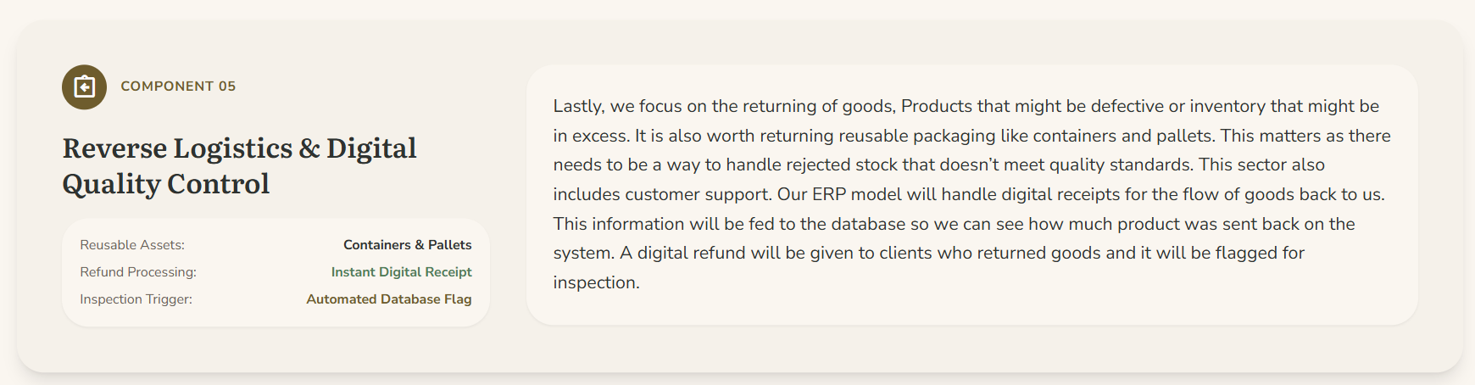

End To End Digital Traceability
It is important in the current world for the customers to know that the product is kept to a certain standard of production. In this section i explain how we can do this using the ERP system as well as why it is important.
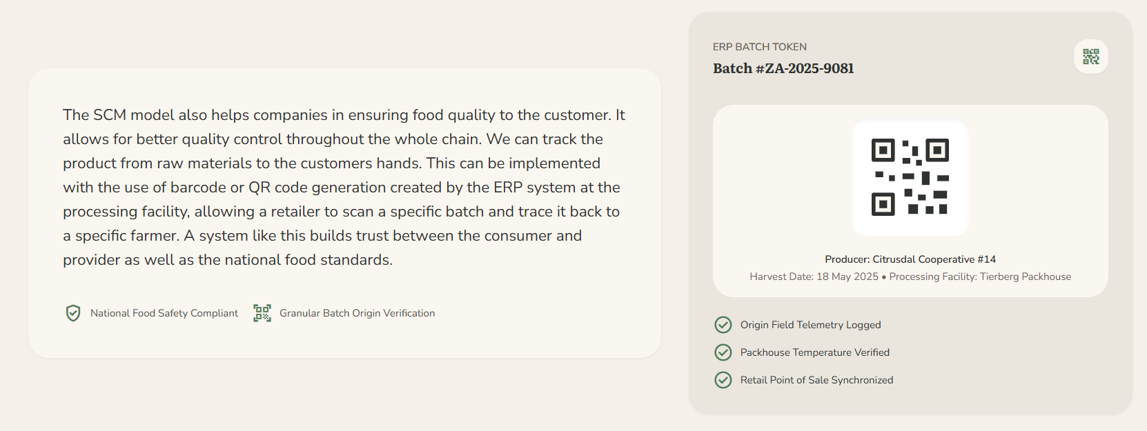

Technical Deployment & IS Integration Challenges
Here, i explain some of the disadvantages of the ERP system integration. It is important that any potential investors understand the risks involved.
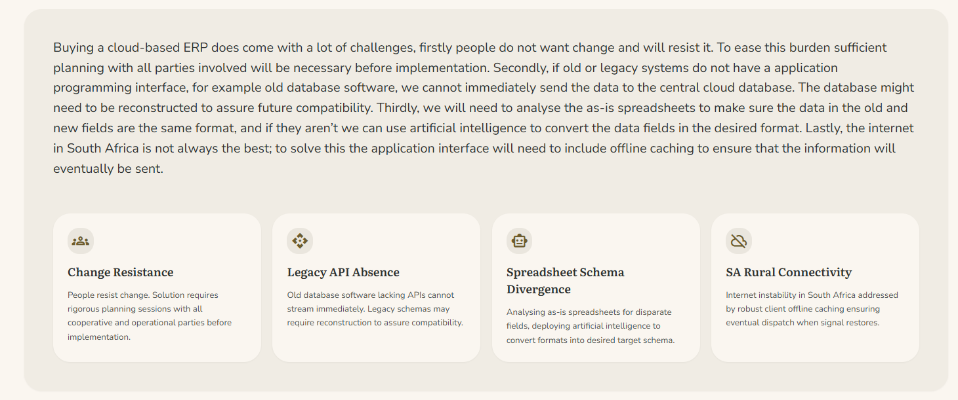

Adaptability

System Adaption
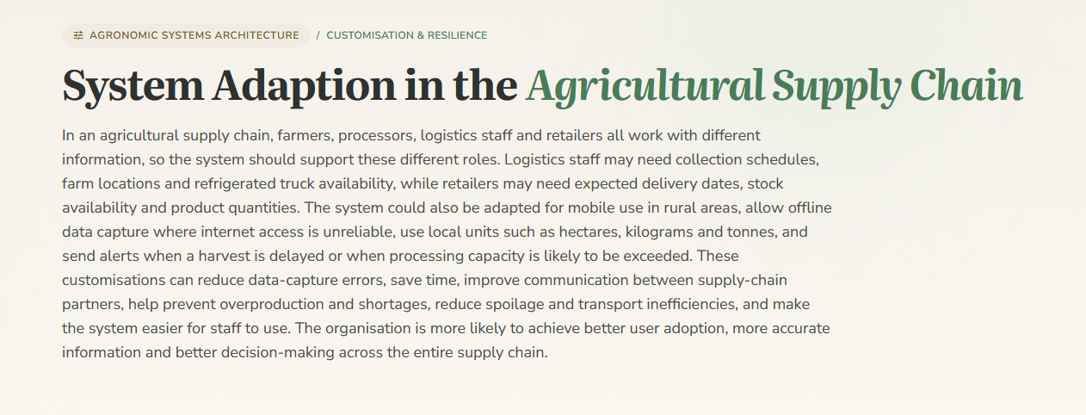
This section shows how an information system can be adapted to the specific needs of farmers, processors, logistics staff and retailers. Agricultural examples such as harvest tracking, processing capacity, collection planning and offline mobile access were used to make the concept practical. The section also explains how customisation can reduce errors, improve communication, save time and support better decision-making.

Data Privacy Customisation
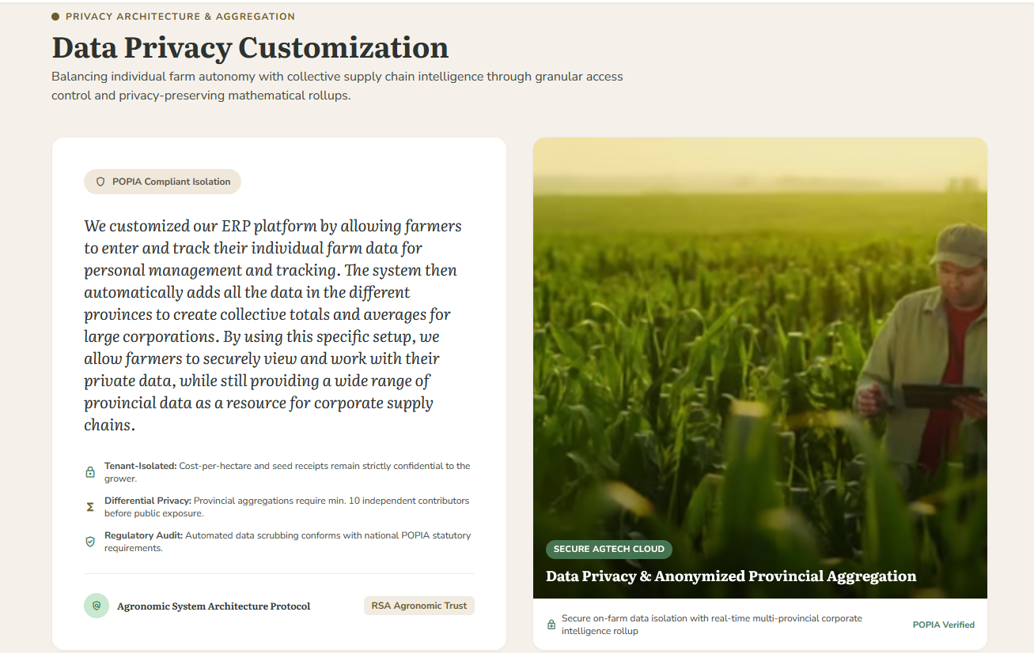
We included this section in our project to explain how our ERP is customised to solve the very problems that our farmers struggle with. This purpose of this section is also to persuade farmers to use our ERP over the old method of data storage because of the privacy we offer compared to what they used to have.

Internet Adaptability in South Africa
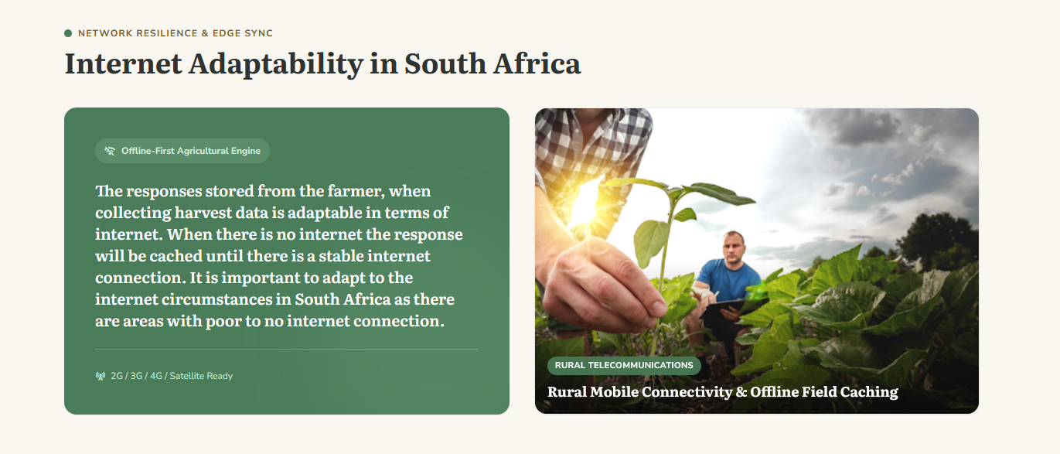
Since the proposed system will use offline caching, it is adaptable to the internet circumstances in South Africa. This prevents internet connectivity of being a major limitation, and it expands the user base to people with unstable internet connection.

ERP adaptability Across Farming Sectors
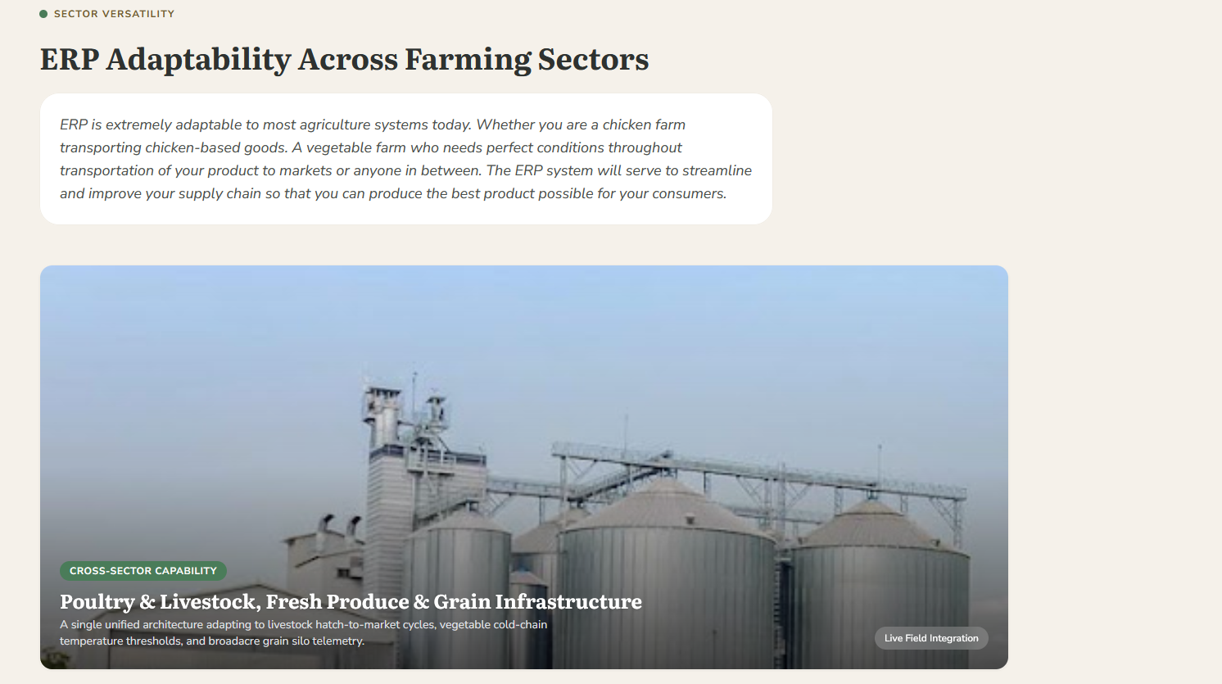
The purpose of this section is to explain the adaptably potential of the SCM and ERP system as well as provide a conclusion on the SCM section of this paper.

Workload Distribution

Alexander Kruger
Website and dashboard creation

Jacinta De Sousa
Data Ethics, Privacy and POPIA Compliance

Nathan Taylor
Enterprise Systems & supply Chain Integration

Herman Eduan Badenhorst
AI and DSS

Link to Website
Agriculture-IS-Resource-website

AI Disclaimer

Usage of Stich Ai
We used Stich ai to create the visual design and code for the website based of the content we made ourselves. All written content on the website is made by us.

Usage of Claude
We used Claude to create dummy data for google sheets, after manually entering validation rules on google sheets, as well as the headings .

Usage of ChatGPT
We used ChatGPT to review Claude generated dataset in addition to manual review .

