1.When to use (Rapid Application Development) RAD model & When not to use (Rapid Application Development) RAD model

Rapid Application Development can be used when
- there is a need to create a system that can be modularized in 2-3 months of time
- there’s high availability of designers
- the requirements are well known
- user are involved throughout the life cycle
- budget is high enough
- only if resources with high business knowledge are available
- System can be modularised
- Quality is not an issue
- technical risks are less

Rapid Application Development should not be used when
- no highly skilled developers/designers are available
- budget is low
- High quality software is required
- There is a lot of time to develop a efficient software
- High dependencies on modelling skill

3. Describe the Entity Relationships for the following diagram

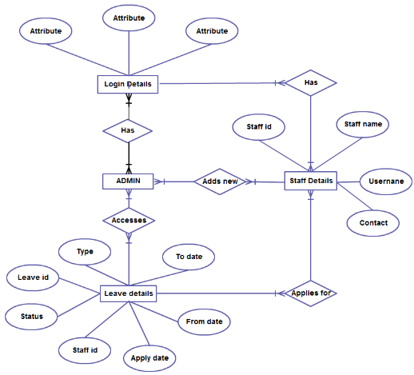

Entities include:-
- Login Details
- Admin
- Staff Details
- Leave Details
Entity relationship:-
- One or more Admin has their own login details .
- One or more Admin can access leave details
- One or more Admin can add new Staff and their details
- One or more Staff have their own login details
- One or more staff can apply for leave

Each staff has
- Staff id
- Staff name
- Username
- Contact
- Login details

Leave details consists of
- Type
- leave id
- Status
- From date
- To date
- Staff id
- Apply date
Each login details consists of
- login id
- password

2.Define an ER diagram of a software Organization with all the relationship model that was discussed in the classroom

