Improved discovery and quantification of post-translational modifications in single-cell proteomics
Alexander J. Solivais¹, Madeleine Hastings¹, Lloyd M. Smith¹
¹Department of Chemistry, University of Wisconsin-Madison

Keywords: ALS, amyotrophic lateral sclerosis, single-cell proteomics, post-translational modifications, motor neuron, PIP-ECHO, limpa, label-free quantification
Abstract
Single-cell proteomics (SCP) enables the analysis of thousands of proteins in single mammalian cells. In contrast to single-cell RNAseq, SCP can detect and quantify peptides bearing post-translational modifications (PTMs). However, quantitative SCP studies including such PTMs are uncommon. We present here a pipeline for the discovery and quantification of multiple PTMs in SCP. Using the search engine MetaMorpheus and FlashLFQ + PIP-ECHO for quantification, we were able to detect a myriad of post-translationally modified peptides in a previously published SCP dataset of motor neurons from patients with amyotrophic lateral sclerosis (ALS) and healthy controls. We identified over 17,000 modified peptides, a 55% increase in the total number of peptides identified. We were able to quantify over 5500 of these post-translationally modified peptides and found that over 200 of these peptides were differentially modified in ALS motor neurons compared to controls. These differentially modified peptides were associated with biological processes known to be dysregulated in ALS such as cytoskeletal regulation, myelin structure, and protein degradation. Importantly, we found that including modified peptides in the analysis substantially changes the set of proteins that are found to be differentially abundant. This pipeline enables a more complete and accurate quantitative analysis of single-cell proteomics data.

Introduction
Single-cell proteomics using liquid chromatography mass spectrometry (LCMS) is an emerging technology that has been enabled by advances in instrumentation, methodology, and data analysis [40091206]. Interrogating biology at the level of the single cell has advanced our understanding of developmental biology, rare cell types, and disease pathology. Mass spectrometry-based single-cell proteomics (SCP) offers two major advantages over single-cell RNA sequencing technologies: Direct interrogation of protein abundance, which displays a variable relationship to transcript abundance [cite Slavov SILAC paper], and the ability to detect protein processing events such as proteolytic cleavage or post-translational modifications (PTMs).
Previous work has demonstrated that PTMs can be reliably detected by SCP [39030393, 36433961]. However, quantitative analysis of PTMs is rarely done in SCP. Many commonly used informatics approaches are not amenable to PTM discovery and so ignore the vast majority of the 400 different PTMs that are known to regulate protein function. Additionally, the quantification of PTMs is much more difficult than the quantification of proteins. In bottom-up proteomics, proteins are enzymatically digested into peptides prior to analysis. Multiple unique peptides are required to confidently identify a protein, and the intensities of these different peptides are combined to determine protein abundance. In contrast, most post-translational modifications are identified based on a single peptide. Therefore, quantitative analysis of PTMs requires precise and accurate peptide-level quantification.
Our recently developed tool for label-free quantification of proteomics data, FlashLFQ + PIP-ECHO, demonstrated outstanding precision when performing peptide-level quantification, outperforming other state-of-the-art tools by a wide margin. Armed with this new capability to accurately quantify individual peptides, we show here that it is possible to identify PTMs in SCP that are correlated with disease pathology. In addition, we show that considering modified peptides when performing protein quantification substantially changes which proteins are found to be differentially abundant.
To evaluate this, we analyzed a previously published single-cell proteomics dataset for motor-neurons obtained from post-mortem spinal cord of ALS patients and healthy controls. ALS is a progressive neurodegenerative disease marked by selective loss of motor neurons (MNs): nerve cells in the brain and spinal cord that control voluntary muscle movement and respiration. Specific, motor-neuron-targeted biomarkers could be valuable for early diagnosis and therapeutic evaluation in ALS. Previous research has identified ALS-induced changes in cellular function that are correlated with post-translational modifications such as acetylation, phosphorylation, glycation, and citrullination. [39712644, 36076282] Elucidating the pathophysiology of ALS, including PTM-based dysregulation, is essential for biomarker discovery and disease mechanism understanding [38183652].
We used MetaMorpheus, a database search engine optimized for the detection of PTMs, and FlashLFQ + PIP-ECHO, to detect and quantify modified (and unmodified) peptides in the ALS dataset[cite gptmd]. FlashLFQ + PIP-ECHO’s high precision in peptide-level quantification is enabled by controlling the false-discovery rate of peptide-identity-propagation (PIP)[cite pip-echo]. PIP, also known as Match-Between-Runs, identifies and quantifies peptides that were not selected for MS2 fragmentation in some samples, thereby reducing the number of missing values in the quantitative data. PIP is frequently used in bulk proteomics experiments and commonly accounts for as many as 40% of all reported quantitative values. PIP is even more important in SCP, where the limited sample amounts make missing values much more common. The PIP-ECHO algorithm – where ECHO stands for Error Control through Hybrid cOmpetion – assigns a confidence level to each PIP identification and filters out all those that do not reach a pre-specified confidence threshold in order to control the number of erroneous PIP identifications. This filtering strategy increases quantitative precision, but because low-confidence PIP identifications are removed, the number of missing values is greater than if a more liberal PIP algorithm was employed.
Limpa is a recently published tool for differential abundance analysis (DAA) in proteomics experiments[cite]. Limpa adapts the popular tool limma, which is used for differential expression analysis of RNA-Seq data, to proteomics data. Limpa employs a novel strategy to deal with missing values in proteomics data. It determines the relationship between peptide detectability – which affects how frequently the peptide is observed – and peptide intensity. This relationship is used to impute missing peptide intensity values, and those imputed values, along with their associated uncertainties, are leveraged to calculate relative protein abundance and perform differential expression analysis (DEA).
We reasoned that combining FlashLFQ + PIP-ECHO’s quantitative results with limpa’s improved DAA would yield new insights when analyzing single cell proteomics data, a paradigm where missing values are especially common. To fully leverage the promise of single-cell proteomics, it is necessary to develop tools for working with imperfect information about PTMs. From the noisy data of SCP, what conclusions can be drawn, and how confident can we be in those conclusions? We show here that applying our analysis workflow to SCP data reveals a myriad of previously overlooked PTMs – including acetylation, phosphorylation and citrullination – that change between ALS and healthy control motor neurons. Including these modified peptides also impacts protein level quantification, substantially altering which proteins are found to be differentially abundant.

Methods
Data
Two datasets were downloaded from ProteomeXchange, accession number PXD042799. As described in Guisse et al.,(REF # here) the pilot study dataset consisted of 36 motor neurons taken from 6 patients (3 healthy controls, 3 ALS patients) and six samples that were generated by pooling approximately 10 motor neurons from across all patients. [Guise et al.] The TDP-Stratified dataset consisted of 100 motor neurons obtained from 5 patients (2 healthy controls, 3 ALS patients). Samples were obtained from a cohort of frozen thoracolumbar spinal cord tissue samples from the University of Miami Brain Bank. Spinal cord tissues were divided into 3mm sub blocks, embedded in carboxymethylcellulose solutions, and then 12um sections were collected onto histology slides, fixed in 70% ethanol, and desiccated at -80°C. A portion of these sections were stained and scanned to identify motor neurons based on cell morphology and the presence of Nissl substance. After neurons were identified, sections of the same cell from adjacent sections were captured via laser capture microdissection. In effect, each sample was composed of two 12um slices of an individual motor neuron. Samples for the TDP-Stratified dataset were prepared in much the same way, with the differences that the staining used anti TDP-43 antibodies to determine the amount of TDP-43 present in each cell, and that each sample was captured by laser capture microdissection of one 20um section.
After laser capture microdissection, samples were processed using the NanoPOTS workflow (REF), which includes reduction with DTT, alkylation with iodoacetamide, and a two-step digestion using LysC followed by trypsin. Samples were analyzed on a Thermo Orbitrap Exploris 480. MS1 scans were acquired at 375-1800 m/z with a resolution of 120,000. Data-dependent MS/MS spectrum acquisitions were triggered for precursor ions with intensities > 5e3 and charge states ranging from 2-7. MS/MS isolation windows were 1.6 Da with a mass tolerance of +- 10 ppm. Additional details can be found in the original publication.
Database Search
Raw MS data were analyzed using an .xml protein database consisting of reviewed human proteins (20,353 reviewed protein sequences, UniProtKB, downloaded: July 20, 2025) and their annotated post-translational modifications and the default MetaMorpheus contaminant database. MetaMorpheus v1.1.0 was used to calibrate and average the data. Then, potential post-translational modifications were identified using the Global Post Translational Modification Discovery Tool (GPTMD) [ref]. All modifications considered in the initial publication (n-terminal acetylation, methionine loss, and pyroglutamate) were considered, in addition to common biological modifications (including phosphorylation, citrullination, methylation, and acetylation of lysine), common artifactual modifications (formylation, various oxidations), and modifications specific to tryptic digestion (ubiquitination and sumoylation). A full list of the modifications considered can be found in supplemental table STX. Finally, search was performed with the following parameters: Two missed cleavages were allowed; Precursor and fragment mass tolerances were set on a file-by-file basis as determined by the calibration step.
Quantification and Peptide Identity Propagation
The results from the MetaMorpheus search were used as input for quantification by FlashLFQ v2.1.4. A strict FDR cutoff of 1% was used for both PSM and peptide level results. Peptide-identity-propagation was enabled, with a PIP FDR cutoff of 0.05. The “Use PEP Q Values” and “Normalize Intensities” options were enabled. The maximum MBR window was set to 1 minute.
Statistical Analysis
Statistical analysis was conducted in R v4.5.0 using limpa v.1.0.5 and limma v3.64.3. The peptide-level quantification results from FlashLFQ were read in, and contaminant (non-human) peptides were removed. Samples where fewer than 1500 (pilot study dataset) or 2500 (TDP-stratified dataset) peptides were detected were excluded from the analysis. Peptides that were observed in fewer than one sample (pilot study dataset) or fewer than three samples (TDP-stratified dataset) were excluded from analysis. A dropout curve, modelling the relationship between log2-transformed peptide intensity and the frequency with which each peptide was observed, was fit using limpa. Then, protein level abundances were computed using the limpa dpcQuant function, which uses the dropout curve to calculate protein abundances. After protein quantification was performed, peptide level imputation was performed using the dpcImpute function.
Protein level differential abundance analysis was performed using the limpa dpcDE function to fit linear models and determine precision weights. For the TDP-43 stratified dataset, proteins with only one quantified peptide were excluded from the analysis. A linear model, as described by Ritchie et al. [25605792], was fit to account for the dependence structure among samples taken from the same donor (using the “block” argument to dpcDE) and protein expression was normalized for each sample (“sample.weights” was set to True). For the analysis of the TDP-43 stratified dataset, donor sex and post-mortem interval were controlled for in the linear model. Age was not considered as a confounding variable, as all control patients were younger than the ALS patients (CTRL mean age = 48 years. ALS mean age = 75 years), making it impossible to differentiate differences arising from disease state versus those arising from age differences.
Peptidoform level analysis was performed by first calculating the peptidoform fraction for each peptide. A peptidoform fraction is the ratio of a peptide’s intensity to its parent protein abundance (as calculated by limpa), times a constant scaling factor. This effectively normalizes peptide intensities relative to the intensity of their parent protein. Peptidoform fractions were calculated by subtracting the log2 intensity of the parent protein from the log2 intensity of the peptide, then adding a constant scaling factor (the median log2 intensity of the parent protein across all samples). This is shown in Equation 1 below.
 | $${Pf}_{p,s}= I_{p,s}- I_{P,s}+\tilde{I_{P}}$$ | Equation 1

Here, ${Pf}_{p,s}$ represents a peptidoform fraction – the abundance of peptide p in sample s relative to all other peptides derived from the same parent protein. $I_{p,s}$ represents the log2 intensity of peptide p in sample s, and $I_{P,s}$ represents the log2 abundance of the peptide’s parent protein, P, in sample s. As these calculations are performed on log-transformed values, the $I_{p,s}- I_{P,s}$term represent the ratio between peptide and protein intensity. The term $\tilde{I_{P}}$ represent the median intensity of protein P across all samples and is a constant scaling factor, as addition of log transformed values is equivalent to multiplication of non-log-transformed values. If the parent protein for a given peptide had fewer than 4 quantified peptides in total, it was excluded from this analysis. Differential fraction analysis was conducted the same as for the protein level analysis, with the exception that normalization was disabled in the dpcDE function (“sample.weights” was set to False).

Results and Discussion
Identification of Post-Translationally Modified Peptides
We searched 100 data files from the study by Guise et al. [REF] Each file corresponds to a single spinal-cord motor neuron; a total of 75 cells were taken from three different ALS patients, and a total of 25 cells were taken from two control patients. First, we searched the data against the UniProt Human FASTA database considering a small number of variable modifications. On the protein N-terminus, we considered acetylation, cyclization of glutamine or glutamate to form pyroglutamate, and loss of methionine. We also considered deamidation of any glutamine or asparagine residue and oxidation of any methionine residue. These are all commonly included in standard proteomic analyses and were considered in the original publication’s analysis. Our initial search identified 805,154 PSMs, 31,069 peptides and 3,243 proteins at a 1% false-discovery rate (FDR).
A second search, where a diverse set of post-translational modifications were considered, identified substantially more peptides and proteins. In this search, we used the UniProt Human XML database which is annotated with PTMs that have previously been reported in the literature. We also used GPTMD to discover 36 types of PTMs that were present in the data: common biological modifications such as phosphorylation, and artifactual modifications such as ammonia loss or adducted metals. This search identified 1,137,831 PSMs, 48,581 peptides and 3,353 proteins at a 1% FDR. The inclusion of additional PTMs increased the number of PSMs by 41% and the number of peptide identifications by 55% as shown in Figures 1A and B.
Among these ~18,000 newly identified peptides, a large proportion (40%) can be attributed to one artifactual modification: off target carbamidomethylation. Off target carbamidomethylation occurs when iodoacetamide, an alkylating agent used in standard proteomics workflows, alkylates the n-terminus of a peptide or protein, or an amino acid other than cysteine. After samples are denatured and reduced to break disulfide bonds, iodoacetamide is used to cap the free thiols on cysteine residues and prevent disulfide bridges from reforming. In this work, and generally within the field, carbamidomethylation of cysteine is not considered a PTM and peptides with carbamidomethylation of cysteine are not considered to be modified. It has been shown in the literature that iodoacetamide can react with lysine, histidine, or the n-terminus of peptides or proteins [cite, cite, cite]. We found that off-target alkylation occurred frequently in this dataset. While this modification is an artifact of the sample processing workflow, it can have a sizeable impact on data analysis. When the degree of over-alkylation differs between samples, it can create differences in calculated peptide or protein abundances, even where none exist.
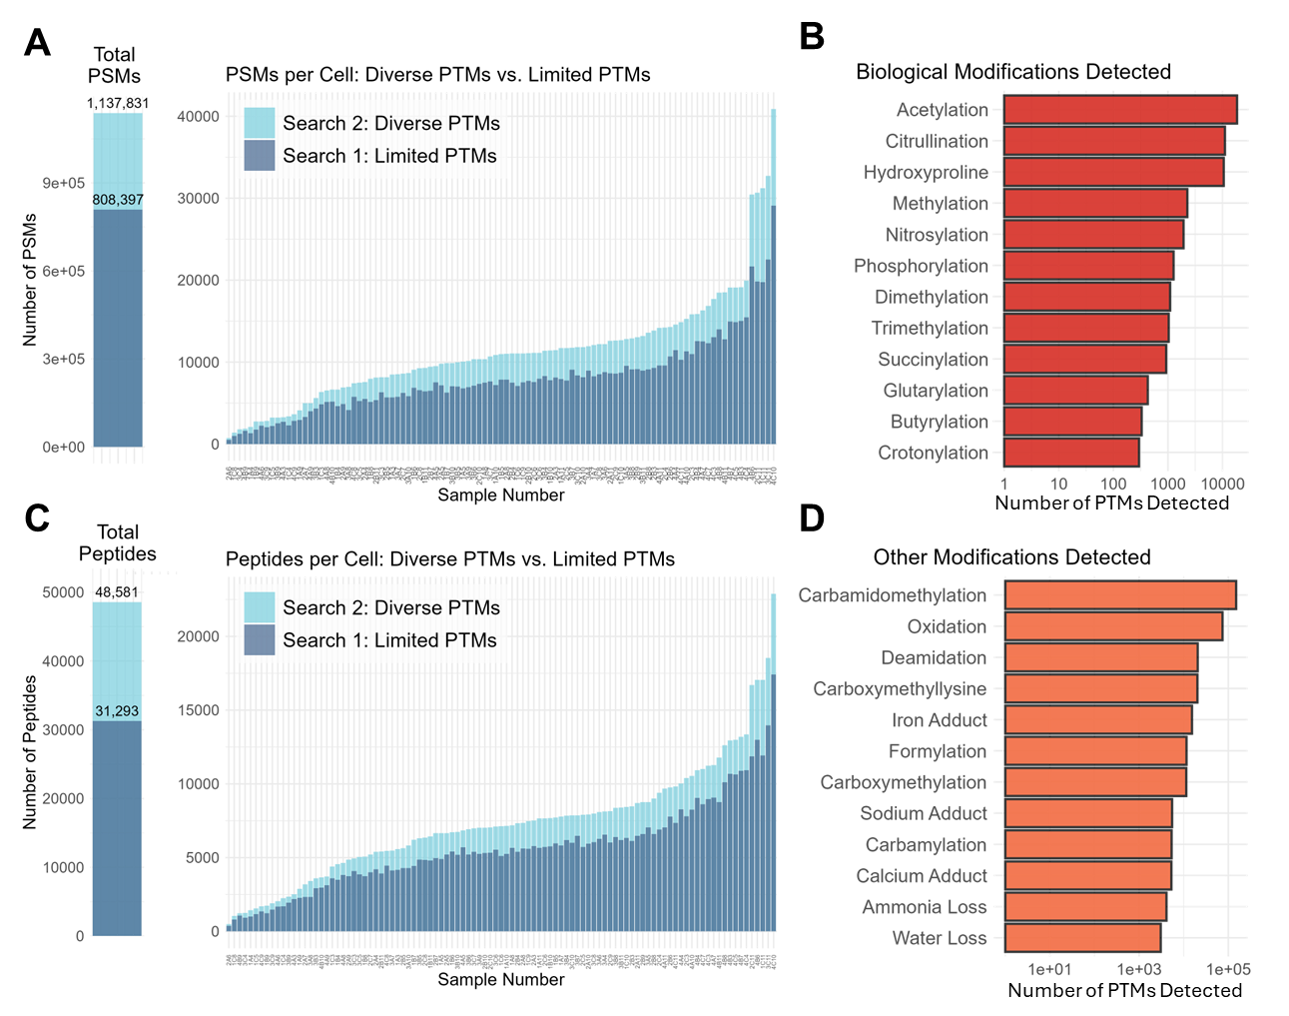
Figure 1: Frequency of Post-Translational Modifications in the ALS Motor Neuron Dataset A. Number of PSMs detected at 1% FDR in each cell, for the limited PTM search and the diverse PTM search. B. Frequency at which biologically relevant post-translational modifications that were detected in the dataset. Each bar represents the sum of spectra mapped to peptides containing each modification. C. Number of PSMs detected at 1% FDR in each cell, with and without the consideration of PTMs for the limited PTM search and the diverse PTM search. D. Frequency at which non-biological post-translational modifications were detected in the dataset.
The other 60% of the modified peptides bear a wide range of PTMs. Figures 1B and D show 24 of the most frequently observed modifications. These modifications fall into two broad categories: (1) biological modifications—those installed enzymatically, such as phosphorylation, acetylation, or citrullination (Figure 1B); and (2) non-biological modifications—those that may arise during sample handling, such as oxidation, deamidation, or metal adducts (Figure 1D). Many modifications, such as ubiquitination and carboxymethylation, may arise from either biological or artifactual mechanisms, and as such it is unclear how they should be classified. Ubiquitination, the covalent attachment of ubiquitin to lysine residues that marks proteins for proteasomal degradation, leaves a diagnostic diglycine remnant on the substrate peptide after tryptic digestion. However, this mass shift is isobaric with dialkylation, the artifactual double carbamidomethylation of lysine by iodoacetamide, complicating confident identification [18511913]. Due to the frequency of off target carbamidomethylation in these samples, we have labeled all mass shifts of 114.04 Da on lysine residues as “dialkylation*”, not ubiquitination, and treat it as a non-biological modification.
Quantification and Peptidoform-Fraction Analysis
We performed a differential abundance analysis to identify peptides and PTMs that significantly differ between ALS and control motor neurons (MNs). Only peptides that were quantified in at least 25% of all runs were considered for peptide-level analysis, which left us with 17,273 (38%) of all peptides. In the original publication, the cells from ALS patients were classified based on their expression of TDP-43 (transactive response DNA-binding protein 43), a protein that has been implicated in ALS pathogenesis. [REF] We chose to disregard these classifications and focus solely on the difference between ALS and control MNs. Our reason for this decision is discussed in detail in Supplementary Note X.
We used limpa for both differential abundance analysis and data imputation. Limpa determines the relationship between peptide "missingness"—how consistently it is quantified across samples—and peptide intensity. This relationship is used to impute intensity measurements in samples where the peptide was not quantified. The uncertainty associated with imputed values is stored and used for differential abundance analysis, meaning that an imputed value is not given the same weight as a directly measured value. We stress that this imputation differs from PIP: quantitative values from PIP are based upon the intensity of the peptide in the MS1 signal, whereas imputed values are not.
To identify PTMs and modified peptides that are correlated with disease condition, we calculated a “peptidoform fraction” for each peptide, which represents the abundance of each peptidoform relative to the abundance of the parent protein. The peptidoform fraction is the log intensity of a peptide minus the log intensity of its parent protein, plus a constant scaling factor (the median log intensity of the parent protein across all samples; Equation 1). Expressing peptide abundances as peptidoform fractions isolates changes specific to individual peptidoforms rather than those reflecting protein-level differences.
When the peptidoform fraction for a peptide is significantly different between conditions, this indicates that changes have occurred in the corresponding proteoform family (REFS). Differentially abundant proteoforms could be proteins with different PTMs or different isoforms of the same protein. In this dataset, the majority of peptides with significantly different peptidoform fractions are modified in some way. For this reason, and for the sake of brevity, we will refer to peptides with significantly different peptidoform fractions as differentially modified peptides. We performed a differential analysis of peptidoform fractions using limpa to identify peptides that were differentially modified between ALS and control MNs. This analysis revealed over 500 differentially modified peptides (Figure 2A). Out of the ~17,000 peptides analyzed, approximately 4% bore biological modifications, 2% were carboxymethylated, 13% were carbamidomethylated (excluding carbamidomethylation of cysteine), 23% bore other artifactual modifications, and 68% were unmodified. Among peptides with significantly different peptidoform fractions, this distribution was shifted: 11% of all differentially abundant peptides bore biological modifications, 19% were carboxymethylated, 12% were carbamidomethylated, 29% bore other modifications, and 28% were unmodified (Figure 2B). Six proteins account for 30% of all differentially modified peptides: glial fibrillary acid protein (GFAP), Neurofilament Light, Medium, and Heavy Chain (NEFL, NEFM, and NEFH, respectively), and myelin basic protein (MBP). All of these are discussed in more detail below.
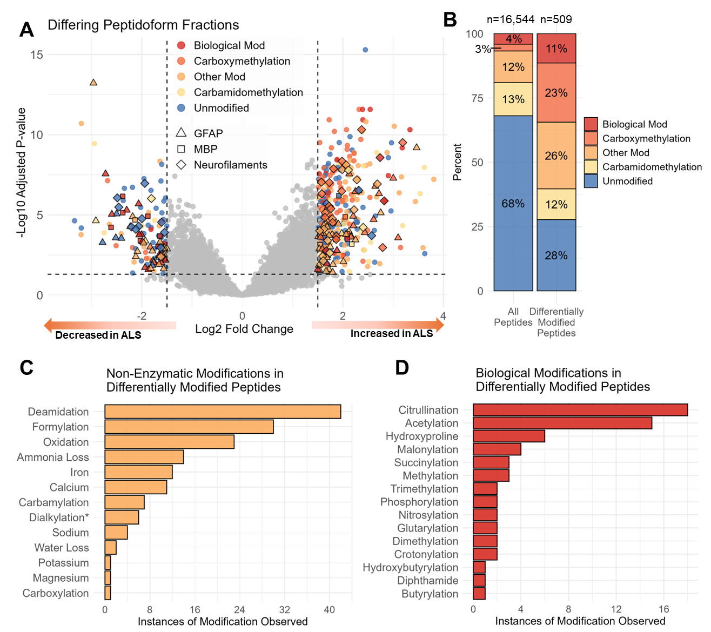
Figure 2: Peptidoform Fraction Analysis A. Volcano plot showing differentially modified peptides, where each point represents one peptide. Peptides with significantly different peptidoform fractions are colored according to how they are modified. Peptides derived from GFAP, MBP or NEFL, NEFM, or NEFH are shown with unique shapes. B. Bar chart showing the frequency of different modifications for all quantified peptides (left) or differentially modified peptides (right). C, D. Bar chart showing the frequency of non-biological modifications (C) and biological modifications (D) among differentially modified peptides.

Among the differentially modified peptides with biological modifications, we observed a diverse array of PTM types (Figure 2C, D). Citrullination and acetylation were the most common biological modifications, followed by hydroxylation of proline, acylation (e.g., malonylation), methylation, and phosphorylation. Among differentially modified peptides with non-biological modifications, formylation, deamidation, and iron adducts were observed most frequently. Protein deamidation has previously been implicated in the progression of ALS, and the accumulation of iron in neurons is common in many neurodegenerative diseases, including ALS. Whether the enrichment of these modifications reflects true biological differences or variation in sample handling cannot be determined from this analysis alone.
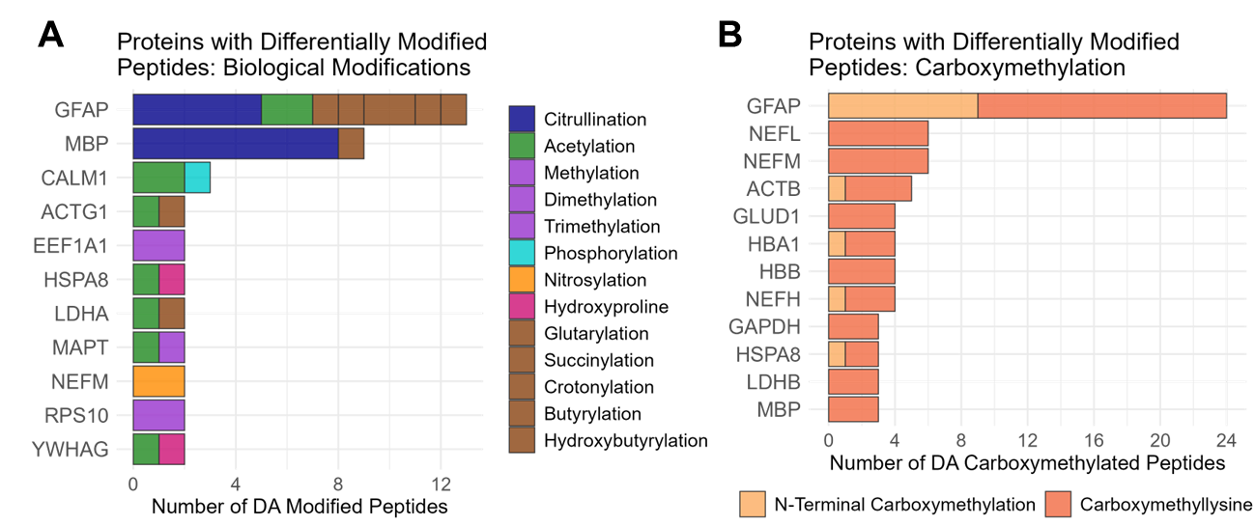
Figure 3: Proteins bearing differentially abundant modifications Bar charts showing proteins that have the most differentially modified peptides. A. Biological modifications, denoted by color. B. Carboxymethylation, highlight n-terminal carboxymethylation (likely artifactual) or carboxymethylation of lysine, and advanced glycation end product.
In total, our analysis identified 59 differentially modified peptides bearing biological modifications across a diverse range of proteins and PTM types (Figure 3A). These included phosphorylated and nitrosylated neurofilament peptides (NEFH, NEFM), acetylated tau (MAPT) and actin (ACTB, ACTG1), trimethylated eEF1A1, hydroxyproline-modified collagen peptides (COL1A1, COL1A2), and multiple differentially modified GFAP and MBP peptidoforms. Notably, many of these proteins — including neurofilaments, actin, and GFAP — were also decorated with carboxymethyllysine (CML), an advanced glycation end product (AGE) whose accumulation is associated with oxidative stress and disease progression in ALS and other neurodegenerative diseases (Figure 3B)[PMID]. The prevalence of CML across multiple structurally and functionally distinct proteins suggests a broad, systemic elevation of glycoxidative damage in ALS motor neurons. A detailed discussion of carboxymethylation, including evidence that the CML residues detected originated in vivo rather than during sample processing, is provided in Supplemental Note X.

While the majority of peptides with significantly different peptidoform fractions are modified, a subset of unmodified peptides also showed significant changes. In most cases, these peptides had opposing modified counterparts: peptides from the same protein, covering the same region of the protein sequence, that were modified and had an opposite fold change. One example of this can be found in glial fibrillary acid protein. In the region of GFAP shared between all major isoforms, we identified multiple unmodified peptides with significantly reduced peptidoform fractions in ALS. Two of these unmodified peptides spanned the same region of the protein, and both began at position 155. These are explained by the opposing peptide QKLQDETNLR, which spans the region 153 to 162 and has a carboxymethyllysine at 154 (shown in bold). This peptide is significantly more modified in ALS motor neurons, and the difference in peptidoform fraction is one of the most dramatic changes observed in the analysis, with a log fold-change of 3.5 and an adjusted P-value of 6.5×10⁻¹⁰. Carboxymethylation of lysine prevents tryptic cleavage, which means that this peptide is mutually exclusive with the unmodified peptides that begin at position 155, immediately after the carboxymethyllysine. This example shows how even among unmodified peptides, differentially abundant peptidoform fractions reflect underlying differences in PTM.
However, peptides with differing peptidoform fractions can also indicate that different protein isoforms are differentially abundant. GFAP has three major splice isoforms —GFAPα, GFAPε, and GFAPκ — that share an identical sequence from residues 1–390 but diverge at the C-terminal tail (residues 391–432). Six peptides mapping to the GFAPα-specific tail had peptidoform fractions that were significantly decreased in the ALS condition, including one unmodified peptide. An additional unmodified peptide showed the same trend, but with a fold change less than our cut-off (logFC = -1.1, adj. p-value= 0.014). This indicates a selective decrease in GFAPα in ALS motor neurons and a concomitant increase in GFAPε. To confirm this, we performed an analysis where we replaced GFAPα with GFAPε in the protein database. We identified two peptides specific to GFAPε and three peptides that are shared between GFAPε and another protein, vimentin. All 5 peptides had peptidoform fractions that were significantly increased in the ALS condition. GFAPε disrupts intermediate filament networks [25975510] and is associated with malignant glioblastomas [27141937]. While altered GFAP isoform ratios have never been reported in ALS before, the evidence for altered isoform ratios in this dataset is strong and merits further investigation.
In myelin basic protein, we identified six peptides spanning five unique sites that were all significantly less citrullinated in ALS motor neurons. For several of these, we observed two peptidoforms originating from the same position within the protein. In one example, the peptide YLATASTMDHARHGFLPR (148-165, logFC = -1.6) is citrullinated at R159, shown in bold, and the other peptide, YLATASTMDHAR (148-159, logFC = 1.1), is not citrullinated. The peptidoform fraction for the citrullinated peptide is significantly higher in control MNs (adj. p-value= 0.0002), and the peptidoform fraction for the unmodified peptide is higher in ALS MNs (adj. p-value = 0.07), although it does not reach the same level of statistical significance. From this, we can conclude that MBP proteoforms that are citrullinated at R159 are more abundant in control MNs.
This result further highlights a key advantage of single-cell studies. The six MBP peptides were significantly less citrullinated in ALS MNs—opposite to the upregulation of MBP citrullination reported in reactive astrocytes in bulk ALS spinal cord (Bhargava et al., 2022; 2024). This cell-type-specific inversion, which has previously been observed in immunohistochemical studies [ref], would be entirely obscured in bulk tissue, illustrating that single-cell proteomics can recover modification-level biology that is invisible at the tissue level (Supplemental Figure XYZ).
In another example, we identified a peptide from the neurofilament heavy chain protein that was phosphorylated at S763. Because peptidoform fractions are calculated based on total protein abundance, we are able to identify differentially modified peptides when only one peptidoform is observed. It is not necessary to quantify both modified and unmodified forms of the same peptide to draw conclusions about relative PTM abundance. The peptidoform fraction for this peptide was significantly higher in the ALS condition. While no other quantified peptides contained that specific residue, it was still possible to calculate the ratio of the modified peptide to all other NEFH peptides and see that the ratio was significantly different in ALS MNs. This finding is consistent with existing research, as the phosphorylated form of the neurofilament heavy chain protein (pNEFH) has been proposed as a biomarker for ALS [35715961].
The direction of change for many of the modifications associated with differentially modified peptides was consistent with known ALS pathology. Phosphorylated NEFH is a biomarker of ALS-associated neurodegeneration [PMID], and the nitrosylation detected on NEFM reflects the elevated oxidative and nitrosative stress characteristic of ALS motor neurons [REF]. Acetylation of tau impairs its clearance via chaperone-mediated autophagy, consistent with the tau co-pathology observed across the ALS-FTD spectrum[REF]. Hydroxyproline-deficient collagen peptides are consistent with decades of reports of reduced collagen hydroxyproline in ALS tissue [REF]. Differential trimethylation of eEF1A1 is consistent with emerging evidence that translational elongation is dysregulated in ALS motor neurons [REF]. Taken together, the PTMs identified by our pipeline converge on pathways already implicated in ALS, providing biological validation of the pipeline output.
Protein-Level Analysis
We also performed protein-level differential abundance analysis to complement the peptide-level PTM findings described above. We required that at least two distinct peptides be observed for each protein to be considered for this analysis. After excluding proteins with only a single quantified peptide, 2,569 proteins remained. This is shown in Figure 4B. Of these, 597 proteins were significantly less abundant and 222 were significantly more abundant in ALS motor neurons compared to controls (adj. p-value< 0.05, |log2FC| > 1.5).
Notably, among the differentially abundant proteins, we identified 45 with known PTM-related enzymatic activity: 33 PTM writers (enzymes that install modifications) and 12 PTM erasers (enzymes that remove them). These include several kinases (PRKCA, FYN, CSNK2A1, MAP2K4), the citrullination enzyme PADI2, and the NAD-dependent deacetylase SIRT2, whose dysregulation may contribute to the acetylation changes observed on GFAP and tau. Additionally, 13 E3 ubiquitin ligases were differentially abundant, including HUWE1 and STUB1/CHIP, both of which play key roles in protein quality control pathways that are disrupted in ALS. The differential abundance of these PTM-modifying enzymes provides a potential mechanistic link between the protein-level changes and the peptide-level PTM alterations described above.
In this analysis, proteins were quantified based on the peptides identified in the diverse PTM search, where a wide variety of PTMs were considered. We performed an additional analysis where proteins were quantified based on the results of the limited-PTM search, where only a handful of PTMs were considered. The two analyses produced dramatically different results: 137 proteins are found to be DA only in the limited-PTM analysis, and 84 proteins are found to be DA only in the diverse-PTM analysis. Considering modifications substantially changes the set of proteins that are found to be differentially abundant. While similar numbers of proteins are found to be differentially abundant, the set of proteins differs by about 30%. Figures 5 C and D compare the results from the two analyses. Points highlighted in green represent proteins that are only DA when diverse PTMs are considered and points highlighted in red represent proteins that are DA when only limited PTMs are considered.
Figure 4: Differential Abundance Analysis of Protein – Diverse vs. Limited PTMs. A. Volcano plot showing the results of a protein-level differential abundance analysis based on the diverse PTM search. Some proteins that are known to install or remove PTMs are highlighted. B. Distribution showing how many peptides were detected from each protein. Most proteins were identified based on 3 peptides or less (dotted red line.) C. Volcano plot showing the difference between the protein-level differential analysis considering diverse vs limited PTMs. Green dots are proteins that are only found to be differentially abundant when PTMs are considered. Red dots are PTMs that are only found to be differentially abundant when PTMs are not considered. D. Plot showing the correlation between protein log2 fold changes when considering a limited vs. diverse set of PTMs.

Several notable proteins change in significance when diverse modifications are considered, but not when limited modifications are considered, or vice versa (Figure 4C, D). EEF1A1, the translation elongation factor that was found to be differentially trimethylated, is significantly less abundant in ALS only when diverse PTMs are considered. Conversely, NEFM is not differentially abundant when diverse modifications are considered, whereas it is significantly less abundant in the ALS condition in the limited-PTM analysis. This is likely because multiple NEFM peptides are significantly more nitrosylated in the ALS condition. When the nitrosylated peptides are not identified, it decreases the apparent abundance of ALS. When PTMs are not considered, modified peptides are ignored in the quantitative analysis, resulting in incorrect conclusions about overall protein abundance. By including PTMs in search and quantification, not only can we achieve greater quantitative accuracy, but we can also discover differences in specific modifications at specific sites, discoveries that advance understanding more than an additional upregulated protein in a list of a thousand upregulated proteins.

Conclusion
We have demonstrated that combining MetaMorpheus for PTM-aware search with FlashLFQ + PIP-ECHO for precise peptide-level quantification enables the discovery and quantification of post-translational modifications in single-cell proteomics data. Applying this pipeline to a dataset of ALS and control motor neurons, we identified over 200 differentially abundant modified peptides spanning a diverse array of PTM types. Among the most notable findings, we observed widespread carboxymethylation consistent with advanced glycation end products (AGEs) enriched in ALS motor neurons, citrullination changes on myelin basic protein and other substrates, differential phosphorylation and nitrosylation of neurofilament proteins, and acetylated tau peptides consistent with tau co-pathology in the ALS-FTD spectrum.
The single-cell resolution of this dataset proved essential for interpreting several of these findings. The observation that citrullinated MBP peptides are less abundant in ALS motor neurons—opposite to the pattern reported in reactive astrocytes—demonstrates that cell-type-specific PTM changes can be masked or inverted in bulk tissue analyses. Similarly, the detection of differentially abundant PTM-modifying enzymes such as PADI2 and SIRT2 among the protein-level results provides a potential mechanistic basis for the peptide-level PTM changes and illustrates the value of integrating protein- and peptide-level analyses. Notably, considering modified peptides in protein quantification altered the set of differentially abundant proteins by approximately 30%, highlighting that ignoring PTMs in single-cell proteomics can lead to incomplete or misleading conclusions about protein-level changes.
Several limitations of this work should be acknowledged. Some modifications—particularly ubiquitination and carboxymethylation—cannot always be definitively distinguished from sample-processing artifacts based on mass spectrometry data alone. Additionally, while our peptidoform fraction analysis successfully separated PTM-level changes from protein-level abundance differences, the analysis was limited to only the most abundant proteins; the requirement that parent proteins have at least four quantified peptides necessarily limits the analysis to more abundant proteins. Looking ahead, validation of the PTM changes identified here through orthogonal approaches such as targeted mass spectrometry or enrichment-based methods will be important.
The analytical framework presented here—combining PTM-aware database searching with precise peptide-level quantification—is broadly applicable to any single-cell proteomics study where post-translational regulation is of interest. The impact of PTMs on protein differential abundance analysis is particularly important. By examining proteins that change the most when PTMs are considered, we can identify altered pathways that are mediated by post-translational modification, even if we are unable to identify specific PTMs with statistical confidence. Including the analysis of PTMs can substantially increase the number of unique peptides detected in SCP while also greatly improving the quality of the biological conclusions that can be drawn from the data.

