Capstone – Crixus
Group 1:
Alexander Sturgeon, Kenneth Barclay, Gurkirat Singh
Xx, 00, 2026

Student 1 (Kenneth)
Project Topic:
Crixus is a fight organizer designed for medieval fight reenactments. This will allow for users to create a custom profile for their fighter(s), add/edit/delete fighters up to a max of 4. You can buy armor and weapons in the armory, with in app currency that can be equipped to your fighters. You can earn that in game currency by sending your fighters to the arena to have them duel in single combat or team combat. The arena combat has a winners bonus which will be determined based on the salary(s) of the fighter(s) you are putting in the arena.

Technology:
- Database: MySQL
We chose MySQL for a variety of reasons. A primary motivation was the built in ERD creation tools and how easily they can be turned into SQL queries. In addition to this, PostgreSQL, the database we were originally looking to implement, was a technology that we had already looked at in detail. For this project, we really wanted to utilize a new database solution. MySQL is also known for its speed and simplicity. This will allow us to implement features efficiently, while allowing for future expansion should new features be designed.
- Frontend: ReactJS
- Backend: Express TS + Typescript

Table 1-
Name: Users
Purpose: Tracks basic user data, including in-game wallet and login details.
Fields: user_id, first_name, last_name, password, email, birth_date, wallet_gold, username, Team_team_id
Data Types: INT, VARCHAR, DATE, DOUBLE
Relationships: One to Many with Fighter, as a single user has multiple fighters. One to One with Team as each User has one team.
Table 2-
Name: Fighter
Purpose: Logs fighter details, including current weapon and armour ids, general skills, and cost.
Fields: fighter_id, first_name, last_name, appearance, strength, dexterity, constitution, intelligence, salary, Weapons_weapon_id, Armour_armour_id, User_users_id, Team_team_id
Data Types: INT, VARCHAR, DOUBLE
Relationships: Many to One with weapons, as multiple fighters can have the same weapon type. Many to One with armour, as multiple fighters can have the same armour type. One to Many with Fighter_has_Battle conjunction table, as a fighter can have many battles.Many to One with Team as each fighter only has one team.

Table 3-
Name: Weapon
Purpose: Stores weapon details, including their cost, damage and other stats.
Fields: weapon_id, name, appearance, damage, type, price, rarity
Data Types: INT, VARCHAR, DOUBLE
Relationships: One to Many with Fighter, as many fighters can have the same weapon type.

Table 4-
Name: Armour
Purpose: Stores armour details, including damage protection, cost, and other stats.
Fields: armour_id, name, appearance, damage_protection, type, price, rarity
Data Types: INT, VARCHAR, DOUBLE
Relationships:

Table 5-
Name: Battle
Purpose: Logs individual battle details for user analysis and statistics.
Fields: battle_id, battle_date
Data Types: INT, DATE
Relationships: One to Many relationship with Fighter_has_Battle, as a battle can have many fighters. One to Many Relationship with Team_has_Battle, as a battle has two teams.

Table 6-
Name: Fighters_has_Battle
Purpose: Conjunction table linking the Fighter table to the Battle table, resolving the Many to Many relationship between them. Tracks result for duels and provides information about which fighters were part of which team battles. (Without this table there would be no way of knowing which fighters fought in a battle, only that the team itself did).
Fields: Fighter_fighter_id, Battle_battle_id, result.
Data Types: INT, BINARY
Relationships: Many to One relationship with Fighter and Battle.

Table 7-
Name: Team
Purpose: Organizes fighters as a team for team battles.
Fields: team_id, team_label
Data Types: INT, VARCHAR
Relationships: One to One with User as each team only has one user. One to many with conjunction table Team_has_Battle as each team can be in multiple battles. One to Many relationship with Fighter as one team has many fighters.

Table 8-
Name: Team_has_Battle
Purpose: Conjunction table that logs team battles, their results, and winnings.
Fields: Team_team_id, Battle_battle_id, result, winnings_gold
Data Types: INT, BINARY, DOUBLE
Relationships: Many to One relationship with both Team and Battle
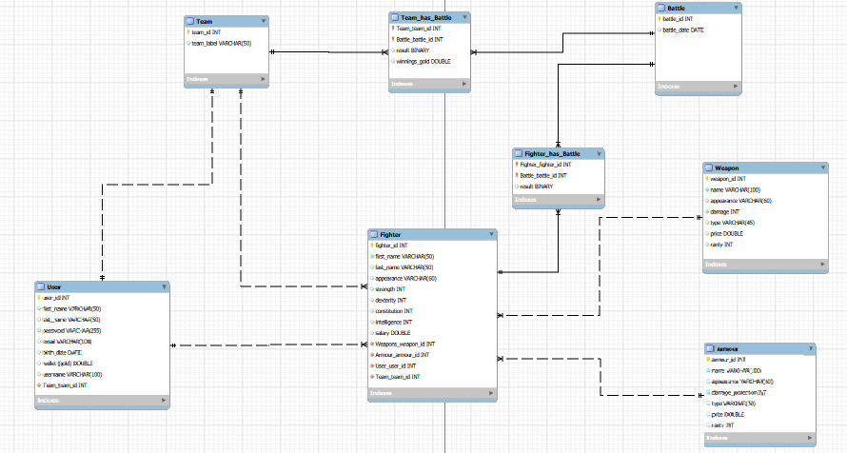

Student 2 (Gurkirat)

Student 3 (Alexander)

Wire Frames
Home Page
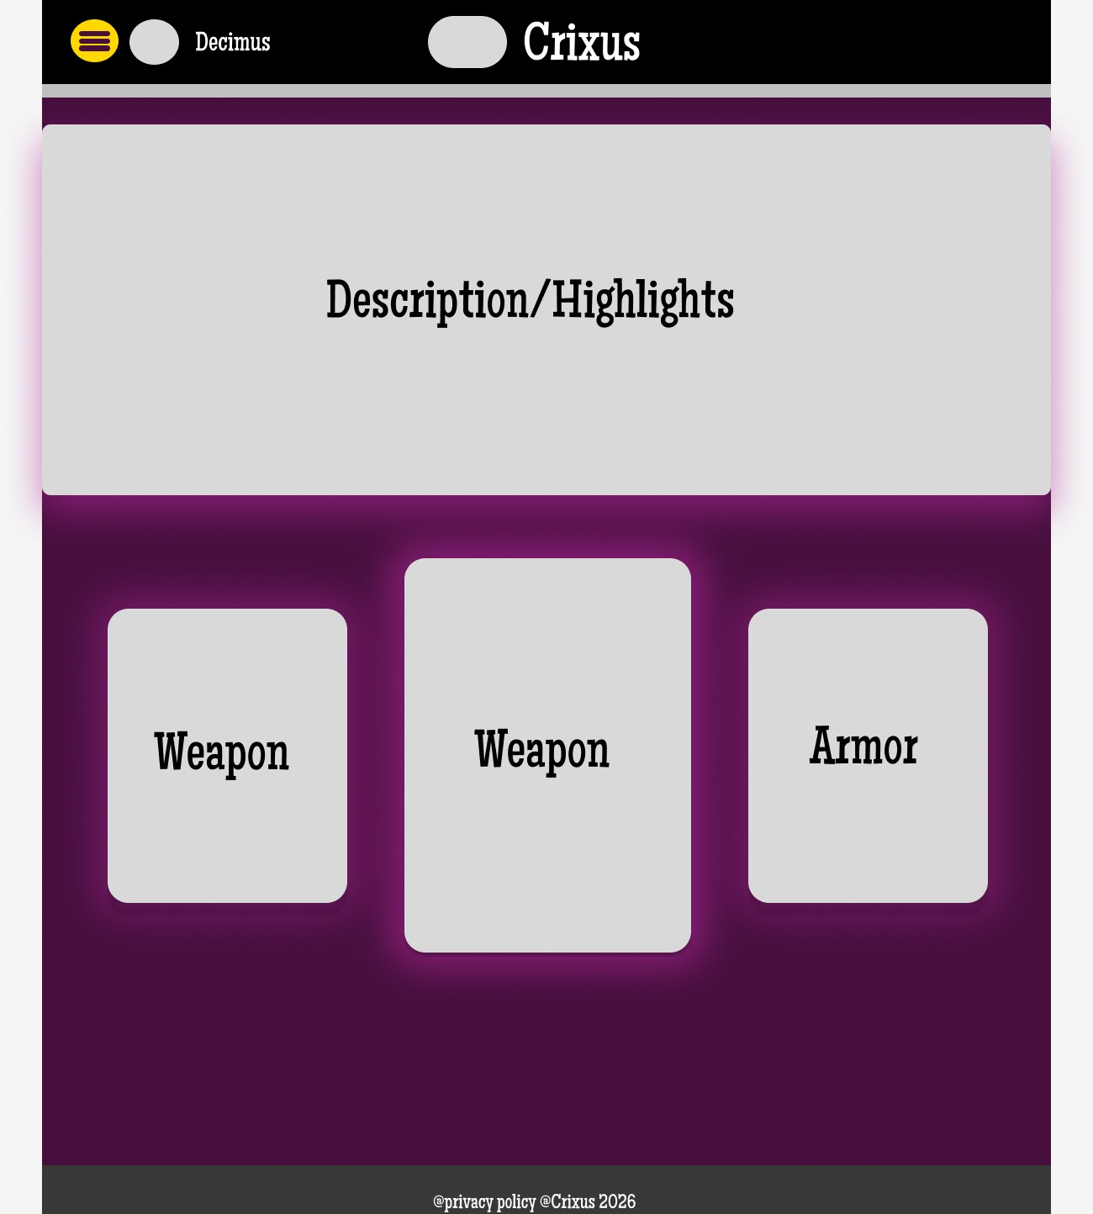
Home Page w/ Drop Down
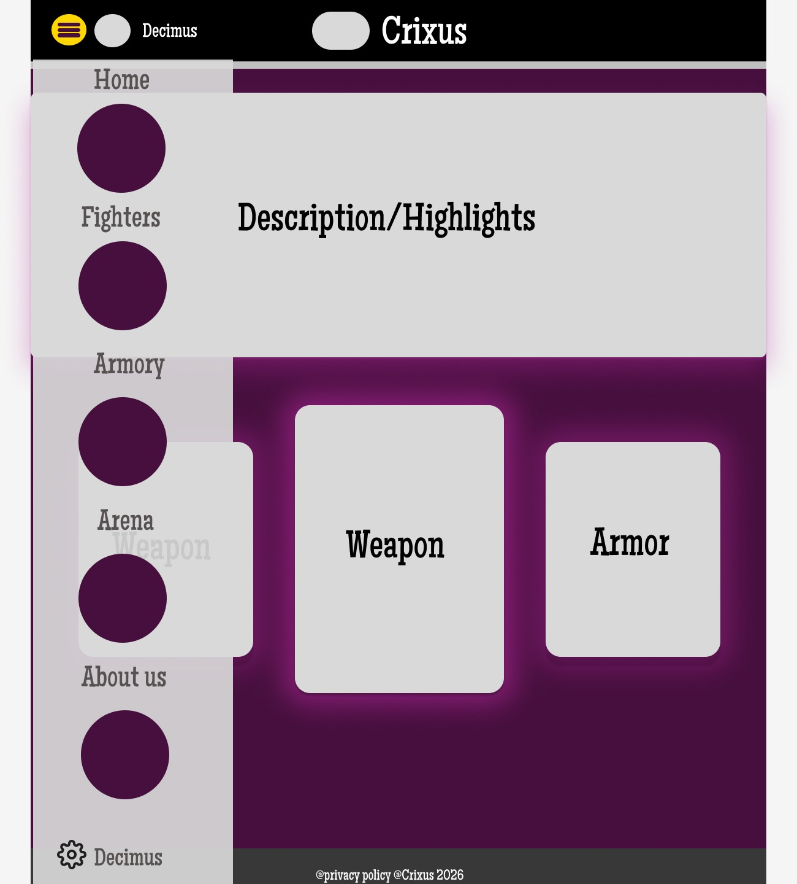

View Fighters(Data Listing Page)
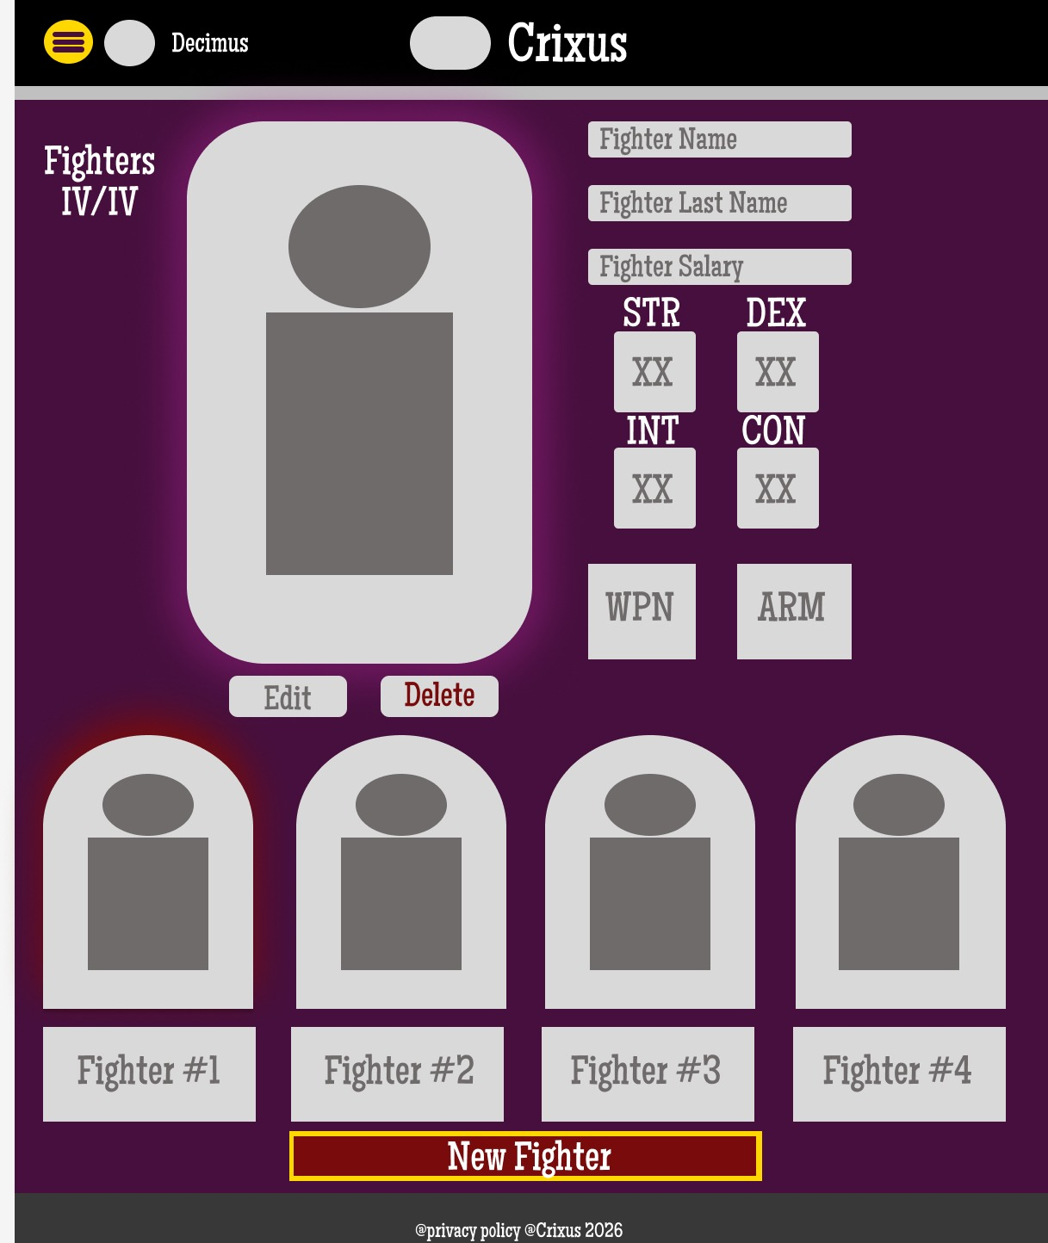

Add Fighters(Data Entry Page)
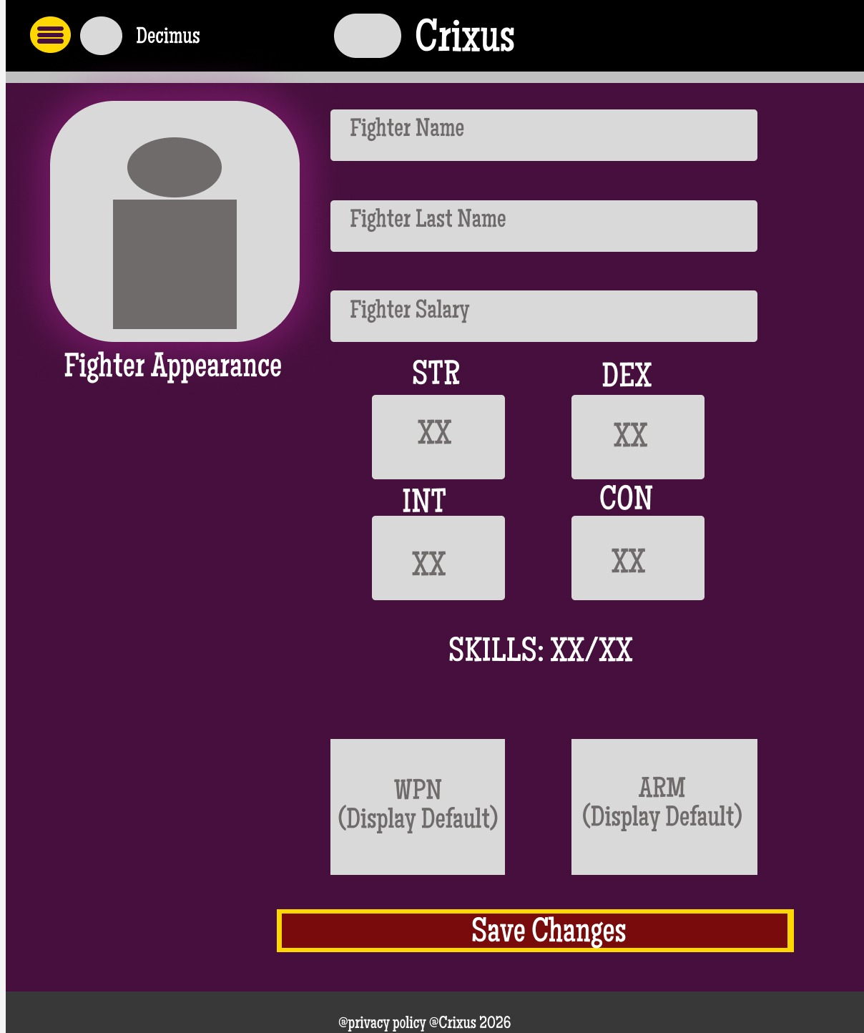

Edit Fighters(Edit/Update Page)
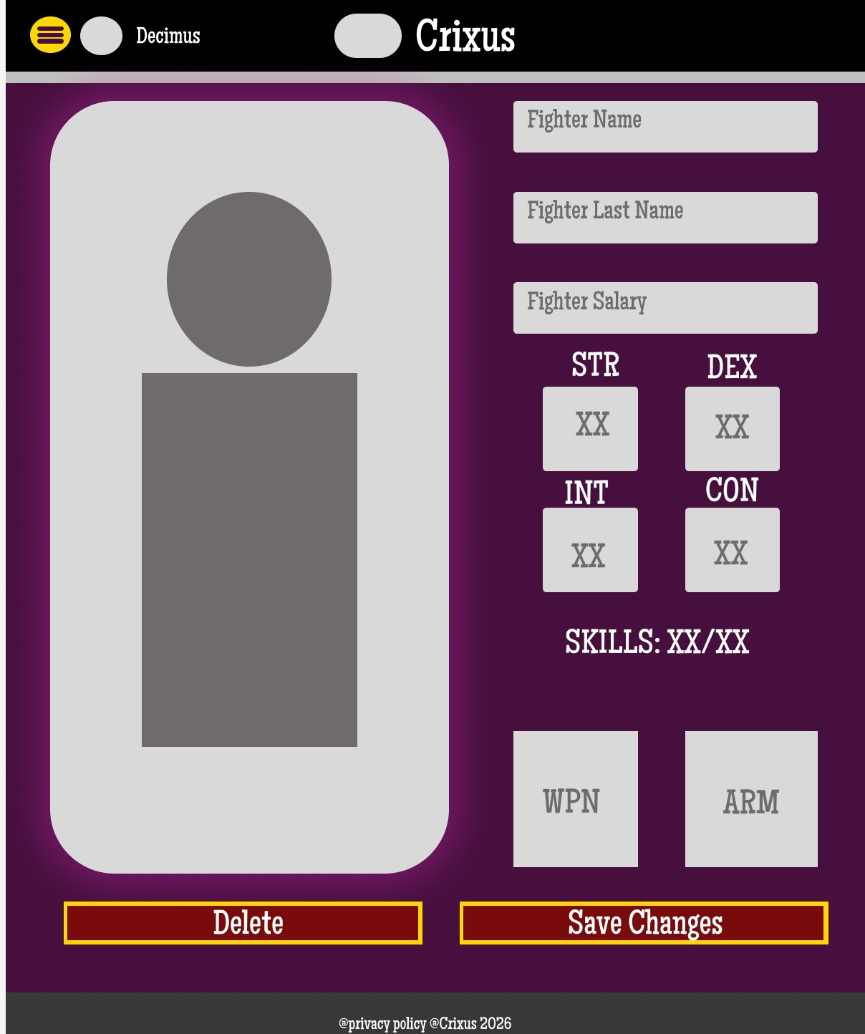

Arena
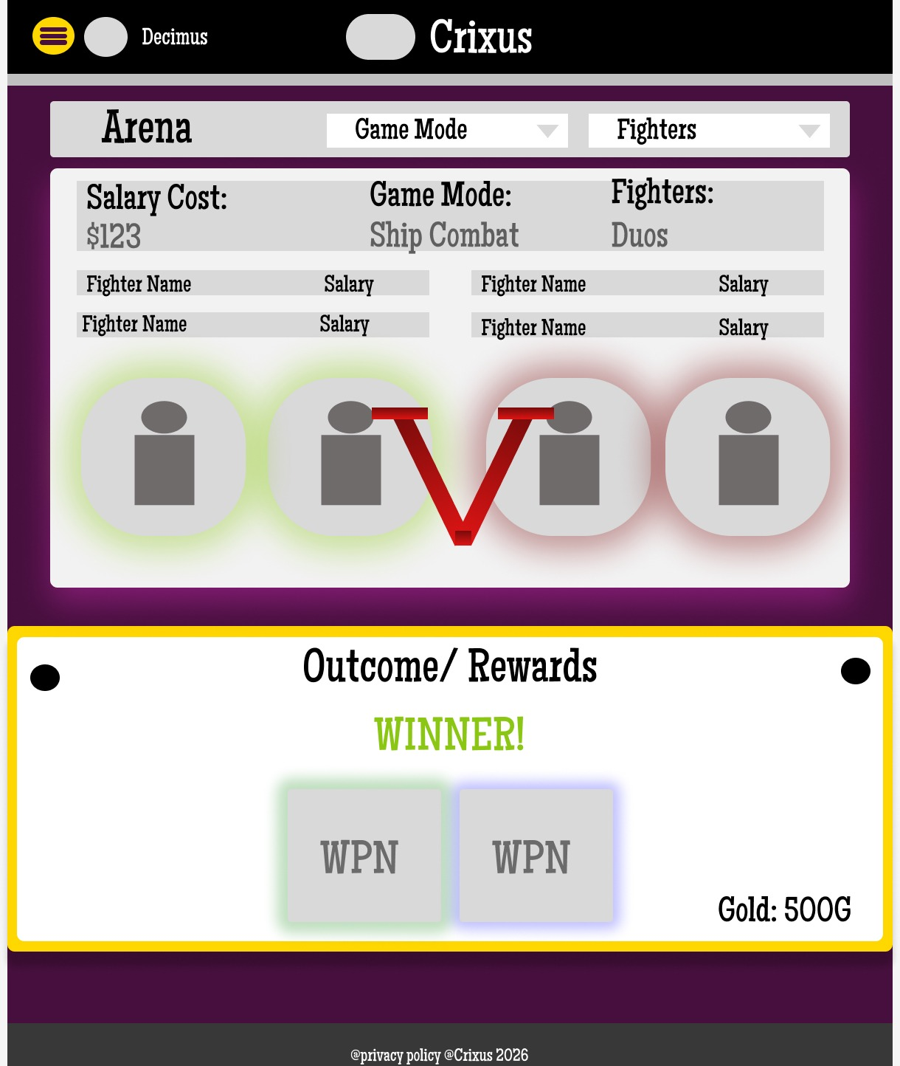

Armory
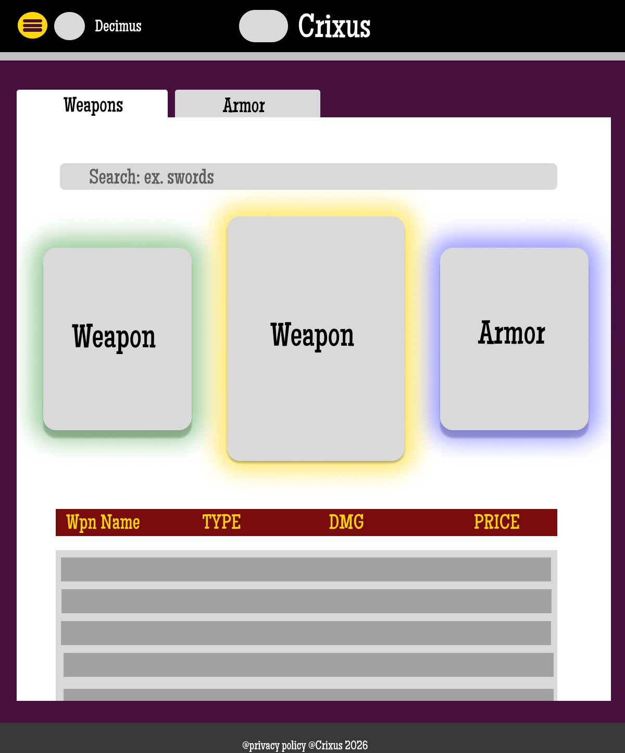

Login
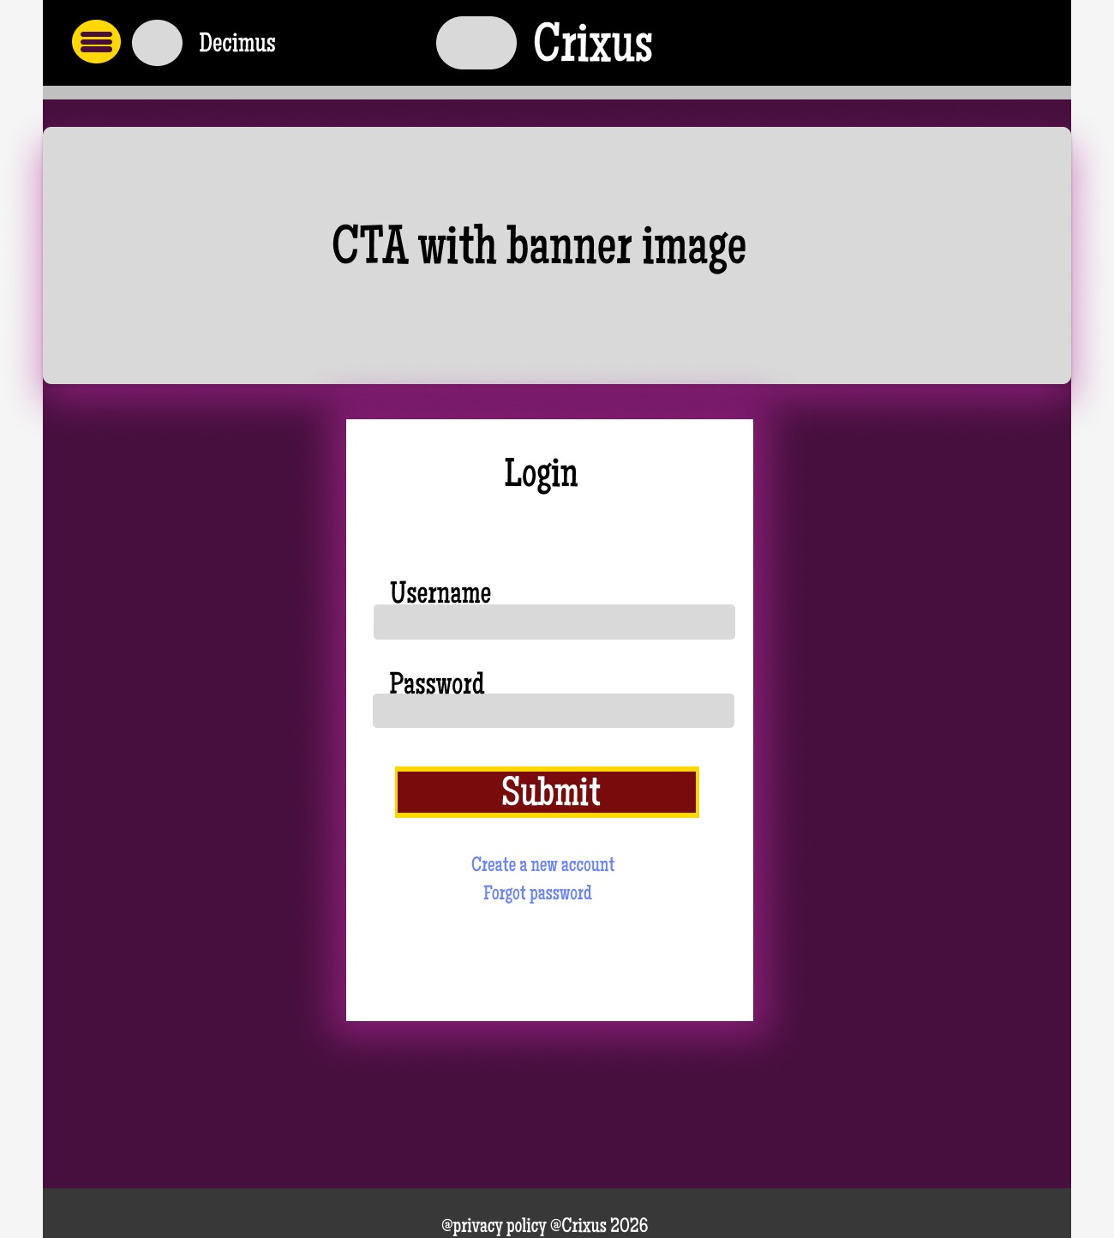

Register
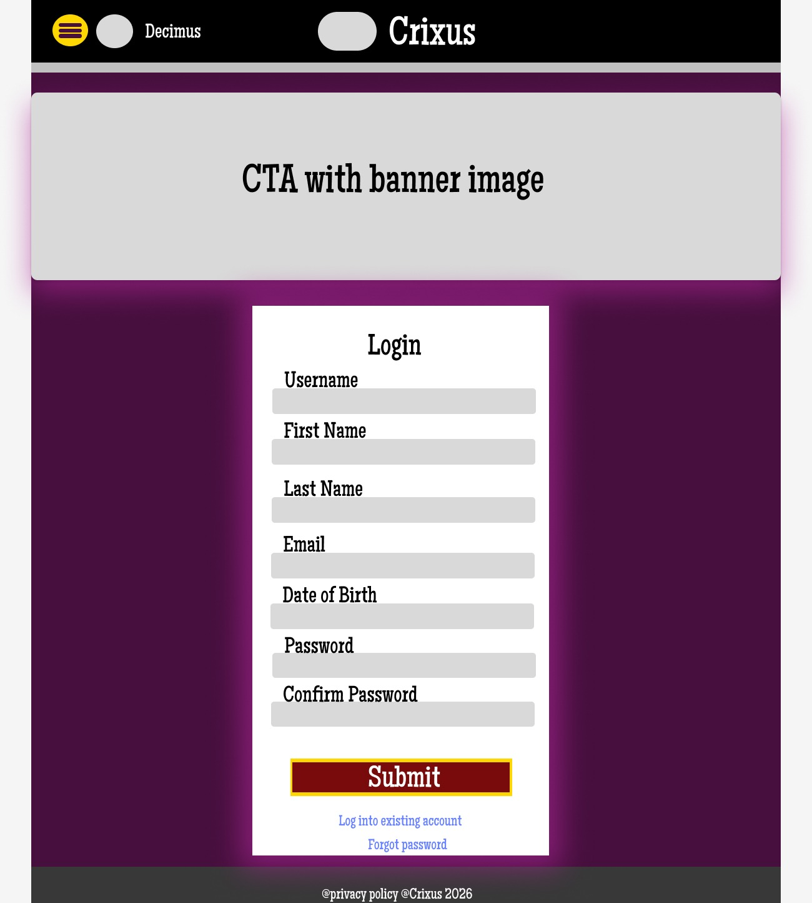

User Settings
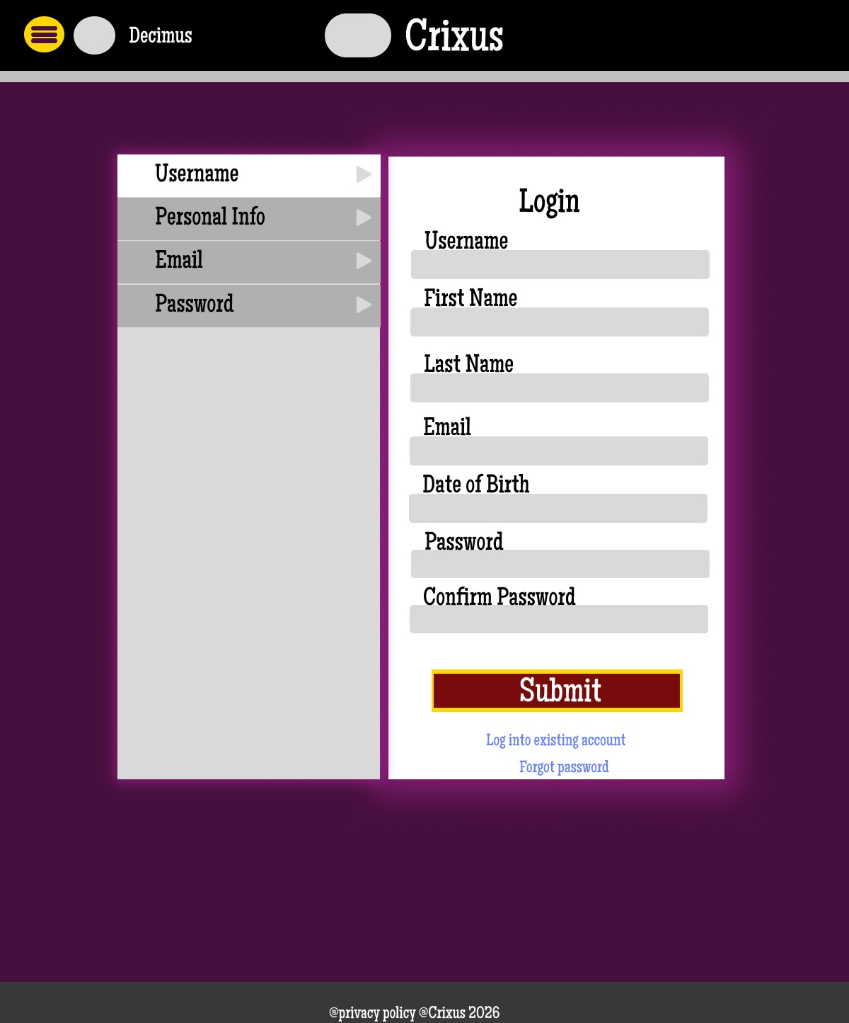

About Us
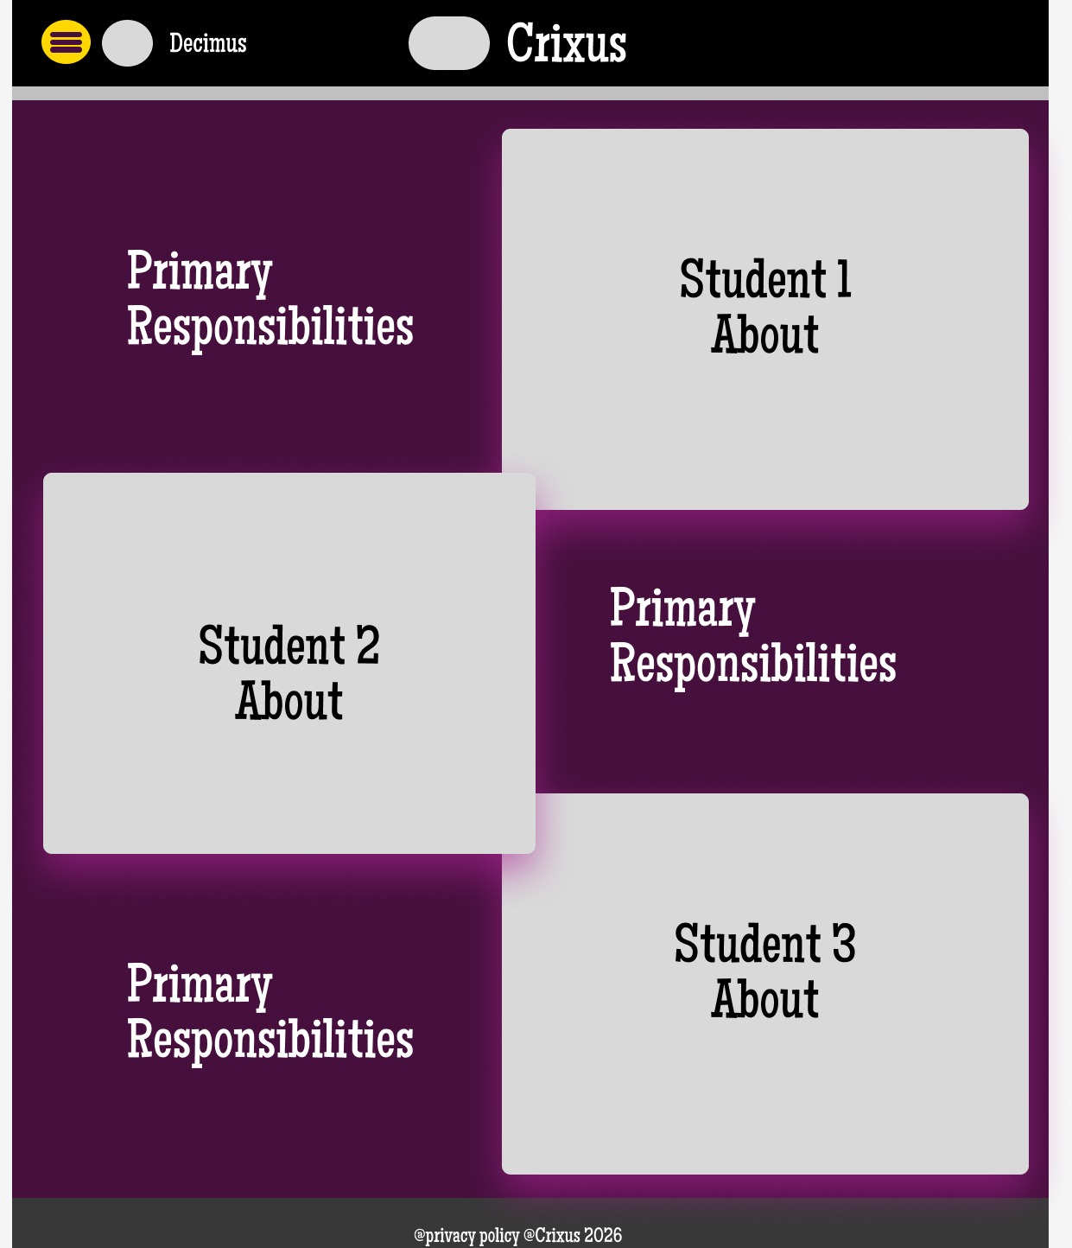

User Interface Planning
Our planning of the user interface started with the color palette figuring that is the foundation of the interface. In selecting colors, we went with colors that represented the roman empire in its prime. The classic red that almost all cinematic gladiators are associated with, purple the color of royalty and high class in Rome during the time period, as the pigment was expensive to acquire. Silver and gold accents felt right for gladiators representing money which was one of the main reasons for the coliseum. Then a greyish black to round out the nav bar and footer to make the page aesthetic a bit cleaner and more cohesive. There were other colors used but mostly just greys and different tones of the red and purple due to opacity. With the colors established it was onto how we do the pages to present their main content. We tried to find the sweet spot of minimalist and maximalist designs. Giving the user important data to look at for the most part and if there were “gaps”, those are filled in with details about the website/page/fighters/etc. The goal was to make the interface streamlined without clutter. We want users to be able to go where they want to go when they would most likely want to go there. The attempt to achieve this is adding buttons or ‘a tags’ at areas where a user might think “I would love to go to this page now”. In conclusion we were trying to capture a historically accurate them while also trying to step in the shoes of the user and make sure there isn’t any clunkiness in their use cases.
Color Palette:
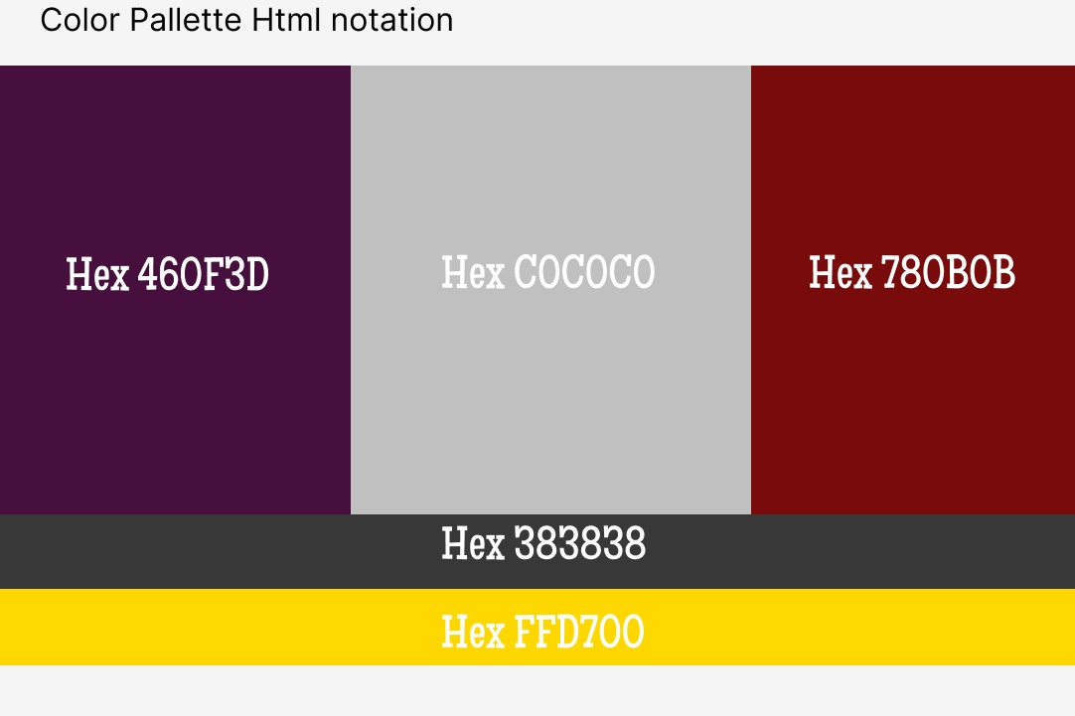
Navigation
The user will navigate the page primarily through the popup side bar accessed through the drawer button in the top left of the navigation bar. In the side bar there are five images that serve as buttons, these buttons direct the user to the five main pages. At the bottom of the side bar there is also a cog icon which is standard for settings, this will effectively bring the user to their account settings, their name will be clickable and prompt them to log out which will ask them to confirm they want to sign out. If a user is not logged in that will be instead of username will say login. If the user clicks the aforementioned login button in the side bar, they will be brought to the login page which has a tags under the form which send the user to a create a user form page, and the forgot password will send the user to a separate password recovery page (which you may notice has been left out because were currently unsure as how to handle that edge case). Other navigation will be on the ‘View Fighters’ page, there are buttons there for edit fighter which sends the user to the ‘Edit/Delete Fighter’ page. The other navigation component I will add that is semi page navigation related is, in the armory there are tabs that will just be React components for ‘Weapons’ and ‘Armor’. Each of the ‘Armory’ tab you click will navigate those React components.

