Functionality – login process, layout (visually appealing & easy to navigate), supports concepts, system provides feedback
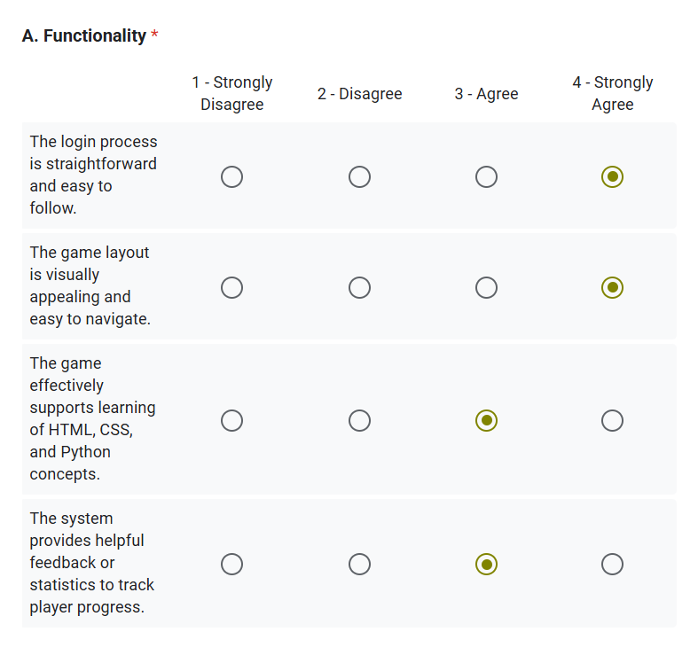

Reliability – runs smoothly, consistently available when needed, performs reliably without interruptions, functions well without connectivity issues
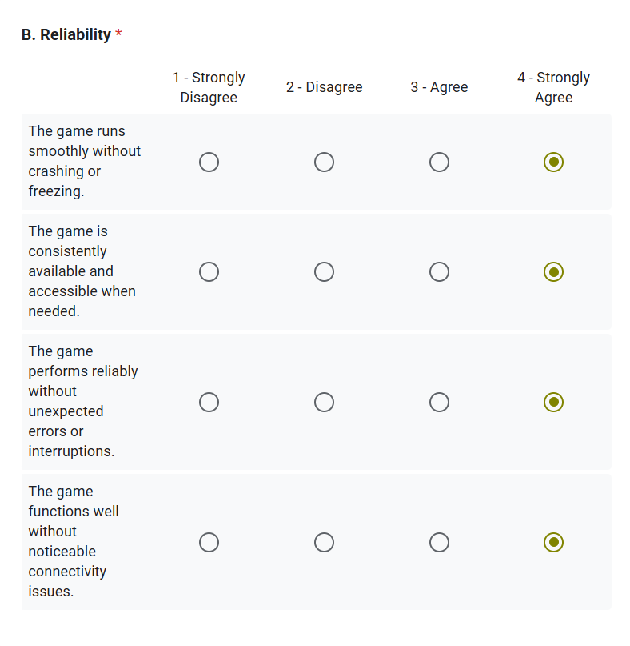
Usability – easy to learn, understand for first time users, can be used without extensive guidance or effort, accessible with stable internet connection, works well across commonly used browsers
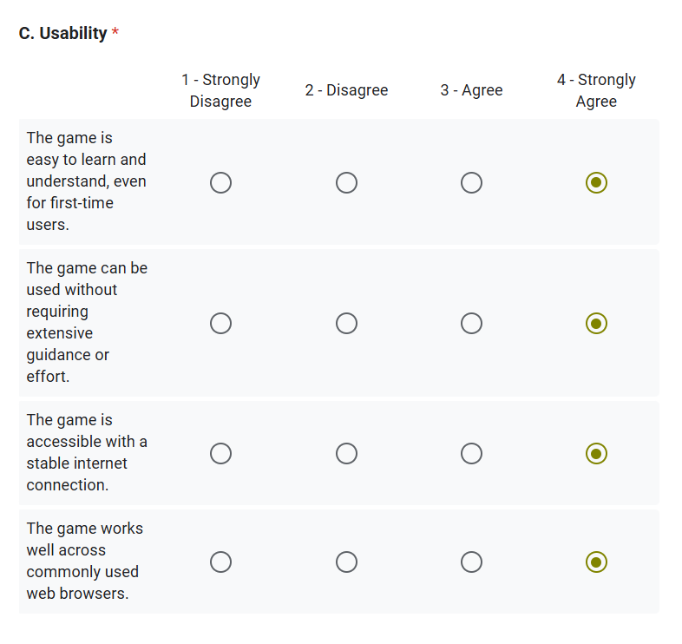
Maintainability – easily updatable or expandable in the future, functions correctly after updates or changes are made, responds properly when performing various tasks, maintain compatibility across different devices, OS, screen sizes
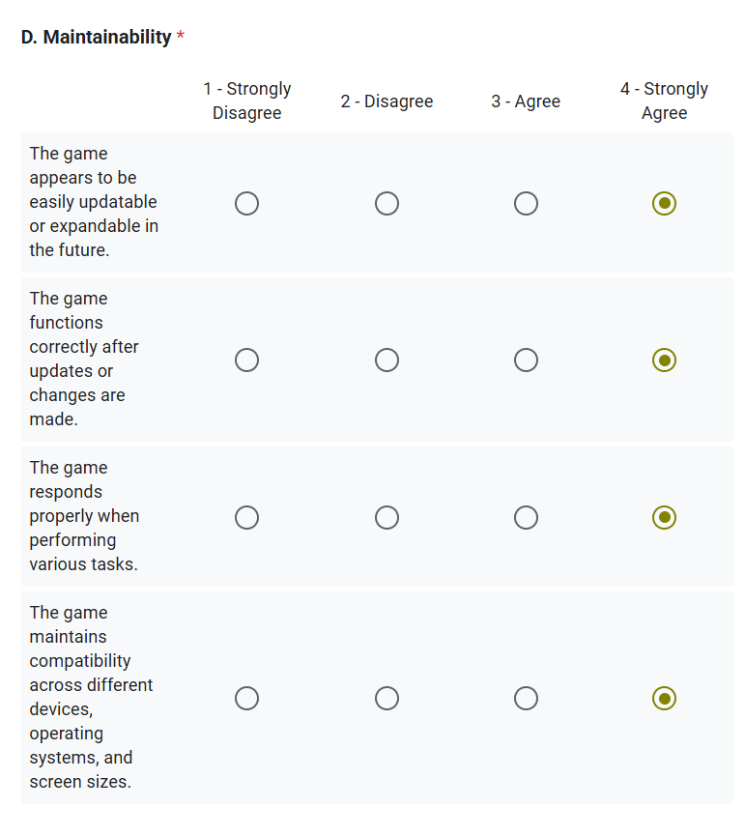
Security – clearly communicates how user data and privacy are handled, connection between game and browser is secured
Portability – adapts well to different screen sizes, compatible with various browsers without needing additional setup
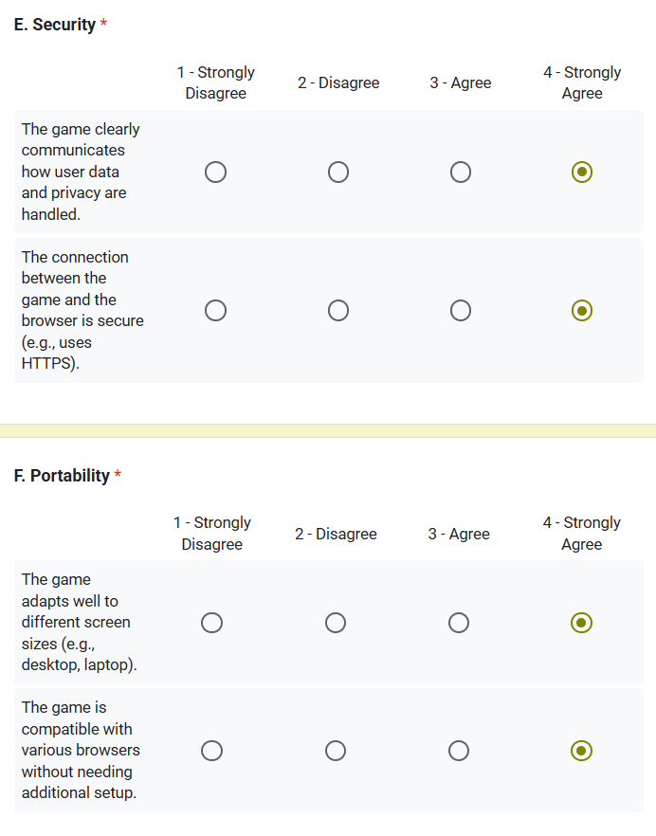

Power point format: title, introduction, problem statement, objectives, use case diagram, hypothesis, scope and limitation, significance, RRL, methodology,
Thesis title defense feedbacks:
- Consider costing in the long run
- Not more than 10 words in title, must be specific and has bigger scope
- Particular innovation if may existing already
- 6x6 rule in power point = 6 words per row, 6 lines per slide
- 28 in font size
- Template for title = first word application name, second word technology, last is scope
- Target market?

Computer Science Research
Technological Innovation and Advancement Artificial Intelligence (AI) and Machine Learning (ML): Development of AI algorithms for personalized services in various domains. Ethical AI and bias mitigation in decision-making systems.
Blockchain Technology: Applications of blockchain in secure data management across industries. Development of decentralized systems for transparency in governance.
Cybersecurity and Data Privacy: Next-generation encryption techniques for sensitive information. AI-driven threat detection and mitigation strategies.
Quantum Computing: Exploration of quantum algorithms for solving complex computational problems. Practical applications of quantum computing in health, education, and governance.

Multidisciplinary Research in Education
Adaptive Learning Systems: AI-powered tools for personalized and inclusive education. Intelligent tutoring systems for underrepresented or disadvantaged groups.
EdTech Development: Virtual and augmented reality for immersive learning experiences. Gamification of education to enhance student engagement.
Data Analytics in Education: Predictive models for student performance and dropout prevention. Learning analytics to optimize curriculum design and delivery.

Research in Government Systems
E-Government Platforms: Designing accessible and secure e-governance systems for public services. Using AI for efficient public administration and decision-making.
Digital Democracy: Platforms for participatory governance and citizen engagement. Cybersecurity for electoral systems and data integrity.
Smart Cities: IoT-driven urban management systems for sustainable development. Real-time data analytics for resource optimization and urban planning.

Healthcare Innovation
Telemedicine and Remote Monitoring: Development of mobile applications for remote diagnostics and health monitoring. AI-powered tools for early disease detection and management.
Health Data Analytics: Big data analysis for predicting healthcare trends and outbreaks. Personalizing treatment plans using patient data and ML algorithms.
Wearable Technology: Smart wearables for tracking physical and mental health metrics. Integration of wearables with healthcare systems for seamless data sharing.

Scientific Research and Computing
High-Performance Computing (HPC): Simulation models for complex scientific research (e.g., climate change, space exploration). Optimizing algorithms for large-scale scientific computations.
Data-Driven Science: Application of big data in biology, physics, and chemistry. Using AI to process and analyze experimental data efficiently.

Cultural Studies and Heritage Preservation
Digital Heritage: 3D scanning and modeling of historical sites and artifacts. Development of virtual museums and cultural archives.
Cultural Analytics: Text mining and sentiment analysis of historical texts and oral traditions. Analysis of cultural trends using social media data.
AI in Language Preservation: Machine translation tools for endangered languages. Speech recognition and text generation for underrepresented dialects.

Multidisciplinary Research in Culture and Society
Human-Computer Interaction (HCI): Designing interfaces that cater to diverse cultural and linguistic groups. Inclusive technology design for people with disabilities.
Technology and Social Change: Studying the impact of emerging technologies on societal structures. Promoting digital literacy in underserved communities.
Consider the tracking of users sap ag log-in and log-out

Thesis topics:
Topic # 1:
- General area: Research in Government Systems
- Specific area: Digital Democracy - Platforms for participatory governance and citizen engagement. Cybersecurity for electoral systems and data integrity.
- Problem: Local Government Units (LGUs) collect citizen data through surveys, consultations, or feedback forms, but the information is not analyzed in depth. As a result, LGUs cannot clearly understand citizen sentiment, priorities, or engagement patterns. This leads to programs that may not fully address community needs.
- Variables: LGU, citizens (young adults, middle-aged people, senior citizens), program, data, citizen sentiment, feedback
- Solution:
- Digital democracy platform
- AI-powered sentiment analysis for citizen complaints, suggestions, and feedback
- Transparency dashboard for program budgets and documents (receipts, liquidation reports)
- Program announcements hub with complete details
- AI chatbot to assist users with low digital literacy in navigating the system
- Title: (maximum of 10 words, specific, wide range + first word: application name, second word: technology name, last word: scope)

Topic # 2:
- General area: Multidisciplinary research in education
- Specific area: Technology and Social Change - Studying the impact of emerging technologies on societal structures. Promoting digital literacy in underserved communities.
- Problem: Junior High School (JHS) students in <place> lack essential digital literacy skills—computer basics, online safety, information evaluation, and AI usage—which affects their readiness for Senior High School and modern learning environments.
- Variables: JHS students, Study habits, digital literacy
- Solution: A gamified literacy learning platform with modules on computer basics, internet safety, productivity tools, websites, and AI quizzes and challenges, an interactive AI chatbot that guides learners and answers questions, progress tracking
- Title: (maximum of 10 words, specific, wide range + first word: application name, second word: technology name, last word: scope)

Topic # 3:
- General area: Multidisciplinary Research in Education
- Specific area: Data Analytics in Education - Predictive models for student performance and dropout prevention. Learning analytics to optimize curriculum design and delivery.
- Problem: Current grade monitoring in IT/CS programs lacks transparency and real-time analytics. Students cannot see their performance trends, and professors cannot easily identify at-risk students. This limits the ability to evaluate curriculum effectiveness and support struggling students early.
- Variables: Students under IT and CS (1st year to 2nd year), grades, performance indicators
- Solution: a learning analytics system that provides student-accessible raw grade breakdown, performance visualizations (graphs, score trends), risk alerts for students likely to fail or drop, professor dashboard for class performance analysis
- Title: (maximum of 10 words, specific, wide range + first word: application name, second word: technology name, last word: scope)

