Optimization of Faculty of transport and traffic sciences web based upon student's habits

Darko Dujmović, Dragan Peraković, Marko Periša

Department of Information and Communication Traffic

Faculty of Transport and Traffic Sciences

Zagreb, Croatia

Darko.j.Dujmovic@gmail.com; Dragan.Perakovic@fpz.hr; Marko.Perisa@fpz.hr

Abstract—This paper introduces new web content technologies made to suit today's terminal devices and user habits. First step is the analysis of current state in global telecommunications, and web content development technologies. Next step is to analyze FPZ's students (Faculty of transport and traffic sciences – FPZ) trends both in telecommunications and content consumption. Further more, there is a need to go over the improvements that HTML5 has over the previous generations, and finally the implementation of said technologies based upon the mentioned analysis. The result is an optimized web page that displays properly no matter the device the user has.

Keywords- formatting; HTML5; Content; Mobile phone;

# Introduction

Technology has enabled people to use their smartphone as a main device to access information. Global trends show a significant jump in number of smartphone users, and with that, an exponential growth in mobile data traffic generating 1.5 exabyte of data monthly, according to Cisco [1]. Cisco also states that the number of mobile devices reached 7 billion globally, of which 77% are smartphones. Furthermore, the average data volume in megabyte per smartphone user had increased from 353 to 529 megabyte. It is forecasted that smartphones will outnumber people in 2014, and by 2018 the average smartphone user will generate 2.8 gigabyte of mobile data.

Smartphone and computer development also means that the software and protocols have to develop. Multimedia web content most consumed type of data on people's devices, and up until recently, it had no proper way of adjusting to modern devices.

The HTML4.01 standard did not feature anything other than purely displaying simple elements such as text, image or link to another webpage. It had to be combined alongside CSS, JavaScript and Flash to add multimedia features and/or interactivity, which made development hard and displaying content on random devices even harder. It also had undefined standards so the developer would have to reference to the version of HTML 4 the website is coded in. That reference was used by user's browser so it could adjust it self to the level of quirks in certain version of HTML 4.

Hence it necessary to define new types of today's terminal devices based on their characteristics, and to forecast the possible course of technology and content development. The content has to be accessible on all platforms, and has to adjust itself to the device it is being consumed on. It's also important to compare the new and the old technology to see the advances HTML5 makes over HTML 4, and how it makes native application development unnecessary for certain types of services. But the technology would have no purpose if it weren't for users demanding it, and with all mentioned before, there is a necessity to examine the habits of a modern user.

# Characteristics of today's terminal devices and telecommunication habits of users

Before looking at today's trends there is a need to glance over the trends of last two decades when the mobile trend started.

Smartphones are nothing new to telecommunications, there are some models dating all the way to first half of the '90s. They've represented a pinnacle of technology although they could merely do functions modern calculators are capable of. At the start of the century smartphones started evolving by adding color screens, cameras but each having their specific OS that had different versions even on the same generation phones made by the same company. There were a lot of problems for developers and content creators in the process of delivering the content and service to end user, and to worsen the situation the telecom operators had not been able to handle the ever increasing data volume. In 2007 Apple introduced iPhone, the phone that changed the smartphone market by removing the hardware keyboard and replacing it with a touchscreen. The time has shown that it was the dawn of the new era in telecommunication and content consumption.

Computers (PC) users also started moving from table computers to laptops, and today to ultrabooks. Technology has enabled users to have processing power of a 2008th table computer in their modern laptops. So the modern user prefers mobile and compact computer rather than table computers.

## Global trends for telecommunications terminal devices

Mobile access is becoming the main type of access to information. According to Gartner, in 2013 sales of smartphones surpassed the sales of regular mobile telephones and with a number of 968 million units sold, or 53,6% of total market sales. Android makes 79% of smartphone operating systems [1]. The biggest expansion of sales took place new markets of developing countries, and in Eastern Europe there is a 50% growth in Q4 of 2013. Android and iOS combined make 93,8% of sold smartphone's operating systems leaving little space for competition such as Windows phone, Bada and Tizen [1].

The two dominant operating systems have highly developed market store applications that provide users with modern browsers such as Safari, Chrome, Opera and Firefox. This makes the HTML5 ready to use on them without a need to install any add-on.

As for the vendors there are two dominating by number of sold devices and revenue. Samsung and Apple have sold 132 million devices in Q1 of 2014 alone, where Samsung sold nearly 90 million and Apple around 43 million devices. It is important to state that the prices of terminal devices are decreasing, therefore making the penetration easier [1]. The table number 1 shows the number of sold devices per vendor where it is visible that smartphone sale is drastically expanding over the years.

1. Global smartphone vendor shipments and market share in Q1 2014, source: Strategy Analytics

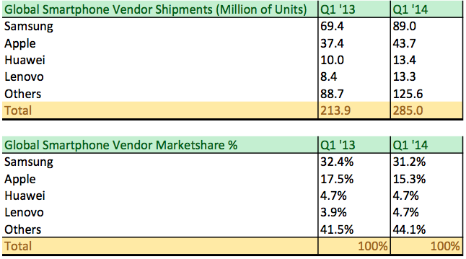

But the price of the device is also important when user is making a choice whether to buy a smartphone. Shown in table 2 is a graph that marks the average selling price of certain operating system. It is visible that almost all of the platforms (excluding Blackberry OS) are moving towards lower price per unit. Thus it can be concluded that with lowering the price of smartphones they will become more affordable to wider population. The forecast also predicts lowering the price per smartphone (excluding Blackberry) in future.

1. Smartphone average selling price in USD for 2012-2018 [2]

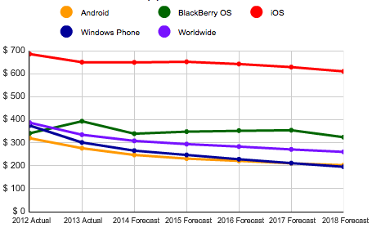

Making smartphones more affordable means that there will be even more mobile users that will demand content optimized for their smartphones.

## Croatian trends in telecommunication terminal devices

In the first half of 2013 there were 349,000 sold smartphones in Croatia that resulted in 61% growth over the previous year. Even greater leap made the tablet market that has shown 780% growth over the previous year, counting 172,000 sold tablets. Total accumulative makes to 521,000 sold smart devices in first half of 2013 alone [3]. Thus it can be concluded that Croatian smart device market is rapidly growing and that the users are embracing the technology.

Group at *Mobile Innovation and Experience Day conference* in Zagreb anticipates that 2014 will be a turning point in sales of smartphones, and that smartphones will surpass the number of regular mobile telephones in Croatia. In addition to that there is a prediction for Croatian market that by 2020 the sales of smartphones will be 6 times greater generating 60 times more data volume than today [4]. Mobility becomes the imperative of today, and mobile devices are central platform for work, leisure and information. It is therefore predicted that by 2020 every user will consume 1GB of data daily, while today's average is 500MB [4]. It is also important to state that the number of mobile data users grew by rate of 60% in just two years, and the data volume grew 70% [4].

One can therefore conclude that it is important to react to this situation where users are embracing smart devices, and give them optimized content that will be shown properly no matter the device.

## Student's trends in telecommunications

A web survey posted in two Facebook groups of FPZ's students resulted in 80 people answering it. The survey has shown that our students not only follow global trends but that they embrace it in ever-greater percentage. Regarding the smartphone ownership and using the Internet the results are:

* 92% of them owns a smartphone and
* 97% of them uses internet all the time.

These results show that our students have the devices to consume modern content, and that they use them non-stop.

The students also stated that they dislike the current web design since it doesn't display properly on their smart devices. They find it hard or rather complex to get to the needed information. In one question they were asked to select the most used features of current FPZ web, and the answers for majority were:

1. Consultation time
2. Class schedule
3. Professor information
4. News

According to the analysis the students seem to follow global trends and even surpass the Croatian average for smartphone and Internet usage.

## Web content development

Seeing how smartphone sales are growing there is a need to improve the existing content that is now present on the web. HTML was initially released in 1993 when there were only table computers. It performed poorly due to undefined standards, *tag soup* (messy code), unstandardized web browsers and plethora of third-party add-ons such as Flash player or Java that made it possible to display multimedia but were very demanding in computer power. As bad as the situation was it got ever worse when smartphones and other devices appeared. Some vendors didn't have support for particular third-party add-ons, and some devices were just to slow to process them. Hence the need to reconstruct the web content development and tools.

There is no reason why content must be of fixed size because today just a user can have multiple different devices and wants to consume content on all of them. There is no need to have third-party plugins that all do the same if it can be implemented into a standard. Furthermore, there is a need to semantically divide the content so browser can give priority to certain types of content, and the search engines can be used more effective.

To put it in perspective here is a simple example of HTML5 code simplification [5]:

HTML4

<!DOCTYPE html PUBLIC "-//W3C//DTD XHTML 1.0 Strict//EN" "http://www.w3.org/TR/xhtml1/DTD/xhtml1-strict.dtd">

HTML 5

<!DOCTYPE html>

It is clearly visible that declaring an HTML5 document is noticeably easier than declaring one of plenty possible HTML4 standards. Using HTML5 means that user doesn't need to update all of the components needed for content consumption, he only needs to update web browser.

Beside the smaller amount of code needed, HTML5 allows *caching,* a term that marks the ability to store crucial data needed for web applications to run offline.

Geo-location is also a feature in HTML5 that allows a web page or a web application to use users location to perform certain actions.

The mentioned semantic elements such as <video>, <article>, <aside> or <audio> make web content more understandable to browsers and search engines that can disregar certain types of elements containing key word(s). A good example is the <time> tag hat is usually put when a content creator needs to mark the time when content is created (i.e. an news article). The user searching for an article of the exact date can find the information easier since the search engine will only take the date in <time> tag in consideration, even if the content is a list of dates.

Three main components make up HTML5 standard, and those are HTML5 itself for webpage structure, CSS3 for webpage design and JavaScript for webpage interactivity. Alongside mentioned jQuery is often used as a JavaScript library that enables simpler JavaScript implementation [5]. These make the essential tools for HTML5 development and besides jQuery every all of the languages are supported by default on every modern browser, including browsers on mobile devices. Since every browser has the freedom to interpret HTML and CSS definition their own way, there is a need to make them all do the same interpretation. And to do this it is necessary to do a CSS reset that is essentially a technique of ignoring all browser rules for CSS interpretation.

Developer can do this on his own CSS rules but there are pre-made solutions such as Bootstrap. Bootstrap is a platform made by Twitter in order to standardize the work of its developers[6]. As they've released it publicly it gained in popularity because of its simplicity and strengths.

Bootstrap is made of CSS and JavaScript premade files that do CSS reset and give the developer ready-to-use element designs such as buttons, forms, dropdown menus and other. It is based on a 12 column rows design with a relative size[6], so no matter the size of the screen it will always be separated into 12 columns. But, depending on the screen size the elements of the page will reformat so a developer can choose to hide or show some of the elements on mobile platform.

This functionality is based upon premade CSS classes that ensure every element is displayed properly[6]. For example, one can put a <button> element into a bootstrap class of btn btn-info to apply bootstrap rules over it, as shown in the example below. The platform is using CSS @media query to detect the screen size and adjust content display accordingly.

JavaScript part of bootstrap gives the ability to the developer to easily make dropdown menus that will automatically be resized to native-application-like menus when the screen is small enough. Among plenty of features there is a modal functionality that makes a simple pop-up like element that is useful for displaying notifications.

There are a lot of additional features that Bootstrap has, and it is therefore chosen as a tool for optimizing the frontend of FPZ web.

# History of web services on Faculty of transport and traffic sciences

It is necessary to determine if Faculty of transport and traffic sciences (FPZ) students follow the global trends in telecommunications, data and content consumption. As a starting point for future engineers, the FPZ has to set an example of embracing new technologies so that our students are in touch with the modern world, as shown in current solutions [7]. E-learning modules also require transition to HTML5 standard so that the whole system can benefit from it, as the current version of e-learning system is based on older versions of HTML, JavaScript and CSS.[7], [8].

Faculty of transport and traffic sciences has always been up to date with modern technologies. Implementing web services it allowed their students to access information from any place in the world. Faculty did that by developing and implementing its own learning management system (LMS) that is still the center point of professor-to-student communication [9]. The Learning Management System (LMS), designed by the Faculty of Transport and Traffic Sciences, has been in use since 2004, when it was developed according to both the German Fachhochschule concept and specific requirements of studying in the Republic of Croatia at that time. The system consists of 5 individual modules (DMS, SAN, e-Student, SMSCentar i FPZmobile), which in mutual synergy represent the LMS of the Faculty. The Document Management System (DMS) is a system used for managing documents and processes used by the Faculty staff for authorized access to the modules for monitoring work in computer labs, e-Learning system administration (publication of instructional materials, checking and evaluating of seminar papers, etc.), and the module for managing documents and processes within the Faculty (equipment orders, malfunction reporting, updating of the online directory, etc.). The Authorization and Control System (SAN) is a combination of technologies and applications which enable monitoring of students working in the computer labs of the Faculty and personalization of working environment in the Windows operating system, regardless of which computer a student is working on. The e-Student System enables students to have authorized access to instructional materials, exercises and instructions. Furthermore, the system provides support to registration and preparation of seminar papers as well as other forms of testing (e-Blitz, e-Test, e-Quiz)[10].

All of the web services were made when HTML4 was a standard and many students didn't own smartphones. They still function today, but they aren't optimized to show HTML 5 properly on today's devices. There is a great need to optimize the frontend of these services so our students can fully utilize them regardless of the device they are using.

But the design and old standard are not the only problem. Some functions don't work on certain mobile platforms, and the complexity of some actions on the webpage results in improper use of computer and energy resources. The example in figure 3 shows that the current procedure to get to professor information takes four steps, and each of these steps consumes energy and server time.

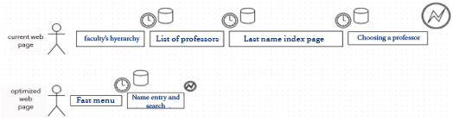

1. Process comparison between the current and the new webpage

The analysis has shown that students use this feature extremely frequently, and that results in high inefficiency. Thus, the need for optimizing the web's complexity is apparent. The action is now shortened on just two steps, selecting the *fast menu* and then entering the name of the professor in an auto-complete input element that also saves time, since it is necessary to enter just a few letters of the desired name.

Figure 2 shows the display of current FPZ's webpage. It can be seen that it is not easy to navigate or read text on it without zooming, and scrolling over.

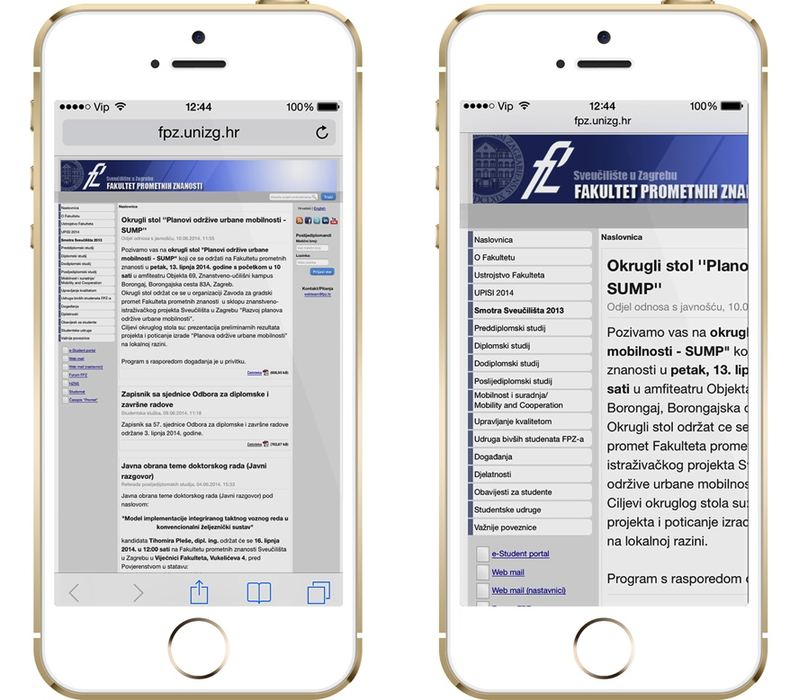

1. The current display of FPZ's webpage on mobile devices

Many of the menus do not work on certain products because they do not support flash or similar third-party add-ons. The display is cluttered with content that is not needed to be in users primary screen.[11]

Therefore the optimized page has to offer much simpler content delivery that conforms to the screen estate making it optimized for every device as can be seen in figure 3.

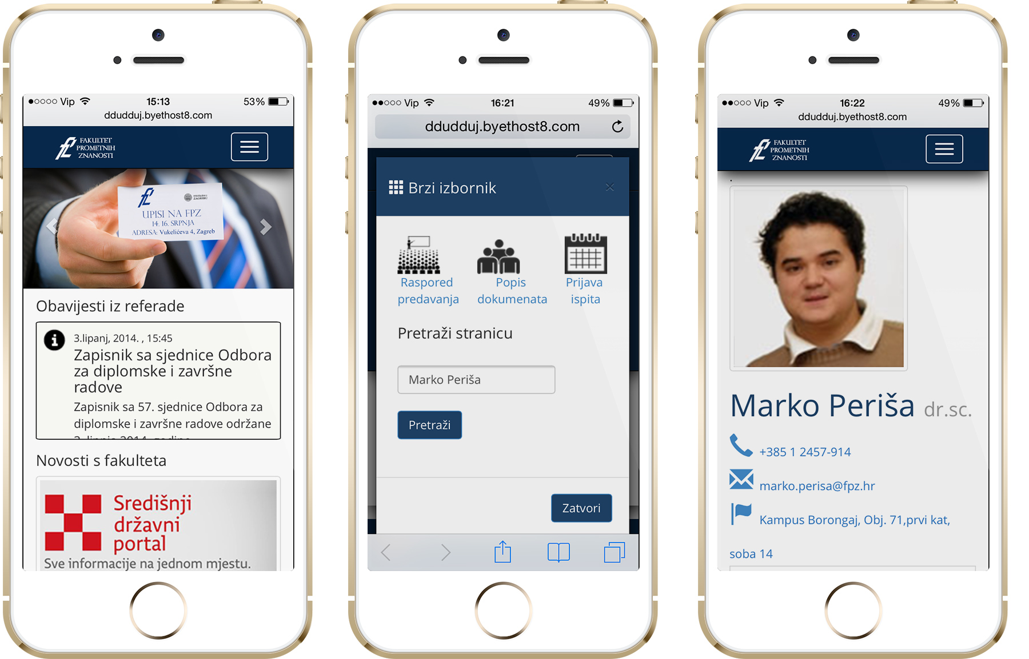

1. Optimized FPZ's webpage that automatically adjusts its display according to the device

It is visible that the optimized solution makes the most of available screen estate and adjusts the elements to the mobile phone. The content is more readable, the functions work on every device and there is no need for third-party add-ons or native applications. [11]

# Conclusion

Based on the conducted research it can be concluded that global, Croatian and FPZ's Internet users are highly mobile and following smart device trends. It can also be seen that smart devices are so different from each other that there is no possibility for using fixed sizes for media content. Hence the need to migrate from old techniques, technologies and philosophies of making web content to the new HTML5 standard that allows developers to make their content available to all users regardless of the device they use, and to use advanced features such as local data storage, location based services and direct audio and video reproduction. This not only allows unified content reproduction, but also makes developing applications simpler because there is no need for various versions for each individual platform.

One version of HTML5 application is sufficient to run on all platforms, and all types of devices. Moreover, every new version is instantly available for all users, and the developer is certain that every user is using the newest version because of the fact that all modern web browsers follow the HTML5 as it develops.

Applying aforementioned HTML5 standard on FPZ's website makes the information available to all of our students no matter the platform they are using, considerably saving their time.

This optimization has also taken in consideration people with impaired sight, and it is therefore optimized for visual aids (text-readers). [12]

These improvements directly change the environmental behavior of FPZ by not using energy in vain. Less server work means that there is less energy to be spent, and less terminal device energy need also means that user needs recharging more seldom.

It is also a sign that Faculty of transport and traffic sciences is always embracing new technologies, and developing its custom solutions that can be implemented to all other faculties. Faculty of transport and traffic sciences is then a leader in implementing new and modern solutions that optimize the way we consume content and limited resources.

##### References

1. N. Lomas, (2014, April 29th), Online document [Web article]. Available: <http://www.techcrunch.com/2014/04/29/STRATEGY-ANALYTICS-Q1/>
2. [www.idc.com](http://www.idc.com), (2014, April 29th ), Online document [Web page]. Available: <http://www.icharts.net/chartchannel/smartphone-average-selling-price-asp-os-usd-2012-2018_m3puyi9fc>
3. B. Ivezić, (2013, November 7th ), Online document [Web article]. Available: <http://www.poslovni.hr/tehnologija/do-2020-u-hrvatskoj-sest-puta-vise-pametnih-mobitela-nego-danas-256218>
4. T.I. Belošević, (2013, November 8th), Online document [Web article]. Available: <http://www.vecernji.hr/kompanije-i-trzista/promet-podataka-telefonom-veci-70-901663>
5. R. Clark, O. Studholme,C. Murphy,D. Manian, "Beginning HTML5 and CSS3", New York: Apress; 2012.
6. J. Spurlock, Bootstrap, California: O'Reilly, 2013
7. Cisco, (2014, February 5th), Online document [Web article]. Available: <http://bit.ly/Msevdw>
8. J. Bento da Silva, W. Rochadel, J.P. Schardosim Simao, A. Vaz da Silva Fidalgo: Adaptation Model of Mobile Remote Experimentation for Elementary Schools, Tecnologias del Aprendizaje, IEEE Revista Iberoamericana de (Volume:9 , Issue: 1 ), p28-32, 2014.
9. D.Peraković, V.Remenar, Z.Šašek: Analysis of operation and possibilities of improving e-Learning system in traffic engineering, Promet - Traffic & Transportation (0353-5320) 19 (2007), 3; 167-172
10. D.Peraković, V.Remenar, I.Jovović: Model of the New LMS Generation with User-Created Content, New Trends in Technologies: Devices, Computer, Communication and Industrial Systems, Sciyo, Rijeka, p. 179-196, 2010.
11. D. Dujmović: Frontend web optimization for Faculty of transport and traffic sciences, Final master thesis: Faculty of Transport and Traffic Sciences, University of Zagreb, p.59 - 64 2014.
12. M.Periša, D.Peraković, V. Remenar: Guidelines for Developing e-Learning System for Visually Impaired, International Conference on Computers Helping People with Special Needs, Universal Learning Design, vol. 2, p 167-173, 2012.