# Chapter 1: Introduction

When you start to consider abstract superclasses or parent classes that are not persistent, inheritance rapidly becomes a complex issue in object-relational mapping. Not only is there a challenge with storage of the class data but the complex table relationships are also difficult to query efficiently

* JDO - java data object
* POJO - plain old java object

The Java Persistence API is a lightweight, POJO-based framework for Java persistence

New features in JPA 2.1

1) support for stored procedures

2) mapping converters

Queries use schema abstraction that is based on the entity model

# Chapter 2:

Objects that leave the persistence layer are called detached. Dattachement model provides a way of reconciling the state of entity being rettached with the state that it was in before it became detached

Characteristics of object that has been turned into an entity

1. Persistability
   1. Their state can be represented in a data store and can be accessed at a later time
   2. Persistent objects become persistent in a moment they are instantiated in a memory. If a persistent object exists, then by definition it is already persistent
2. Identity
   1. (it has object and database identity) Persistent identity is a key that uniquely identifies entity. An entity has a peristance identity when there exists a representation of it in the data store. (row in table)
3. Transactionality
   1. transactions are needed for the changes to be committed in the database. In-memory entities are simple Java objects that obey all of the rules and constraints that are applied by the JVM to other objects.
4. Granularity
   1. Entities are business domain objects that have specific meaning to the application that access them.

**Entity** - Java Bean with default constructor. Class turns to Entity by annotating with @Entity and adding @Id annotation for unique key (@Id annotation can be placed also on getter method)

**EntityManager**

* interface, Until an Em is not used the entity is no more than a regular (nonpersistent) Java object.
* When EM obtains a reference to an entity, either by having it explicitly passed in as an argument to a method call or because it was read from Database - that object is managed by EM
* The set of managed entity instances within EM at any given time is called PERSISTANCE CONTEXT (only one java instance with the same persistent identity may exist in a persistence context at any time.)
* EM are implemented by a particular PERSISTANCE PROVIDER - supplies implementation for the entire JPA. (from EM to Query classes a SQL generation)

Entity mangers come from EntityManagerFactory [EMF] (Configuration for EM is template from the EMF that created it, it is defined separately as persistence unit)

**Persistence** **unit**

* dictates settings and entity classes used by all EM obtained from the unique EMF instance bound to that persistence unit. (EMF one-to-one correspondence to Persistence unit)
* allows differentiation of one EMF from another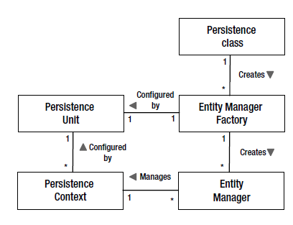

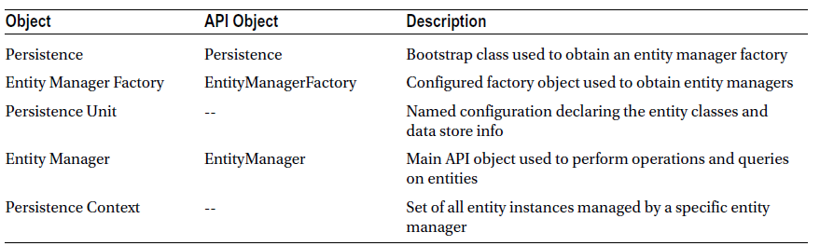

Creation of EMF and EM in Java SE

EntityManagerFactory emf **=**

Persistence**.**createEntityManagerFactory**(**"EmployeeService"**);**

EntityManager em **=** emf**.**createEntityManager**();**

Persisting – transient entity or one that doesn’t yet have any representation in DB storing it into DB.

When EM is not properly instantiated throw PersistenceException.

If EM doesn’t find item in DB return null.

Correct delete statement –

Employee emp **=** em**.**find**(**Employee**.**class**,** id**);**

**if** **(**emp **!=** **null)** **{**

em**.**remove**(**emp**);**

**}**

When running this code in Java EE container is used JTA. The transaction model when running inside the container assumes that a transactional context is present when is required. It transaction context is not available than will be thrown Exception or changes we be never persisted

In Java SE environment exists EntityTransaction which serves to begin and commit transactions. Entity transaction is retrieved from EM.getTransaction() then {begin, em.persit, em.remove… commit}

JPQL (Java Persistence Query Language)

* is impelemented in code as a *Query* or *TypedQuery<X>* object.
* Query can be defined statically or dynamically
* To execute query it is needed to call i.e. (getResultList())

Transaction-type (inside persistence.xml) RESOURCE_LOCAL – indicates that persistence unit uses resource-level EntityTransaction instead of JTA transactions.

<class> is needed for Java SE environment but for Java EE environment it is no needed. (Because container scan for entity classes annotated with @Entity)

Persistence artifacts are packaged in persistence archive (jar file which contains persistence.xml file in META-INF dir)

# Chapter 3: Enterprise Applications

## Session beans

* Component technology designed to encapsulate business services
* Bean class is a bit different from regular java Class because it is part of EJB component model
* Bean has access to wide array of container services
* The logical interface of the session bean consists of its public methods
* To allow both the server and the bean to achieve their initialization requirements, EJBs support lifecycle callback methods, that are invoked by server at various points in the bean’s lifecycle
* Communicate with client via proxy
* All beans can use interfaces (local, Remote)

Three types of session beans (Stateless, Stateful, Singletion)

**Stateless**

* no state is carries over from one business operation to the other.
* Callback methods –
  + PostConstruct – invoked as soon as are initialize all container services
  + PreDestory – invoked before the server releases the bean instances to be GC

**Stateful** – state is maintained across calls

* @Remove – methods that the client will use to end the conversation with the bean [Every stateful bean have to implement at least 1 @Remove method]
* Callback methods –
  + PostConstruct
  + PreDestroy
  + PrePassivate – before bean passivation is called [prepare bean for serialization]
  + PostActivate – after bean has been activated

Passivation is process by which server serializes the bean instances so that it can be stored offline

Activation is the process of deserializing a passivated session bean instance and making it active in the server.

**Singleton –**

* hybrid between stateless and stateful beans. All clients share the same singletion bean instance, so it becomes possible to share state across method invocations, but this bean lack conversational contract and mobility of stateful bean. (There are issues with concurrency).
* Bean instance will be never re-created in the event of the system exception
* Ideal for storing common application state (think about concurrency in different ways)
* By default all access to the bean are synchronized
* The lifecycle of stateless session bean is tied to the lifecycle of the overall application.
* Callbacks
  + PreDestroy – is invoked when application is shutting down (called only once)
  + PostConstruct

## Servlets

* HTTP session is a map of data associated with a session id.
* Cookies are used to link the session id with the client.
* Session beans, for example are easily accessible from anywhere within a Java EE application, making them perfect neutral.

## Dependency Management and CDI

Core Java EE has problems with injecting dependencies into a limited number of predefined server resources

References to resources

* reference is name link to resource that can be resolved dynamically at runtime (within app code or resolved automatically by the container)
* reference consists of two parts: Name and Target
  + Name – used by app code to resolve reference dynamically
  + Target – used by server to find resource that the app is looking for
* Reference is declared one of the following annotations (these annot. Can be placed on class[name attribute is mandatory], field, setter)
  + @Resource
  + @PersistentContext
  + @PersistentUnit
  + @EJB

1. Resource Injection can inject JNDI Resources directly whereas Dependency Injection cannot.
2. Dependency Injection can inject Regular Classes (managed bean) directly whereas Resource Injection cannot.
3. Resource Injection resolves by resource name whereas Dependency Injection resolves by type.
4. Dependency Injection is typesafe whereas Resource Injection is not.

**Dependency lookup**

Traditional form of dependency management in Java EE. App code is responsible for looking up named reference using JNDI. Each Java EE component has its own locally scoped JNDI naming context => environment naming context. “java:comp/env/” that was added to the reference name indicates to the server that the environment naming context should be searched to find the reference

@EJB**(**name**=**"deptAudit"**,** beanInterface**=**AuditService**.**class**)**

public class DeptService **{**

**try** **{**

Context ctx **=** **new** InitialContext**();**

audit **=** **(**AuditService**)** ctx**.**lookup**(**"java:comp/env/deptAudit"**);**

**}** **catch** **(**NamingException e**)** **{**

**throw** **new** EJBException**(**e**);**

**}**

EJB supports alternative to JNDI lookup – lookup method from EJBContext interface (SessionContext sub-interface)

SessionContext context**;**

public void setSessionContext**(**SessionContext context**)** **{**

**this.**context **=** context**;**

**}**

**(**AuditService**)** context**.**lookup**(**"deptAudit"**);**

EJB lookup has two advantages

* Name is exactly the same as it was specified in the resource reference
* Only RuntimeExceptions are thrown

**Dependency Injection**

The process of automatically looking up a resource and setting it into the class is called dependency injection. DI simplified testing.

1. Field Injection – server looks up the dependency in the environment naming context, it assigns the result directly into the annotated field of class. If I want to unit test there is needed add setter or make the field accessible to the unit tests. Environment naming context should be package.Class/fieldname
2. Setter Injection – Works well with unit testing

**Declaring dependencies**

**PersistanceContext**

@PersistenceContext**(**unitName**=**"EmployeeService"**)**

EntityManager em**;**

If the unitName is omitted , it is vendor-specific how the unit name for the persistence context is determined (required or not required). If EM is injected into stateless bean (EM is state field). The EM value is a container-managed proxy instance that acquires and releases persistence context on behalf of the app code. (In Spring it works in similar way but it needs additional configuration)

**PersistenceUnit**

@PersistenceUnit**(**unitName**=**"EmployeeService"**)**

private EntityManagerFactory emf**;**

It is vendor specific how unitName is determined. There is diff. between that how is EM is acquired.

**Referencing server resources**

@Resource

SessionContext context**;**

For resources that they don’t have dedicated annotations. resourceType specify type of resource if the server can’t it figured out automatically.

**CDI**

CDI bean is any class that qualifies for the CDI injection services. We can also use Constructor injection [good for testing]

**Scopes and Contexts**

5 pre-defined scopes exists, three of which(session, request, application) are defined by the servlet spec., by CDI was added conversation scope (spans a series of sequential JSF requests), by JTA was added Transaction scope (maps lifetime of the active JTA transaction).

Bean type is associated with the scope by annotation. Managed instances of that bean will have a lifecycle similar to the declared scope.

The context is a place where the scoped instances reside for the duration of the scope. There can be only one instance of each bean type in each context. Also exists dependent scope => it is really absence of scope. If no scope is specified, then the dependent scope is assumed. The @Dependent annotation can be used to explicitly mark a bean as being dependent.

beans.xml was required in CDI 1.0. In CDI 1.1 beans may be instead annotated.

**Qualified Injection**

Used to distinguish a bean type from other bean types that have the same inherited or implemented interface type. Helps container to decides which bean can be injected.

**Producer**

Producer method is a method that the CDI container will invoke to obtain a new bean instance. Producer method can decide in runtime which subclass could be returned. Producer fields work the same way as producer methods except that the container accesses the field to the instance instead of invoking a method.

A producer method acts as a source of objects to be injected, where:

* the objects to be injected are not required to be instances of beans, or
* the concrete type of the objects to be injected may vary at runtime, or
* the objects require some custom initialization that is not performed by the bean constructor

## Transactions

Basic transaction properties (ACID):

1. Atomicity – The success of every individual operation is tied to the success of the entire group.
2. Consistency – At the end of transaction data are legal and valid with the respect to the rest of the data in the system.
3. Isolation – Changes within transaction are visible only to the transaction that is making changes. After commit all transactions see changes.
4. Durability – changes after transaction endure beyond of the completion the transaction

Transactions live in enterprise application at different levels.

1. The basic and on the bottom level are transaction of the resource (relational db transactions) fronted be DataSource interface. => Resource local transaction. These types of transactions are manipulated directly by JDBC DataSource that is obtained from the app. Server. These transactions are demarcated by app (BMT- bean managed transaction).
2. Container transactions (uses JTA) – can enlist number of resources, including data sources as well as other types of transactional resources. Containers add custom level on top of the JDBC DataSource to perform functions such as connection management and pooling…. They are also called global transactions. These transactions can be demarcated by app. or by default they are demarcated by container(CMT – container managed transaction).

EJB can use both BMT and CMT . Servlet can use only BMT

Changing transaction management type in EJB from default CMT to BMT

@TransactionManagement**(**TransactionManagementType**.**BEAN**)**

public class ProjectService **{**

### Container –managed Transactions CMT

Transactional attributes:

* MANDATORY – it expected that transaction is already started and this transaction has to be active when method is called. If no transaction is active an exception is thrown.
* REQUIRED – (the most common) expected that method is already in transaction. The container provides a guarantee that transaction is active. If one is active, it is used. If one doesn’t exist the new one is created
* REQUIRES_NEW – it is useful when we want in order to the method was in own transaction. The method should be committed or rolled back independently of others methods. It can lead to the excessive transaction overhead.
* SUPPORTS – methods are not dependent on a transaction, but will tolerate running inside one if it exists. No transactional resources are access in the method.
* NOT_SUPPORTED – container suspends active transaction when method with this attribute is called inside transaction
* NEVER – method will cause thrown exception (use when it is expected that transaction has to be completed)

There are actually two different ways of specifying CMT, one for EJB and one for CDI, servlets, JAX-RS [use transactional interceptors]….

**EJB container-managed transactions**

By default REQUIRED attribute will be applied. In case when any bean wants in order to the transaction was rolled back, it can be done by setRollbackOnly() method on EJBContext. This will be not cause immediately rollback the transaction but after transaction is completed. It is same as container thrown Exception in transaction.

**Transactional interceptors**

The main difference to EJB is in using different annotation @Transactional [In Java EE 7] and instead of TransactionalAttributeType is used Trasactional.TxType. The main difference between EJB CMT and transactional interceptors-based components [TIBC] is that, that TIBC do not automatically get CMT but it has to declared by annotation @Transactional [interceptor] (can be used on managed beans or CDI but not by EJB)

### Bean-managed Transactions

Only EJBs are provided CMT by default. Method which begins transaction has to ensure in order to finish this transaction, in other case exception occurs. For EJB beans BMT transactions are not propagated. When other method is called from transaction this transaction is not propagated to this method [transaction is suspended] but after finishing this method transaction goes further, this is not true for none EJB components. Don’t use in EJB.

**UserTransaction**

The component in order to start or end the transaction needs an interface for it. UserTransaction JTA interface. UserTransaction is not current transaction instance, it is sort of proxy that provides the transaction API and represents current transaction. Can be injected by CDI @Inject or by @Resource. In environment naming context is reserved by name java:comp/UserTransaction

Only one transaction can be active at a given time. For BMT doesn’t exist possibility to suspend transaction. At a given time can be active only one transaction but multiple transactions can be associated with single thread. Transaction can be rolled back by different ways:

* setRollbackOnly() – transaction can end only with the rollback
* rollback() – transaction is immediately rolled back
* setTransactionTimeout(int second); - transaction is roll back when time limit is reached. It can not be changed during the transaction. It has to be set before transaction starts

Every transaction has a status – getStatus() If no transaction is active then value returned will be STATUS_NO_TRANSACTION [setRolledBack() => status STATUS_MARKED_ROLLBACK]

**How to pack it**

Persistence xml

<persistence>

<persistence-unit name="EmployeeService">

<jta-data-source>jdbc/EmployeeDS</jta-data-source>

</persistence-unit>

</persistence>

Persistence xml should be located in META-INF for jar or in the WEB-INF/classes/META-INF for war.

# Chapter 4: Object Relational Mapping

The mapping annotations can be categorized as being in one of two categories:

1. Logical annotations: describe the entity model from object modelling view. Tight to Domain Model
2. Physical annotations: relate to concreate Data model in Database. They deal with tables , columns

Access Mode: the way how is state accessed in the entity

* Field Access: all fields has to be declared as either, package, default or protected access modifier
* Property Access – must exist getter and setter methods. Return type of getter must be same as parameter into setter. Both methods must be either protected or public visibility. The mapping must to be on getter method.
* Mixed access: @Access annotation with specific access mode on the subclass entity will be cause the default access type to be overridden for the entity subclass. Also useful when you need to perform a simple transformation to the data when reading or writing to the db. In Case when we want to mixed property and field Accesstypes. (Don’t forget on transient annotation on field !!!!)

@Entity

@Access**(**AccessType**.**FIELD**)**

public class Employee **{** **...** **}**

@Transient private String phoneNum**;**

@Access**(**AccessType**.**PROPERTY**)** @Column**(**name**=**"PHONE"**)**

protected String getPhoneNumberForDb**()** **{** **...** **}**

## Mapping to a Table

When table name doesn’t match with entity name add @Table annotation @Table(name="EMP")

@Table(name="EMP", schema="HR", catalog="HR")– we can set table name, schema name [@Table(name="HR.EMP")] – none standard

Schema is used to differentiate one set of tables from different set.

Catalogs are named collections of schemas in an SQL-environment. An SQL-environment contains zero or more catalogs. A catalog contains one or more schemas, but always contains a schema named INFORMATION_SCHEMA that contains the views and domains of the Information Schema.

## Mapping Simple Types

If type of JDBC layer cannot be converted to Java type Exception is thrown but it is not guaranteed. If Database type cannot be converted to JDBC type, It can be on provider or JDBC driver might perform conversation.

@Basic – is optional, can be placed on property or field and explicitly mark it as persistent.

## Column mappings

@Column(name="COMM") – if default name doesn’t correspond to db name

**Fetching type**

In @Basic annotation we can choose fetch type @Basic(fetch = FetchType.Lazy/Eager). Default behavior is load data eagerly. Lazy data are not loaded by default. Lazy attribute can be returned from the query as empty value. Not good idea lazy fetch simple types.

**Large Objects (LOB)**

Character large objects (CLOB) Byte Large Objects(BLOB). When is in database large object Lob than we have to mark column with annotation @Lob.

* Database BLOB is equivalent Java byte[], Byte[] and Serializable types
* Database CLOB is equivalent Java char[], Character[], String

**Enumerated types**

Each enum has an ordinal value which we can don’t change at runtime and this value is specified by order in enum, first value is 0. Enum is mapped with database integer. This solution works by default without any annotations. Problem with adding values in the middle.

Better approach is store the value as a string. We can do this be adding @Enumerated annotation. Default value of @Enumerated(Ordinal). When we want to map string values @Enumerated(EnumType.STRING). Here is problem with renaming enumarion values.

Enum in Java can have also state, but this property is not supported by JPA.

**Temporal types**

Set of times: java.sql.Data, java.sql.Time, java.sql.Timestamp, java.util.Date, java.util.Calendar.

Util types need additional metadata in order to indicate how communicate with jdbc @Temporal => TemporalType.TIME/DATE/TIMESTAMP

**Transient state**

@Transient- attribute marked with this annotation will be not mapped. Also can be used java *transient*

## Mapping primary key

Primary key not nullable or updatable and should be insertable. When we want to automatically generate unique values: @GeneratedValue. This values is visible for persisted entity and when newly entity is store to db and flush action is performed or transaction is completed.

Exists four types of generation strategies: GenerationType.AUTO/TABLE/ SEQUENCE/IDENTITY. Table and Sequence generators can be reused by multiple entities. These generators are named and are accessible to all entities in persistence unit.

1. **AUTO** usually create integer. It is good practice to use Long for id. Provider pick own generation strategy . Provider can chooses from three different types of generation strategies. Some strategies need for generation some resources (Table needs create table….). Therefore there is needed some creation phase or schema generation to initialize these resources.
2. **TABLE** – the most generic and portable. Can be specified on table or attribute. You can store multiple sequences in one table. Multiple identifiers for multiple entities in one table. Id generation table should have two columns
   * First is string – used to identify the particular generator sequence. Primary key for all generators.
   * Second is integral type – represents last generated value using jpa generator strategy. Every sequence represents a separate row in the table

@TableGenerator**(**name **=** "employee_gen"**,** table **=** "id_gen"**,** pkColumnName "gen_name"**,** valueColumnName **=** "gen_val"**,** allocationSize **=** 100**)**

@GeneratedValue**(**strategy **=** GenerationType**.**TABLE**,** generator **=** "employee_gen"**)**

If schema generation is choosing it will be created; if not the default table assumed by the provide must be known and must exist in the db.

We can also explicitly specify which table will be used for id storage. @TableGenerator(name=”Emp_gen”)

@GeneratorValue(generator=”Emp_gen”)

The default value for generated values is 0. This value can be also explicitly set on custom value. This value is used only during schema generation. Identifier value is incremented by the allocation size (By default 50).

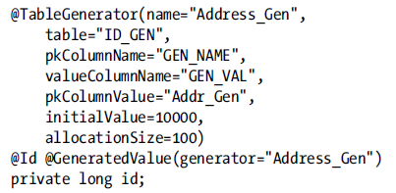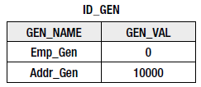

1. **ID Generation using DB Sequence** – If more generator are used and these generators are not named. There is no guarantee whether they use the same default sequence or different ones.

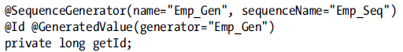

It is good practice to name sequence and we can create sequence in Db with following command.

allocationSize in annotation has to respond to the Increment by

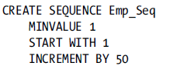

1. **ID Generation using DB Identity –** Is available only when database supports it. For Object-Relational identifier they are less efficient => identifier is available after commit time and they cannot be allocated in the blocks. For others generator there exist possibility to eagerly allocate identifier

## Relationships

That side which has JoinColum is owning side. MappedBy means that the entity is on inverse side of the relationship. It is good practice that logical mapping should be first followed by physical

1. **Many-To-One** – is always on the owning side of the relationship. To specify the name of the join column, the name element is used. If no @JoinColumn is used the default column name will be assumed. The name that is used as the default is formed from a combination of both the source and target entities. DEPARTMENT_ID (name of relationship attribute in source entity[which is not owning] unserscore _ plus name of the primary key of owning entity)

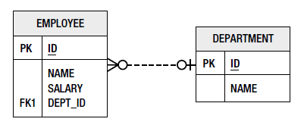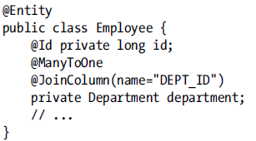

1. **One-To-One –** 
   1. **Unidirectional**

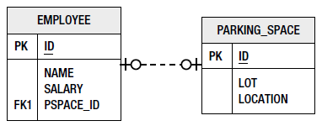 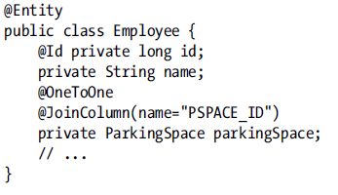

* 1. **Bidirectional –** Either side can be the owner of the relationship => JoinColumn can be on one side or the other. We must add a mappedBy element to indicate which side is owner of the relationship(This should be in attribute that has not JoinColumn annotation

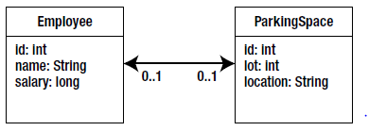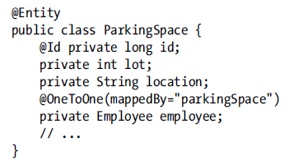

1. **One-To-Many –** 
   1. Bidirectional – in older Version Java there was not implemented collection and we must define target type of entity in @OneToMany(targetType=Employee.class, mappedBy=”..”)

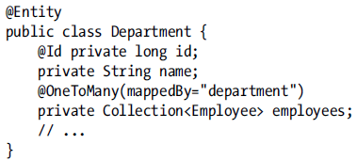

Many-To-One should be the owning side, One-To-Many – inverse side =>mappedBy. Without mappedBy => provider will that handle it as unidirectional One-To-Many

1. **Many-To-Many –** is expressed on both the source and the target entities as @ManyToMany. There is no JoinColumn. When i. e. persistence provider generate schema for us JoinTable can has default name <Owner>_<Inverse> (names of entities). Ids in join table will be with default names. Same approach as default names by One-To-Many. ([attribute_name + _ + entity id name)

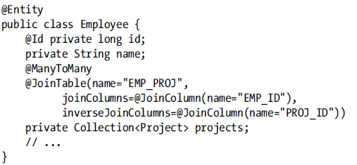 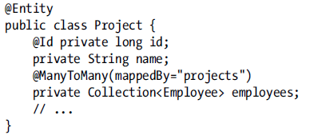

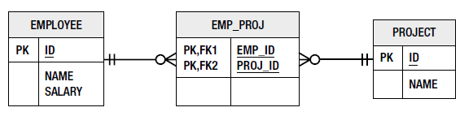

**Unidirectional relationships**

By many-to-many relationship when one side doesn’t have mapping to the other side => unidirectional (in that case Join table still be used, only one entity load data and store entity associations). There is not attribute in target entity to reference the source entity. The join table must now be specified as part of the mapping.

Uniderctional One-to-Many

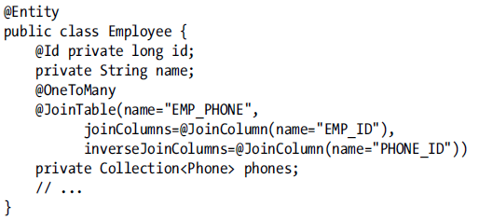

The default naming is slightly different in the unidirectional case

1. The name of the join table is EMPLOYEE_PHONE
2. JOIN column => PHONES_ID

Lazy relationships

By default in all the relationships is EAGER in the single valued relationships @OneToOne(feth=FetchType.Lazy). Collection-valued relationships by default LAZY loaded

## Embedded Objects

Embedded objects cannot be used in inheritance hierarchy.

@Embeddable annotation to the class definition.

@Embedded is optional

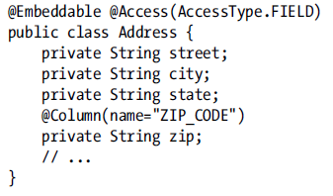 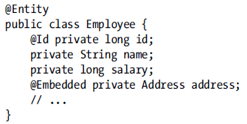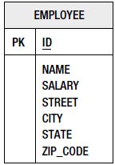

@AttributeOverride – used for each each attribute of the emedded object that we want to override in the entity. The column element allows us to specify the column that the attribute is being mapped to in the entity table. We indicate this in the form of a nested @Column annotation.

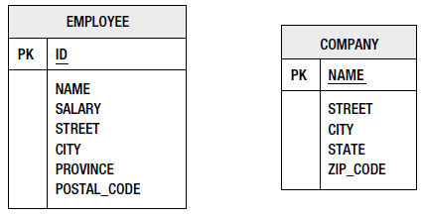 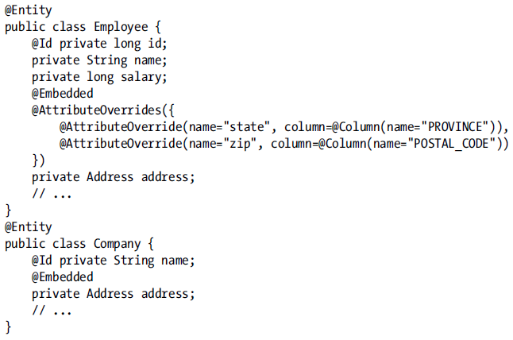

# Chapter 5: Collection Mapping

We can map collections of entities, embeddables, or basic types. Collections of embeddable and basic types are not relationships. Relationships needs minimally annotations @ManyToMany, @OneToMany. Elements collections are annotated with @ElementCollection(targetType= VacationEntry.class, fetchtype = ) and required separate table called a **collection table.** Every collection table has to have join column that refers to the containing entity table.

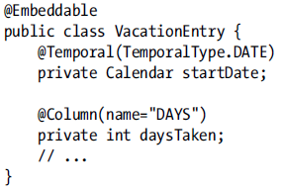 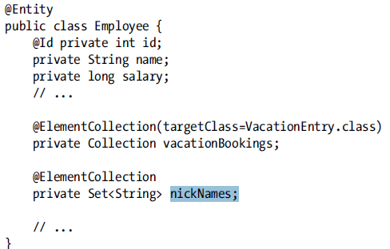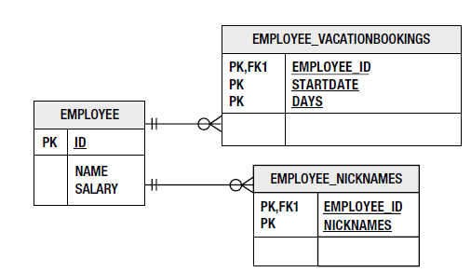

@CollectionTable – (contain JoinColumn, name)

* default name => name of referencing entity + _ + name of the entity attribute that contains the element collection. [EMPLOYEE_VACATIONBOOKINGS] [EMPLOYEE_NICKNAMES]
* Default join column name =>name of referec. Entity + _ + name of the primary key of the entity. [EMPLOYEE_ID]

@AttributeOverride – for simple embedded mappings, the column specified is actually applies to the collection table, not to the entity table

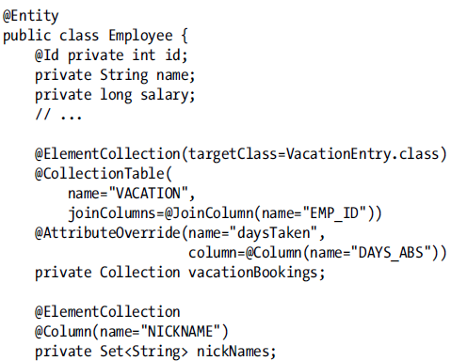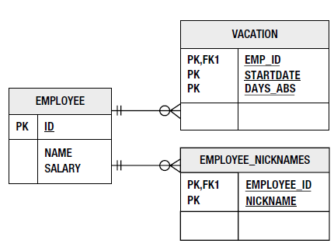

## Different collection types

We can use Collection, Set, List, Map

### Lists

Retrieve entity in pre-defined order

1. **Ordering by entity or element attribute - @OrderBy –** we can order more columns separated by comma. Column should be comparable. (ASC is default value it is not needed to write it down). We can also order by embedded fields.

* Employee has a field info and this field is type of EmbeddableInfo then => @OrderBy("info.name ASC").
* Multilevel ordering @OrderBy("status DESC, name ASC")

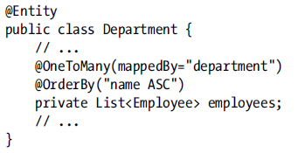

Simple changing the order of the items in a list in memory will not cause that order to be stored in the db at commit time.

1. **Persistently ordered lists - @OrderColumn**

Name is optional => default value is attribute name + _ORDER [JOBS_ORDER]

In many-to-many relations is order column in joinTable. There is problem due to update each row.

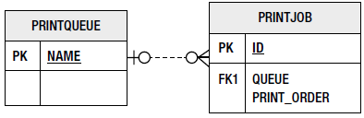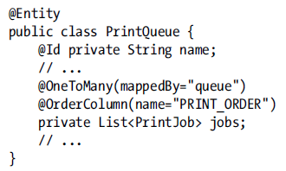

### Maps

1. If the values are entities maps has to be mapped one-to-many or many-to-many relationship
2. The values of map are either embeddable or basic types, map is mapped as an element collection
3. **Keying by basic type**

The keys will be stored in the same collection table in which the Map values are stored. Likewise, if it is a one-to-many relationship, and the foreign key is in the target entity table, the keys will be in the target entity table. If the relationship mapping uses a join table, the keys will be in the join table

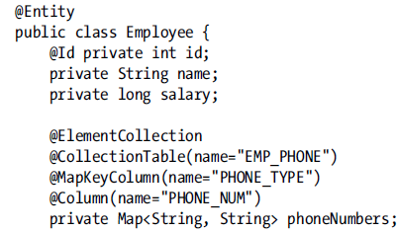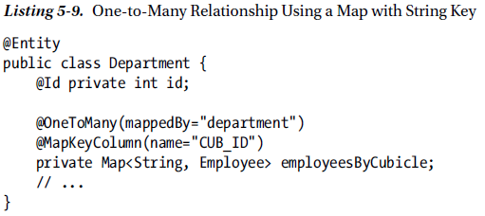

@MapKeyColumn – indicate the column in the collection table that stores the basic key. When this annotation is not specified the key is stored in a column named after the mapped collection attribute appended with the _KEY suffix [PHONENUMBERS_KEY].

@MapKeyEnumarated(EnumType.String), @MapKeyTemporal – are applicable to keys that are of a basic type

Many-to-Many relationship using a Map With strings, (CUB_ID will be stored in join table). Map can be used only on one side of a many-to-many relationship, it make no difference on which side.

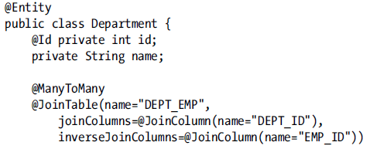



1. **Keying by Entity Attribute**