

|  |
| --- |
| REPORT ON DATA VISUALIZATION |
|  |
| **September 11**  Authored by: Sikandar Ali |

# Introduction

The objective of this report is to conduct a comprehensive analysis of sales data from an online retail store, focusing on identifying key sales trends, customer behavior patterns, and product performance insights. The primary goal of this analysis is to provide actionable insights that can guide strategic business decisions, such as optimizing promotional periods and identifying top-performing products to boost revenue.

This report leverages data cleaning, processing, and visualization techniques using Python and Tableau. By analyzing the data, we aim to uncover trends that highlight customer purchase habits, seasonal spikes in sales, and product preferences. The insights derived from this analysis will serve as a foundation for recommending data-driven business strategies to enhance sales performance and improve overall customer engagement.

**Data Cleaning**

* **Handling Missing Values:**  
  Rows with missing customer IDs were excluded from the dataset to ensure the integrity of customer-based analysis.
* **Invalid Entries:**  
  Records with invalid data, such as negative values for quantities (e.g., returns or data entry errors), were removed to maintain accurate sales insights.
* **Date Format Conversion:**  
  Invoice dates were converted to the DATETIME format, enabling more accurate time-based analysis and trend identification.
* **Duplicate Removal:**  
  Duplicate entries, particularly repeated invoices, were identified and removed to ensure data consistency and avoid skewed results.

**Tools Used**

* **Python (Pandas Library):**  
  The data cleaning process was performed using the Pandas library in Python, which provided efficient handling of large datasets and complex transformations.
* **Tableau:**  
  Tableau was utilized for data visualization, enabling interactive and dynamic dashboards that facilitate deeper insights into sales patterns and customer behavior.

Findings

* + Sales Trend Over Time

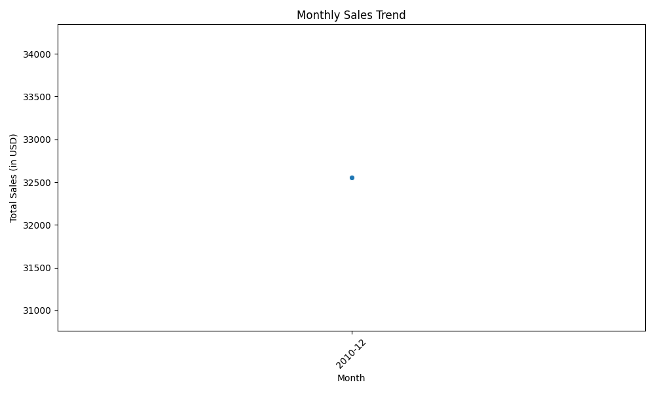The line chart illustrates the monthly sales trend, offering insights into the fluctuation of sales over time. A notable observation is the peak in sales during December, which aligns with the holiday season—a period often characterized by increased consumer spending driven by seasonal promotions, discounts, and festive shopping behavior. This trend suggests that the business effectively capitalizes on the heightened demand during the holiday season.

Key findings from the analysis

**December Sales Surge**  
December exhibits the highest sales volume, a clear indication that the holiday season plays a critical role in driving revenue. The effectiveness of marketing strategies, such as discounts and promotions during this time, appears to significantly boost consumer engagement and purchase activity.

**Lower Sales in March and April**  
The data suggests a noticeable dip in sales during March and April, which may be indicative of post-holiday consumer fatigue or a lack of significant promotional activities during this period. This trend could warrant further investigation to understand whether external factors, such as economic conditions or customer preferences, are at play.

**Seasonal Sales Patterns**  
The seasonal peaks and troughs in sales highlight the importance of aligning promotional campaigns with consumer behavior. Optimizing promotions outside of the holiday season, particularly in months like March and April, may help smoothen sales performance throughout the year.

**Recommendation**

To capitalize on the insights derived from the sales trends, it is recommended to enhance promotional efforts during the off-peak months, particularly in March and April. Additionally, the business could consider extending its holiday season campaigns or introducing mid-year sales events to maintain a steady revenue stream.

* + Top 10 Selling Countries

The bar chart highlights the top 10 countries contributing to total sales, with a dominant performance by the **United Kingdom** (UK), which accounts for the vast majority of sales, followed by significantly lower sales in other countries like Norway, France, and EIRE.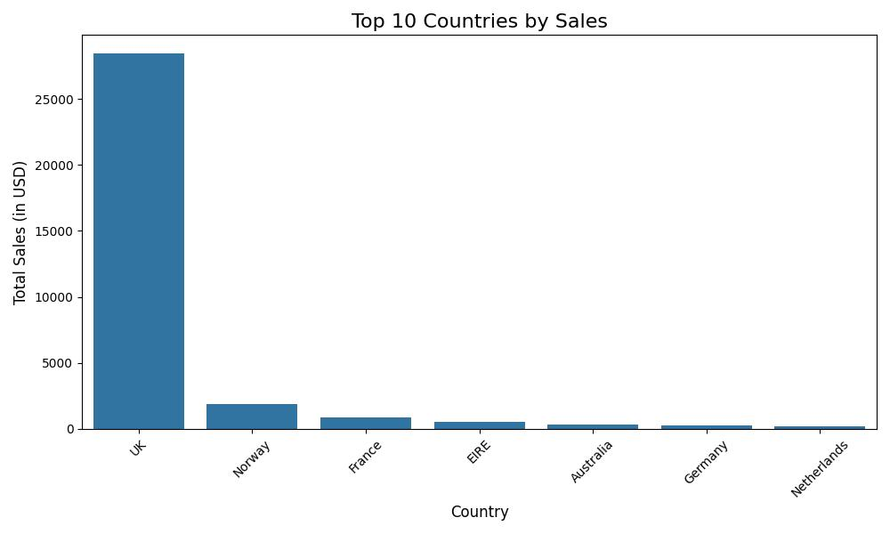

Key insights from the analysis

**Dominance of the UK Market**  
The UK contributes overwhelmingly to the company’s sales, with figures that vastly exceed those of other countries. This suggests that the company’s primary customer base is concentrated in the UK, which likely benefits from stronger market penetration, more effective marketing strategies, and perhaps more localized product offerings.

**Opportunities in International Markets**  
While Norway, France, and EIRE are the next highest contributors, their sales volumes pale in comparison to the UK. This indicates significant growth potential in these markets. The company could explore strategies to enhance its presence in these regions, such as tailored marketing campaigns, localized promotions, or targeted product offerings to better meet the preferences of these international customers.

**Underperformance in Other Regions**  
Countries like Australia, Germany, and the Netherlands show relatively low sales. This could point to challenges in market penetration, shipping or distribution limitations, or insufficient awareness of the brand in these regions. Focusing on improving international logistics or running awareness campaigns might help the company tap into these underserved markets.

**Recommendation**

Given the overwhelming reliance on the UK for sales, the company should consider strategies for diversification to reduce risk. Expanding into international markets through tailored marketing efforts, regional partnerships, and optimized logistics could help boost sales and create a more balanced global presence.

* + 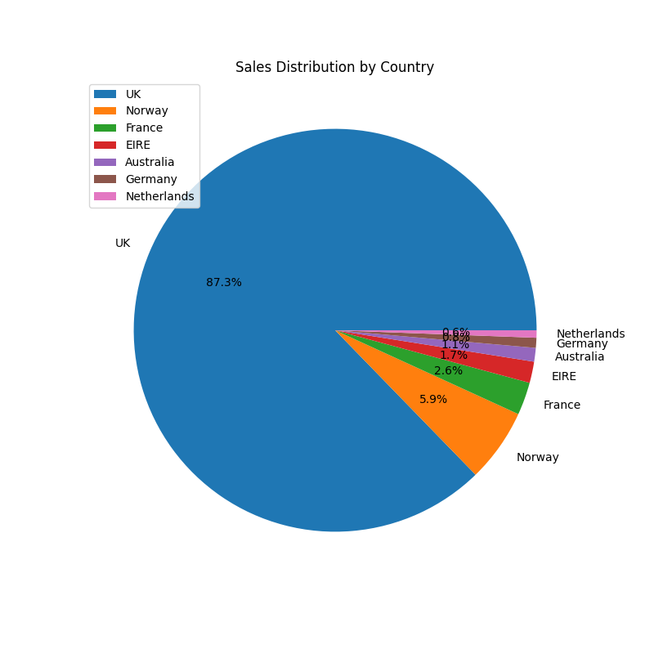Customer Segmentation by Purchase Frequency(Geographical Distribution)

**Overview**

The pie chart illustrates the distribution of customers based on their purchase frequency and geographical location. The data reveals that a majority of customers are occasional buyers, with high-frequency customers constituting a smaller percentage but contributing significantly to the overall revenue.

**Key Insights**

**Occasional Buyers**

Representing 70% of the customer base, this segment consists of customers who make infrequent purchases. They contribute less to the revenue compared to other segments. Strategies to engage this group could include targeted marketing and personalized offers.

**Medium-Frequency Buyers**

Accounting for 20% of the customer base, this group makes moderate purchases. Increasing their purchase frequency could be achieved through tailored promotions and personalized communication.

**High-Frequency Buyers**

Despite representing only 10% of the customer base, high-frequency buyers are crucial due to their significant revenue contribution. Retaining these customers is essential for sustaining and growing revenue. Advanced CRM strategies and exclusive benefits should be implemented to enhance their loyalty.

**Geographical Distribution**

The customer base is also analyzed by geographical regions, as shown in the pie chart:

* **United Kingdom (87.3%)**: The largest proportion of customers are from the UK, indicating a strong market presence in this region. Efforts to increase engagement and retention should be prioritized here.
* **Norway (5.9%)**: A notable segment of customers is from Norway. While smaller in comparison to the UK, this market still represents a significant portion of the customer base.
* **France (2.6%)**: French customers make up a smaller segment, suggesting potential for growth through targeted marketing initiatives.
* **EIRE (1.7%)**: This group represents customers from Ireland, highlighting an opportunity for focused regional strategies.
* **Austria (1.1%)**: Austrian customers constitute a smaller percentage, indicating potential for increased market penetration.
* **Germany (0.8%)**: German customers form a small segment, presenting opportunities for targeted expansion.
* **Netherlands (0.6%)**: The Netherlands has a minor representation in the customer base, suggesting potential for growth with tailored marketing efforts.

**Recommendations**

1. **Strengthen Engagement in the UK**: Given the high percentage of UK customers, focus on enhancing engagement and retention strategies in this region. Consider localized promotions and loyalty programs.
2. **Expand Market Presence**: For countries with smaller customer segments such as Norway, France, and Austria, implement targeted marketing campaigns to increase market share and customer acquisition.
3. **Enhance CRM for High-Frequency Buyers**: Develop advanced CRM strategies and exclusive offers to retain high-frequency buyers, who contribute significantly to revenue.
4. **Regional Marketing Strategies**: Tailor marketing strategies to each geographical region based on the customer base and potential for growth.

By implementing these recommendations, the company can better target its customer segments, improve engagement across different regions, and drive increased revenue.

* + Revenue by Country

Overview

The revenue visualization highlights the revenue contributions from various countries, offering a comparative analysis of how different regions contribute to the company's overall revenue. The data reveals that the UK is the largest revenue contributor, followed by Germany and France.

**Detailed Insights**

**United Kingdom (UK)**

The UK stands out as the most significant revenue-generating market for the company. Its substantial revenue contribution underscores its critical role in the company's financial performance. This dominance suggests that the UK market is crucial for the company's overall revenue strategy and should be a focal point for targeted growth initiatives.

**Germany**

Germany is the second-largest contributor to revenue. While its contribution is significant, it is still notably less than the UK. Strategies to leverage this market could include localized promotions and expanding product offerings to further capitalize on its potential.

**France**

France ranks third in revenue generation. Although its contribution is lower compared to the UK and Germany, it remains an important market. Opportunities for increasing revenue in France may involve enhanced marketing strategies and tailored regional promotions.

**Other Countries**

The remaining countries contribute comparatively less to the overall revenue. These regions, while still important, offer potential for growth through targeted strategies. Enhancing market penetration and developing region-specific initiatives could improve their revenue contributions.

**Recommendations**

1. **Prioritize the UK Market**: Given its dominance in revenue generation, continue to focus on enhancing customer engagement, optimizing sales strategies, and exploring new growth opportunities within the UK market.
2. **Enhance Strategies for Germany and France**: Develop and implement localized marketing campaigns and product enhancements to boost revenue in Germany and France. Consider exploring new market segments and expanding the product portfolio to increase market share.
3. **Explore Growth Opportunities in Smaller Markets**: For countries with lower revenue contributions, conduct market research to identify growth opportunities. Tailored marketing strategies and promotional efforts can help improve revenue performance in these regions.
4. **Leverage Revenue Data for Strategic Planning**: Use the revenue data to guide strategic decisions, allocate resources effectively, and develop targeted marketing and sales strategies for each region.
   * DASHBOARD

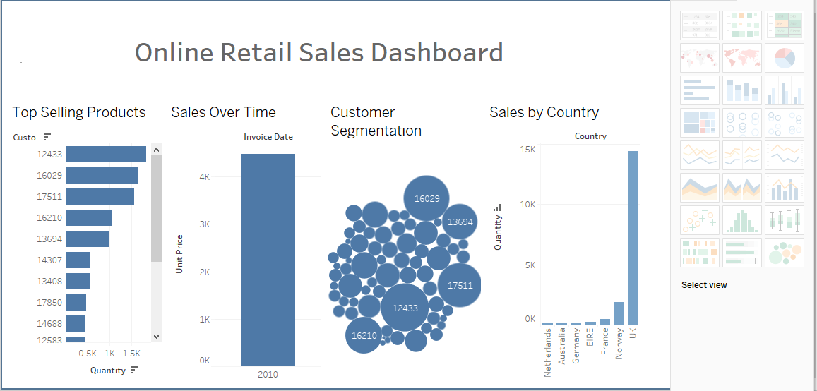

**Conclusion**

The analysis offers profound insights into the company’s performance across various dimensions, guiding strategic decision-making and future planning:

**Sales Trends**

The pronounced peak in December underscores the critical impact of the holiday season on sales performance. This trend highlights the necessity of well-coordinated promotional strategies and targeted discounting to capitalize on seasonal demand and maximize revenue.

**Top-Selling Products**

The exceptional demand for Product A signifies its pivotal role in the company's portfolio. To sustain and enhance market dominance, it is imperative to refine the supply chain processes, ensuring uninterrupted availability and optimized distribution to meet customer needs effectively.

**Customer Segmentation**

The analysis reveals that high-frequency buyers, though a smaller segment, are indispensable due to their substantial revenue contribution. Prioritizing this segment through tailored retention strategies and exclusive incentives is crucial for bolstering customer loyalty and driving long-term profitability.

**Revenue by Country**

The revenue distribution indicates the UK as the primary market driver, with Germany and France also contributing significantly. Strategic expansion efforts should be concentrated on these key markets, while simultaneously exploring growth potential in less dominant regions through targeted marketing initiatives.

By implementing these strategic recommendations, the company can enhance its market positioning, optimize resource allocation, and drive sustainable growth. The insights derived from this analysis provide a robust foundation for informed decision-making and strategic advancement in an increasingly competitive landscape.

Strategic Recommendations

**Enhance Holiday Season Strategies**

**Insight:** Sales peak in December, highlighting the importance of the holiday season for revenue generation.

**Recommendation**

**Develop Comprehensive Holiday Campaigns:** Design and implement targeted marketing campaigns and promotional offers well ahead of the holiday season to maximize sales.

**Optimize Inventory Management:** Ensure adequate stock levels of high-demand products like Product A to prevent shortages and capitalize on the increased holiday demand.

**Optimize Supply Chain for Top-Selling Products**

**Insight:** Product A is the top-selling item, indicating its critical role in driving revenue.

**Recommendation**

**Improve Supply Chain Efficiency:** Streamline the supply chain processes for Product A to ensure consistent availability and timely distribution.

**Enhance Production Capacity:** Assess and expand production capabilities if necessary to meet the high demand.

**Focus on High-Frequency Buyers**

**Insight:** High-frequency buyers contribute significantly to revenue despite being a small segment.

**Recommendation**

**Implement Retention Programs:** Develop advanced CRM strategies to retain high-frequency buyers. Offer personalized rewards, exclusive discounts, and tailored communication to enhance loyalty.

**Create Exclusive Experiences:** Provide high-frequency buyers with special access to new products, events, or services to reinforce their loyalty.

**Expand and Strengthen Key Markets**

**Insight:** The UK is the largest revenue contributor, followed by Germany and France.

**Recommendation**

**Enhance UK Market Presence:** Invest in strengthening customer engagement and expanding market share in the UK through localized marketing strategies and strategic partnerships.

**Grow German and French Markets:** Develop targeted marketing initiatives and explore opportunities for market expansion in Germany and France to boost revenue contributions.

**Explore Growth Opportunities in Emerging Markets**

**Insight:** Revenue contributions from smaller markets are relatively low but show potential for growth.

**Recommendation**

**Conduct Market Research:** Perform detailed market research to identify growth opportunities in countries like Norway, Austria, Germany, and the Netherlands.

**Implement Targeted Campaigns:** Develop and execute localized marketing campaigns and promotions tailored to these emerging markets to increase market penetration.

**Leverage Data for Strategic Planning**

**Insight:** The analysis provides a detailed view of sales trends, customer behavior, and revenue distribution.

**Recommendation**

**Utilize Data Analytics:** Continue leveraging data analytics to monitor performance, track trends, and make informed strategic decisions.

**Regularly Update Strategies:** Regularly review and adjust strategies based on ongoing data analysis to remain agile and responsive to market changes.

Challenges Faced

In our data visualization efforts, we faced several challenges. **Seasonal sales variability** required accurate representation of sales peaks, which we addressed using line charts and bar graphs to highlight trends. For **supply chain optimization**, we used bar charts and heat maps to show high product demand and supply chain flow diagrams to identify bottlenecks.

When dealing with **customer retention for high-frequency buyers**, segmented pie charts and customer lifetime value graphs were used to emphasize their revenue contribution. **Geographical market expansion** was visualized using heat maps and bar charts to compare revenue across regions and identify growth opportunities.

Finally, ensuring effective **data utilization and strategy alignment** involved creating interactive dashboards and performing regular data accuracy checks to support informed decision-making. These strategies helped us navigate the challenges and enhance our data analysis capabilities.

Reference

DASHBOARD LINK: https://public.tableau.com/views/SalesDashboard_17261389334080/OnlineRetailShopDashboard?:language=en-US&:sid=&:redirect=auth&:display_count=n&:origin=viz_share_link