**I. Overview of Project**

An analysis on successful, canceled, and failed outcomes was done for Louise to cross compare factual findings to best compare the best way to move forward with investing into different outlets. Performing the analysis there were evident results that we can draw upon. For instance, we can see that the data is heavily leaning towards outcomes in the months of May, June, and July in the case of theater outcomes based on launch dates. Outcomes based on goals, demonstrated a loose inverse relationship between fails and successes.

**II. Purpose**

The purpose of analyzing the data was to display the fluctuation of percentage changes depending on the month that the campaign launched. Judging from the data, one can deduce that certain months in comparison to another, had a tendency of performing better (May’s high success compared to November). The data can also be cross compared to show cross comparison between successes, failures, and cancellations by goal.

**III. Analysis and Challenges**

The ‘Theater Outcomes Based on Launch Date’ demonstrates a trend of successful outcomes from March through May, and then a gradual decline until the end of the year. From our ‘Outcomes Based on Goal,’ the percentage of successful goals gradually declines as the goal gradually increases.

**IV. Analysis of Outcomes Based on Launch Date**

The analysis shows a up-down trend from January until May where the successful outcomes pick up significantly till 111 but then gradually decline to December at a low of 37.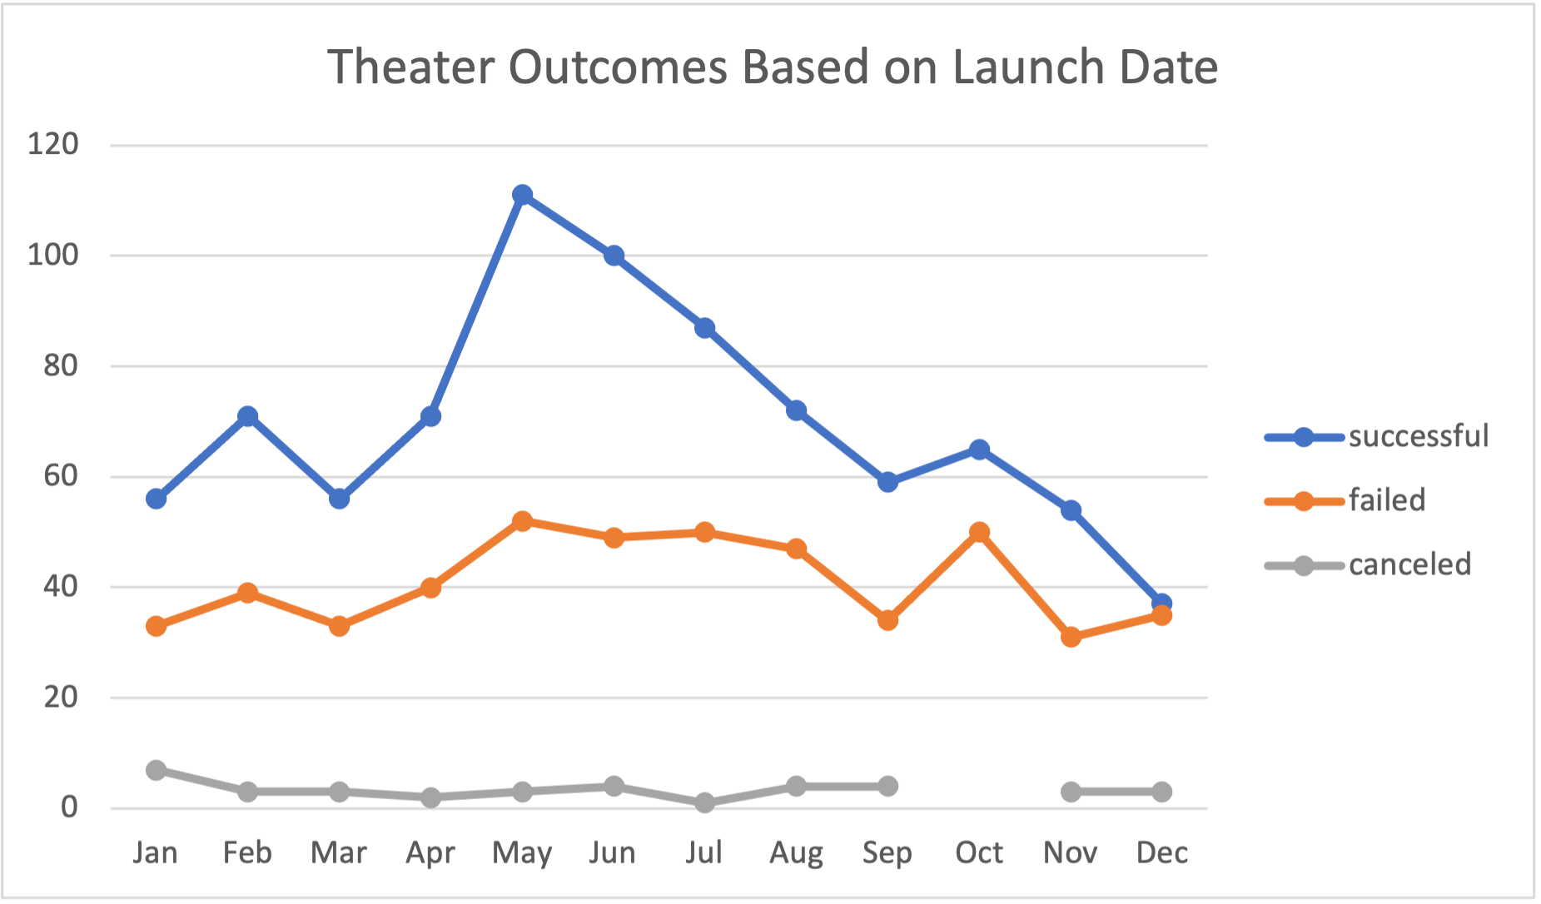

**V. Analysis of Outcomes Based on Goals**

The goals show almost a defined inverse relationship. As the monetary goal increases, the success rate decreases. This can be seen from the gradual decline in success rates from less than 1,000 to 2,999. A slight uptick occurs until it drops off completely around 45000.

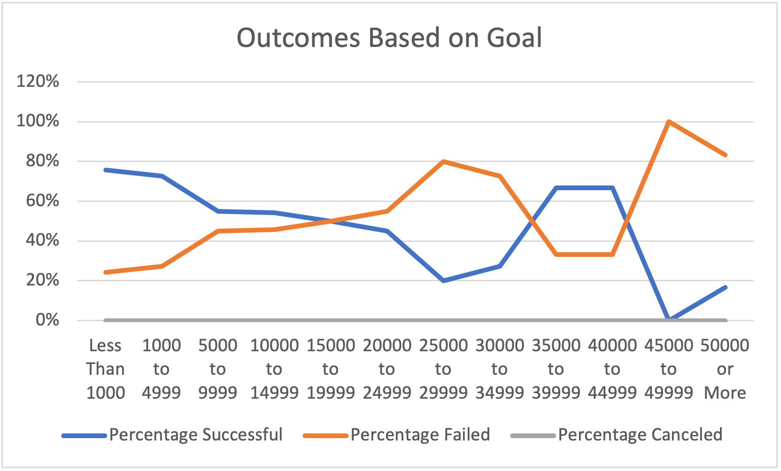

**VI. Challenges and Difficulties Encountered**

As far as challenges, the data was straightforward and the main hurdle I had to overcome was setting up the formulas in order to get the correct data to analyze.

**VII. Results**

The Outcomes Based on Goal chart represents a different story to us. There appears to be a slight inverse relationship between successful and failed goals. When the goal rate was less than $1,000, the success rate was rather high relative to the fail rate, but when we look at the inverse relationship we can see that the percentage failed is dramatically greater than that of the success percentage.

Some limitations of the dataset could be the amount of data being held for this purpose. Excel could only handle so much data before it starts to lag. We had around 4,000 rows of data but if we would've had a larger pool of data we could have done a deeper dive into the data analysis of what was represented.