## Problem 2 – Quotes Page

Create a Web site (HTML5 + CSS3 + images) that looks and behaves like the screenshots below:

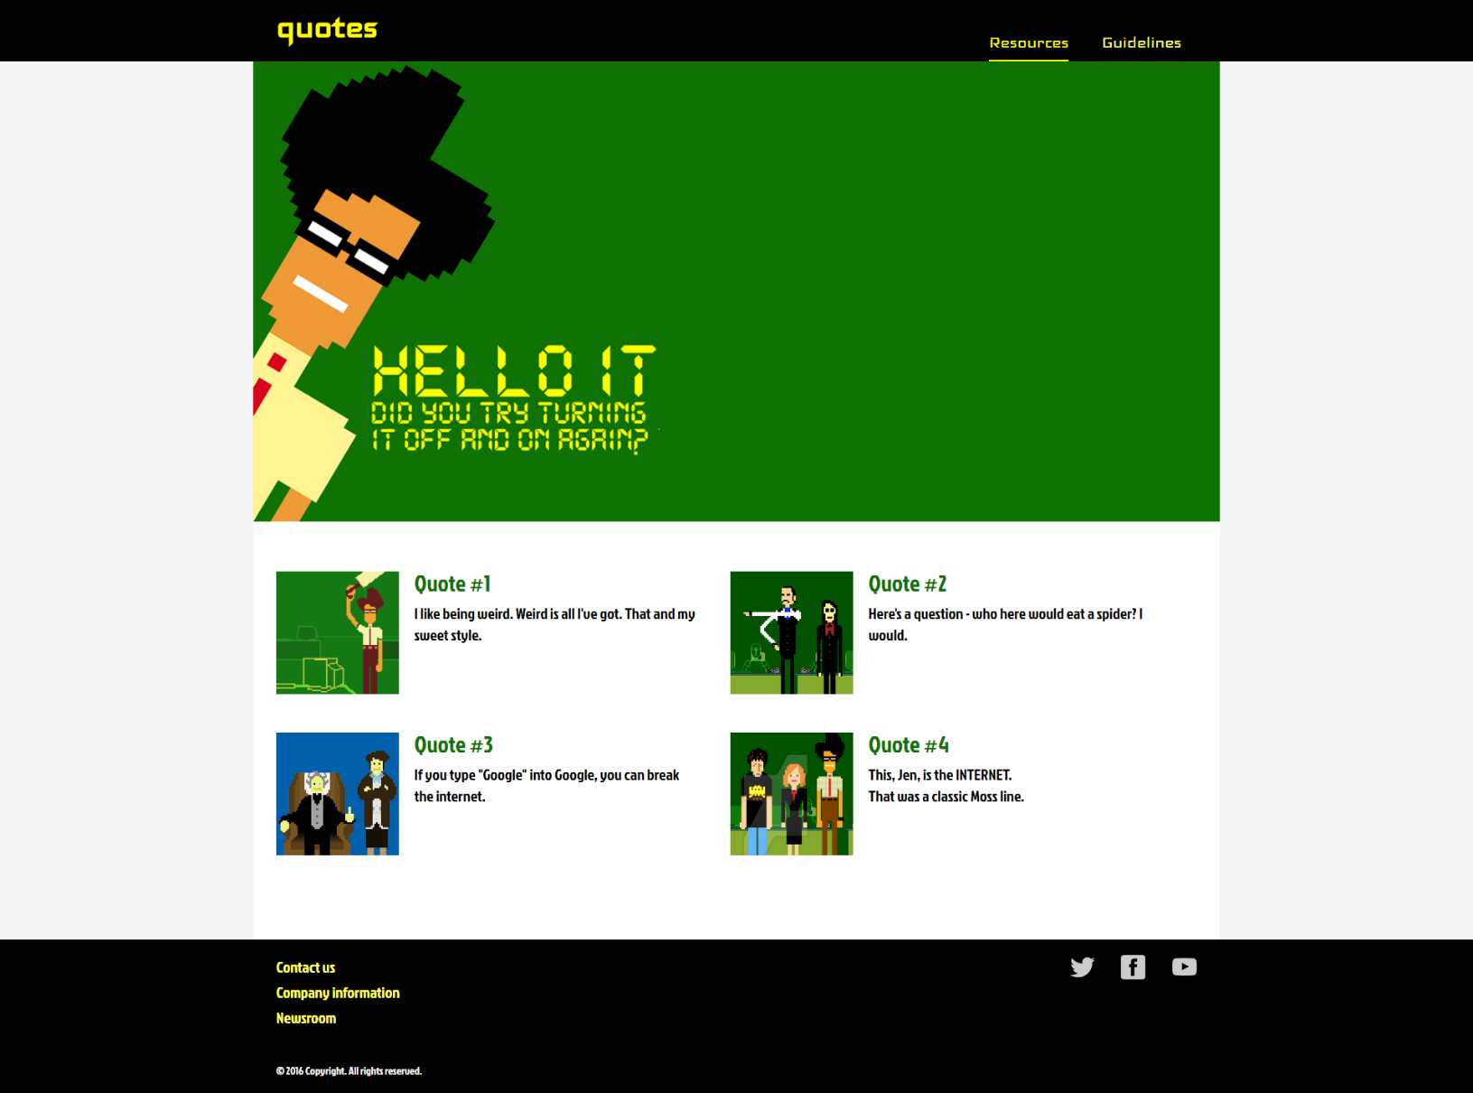

### Example

<https://invis.io/R38PWNYVP#/191479307_02-Preview>

### Input

You are given the above screenshots + the texts on the site + the images.

### Output

The output should be valid HTML5 + CSS3 + images that implement the above Web site.

### Constraints

* Fonts:
  + Default font: 20px; 'Jockey One', sans-serif; <https://fonts.googleapis.com/css?family=Jockey+One>" checked
  + Top nav and logo font: 'Iceland', cursive;
  + <https://fonts.googleapis.com/css?family=Iceland>" checked
  + Top nav font: 26px;
  + Logo: 50px;
  + Green titles: 30px;
  + Copyright text: 14px;
* Layout: fluid; Header is fixed; Header and footer are 100%; Content has max-width 1260px.
* The site should open correctly in Chrome 35.
* Responsive design is not required.
* Pixel-perfect implementation is not required.