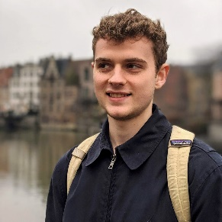

@alexanderameye

alexanderameye.github.io

+32 487 17 61 04

alexanderameye@gmail.com

**ALEXANDER AMEYE**

I am eager to learn and have an entrepreneurial spirit. I want to be part of a motivated team and strive for excellence in what I create. I am a dynamic team player and enjoy human connections.

**EDUCATION**

**KU Leuven**

Leuven, Belgium | 2020 - 2021

Master in Electronics and ICT Engineering Technology

Internet Computing

Thesis - Editor tool for an augmented reality tourist map.

**Relevant Coursework:** Machine Learning, Media Processing, Games & Tangibles, Fundamentals of Computer Graphics

Leuven, Belgium | 2017 - 2020

Bachelor’s in Engineering Technology

Electronics and ICT

**Relevant Coursework:** Object-Oriented Programming and Databases, Software Development

**Sungkyunkwan University**

Seoul, South Korea | 2019

Erasmus student exchange

College of Software

**Relevant Coursework:** Computer Networks, Introduction to Computer Architectures, Operating Systems

**EXPERIENCE**

**Freelance** /*Graphics Programmer*

2015 - Present

Designing, creating, and publishing several graphical assets for the Unity Asset Store inside of a highly competitive market segment. Also doing commissioned work for client studios.

**Leveraged Knowledge:** C#, Shader Programming, UI/UX Design, Customer Support, Project Management, Community Management, Marketing

**KU Leuven Buddy Project** /*Buddy*

2018 - 2020

I was paired with incoming international students and guided them on a practical and social level.

**PAL Project** /*Tutor*

2019

I worked as a teaching assistant in the peer assistant learning project for a Python programming course.

**LANGUAGES**

Dutch | native

English | fluent

French | intermediate

**CODE**

Java

C++, C#

Python

SQL

HLSL

**TOOLS**

Unity3D

Blender

Android Studio

Adobe Illustrator

MS Office

**ACHIEVEMENTS**

**Unity Awards 2020** /*Best artistic tool*

Nominee

In recognition of my asset Stylized Water For URP