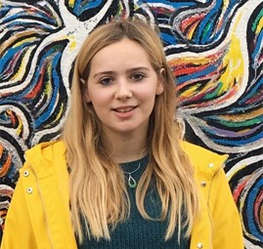

**MARLIES VANDERSNICKT**

I am eager to learn and have an entrepreneurial spirit. I want to be part of a motivated team and strive for excellence in what I create. I am a dynamic team player and enjoy human connections.

+32 479 69 67 75

marlies.vandersnickt@student.kuleuven.be

**EXPERIENCE**

**EDUCATION**

**COVID-19 Outbreak Response Team**

KU Leuven | 2020

**KU Leuven**

Leuven, Belgium | 2020 – 2022

Master in Medicine

Leuven, Belgium | 2016 – 2019 | Summa cum laude

Bachelor in Medicine

**COVID-19 Steward**

Nieuwpoort Stad | 2020

**Student-Research Abdominal Transplantation**

KU Leuven | 2019 - 2020

**First Aid Responder**

Red Cross | 2018 - Present

**Extracurricular Courses**

KU Leuven | 2020

Medical English

KU Leuven | 2019

Tropical Medicine

KU Leuven | 2019

Certificate Laboratory Animal Science

Red Cross | 2019

First Aid Course

Red Cross | 2018

First Aid Responder Course

KU Leuven | 2017 - 2018

Biomedical Development Cooperation

**Unit Heart for Life**

BeMSA Leuven | 2018

**Peer Tutorship OPO Metabolisme**

KU Leuven | 2017 - 2018

**Student Job Administration**

Brabantse Golf | 2014 - 2019

**Blood -and Plasmadonor**

**LANGUAGES**

Dutch | native

English | fluent

French | intermediate

**INTERESTS**

Medicine

Golf | selectie jong Vlaanderen

Violin