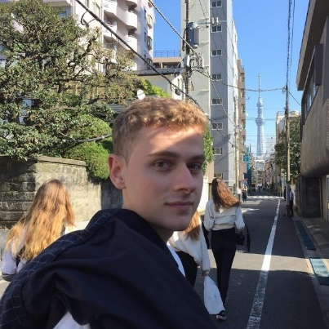

**ALEXANDER AMEYE**

I am eager to learn and have an entrepreneurial spirit. I want to be part of a motivated team and strive for excellence in what I create. I am a dynamic team player and enjoy human connections.

@alexanderameye

alexanderameye.github.io

+32 487 17 61 04

alexanderameye@gmail.com

**EXPERIENCE**

**EDUCATION**

**AE** /*Software engineer*

Summer 2021

Worked on the AI powered data intelligence engine ‘Adore’ as a full-stack software engineer during a summer internship.

**Leveraged Knowledge:** Micro-service-oriented architectures, JavaScript front-end frameworks, Docker, CI/CD, TDD, Scrum

**KU Leuven**

Leuven, Belgium | 2021 - 2022

Master of Engineering – Computer Science

Additional year of study

**Relevant Coursework:** Distributed Systems, Comparative Programming Languages, Image Analysis and Understanding, Software Architecture

Leuven, Belgium | 2020 - 2021

Master in Electronics and ICT Engineering Technology - Internet Computing

Thesis - Editor tool for an augmented reality tourist map.

**Relevant Coursework:** Fundamentals of Computer Graphics, Media Processing, Machine Learning

Leuven, Belgium | 2017 - 2020

Bachelor’s in Engineering Technology

Electronics and ICT

**Master’s Thesis** /*Developer*

2020 - 2021

Development of an editor tool facilitating the design and creation of augmented reality experiences in the context of an interactive city tour.

**Leveraged Knowledge:** C#, Mobile AR, UI/UX Design, Project Management, API design

**Freelance** /*Graphics Programmer*

2015 - Present

Designing, creating, and publishing several assets for the Unity Asset Store inside of a highly competitive market segment. Combined with creating commissioned rendering solutions for client studios.

**Leveraged Knowledge:** C#, Shader Programming, UI/UX Design, Community Management, Marketing

**Sungkyunkwan University**

Seoul, South Korea | 2019

Erasmus student exchange

College of Software

**Relevant Coursework:** Computer Networks, Introduction to Computer Architectures, Operating Systems

**KU Leuven Buddy Project** /*Buddy*

2018 - 2020

I was paired with incoming international students and guided them on a practical and social level.

Dutch | native

English | fluent

French | intermediate

**CODE**

**LANGUAGES**

**RECOGNITION**

**Unity Awards 2020** /*Best artistic tool*

Nominee

In recognition of my asset *Stylized Water For URP.*

C#, C++, Java, Rust

JavaScript, TypeScript, CSS

HLSL

**TOOLS**

Computer graphics

Unity3D, Blender

Android Studio

Git, Docker, k8s

**INTERESTS**