Akbarhon Avazkhodjayev

Mobile Apps

Homework 8

10/30/2020

<https://github.com/AlexanderAvazkhodjayev/hw8>

<https://github.com/AlexanderAvazkhodjayev/hw8>

GitHub with Android Studio Guide (10 points)

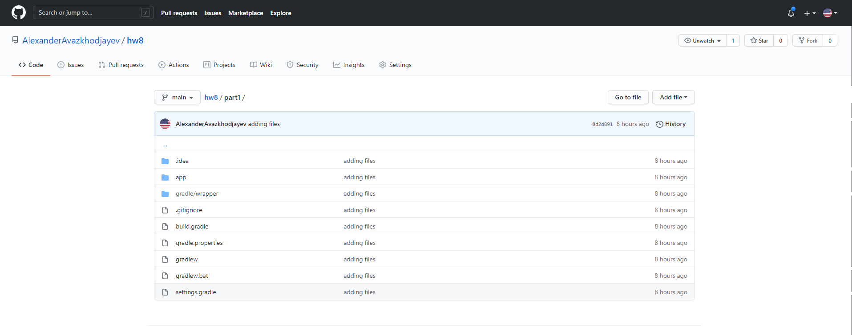

Navigation Guides (20 points / 10 points each)

Part One

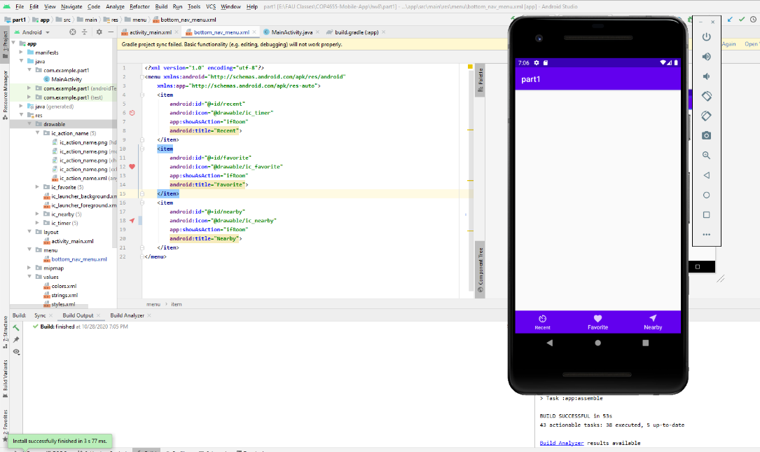

Part Two

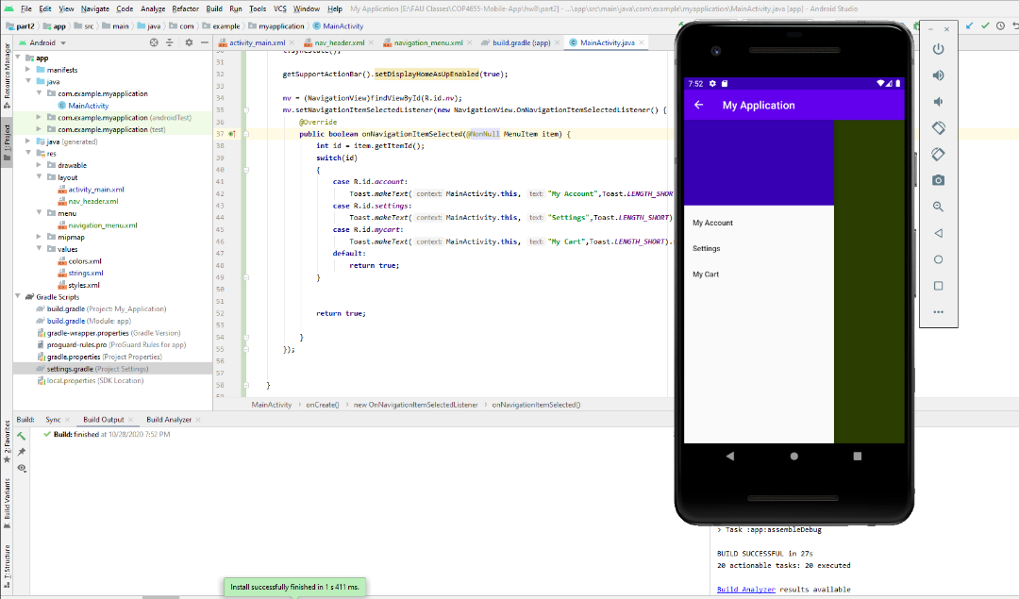

Text to Speech App Guide (10 points)

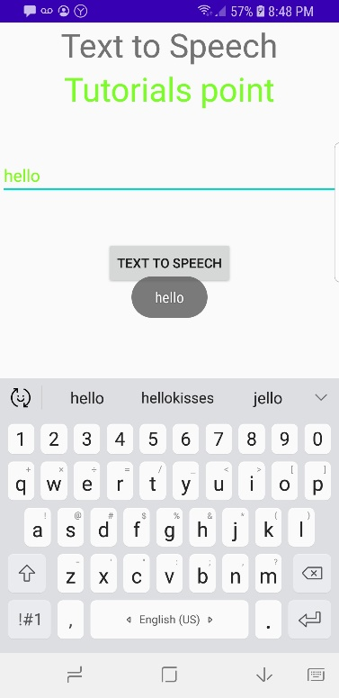

Speech to Text App Guide (10 points)

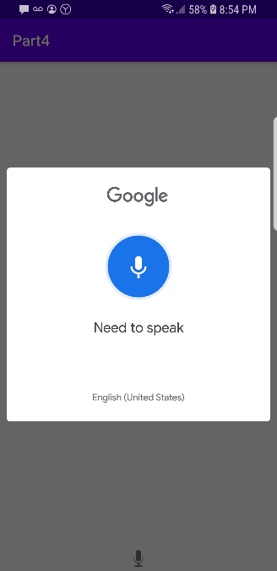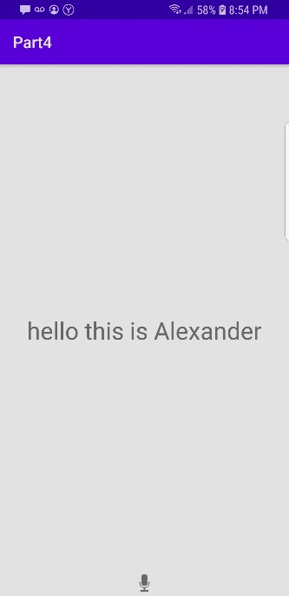

Conclusion

Parts 1-4 were easy and just a matter of following instructions.

**Multi-Activity App (50 points / 10 points for GitHub / 10 points each for 4 Activities)**

**IMAGES**

History Page Speech-To-Text Text-to-Speech(Left) Text-to-Speech(Right)

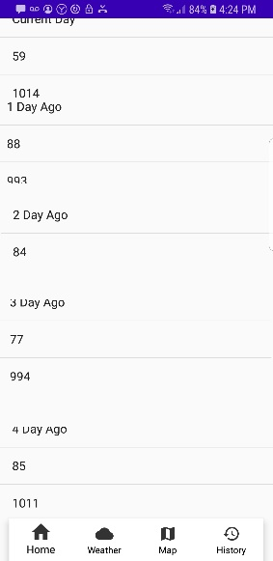 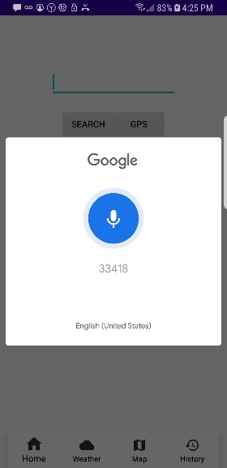 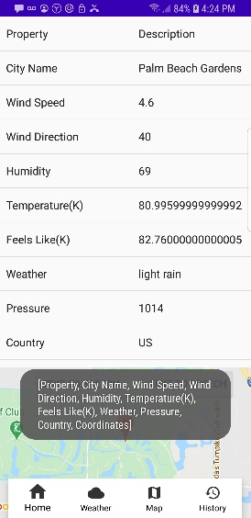 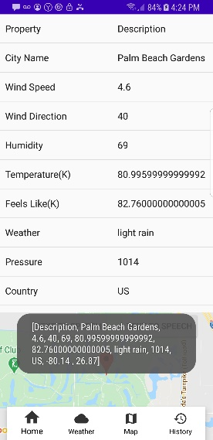

Maps Button CityName GPS

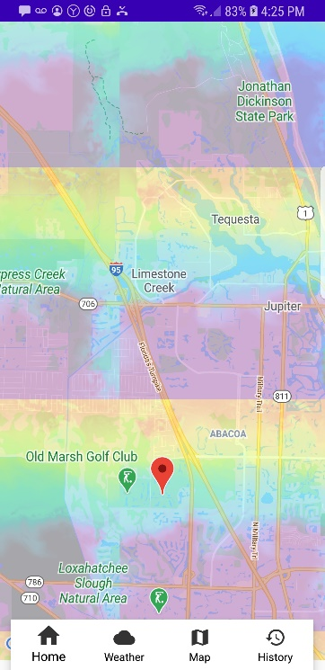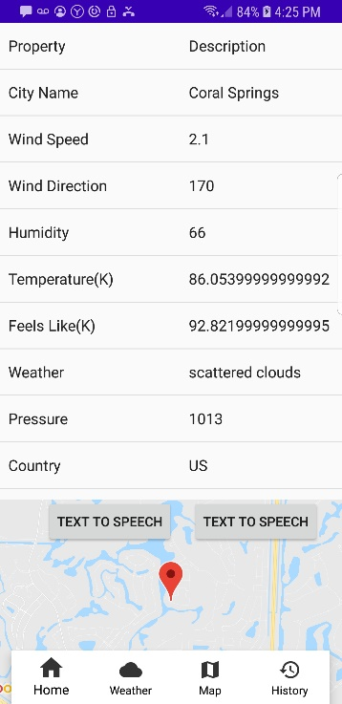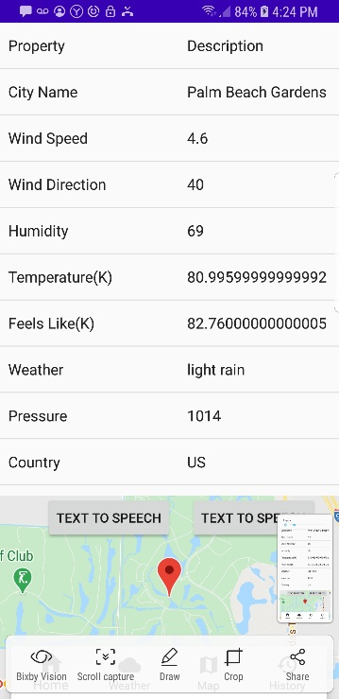

Zip Code Zip Code Cont.

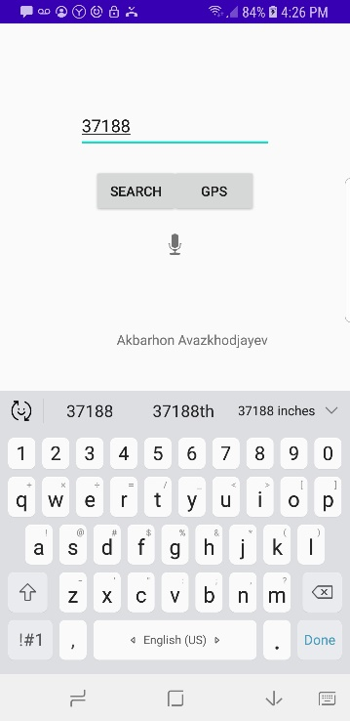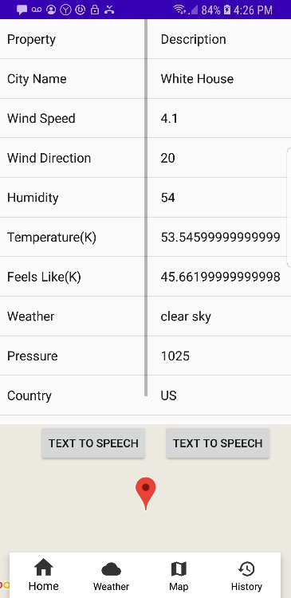

Actual Code – On GitHub

<https://github.com/AlexanderAvazkhodjayev/hw8>

**Conclusion /w Errors and Solutions**

MainActivity Explanation(Home tab)

This section had two buttons(search and gps) and the speech to text. Implementing these three buttons was a matter of going back to hw7 and getting the code. Getting the speech to text was a matter of following the guide. Each button had an onclick listener so when it was pressed, it would do a certain action like send the input data, get GPS Coords, and pull up the speech to text feature.

Weather Explanation(weather tab)

This page had the data from the json request. Volley was used to send the request and receive the response which was manipulated to get the 10 data points. There were two buttons to read the data from the two listviews. The map which is a fragment contains the map which takes in lat and long coords from the GPS tracker class. The bottom navigation is at the bottom for all the activities. There is an intent for each of the four activities. The two buttons for text to speech have on click event listeners.

Map Explanation(map tab)

Implementing the map was a matter of copying the code provided by the professor and getting the lat and long from the weather data class. Other than following the instructions, implementing the API link was easy.

History Explanation(history tab)

In order to show the 5 different days I used 5 different listviews. Each list view had how many days the data is old and the humidity and pressure values. Furthermore, there was 5 different links to the api call and 5 different volley api get request calls. This section was super repetitive. Other than copying and pasting the code five times, it was simple overall.

Issue 1: 5 Day History Solutions

**long** oneDay = 24 * 60 * 60;  
**long** currentDay = System.*currentTimeMillis*() / 1000L;  
**long** fourthDay = currentDay - oneDay;  
**long** thirdDay = currentDay - 2 * oneDay;  
**long** secondDay = currentDay - 3 * oneDay;  
**long** firstDay = currentDay - 4 * oneDay;

Solution: Create a variable onDay which is the amount of seconds in a day as shown above. Then set the current day to the current time in UNIX as shown above. Then create 4 different variables for the previous four days.

Issue 2: Fixing the public static class

Problem: In order to get the data saved in the class, you need an if statement as shown below to make sure the data isn’t null. If the data shows NULL then the app will crash

Solution:

WeatherData w = weather.*getWeatherData*();  
**if**(w != **null**) {  
 **lat_value** = Double.*parseDouble*(w.**Lat**);  
 **long_val** = Double.*parseDouble*(w.**Long**);  
}**else** {  
  
}

Issue 3: Saving the Lat and Long variable to public static class to access for map and history

Problem: In order to access the lat and long value from different activities you can implement the solution below. Or you can call the GPS Tracker and rewrite all the code which would be unnecessary and clutter the code.

Solution:

In WeatherData.java file-

**public class** WeatherData {  
 **public** String **cityName**;  
 **public** String **windSpeed**;  
 **public** String **windDirection**;  
 **public** String **humidity**;  
 **public** String **temperature**;  
 **public** String **feelsLike**;  
 **public** String **Lat**;  
 **public** String **Long**;  
 **public** String **coords**;  
  
}

In Main Activity file-

**public static** WeatherData *WeatherData*;  
**public static** WeatherData getWeatherData() {  
 **return** *WeatherData*;  
}

*WeatherData*.**Lat** = String.*valueOf*(json.getJSONObject(**"coord"**).getString(**"lat"**));  
*WeatherData*.**Long** = String.*valueOf*(json.getJSONObject(**"coord"**).getString(**"lon"**));

Issue 4: Maps not working

Solution 1: First Check if your API is in the meta tag as shown below. This meta tag should be in the manifest file.

<**meta-data  
 android:name="com.google.android.geo.API_KEY"  
 android:value="API KEY HERE NOT ABOVE "** />

Solution 2: Check if your ID to get the fragment is correct.

SupportMapFragment mapFragment = (SupportMapFragment) getSupportFragmentManager()  
 .findFragmentById(R.id.***map2***);  
mapFragment.getMapAsync(**this**);

Solution 3: Make sure the lat and long values are saved properly in the onMapReady function.

**public void** onMapReady(GoogleMap googleMap) {  
 **mMap** = googleMap;  
 **double** lat_value = 0;  
 **double** long_val = 0;  
 *// Add a marker in Sydney and move the camera* **if**(*WeatherData* != **null**) {  
 lat_value = Double.*parseDouble*(*WeatherData*.**Lat**);  
 long_val = Double.*parseDouble*(*WeatherData*.**Long**);  
 }**else** {  
 }  
 LatLng TutorialsPoint = **new** LatLng(lat_value, long_val);  
 **mMap**.addMarker(**new** MarkerOptions().position(TutorialsPoint).title(**"Tutorialspoint.com"**));  
 **mMap**.moveCamera(CameraUpdateFactory.*newLatLng*(TutorialsPoint));  
 **mMap**.animateCamera(CameraUpdateFactory.*newLatLngZoom*(TutorialsPoint,14));  
  
}

Issue 5: Basic Git Commands instead of going through Android Studio

Solution:

Step One: Go to where the git directory is.

Step Two: Track all files in your file type out the following: Git add .

Step Three: Commit the files and changes type out the following: Git commit -m “YOUR COMMENT HERE”

Step Four: Update changes to your remote repository type out the following: Git push