Peter the Great St. Petersburg

Polytechnic University

Laboratory work № 3

« Direct methods for the solution of linear systems»

Student: Andreev A.A.

Group: 3332301/90001

Lecturer: Kurtz V.V.

Saint-Petersburg

2021

Code for the GEM with pivoting strategy method:

n = 11

for t = 1:15

condition_number = 10^t;

a = sprandsym(n, 1, 1/condition_number);

x_exact = ones(n,1);

b = a * x_exact;

for k=1:n-1

stolb = a(k:end,k);

[m,z]=max(stolb);

z = z+(k-1);

strok = a(z,:);

buf = a(k,:);

a(k,:) = strok;

a(z,:) = buf;

b1 = b(z);

b_buf = b(k);

b(k) = b1;

b(z) = b_buf;

for i = k+1 : n

u = a(i,k) / m;

b(i) = b(i) - b(k)*u;

a(i,:) = a(i,:) - a(k,:)*u;

end

end

disp(a)

x(n) = b(n)/a(n,n)

for i=n-1:-1:1

sum = b(i);

for j=i+1:n

sum = sum-a(i,j)*x(j);

end

x(i) = sum/a(i,i)

end

error_relative(t) = norm(x_exact - x) / norm(x_exact)

c(t)= cond(a);

end

figure

loglog(c, error_relative, '*b--')

grid on

xlabel('condition_number')

ylabel('relative error')

Example with detailed calculations

n = 3

0.4387 0.7952 0.4456

a = 0.3816 0.1869 0.6463 x_exact = (1, 1, 1)

0.7655 0.4898 0.7094

1.6795

b = 1.2147

1.9646

Прямой ход

1 шаг:

0.4387

stolb = 0.3816 m = 0.7655 z = 3

0.7655

0.7655 0.4898 0.7094 1.9646

a = 0.3816 0.1869 0.6463 b = 1.2147

0.4387 0.7952 0.4456 1.6795

i =2

u = 0.4984

0.7655 0.4898 0.7094 1.9646

a = 0 -0.0572 0.2927 b = 0.2355

0.4387 0.7952 0.4456 1.6795

u = 0.5731

0.7655 0.4898 0.7094 1.9646

a = 0 -0.0572 0.2927 b = 0.2355

0 0.5145 0.0390 0.5535

3 шаг:

0.7655 0.4898 0.7094 1.9646

a = 0 0.5145 0.0390 b = 0.5535

0 0 0.2971 0.2971

Обратный ход:

x1 = 0.2971/0.2971 = 1

x2 = (0.5535-0.0390)/ 0.5145 = 1

x3 = (1.9646-0.7094-0.4898)/ 0.7655 = 1

The result of the program:

n = 11

t = 1

a =

(1,1) 0.2848

(6,1) -0.0000

(7,1) -0.0000

(8,1) -0.0000

(9,1) -0.0000

(10,1) -0.0000

(11,1) 0.0000

(1,2) 0.0886

(2,2) 0.1865

(1,3) -0.0241

(2,3) -0.1018

(3,3) 0.1873

(5,3) -0.0000

(6,3) 0.0000

(7,3) 0.0000

(8,3) -0.0000

(9,3) 0.0000

(10,3) -0.0000

(11,3) 0.0000

(1,4) 0.1856

(2,4) 0.1171

(3,4) -0.0301

(4,4) 0.2125

(1,5) -0.0224

(2,5) -0.0004

(3,5) -0.0432

(4,5) -0.0364

(5,5) 0.1229

(1,6) -0.0851

(2,6) -0.0064

(3,6) -0.1352

(4,6) -0.1386

(5,6) -0.0717

(6,6) 0.0142

(1,7) -0.1343

(2,7) 0.0053

(3,7) -0.2342

(4,7) -0.2107

(5,7) -0.1121

(6,7) 0.0671

(7,7) 1.3707

(8,7) -0.0000

(9,7) 0.0000

(10,7) -0.0000

(11,7) 0.0000

(1,8) -0.0146

(2,8) 0.1095

(3,8) 0.0180

(4,8) 0.2722

(5,8) -0.0008

(6,8) 0.3595

(7,8) 11.6048

(8,8) 1.2697

(10,8) 0.0000

(11,8) -0.0000

(1,9) -0.0679

(2,9) -0.2202

(3,9) 0.5274

(4,9) -0.0987

(5,9) 0.0034

(6,9) -0.1110

(7,9) -3.5043

(8,9) -0.3943

(9,9) 1.3799

(1,10) 0.5725

(2,10) 0.2769

(3,10) 0.3099

(4,10) 0.9051

(5,10) 0.0003

(6,10) -0.0385

(7,10) 1.1866

(8,10) -0.1870

(9,10) -0.8168

(10,10) -0.1091

(1,11) 0.2813

(2,11) 0.1160

(3,11) 0.1388

(4,11) 0.2800

(5,11) 0.0053

(6,11) -0.1470

(7,11) -3.7513

(8,11) -0.5447

(9,11) -0.5053

(10,11) -0.2563

(11,11) 3.2703

x = 0 0 0 0 0 0 0 0 0 0 1.0000

x = 0 0 0 0 0 0 0 0 0 1.0000 1.0000

x = 0 0 0 0 0 0 0 0 1.0000 1.0000 1.0000

x = 0 0 0 0 0 0 0 1.0000 1.0000 1.0000 1.0000

x = 0 0 0 0 0 0 1.0000 1.0000 1.0000 1.0000 1.0000

x = 0 0 0 0 0 1.0000 1.0000 1.0000 1.0000 1.0000 1.0000

x = 0 0 0 0 1.0000 1.0000 1.0000 1.0000 1.0000 1.0000 1.0000

x = 0 0 0 1.0000 1.0000 1.0000 1.0000 1.0000 1.0000 1.0000 1.0000

x = 0 0 1.0000 1.0000 1.0000 1.0000 1.0000 1.0000 1.0000 1.0000 1.0000

x = 0 1.0000 1.0000 1.0000 1.0000 1.0000 1.0000 1.0000 1.0000 1.0000 1.0000

x = 1.0000 1.0000 1.0000 1.0000 1.0000 1.0000 1.0000 1.0000 1.0000 1.0000 1.0000

error_relative = 4.6972e-15

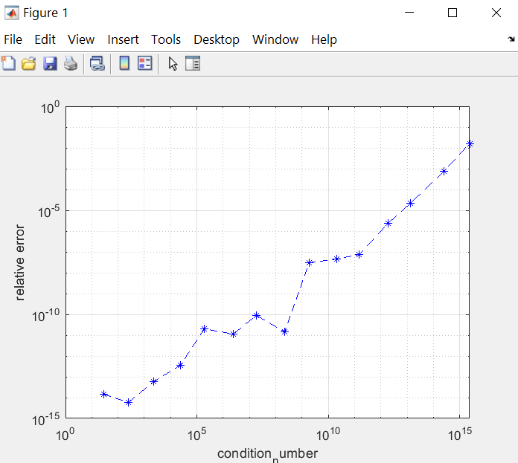

Analysis: this method solves systems of linear algebraic equations with a rather small relative error.

Conclusion: the text of the program was written to solve the SLAE using the GEM with pivoting strategy method and a fairly accurate solution was obtained.