Study Notes

Introduction
How Light Works
At its simplest level, light is linear. It is measured in lumens, which is the total amount of light emitted by a source, which feeds into luminance, a measure of light intensity per unit of projected area [1]. This means that an object emitting 10,000 lumens is twice as bright as an object emitting 5,000 lumens. This linear behaviour of light is also how digital devices such as cameras capture it, where pixel values in a captured image are directly proportional to the physical intensity of light. Such images are called raw images.

How Humans Perceive Light
While cameras record light linearly, the human eye perceives it logarithmically [1]. This means we are far more sensitive to differences in dark areas than in bright ones — we can distinguish subtle shadow detail far more easily than subtle highlight detail (Refer to Figure 1) [2].

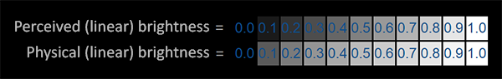
Figure 1: Equal steps in perceived brightness do not correspond to equal steps in physical light intensity [3]
Analogy Comparison
💡Imagine you are turning up the volume on a speaker:
- The difference between 0 and 10 is enormous → you go from silence to clearly audible
BUT
- The difference between 90 and 100 is barely noticeable, even though it's the same 10-unit jump.
This is because our ears respond logarithmically, not linearly, and so do our eyes with light.

The Problem

Since light behaves linearly while humans perceive it logarithmically, we have a mismatch between how cameras capture the world and how we actually see it. This creates a mismatch between image capture and human perception . The question arises:

“If cameras store light linearly, but our eyes perceive it logarithmically, how do we store an image that actually looks natural to a human?”

In order to solve the gap we must artificially replicate the logarithmically-perceived contrast within a linear digital environment.

Gamma Correction
To compensate for our logarithmic perception of brightness, we apply the inverse of this response to the image using the Power Law. When our visual system then processes the corrected image, the two effects cancel out, and the image looks natural. The process by which we apply the power law is called Gamma Correction.

Power Law
A fundamental mathematical tool for non-linear image adjustment, allowing for the precise mapping of pixel intensities to match human visual perception. By adjusting a single parameter (gamma), the same equation can brighten or darken an image. It is not a linear shift but it is reshaping the entire distribution by compressing and expanding ranges.
Gamma Correction (Perception)
The process of applying the power law on raw camera data. Since the human eye notices dark-area details better than bright ones, we use the power law to adjust raw camera data so it looks “natural” to our eyes on a screen. This adjustment can work in two directions:
- Encoding: A process applied to images where bits are allocated based on human perception. Since the eye is more sensitive to changes in darker areas, more values are assigned to the shadow range and fewer to the highlights. This ensures the stored image makes efficient use of its available bit depth. (Refer to Figure 2)
- Decoding: Performs the opposite of encoding. Reverses gamma compression by raising encoded pixel values to a power to convert non-linear, gamma-encoded data (like sRGB) back to linear light values for accurate rendering or image computations. (Refer to Figure 2)

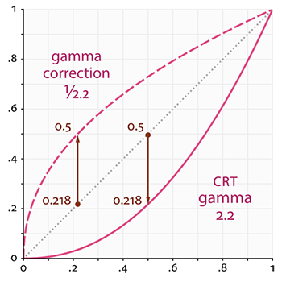
A Fortunate Coincidence - Display Hardware
Figure 2: Inverse gamma correction to cancel out physical CRT gamma
Gamma correction was not only useful for human perception. Before the perceptual argument was formalised, CRT monitors had a physical nonlinearity, their electron gun naturally produced a power curve of approximately γ = 2.2 [3], darkening any linear signal sent to them. Engineers corrected for this by encoding images with γ = 1/2.2 before display, so the two curves would cancel. This is the same correction applied for perceptual reasons. The γ = 2.2 value chosen to fix CRT hardware turned out to coincidentally match human visual sensitivity, meaning one curve solved both problems at once [3]. Modern displays preserve the same sRGB standard to this day for backwards compatibility.

Technical Section
The mathematical form of gamma correction is the power law transform [2]:
s = C · r^{ɣ}
Where:
- s = output pixel value
- r = input pixel value (normalised between 0 and 1)
- C = a positive scaling constant, typically set to 1 for standard use
- γ = the exponent that controls the shape of the transformation
Effects of γ on the transformation:
- When γ < 1 (the curve bows upwards):
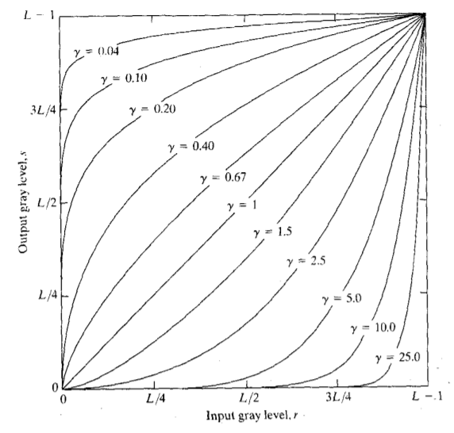
  - Shadows are stretched out, providing more precision in darker tones
Figure 3: Different curves produced by various gamma values
  - Highlights are compressed
  - This is what cameras apply during encoding
- When γ > 1 (the curve bows downwards):
  - Dark values are compressed
  - Highlights are stretched
  - What displays apply during decoding
- When γ = 1 (Identity):
  - The transformation reduces to: s = C*r
  - No change is applied

💡Note:
By varying γ, we obtain a family of possible transformation curves, each redistributing tonal values differently. The curves are generated for r values normalised from 0 to 1, then multiplied by the scaling constant C corresponding to the bit depth used [2].

Worked Example
1. r = 0.5, C= 1, γ = 1.5: 2. r = 0.5, C= 1, γ = 0.67: 3. r = 0.5, C= 1, γ = 0.4:
s = 1· 0.5^{1.5} = 0.3536 (4d.p.) s = 1· 0.5^{6.7} = 0.6285 (4d.p.) s = 1· 0.5^{0.4} = 0.7579 (4d.p.)
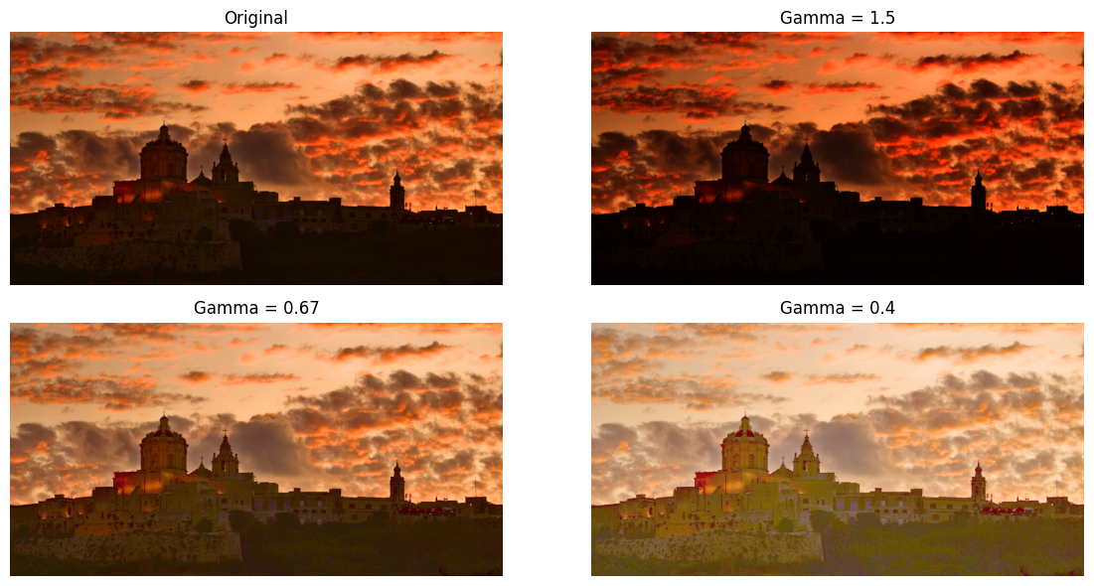
Figure 4: The effect of different gamma values on an image

Tone Mapping
Introduction
Dynamic range refers to the span between the darkest and brightest values a system can simultaneously capture or display.

A low dynamic range (LDR) image is limited in the breadth of luminance it can represent, typically encoded in 8 bits per channel, giving 256 possible values [4].
A high dynamic range (HDR) image, by contrast, encodes a far wider luminance span, capturing detail across conditions that would force an LDR system to either clip highlights or crush shadows entirely [4][5].
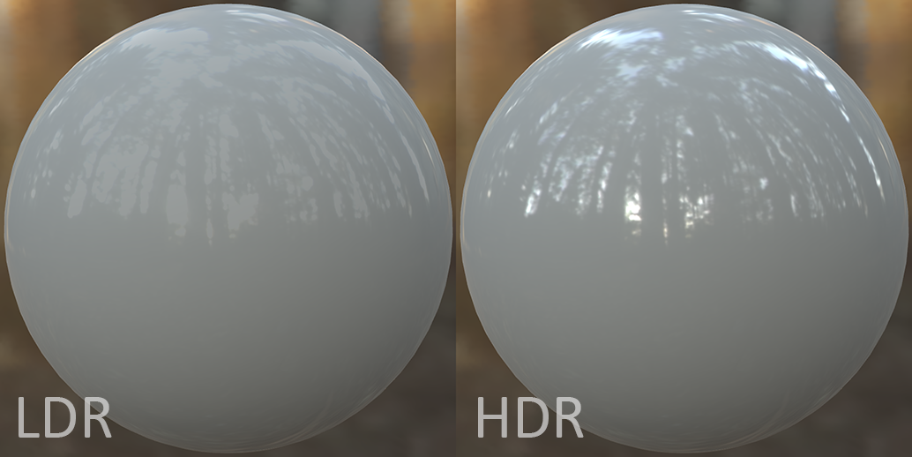
Figure 5 comparison of LDR and HDR images
Taken from https://dqlin.xyz/tech/2016/12/02/04_hdr/

💡Note: Since HDR represents a wider range of luminance, more bits are typically used to encode it. This distributes luminance values more evenly across the available range, reducing the visible stepping between adjacent values. Without sufficient bit depth, smooth gradients such as a clear sky or a sunset appear as harsh, visible bands of colour. Common HDR configurations use 10 or 12 bits per channel to avoid this.

The Problem
“If an image was captured in HDR, how can we display it on an LDR screen while maintaining the overall quality of the original image?”

Solution - Tone Mapping
Definition: Tone mapping is the process of remapping a high dynamic range image (often with thousands of nits of range) into a low dynamic range output (typically 100 nits in traditional LDR workflows), while preserving as much perceived detail as possible [4].
It ensures that high contrast images, such as sunsets and shadows, look more natural while maintaining details in certain areas without bright areas losing detail (Clipping) or having dark areas become solid black (Crushing), therefore preserving the creator’s intent. It also improves LDR content, making games and videos look brighter and more vibrant.

Why this is needed: Cameras and other devices can capture and store media in HDR format, recording a far wider range of luminance than any standard display can reproduce. When this content is viewed on an LDR screen, the HDR data must be compressed down to fit within the display's limitations. [5]

A simple rescale would destroy the contrast relationships and colour balance that make the image look natural. Tone mapping handles this conversion intelligently, reducing the format from HDR to LDR while preserving as much of the original perceived contrast and colour as possible.

How it is done: A tone mapping operator (TMO) applies a non-linear curve to the luminance (or RGB) values of an image. The curve is nearly linear in the shadow and midtone regions (to preserve detail there) but gradually flattens toward the top, the shoulder, to compress highlights without clipping.

Common operators include:
- Reinhard: Compress high dynamic range (HDR) images for display on standard devices effectively, but highlights can become flat and slightly desaturated.
- ACES Filmic: The industry standard in cinema and high-end gaming. Produces a characteristic S-curve that slightly lifts shadows, preserves midtones, and rolls off highlights in a way that mimics how film stock responds to light. The result is rich, natural-looking images with depth and contrast.
- Hable (Uncharted 2): sits between Reinhard and ACES in complexity. Developed specifically for video games, it produces a film-like quality without the full computational cost of ACES.

Example - Reinhard
$$L_{mapped} = \frac{L}{1+L}$$
- HDR luminance = 8
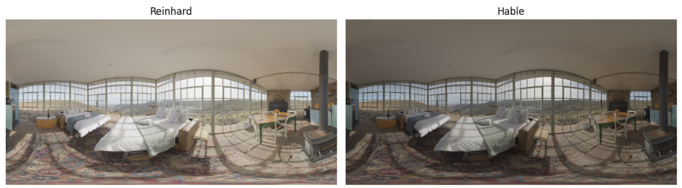
- mapped = 8/9 = 0.889
Figure 6 comparison of Reinhard and Hable TMOs
Real-World Applications
Broadcast & Television
- sRGB is the standard gamma encoding used for most web and screen content
- Rec. 709 television applies γ = 0.45 at capture and assumes γ ≈ 2.2 at display
- Without gamma correction, broadcast footage appears unnaturally dark on consumer TVs
- Modern HDR broadcasting commonly uses HLG (Hybrid Log-Gamma), which remains backwards compatible with SDR displays
Photography & Camera
- RAW images store linear light data; gamma encoding applied during RAW conversion
- Multi-sensor HDR cameras capture up to 20–24 f-stops of dynamic range [5]
- Tone mapping allows the same footage to be adapted differently for cinema, streaming, and broadcast [4][6]
- HDR preserves detail in both highlights and shadows simultaneously
- Widely used in real estate, travel, and nature photography to handle high-contrast scenes
Advertising & Marketing
- HDR improves perceived depth, colour accuracy, and surface detail [6]
- Automotive advertising relies heavily on HDR workflows to preserve reflections and paint finish detail
Radiographic Imaging (X-rays, MRI)
- Gamma correction and tone mapping applied through Look-Up Tables (LUTs) [5]
- Tissue data must be perceptually remapped into visible luminance values
- DICOM GSDF standard ensures consistent visibility of detail across brightness ranges [5]
Video Games
- Modern game engines render scenes internally in linear HDR
- Gamma correction and tone mapping applied only during final display output
- Applying gamma correction mid-pipeline produces incorrect lighting and colour calculations
- Real-time tone mapping simulates realistic adaptation between bright and dark scenes [6]
Display Hardware
- HDR monitors provide improved contrast and luminance reproduction compared to SDR displays [6]
- Older SDR displays still rely on gamma correction despite limited brightness range
💡Note: In the above cases, HDR media requires tone mapping to be displayed naturally on an LDR screen
Quick Reference

Gamma Correction vs Tone Mapping:
Feature | Gamma Correction | Tone Mapping
Goal | Match digital storage to human perception | Compress HDR into displayable LDR range
Motivation | Human eye sensitivity vs. linear sensors | Screen limits (~100 nits) vs. real-world light
Math | Power law: s = C · r^{γ} | Non-linear S-curves (Reinhard, ACES)

Effects of γ:
γ < 1: Brightens → stretches shadows, compresses highlights. Curve bows upwards. Applied during encoding (camera → file)
γ > 1: Darkens → compress shadows, stretches highlights. Curve bows downwards. Applied during decoding (file → display)
γ = 1: Identity → no change: reduces to s = C · r

Glossary:
Term | Definition
Power Law | A non-linear function that adjusts image brightness using a gamma value
Gamma Correction | The use of the power law to make images appear natural to human vision
Encoding | The process of compressing image brightness values using gamma correction
Decoding | The process of restoring gamma-compressed values back to linear light values
Dynamic Range | The range between the darkest and brightest values in an image
LDR | An image format with a limited brightness range
HDR | An image format that stores a wider range of brightness values
Tone Mapping | The process of converting HDR images into LDR while preserving detail
Clipping | Loss of detail in overly bright image areas
Crushing | Loss of detail in very dark image areas

Common Misconceptions:
- “Gamma correction and tone mapping are the same”
➥ They solve different problems: Gamma aligns linear data with human perception (logarithmic response). Tone mapping compresses a massive High Dynamic Range (HDR) into a displayable Low Dynamic Range (LDR)
💡Gamma is the “lens” for how we see while tone mapping is the “editor” deciding what fits on screen

- “Half the lumens look half as bright”
➥ Not to the human eye, since perception is logarithmic.

- “HDR means more bits”
➥ Dynamic range and bit depth are separate → HDR is the “span” (darkest to brightest), bits are the “precision” (steps between them)
💡HDR is the height of the building and bit depth is the number of steps in the staircase

- “Encoding and decoding are independent steps”
➥They are a pair: one cancels the other to ensure the final output looks natural
💡 It is a “lock and key” system: using one without the other results in a “washed out” image

References

[1] C. Poynton, "Frequently Asked Questions about Gamma," inforamp.net, Dec. 30, 1999. [Online]. Available: https://www.compression.ru/download/articles/color_space/gammafaq.pdf

[2] Kang & Atul, “Power Law (Gamma) Transformations,” TheAILearner, Jan. 26, 2019. https://theailearner.com/2019/01/26/power-law-gamma-transformations/

[3] J. de Vries, “LearnOpenGL - Gamma Correction,” learnopengl.com.
https://learnopengl.com/Advanced-Lighting/Gamma-Correction

[4] G. Eilertsen, R. K. Mantiuk, and J. Unger, "A comparative review of tone-mapping algorithms for high dynamic range video," Computer Graphics Forum, vol. 36, no. 2, pp. 160–180, 2017.
[5] G. Guarnieri, High Dynamic Range Images: Processing, Display and Perceptual Quality Assessment, Ph.D. dissertation, Università degli Studi di Trieste, Trieste, Italy, 2008.
[6] Lenovo, “What is HDR and How it Improves Visual Experience,” Lenovo, 2025. https://www.lenovo.com/us/en/knowledgebase/what-is-hdr-and-how-it-improves-visual-experience/?orgRef=https%253A%252F%252Fwww.google.com%252F&srsltid=AfmBOorH_SeM1pGWqFVRTm5QP9uWR1Y920qQOqF6xhmJKCERUnywQoRC (accessed May 05, 2026)

Key Papers

Reference [1]
This document by C. Poynton covers frequently asked questions about the symbol gamma (γ). It offers a thorough explanation of what gamma is, describing it as the mathematical exponent that differentiates the nonlinear relationship between digital pixel values and actual light intensity. The author clarifies essential terminology, distinguishing between brightness and luminance, while explaining how gamma correction is used to compensate for the visible difference between natural light and human-perceived vision. Furthermore this document explains how gamma is handled for video, computer graphics, and different operating system’s desktops.
This document was mainly used to explain such essential terminology and as help to introduce the topic of gamma correction.

Reference [2]
This blog post on TheAILearner by Kang & Atul offers a simple yet comprehensive explanation of what power law (gamma) transformations are and how they are used. The blog is focused mainly on the power law equation as well as how the gamma value affects the target image. The blog explains how gamma Finally, included within this blog is also a code example, in python, using the opencv’s cv2 library, where different values of gamma are calculated on a single image. This is followed by the respective output display of the images.
Therefore, it was used in the technical section of our notes which included and explained the power law. This blog also includes a diagram displaying different gamma curves according to the gamma value. This diagram is included in the notes.

Reference [3]
This tutorial by J. de Vries explores the necessity of gamma correction for digital rendering, explaining how most displays naturally display light in a nonlinear fashion in a way which darkens colour values. The tutorial describes how most displays reproduce brightness nonlinearly, causing intermediate colour values to appear darker than intended. It further explains how gamma correction compensates for this behaviour by applying the inverse gamma curve before final image output, allowing rendering calculations to remain in linear space while still appearing perceptually natural on screen.
This site was used to explain the history of gamma correction. In addition, two images on this site were used to explain gamma correction in further detail.

Reference [4]
This paper by G. Eilersten, R.K. Mantiuk, and J. Unger provides a comprehensive review of different tone-mapping algorithms designed for high dynamic range (HDR) video. Although traditional tone-mapping for static images is well-established, the authors identify new challenges that arise when applying tone mapping to dynamic video. This study assesses various classic tone mapping operators and evaluates their performance across several different categories. It includes a detailed definition of tone mapping and a comparison between LDR and HDR images.
This paper was utilised in the tone mapping section of our notes, particularly when explaining what tone mapping is, why it is necessary, and how different operators function.

Reference [5]
This doctoral thesis by Dr. G. Guarnieri offers a deep dive into High Dynamic Range images and several issues related to capturing, processing, and displaying such HDR images. The author delves into the human visual system, explaining how brightness is perceived differently by humans according to the different wavelengths of colour. Ultimately, this thesis seeks to bridge the gap between the luminance of the natural world and the technological constraints of electronic displays through advanced mathematical-formula optimisation
This paper included several examples of applications of tone mapping which were listed within our notes to further help the reader.

Reference [6]
This article by Lenovo serves as an introduction to HDR Technology, offering insight to what HDR means and explaining how it can improve the visual experience for a user. This page defines and explains the key components of HDR display such as contrast range and colour depth and also categorises the various formats of HDR display, for example, HDR10 (10-bit colour depth), HDR10+, and Dolby Vision. The many benefits of HDR are also listed, and several popular applications of HDR in display technology are mentioned to substantiate these benefits. Essentially, this article serves as an introductory guide to HDR overall.
Some of the applications of Tone Mapping mentioned throughout this page were used as examples for our notes.

