FACULTY OF
KUALA LUMPUR CAMPUS
DEPARTMENT OF MATHEMATICAL SCIENCES
BMMS2094 Statistics for Data Science
Assignment Individual
Title Forecasting Monthly Mean Precipitation in Kuala Lumpur
Student Name | Chan YH
Student ID | [To be completed]
Academic Session | 202605
Programme | Bachelor in Data Science
Tutorial Group | 6
Lecturer's Name | Assoc. Prof. Dr Chin Wan Yoke
Practical Tutor's Name | Assoc. Prof. Dr Chin Wan Yoke
Date of submission | 05 September 2026
Declaration:
I declare that this submitted coursework is my own work and that all material from other sources has been acknowledged appropriately.
Signature: ______________________________

I. METHODOLOGY
A. Dataset Characteristics Motivating Model Selection
This report analyses monthly mean precipitation in Kuala Lumpur, measured in millimetres per day, using NASA POWER data from January 1981 to December 2025. The series contains 540 monthly observations and no missing values after the data-quality check. The exploratory decomposition indicates moderate annual seasonality and only a weak long-run trend. The raw-series Ljung-Box test at lag 24 is strongly significant, so a useful forecasting model must represent the recurring twelve-month pattern and the remaining serial dependence rather than treat rainfall as independent observations.
B. Model Specification and Parameter Selection
I selected ETS(A,N,A), an exponential-smoothing model with additive error, no trend and additive monthly seasonality. This form is appropriate because the decomposition does not support a persistent trend, while the seasonal pattern is regular enough to be represented by twelve additive seasonal states. The fitted level smoothing parameter was 0.017 and the seasonal smoothing parameter was approximately 0.0001. These small values mean that the model updates cautiously and lets the established monthly pattern carry most of the forecast. The final 12 months were reserved as a time-ordered test set; the remaining 528 months were used for estimation. Rolling-origin cross-validation then used 27 forecast origins, keeping the test year separate from model selection.
II. DATA ANALYSIS
Performance was evaluated using RMSE, MAE and MASE, with seasonal naive forecasting as the benchmark. A MASE below one indicates that the model improves on repeating the rainfall value from the same month in the previous year. ETS obtained a training RMSE of 2.436 and a training MASE of 0.738. In rolling-origin validation, RMSE was 2.566 and MASE was 0.811, compared with 0.985 for seasonal naive forecasting. Thus, the ETS model reduced cross-validated scaled error by about 17.7 percent while its RMSE increased only 5.3 percent relative to the training estimate. The held-out test MAE was 2.077 mm/day and test MASE was 0.807, which remains below the seasonal-naive test MASE of 0.942.
The residual evidence is consistent with an adequate monthly forecasting model. The lag-24 Ljung-Box p-value is 0.122, so the residuals do not show statistically significant autocorrelation at the 5 percent level. Figure 3 shows residuals centred around zero and a distribution that is broadly bell-shaped. Only one of the first 24 autocorrelations is outside its approximate confidence band. Figure 2 shows that the forecast follows the usual seasonal movement, although unusually high or low monthly rainfall remains difficult to reproduce exactly.
III. CONCLUSION
ETS(A,N,A) provides a compact and interpretable forecast for monthly Kuala Lumpur rainfall. It captures the annual pattern, outperforms the seasonal-naive benchmark in both validation and the held-out year, and leaves no significant residual autocorrelation at lag 24. The model is therefore suitable for routine monthly planning where an estimate of the expected rainfall level is required.
Its limitations are equally important. Additive seasonality smooths extreme wet months, so the model should not be interpreted as an extreme-rainfall or flood-warning system. In addition, the data represent one gridded location and include no atmospheric covariates. Future work could compare damped-trend and multiplicative-error alternatives, incorporate climate indicators such as ENSO, and test the model at several locations across Greater Kuala Lumpur.

REFERENCES
Hyndman, R. J., Koehler, A. B., Ord, J. K., & Snyder, R. D. (2008). Forecasting with exponential smoothing: The state space approach. Springer.
Hyndman, R. J., & Athanasopoulos, G. (2021). Forecasting: Principles and practice (3rd ed.). OTexts. https://otexts.com/fpp3/
NASA Langley Research Center. (n.d.). NASA POWER: Prediction of worldwide energy resources. https://power.larc.nasa.gov/
United Nations. (n.d.). Sustainable Development Goal 13: Climate action. https://sdgs.un.org/goals/goal13

APPENDIX A: TABLE AND FIGURES
Table 1. Final ETS(A,N,A) model accuracy, overfitting measures and residual whiteness.
Metric | Training | Cross validation | MASE gap % / RMSE Ratio
MASE | 0.738 | 0.811 | 9.9%
RMSE | 2.436 | 2.566 | 1.053
Ljung Box p (lag-24) | 0.122 | - | -
Figure 1. ETS(A,N,A) estimated level and seasonal states
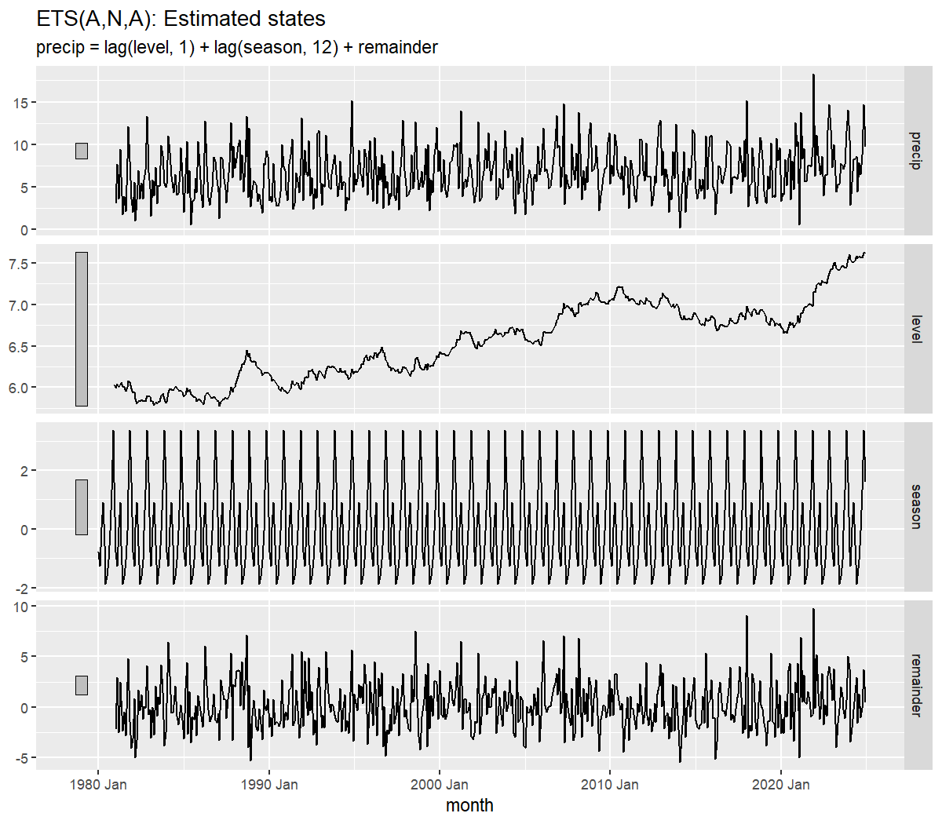
Figure 2. ETS twelve month test window forecast against actual rainfall
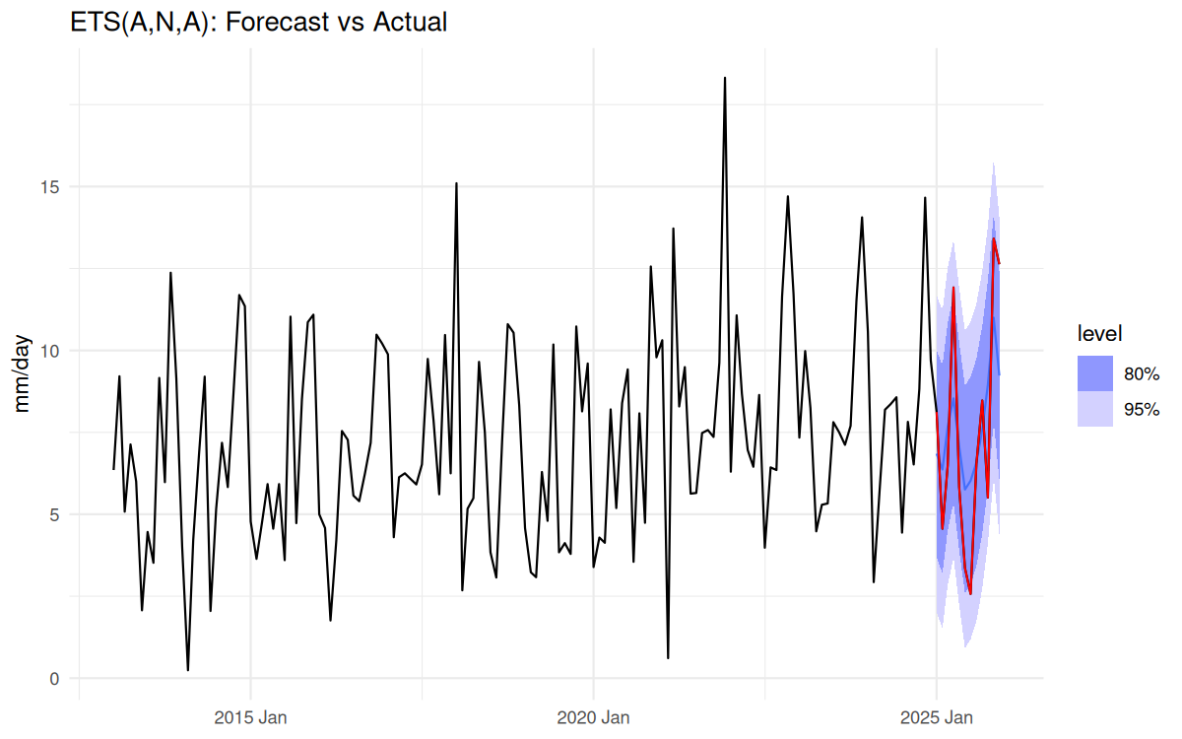
Figure 3. Residual diagnostics for the ETS model
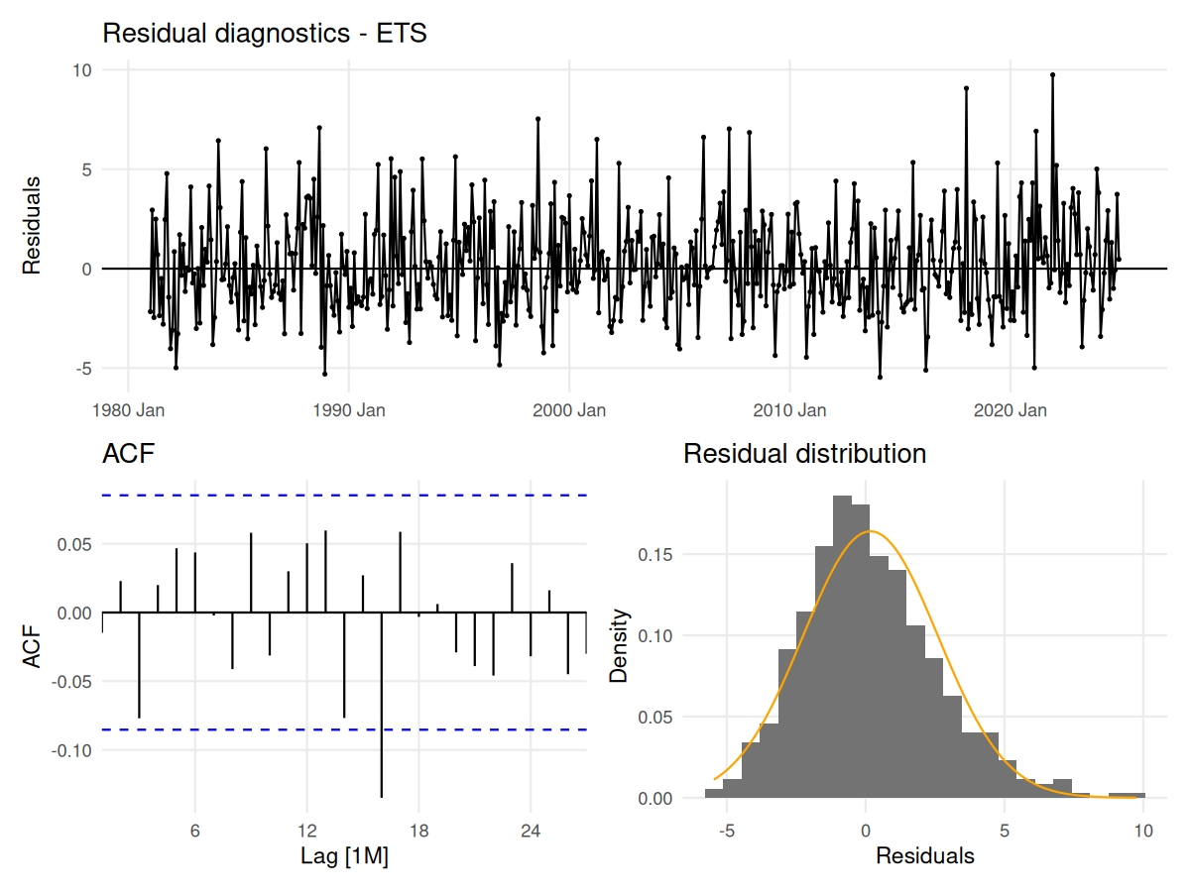

APPENDIX B: PROGRAMMING SOURCE CODE (03_ChanYH_ets.R)
# ETS(A,N,A) rainfall forecast

# Shared setup and data acquisition make this script independently runnable.
source("scripts/00_setup.R")
source("scripts/01_data_pull.R")

cat("rain:", nrow(rain), "obs,", format(min(rain$month)), "to", format(max(rain$month)), "\n")
cat("Missing before interpolation:", missing_before,
"| Missing after interpolation:", missing_after, "\n")

# EDA
p_raw <- rain |> autoplot(precip) +
labs(title = "KL monthly mean precipitation rate (mm/day)", y = "mm/day")
p_season <- rain |> gg_season(precip) + labs(title = "Seasonal plot - monsoon cycle")
p_subseries <- rain |> gg_subseries(precip) + labs(title = "Subseries plot - by calendar month")
p_acf <- rain |> ACF(precip, lag_max = 36) |> autoplot() + labs(title = "ACF - raw series")
p_pacf <- rain |> PACF(precip, lag_max = 36) |> autoplot() + labs(title = "PACF - raw series")

print(rain |> features(precip, feat_stl))

# Statistical tests
cat("\n== ADF test ==\n")
print(adf.test(rain$precip))

cat("\n== KPSS test ==\n")
print(kpss.test(rain$precip))

cat("\n== Ljung-Box test: raw series ==\n")
print(Box.test(rain$precip, lag = 12, type = "Ljung-Box"))
print(Box.test(rain$precip, lag = 24, type = "Ljung-Box"))

cat("\n== Mann-Kendall trend test ==\n")
print(Kendall::MannKendall(rain$precip))

cat("\n== Minimum precipitation ==\n")
print(min(rain$precip, na.rm = TRUE))

# Train/test split
h <- 12
train <- rain |> filter(month <= max(month) - h)

# Model
fit <- train |> model(
snaive = SNAIVE(precip),
ets = ETS(precip ~ error("A") + trend("N") + season("A"))
)
fc <- fit |> forecast(h = h)

# Accuracy
accuracy_display <- bind_rows(
fit |> accuracy() |> mutate(data_set = "Training set"),
fc |> accuracy(rain) |> mutate(data_set = "Test set")
) |>
transmute(
model = recode(.model, snaive = "Seasonal naive", ets = "ETS"),
data_set, RMSE, MAE, MAPE, MASE
) |>
arrange(model, factor(data_set, levels = c("Training set", "Test set"))) |>
mutate(across(c(RMSE, MAE, MAPE, MASE), ~ round(.x, 3)))

cat("\n--- ETS and Benchmark Accuracy ---\n")
print(accuracy_display)
fit |> select(ets) |> report()
fit |> select(ets) |> gg_tsresiduals()

# Save the fitted smoothing parameters and initial states printed by tidy().
ets_parameters <- fit |>
select(ets) |>
tidy() |>
mutate(model = "ETS(A,N,A)") |>
relocate(model)

# Residual checks
cat("\n== Ljung-Box test: ETS residuals ==\n")
print(augment(fit) |> filter(.model == "ets") |> features(.innov, ljung_box, lag = 12))
print(augment(fit) |> filter(.model == "ets") |> features(.innov, ljung_box, lag = 24))

cat("\n== Residual ACF summary ==\n")
print(augment(fit) |> filter(.model == "ets") |> as_tibble() |>
summarise(n_lags_out_12 = acf_out_of_bounds(.innov, lag.max = 12),
n_lags_out_24 = acf_out_of_bounds(.innov, lag.max = 24)))

# Train/test comparison
acc_train <- fit |> accuracy() |> filter(.model == "ets") |>
select(.model, MASE_train = MASE, RMSE_train = RMSE)
acc_test <- fc |> accuracy(rain) |> filter(.model == "ets") |>
select(.model, MASE_test = MASE, RMSE_test = RMSE)
holdout <- acc_train |> left_join(acc_test, by = ".model") |>
select(.model, MASE_train, RMSE_train, MASE_test, RMSE_test)

# Rolling-origin CV
n_folds_clean <- length(seq(360, nrow(train) - h, by = 6))
cv_data <- train |>
stretch_tsibble(.init = 360, .step = 6) |>
filter(.id <= n_folds_clean)

set.seed(2026)
cv_acc <- cv_data |>
model(ets = ETS(precip ~ error("A") + trend("N") + season("A"))) |>
forecast(h = h) |>
accuracy(train, by = c(".model", ".id"))

cv_summary <- cv_acc |>
summarise(mean_MASE = mean(MASE), sd_MASE = sd(MASE),
min_MASE = min(MASE), max_MASE = max(MASE),
mean_RMSE = mean(RMSE), n_folds = n())
print(cv_summary)

results <- tibble(
model = "ets_additive",
MASE_train = holdout$MASE_train,
RMSE_train = holdout$RMSE_train,
MASE_cv = cv_summary$mean_MASE,
RMSE_cv = cv_summary$mean_RMSE,
sd_MASE_cv = cv_summary$sd_MASE,
n_folds = cv_summary$n_folds
)

# Output
dir.create("output/plots/group_summary", recursive = TRUE, showWarnings = FALSE)
dir.create("output/tables/model_details", recursive = TRUE, showWarnings = FALSE)
write.csv(ets_parameters, "output/tables/model_details/ets_parameters.csv", row.names = FALSE)

# Forecast plot
plot_from <- yearmonth("2013 Jan")
test_actual_tbl <- rain |> as_tibble() |> filter(month > max(train$month)) |>
transmute(month, precip)

p_fc <- fc |> filter(.model == "ets") |>
autoplot(rain |> filter(month >= plot_from), level = c(80, 95)) +
geom_line(data = test_actual_tbl, aes(x = month, y = precip),
color = "red", linewidth = 0.45) +
labs(title = "ETS(A,N,A): Forecast vs Actual", y = "mm/day", x = NULL) +
theme_minimal()
save_fable_forecast_plot(
fc |> filter(.model == "ets"), rain, "ETS",
"ETS(A,N,A): Forecast vs Actual",
"output/plots/group_summary/fc_ets.png"
)
u_ets <- augment(fit) |> filter(.model == "ets") |> as_tibble()
save_residual_diagnostic(u_ets$.innov, u_ets$month, "ETS",
"output/plots/group_summary/resid_ets.png")

cat("\nDone. Wrote the ETS parameter table and 2 plots.\n")

