FACULTY OF
KUALA LUMPUR CAMPUS
DEPARTMENT OF MATHEMATICAL SCIENCES
BMMS2094 Statistics for Data Science
Assignment Individual
Title Forecasting Monthly Mean Precipitation in Kuala Lumpur
Student Name | Ham GQ
Student ID | [To be completed]
Academic Session | 202605
Programme | Bachelor in Data Science
Tutorial Group | 6
Lecturer's Name | Assoc. Prof. Dr Chin Wan Yoke
Practical Tutor's Name | Assoc. Prof. Dr Chin Wan Yoke
Date of submission | 05 September 2026
Declaration:
I declare that this submitted coursework is my own work and that all material from other sources has been acknowledged appropriately.
Signature: ______________________________

I. METHODOLOGY
A. Dataset Characteristics Motivating Model Selection
This report forecasts monthly mean precipitation in Kuala Lumpur using NASA POWER observations from January 1981 through December 2025. The cleaned data contain 540 consecutive monthly values. Exploratory analysis identifies an annual cycle as the most visible feature, while the long-run trend is much weaker. The raw series is autocorrelated at seasonal lags and rainfall occasionally shows large positive departures. These characteristics support a regression model that can estimate both a gradual time effect and a smooth seasonal pattern. The final 12 months were set aside for testing and the preceding 528 months formed the training sample.
B. Model Specification and Parameter Selection
I used a time-series linear model (TSLM) with a linear trend and Fourier terms with K = 4. The specification estimates one linear time coefficient and eight trigonometric regressors, four sine and four cosine terms, for the annual period of 12 months. The trend estimate was 0.00348 mm/day per month, which is small but positive. This model was chosen because it is interpretable: the trend shows the average long-run movement and the Fourier terms show the recurring annual pattern without creating twelve separate dummy coefficients. Twenty-seven rolling-origin folds were used to evaluate how consistently the regression forecasts future months.
II. DATA ANALYSIS
The TSLM plus Fourier model produced a training RMSE of 2.417 and MASE of 0.736. Under rolling-origin validation, RMSE was 2.557 and MASE was 0.814. The seasonal-naive benchmark produced a cross-validated MASE of 0.985, so the regression lowers scaled error by about 17.4 percent. The ratio of cross-validated to training RMSE is 1.058, which indicates a modest and acceptable decline outside the fitting sample. In the 2025 test period, RMSE was 2.407, MAE was 2.146 mm/day and MASE was 0.833, again below the seasonal-naive test MASE of 0.942.
The error checks are encouraging. The lag-24 Ljung-Box p-value is 0.148 and only one of the first 24 ACF bars exceeds its approximate confidence bound. The residuals are centred near zero, with a roughly bell-shaped central distribution and a small number of high-rainfall outliers. Figure 2 indicates that the model represents normal seasonal changes well, but a linear trend plus fixed Fourier waves cannot reproduce every abrupt monthly peak. This is an expected trade-off for a model designed for clarity and stable average forecasts.
III. CONCLUSION
The TSLM plus Fourier specification is a useful interpretable baseline for monthly rainfall forecasting. It improves on seasonal naive forecasting in rolling validation and the held-out year, while its residuals pass the lag-24 whiteness check. The explicit trend and seasonal coefficients also make the model easy to communicate to non-technical planning users.
However, the linear trend and fixed Fourier cycle cannot react to sudden weather regimes or rare extremes. The model also excludes explanatory information such as sea-surface temperature, humidity and regional circulation. Future work should test dynamic regression with climate covariates, robust or transformed responses for extreme months, and forecasts across multiple stations before using the results for regional decisions.

REFERENCES
Hyndman, R. J., & Athanasopoulos, G. (2021). Forecasting: Principles and practice (3rd ed.). OTexts. https://otexts.com/fpp3/
NASA Langley Research Center. (n.d.). NASA POWER: Prediction of worldwide energy resources. https://power.larc.nasa.gov/
Wickham, H., Francois, R., Henry, L., & Muller, K. (2023). dplyr: A grammar of data manipulation [Computer software]. https://CRAN.R-project.org/package=dplyr
United Nations. (n.d.). Sustainable Development Goal 13: Climate action. https://sdgs.un.org/goals/goal13

APPENDIX A: TABLE AND FIGURES
Table 1. Final TSLM + Fourier model accuracy, overfitting measures and residual whiteness.
Metric | Training | Cross validation | MASE gap % / RMSE Ratio
MASE | 0.736 | 0.814 | 10.6%
RMSE | 2.417 | 2.557 | 1.058
Ljung Box p (lag-24) | 0.148 | - | -
Figure 1. TSLM fitted-value diagnostics for the Kuala Lumpur rainfall series
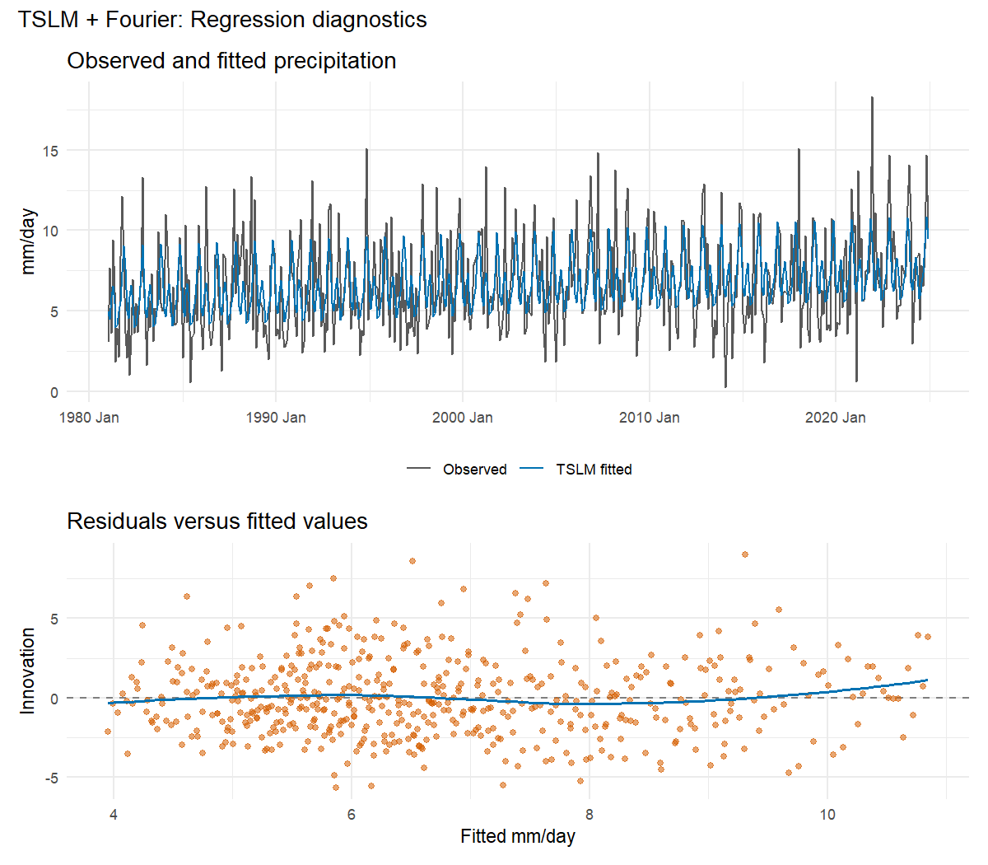
Figure 2. TSLM plus Fourier twelve month test window forecast against actual rainfall
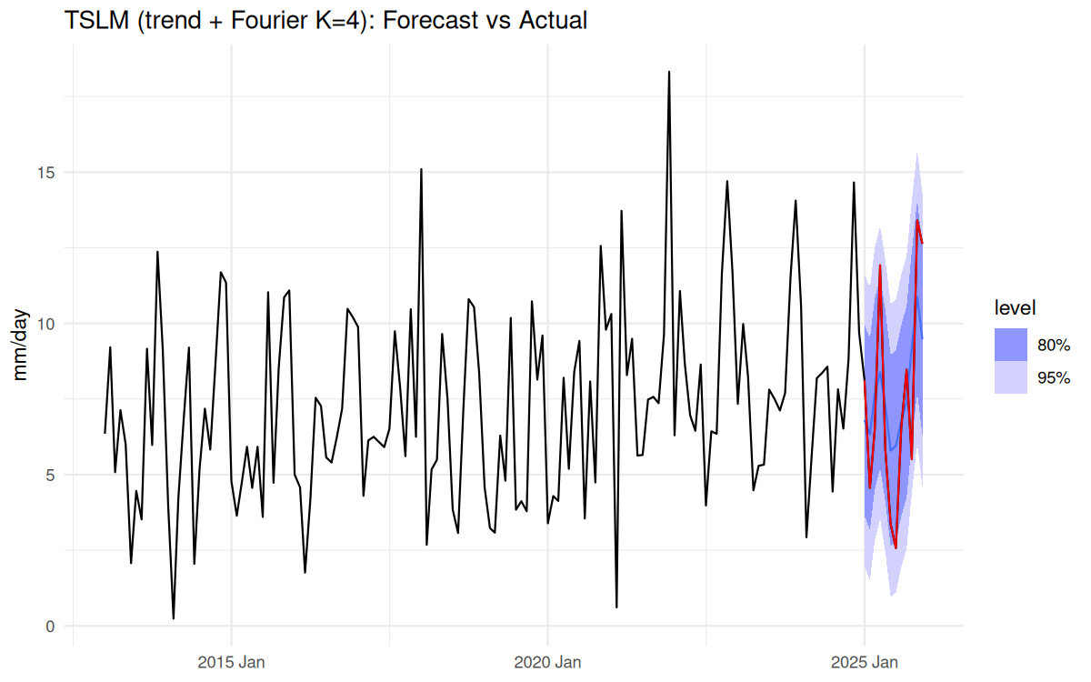
Figure 3. Residual diagnostics for the TSLM plus Fourier model
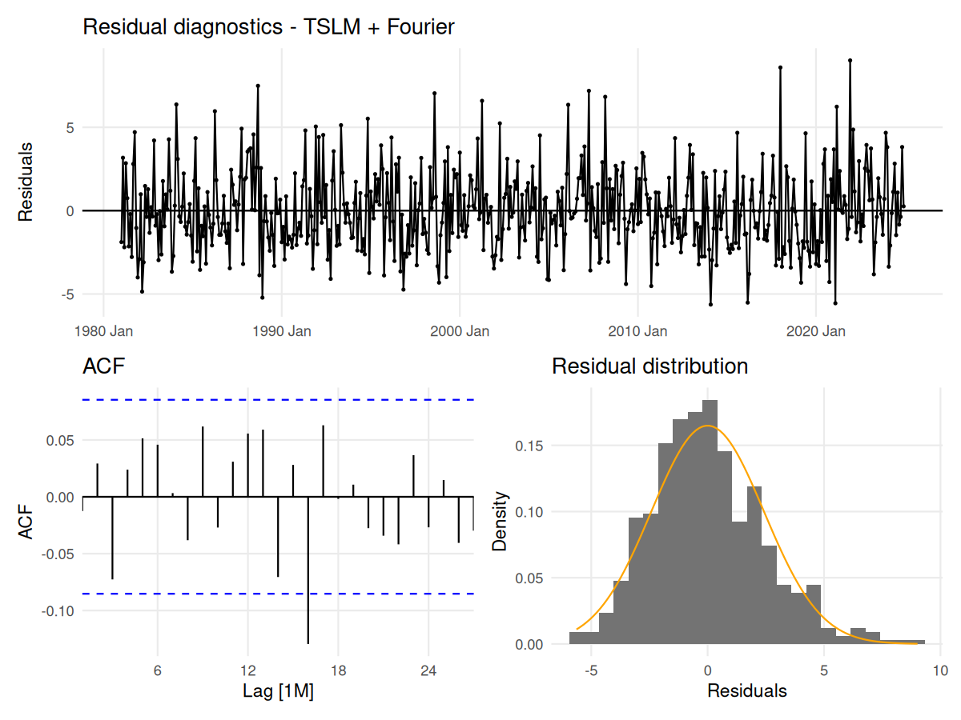

APPENDIX B: PROGRAMMING SOURCE CODE (05_HamGQ_tslm.R)
# TSLM with trend and Fourier terms rainfall forecast

# Shared setup and data acquisition make this script independently runnable.
source("scripts/00_setup.R")
source("scripts/01_data_pull.R")

cat("rain:", nrow(rain), "obs,", format(min(rain$month)), "to", format(max(rain$month)), "\n")
cat("Missing before interpolation:", missing_before,
"| Missing after interpolation:", missing_after, "\n")

# EDA
p_raw <- rain |> autoplot(precip) +
labs(title = "KL monthly mean precipitation rate (mm/day)", y = "mm/day")
p_season <- rain |> gg_season(precip) + labs(title = "Seasonal plot - monsoon cycle")
p_subseries <- rain |> gg_subseries(precip) + labs(title = "Subseries plot - by calendar month")
p_acf <- rain |> ACF(precip, lag_max = 36) |> autoplot() + labs(title = "ACF - raw series")
p_pacf <- rain |> PACF(precip, lag_max = 36) |> autoplot() + labs(title = "PACF - raw series")

print(rain |> features(precip, feat_stl))

# Statistical tests
cat("\n== ADF test ==\n")
print(adf.test(rain$precip))

cat("\n== KPSS test ==\n")
print(kpss.test(rain$precip))

cat("\n== Ljung-Box test: raw series ==\n")
print(Box.test(rain$precip, lag = 12, type = "Ljung-Box"))
print(Box.test(rain$precip, lag = 24, type = "Ljung-Box"))

cat("\n== Mann-Kendall trend test ==\n")
print(Kendall::MannKendall(rain$precip))

cat("\n== Minimum precipitation ==\n")
print(min(rain$precip, na.rm = TRUE))

# Train/test split
h <- 12
train <- rain |> filter(month <= max(month) - h)

# Model
fit <- train |> model(
snaive = SNAIVE(precip),
tslm = TSLM(precip ~ trend() + fourier(K = 4))
)
fc <- fit |> forecast(h = h)

# Accuracy
accuracy_display <- bind_rows(
fit |> accuracy() |> mutate(data_set = "Training set"),
fc |> accuracy(rain) |> mutate(data_set = "Test set")
) |>
transmute(
model = recode(.model, snaive = "Seasonal naive", tslm = "TSLM + Fourier"),
data_set, RMSE, MAE, MAPE, MASE
) |>
arrange(model, factor(data_set, levels = c("Training set", "Test set"))) |>
mutate(across(c(RMSE, MAE, MAPE, MASE), ~ round(.x, 3)))

cat("\n--- TSLM and Benchmark Accuracy ---\n")
print(accuracy_display)

fit |> select(tslm) |> report()
fit |> select(tslm) |> gg_tsresiduals()

tslm_parameters <- fit |>
select(tslm) |>
tidy() |>
mutate(model = "TSLM with trend and Fourier K=4") |>
relocate(model)

tslm_specification <- tibble(
model = "TSLM with trend and Fourier terms",
estimation = "ordinary least squares",
trend = "linear",
seasonal_period = 12L,
fourier_K = 4L,
fourier_regressors = 8L,
autoregressive_errors = FALSE
)

# Residual checks
cat("\n== Ljung-Box test: TSLM residuals ==\n")
print(augment(fit) |> filter(.model == "tslm") |> features(.innov, ljung_box, lag = 12))
print(augment(fit) |> filter(.model == "tslm") |> features(.innov, ljung_box, lag = 24))

cat("\n== Residual ACF summary ==\n")
print(augment(fit) |> filter(.model == "tslm") |> as_tibble() |>
summarise(n_lags_out_12 = acf_out_of_bounds(.innov, lag.max = 12),
n_lags_out_24 = acf_out_of_bounds(.innov, lag.max = 24)))

# Train/test comparison
acc_train <- fit |> accuracy() |> filter(.model == "tslm") |>
select(.model, MASE_train = MASE, RMSE_train = RMSE)
acc_test <- fc |> accuracy(rain) |> filter(.model == "tslm") |>
select(.model, MASE_test = MASE, RMSE_test = RMSE)
holdout <- acc_train |> left_join(acc_test, by = ".model") |>
select(.model, MASE_train, RMSE_train, MASE_test, RMSE_test)

# Rolling-origin CV
n_folds_clean <- length(seq(360, nrow(train) - h, by = 6))
cv_data <- train |>
stretch_tsibble(.init = 360, .step = 6) |>
filter(.id <= n_folds_clean)

set.seed(2026)
cv_acc <- cv_data |>
model(tslm = TSLM(precip ~ trend() + fourier(K = 4))) |>
forecast(h = h) |>
accuracy(train, by = c(".model", ".id"))

cv_summary <- cv_acc |>
summarise(mean_MASE = mean(MASE), sd_MASE = sd(MASE),
min_MASE = min(MASE), max_MASE = max(MASE),
mean_RMSE = mean(RMSE), n_folds = n())
print(cv_summary)

results <- tibble(
model = "tslm_fourier",
MASE_train = holdout$MASE_train,
RMSE_train = holdout$RMSE_train,
MASE_cv = cv_summary$mean_MASE,
RMSE_cv = cv_summary$mean_RMSE,
sd_MASE_cv = cv_summary$sd_MASE,
n_folds = cv_summary$n_folds
)

# Output
dir.create("output/plots/group_summary", recursive = TRUE, showWarnings = FALSE)
dir.create("output/tables/model_details", recursive = TRUE, showWarnings = FALSE)
write.csv(tslm_parameters, "output/tables/model_details/tslm_parameters.csv", row.names = FALSE)

# Forecast plot
plot_from <- yearmonth("2013 Jan")
test_actual_tbl <- rain |> as_tibble() |> filter(month > max(train$month)) |>
transmute(month, precip)

p_fc <- fc |> filter(.model == "tslm") |>
autoplot(rain |> filter(month >= plot_from), level = c(80, 95)) +
geom_line(data = test_actual_tbl, aes(x = month, y = precip),
color = "red", linewidth = 0.45) +
labs(title = "TSLM (trend + Fourier K=4): Forecast vs Actual", y = "mm/day", x = NULL) +
theme_minimal()
save_fable_forecast_plot(
fc |> filter(.model == "tslm"), rain, "TSLM + Fourier",
"TSLM (trend + Fourier K=4): Forecast vs Actual",
"output/plots/group_summary/fc_tslm.png"
)
u_tslm <- augment(fit) |> filter(.model == "tslm") |> as_tibble()
save_residual_diagnostic(u_tslm$.innov, u_tslm$month, "TSLM + Fourier",
"output/plots/group_summary/resid_tslm.png")

cat("\nDone. Wrote the TSLM parameter table and 2 plots.\n")

