FACULTY OF
KUALA LUMPUR CAMPUS
DEPARTMENT OF MATHEMATICAL SCIENCES
BMMS2094 Statistics for Data Science
Assignment Individual
Title Forecasting Monthly Mean Precipitation in Kuala Lumpur
Student Name | Steph QF
Student ID | [To be completed]
Academic Session | 202605
Programme | Bachelor in Data Science
Tutorial Group | 6
Lecturer's Name | Assoc. Prof. Dr Chin Wan Yoke
Practical Tutor's Name | Assoc. Prof. Dr Chin Wan Yoke
Date of submission | 05 September 2026
Declaration:
I declare that this submitted coursework is my own work and that all material from other sources has been acknowledged appropriately.
Signature: ______________________________

I. METHODOLOGY
A. Dataset Characteristics Motivating Model Selection
The analysis uses the NASA POWER monthly mean precipitation rate for Kuala Lumpur from January 1981 to December 2025. There are 540 observations with no missing values after checking and interpolation. The series displays a repeated annual cycle, a weak trend and considerable short-term variability. A lag-24 Ljung-Box test on the unmodelled series rejects white noise, confirming that a forecast should account for both annual seasonality and temporal correlation. The last 12 observations were held out for final testing, leaving 528 months for model estimation.
B. Model Specification and Parameter Selection
I selected a dynamic regression model with four Fourier pairs for the annual cycle and ARIMA(0,1,1) errors. Fourier terms provide a parsimonious smooth representation of seasonality: four sine and cosine pairs replace a full set of separate monthly indicators. Differencing addresses the non-stationary level, while the moving-average error term captures the short-run dependence left after seasonal adjustment. The estimated MA(1) coefficient was about -0.977, indicating that consecutive forecast errors are strongly offset. Model evaluation used 27 rolling-origin validation folds in addition to the fixed 2025 test set, so the selected specification was assessed on observations not used in fitting.
II. DATA ANALYSIS
The ARIMA plus Fourier model achieved a training RMSE of 2.438 and MASE of 0.738. Its rolling-origin RMSE was 2.538 and MASE was 0.801, against 3.179 and 0.985 respectively for the seasonal-naive benchmark. The cross-validated MASE is therefore about 18.7 percent lower than the benchmark, and the RMSE ratio of 1.041 suggests little loss when the model is applied to new data. The final-year test RMSE was 2.424, test MAE was 2.170 mm/day and test MASE was 0.843. Although the test year includes irregular monthly variation, the model still improves on seasonal naive forecasting, whose test MASE was 0.942.
Residual diagnostics support the fitted specification. The lag-24 Ljung-Box p-value is 0.108, above the 5 percent threshold, and only one of the first 24 ACF lags lies outside the confidence limits. The residual plot fluctuates around zero without a sustained sequence, while the histogram is approximately symmetric with some upper-tail rainfall errors. Figure 2 shows that the fitted seasonal shape tracks ordinary months well; the largest peaks remain more difficult because a smooth Fourier representation deliberately avoids chasing isolated shocks.
III. CONCLUSION
The ARIMA plus Fourier model combines a transparent seasonal structure with an error process that handles remaining short-run correlation. It performs better than seasonal naive forecasting in cross-validation and in the held-out year, and its residual diagnostics do not indicate significant autocorrelation at lag 24. This makes it a credible model for monthly rainfall planning and comparison against more flexible approaches.
The model still has limitations. A fixed set of Fourier terms assumes that the average seasonal shape changes smoothly, so rare convective or monsoon extremes may be understated. The differencing step also makes long-run interpretation less direct. Further work could add weather or climate predictors, assess time-varying Fourier coefficients, and evaluate interval calibration for high-impact rainfall months.

REFERENCES
Hyndman, R. J., & Athanasopoulos, G. (2021). Forecasting: Principles and practice (3rd ed.). OTexts. https://otexts.com/fpp3/
Hyndman, R. J., & Khandakar, Y. (2008). Automatic time series forecasting: The forecast package for R. Journal of Statistical Software, 27(3), 1-22. https://doi.org/10.18637/jss.v027.i03
NASA Langley Research Center. (n.d.). NASA POWER: Prediction of worldwide energy resources. https://power.larc.nasa.gov/
United Nations. (n.d.). Sustainable Development Goal 13: Climate action. https://sdgs.un.org/goals/goal13

APPENDIX A: TABLE AND FIGURES
Table 1. Final ARIMA + Fourier model accuracy, overfitting measures and residual whiteness.
Metric | Training | Cross validation | MASE gap % / RMSE Ratio
MASE | 0.738 | 0.801 | 8.5%
RMSE | 2.438 | 2.538 | 1.041
Ljung Box p (lag-24) | 0.108 | - | -
Figure 1. ACF and PACF after differencing the rainfall series
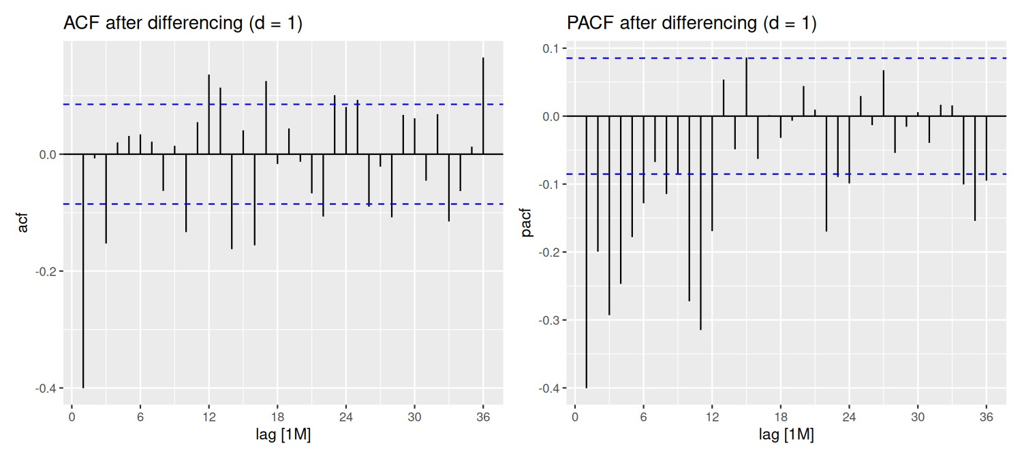
Figure 2. ARIMA plus Fourier twelve month test window forecast against actual rainfall
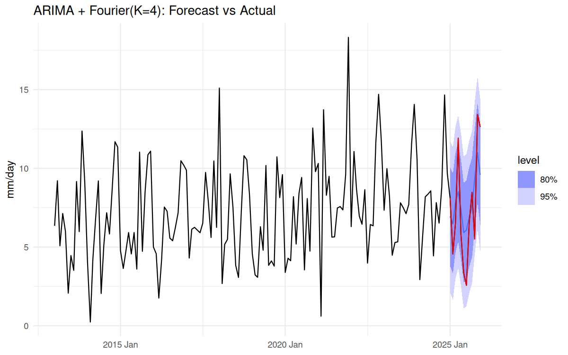
Figure 3. Residual diagnostics for the ARIMA plus Fourier model
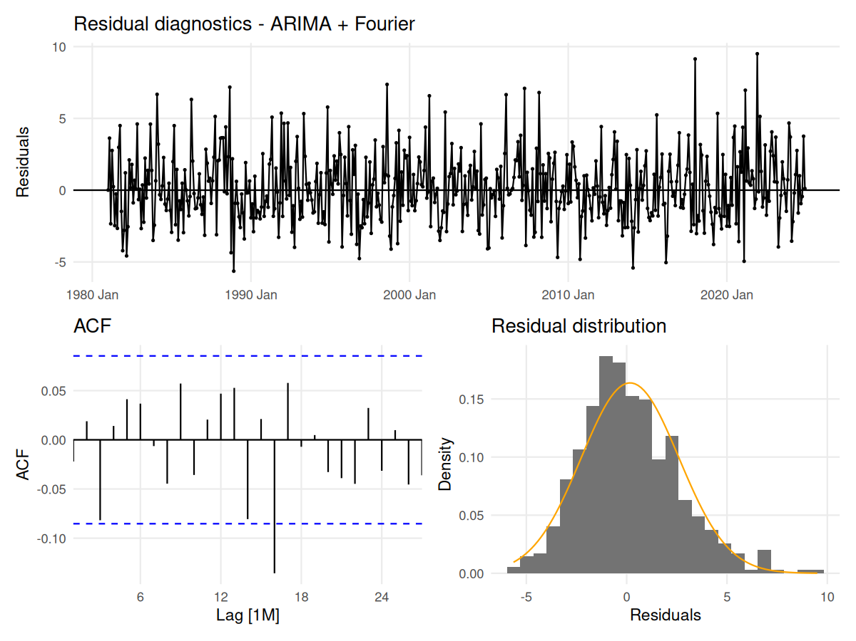

APPENDIX B: PROGRAMMING SOURCE CODE (04_StephQF_arima.R)
# ARIMA with Fourier terms rainfall forecast

# Shared setup and data acquisition make this script independently runnable.
source("scripts/00_setup.R")
source("scripts/01_data_pull.R")

cat("rain:", nrow(rain), "obs,", format(min(rain$month)), "to", format(max(rain$month)), "\n")
cat("Missing before interpolation:", missing_before,
"| Missing after interpolation:", missing_after, "\n")

# EDA
p_raw <- rain |> autoplot(precip) +
labs(title = "KL monthly mean precipitation rate (mm/day)", y = "mm/day")
p_season <- rain |> gg_season(precip) + labs(title = "Seasonal plot - monsoon cycle")
p_subseries <- rain |> gg_subseries(precip) + labs(title = "Subseries plot - by calendar month")
p_acf <- rain |> ACF(precip, lag_max = 36) |> autoplot() + labs(title = "ACF - raw series")
p_pacf <- rain |> PACF(precip, lag_max = 36) |> autoplot() + labs(title = "PACF - raw series")

print(rain |> features(precip, feat_stl))

# Statistical tests
cat("\n== ADF test ==\n")
print(adf.test(rain$precip))

cat("\n== KPSS test ==\n")
print(kpss.test(rain$precip))

cat("\n== Ljung-Box test: raw series ==\n")
print(Box.test(rain$precip, lag = 12, type = "Ljung-Box"))
print(Box.test(rain$precip, lag = 24, type = "Ljung-Box"))

cat("\n== Mann-Kendall trend test ==\n")
print(Kendall::MannKendall(rain$precip))

cat("\n== Minimum precipitation ==\n")
print(min(rain$precip, na.rm = TRUE))

# Train/test split
h <- 12
train <- rain |> filter(month <= max(month) - h)

# Model
fit <- train |> model(
snaive = SNAIVE(precip),
arima_four4 = ARIMA(precip ~ fourier(K = 4) + pdq() + PDQ(0, 0, 0))
)
fc <- fit |> forecast(h = h)

# Differenced-series diagnostics
arima_d <- train |>
features(precip, unitroot_ndiffs) |>
pull(ndiffs)

arima_series <- if (arima_d > 0) {
train |> mutate(precip_diff = difference(precip, differences = arima_d))
} else {
train |> mutate(precip_diff = precip)
}

p_acf_diff <- arima_series |>
ACF(precip_diff, lag_max = 36) |>
autoplot() +
labs(title = paste0("ACF after differencing (d = ", arima_d, ")"))

p_pacf_diff <- arima_series |>
PACF(precip_diff, lag_max = 36) |>
autoplot() +
labs(title = paste0("PACF after differencing (d = ", arima_d, ")"))

p_arima_correlation <- patchwork::wrap_plots(p_acf_diff, p_pacf_diff, ncol = 2)

# Accuracy
accuracy_display <- bind_rows(
fit |> accuracy() |> mutate(data_set = "Training set"),
fc |> accuracy(rain) |> mutate(data_set = "Test set")
) |>
transmute(
model = recode(.model,
snaive = "Seasonal naive",
arima_four4 = "ARIMA + Fourier"),
data_set, RMSE, MAE, MAPE, MASE
) |>
arrange(model, factor(data_set, levels = c("Training set", "Test set"))) |>
mutate(across(c(RMSE, MAE, MAPE, MASE), ~ round(.x, 3)))

cat("\n--- ARIMA and Benchmark Accuracy ---\n")
print(accuracy_display)
fit |> select(arima_four4) |> report()
fit |> select(arima_four4) |> gg_tsresiduals()

# Residual checks
arima_coefs <- fit |> select(arima_four4) |> tidy()
arima_dof <- sum(grepl("^(ar|ma)[0-9]+$", arima_coefs$term))
arima_p <- sum(grepl("^ar[0-9]+$", arima_coefs$term))
arima_q <- sum(grepl("^ma[0-9]+$", arima_coefs$term))

arima_specification <- tibble(
model = "ARIMA with Fourier terms",
p = arima_p,
d = arima_d,
q = arima_q,
P = 0L,
D = 0L,
Q = 0L,
seasonal_period = 12L,
fourier_K = 4L,
ljung_box_fitdf = arima_dof
)

arima_parameters <- arima_coefs |>
mutate(model = "ARIMA with Fourier terms") |>
relocate(model)

cat("\n== Ljung-Box test: ARIMA residuals ==\n")
print(augment(fit) |> filter(.model == "arima_four4") |> features(.innov, ljung_box, lag = 12, dof = arima_dof))
print(augment(fit) |> filter(.model == "arima_four4") |> features(.innov, ljung_box, lag = 24, dof = arima_dof))

cat("\n== Residual ACF summary ==\n")
print(augment(fit) |> filter(.model == "arima_four4") |> as_tibble() |>
summarise(n_lags_out_12 = acf_out_of_bounds(.innov, lag.max = 12),
n_lags_out_24 = acf_out_of_bounds(.innov, lag.max = 24)))

# Train/test comparison
acc_train <- fit |> accuracy() |> filter(.model == "arima_four4") |>
select(.model, MASE_train = MASE, RMSE_train = RMSE)
acc_test <- fc |> accuracy(rain) |> filter(.model == "arima_four4") |>
select(.model, MASE_test = MASE, RMSE_test = RMSE)
holdout <- acc_train |> left_join(acc_test, by = ".model") |>
select(.model, MASE_train, RMSE_train, MASE_test, RMSE_test)

# Rolling-origin CV
n_folds_clean <- length(seq(360, nrow(train) - h, by = 6))
cv_data <- train |>
stretch_tsibble(.init = 360, .step = 6) |>
filter(.id <= n_folds_clean)

set.seed(2026)
cv_acc <- cv_data |>
model(arima_four4 = ARIMA(precip ~ fourier(K = 4) + pdq() + PDQ(0, 0, 0))) |>
forecast(h = h) |>
accuracy(train, by = c(".model", ".id"))

cv_summary <- cv_acc |>
summarise(mean_MASE = mean(MASE), sd_MASE = sd(MASE),
min_MASE = min(MASE), max_MASE = max(MASE),
mean_RMSE = mean(RMSE), n_folds = n())
print(cv_summary)

results <- tibble(
model = "arima_fourier",
MASE_train = holdout$MASE_train,
RMSE_train = holdout$RMSE_train,
MASE_cv = cv_summary$mean_MASE,
RMSE_cv = cv_summary$mean_RMSE,
sd_MASE_cv = cv_summary$sd_MASE,
n_folds = cv_summary$n_folds
)

# Output
dir.create("output/plots/group_summary", recursive = TRUE, showWarnings = FALSE)
dir.create("output/tables/model_details", recursive = TRUE, showWarnings = FALSE)
write.csv(arima_parameters, "output/tables/model_details/arima_parameters.csv", row.names = FALSE)
ggsave("output/plots/group_summary/arima_differenced_acf_pacf.png",
p_arima_correlation, width = 10, height = 4.5, dpi = 150)

# Forecast plot
plot_from <- yearmonth("2013 Jan")
test_actual_tbl <- rain |> as_tibble() |> filter(month > max(train$month)) |>
transmute(month, precip)

p_fc <- fc |> filter(.model == "arima_four4") |>
autoplot(rain |> filter(month >= plot_from), level = c(80, 95)) +
geom_line(data = test_actual_tbl, aes(x = month, y = precip),
color = "red", linewidth = 0.45) +
labs(title = "ARIMA + Fourier(K=4): Forecast vs Actual", y = "mm/day", x = NULL) +
theme_minimal()
save_fable_forecast_plot(
fc |> filter(.model == "arima_four4"), rain, "ARIMA + Fourier",
"ARIMA + Fourier(K=4): Forecast vs Actual",
"output/plots/group_summary/fc_arima.png"
)
u_arima <- augment(fit) |> filter(.model == "arima_four4") |> as_tibble()
save_residual_diagnostic(u_arima$.innov, u_arima$month, "ARIMA + Fourier",
"output/plots/group_summary/resid_arima.png")

cat("\nDone. Wrote the ARIMA parameter table and 3 plots.\n")

