Forecasting Monthly Rainfall in Kuala Lumpur for Climate Resilience
[Member 1 Full Name]  Department of Mathematical Sciences  Tunku Abdul Rahman University of Management and Technology  Kuala Lumpur Malaysia  [Student email or ORCID] | [Member 2 Full Name]  Department of Mathematical Sciences  Tunku Abdul Rahman University of Management and Technology  Kuala Lumpur Malaysia  [Student email or ORCID]
[Member 3 Full Name]  Department of Mathematical Sciences  Tunku Abdul Rahman University of Management and Technology  Kuala Lumpur Malaysia  [Student email or ORCID] | [Member 4 Full Name]  Department of Mathematical Sciences  Tunku Abdul Rahman University of Management and Technology  Kuala Lumpur Malaysia  [Student email or ORCID]
Abstract—This study compared four methods for forecasting monthly mean precipitation in Kuala Lumpur: exponential smoothing, dynamic regression with ARIMA errors, time-series linear regression, and TBATS. The NASA POWER record contained 540 monthly observations from January 1981 to December 2025. Models were evaluated on the 2025 holdout period and by 27 rolling-origin forecasts. All four models improved on a seasonal-naive benchmark. TBATS produced the lowest test RMSE of 2.335 mm/day and test MASE of 0.771, as well as the lowest cross-validation MASE of 0.783. Its residual diagnostics were acceptable at the 5% level, although rainfall peaks remained difficult to predict. The results support the use of monthly forecasts for seasonal water and climate-resilience planning under SDG 13, but not for short-term flood warnings.
Keywords—climate resilience, forecasting, Kuala Lumpur, rainfall, SDG 13, time series

I. INTRODUCTION
Monthly rainfall affects reservoir operations, drainage planning, agriculture, and preparedness for wet and dry periods. Kuala Lumpur experiences a recurring annual rainfall cycle, but individual months can depart sharply from the seasonal pattern. A useful planning model must therefore represent seasonality while remaining stable when evaluated on observations that were not used for fitting.
This study aimed to describe the monthly rainfall pattern, compare four forecasting approaches, select the most reliable model using out-of-sample evidence, and relate the findings to Sustainable Development Goal 13 Climate Action. Target 13.1 calls for stronger resilience and adaptive capacity to climate-related hazards and natural disasters [1]. Monthly forecasts cannot predict individual storms, but they can inform seasonal preparedness and resource allocation.
The analysis used the NASA Prediction Of Worldwide Energy Resources monthly point service, which distributes analysis-ready meteorological time series for selected coordinates [2]. The study location was 3.1390 N and 101.6869 E, representing Kuala Lumpur. The response variable was corrected precipitation rate PRECTOTCORR in mm/day.
II. METHODOLOGY
A. Data Preparation and Exploratory Analysis
The record covered January 1981 through December 2025 and contained 540 monthly observations. Values coded as -999 were designated as missing and would have been linearly interpolated in time order; the downloaded record contained no missing values. The final 12 months formed an independent test set, leaving 528 observations for model estimation.
Exploration included a time plot, monthly seasonal and subseries plots, box plot, autocorrelation and partial autocorrelation functions, and seasonal-trend decomposition using LOESS. STL estimated seasonal strength at 0.469 and trend strength at 0.181. The raw-series Ljung-Box tests at lags 12 and 24 both had p < 0.001, confirming strong serial dependence. The ADF test rejected a unit root whereas the KPSS test rejected level stationarity; this mixed result and the visible annual pattern motivated explicit seasonal modelling rather than reliance on one stationarity test.
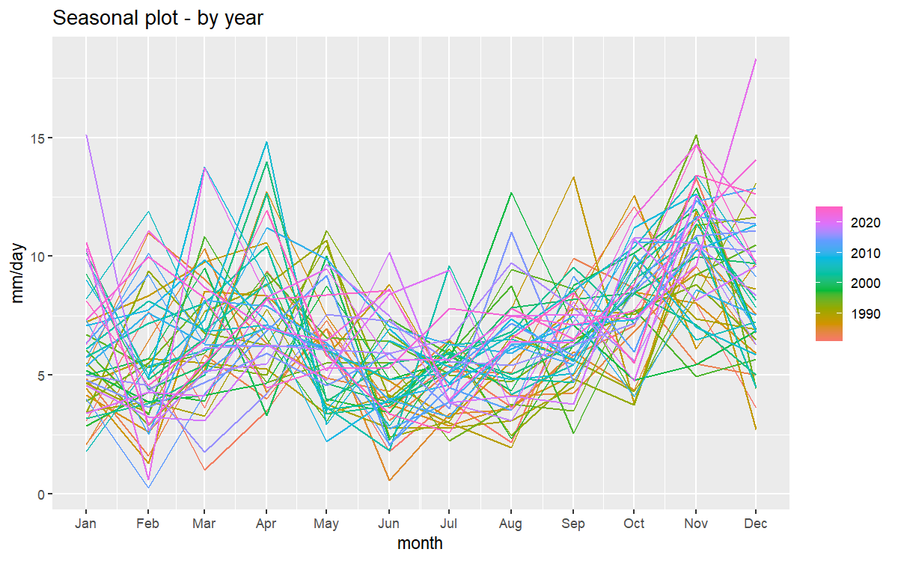
Fig. 1. Monthly seasonal pattern in Kuala Lumpur precipitation.
B. Forecasting Models
Each model used a 12-month seasonal period. ETS(A,N,A) represented a slowly changing level and additive seasonality without a trend state. The dynamic regression model combined four Fourier pairs with automatically selected ARIMA(0,1,1) errors. TSLM estimated a linear trend and the same four Fourier pairs by ordinary least squares. TBATS allowed trigonometric seasonality and automatic Box-Cox selection; the fitted transformation parameter was 0.596 and the final model used three harmonics, no trend, and no ARMA error terms. A seasonal-naive forecast served as the benchmark. Table I summarises the fitted forms.
TABLE I
MODEL SPECIFICATIONS
Model | Final specification
ETS | ETS(A,N,A)
ARIMA | ARIMA(0,1,1) errors and Fourier K=4
TSLM | Linear trend and Fourier K=4
TBATS | TBATS(0.596,{0,0},-,{<12,3>})
C. Forecast Evaluation
Performance was measured with root mean squared error, mean absolute error, mean absolute percentage error, and mean absolute scaled error. MASE used the seasonal-naive training error at lag 12 as its denominator, so a value below one indicated improvement over that benchmark. MAPE was treated as supporting evidence because precipitation approached zero in some months.
The independent holdout evaluation forecast January through December 2025. Rolling-origin cross-validation provided a second comparison [3]. It began with 360 months, advanced by six months, and generated a 12-month forecast at each of 27 origins that ended before the 2025 holdout. Residual ACF plots and Ljung-Box tests at lags 12 and 24 assessed remaining autocorrelation. The ARIMA test deducted one fitted ARMA degree of freedom; the other models followed their package conventions.
III. RESULTS AND DISCUSSION
A. Rainfall Characteristics
Monthly precipitation ranged from 0.240 to 18.320 mm/day, with a mean of 6.739 and median of 6.305 mm/day. The seasonal plot shows repeated within-year changes but substantial variation among years. The STL trend component was weak relative to seasonality, which supported seasonal models without a strong trend. Large positive rainfall departures also produced right-skewed residual distributions in the fitted models.
B. Forecast Accuracy
All four fitted models achieved test and cross-validation MASE values below one and below the seasonal-naive benchmark. TBATS ranked first on every 2025 test metric: RMSE 2.335 mm/day, MAE 1.984 mm/day, MAPE 35.702%, and MASE 0.771. Relative to seasonal naive, it reduced test RMSE by 13.3% and scaled absolute error by 18.2%.
TABLE II
FORECAST ACCURACY COMPARISON
Model | Test  RMSE | Test  MASE | CV  RMSE | CV  MASE
TBATS | 2.335 | 0.771 | 2.495 | 0.783
ETS | 2.363 | 0.807 | 2.566 | 0.811
TSLM | 2.407 | 0.833 | 2.557 | 0.814
ARIMA | 2.424 | 0.843 | 2.538 | 0.801
SNaive | 2.694 | 0.942 | 3.179 | 0.985
RMSE is in mm/day. CV uses 27 rolling origins. Lower values are better.
The rolling-origin results led to the same decision. TBATS achieved the lowest CV RMSE of 2.495 and CV MASE of 0.783. ARIMA ranked second on CV MASE at 0.801, while ETS and TSLM recorded 0.811 and 0.814. On the single 2025 holdout, ETS ranked second at 0.807, followed by TSLM at 0.833 and ARIMA at 0.843. The agreement between the two evaluation designs supports TBATS as the final model rather than selecting it from one favourable test year.
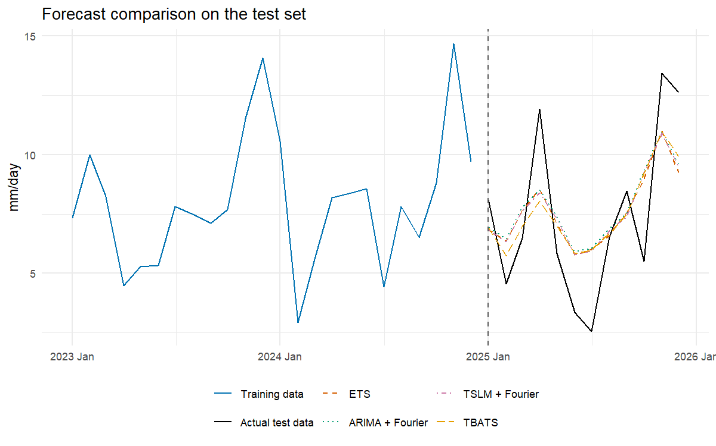
Fig. 2. Twelve-month forecasts compared with observed precipitation in 2025.
C. Residual Diagnostics and Model Selection
The four fitted models had Ljung-Box p-values above 0.05 at lags 12 and 24. At lag 24, the p-values were 0.122 for ETS, 0.108 for ARIMA, 0.148 for TSLM, and 0.089 for TBATS. The TBATS result passed at the 5% level but was close enough to the threshold to warrant monitoring. Its residual ACF contained one out-of-bound lag within 12 months and two within 24 months. These diagnostics do not prove independence, but they did not identify enough remaining autocorrelation to overturn the accuracy-based choice.
TBATS was designed for complex seasonal patterns and can combine transformations, trigonometric seasonality, trend, and ARMA errors [4]. In this application, automatic selection retained the Box-Cox transformation but omitted trend and ARMA terms. The resulting model was flexible enough to improve forecast accuracy without adding unsupported components. Its central forecasts still smoothed sharp observed peaks, so prediction intervals and periodic refitting remain important.
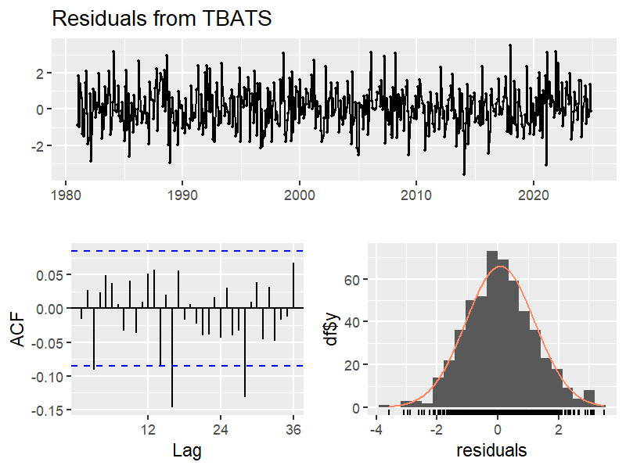
Fig. 3. Residual time plot, autocorrelation function, and distribution for TBATS.
IV. CLIMATE RESILIENCE IMPLICATIONS
The analysis supports SDG 13 by providing a reproducible way to anticipate typical monthly rainfall conditions. Water managers and local authorities could use updated forecasts when scheduling drainage maintenance, reviewing reservoir or supply plans, and preparing resources for wetter seasons. The practical value lies in seasonal readiness rather than precise prediction of a specific flood event.
The forecast horizon and data frequency impose an important boundary. Monthly mean precipitation can hide short, intense storms and local drainage conditions. The model should therefore complement daily weather forecasts, flood sensors, and hydrological assessments. Its predictions should be refreshed as new NASA POWER observations become available and compared against the same benchmark and rolling-origin design.
V. LIMITATIONS AND RECOMMENDATIONS
The dataset represents one gridded point rather than the spatial variation across Greater Kuala Lumpur. It contains only precipitation, so the models cannot anticipate changes driven by temperature, circulation, soil moisture, land use, or other explanatory variables. The test set covers one year, and all central forecasts smooth extreme monthly values. TBATS also returns a median forecast after back-transforming by default; a bias-adjusted mean forecast could be examined in a sensitivity analysis when RMSE is the primary loss measure.
Future work should add nearby grid points or station observations, evaluate relevant climate predictors only when their future values are available, and repeat the rolling-origin comparison after each annual update. Alternative Fourier orders and transformed ETS specifications should be assessed with the same origins. For operational use, monthly results should be combined with higher-frequency rainfall and catchment information.
VI. CONCLUSION
Kuala Lumpur monthly rainfall showed a persistent annual cycle and large irregular peaks. ETS, ARIMA with Fourier terms, TSLM with Fourier terms, and TBATS all outperformed seasonal naive forecasting. TBATS provided the strongest overall evidence, with the lowest 2025 test errors and the lowest rolling-origin CV errors. Its lag-24 residual test was acceptable but not conclusive, and extreme rainfall remained difficult to forecast. The model is suitable as a seasonal planning aid that can contribute to climate resilience under SDG 13, provided that it is updated regularly and not interpreted as a short-term hazard warning.
REFERENCES
[1] United Nations, "Goal 13 Climate action," Department of Economic and Social Affairs. [Online]. Available: https://sdgs.un.org/goals/goal13. [Accessed: Sep. 6, 2026].
[2] NASA POWER, "Monthly and Annual API," NASA Langley Research Center. [Online]. Available: https://power.larc.nasa.gov/docs/services/api/temporal/monthly/. [Accessed: Sep. 6, 2026].
[3] R. J. Hyndman and G. Athanasopoulos, Forecasting Principles and Practice, 3rd ed. Melbourne, Australia: OTexts, 2021. [Online]. Available: https://otexts.com/fpp3/.
[4] A. M. De Livera, R. J. Hyndman, and R. D. Snyder, "Forecasting time series with complex seasonal patterns using exponential smoothing," Journal of the American Statistical Association, vol. 106, no. 496, pp. 1513-1527, 2011, doi: 10.1198/jasa.2011.tm09771.
[5] R. J. Hyndman and Y. Khandakar, "Automatic time series forecasting The forecast package for R," Journal of Statistical Software, vol. 27, no. 3, pp. 1-22, 2008, doi: 10.18637/jss.v027.i03.
[6] M. O'Hara-Wild, R. J. Hyndman, and E. Wang, "fable Forecasting models for tidy time series," R package version 0.5.0, 2026. [Online]. Available: https://CRAN.R-project.org/package=fable.
[7] R. J. Hyndman et al., "forecast Forecasting functions for time series and linear models," R package version 9.0.2, 2026. [Online]. Available: https://CRAN.R-project.org/package=forecast.

